MODELLING AND ANALYSIS OF EV COMMUNICATUION SYSTEM FOR ROAD SAFETY APPLICATIONS

Sheik Dhavud S¹, Suresh S², Purushothaman A³, Jeswin Vincent Raj R⁴, Sakthimurugan M⁵
¹B.E Student ,² Professor,³⁴⁵B.E. Student, Dept of Electrical and Electronics Engineering,
¹kit.23.19bee050@gmail.com ² engrsuresh@gmail.com ³ kit.23.19bee039@gmail.com
⁴kit.23.19bee302@gmail.com ⁵ kit.23.19bee307@gmail.com
KIT-Kalaignarkarunanidhi Institute of Technology, Coimbatore

ABSTRACT –As the continuous usage of transports the accidents also increased. The Major reason or cause of the vehicle is due to only two reasons one is Automobile failure and another one is human failure. Human failure is like high speed, drunk and drive, high stress. In this Paper we must control the drunk and drive accidents and track the accident exact location with the help of GSM and GPS technology. Furthermore, the frequency of traffic accidents is rising quickly. This essay discusses a system that was created to automatically identify accidents and notify the nearby hospitals and emergency services. Additionally, this system can pinpoint the accident's location so that emergency medical assistance can be sent there right away. With the help of ACCELEROMETER, GPS, and GSM and Alcohol sensing technology, this article aims to develop a vehicle accident monitoring system. In order to send messages, the system includes an accelerometer, an MCU, a GPS module, and a GSM module. The Threshold Algorithm is used to detect accidents, whereas the accelerometer is utilized to detect falls. In order to help locate the automobiles, the short message will provide GPS [Latitude, Longitude].

Keywords- Arduino UNO, MQ3 Sensor, Motor Driver, Accelerometer Sensor, GPS Module, LCD Display.

I INTRODUCTION
The current environment could soon lead to a rise in accident rates. Due to an increase in employment, more people may use bicycles and cars, which could lead to an increase in occurrences involving excessive speed. Accident rates cannot be decreased due to a lack of advanced processes and the risks involved with driving too quickly and consuming alcohol also. This analysis offers the best plan of action for reducing the country's accident rate. This article describes the automatic alert system for auto accidents and sense alcohol detection, if the alcohol is sensed means the vehicle doesn’t start, whose main objective is to prevent them by using wireless communication to send a message to the registered cellphone. When an accident occurs in a city, the registered cellphone immediately receives a GSM alert. The system's brain, Arduino, facilitates communication with different system parts.”

LITERATURE SURVEY
Number of accidental deaths worldwide, as reported by V.N.Ghodke et al[1]. Many accidents in such cases are caused by delayed access to medical assistance and first aid. In the event of an accident, vibration sensors detect the collision and send a signal to the microcontroller. Protection activated successfully. This author only tracks latitude and longitude. According to T. Kalyani et al. [2] reports that there are numerous advanced vehicle protection and tracking technologies available today. Previously, we were able to submit accident information, but could not justify or identify the scene of the accident. According to AboliRavindraWakure et al.[3], the existing system also uses an Atmega 328 microcontroller and his RF transmitter and receiver to provide the accident location as well. Information will be sent to your saved mobile number.

II PROBLEM STATEMENT
Crash detection and vehicle messaging systems use GSM modems to help detect collisions via vibration sensors. Vibration sensors are useful when you need to detect vibrations or shocks. Vibration sensors help send signals to the Arduino controller. The Arduino controller sends alert messages with location information via GSM modem. In the event of a minor accident, the driver can switch off the message to let them know that they do not need to pay attention. You can also feel the driver's alcohol.

III EXISTING SYSTEM
Current systems can identify traffic accidents and send SMS alerts via GSM to the right person or necessary authorities such as: B. Hospital ambulance service or traffic police emergency service. The only information in the alert is a direct link synced with the latitude and longitude program and the geodetic location data of the accident.
Fig 1. Existing Block Diagram
- Disadvantages Of Existing System

- Here it only sends the GPS location When an Accident occurs the through GSM and GPS.
- Even it is a minor Accident it Intimates.

PROPOSED SYSTEM
In this time of rapid professional advancement, everyone is occupied with their daily lives. People, especially those who live in cities, must move quickly from one location to another at all hours of the day. Road accidents are a typical occurrence because of this, as well as occasionally because of ineffective drivers. If the victim of a car accident is not provided the right medical care at the right moment, their life may be taken. As a result, we must create a system for this project that can identify traffic accidents and pinpoint their locations using GPS. This will then be communicated to the closest emergency care facility via a GSM interface so that the victim can receive prompt medical help. Here, we show and include an automobile geolocation system that makes use of GPS, GSM-SMS, and a MQ alcohol sensor. If the scent of alcohol is detected, it detects it and prevents the vehicle from starting. Through the messaging system, it will deliver the location to the appropriate owners. This system is very useful for families, Friends, and cab services. This will help us to know where the accident occurs and sends the exact google map locations for the friends or relatives for quicker recovery. This system will help us to for future purposes. Here we using some of the main components for tracking, detecting, and Sensing.
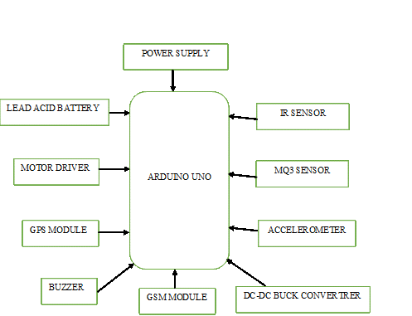
Fig 2. Proposed Block Diagram

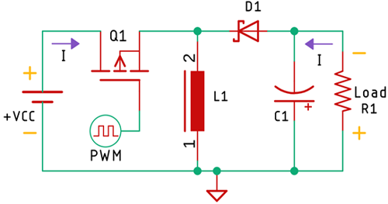
Fig.3 Buck booster Circuit
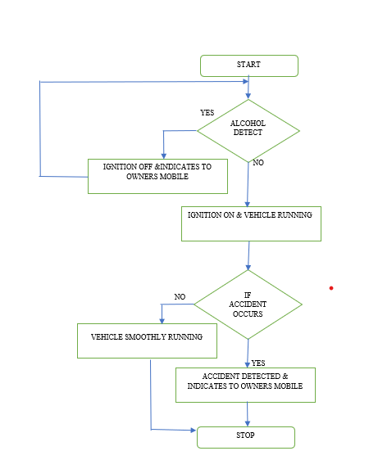
Fig.4 Flow Analysis of the Road Safety System

- Block Diagram Explanation

- This project uses an Arduino with a GPS receiver and a GSM module to control each step of the workflow.
- Vehicle coordinates are determined using a GPS receiver and an SMS notification containing the coordinates and a link to Google Maps is sent via the GSM module.
- The accelerometer is used to detect an accident or a rapid shift in any axis.
- Additionally, status updates or coordinates are shown on an optional 16x2 LCD and buck circuit(fig 3).
- We used the GSM Module SIM900A and the GPS Module SIM28ML.
- MQ sensor is connected to the Arduino, GPS and GSM for track and send information’s send to mobile.
- We can receive information through SMS with exact location where the car is accident.

- Advantages Of Proposed System

- Automated Areas
- Simple to utilize in rural locations.
- little electricity usage.
- Flexible and trustworthy
- Both installing and using this programmed are simple.
- Dependable compared to manual operation.
- Losses in this project are very minimal.
- This initiative can be put into action to ensure supply security.

- Limitations Of Proposed System

- Compared to digital systems, it raises the price of the system.
- High price because we got accurate results when we use these kinds of modules,
- Applications Of Proposed System
- This system is used for in-the-moment traffic observation. It might be a useful tool for real-time travelers.
- This system is applicable to industries.
- This project is applicable to all cars.
- We can implement this project in areas where security is a priority.
- Any four-wheeler can be used with it because the circuit hasn't changed substantially.

MATHEMATICAL EXPRESSION
The microcontroller reads the raw numbers from the accelerometer and obtains them through data fusion using complimentary filters. In this instance, the gyroscope drift is fixed using the accelerometer. The equation known as a complementary filter produces a weighted arithmetic mean from the measurements of the accelerometer and gyroscope.
+y
+z
+x
-z
-y
Fig. 5. G-sensor (accelerometer) axes.
The following example is the formula for calculating x1. This way you can get the values ​​of y1, z1 and x2, y2, z1
First average: (X1+X2+X3+X4+X5+X6)/ 6 -1
Second average: (X1+X3+X5)/ 3 + (X2+X4+X6)/ 3- 2
x1 = (1st avg. + 2nd avb.)/ 2 -3

The following equation can be used to calculate the vector sum as well as the difference between the previous and current values.

Table 1. Crash Detection Comparisons
 | Direction | Crash1 | Crash 2 | Proposed
Driving-  (M-Mode) | Front | M | M | M
Driving-  (M-Mode) | Front Right | M | M | M
Driving-  (M-Mode) | Right Front Door | M | - | M
Driving-  (M-Mode) | Right Rear Door | M | - | M
Driving-  (M-Mode) | Rear Right | - | M | M
Driving-  (M-Mode) | Rear | M | M | M
Driving-  (M-Mode) | Left Rear Door | - | M | M
Driving-  (M-Mode) | Left Front door | M | - | M
Driving-  (M-Mode) | Front left | - | M | M
Driving-  (M-Mode) | Top | M | M | -
Driving-  (M-Mode) | Bottom | M | M | M
Parking | Front | M | M | M
Parking | Front Right | - | - | M
Parking | Right Front Door | M | M | M
Parking | Right Rear Door | - | - | M
Parking | Rear Right | - | M | M
Parking | Rear | - | - | M
Parking | Rear left | M | M | M
Parking | Left Rear Door | - | M | M
Parking | Left Front Door | M | - | M
Parking | Front Left | - | M | M
Parking | Top | M | M | -
Parking | Bottom | - | - | -

IV SOFTWARE REQUIREMENTS

- Proteus 8.11
Proteus is the leading simulation software for various microcontroller architectures[1]. Its popularity is largely due to its ability to support almost all microcontrollers, making it a useful tool for electronics enthusiasts to test embedded systems and for programmers. Proteus allows users to design a circuit and then create a PCB (Printed Circuit Board) design.

- Arduino Ide Programming
The Arduino integrated development environment (IDE) is software that includes a text editor for writing code, a message window, a console for viewing text output, a toolbar with basic control buttons, and several menus. It also contains a message area for uploading code to communicate with the Arduino hardware.

Arduino UNO collects all data from touch sensor, ultrasonic sensor, PIR (passive infrared sensor) and ESP32 (camera module). A user's finger is a major source of common-mode noise in touch-sensing systems. The user is connected to the sensor through stray capacitance because the human body and the sensor have different ground references. Additionally, thermal infrared sensors, also called pyroelectric infrared sensors, use infrared light as a source of thermal energy to detect objects. The sensitivity of these sensors is wavelength independent. Track activity near fences using open source ESP32. Ultrasonic sensors send and receive ultrasonic pulses from a transducer to determine the proximity of objects. In this system, Arduino controls all sensor inputs to send data to his WIFI module in the communication system
ANALYSIS AND TESTING
A series of tests that demonstrate conformity with specifications are used to validate software. As a result, validation testing was done on the suggested system under consideration, and it was determined to be functioning satisfactorily.
- Black Box Testing
Rather than going into statement-level detail, this testing approach takes the module as a single entity and evaluates the module's interfaces and communication with other modules. In this scenario, the module appears as a block box that accepts inputs and produces outputs. Outputs for a given set of input combinations are passed to additional modules.
- Unit testing
Unit testing concentrates verification work on the module, which is the smallest piece of software. Testing is done to find problems within the module's perimeter using the comprehensive design and the process standards. The unit test for every module must pass.

- User acceptance Testing
By frequently talking with prospective system users during the development phase and adjusting as necessary, the system under consideration is put to the test for user acceptance. This is carried out with regard to the following things.
- Output Testing
Because no system can be helpful if it cannot give the required output in the appropriate format, the output testing of the proposed system is performed after the validation testing. Users are asked what format they want their outputs from the system under consideration to be in. The output in this case is split into two groups: printed format and screen format. Since it was designed to satisfy user needs, it is concluded that the output format that is displayed on the screen is accurate. Even for the hard copy, the output is produced according to the user's specifications. Output testing therefore does not result in system correction.
- Validation Testing2
When the software performs as the consumer might expect, validation has been successful. After the application was thoroughly checked for logical and interface flaws, validation testing involved entering data to make sure the software met all the specifications for typical input. If invalid data is entered, a notice about invalid data entry must appear to the user. However, the data are generated with the aim of evaluating how well the system will handle them.

V SIMULATION TESTING AND RESULTS

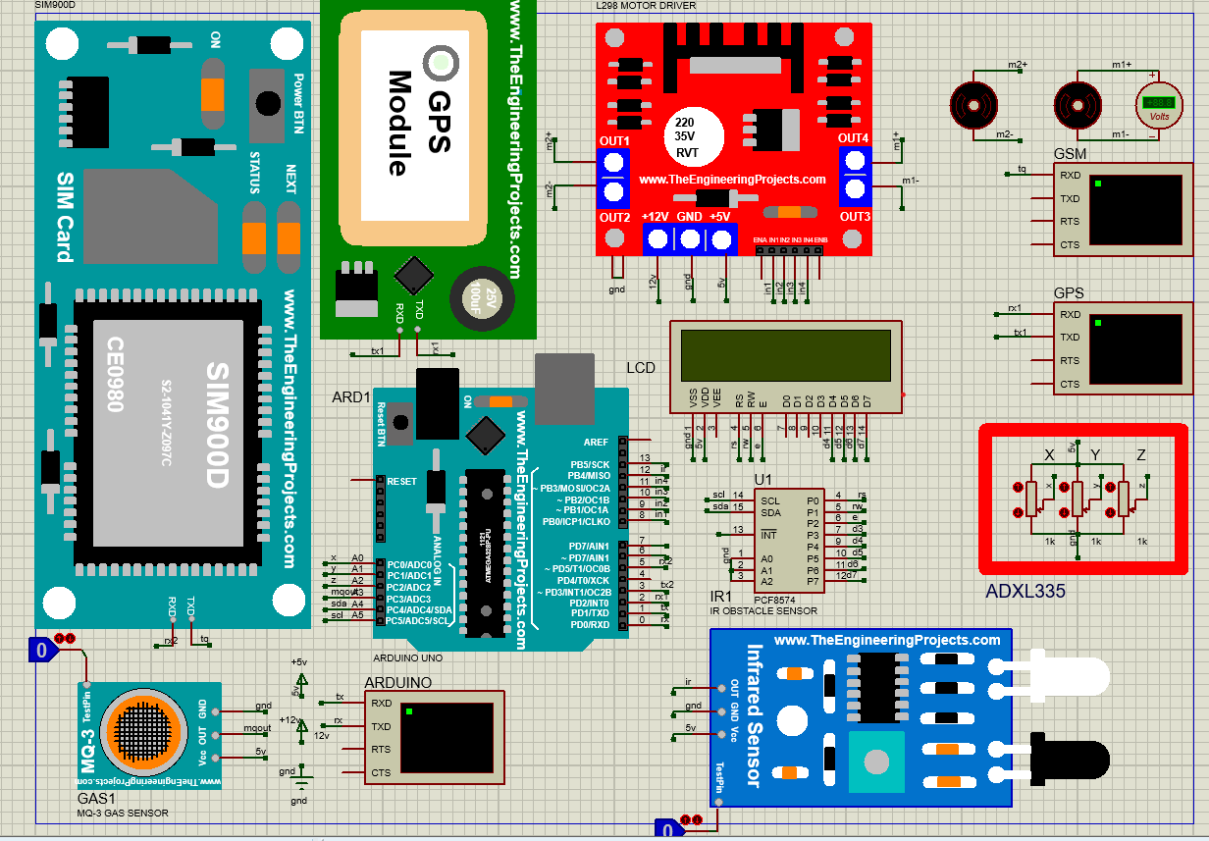
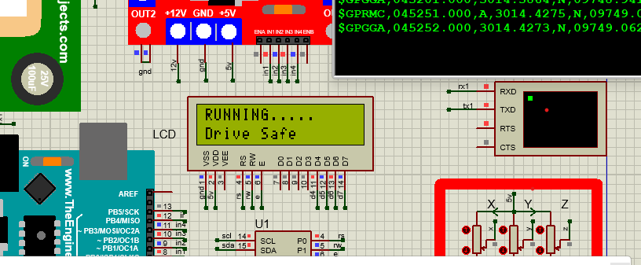
Fig 6. Schematic Diagram for Road Safety
Fig 7. Vehicle Running Safely
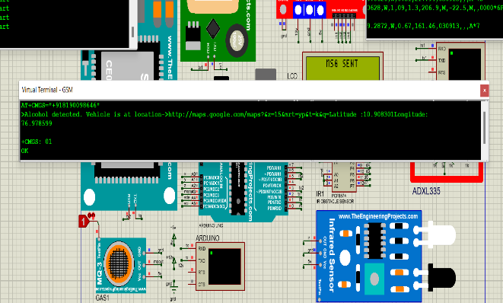
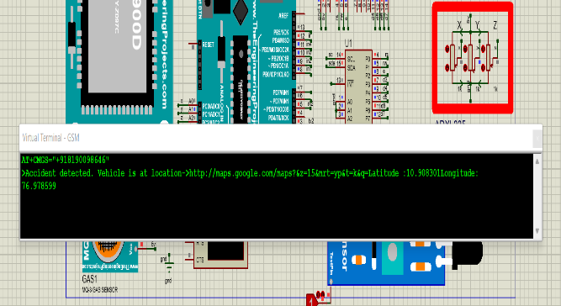
Fig 8.Alcohol Detected and Information Sent
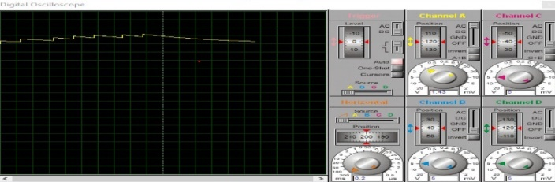
Fig.9. Accident Detected and Information Sent
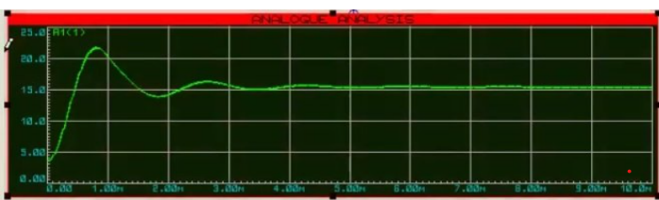
Fig 10. Analog Output Waveform
Fig 11. Buck Boost Waveform

SIMULATION RESULTS
This road safety system device first detects the driver consumes alcohol or not. If the driver consumes alcohol means the vehicle does not start and this information send to owner’s mobile through SMS. After checking the driver, the vehicle runs safely. If suddenly accident occurs means that accident exact location is send to the owner’ mobile through SMS. If the accident does not occur means the car will going safely. If driver consumes alcohol occurs means that drunken exact location is send to the owner’ mobile through SMS. If the driver does not consume alcohol means the car will going safely. After that Vehicle is going safely if suddenly accident occurs means the accelerometer triggers the information into GPS and GSM module through ARUDUINO and information sent to respective mobile number and make calling also.

COMPARISON BETWEEN EXISTING AND PROPOSED RESULTS
In this comparison I compared our result with Author [1]. This result has been completely different from results. Author [1] has results is just sending the GPS location through SMS. But the location of the accident place should not be very clearly and exactly. Thar SMS contains Simply like Latitude and longitude. But we can view in google maps. According To our results the exact and accurate location of the accident place should be sent to respective mobile via SMS and one more additional technology with calling. This should be easily identified in night time also.

Accident Alert System [1] RESULT
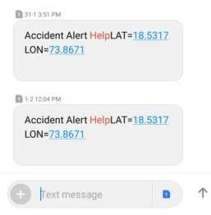
Fig 12. Accident Alert System [1] Result

PROPOSED RESULT
Fig 13. Proposed Result

VI CONCLUSION
One of the biggest causes of accidents is speed. GPS receivers are now essential in every car. Besides being used for other purposes, GPS can also be used for speed tracking and accident detection. Widespread and inexpensive GSM modems can be used to transmit the scene of an accident to an alarm centre. You can also initiate a voice call and send your latest pre-crash speed to assess the severity of the accident. In addition to the automatic detection system, the car driver or passenger can manually send the accident situation by turning on the manual detection switch. Many lives can be saved by taking swift, strategic and timely action in the right places. Human life is valued, so the proposed strategy can greatly help humanity.

FUTURE SCOPE
The system can be linked to the car's airbag system to prevent occupants from colliding with interior components such as steering wheels and windows. Additionally, the control module can be equipped with a camera that takes pictures of the accident scene to aid in tracking. By connecting to a bomb detector, the device can be used to find bombs.

REFERENCES

[1] V.N. Ghodke, Shruthi Navanath Lokhande, Kiran Shivaji Ghule, Mandar Manohar More, “Automatic Accident Alert System” , International Journal of scientific development and research”,2019.
[2] National statistics of road traffic accidents in India, September 2013, Available from http://www.jotr.in/article.asp?issn=09757341;year=2013;volume=6;issue=1;spage=1;epage=6;aulast= Ruikar /[Last accessed on 2017 Dec 16]
[3] “Vehicle Accident Detection and Reporting System Using Gps and Gsm.” by AboliRavindraWakure, ApurvaRajendraPatkar,
IJERGS April 2014.
[4] Tanushree Dalai, "Emergency Alert and Service for Automotives for India", International Journal of Advanced Trends in Computer Science and Engineering (IJATCSE) Mysore India, vol. 2, no. 5, pp. 08-12, 2013.
[5] Amit Meena, Srikrishna Iyer, Monika Nimje, Saket JogJekar, Sachin Jagtap, Mujeeb Rahman, "Automatic Accident Detection and Reporting Framework for Two Wheelers", IEEE International Conference on Advanced Communication Control and Computing Technologies (ICACCCT), pp. 962-967, May 2014.
[6]. J. White, C. Thompson, H. Turner, B. Dougherty, and D. chmidt, “Wreckwatch Automatic traffic accident detection and notification with smartphones,” Mobile Networks and Applications, vol. 16, no. 3, pp. 285–303, 2011.
[7]. Amin, J. Jalil, and. Reaz, “Accident detection and reporting system using GPS, G R and G technology,” in Proc. IEEE International Conference on Informatics, Electronics & Vision (ICIEV), pp. 640–643, 2012.
[8]. Tushara D.B., Vardhini P.A. Wireless vehicle alert and collision prevention system design using Atmel microcontroller; Proceedings of the International Conference on Electrical, Electronics, and Optimization Techniques (ICEEOT); Chennai, India. 3–5 March 2016; pp. 2784–2787.
[9]. Pooja Shindalkar, Aasiya Fatema Shaikh, Chaitanya Mate, “Arduino Based Vehicle Accident Detection System”, International journal of Innovative Research in Computer and Communication Engineering (A 3297:2007 certified organization) Vol.5, Issue 4.
[10]. E.Krishna Priya, P.Manju, V.Mythra, “IoT Based Vehicle Tracking and Accident Detection System” International journal of Innovative Research. Engineering, (An ISO 3297:2007 Certified organization) Vol.5, Issue 3.
[11]. Hemjit Sawant, Jindong Tan, Qingyan Yang Qizhi Wang,” Using Bluetooth and Sensor networks for intelligent transport systems”, In proceeding of Intelligent Transport System; 2004. 8. Jules White, Brian Dougherty, Adam Albright, Douglas C,” Using Smartphone to Detect Car Accidents and Provide Situational awareness to emergency responders chirs Thompson”, Mobile Wireless Middleware, Operating system and Application;2010
[12]. R. Ganiga, Rohit Maurya, Archana Nanade, ”Accident detection system using Piezo Disk Sensor”, International Journal of science, Engineering and Technology Research(IJSETR) volume6,Issue3,March 2017,ISSN 2278-7798.
[13]. Vikram Singh Kushwaha, Deepa Yadav, Abuyeed Topinkatti, Amrita Kumari. “Car Accident Detection System using GPS And GSM”, Volume 2, Issue 1(Jan-Feb 2015), PP12-17
[14]. Lih-Jen Kau, Member, IEEE, and Chih-Sheng Chen, “A Smart Phone-Based Pockert Fall Accident Detection, Positioning and Rescue System”, Dec 2013
[15]. G. Acampora, D. J. Cook, P. Rashidi, A. V. Vasilakos, “A Survey on Ambient Intelligence in Healthcare”, Proceedings of the IEEE, pp. 2470-2494, Vol. 101, No. 12, Dec. 2013

