A Research Paper on
RIGHT TO INFORMATION ACT 2005: ADVANTAGES AND DISADVANTAGES
Subject: REGULATORY LAW

Author
Nithish kumar.I
B.A.,LL.B(HONS)
131801091
2nd YEAR,BA,LL.B(Hon’s),
SAVEETHA SCHOOL OF LAW Saveetha Institute of Medical and Technical Sciences (SIMATS), Saveetha University, Chennai- 600077Phone number:8248435771
Email id:nithishnk1111@gmail.com
Phone number:8248435771

CO AUTHOR
VAISHALI.T
B.A., B.L(HONS)., L.L.M.,
NET ASSISTANT PROFESSOR OF LAW SAVEETHA SCHOOL OF LAW Saveetha Institute of Medical and Technical Sciences (SIMATS), Saveetha University, Chennai- 600077.
MAIL: vaishunathan5@gmail.com
Contact phone number:9894050193

SAVEETHA SCHOOL OF LAW
SAVEETHA INSTITUTE OF MEDICAL AND TECHNICAL SCIENCE
CHENNAI
2019

RIGHT TO INFORMATION ACT 2005: ADVANTAGES AND DISADVANTAGES

Author: I.Nithish kumar
Co-Author-T.vaishali
Abstract
The Right to Information Act, 2005 was enacted to give the citizens with the Right to information. It gives a direct nexus to the people to request for information about the administrative works of the Government. Right to Information Act, 2005 has changed the representative democracy into participative democracy A decade has passed since the enactment of the Act and the Act has shown impact on the functioning of the Government and the staffs has become active, responsible and accountable. It has given the people the power the question about the policies and schemes. Right to Information has become a key to good governance. There are many benefits conferred by and positive consequences by the Act. But there is also a misuse of the Act by people for harassing the public authorities. This paper deals with the study of RTI, Act, 2005, it analyzes the uses and misuse of the RTI Act, 2005. This paper also studies cases where RTI has been misused. The paper also analyses the shortcomings in the Act.

Keywords: Right to Information, participative democracy, good governance, misuse, shortcomings.

INTRODUCTION
Right to information Act, 2005 was enacted to enable the citizens to access information. It is a central legislation enacted by the Government of India and it came into force on October 12, 2005. This Act has replaced the prior Act which existed for information known as the Freedom of Information Act, 2002. Like many other Acts this Act is applicable to the whole of India except the state of Jammu and Kashmir. The State of Jammu and Kashmir has a similar Act which was enacted in the year of 2009. (Fattah 2015)India is a democratic country where people rule with their elected representatives. In a democratic country, people have the right to know. The Act ensures such right by letting the people to know the work of the elected representatives. Through this Act people have the right to obtain copies of the works of the Government from respective authorities. Right to information Act ensures the citizens with their fundamental rights. Though not expressly stated right to information is provided in article 19. Right to information Act greatly promotes transparency and accountability. (Gnassi 1997)If any work carried out by the government representatives for the welfare of the public is held up then the people under this Act can ask for the reason for such delay. The main object is to study about the Right to Information Act, 2005, To know about the evolution of RTI Act in India, To analyse the uses of RTI Act, To analyze how RTI Act is being misused.

OBJECTIVES:
- To find the advantages and disadvantages of RTI act.
- To find the time limit to get information under RTI act 2005.
- To find powers and functions of RTI Act.
- To find time limit to get information about life and liberty of a person.
HYPOTHESIS
ALTERNATIVE HYPOTHESIS:
RTI act is useful to get information in a short period of time.
NULL HYPOTHESIS
RTI act is not helpful to get information in a short period of time.

REVIEW OF LITERATURE
Under this Act, the right to information means right to information held by a public authority as accessible under the Act and includes the right to inspect works, documents, records; take notes, extracts or certified copies of documents or records, take certified samples of material, obtain information in forms of printouts,(Pérez et al. 2005) diskettes, floppies, tapes, video cassettes or in any other electronic mode or through print outs. The people can obtain information from the public authorities and public authority has been defined under this act as constituted under constitution, by any other law made by the parliament or state legislature, by notification issued or order made by appropriate Government and includes body owned or non-governmental organizational directly or indirectly financed by the appropriate Government. The Act vests with the public authorities with obligations where the public authorities is required to publish like the particulars of its organizational, functions and duties, the powers and duties of its officers and employees, the norms set by it for the discharge of its functions , the budget allocated to each of its agency indicating the particulars of all plans, proposed expenditures and reports on disbursements made and so on. (Naib 2014)Although this Act promotes transparency it excludes certain domain of the Government to be exempted from disclosure for the security of the country such as the information when disclosed would affect the sovereignty and integrity of India, disclosure which would result in contempt of court, disclosure which would result in breach of privilege of Parliament and State Legislature, disclosure which would affect the competitive position of third party such as trade secrets and intellectual property and so on. This Act allows for partial disclosure where the exempted information can be reasonably severed.(Freeman et al. 2005)
Citizens can seek for information under this Act through the public information officer under this Act. This Act vests certain duties with the public information officer. PIO has to deal with requests from persons seeking information. (Naib 2011)On the receipt of request the public information officer has to furnish the information within 30 days to the person upon payment of prescribed fee. The PIO can refuse to furnish information if the information sought is an exempted one under the Act. The procedure for seeking information by the citizens is provided under the Act. It can be made in writing or through electronic means in English or in official language of the area. Reason for seeking information need not be given by the person and request should be made along with the payment of prescribed fee. (Baka 2017)The RTI Act, 2005 provides for establishment of Central and State Information Commission to receive and inquire into complaint from any person. The central and state information commission is responsible for the implementation of this Act. Central information commission and the state information commission has to submit the annual report to the Central and the State Government. The Central Government has to submit the report before the Parliament and the State Government before the Vidhan Sabha. Appeal can be made if the person is not furnished with information within the prescribed time. First appeal should be made to the senior in rank to the public information officer in the concerned public authority within 30 days from the expiry of the prescribed time limit. Second appeal should be made to the Central Information Commission or Stare Information Commission within 90 days of the date on which the decision was given or should have been made by the First Appellate Authority. (Florini 2012)
Third party appeal against PIO decision must be filed within 30 days before Appellate authority and within 90 days of the decision on the first appeal before the appropriate linformation commission which is the second appellate authority. Burden of proving that denial of information was made in a justified manner lies with the Public information Officer.

ADVANTAGES OF RTI ACT, 2005
The Right to information Act, 2005 provides benefit to the citizens by providing opportunity to them to access the basic and relevant information. This makes them to participate in the public affairs where they can seek for information. Right to information promotes friendly relationship with government officials and common man. (Legislation Enacted State 1945)The Act makes the public authorities accountable, citizen friendly and mainly promotes ethical works by the administration. The expectations of the citizens are that services which are done by the Government should be in a timely manner. The presence of minimum red tape who escape through the loopholes. The citizens feel to avoid their visit to multiple officers for their work to be done related to public services. Absence of arbitrariness in the public services. The RTI Act in India is a transparent, friendly to the citizens.(Legislation Enacted State 1945; Central Intelligence Agency 2015) RTI Act, 2005 contributes in way that representative democracy has changed to participatory democracy as it makes open the governmental works. The Act has empowered the poor people, marginalised and rural people also to have access to information. The Supreme Court held that the right to know news and information regarding administration of Government is included in the freedom of press. In a country like India which is committed to socialistic pattern of society right to know becomes the necessity for poor, illiterate and ignorant masses. RTI can break the impact of corruption and provide people their share of interest. The Act also makes the people of rural areas to come forward and know about the welfare scheme. RTI Act is also useful for students because in any board or competitive examinations if the students are not satisfied with their marks they can as for their original mark sheets with the RTI application. The students can check their answer sheets and report if any mistake in correction us found by them. The Supreme Court of India has also ruled that students are allowed to ask for their answer sheets through RTI. But before the commencement of the RTI Act students only had option to ask for re-totaling but not for re-evaluation. (Barak 2009)In case of examination which involved optical mark recognition the students can ask for copy of OMR sheet, marks for all sections, cut-off marks for category and the answer key. RTI helps the students to ask questions about the degree and mark sheet issued by the Government. Since private institutions does not come under the purview of RTI, students can file the application to public information branch of the concerned state where the institution is established and request them to verify the mark sheet which is issued. In a case the petitioner was not given with the marks sheet by the University after the completion of the course for four years. The petitioner filed the RTI application and to her shock she came to know that the University has no recognition to conduct the courses in which seems had been given with admission by the university.
RTI Act is also useful to prisoners. (Emmanuel 2010)A prisoner through RTI application can seek for information about the facilities which are available to him inside the prison. A prisoner has a full right to apply for RTI. A under trial prisoner of Hyderabad Central prison filed an application through RTI to the Securities Exchange Board of India for the details of the list of stock exchanges in India with the complete list of stock exchanges in India. The applicant mentioned him to the person below poverty line and the information to be given to him with free of cost. The public information officer of SEBI asked the proof from the applicant that he is a person below poverty line. (United Nations Development Programme ...)An appeal was made to the first appellate authority by the applicant. The first appellate authority directed the Public Information officer to give information to the applicant without any proof of below poverty line as he was a prisoner. There is no necessity to have a certificate regarding income from the competent authority to treat prisoner below poverty line. Tihar prisoners file RTIS to get information. The prisoners headquarters which carries out the administrative work gets at least two questions everyday on an average. More than 70 applications were received in the month of December 2017 and it was 59 in the month of January 2018.(United Nations Development Programme ...; Experts ) In case right to know was realized as a fundamental right for the first time and the Supreme Court rules that the right to freedom of speech and expression guaranteed by article 19 (1) (a) includes the right to information. In a case it was held that the responsibility of any public authority to any correspondence let alone an RTI application even if the information is refused, providing information is refused providing information of such refusal. Officials will be liable to the penalty in accordance with the RTI Act.

DISADVANTAGES OF THE ACT
As every coin has two sides one with a positive side and one with a negative side, RTI Act also has the same case where the Act is being misused. The Act doesn’t enquire about the purpose of the information which is requested by the people. (Rattan 2014)The purpose behind acquiring information is not always to know about the administrative works but also sometimes to malaise the department. In the year 2011 PM Dr. Manmohan Singh spoke about the misuse of RTI Act that misuse of RTI Act discourages honest people and public servants to express their views. The right to access information is often being misused by people for their personal disputes inside their family or vengeance or for causing harassment to public officials.(Chitra and Neelamalar 2011)
The Act does not actively intervene in creating awareness and educating people about RTI. The Act also has given a controlling role to the government officials where they can withhold the information. According to State Information Commissioner in Nagpur Bhaskar Patel who has vast experience in dealing with cases related to RTI, the information sought was misused at times by the people for blackmailing as the law does not enquire about the purpose of information given. He further said that many times information sought infringed the privacy of the individuals. He stated that still there are many loopholes in the Act which need to be sought out so as to avoid misuse of the Act. RTI law has been misused for two reasons, one is non applicability of locus standi rule and non requirement of giving reasons for seeking information. The Supreme Court in a case held that the right to information is a cherished right, information and right to information are intended to be formidable tools in the hands of responsible citizens to fight corruption and to bring in transparency and accountability.(Naib 2011) The provisions of RTI Act should be enforced strictly and all efforts strictly and all efforts should be made to bring to securing transparency and accountability in the working of public authorities and in discouraging corruption. But in regard to other information equal importance and emphasis are given to other public interests. Indiscriminate and impractical demands or directions under RTI Act for disclosure of all and sundry information would be counter-productive as it will adversely affect the efficiency of the administration and result in the executive getting bogged down with non-productive work of collecting and furnishing information. The court further said that the exemptions specified in Section 8 of the Act 2005 should be considered as a fetter on the right to information but they should be taken as equally important provisions protecting other public interests essential for the fulfillment as preservation of democratic ideals.
In a case the Central Information Commission advised the appellant to refrain from misusing the provisions of RTI Act, failing which appropriate action would be taken against him. The scope of RTI is very clear that is to provide the information that exist and in accordance with RTI Act and rules the information can be provided. Any application which is made against the spirit of RTI Act should be discouraged by imposing penalty.(Williams and Williams 1987)
Where the information is not related to any public interest nor the intention of information seeker showed any public interest, the same may be refused as it would be deemed to be a misuse of the RTI law. For instance, in a case, Hardev Arya v Chief Manager (Public Information Officers) & others, the petitioner sought information regarding details with regard to opening of bank account of an institution named arya Kanya Gurukul Chhawani, Sheoganj (District Sirohi) which was a registered society running educational schools etc. The petitioner having doubt about the legality of the said institution sought information allegedly for safeguarding public merest at large. The Bank refused to disclose information claiming exemption under section 8(j) of the RTI Act and Section 13 of the Banking Companies Act, 1970, and informed the petitioner that it being a third party information, cannot be imparted to him because it was not in public interest.

Disposing of the writ petition, the High Court of Rajasthan held that the petitioner was neither the member of Arya Kanya Gurukul, Chhawani nor he had disclosed in his petition how he is interested with the functioning of the said institution and there appeared no relationship of the information sought with any public activity or interest. Therefore, it was evident that the purpose of obtaining information was to misuse or threaten the institution and it is for this reason that the petition deserves to be dismissed. The Court warned that RTI has been enacted to bring transparency in administration and strengthen the faith and trust of the people in the governance of the country. Therefore, the RTI law is a vital weapon in the hands of the citizens but at the same time, it cannot be allowed to be wielded unlawfully so as to be abused or misused by unscrupulous information-seekers. The conduct of the petitioner in this case was far from fair and therefore, the writ was dismissed with a cost of Rs 10,000/- which the petitioner was directed to deposit with the Free Legal Aid Board of the High Court, Jodhpur within one month.(Goel 2007)

Materials and Methods
This is a non- doctrinal study. This paper depends on both primary and secondary data. The primary data for the present study is collected using sampling technique. Random sampling is used to collect the primary information from the respondents. A random ( )samples selected from the study area to analyse the status of men with regard to adultery in India. The primary data which has been analysed using Frequencies, Chi-Square test and Crosstab method. The secondary data is collected from books, journals, articles and e-sources. The researcher has also utilized commentaries, books, treatises, articles, notes, comments and other writings to incorporate the various views of the multitude of jurists, with the intention of presenting a holistic view. The researcher has made extensive use of Case Laws in this paper, so as to discern a trend in the judicial pronouncements.And the current paper uses.

RESEARCH METHODOLOGY : A field survey was conducted in an independent manner the questions were name qualification gender age occupation were instructed in that survey to the public about there option on my research work .the sample size is ( )limited to chennai only.This research is a non doctrinal research completely based on the survey and data collected through interviews. Sample size ( ).

DATA ANALYSIS

Age * Are you aware of the right to information Act,2005?

Crosstab
Count
 |  | Are you aware of the right to information Act,2005? |  |  | Total
 |  | Maybe | No | Yes | Total
Age | 18-25 | 154 | 241 | 177 | 572
Age | 25- 35 | 192 | 261 | 60 | 513
Age | 35- 45 | 178 | 178 | 82 | 438
Age | 50 and above | 15 | 4 | 0 | 19
Total |  | 539 | 684 | 319 | 1542

Chi-Square Tests
 | Value | df | Asymptotic Significance (2-sided)
Pearson Chi-Square | 89.152ª | 6 | .000
Likelihood Ratio | 91.288 | 6 | .000
N of Valid Cases | 1542
a. 1 cells (8.3%) have expected count less than 5. The minimum expected count is 3.93.

Age * whether the public information officer has the right to give information about the national security?

Crosstab
Count
 |  | whether the pubilc information officer has the right to give information about the national security? |  |  | Total
 |  | Maybe | No | Yes | Total
Age | 18-25 | 97 | 260 | 215 | 572
Age | 25- 35 | 90 | 276 | 147 | 513
Age | 35- 45 | 57 | 192 | 189 | 438
Age | 50 and above | 10 | 4 | 5 | 19
Total |  | 254 | 732 | 556 | 1542

Chi-Square Tests
 | Value | df | Asymptotic Significance (2-sided)
Pearson Chi-Square | 42.314ª | 6 | .000
Likelihood Ratio | 37.843 | 6 | .000
N of Valid Cases | 1542
a. 1 cells (8.3%) have expected count less than 5. The minimum expected count is 3.13.

Education qualification * Are you aware of the right to information Act,2005?

Crosstab
Count
 |  | Are you aware of the right to information Act,2005? |  |  | Total
 |  | Maybe | No | Yes | Total
Education qualification | 10th | 65 | 19 | 34 | 118
Education qualification | 12 th | 145 | 153 | 39 | 337
Education qualification | Illiterate | 15 | 21 | 8 | 44
Education qualification | PG | 109 | 204 | 58 | 371
Education qualification | UG | 205 | 287 | 180 | 672
Total |  | 539 | 684 | 319 | 1542

Chi-Square Tests
 | Value | df | Asymptotic Significance (2-sided)
Pearson Chi-Square | 92.464ª | 8 | .000
Likelihood Ratio | 98.168 | 8 | .000
N of Valid Cases | 1542
a. 0 cells (0.0%) have expected count less than 5. The minimum expected count is 9.10.

Education qualification * whether the pubilc information officer has the right to give information about the national security?

Crosstab
Count
 |  | whether the pubilc information officer has the right to give information about the national security? |  |  | Total
 |  | Maybe | No | Yes | Total
Education qualification | 10th | 23 | 25 | 70 | 118
Education qualification | 12 th | 35 | 91 | 211 | 337
Education qualification | Illiterate | 10 | 10 | 24 | 44
Education qualification | PG | 42 | 260 | 69 | 371
Education qualification | UG | 144 | 346 | 182 | 672
Total |  | 254 | 732 | 556 | 1542

Chi-Square Tests
 | Value | df | Asymptotic Significance (2-sided)
Pearson Chi-Square | 254.260ª | 8 | .000
Likelihood Ratio | 254.095 | 8 | .000
N of Valid Cases | 1542
a. 0 cells (0.0%) have expected count less than 5. The minimum expected count is 7.25.

SUGGESTION
The government can take steps to increase awareness among the people through radio, television, newspaper. Advertisements, printing and distribution booklets, pamphlets, walling, etc., may be resorted to spread the aims and objectives of Right to Information Act among the people.It has been marked that a number of posts under various departments are lying vacant due to restrictions on fresh recruitment. Moreover, most of the departments are neither computerized nor have its own website. It is the duty and responsibility of the government to initiate e-governance system in all departments for the successful implementation of Right to Information Act. A time may come when information requirements may be more than the generation of information. The government should proactively take concrete steps like making available the information on the internet on a really large scale.A separate study is recommended to improve the current record management guidelines and make them ‘Right to Information friendly’. Re-organisation of record management system to promote information management is recommended.

CONCLUSION

Right to Information, 2005 is good law which guarantees the citizens with right to information and also ensures the right under Article 19 of the Indian Constitution. It promotes transparency and also makes representative democracy into participative democracy. Without the right to information there will not be a presence of an approachable Government for the people. Although the Act is an excellent enactment conferring the rights there are certain shortcomings as discusses which paves the way for the misuse of the Act. Therefore the Right to Information Act of 2005 has to be scrutinized effectively and appropriate changes should be made in order to make use of it in a better way.

REFERENCES

- Right to Information Act, 2005.
- Akanksha Singh, How to make the best use of Right to Information Act, 2005, https://www.ipleaders.in
- Gopi. M, Right to Information Act in India, an overview, Journal of Political Sciences & Public Affairs.
- Dr. Abhe Singh Yadhav, Right to Information Act, 2005, an Analysis, Central Law Publications, 2012.
- Rajeev Kumar Singh, Right to Information: The basic need for democracy, Journal of Education and Social Polity.
- Chintamani Rout, Right to Information Act: An endevour for deepening, Journal of Research in Humanities, Arts and literature.
- Sri Keshabanandha Borah, Right to Information- a key to good governance, International Journal of Humanities and Social Sciences.
- N.N. Mishra, Privacy and the Right to Information Act, Indian Journal of Medical Ethics.
- Dr. Dilip Kumar Mahapatra, Right to Information Act, 2005, a democratic weapon, IOSR Journal of Humanities and Social Sciences, 2017.
- Manish Kumar Khunger, Right to Information Act, 2005: operational issues and major concerns, International Journal of Multi disciplinary and Current Research, 2015.
- Smita Srivatsava, The Right to Information Act in India: Implementation and Impact, Afro Asian Journal Of Social Sciences, 2010.
- Dr. Anil Singh, Right to Information and democracy legal position in India, International Journal of legal discipline and allied issues.
- Use and misuse of Right to Information Act, 2015, http://www.editedkumarwordpress.com.
- Misuse and Shortcomings in the implementation of the RTI Act, https://www.shodhganga.inflibnet.in
- Right to Information: a critique, https://www.shodhganainflibnet.in.
- Shailesh Gandhi, Right to Information is misused but those who do so make up less than 5% of total applicants, https;//www.ampscroll.in.
- Guard against misuse of RTI Act, The Hindu, 18th October, 2015.
- Dhananjay Mahapatra,Right to Information good law but being misused: CJI. H .Kapadia, The Hindu, April 18th 2012.
- Focus on restricting misuse of RTI Act, The Hindu, 25th October, 2015.
- RTI ACT, 2005: All you need to know aout the Right to Information Act, https://newsgram.com, February 5,2018
- RTI Act and the right to information what constitutes the private and the public, https://www.cisindia.org/internet.org.
- Vinita Deshmukh, Yet again RTI, a thorn in the flesh of corrupt politicians, News minute, Wednesday, May 11, 2016.
Citation

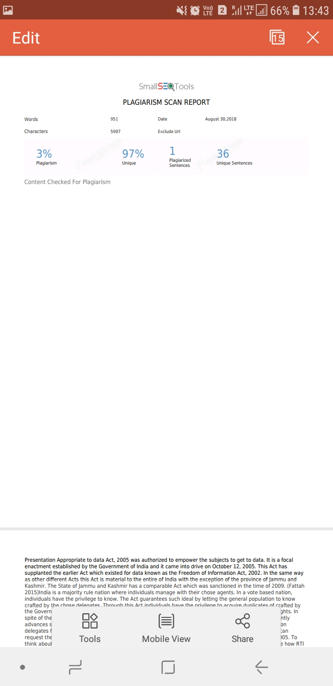
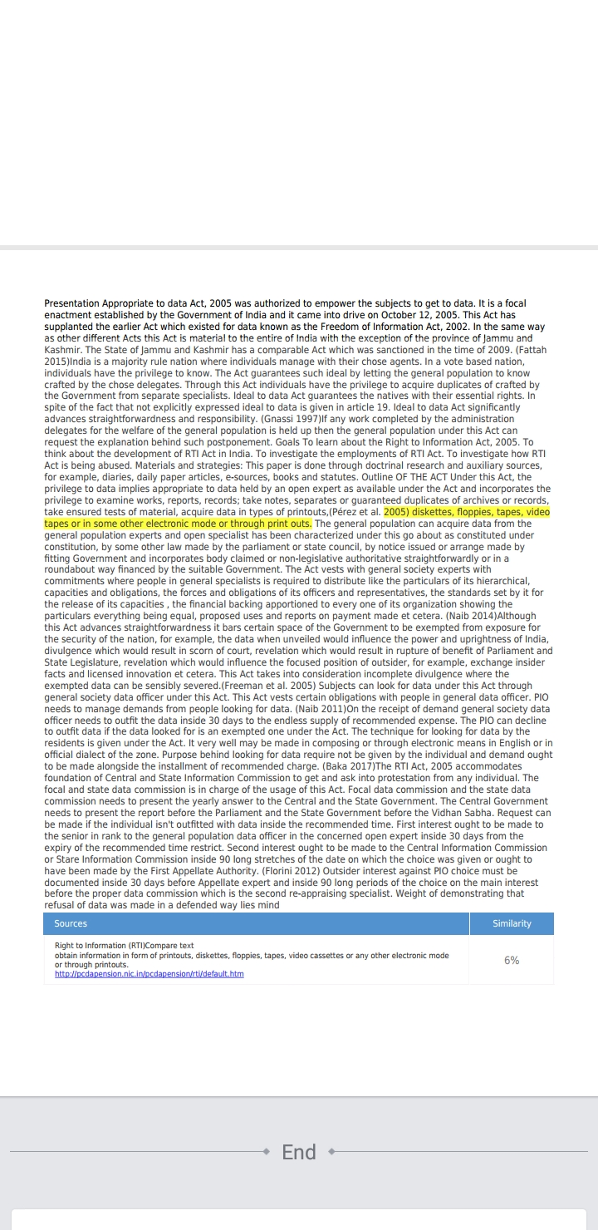

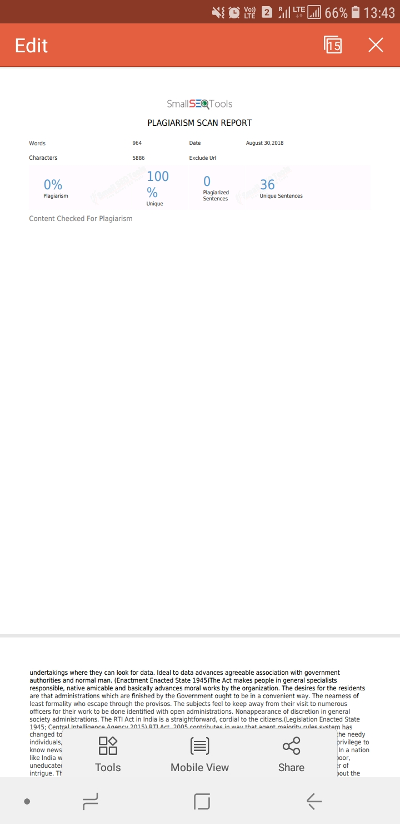
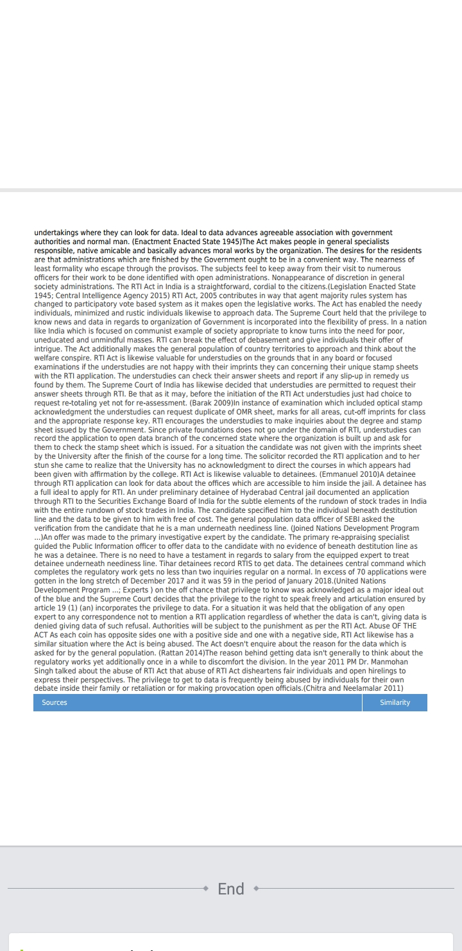

Student, 2nd yr ,B.A.,B.L(HON’s), Saveetha School of law, Saveetha University, mail id:nithishnk1111@gmail.com@gmail.com
Associate professor of law, Saveetha School of law, Saveetha University, mail id: pandianr.ssl@saveetha.com
Section 2(j) of Right to Information Act, 2005.
Section 2(h) of Right to Information Act, 2005
Section 4 of Right to Information Act, 2005
Section 8 of Right to Information Act, 2005
Section 7 of Right to Information Act, 2005
Section 6 of Right to Information Act, 2005
Akanksha Singh, How to make the best use of Right to Information Act, 2005, https://www.ipleaders.in
Ibid, 7
Gayathri Vishwa Karma V. Union of India
Tihar Prisoners file RTI to access their sentence information and diet entitlement, https://www.moneycontrol.com, February 19, 2018.
Bennet Coleman vs. Union of India.
Dr. Amitabh Kumar vs. Indo Tibetan Border Police Force
RTI Act needs critical review: Manmohan Singh, India Today, October 14, 2014.
Central Board of Secondary Education & Anr. Vs. Adhitya Bandhopadhyay & Anr.
Ramakrishna Vs. Ministry of Steel
Misuse and shortcomings in the implementation of the Act, https://www.shodhganga.inflibnet.ac.in.

