DESIGN OF METAMATERIAL ANTENNA FOR WIDE BAND APPLICATIONS
Gokul R¹, Deepak Akash Raj T ², Charan M³, Gnaneshwaran S⁴, Gomatheeswari Preethika C⁵
¹²³⁴ Students of Electronics and Communication Engineering, Sri Venkateswara College of Engineering, Sriperumbudur, TamilNadu. ⁵Assistant Professor, Sri Venkateswara College of Engineering, Sriperumbudur, TamilNadu.

---------------------------------------------------------------------***---------------------------------------------------------------------
Abstract - A wideband antenna with excellent efficiency is the most important requirement of wireless communication. There are many ways to improve the antenna bandwidth, such as using a low permittivity substrate, increasing the substrate thickness, and using different shapes of radiating patches. However, this cannot achieve wideband. This problem can be solved by using a metamaterial-based microstrip antenna that can achieve wideband. The proposed patch antenna has a metamaterial unit cell loaded on the top patch and on the bottom ground plane. The top unit cell, which consists of a square loop with Complementary Split Ring Resonator (CSRR) and the bottom unit cell, which is a Square Shaped Cross-Slot (SSCS), is loaded on the patch and ground. The objective is to achieve a compact metamaterial-loaded antenna with enhanced radiation characteristics and to design a metamaterial antenna for wideband applications. The wideband and high gain features of the proposed antenna make it suitable for 5G NR FR1 and Wi-Fi 6E applications.

Key Words: Metamaterial, wideband.

1.INTRODUCTION
Antennas are key components of any wireless communication system. They are devices that allow signal transmission into waves that propagate through space and can be received by another antenna. The receiving antennas are responsible for the reciprocal process that changes the electromagnetic wave into a signal or voltage at its terminals, which can then be processed by the receiver. The receiving and transmitting functions of the antenna structure itself are fully characterized by Maxwell's equations.

2. LITERATURE REVIEW

KM Neeshu & Anjini Kumar Tiwary proposed work on “Metamaterial loaded antenna with improved efficiency and gain for wideband application”, a microstrip patch antenna based on metamaterial loading is designed for UWB application. This proposed antenna radiates from 2.88 to 14 GHz due to the bottom loading of the metamaterial unit cell. The antenna miniaturization is achieved by the top unit cell loading in the patch. The radiation efficiency is enhanced by removing partial ground on the backside of the antenna, which eliminates stored energy in antenna. It maintains an average efficiency of 75% and the highest efficiency achieved is 87%. The antenna gives gain greater than 1.5 dBi at a higher frequency and peak gain of 7.2 dBi is achieved at 13.39 GHz. Thus, the antenna shows an apparent enhancement of antenna properties. This antenna can be used in some wireless communication operation similar to UWB, Wi- Max, 5G and Wi- Fi 6E. [1]
Aiting Wu, Furan Zhu, Pengquan Zhang, Zhonghai Zhang, and Boran Guan worked on "Bandwidth enhancement of printed microstrip wide-slot rotating antenna based on eigenshape interleaving algorithm". This paper proposed a self- shape fusion algorithm for antenna bandwidth improvement. This method can be used to ameliorate the bandwidth of various types of antennas. A microstrip Slot antenna based on the proposed algorithm was developed to test its feasibility and efficiency. The shape of the reference antenna was changed then using the self- shape blending algorithm to ameliorate its bandwidth and also compared against the reference antenna to observe its performance. The source shapes were determined by reference to former studies. The shape of patch and slot of the microstrip antenna both affect the bandwidth, so the shape of the patch and Slot can be optimized contemporaneously. The self- shape blending algorithm improves the antenna’s operating bandwidth by importing redundant resonances. The proposed antenna has a wider bandwidth than an analogous reference antenna. [2]
Kabir Hossain, Thennarasan Sabapathy, Muzammil Jusoh, Mahmoud A. Abdelghany, Ping Jack Soh, Mohamed Nasrun Osman, Mohd Najib Mohd Yasin, Hasliza A. Rahim and Samir Salem Al-Bawri proposed an antenna design called "A Negative Index Nonagonal-CSRR Meta Compact flexible planar monopole antenna for ultra-wideband applications using viscose wool felt”. A compact textile UWB planar monopole antenna integrated with an MTMUCA featuring ENG and NZRI parcels was proposed and studied. The MTM- integrated antenna prototype was fabricated using flexible polymer viscose- wool felt as the substrate and Shieldit SuperTM as the conductive element. This proposed MTMUC structure consists of a unique combination of square- and nonagonal-structured CSRR- type MTMs. The proposed MTMUCA and MTMUC displayed SNG properties in different frequency bands. The proposed design can potentially be applied for wearable applications, where future research could be carried out to probe the feasibility of on- body application, specifically for breast cancer discovery. [3]
Soumik Dey, Santanu Mondal and Partha P. Sarkar proposed the antenna design on "Single Conductor Circularly Polarized Antenna with Complementary Split Ring Resonator (CSRR)". A CSRR based rectangular microstrip antenna (RMSA) is designed for circular polarization. In the first antenna design, two circular CSRRs are embedded on the ground plane, and for the second antenna design, CSRRs are loaded on the radiating patch. Introduction of CSRRs on ground and patch is used to reduce the antenna size, and it also increases the impedance bandwidth. The impedance bandwidth of the antennas for S11< −10 dB is between 2.3 and 2.4 GHz. Minimal axial ratios of the antenna with CSRR loaded on ground and patch are attained as 1.48 dB at 2.35 GHz and 0.5 dB at 2.336 GHz. It is observed that gain variation is below 0.5 dB within the 3 dB axial ratio bandwidth. Higher isolation (> 20 dB) is maintained between co- and cross-polarized factors. The quality factor and efficiency characteristics of the antenna are observed. [4]
Maroli S. Rao and Prabhugoud I. Basarkod proposed "A new complementary slot split ring resonator truncated arc antenna with enhanced performance". The paper has discussed the design from the perspective of numerical and circuit proposition aspect and the results subsequently compared with the measured values. A detailed parametric analysis was conducted to ascertain the values of the design parameters of the patch and the novel CSlSRR. The fabricated antenna resonates at 2.48 GHz and 2.66 GHz in the band of 2.44 to 2.76 GHz. The measured conterminous impedance bandwidth is 320 MHz (12.3). RHCP is generated along the boresight and has a 100 MHz (4.07) axial rate bandwidth. The peak measured gain is 2.476 dBi at 2.75 GHz. The new CSlSRR contributes to miniaturisation and enhancing the bandwidth of the antenna and also produces DNG material parameter response. [5]
3. PROPOSED WORK

This section is subdivided into two parts.
3.1. Strip line feeding
3.2 Geometry of designed antenna
3.1 Strip line feeding
In this type of feeding technique, the conductive strip is attached directly to the edge of the microstrip patch. The conductive strip has a smaller width compared to the patch and this kind of feed arrangement has the advantage that the feed can be etched on the same substrate to form a planar structure. This is an easy feeding scheme as it allows for ease of fabrication. It also provides simplicity in housing as well as impedance matching. However, the thickness of the dielectric substrate being used increases the surface wave spurious feed radiation also increases, which limits the bandwidth of the antenna.
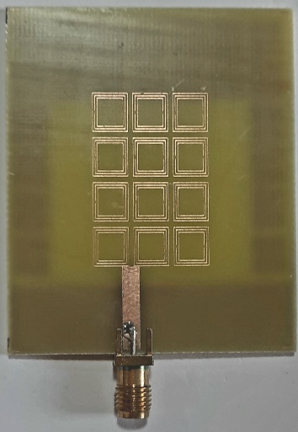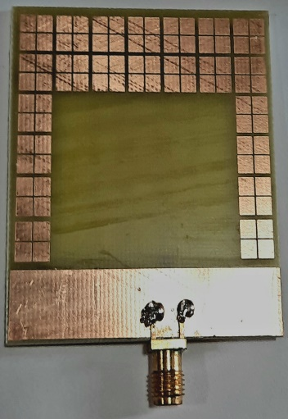
Fig -1: Fabricated antenna top & bottom view

3.2 Geometry of Designed Antenna

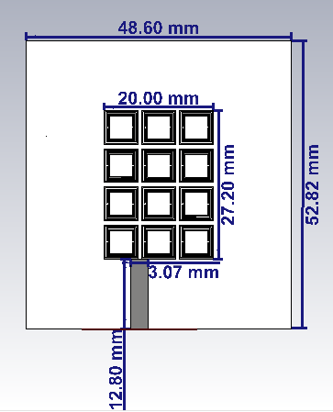
Fig -2: Top View

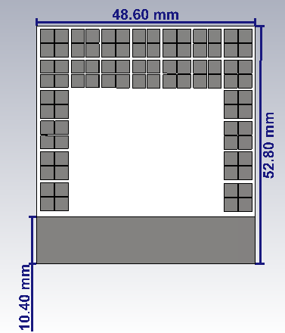
Fig -3: Bottom View
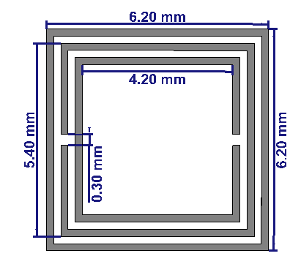
Fig -4: Top unit cell

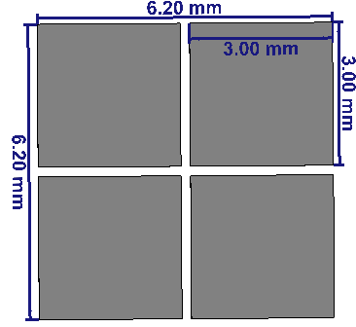
Fig -5: Bottom unit cell

The dimensions of the proposed unit cell as shown Fig-4, are L = 6.20mm, W = 6.20mm which gives a wide response. Three square rings are designed in each unit cell. The difference in size of each square ring is 0.8mm. The top unit cell consists of a square loop with Complementary Split Ring Resonator (CSRR). The bottom unit cell is square-shaped with a cross-slot (SSCS) is loaded on the patch and ground respectively.

A metamaterial loaded planar patch antenna is proposed and shown in Figure 2 & 3 has a top view and bottom view, respectively. The FR4 substrate of relative permittivity ℇr = 4.4, loss tangent 0.025, and thickness (h) 1.6 mm is used to fabricate the proposed antenna of size 48.6 mm × 52.8 mm. This antenna comprises loading of CSRR and SSCS in the patch and ground plane, respectively. The partial ground plane of length 12.8 mm underneath the input port of the antenna. Top patch of antenna is loaded with 4 × 3 CSRR unit cells and to improve the radiation efficiency, a window is etched on the backside of patch antenna. The optimized dimensions of antenna are W = 48.6 mm, L = 52.8 mm,

4. RESULTS AND DISCUSSION

4.1 Return loss

Return loss is related to both Standing Wave Ratio (SWR) and reflection coefficient. Increasing return loss corresponds to lower SWR. Return loss is a measure of how well the equipment or lines are matched. The match is good if the return loss is high. A high return loss is desirable and leads to a lower insertion loss.
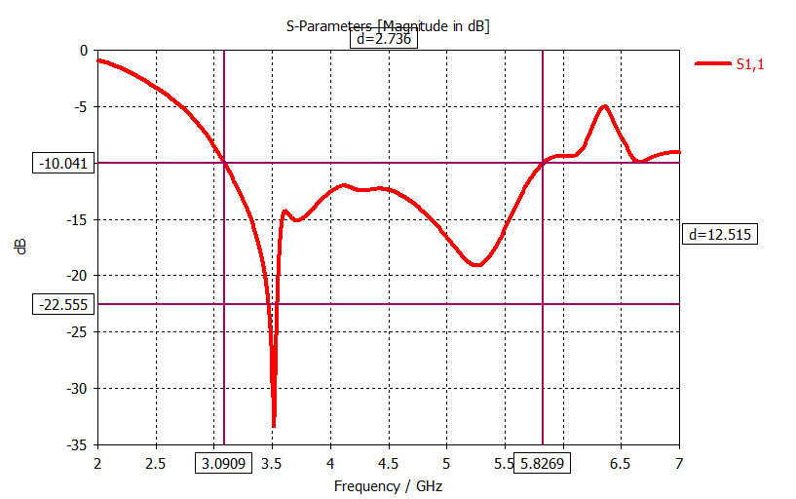

Fig -6: Return loss

Figure 6 shows us the simulated results shows that, the antenna operates at 7.5 GHz with the return loss of -18.519 respectively.
4.2 Gain
An isotropic antenna radiates evenly in all directions. An isotropic radiator is considered 100% efficient. The gain of an actual antenna increases the power density in the direction of the peak radiation.

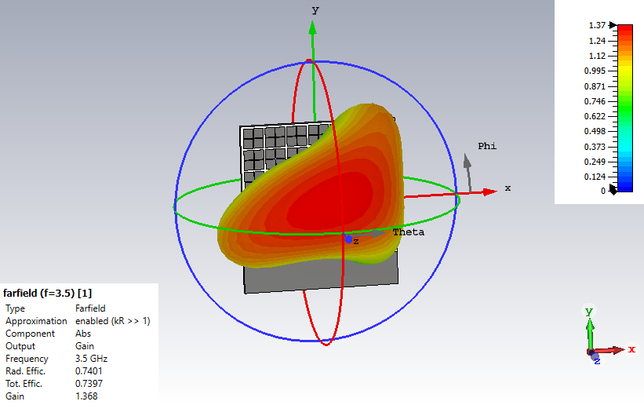
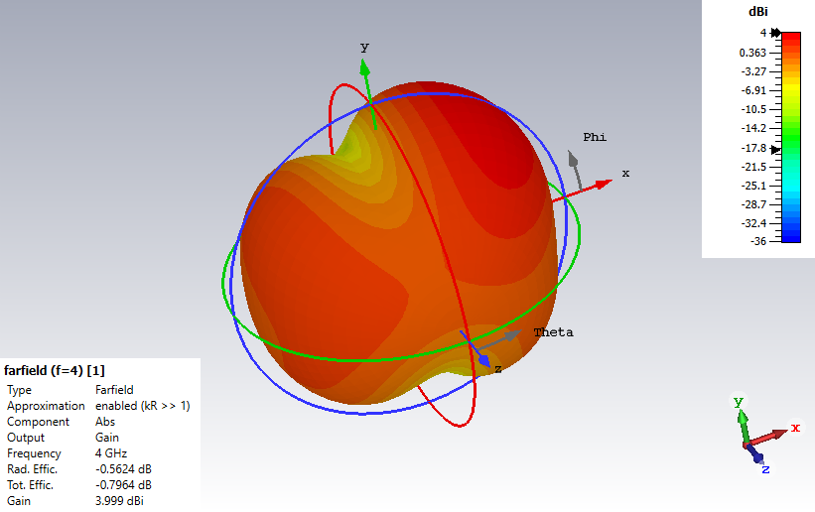
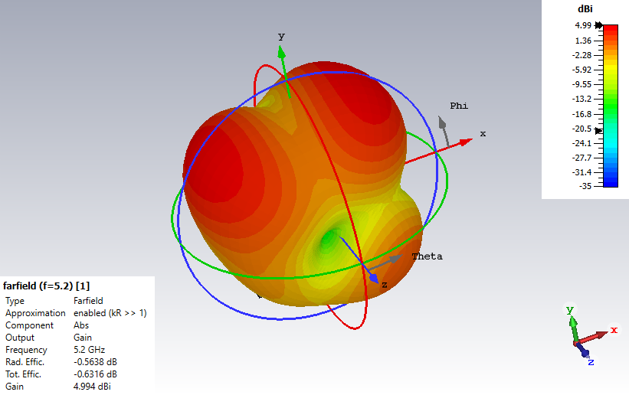
Fig -7: Gain when f = 3.5 GHz, 4 GHz & 5.2 GHz respectively.
4.3 Directivity

Directivity measures the power density radiated by an antenna in the direction of its strongest emission, compared to the power density radiated by an ideal isotropic radiator emitting the same total power.
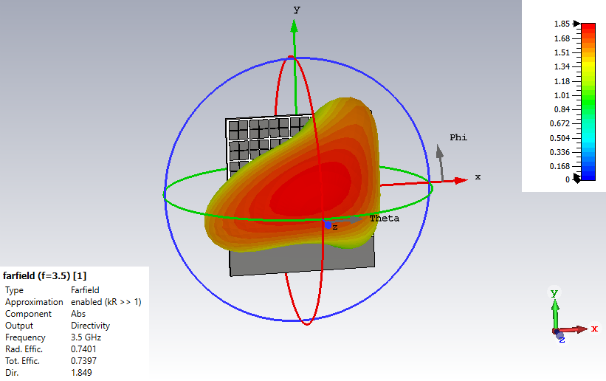

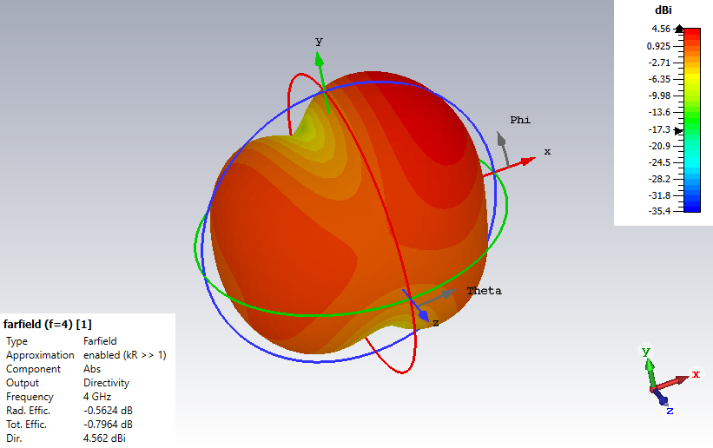
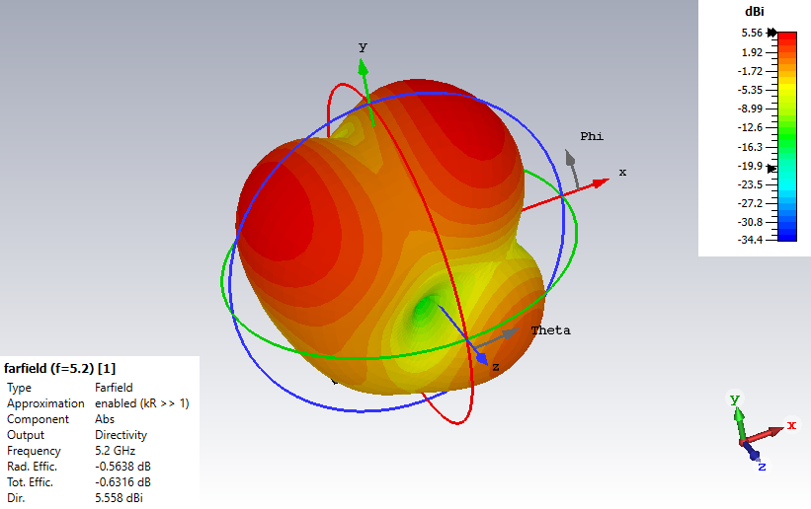
Fig -8: Directivity when f = 3.5 GHz, 4 GHz & 5.2 GHz respectively.
4.4 VSWR Measurement
VSWR is a function of the reflection coefficient, which describes the power reflected from the antenna.
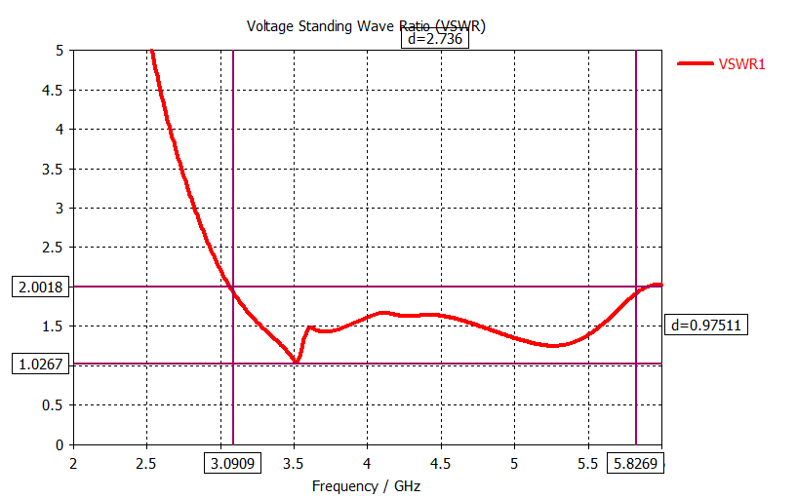
Fig -9: VSWR Measurement
Figure 9 depicts the antenna yields minimum VSWR value of 1.269.

FREQUENCY | GAIN | DIRECTIVITY
3.5 GHz | 1.319 dBi | 2.613 dBi
4 GHz | 4.013 dBi | 4.578 dBi
5.2 GHz | 5.021 dBi | 5.585 dBi

Table -1: Gain, Directivity & Efficiency when f = 3.5 GHz, 4 GHz & 5.2 GHz respectively.
After analyzing the data presented in Table 1, it can be discerned that there is a discernible pattern in which gain and directivity show an upward trend with increasing frequency, implying a positive correlation between these parameters and the varying frequencies under consideration

5. CONCLUSION

In this paper, the crucial requirement of wideband antennas with excellent efficiency in wireless communication systems has been addressed. While various methods to increase antenna bandwidth, such as using low-permittivity substrates, increasing substrate thickness, and using differently shaped radiating patches, have been explored, these approaches often fall short of the required wideband performance. The primary goal of this research was to develop a compact antenna with improved radiation characteristics, taking advantage of metamaterial patch. The results have shown that the proposed antenna exhibits wideband performance along with high gain characteristics. These features make it highly suitable for applications in 5G NR FR1 and Wi-Fi 6E systems, where wideband communication is of paramount importance.

REFERENCES

- KM Neeshu and Anjini Kumar Tiwary, “Metamaterial Loaded Antenna with Improved Efficiency and Gain for Wideband Application” - IETE Journal of Research, Dec 2020.

- Aiting Wu, Furan Zhu, Pengquan Zhang, Zhonghai Zhang, and Boran Guan, “Bandwidth Enhancement of a Microstrip-Line-Fed Printed Rotated Wide-Slot Antenna Based on Self-Shape Blending Algorithm - Hindawi”, Aug 2021.

- Soumik Dey, Santanu Mondal, and Partha P. Sarkar, “High gain and frequency reconfigurable copper and liquid metamaterial tooth based microstrip patch antenna”, Feb 2019.

- Kabir Hossain, Thennarasan Sabapathy, Muzammil Jusoh, Mahmoud A. Abdelghany, Ping Jack Soh, Mohamed Nasrun Osman, Mohd Najib Mohd Yasin, Hasliza A. Rahim and Samir Salem Al-Bawri,” A Negative Index Nonagonal CSRR Metamaterial-Based Compact Flexible Planar Monopole Antenna for Ultrawideband Applications Using Viscose-Wool Felt”, Aug 2021.

- Maroli S. Rao and Prabhugoud I. Basarkod, “A Novel Complementary Slotted Split Ring Resonator Loaded Truncated Arc Patch Antenna with Enhanced Performance - Progress In Electromagnetics Research”, May 2020.

- Sunil P. Lavadiya, Shobhit K. Patel, Rayisyan Maria,” High gain and frequency reconfigurable copper and liquid metamaterial tooth based microstrip patch antenna”, May 2021.

- Khaled Aliqab, Sunil Lavadiya, Meshari Alsharari, Ammar Armghan, Malek G. Daher and Shobhit K. Patel,” Design and Fabrication of a Low-Cost, Multiband and High Gain Square Tooth-Enabled Metamaterial Superstrate Microstrip Patch Antenna”,Jan 2023.

[8] Asghar Bakhtiari,” Investigation of Enhanced Gain Miniaturized Patch Antenna Using Near Zero Index Metamaterial Structure Characteristics”, Jul 2019.

[9] M. Z. Mahmud, M. T. Islam, and M. Samsuzzaman, “A high performance UWB antenna design for microwave imaging system,” Microw. Opt. Technol. Lett., Vol. 58, pp. 1824–31,2016.

[10] Saleem, M. Bilal, T. Shabbir, and M. F. Shafique, “An FSS- employed UWB antenna system for high gain portable devices,” Microw. Opt. Technol. Lett., Vol. 61, pp. 1404–10, 2019.

[11] A. Bakhtiari, “Investigation of enhanced gain miniaturized patch antenna using near zero index metamaterial structure characteristics,” IETE. J. Res., Vol. 65, pp. 1–8, 2019

[12] Zhu and G. V. Eleftheriades, “A compact transmission-line metamaterial antenna with extended bandwidth,” IEEE Antennas Wireless Propag. Lett, Vol. 8, pp. 295–8, 2009.
[13] H. Xiong, J. S. Hong, Z. Q. Yi, and J. D. Lin, “Compact ultra-wideband microstrip antenna with metamaterials,” Chin. Phys. Lett., Vol. 29, pp. 102–14, 2012.
[14] A. Gupta and R. K. Chaudhary, “A compact CPW-fed wideband metamaterial antenna with EBG loading,” Microw. Opt. Technol. Lett., Vol. 57, pp. 2632–6, 2015.

[15] M. Z. Mahmud, M. T. Islam, and M. Samsuzzaman, “A high performance UWB antenna design for microwave imaging system,” Microw. Opt. Technol. Lett., Vol. 58, pp. 1824–31, 2016.

