Design and Fabrication of Remote-Controlled Floor Cleaning Machine with Sensors
Prof. V.D. Dhopte1, Karshit Suraj Dongre2, Amey Kutarmare3, Kunal Padole4, Harshal Pande5, Siddhesh Chaudhari6

¹Professor of Mech Engg., K.D.K. College of Engineering, Nagpur.
^{2,3,4,5,6}Student, Dept. Of Mech Engg., K.D.K. College of Engineering, Nagpur.

Abstract:
This paper describes the design and fabrication of floor cleaning machine that can be remotely operated, perform several cleaning tasks at once, and be equipped with various sensors. The machine uses advanced sensors that allow for the effective cleaning of various types of surfaces. It uses a combination of sweeping, mopping, and vacuuming techniques to perform a thorough cleaning in one motion. The sensors detect obstacles, adjusting the cleaning path accordingly to ensure thorough cleaning while avoiding collisions. The remote control feature allows users to operate the machine from a distance, offering convenience and flexibility. Overall, this floor cleaning machine delivers a user-friendly cleaning experience and increases cleaning efficiency.

INTRODUCTION

In recent years, the demand for efficient and automated cleaning solutions has escalated across various industries, driven by the need for enhanced cleanliness and sanitization practices. To meet these demands, floor cleaning machines have undergone remarkable advancements, integrating sensors and cutting-edge technology to perform multiple cleaning operations simultaneously. This research paper aims to delve into the capabilities and impact of floor cleaning machines equipped with sensors, revolutionizing the cleaning industry. Traditionally, floor cleaning involved sequential processes, where different tasks such as sweeping, mopping, and drying were performed separately. However, with the integration of advanced sensors, modern floor cleaning machines have become capable of executing multiple cleaning operations simultaneously. These sensors play a vital role in detecting various cleaning requirements, allowing the machine to adapt its cleaning mechanism in real-time. One of the key advancements in floor cleaning machines is the incorporation of smart sensors for obstacle detection and avoidance. These sensors enable the machine to navigate around furniture, equipment, and other obstructions, ensuring efficient cleaning without interruptions. Furthermore, sensors like floor detection sensors provide real-time feedback on the type of flooring surface, allowing the machine to adjust its cleaning approach accordingly. For instance, the machine can automatically switch from sweeping to mopping mode when transitioning from carpeted areas to hard floors.
Additionally, sensors play a crucial role in monitoring and optimizing the cleaning process. For instance, dirt and dust sensors detect the cleanliness of the floor and adjust the cleaning intensity accordingly, ensuring thorough cleaning. Sensors can also measure the level of moisture on the floor, enabling the machine to optimize the drying operation. The integration of sensors in floor cleaning machines offers several advantages. Simultaneous cleaning operations not only save time but also enhance overall cleaning effectiveness. Moreover, sensors ensure precise and efficient cleaning by adapting to different surfaces and detecting cleaning requirements in real-time.

This research paper will explore the various sensors integrated into floor cleaning machines, their functionalities, and their impact on cleaning performance and efficiency. By understanding the potential of sensor-based cleaning technologies, we can pave the way for improved cleaning practices, ultimately leading to cleaner and healthier environments in various industries.

LIST OF COMPONENTS

Sr.  No. | Name of Components | Quantity
1 | Frame | 1
2 | DC Motor | 2
3 | Battery (12v) | 1
4 | Vacuum Cleaner | 1
5 | Water Pump | 1
6 | Dust Bag | 1
7 | Water Reservoir | 1
8 | Wet mop | 1
9 | Wheels | 4
10 | Sensors | 2
11 | Switches | 2
12 | Remote Controller | 1

METHODOLOGY

The floor cleaning machine involves a trolley-like structure equipped with electrical and electronic circuits, sensors, and a rechargeable battery to ensure efficient and cost-effective operation. The key components and their functions are outlined below.

The floor-cleaning machine utilizes electrical energy stored in a battery to power its operation. This allows for flexibility and portability, eliminating the need for a constant power source. The electrical and electronic circuits will be integrated into the trolley-like structure of the machine. These circuits will be responsible for controlling various functions of the floor cleaner, including motor speed, the water spray system, and sensor operations. Sensors will play a crucial role in detecting obstacles and ensuring efficient navigation. To power the machine, an electrical energy storage system will be implemented using rechargeable batteries. These batteries will store the required electrical energy and provide power to the motor and other electrical components. The battery pack will be strategically positioned within the chassis to optimize weight distribution and stability.
The floor cleaning mechanism consists of a motor-driven mop, which rotates at a speed of 1440 revolutions per minute (rpm). The mop will be connected to the motor and designed to efficiently clean the floor surface. Additionally, a water spray system with a nozzle will be incorporated into the machine. This system will enable effective wet mopping by spraying water onto the floor surface.

The machine will also feature a dust collection mechanism. A hose pipe will be used to vacuum and collect the dust and debris from the floor. The collected dust will be stored in a dedicated dust tank located on the main body of the machine. On the other hand, water storage will be facilitated by a separate tank. The water required for the cleaning process will be supplied from this tank.

To ensure mobility, the machine will be equipped with ABS plastic wheels. These wheels offer frictionless movement, allowing the machine to navigate smoothly across various floor surfaces. The handle of the machine will be designed with a comfortable grip, making it easy for the operator to control and maneuver the system.

Finally, fans will be incorporated into the machine to facilitate the drying process. These fans will blow air onto the wet floor, accelerating the evaporation of moisture and ensuring quick drying.

CAD MODEL
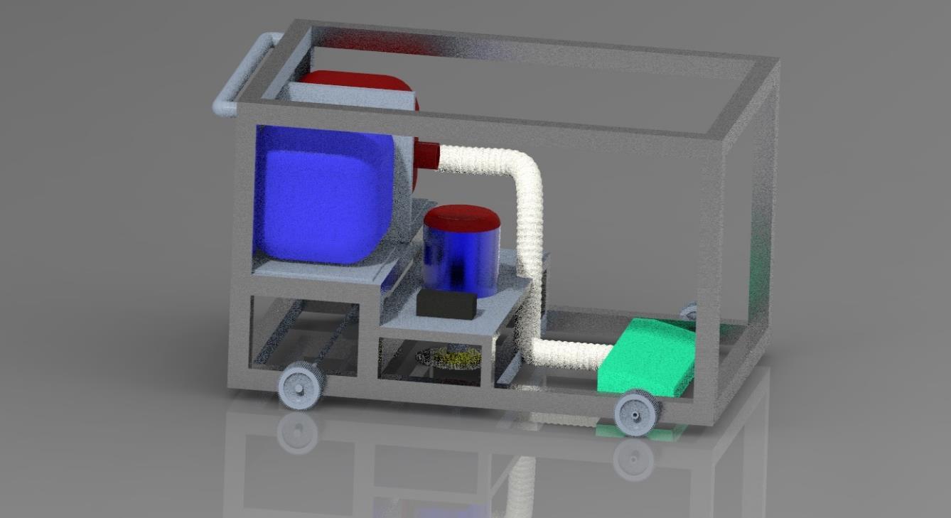

Fig.1 Design of Prototype in 3D by using Creo Software

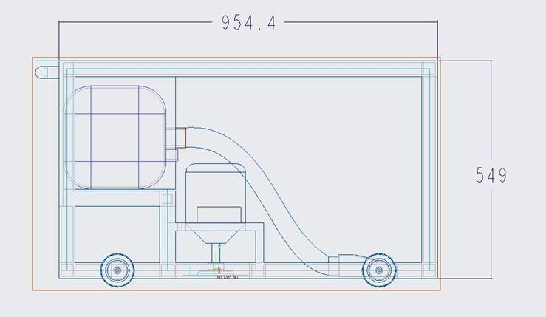

Fig.2 Design of Prototype in 2D by using Creo Software
DESIGN ASPECT

Calculations

1.Design of frame

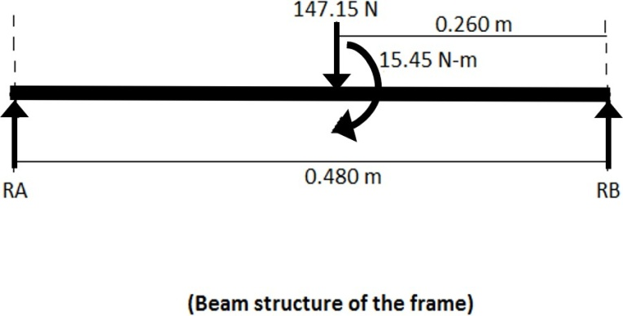

In Fig RA & RB are the reaction given by Frame. The motor weight is 15 kg.
So, 15*9.81=147.15 N Force will act on the beam whose diameter is to be found RA+RB =147.15 N
Taking moment RA, we get (147.15*220) +15.45=(RB*0.480) RA=66.42 N, RB =31.679 N
After taking the bending moment at various points we can recognize that point at Which load is acting as max bending moment = 31.88 N/M
By Formula, (Bending moment)/(MI) = (Bending strength of mild steel/ Y)
Where Y= distance between neutral axis to the outer surface of fiber = diameter /2
MI=(π*diameter2)/64, bending strength=480 n/mm2
Put all the values in Equation, and we get, Diameter = 10.49 mm. Hence, here we can take a 16mm standard rod which is easily available in the market.
2.Torque requirement of traveling motor
The coefficient of friction between the brush and the floor= is 0.8 Load on bracket=40cm
Torque required= F ∗ R= (0.87*5*9.81) *0.4=16.87 N-m Formula P = 2𝜋NT/60
Where, P= Power
N=Speed in RPM

T= Torque
1 hp torque of motor = 4.94 N-M at 1440 RPM Then at 360 RPM Torque will be 19.78 N-M Therefore, a 1 hp motor at 360 RPM can be used.
3.Scrubber motor
To calculate the RPM of the motor, by using the formula: RPM= [Power/(2 ∗ π ∗ Torque)] ∗ 60
Where: Motor power=3.6 watts motors torque= 0.412Nm
60 is the conversion factor from minutes to seconds. By giving the specified values, we obtain:
RPM= (3.6/ (2*𝜋*0.412)) *60 Rpm = 165.96

CONCLUSION

An innovative and efficient method to maintain cleanliness in both residential and commercial settings is to design and construct an automatic floor-cleaning machine. An overview of the design and fabrication process, including the choice of components, the assembly of the machine, and the programming of the control system, has been given in this research paper. The automatic floor cleaning equipment is efficient at cleaning a variety of floors and is simple to use, according to comprehensive testing and analysis. Due to its use of rechargeable batteries and minimal energy usage, the device is also economical and environmentally beneficial.
Future studies can concentrate on enhancing the machine's operation and effectiveness as well as investigating the possibility of adding new capabilities like obstacle avoidance and identification. Overall, there is a lot of potential for improving cleanliness and reducing labor costs in a range of situations that can be achieved through the design and manufacture of an automatic floor cleaning system.

REFERENCES

[1] Shubham Khade- MULTI-USE FLOOR CLEANING MACHINE ‖ - International Journal of Mechanical Engineering and Technology (IJMET Volume 8, Issue 5, May 2017, pp. 656–664, Article ID: IJMET_08_05_072 Available online at http://iaeme.com/Home/issue/IJMET?Volume=8&Issue=5 ISSN Print: 0976-6340 and ISSN Online: 0976-6359
[2] M. Ranjit Kumar1 M. Tech Student, Mechanical Engineering, Nagarjuna College of Engineering and Technology, Bangalore, India. ISSN: 2278-0181 Vol. 4 Issue 04, April-2015.
[3] Imaekhai Lawrence -Evaluating Single Disc Floor Cleaners‖ – An Engineering Evaluation, Innovative Systems Design and Engineering, Vol 3, No 4, 2012, 41-44.
[4] Prof. Dr. A. Muniaraj Professor, Department of Mechanical Engineering, Kings Engineering College, Chennai, Tamil Nādu, India ISSN 2394-3777 (Print) ISSN 2394-3785.
[5] Haslam, R.A. and Williams, H.J, Ergonomics considerations in the design and use of single disc floor cleaning machines, Applied Ergonomics, 30,391- 399.2010.
[6] Sahil S. Pardhi Assistant Professor, -A Floor Cleaner with Sweeping and Mopping Operates Autonomously International Journal for Research in Applied Science & Engineering Technology (IJRASET) ISSN: 2321-9653; IC Value: 45.98; SJ Impact Factor: 7.538 Volume 10 Issue V May 2022 KDK College of Engineering, Nagpur
[7] P. Vignesh, Mr. A. Arun-Design and Fabrication of Smart Floor Cleaning Machine-Department of Mechanical Engineering, IFET College of Engineering, Villupuram.
[8] Seshahari Varma Chekuri-Design and Development of Floor Cleaning Robot-International Journal for Research in Applied Science & Engineering Technology (IJRASET) ISSN: 2321-9653; IC Value: 45.98; SJ Impact Factor: 7.538 Volume 10 Issue V May 2022.
[9] Mayur Bhende-Design and Analysis of Portable Floor Cleaning Machine-Design and Analysis of Portable Floor Cleaning Machine
[10] Sandeep. J. Meshram, Dr. G.D. Mehta - “Design and Development of Tricycle Operated Street Cleaning Machine” - Journal of Information, Knowledge and Research in Mechanical Engineering ISSN 0975 –668X| Nov 15 To Oct 16 | Volume– 04, Issue-01.
[11] ) Liu, Kuotsan, Wang Chulun, A Technical Analysis of Autonomous Floor Cleaning Robots Based on US Granted Patents, European International Journal of Science and Technology Vol. 2 No. 7September 2013, 199-216.

