Diabetic Retinopathy Detection using Machine Learning
Prof. Shailendra Bandewar¹, Prof. Sagar Janokar², Prathamesh Lakhe³, Laksh Sharma⁴, Yogesh Lale⁵, Lalropuia Sailo⁶, Akhilesh Lambat⁷ , Indrajit Landge⁸.

Department of Engineering, Sciences and Humanities,
Vishwakarma Institute of Technology, Pune-37

Abstract - This research paper presents a machine learning model for the automated identification of diabetic retinopathy, a serious disease that, if not recognized and treated promptly, can result in visual loss. The model uses features of hemorrhage, microaneurysms, and exudates along with convolutional neural networks to categories images into five severity levels. Our online application streamlines user engagement with machine learning models by allowing users to submit photos and display the projected category of a chosen image. Our model's output predicts accuracy rates of about 87%, and its findings support the creation of automated systems for the identification of diabetic retinopathy, which would eventually improve patient outcomes and public health.
Keywords - diabetic retinopathy, image classification, data augmentation, machine learning, convolutional neural networks, fundus images, Karas, TensorFlow, Flask.

INTRODUCTION
The presence of diabetic retinopathy among people with diabetes is distinguished by damage to the blood vessels present in the retina, and if not dealt with in a timely fashion, it can lead to loss of vision. Early symptoms include blurry vision, darkened areas of vision, floaters, and color perception difficulties. Early detection is critical to prevent complete blindness. Physical tests, such as dilation of pupil, and optical coherence tomography (OCT), visual acuity tests are available, but these are very much time-consuming and unpleasant for patients. In recent years, machine learning techniques have demonstrated great potential in detecting diabetic retinopathy, which is a more efficient and accurate screening approach. This project aims to identify diabetic retinopathy automatically using a machine learning model that extracts the features of hemorrhage, microaneurysms, and exudates.

Literature Review

Investigates the identification of diabetic retinopathy utilizing a collection of machine learning classification algorithms on data taken from techniques for processing retinal images, such as the diameter of the optic disc and lesion-specific features. The study assesses the performance of various algorithms for identifying diabetic retinopathy, including alternating decision trees, Naive Bayes, and Random Forest. [1]
The DREAM computer-aided screening system is described in this study. It uses machine learning to evaluate the severity of diabetic retinopathy (DR) based on the analysis of fundus pictures with various lighting and fields of vision. In order to distinguish retinal lesions from no lesions, the performance of several classifiers including Gaussian Mixture Model, k-Nearest Neighbor, Support Vector Machine, and AdaBoost is examined. To address the imbalanced datasets, a unique two-step hierarchical classification strategy is provided, with successful results on datasets that are readily accessible to the public. For categorizing pictures with or without DR, the DREAM system has good sensitivity, specificity, and AUC, and feature reduction greatly decreases calculation time for DR severity grading. [2]
If untreated, diabetic retinopathy can result in blindness, and manual identification is labor-intensive. In order to facilitate quicker automated identification, this study suggests a machine learning technique that extracts three characteristics and use a hybrid classifier. High accuracy of 82% is achieved using the hybrid technique, and scores for precision, recall, and f-measure indicate successful categorization. [3]
The objective of this work was to create a deep learning system for color fundus pictures to automatically diagnose diabetic retinopathy (DR). With an AUC of 0.97 on five-fold cross-validation and 0.94-0.95 on external validation, the algorithm successfully achieved excellent sensitivity and specificity. The anomaly heatmap that the algorithm produces can be used to flag specific areas for clinical examination. The study hypothesizes that by assisting in prompt diagnosis and referrals, the algorithm's application might lower the rate of DR-induced vision loss. [4]
Diabetic Retinopathy is a common complication of diabetes and is a leading cause of blindness. Current detection methods require manual examination by an ophthalmologist. This study proposes an automated approach using Deep Learning with a model trained on publicly available retinal images achieving an accuracy of approximately 81%.[5]
This paper suggests a model that combines five deep convolutional neural networks (CNNs) that were trained on a publicly available Kaggle dataset: Resnet50, Inceptionv3, Xception, Dense121, and Dense169. The approach seeks to categories the five phases of DR and increase classification precision, particularly for the early stages that are difficult to identify. The suggested model performs better than cutting-edge techniques and achieves high accuracy for all DR phases, demonstrating the ensemble approach's capacity to encode rich characteristics for better categorization. [6]
The identification, grading, and segmentation of diabetic retinopathy (DR) using artificial intelligence-based methods, such as machine learning and deep learning, are covered in this review article. Fundus and optical coherence tomography images are utilized to locate DR, evaluate its severity, and spot any accompanying lesions. The evaluation includes 114 papers that satisfied the inclusion criteria and covers research that was published between 2016 and 2021. A list of 43 significant datasets utilized for DR research is also provided. The research demonstrates the potential of AI methods to enhance DR diagnosis and therapy and emphasizes the significance of data accessibility for developing and validating these models. [7]
Overall, the literature surveys provide evidence supporting the potential of AI-based approaches for the detection, grading, and segmentation of diabetic retinopathy. Automated models accurately diagnose early stages of the disease, providing timely referrals and treatment. Robust and reliable models can reduce manual labor and improve diagnosis and treatment efficiency. However, additional research and validation are required to optimize these models' clinical utility and ensure their integration into standard clinical practice, ultimately improving patient outcomes. Developing user-friendly interfaces is essential to ensure effective utilization of these models by clinicians, including primary care providers, and improving accessibility to patients. Therefore, the development of user-friendly interfaces alongside robust and reliable AI-based models for diabetic retinopathy detection, grading, and segmentation should be prioritized.

Methodology/Experimental

Dataset:
We created a new database by combining two publicly available databases from Kaggle: the Diabetic Retinopathy Detection Challenge and the EyePACS dataset. Our dataset was divided into the following categories: No DR (NDR), Mild NPDR (MNPDR), Moderate NPDR (MoNPDR), Severe NPDR (SNPDR), and Proliferative (PDR).. These categories are assigned based on the severity of diabetic retinopathy seen in each image. The data set was divided into training and test sets using stratified sampling to ensure that each category was proportionally represented in both sets. The training set consists of images X and the test set consists of images Y. This dataset provides a valuable resource for the development and evaluation of machine learning algorithms to detect diabetic retinopathy, and we make it publicly available for use by the research community.

Biased Data-set:
Our dataset includes a total of 34726 fundus images of the retina, which were collected by combining two publicly available datasets from Kaggle. However, we faced difficulties in creating a balanced dataset because one dataset had more images than the other, and the majority of the images belonged to the "No DR" category. This created a bias in the dataset that could potentially affect the performance of machine learning algorithms trained on the data.

Data Normalization:
To address the issue created due to imbalanced classes in the dataset, we employed data augmentation techniques to artificially inflate the number of photos in the underrepresented classes. Data normalization involves applying various transformations to the existing images to generate new images that are slightly different from the original ones. Common data augmentation techniques used in our study included random rotation, flipping, scaling, and cropping. By using these techniques, we were able to increase the number of images in the "Mild Non-Proliferative Diabetic Retinopathy," "Moderate Non-Proliferative Diabetic Retinopathy," "Severe Non-Proliferative Diabetic Retinopathy," and "Proliferative Diabetic Retinopathy" categories.. The resulting augmented dataset helped to balance the original distribution of images across the different categories, reducing the bias and improving the accuracy of the machine learning models trained on the dataset.
The table below shows the number of images in each category before and after data augmentation:

Class | Original Count | Augmented Count | Total Count
NDR | 25810 | 0 | 25810
MNPDR | 2443 | 5557 | 8000
MoNPDR | 5292 | 4708 | 10000
SNPDR | 873 | 9127 | 10000
Proliferative | 708 | 9292 | 10000
Table.[I]

Pre-processing
The dataset underwent several preprocessing steps to prepare the images for training. The steps included editing and removing black spots from image. The original images were of size around 4500x3200, but they were cropped to edit the black spots and focus on the center image of the retina. The cropped photos were then resized at size 224x224 pixels to standardize the photo size and save the space. Additionally, some images were completely black, and these were removed from the dataset by calculating the average of all pixels and dropping images with a mean of zero. Overall, these preprocessing steps were necessary to clean and prepare the data for accurate training and analysis, and to reduce noise in the dataset.
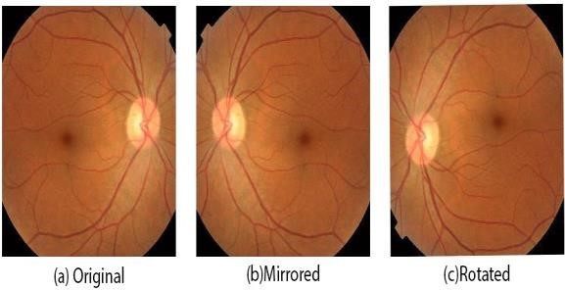

CNN model for image identification:
Convolutional Neural Networks (CNNs) algorithm specifically developed for image recognition using neurons that have weights and biases. These neural networks work by receiving multiple inputs, calculating a weighted sum, applying an activation function, and producing an output. What makes CNNs superior is their filters, which function as "feature detectors". An input layer, an output layer, and multiple hidden layers make up CNNs. The structure of a CNN is depicted in Fig, illustrating its various components.

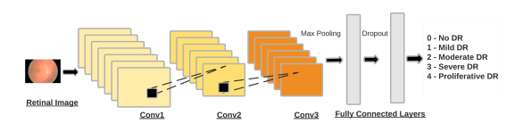

Collection of Data set
Data Augmentation

Preprocessing of Data

Generating results based on trained model

Showing Predictions on web app

Integration of Model with web application:
For the implementation of the machine learning model, we used the Keras library with a TensorFlow backend. The front-end of the web application was created using HTML, CSS, and JavaScript, and provided users with an intuitive and user-friendly interface for uploading images and viewing the corresponding predictions. The back-end of the application was implemented using Flask, a lightweight web framework that was responsible for handling user requests, accepting uploaded images, and passing them to the machine learning model for processing. By leveraging these technologies, we were able to create a robust and effective machine learning system that was capable of accurately predicting the severity of diabetic retinopathy based on fundus images of the retina
.
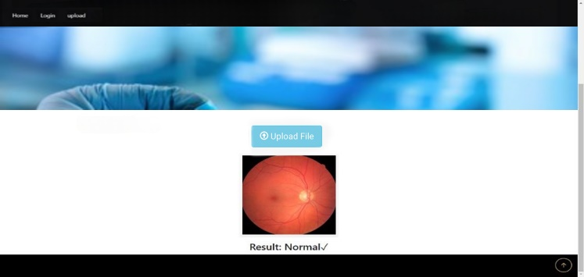

Results and Discussions

Evaluation Metrics
Due to the innate class imbalance, accuracy may not be a suitable assessment metric for a medically connected classification issue like diabetic retinopathy. Instead, assessment criteria like sensitivity and accuracy are frequently utilised. Four parameters—True Positive (TP), True Negative (TN), False Positive (FP), and False Negative (FN)—are required to compute sensitivity and specificity. The percentage of actual positive cases that were accurately predicted as positive (TP) is known as sensitivity (or recall). Sensitivity may be computed mathematically as Sensitivity = TP / (TP + FN).The percentage of real negative cases that were accurately predicted as negative is known as specificity (TN). Specificity may be computed mathematically using the formula Specificity = TN / (TN + FP).Calculated as: Accuracy = (TP + TN) / (TP + TN + FP), accuracy (AC) is the proportion of all forecasts that were accurate. These evaluation metrics help us to better understand how well our machine learning model is performing in predicting diabetic retinopathy, taking into account the class imbalance and the consequences of false positive and false negative predictions.

Performance
we divided our dataset into 10 parts using some functions from the scikit-learn library, with a test set sizing 10%. This gave us 9 parts for training and 1 part for testing. To evaluate the performance of our model, we generated a confusion matrix, which is presented in Table II

Class | NDR | NDR | NDR | NDR | NDR
NDR | 2530 | 180 | 35 | 11 | 19
MNPDR | 132 | 711 | 50 | 5 | 2
MoNPDR | 37 | 145 | 916 | 75 | 12
SNPDR | 5 | 14 | 75 | 768 | 138
Proliferative | 6 | 0 | 2 | 87 | 613
Table[II]
Class | TP | TN | FP | FN | Accuracy | Specificity | Sensitivity | Precision | Recall
NDR | 2530 | 14096 | 23 | 161 | 98.58% | 99.84% | 94.05% | 99.09% | 94.05%
MNPDR | 711 | 6922 | 111 | 2567 | 70.35% | 98.43% | 21.67% | 86.54% | 21.67%
MoNPDR | 916 | 8128 | 294 | 662 | 88.24% | 96.41% | 58.05% | 75.73% | 58.05%
SNPDR | 768 | 8387 | 355 | 490 | 89.25% | 95.79% | 61.03% | 68.43% | 61.03%
Proliferative | 613 | 8403 | 189 | 795 | 90.54% | 97.76% | 43.50% | 76.43% | 43.50%
Overall Metrics | - | - | - | - | 87.28% | 97.03% | 55.06% | 83.66% | 55.06%
Table[III]

Conclusion

In conclusion, this study explored the potential of machine learning methods in detecting diabetic retinopathy, a critical condition that can lead to vision loss if not identified and treated early. Through the use of machine learning and convolutional neural networks, this study demonstrated the ability to automatically classify diabetic retinopathy using retinal imaging features. The results showed that these models achieved promising accuracy rates, with an overall accuracy of around 81%. The results show promising accuracy rates, also there is still room for improvement as the model will continuously train on real world clinical feedbacks. The findings of this study contribute to the development of automated systems for diabetic retinopathy detection, which could improve medical diagnosis and treatment, ultimately leading to better patient outcomes and improving public health.

ACKNOWLEDGEMENT
We would like to express my sincere gratitude to my project guide “Prof. Shailendra Bandewar” and “Prof.Sagar Janokar” Sir for guiding us throughout this research project. Their expertise and valuable insights have been instrumental in shaping this paper. we are truly grateful for their time, patience, and unwavering support in every stage of this project. we would also like to extend my thanks VISHWAKARMA INSTITUTE OF TECHNOLOGY, PUNE. Without the guidance and support of these individuals, this research would not have been possible. We are forever grateful for their contributions to my academic and personal growth.

References
[1] K. Bhatia, S. Arora and R. Tomar, "Diagnosis of diabetic retinopathy using machine learning classification algorithm," 2016 2nd International Conference on Next Generation Computing Technologies (NGCT), Dehradun, India, 2016, pp. 347-351, doi: 10.1109/NGCT.2016.7877439.

[2] S. Roychowdhury, D. D. Koozekanani and K. K. Parhi, "DREAM: Diabetic Retinopathy Analysis Using Machine Learning," in IEEE Journal of Biomedical and Health Informatics, vol. 18, no. 5, pp. 1717-1728, Sept. 2014, doi: 10.1109/JBHI.2013.2294635.

[3] R, Revathy. (2020). Diabetic Retinopathy Detection using Machine Learning. International Journal of Engineering Research and. V9. 10.17577/IJERTV9IS060170.

[4] Rishab Gargeya, Theodore Leng, Automated Identification of Diabetic Retinopathy Using Deep Learning, Ophthalmology, Volume 124, Issue 7, 2017, Pages 962-969, ISSN 0161-6420,

[5] S. Thorat, A. Chavan, P. Sawant, S. Kulkarni, N. Sisodiya and A. Kolapkar, "Diabetic Retinopathy Detection by means of Deep Learning," 2021 5th International Conference on Intelligent Computing and Control Systems (ICICCS), Madurai, India, 2021, pp. 996-999, doi: 10.1109/ICICCS51141.2021.9432075

[6] S. Qummar et al., "A Deep Learning Ensemble Approach for Diabetic Retinopathy Detection," in IEEE Access, vol. 7, pp. 150530-150539, 2019, doi: 10.1109/ACCESS.2019.2947484.

[7] Lakshminarayanan V, Kheradfallah H, Sarkar A, Jothi Balaji J. Automated Detection and Diagnosis of Diabetic Retinopathy: A Comprehensive Survey. J Imaging. 2021 Aug 27;7(9):165. doi: 10.3390/jimaging7090165. PMID: 34460801; PMCID: PMC8468161.

