 | EVALUATION AND ANTIFUNGAL ACTIVITY OF POLY HERBAL PLANT LEAF CREAM AGAINST FUNGAL DISEASES | 

A PROJECT REPORT

Submitted by

KIRUBHAKARAN K.

In partial fulfillment of the requirement for the award of the degree

Of

MASTER OF TECHNOLOGY

In

BIOTECHNOLOGY
K.S. RANGASAMY COLLEGE OF TECHNOLOGY (An Autonomous Institution,affiliated to Anna University Chennai and Approved by AICTE,New Delhi)
TIRUCHENGODE – 637 215
MAY 2023
K.S. RANGASAMY COLLEGE OF TECHNOLOGY
TIRUCHENGODE – 637 215
BONAFIDE CERTIFICATE
Certified that this project report titled “EVALUATION AND ANTIFUNGAL ACTIVITY OF POLY HERBAL PLANT LEAF CREAM AGAINST FUNGAL DISEASE ” is the bonafide work of MR.KIRUBHARAN K. (73772153106) who carried out the project under my supervision. Certified further, that to the best of my knowledge the work reported herein does not form part of any other project report of disseration on the basis of which a degree or award conferred on an earlier occasion on this or any other candidate.

SIGNATURE SIGNATURE
Dr.J.Philip Robinson, M.Sc.,M.Phil.,Ph.D., Dr.M.Nithya, M.Sc.,M.Phil.,Ph.D.,
HEAD OF THE DEPARTMENT SUPERVISOR
Professor Assistant professor
Department of Biotechnology Department of Biotechnology
K.S. Rangasamy College of Technology K.S. Rangasamy college of Technology
Tiruchengode – 637 215 Tiruchengode – 637 215

Submitted for the viva-voce examination held on………………...

Internal Examiner External Examiner

DECLARATION
I declare that the project report on “EVALUATION AND ANTIFUNGAL ACTIVITY OF POLY HERBAL PLANT LEAF CREAM AGAINST FUNGAL DISEASE ” is the result of original work done by me and best of my knowledge,similar work has not been submitted to “ ANNA UNIVERSITY CHENNAI ’’for the requirement of Degree of Master of Technology.This project report is submitted on the partial fulfilment of the requirement of the award of Degree of Master of Technology.

Signature

---------------------------
(KIRUBHAKARAN K.)

Place : Tiruchengode
Date :

ACKNOWLEDGEMENT
I wish to express my sincere gratitude to our honourable Chairman SHRI. R. SRINIVASAN for providing immense facilities at our institution.
I would like to express special thanks of gratitude to our Chief Executive Officer Dr. K. THYAGARAJAH, M.E., Ph.D., who has been the key spring of motivation to us throughout the completion of our course and project work.
I very proudly rendering my thanks to our principal Dr. R. GOPALAKRISHNAN, M.E., Ph.D., for the facilities and the encouragement given by him to the progress and completion of our project.
I proudly render my immense gratitude to the Head of the Department DR. J. PHILIP ROBINSON, M.Sc., M.Phil., Ph.D., for his effective leadership, encouragement and guidance in the project.
I express my sincere and heartfelt thanks to our project coordinator of the Department Dr. S. SIDHRA, M.Sc., M.Phil., Ph.D., for her continuous towards the completion of my project.
I highly indebted to provide my heart full thanks to my supervisor Dr. M. NITHYA, M.Sc., M.Phil., Ph.D., Assistant professor, for her valuable ideas, encouragement and supportive guidance throughout the project.
I wish to extend my sincere thanks to all faculty members of our Biotechnology Department for their valuable suggestions, kind co-operation and constant encouragement for successful completion of this project.
I wish to acknowledge the help received from various Departments and various individuals during the preparation and editing stages of the manuscript.

ABSTRACT
Herbal plants are integral parts of the traditional medicine worldwide and most of the rural and urban population uses these plants in many of their regular needs even today. The current researchers are more focused on natural chemicals than the synthetic chemicals due to their environmental, economic and health benefits. Plants produce many chemical compounds for its biological activities including defence mechanism against microbes, insects and herbivorous animals and these chemicals are called as phytochemicals. Herbal plants are a natural source of many important phytochemicals and widely used in pharmaceutical, food and cosmetic industries. The goal of the research was to develop a poly herbal plant leaf cream for fungal diseases. The antifungal cream was prepared by mixing of various amounts of ingredients as well as a poly herbal plant leaf extract. Acalypha indica, Calotropia procera, Millettia pinnata, Senna alata, Leucas aspera and Carica papaya are some of the basic drugs used to make the cream. The selection of components is based on the agents various therapeutic characteristics. Various evaluation parameters are used to the cream. The cream that was proven to be natural, stable and safe. The antimicrobial activity of the aqueous extract of leaves of the plants were tested against one microorganism Aspergillus niger. The susceptibility of the microorganism was determined using the disk diffusion method. The poly herbal plant leaf cream and Chloramphenicol has antifungal action against Aspergillus niger according to the study.
Key Words: Poly Herbal Cream, Phytochemical, Microorganism, Antifungal, Acalypha indica, Calotropia procera, Millettia pinnata, Senna alata, Leucas aspera and Carica papaya.

TABLE OF CONTENTS
CHAPTER TITLE PAGE NO.
ABSTRACT v
LIST OF TABLES ix
LIST OF FIGURES x
LIST OF SYMBOLS AND ABBREVIATIONS xi
- INTRODUCTION 1
1.1 role of plant leaf activity in poly
herbal plants 2
1.2 SCIENTIFIC CLASSIFICATION OF POLY HERBAL
PLANT LEAF 3
1.3 USES OF POLY HERBAL PLANT TRADITIONAL
TREATMENT PROCESS 6
OBJECTIVE 8
- LITERATURE REVIEW 9
2.1 POLY HERBAL PLANTS 9
2.2 METHODS OF EXTRACTION TECHNIQUES 12
2.3 PHYTOCHEMICALS ANALYSIS 14
2.4 PREPARATION OF HERBAL CREAM 15
2.5 EVALUATION PARAMETERS OF HERBAL CREAM 15
2.6 ANTIMICROBIAL EVALUATION USING THE CUP
PLATE METHOD 16
2.7 conclusions from THE literature review 17
- MATERIALS AND METHODS 18
3.1 COLLECTION OF POLY HERBAL PLANT LEAF
MATERIALS 18
3.2 PREPARATION OF POLY HERBAL PLANT LEAF POWDERS 18
3.3 PREPARATION OF POLY HERBAL PLANT LEAF
EXTARCTS 18
3.4 PHYTOCHEMICAL ANALYSIS 19
3.5 EXCIPIENT PROFILE 21
3.6 FORMULATION OF POLY HERBAL PLANT LEAF CREAM 21
3.7 EVALUATION OF POLY HERBAL PLANT LEAF CREAM 22
3.8 DETERMINATION OF ANTIFUNGAL ACTIVITY 24
3.8.1 PREPARATION OF INOCULUM 24
3.8.2 DETERMINATION OF ZONE OF INHIBITION 24
- RESULTS AND DISCUSSION 25
4.1 PREPARATION OF POLY HERBAL PLANT LEAF EXTARCTS 25
4.2 PHYTOCHEMICAL ANALYSIS 26

4.2.1 AQUEOUS EXTRACTION OF POLY HERBAL PLANT LEAF 27

4.2.2 CHLOROFORM EXTRACTION OF POLY HERBAL PLANT LEAF 28

4.2.3 ETHANOL EXTRACTION OF POLY HERBAL PLANT LEAF 29
4.3 FORMULATION OF POLY HERBAL PLANT LEAF CREAM 30

4.4 EVALUATION OF POLY HERBAL PLANT LEAF CREAM 30 4.5 ANTI FUNGAL ACTIVITY 31
- CONCLUSION 33
PAPER PRESENTATION 34
REFERENCES 35
LIST OF TABLES
table no. | title | page no.
1.1  1.2  1.3  1.4  1.5  1.6  1.7  3.1  3.2  3.3  4.1  4.2  4.3  4.4  4.11 | Role of Plant Activity  Classification of Acalypha indica  Classification of Calotropia procera  Classification of Millettia pinnata  Classification of Leucas aspera  Classification of Senna alata  Classification of Carica papaya  Lists of Test Conducted  Uses of Ingredient  Composition of Cream  List of Phytochemical Compound Analysis in  Maceration Methods of Dry Powder  List of Phytochemical Compound Analysis in  Maceration Methods of Dry Powder  List of Phytochemical Compound Analysis in  Maceration Method of Dry Powder  Evaluation Parameters of Poly Herbal Plant Leaf Cream  Zone of Inhibition obtained by Poly Herbal Plant Leaf Cream  and Chloramphenicol Against Aspergillus Niger | 2  3  3  4  4  5  5  19  21  22  27  28  29  31  32

LIST OF FIGURES
FIGURE NO. | TITLE |  | PAGE NO.
1.1  1.2  1.3  1.4  1.5  1.6  4.1  4.2  4.3  4.4  4.5 |  | Acalypha indica  Calotropia indica  Millettia pinnata  Leucas aspera  Senna alata  Carica papaya  Aqueous Extraction of Poly Herbal Plant Leaf  Chloroform Extraction of Poly Herbal Plant Leaf  Ethanol Extraction of Poly Herbal Plant Leaf  Formulated Polyherbal plant Leaf Cream  Zone of Inhibition obtained by Poly Herbal Plant Leaf Cream  and Chloramphenicol against Aspergillus niger |  | 3  3  4  4  5  5  25  25  26  30  31

LIST OF SYMBOLS AND ABBREVIATION
ABBREVIATION
PDA - Potato Dextrose Agar
DDM - Disk Diffusion Method

CHAPTER 1
INTRODUCTION
Topical route is most suitable route for skin infections.The development of topical drug delivery systems designed for a number of drugs on account of the several advantages over conventional routes of drug administration.
Herbal medicine are prepared by the association of bioactive ingredients and pharmaceutical products. The presence of number of phytochemicals and botonical in the herbal products have dual significance.One that they are used as cosmetics for body care and another that phytochemicals improve the biological functions of human body (Kumbhar Abhishek Somanath et al 2021).
Herbal plants are integral parts of the traditional medicine worldwide and most of the rural and urban population uses these plants in many of their regular needs even today. The current researchers are more focused on natural chemicals than the synthetic chemicals due to their environmental, economic and health benefits.
Plants are rich in a wide variety of secondary metabolites with anti microbial properties such as alkaloids, flavonoids, phenolic, saponins, tannins and glycoside. Phytochemicals are compounds that occurs in plants. They are chemicals produced by plants through primary or secondary metabolism.The medicinal values of some plants lie in these chemical subtances that produce definite physiological actions in the human body.
Many of these indigeuous medicinal plants are used as spieces and food plants.Plants serves as rich resoures of natural drugs for research and development. The beneficial medicinal effects of plant materials typically result from the combinations of secondary products present in plants. The medicinal actions or groups are the combination of secondary products in a plant are often taxonomically distinct.
Several antifungal agents are available on the market in different topical preparation (eg.cream, ointment, powders for the purpose of local dermatophyte therapy). One of these antifungal agents is traditional indian herbal which has both antifungal and antibacterial properties it is applied locally in mild uncomplicated dermatophyte and other cutaneous infections.
Topical treatment of fungal infections has several superiorities including targetting the site of infecting reduction of the risk of systemic side effects enhancement of the efficacy of treatment high patient compliance.
Different type of topical effective treatment of a variety of dermatological skin infection currently these antifungal drugs are commerly available in converional dosage forms such as cream , gels , lotions and spray. Antifungal drugs should reach effective therapeutic levels in viable epidermis after dermal administration. The greatest challenges for dermal delivery is stratum corneum in order to improve its permeability new formulation approaches have been investigated (Veena et al 2021).
Cream is defined as semisolid emulsions which are oil in water (o/w) or water in oil (w/o) type and these semisolid emulsions are intended for external applications. Cream is classified as oil in water and water in oil emulsions. It is applied on outer part or superficial part of the skin and its main ability is to remain for a longer period of time at the site of application.
The main aim of our work is to develop a herbal cream which can give multipurpose effect like rashes, moisturizer, reduce acne, skin irritation etc (Nikhil Nitin Navindgikar et al 2020).
1.1 ROLE OF PLANT LEAF ACTIVITY IN POLY HERBAL PLANTS
Table: 1.1 Role of Plant Leaf Activity
S.NO | PLANT NAME | ROLE OF PLANT LEAF ACTIVITY
1 | Acalypha indica | Antibacterial, Antifungal activity
2 | Calotropia procers | Snake bite, Burn injuries, Skin diseases
3 | Millettia pinnata | Wasp Bite
4 | Senna alata | Scabies, Herpes
5 | Leucas aspera | Antifungal, Antimicrobial, Antioxidation
6 | Carica papaya | Skin rashes

1.2 SCIENTIFIC CLASSIFICATION OF POLY HERBAL PLANT LEAF
1. Acalypha indica
Table: 1.2 Classification of Acalypha indica
Kingdom | Plantae
Order | Malpighiales
Family | Euphorbiaceae
Subtrine | Acalyphinae
Genus | Acalypha
Species | A.indica
Binomical Name | Acalypha indica
Tamil Name | Kuppai maeni
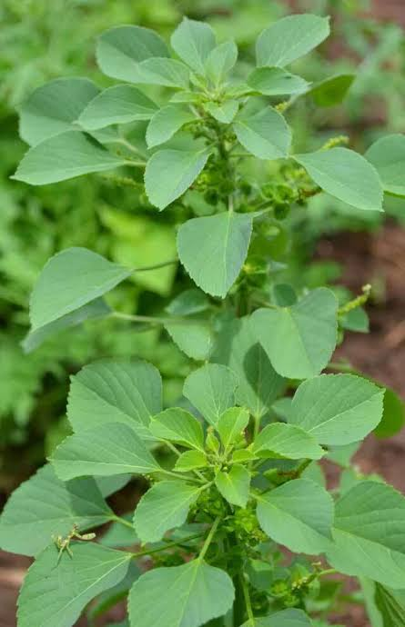
Figure 1.1 Acalypha indica

2. Calotropia procera
Table: 1.3 Classification of Calotropia procera
Kingdom | Plantae
Order | Gentianales
Family | Apocynaceae
Genus | Calotropia
Species | C.procera
Binomical Name | Calotropia procera
Tamil Name | Erukku
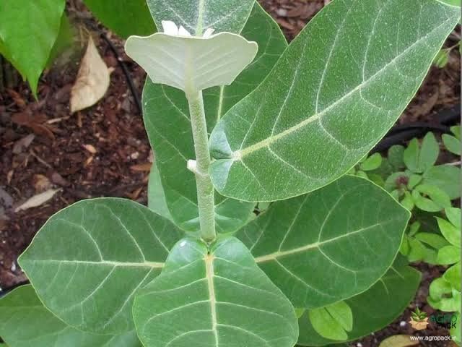
Figure: 1. 2 Calotropia procera

3. Millettia pinnata
Table: 1.4 Classification of Millettia pinnata
Kingdom | Plantae
Family | Fabacea
Subfamily | Faboidea
Tribe | Millettieae
Genus | Millettia
Species | M.pinnata
Binomical Name | Millettia pinnata
Tamil Name | Punga Maran
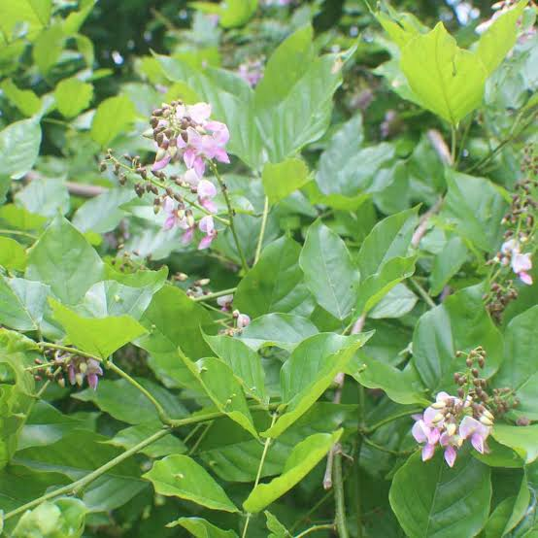
Figure: 1. 3 Millettia pinnata

4.Leucas aspers
Table: 1.5 Classification of Leucas aspera
Kingdom | Plantae
Order | Lamiales
Family | Lamiaceae
Genus | Lecuas
Species | L.aspera
Binomial Name | Leucas aspera
Tamil Name | Thumbai
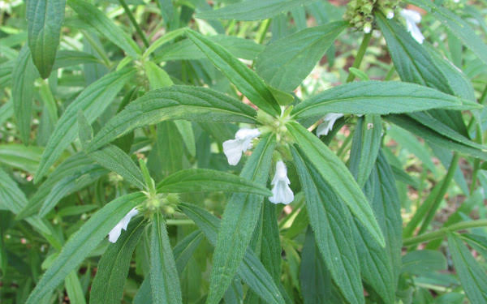
Figure: 1. 4 Leucas aspera

5. Senna alata
Table: 1.6 Classification of Senna alata
Kingdom | Plantae
Order | Fabales
Family | Fabaceae
Subfamily | Carsalpiniodideae
Genus | Senna
Species | S.alata
Binominal Name | Senna alata
Tamil Name | Seemai Agathi

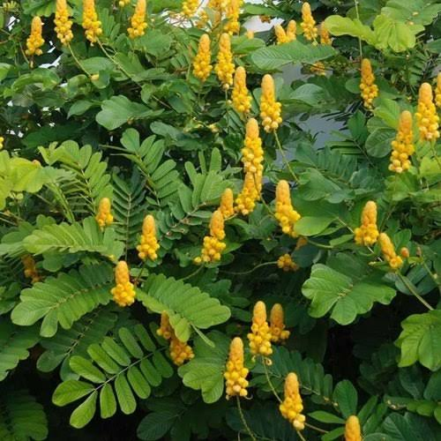
Figure: 1. 5 Senna alata

Table: 1.7 classification of Carica papaya
6.Carica papaya

Kingdom | Plantae
Order | Borassicales
Family | Caricaceae
Genus | Carica
Species | C.papaya
Binominal Name | Carica papaya
Tamil Name | Pappali
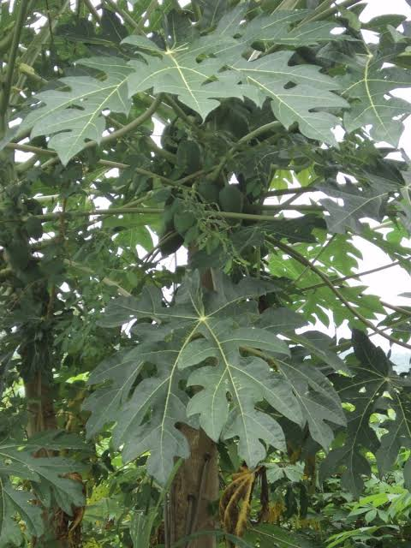
Figure: 1. 6 Carica papaya

1.3 USES OF POLY HERBAL PLANT TRADITIONAL TREATMENT PROCESS
1. Acalypha indica
Acalypha indica is one of weed plants that contain important medicinal values for human health applications. It can be found commonly in India, Sri Lanka, Thailand and Pakistan. The extracts of various parts of the plant, Leaves, leaves, roots and stem parts are used for medicinal purposes to treat various diseases such as the eye infections, respiratory problems, rheumatism and skin problems and decrease blood sugar level. The plant has many traditional medicinal uses. In madagascar the crushed plant is used for skin parasites. In mauritius the sap of crushed leaves mixed with salt or a decoction of plant is used for scabies and other skin problems (Redfilda et al 2021).
2. Calotropis procera
The medicinal potential of Calotropis procera has been known to traditional systems of medicine for a while now with its leaves being widely used. The use of the plants, plant extracts and pure compounds isolated from natural sources has always provided a foundation for modern pharmaceutical compounds. The leaves of calotropis procera are said to be valuable as an antidote for snake bite, sinus fistula, rheumatism, mumps, burn injuries and body pain. The leaves of calotropis procera are also used to treat jaundice (Amarpreet Kaur et al 2021).
3. Millettia pinata
The genus Millettia belongs to family Fabaceae consists of more than 200 species plants which grown in tropical and subtropical regions of the world. The family Fabaceae is positioned as the major groupof angiosperms and the genus was earlier know as pongamia, which is large distributed genus of flowering plants. The plant list includes 363 scientific plant names of species rank, for the genus Millettia, out which 202 are acknowledged species. Ayurveda pungai oil is mainly applied on the skin to manage boils and eczema as well as heal wounds due to its ropan (healing) and antimicrobial property. The paste of its leaves can also be applied on cuts and wound to help promote healings (Rasmita Jena et al 2020).

4. Senna alata
Senna alata is often called the ringworm bush because of its very effective fungicidal properties for treating ringworm and other fungal infections of the skin. The leaves are ground in a mortar to obtain a kind of “green cotton wool”. This is mixed with the same amount of vegetable oil and rubbed on the affected area two or three times a day. A fresh preparation is made every day. Its active ingredients include the yellow chyrysopharic. This plant is indigenous to several regions of the world such as Africa and South America. It is an erect, tropical, annual herb of 0.15m heigh with leathery, compound yellowish-green leaves. It thirves in sunny and moist areas and produces a chaacteristic offensive smell (Muhammad Hamza Ashfaq et al 2022).
5. Leucas aspera
Medicinal plants are the only source for the treatment of diseases in ancient days and since then numerous herbs and plants leaves have been recoganized as medicinal plants because of their potency to cure various ailments. Medicinal plants are the rich sources of lead molecules for new drug discovery and hence the biological importance of medicinal plants is increasing rapidly nowadays. The plant is used traditionally as an antipyretic and insecticide. Medicinally it has been proven to possess various pharmacological activities like antifungal, antioxidant, antimicrobial, antinociceptive and cytotoxic activity and as an antidote to snake venom leucas leaves are used in chronic rheumatism (Vijay Kumar et al 2016).
6. Carica papaya
Papaya is a powerhouse of nutrients and is available throughout the year. It is rich source of three powerful antioxidant vitamins C, vitamin A, vitamin E. The minerals, magnesium and potassium. Vitamin B patothenic acid and folate and fiber. Papaya consists of an enzyme called papain which promotes healing of the skin and will also enhance the secretion of collagen when used topically for the skin. Collagen is a primary skin enhances skin elasticity (Tarun vij et al 2015).

OBJECTIVE
- To prepare the aqueous, chloroform and ethanol extract of poly herbal plant leaves (Acalypha indica, Calotropia procera, Millettia pinnata, Senna alata, Leucas aspera and Carica papaya) and analysing the phytochemicals qualilately.
- Formulation and evaluation of poly herbal plant leaf cream for the treatment of fungal infection.
- Studies on antifungal activity of the formulated cream.

CHAPTER 2
LITERATURE REVIEW
2.1 POLY HERBAL PLANTS
1. Acalypha indica :
Acalypha indica is an important Indian medicinal plant and widely used in Ayurveda and siddha for management of various diseases. This aims a comprehensive of the chemical constituents, pharmacological and clinical uses. Different pharmacological experiments in both in vitro and in vivo have been carried out and also identified the medicinally important phyto-constitutents. A number of biological constituents in good yield and some have been shown to possess useful biological actions belonging mainly to tannins, flavonoids, cyanogenic glucoside (acalyphin), pyranoquinolinone alkaloid (filndersin). Extracts and chemical constituents of this plant possess useful pharmacological activities. The main pharmacological activity of Acalypha indica is wound healing effect, anti-venom property and anti-fertility activity. Many pharmacological studies of Acalypha indica have been demonstrated for their antioxidant, supporting its traditional uses. Suggest a wide range of clinical applications for the treatment of anthelmintic, cathartic, didiuretic and emetic, expectorant. Hence this review contributes to be the knowledge of Acalypha indica plant and their ethnopharmacological uses (Dinesh Kumar et al 2010).
2. Calotropis procera :
Medicinal flora have proven their significance as a source of biologically active ingredients used in folk medicine. These active molecules have therapeutic potential and a vital pool for identifying novel medicine. Medicinal plants are widely used in developing societies like in india, pakistan and southern america because they are thought to be cheaper than modern medicines, most effective and readily available. They have been used for thousands of years to treat and prevent health disorders along with epidemics. Also, they utilized for flavour and for conserving food items. They play a golden role in the development of human culture. Plants produced the diversity of secondary metabolites. That are the responsible for the biological functions of plants used around the world. Calotropis procera is drought-resistant medicinal perennial shrup mostly found in arid to semi-aried areas. It is a major source of secondary metabolites including phenols, flavanoids, terpenoids, sugars, alkaloids, tannins cardenolides, glycoside,saponins and steroids. It has medicinal properties as hepatoprotective, antioxidant, inflammatory, antimicrobial and antimalarial. It is vigorus used for the aliment of common diseases, i.e. fever, leprosy, eczema, diarrhea, dysentery and jaundice. This short-review about the phytochemistry of Calotropia procera and its traditional uses ( Hina Batol et al 2020).
3. Millettia pinnata :
In the indian system of medicine-Ayurveda, azadirachta indica, adhotoda vasica, piper betle, ocimum tenuiflorum and pongima pinnata has been mentioned as a remedy for treatment of various infectious disease and aliments. Based on the folkloric use, the present study was designed to formulate and evaluate polyherbal gel containing extracts of Azadirachta indica, Adhatoda vasica, Piper betle, Ocimum tenuiflorum and Pongimia pinnata. Gel formulation (Formulation A,B and C) were prepared which comprised of the ethanolic extracts of Azadirachta indica, Adhatoda vasica, Piper betle, Ocimum tenuifflorum and Pongima pinnata in a concentration of 0.1, 0.3 and 0.5% respectiviely in a base. The prepared formulations were evaluated for appearance and homogeneity, pH, viscosity and rheological studies, spreadability, skin irritation test (patch test) and washability. The formulations were also screened for their antimicrobial activity by disk plate method against S.aureus, B.subtilis, A.niger and E.coli. the results of the studies revealed that all formulations under study viz. A,B and C showed better zone of inhibition as compared with the control. However, formulation C exhibited maximum activity against the selected strains which may be attributed to its greater amount of herbal extracts as compared to formulation A and B. the polyherbal gel formulations were observed to possess antimicrobial action. The effective activity may be attributed to the synergistic action of the plants constituents present in the formulations (Somnath Bhinge et al 2018).
4. Senna alata :
Herbal medicines is still the mainstay of about 75-80% of the world’s population, mainly in developing countries for primary health care because of better cultural acceptability, better compatibility with human body and lesser side effects. Herbal medicines consist of plant or its part of treat injuries, disease or illnesses and are used to prevent and treat diseases and aliments or to promote health and healing. It is a drug or preparation made from a plant or plants and used for any to such purpose. The aim of present study was to prepare herbal gel formulation containing ethanoic extract of antifungal herbal gel containing ethanoic extract of Senna alata, Murraya koenigii and Alovera. Topical gel formulation was designed by using ethanoic extract antifungal herbal gel containing ethanoic extract of Senna alata, Murraya koenigii and Alovera in varied concentrations. The gel was prepared by using carbopol 940 (1%w/v), ethanol, propylene glycol, methyl paraben, propyl paraben, EDTA disodium, tri-ethanolamine and required amount of distilled water. The prepared gels were evaluated for physical appearance, pH, spread ability, drug content, swelling index, diffusion study, viscosity, homogeneity and grittiness. It was inferred from results that gel formulations were good in appearance and homogeneity. Antifungal herbal gel containing ethanoic extract of Senna alata, Murraya koenigii and Alovera base gel proved to the formula of choice since it showed the highest percentage of extrudability, good spread ability and rheological properties (Shubhangi Vishwakarma et al 2019).
5. Leucas aspera :
To study the phytoconstituents and antibacterial activity of Leucas aspera leaf extracts of petroleum ether, ethyl acetate and aqueous were tested against human pathogenic bacteria. About forty gram of powdered leaf was extracted successively with 200 ml of aqueous (97-103°C), ethyl acetate (77-85°C) and petroleum ether (62-66°C). The prelimilary phytochemical analysis of the leaf extract revealed the presence of glycosides, tannins and terpenoids in petroleum ether and aqueous extract, alkaloids, coumarins, glycosides, flavanoids, quinines, saponins, tannins, terpenoids and almost all the tested compounds in the ethyl acetate extract. The crude extract of petroleum ether, ethyl acetate and aqueous were screened for antibacterial activity. Among the three extractions, the extract of the ethyl acetate showed potent antibacterial activity by inhibiting the growth of all the tested human pathogenic bacteria, maximum inhibition zone of 23mm, 22mm, 21mm and 20mm against the growth of streptococus faecalis, Pseudomonas aeruginosa, Shigella dysenterae and Corynebacterium diphtheria respectively. Minimum inhibitory concentrations (MIC) of crude extract of leucas aspera was determined against gram positive and gram negative bacterial pathogens ranged from 600 µg/ml to 2400 µg/ml. further Minimum Bacterial Concentration (MBC) of 1200 µg/ml was observed against the growth of Staphylococcus faecalis and Pseudomonas aeruginosa, 2400 µg/ml against Bacillus subtilis and Shigella dysenteriae, 4800 µg/ml against Corynebacterium diphtheria and Salmonella typhin respectively. The finding of this study revealed that the metabolites of leaf of Leucas aspera are the poential source for the development of new antibacterial compounds (Suresh Murugesan 2017).
6. Carica papaya :
The present work was performed to investigate the phytochemical and antifungal action of carica papaya L. of family caricaceae. C.papaya is an important tropical fruit also cultivated in pakistan and azad jammu and kashmir. The leaves of the respective plant contain a number of important secondary metabolites. In the present investigation we studied the phytochemical analysis of carbohydrate, protein, phenolic compounds and many other secondary metabolites. Antifungal effectiveness was determined by using different leaf extracts of C.papaya against Aspergillus flavus, Aspergillus niger, Fusarium sp. and Cladosporium sp. The plants methanolic leaf extracts showed better activity against Aspergillus niger, Cladosporium sp. And Fusarium sp. Ethanolic leaf extracts showed pronounced inhibition against Aspergillus niger, Aspergillus flavus and Cladosporium sp. While aqueous leaf extracts did not show inhibitory action against these fungi (Qumqum Nohad et al 2018).
2.2 METHODS OF EXTRACTION TECHNIQUES
Extraction as the term is uses pharmaceutically involves the separation of medicinally active compounds of plant or animal tissues from the inactive or inert components (desired and undesired) by using selective solvents in standard extraction procedures.
The products so obtained from plants are relatively impure liquids , semisolids or powders intended only for oral or external use. Some of the initially obtained extracts may be ready for use as medicinal agents in the form of tinctures and fluid extracts but some need futher processing.
The conventional extraction methods including maceration , precolation and soxhlet methods usually use organic solvents and require a large volume of solvents and long extraction time where as decoction and hydro distillation methods use water as a solvent.

MACERATION
It is an old method used for medicinal preparation. It is consider as a widely and low cost way to get natural products from plant material. The maceration is a method of solid-liquid extraction.
In this process the powdered solid materials is placed in a closed vessel and the solvent is added. It is allowed to stand for long time (varying from hours to days) with occasional shaking. Sufficient time is allowed for the solvent to diffuse through the cell wall to solubilize the constituent present in plant. The process takes places only by molecular diffusion.
After the desired time the liquid is strained off the solid residue is pressed to recover as much solvent as possible. When the solvent is water and the period of maceration is long a small quatity of alcohol may be added to prevent microbial growth.
Maceration involve three principles steps. Firstly plant materials is convert to powder form by grinding. This allow good contact between solvent and materials. After grinding a chosen solvent is added in a closed vessel. Then the liquid is strained off but the solid residue of this extraction process is pressed to recover large amount of occluded solutions.
During the process of maceration occasional shaking faciliate extraction by increasing diffusion and remove concentrated solution from the sample surface for bringing new solvent to the menstruum for more extraction yield.
ADVANTAGES
1.Maceration is a simple method using non complicated utensil and equipment.
2.Skilled operator not required.
3.Energy saving process.
4.For certain substances which are very less soluble in solvent and requires only prolonged contact with solvent is ideal.
5.Suitable method for less potent and cheap drugs.

DISADVANTAGES
1.Unifortunately the duration of extraction time is long and some times takes up to weeks.
2.Not exhaustively extract the drug.
3.It is very slow process and time consuming.
4.Solvent required is more (Mohammed golam rasual 2018).
2.3 PHYTOCHEMICALS ANALYSIS
Phytochemicals are the chemicals that present naturally in plants. Now a days these phytochemicals become more popular due to their countless medicinal uses. Phytochemical play a vital role against number of diseases such as asthma , arthritis , cancer etc. unlike pharmaceutical chemicals these phytochemicals do no have any side effects. Since the phytochemicals cure diseases without causing any harm to human beings these can also be considered as “man friendly medicines”. This paper mainly deals with collection,extraction,qualitative and quantitative analysis of phytochemicals (Sahira banu et al 2015).
Medicinal plants are the treasure house of potential drugs. They possess anti inflammatory, anti helminthic, anti pyretic, analgesi and anti cancer properties. Leucas aspera is one among them. It is commonly used as anti pyretic and insecticide since ancient times. The aim of the present study is to evaluate phytochemical analysis of the leaves of Leucas aspera in different solvents like methanol, ethanol, chloroform, petrolum ether and aqueous by both qualitative and quantitative analysis. The quantitative analysis shows the presence of alkaloids, steroids, flavanoids, terpenoids, saponins, carbohydrates, protein and aminoacids. The quantification of alkaloids, flavanoids and phenols were estimated. The results suggested that the plant Leucas aspera possess significant medically active compounds which can be used as the source for the production of new drugs in the field of medicine (Nithyatharani et al 2018).
Carica papaya Linn is the member of Caricaceae family of kingdom plantae. The study was executed for the development of qualitative standards of male and female leaves of the plant. The study included evaluation of macroscopial, physico-chemical and preliminary phytochemical parameters to authaorize the purity and autheticity of leaf of carica papaya Linn based on guidelines provided by WHO. Qualitative phytochemical screening of extracts revealed the existence of alkaloids, flavonoids, tannins, phenolic compounds, glycosides including cardic glycosides, proteins and carbohydrate in different extracts of Carica papaya Linn which are majorly rich in female leaves as compared to male. Mean ash values, acid insoluble ash, water soluble ash, foaming index, swelling index and moisture contents were also generated that confirmed distinct peak values with respective functional groups exhibited by Carica papaya male and female plant. The current research reflected that female and male plant showed variations in phyto-constituents. This data will be utilized for additional pharmacological and instrumental evaluation of the plant which can not only be beneficial in discriminating and refining the type as well as nature of various phytochemicals present in Carica papaya male and female leaves but also establish the quality standards for future researchers (Syed Zohaib Hussian et al 2018).
2.4 PREPARATION OF HERBAL CREAM
The herbal cream was prepared by the 2 extracts (Murraya koeniggi and Cajanus Cajan). The ingredients for the herbal cream preparation were weighed accurately. The formulation trails were done as per forrmula given in (table 2). The formulation containing Murraya koenigii and Cajanus Cajan extract was formulated by taking aqueous and oil phases into beakers and heated to 75°c over a water bath. The oil phases was comparised of extracts of Murraya koenigii, Cajanus Cajan, liquid paraffin, bees wax, stearyl alcohol, Tween-80 and stearic acid while the aqueous phases was composed of methyl parabens,sorbitol solution and pottassium hydroxide. Drop wise addition of the aqueous phase to the oil phase was done with constant stirring at 2000 rpm in a homogenizer for a period of 15 min. The homogenizer speed was then reduced to 1000 rpm and homogenization was continued for 500 rpm and the homogenization extended for 5 min. Herbal skin cream containing Murraya Koeniggi and Cajanus Cajan extract was formulated (Soumya et al 2020).
2.5 EVALUATION PARAMETERS OF HERBAL CREAM
Herbal cosmetic are the preparation used to enhance the human appearance. The main aim of our work is to develop an herbal cream which can give multipurpose effect like moisturizer, reduce acne and skin irritation. We have used four herbal ingridients in our preparations, which are Aloe vera gel (Aloe barbadensis), Neem (Azadirachta indica), Tulsi (Ocimum sanctum) and Cucumber. All the products were found to be stable with no sign of phase separation and no change in color. The cream was prepared by using the cream base that is bees wax, liquid paraffin, borax, methyl paraben, distilled water, rose oil, aloe vera gel, dimethyl sulphoxide,extracts of neem, tulsi and cucumber. By using slab technique, we have developed three batches of our herbal cream, namely F1, F2 and F3. All three batches were evaluated for different parameters like appearance, pH, viscosity, washability, spreadability,greasiness. All the three formulations F1,F2 and F3 showed good appearance, pH, viscosity, washability, spreadability and greasiness was observed. Also the formulations F1,F2 and F3 showed no redness and irritation during irritancy study and they were easily washable. All the three formulations were stable at room temperature.
Azadirachta indica (Neem) and Ocimum sanctum (Tulsi) are well known for its medicinal value in indian traditional system of medicine. There is growing demand cosmetics for herbal in the world market and they are invaluable gifts of nature. Therfore, I tried to make multipurpose herbal cream containing the extract of Azadirachta indica and Ocimum sanctum (Nitin et al 2023).
2.6 ANTIMICROBIAL EVALUATION USING THE CUP PLATE METHOD
In the last few decades there has been an exponential growth in the field of herbal medicine. It is getting popularized in developing and develpoed countries owing to its natural origin and lesser side effects. The scientific evidence has brought about the possibility of utilization of herbal plant in the treatment of fungal and bacterial infections and the development of anti bactrial and anti fungal products. In the present study, herbal ointment containing Aloe vera, Neem and Turmeric was formulated and evaluated to study antibacterial and antifungal activity. The evaluation is done is using cup plate method for zone of inhibition and two fold dilution method for MIC (Minimum Inhibitory Concentration). The study showed that Aloe ointment is exhibiting broad-spectrum antifungal activity antifungal activity against A.varies and antibacterial activity against E.coli. The overall experiment showed that Aloe vera ointment and Turmeric ointment showed more antifungal activity than neem ointment. Also it was found that ointment containing mixture of Aloe vera, Neem, Turmeric showed prominent antifungal activity than antibacterial activity. This ointment can be used in the treatment of sun burns, rashes, burns, wounds and other skin infections. It can also be used in the treatment of superficial mycosis (Abhijeet Pandey et al 2010).

2.7 CONCLUSIONS FROM THE LITERATURE REVIEW
Herbal plants are integral parts of the traditional medicine worldwide and most of the rural and urban population uses these plants in many of their regular needs even today. The current researchers are more focused on natural chemicals than the synthetic chemicals due to their environmental, economic and health benefits. This plant has a great importance for the Ayurvedic and modern system of formulations in which some have been patented for their better acceptability and therapeutic profile. The study of the phytochemical and pharmaceutical investigation may serve as a new standards to the region specific sample of the plant and key structure for the validation of crude plant material and regarding to its on standardization. The positive antimicrobial activity shows that whole herb extract can be useful for the formulation development against the specific microbial infection.

CHAPTER 3
MATERIALS AND METHODS
3.1 COLLECTION OF POLY HERBAL PLANT LEAF MATERIALS:
The fresh plant leaves of Acalypha indica, Calotropia procera, Millettia pinnata, Senna alata, Leucas aspera and Carica papaya were collected from the local Botanical garden in Salem.
3.2 PREPARATION OF POLY HERBAL PLANT LEAF POWDERS:
The collected fresh plant leaves materials of Acalypha indica, Calotropia procera, Millettia pinnata, Senna alata, Leucas aspera and Carica papaya were washed with running tab water after cleaned of unwanted foreign materials. All the plant leaf materials were shade dried until all the water molecules were evaporated and plant leaves became well dried for grinding, with the help of mortar and pestle all the plant leaves parts ground well in to fine powder form and the stored in the polythene bag with proper labelling.
3.3 PREPARATION OF POLY HERBAL PLANT LEAF EXTRACT:
AQUEOUS EXTRACT:
The powdered leaves of each plant were subjected to successive solvent extraction by using aqueous extract whereas the Maceration process was used for preparation aqueous of extract. For the preparation of aqueous extract, five gram (5g) of dried powder of experimental material of leaves were soaked in 100ml of water for 24hrs, 48hrs and 72hrs and kept in shaking incubator at 50-60 rpm & 40°C. The mixture was then filtered through the Whatmann No.1 filter paper and the extract was collected.
CHLOROFORM EXTRACT:
The powdered leaves of each plant were subjected to successive solvent extraction by using Chloroform extract whereas the Maceration process was used for preparation Chloroform of extract. For the preparation of chloroform extract, five gram (5g) of dried powder of experimental material of leaves were soaked in 100ml of Chloroform for 24hrs, 48hrs and 72hrs and kept in shaking incubator at 50-60 rpm & 40°C. The mixture was then filtered through the Whatmann No.1 filter paper and the extract was collected.
ETHANOL EXTRACT:
The powdered leaves of each plant were subjected to successive solvent extraction by using ethanol extract whereas the Maceration process was used for preparation ethanol of extract. For the preparation of ethanol extract, five gram (5g) of dried powder of experimental material of leaves were soaked in 100ml of ethanol for 24hrs, 48hrs and 72hrs and kept in shaking incubator at 50-60 rpm & 40°C. The mixture was then filtered through the Whatmann No.1 filter paper and the extract was collected.
3.4 PHYTOCHEMICAL ANALYSIS
Phytochemical screening was performed to identify phytochemicals in the water and extracts of the plant leaves were used in the present work, the phytochemicals were detected by color tests.
Table: 3.1 List of Test Conducted
S.NO | TEST CONDUCTED
1 | Alkaloids
2 | Amino Acids
3 | Carbohydrates
4 | Glycosides
5 | Phenolic compounds and Tannins
6 | Phytosterols
7 | Proteins
8 | Saponins

1. TESTS FOR ALKALOIDS
MAYER’ TEST: To a few ml of plant sample extract, two drops of Mayer’s reagent are added along the sides of test tube.
2. TESTS FOR AMINO ACIDS
The extract (100mg) was dissolved in 10ml of distilled water and filtered through Whatmann No.1 filter paper and the filtrate is subjected to test for amino acids.
NINHYDRIN TEST: Two drops of ninhydrin solution (10mg of ninhydrin in 200ml of acetone) was added to 2ml of aqueous filtrate.

3. TESTS FOR CARBOHYDRATES
BENEDICT’S TEST: To 0.5ml of filtrate, 0.5ml of Benedict’s reagent was added. The mixture is heated on a boiling water bath for 2 minutes.
4. TESTS FOR GLYCOSIDES
For 50mg of extract is hydrolysed with concentrated hydrochloric acid for 2 hours on a water bath, filtered and the hydrolysate is subjected to the following tests.
BORNTRAGER’S TEST: To 2ml of filtered hydrolysate, 3ml of chloroform is added and shaken, chloroform layer is separated and 10% ammonia solution was added to it.
5. TESTS FOR PHENOLIC COMPOUNDS AND TANNINS
FERRIC CHLORIDE TEST: The extract (50mg) was dissolved in 5ml of distilled water. To this few drops of neutral 5% ferric chloride solution are added.
6. TESTS FOR PHYTOSTEROLS
LIBERMANN-BURCARD’S TEST: The extract (50mg) was dissolved in 10ml acetic anhydride. To this, 1 or 2 drops of concentrated sulphuric acid are added slowly along the side of the test tube.
7. TESTS FOR PROTEINS
The extract (100mg) was dissolved in 10ml of distilled water and filtered through Whatmann No.1 filter paper and the filtrate is subjected to test for proteins.
MILLON’S TEST: To 2ml of filtrate few drops of Millon’s reagent are added.
8. TESTS FOR SAPONINS
The extract (50mg) was diluted with distilled water and made up to 20ml. The suspension is shaken in a graduated cylinder for 15 minutes.

3.5 EXCIPIENT PROFILE
In this formulation following ingredients are used and their uses as follow
Table: 3.2 Uses of ingredient
S.NO | INGREDIENT | USES
1 | Acalypha indica | Antifungal activity
2 | Calotropis procera | Skin diseases
3 | Millettia pinnata | Wasp Bite
4 | Senna alata | Scabies
5 | Leucas aspera | Antimicrobial
6 | Carica papaya | Skin rashes
7 | Petroleum Jelly | Soothing agent
8 | Hard Paraffin | Lubricant
9 | Cetyl Alcohol | Emollient
10 | Glycerol | Emulsifier
11 | Methyl Paraben | Preservative
12 | Propyl Paraben | Preservative
13 | Peppermint water | Fragrance
14 | Activated Charcoal | Adsorbent

3.6 FORMULATION OF POLY HERBAL PLANT LEAF CREAM
The formulation components used were listed in table 3.3. Oil in water emulsion of 20 and 60% of drug were formulated. The emulsifier (glycerol) and other oil soluble components (petroleum jelly, Cetyl alcohol) were dissolved in the oil phase (part A) and heated up to 80°C. Extract and water soluble components (Acalypha indica, Calotropis procera, Millettia pinnata, Senna alata, Leucas aspera, Carica papaya, Methyl paraben and propyl paraben) were dissolved in (part B) and heated up to 80°C.
After heating the aqueous phase was added in portions to the oil phase with constant stirring unit cream is formed and cream was formulated having super color. Perfume was added when the temperature dropped to 45°C ± 50°C.

S.NO | INGREDIENT | FORMULATION OF CREAM
1 | Acalypha indica | 6ml
2 | Calotropis procera | 6ml
3 | Millettia pinnata | 6ml
4 | Senna alata | 6ml
5 | Leucas aspera | 6ml
6 | Carica papaya | 6ml
7 | Petrolium Jelly | 12.9gm
8 | Hard Paraffin | 6gm
9 | Cetyl Alcohol | 1.5ml
10 | Glycerol | 1.5gm
11 | Methyl Paraben | 1.2gm
12 | Propyl Paraben | 0.9gm
13 | Peppermint water | q.s
14 | Activated Charcoal | 0.03gm
Table: 3.3 Ingredient of Cream

3.7 EVALUATION OF POLY HERBAL PLANT LEAF CREAM :
The evaluation of poly herbal plant leaf cream was following.
1.PHYSICAL EVALUATION :
Formulated poly herbal plant leaf cream was further evaluated by using the following physical parameters : colour, odour, consistency and state of the formulation.
- COLOUR :
The colour of the poly herbal plant leaf cream was observed by visual examination
- ODOUR :
The odour of poly herbal plant leaf cream was found to be characteristics.
- CONSISTENCY :
The formulation was examined by rubbing cream on hand manually. The cream having smooth sonsistency. Cream did not leave greasy substance on skin surface after application.

D) STATE
The state of poly herbal plant leaf cream was examined visually.
2. LOSS ON DRYING :
1gm of cream was placed in the petridis and heated in the water bath at 105°C every 30min until it get constant weight.
3. DETERMINATION OF pH :
The pH of prepared herbal cream was measured by using digital pH meter. The solution of cream was prepared by using 100ml of distilled water and set aside for 2 h.
4. WASH ABILITY :
Herbal cream formulation was applied on the skin and then ease extends of washing with water was checked.
5. NON-IRRITANCY TEST :
Herbal cream formulation was evaluated for the nan-irritancy test. Observation of the sites was done for 24h.
6. PHASE SEPARATION :
The prepared cream was transferred in a suitable wide mouth container. Set a side for storage, the oil phase and aqueous phase separation were visualizing after 24 h.
7. STABILITY STUDY :
The stability are carried out for the prepared cream at temperature of 37°C for 2 months.

3.8 DETERMINATION OF ANTIFUNGAL ACTIVITY :
3.8.1 PREPARATION OF INOCULUM:
For evaluation of antifungal activity, 24 hours fresh culture of fungi were suspended in sterile water to obtain a uniform suspension of microorganism.
3.8.2 DETERMINATION OF ZONE INHIBITION:
Antifungal activity was checked by agar disks diffusion method (DDM). The test organism Aspergillus niger was inoculated in Potato Dextrose Agar (PDA). In this method a previously liquefied medium was inoculated with 0.2ml of fungal suspension having uniformly turbidity at temperature of 40°C. 20 ml of culture medium poured into the sterile petri dish having an internal diameter of 8.5 cm. Care was taken for the uniform thickness of the layer of medium in the plates. After complete solidification of liquefied inoculated medium, poly herbal plant leaf cream was added in a petri dish and antibiotic disks is placed in a petri dish. These plate antibiotic disk (Chloramphenicol) was placed carefully. Plates were kept for pre diffusion for 30 min. After normalized to room temperature. The plate were incubated at 27°C for 48 hrs in case of fungi. After incubation period was over, the zone of inhibition was measured with help of antibiotic zone Scale.

CHAPTER 4
RESULTS AND DISCUSION
4.1 PREPARATION OF POLY HERBAL PLANT LEAF EXTRACT:
Acalypha indica, Calotropia procera, Millettia pinnata, Senna alata, Leucas aspera and Carica papaya are extracted by aqueous, chloroform and ethanol solvent and extracted drugs are subjected preliminary phytochemical investigation. For this the poly herbal plant leaf extracts were prepared by using simple maceration process to obtain good yield of extract and there was no any harm to the chemical constituents and their activity.
This was found to be in conduction with the finding of Azwandida 2015 was all the methods that employ solvents in the procedures (maceration, MAE, UAE and ASE) are critically influenced by the solvents types.
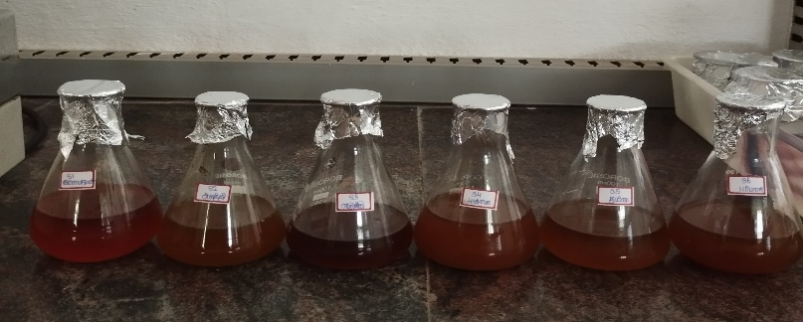
Figure: 4.1 Aqueous Extraction of Poly Herbal Plant Leaf
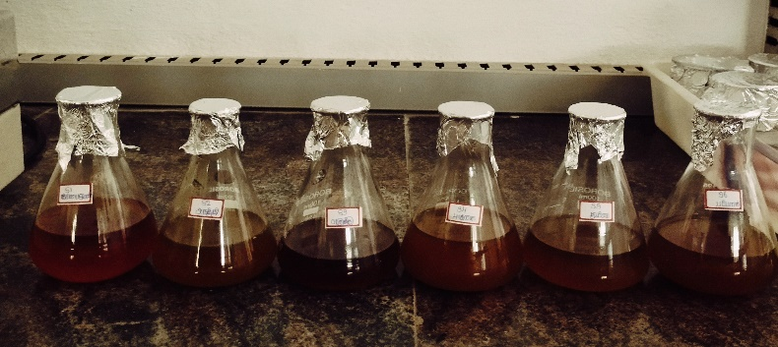
Figure: 4.2 Chloroform Extraction of Poly Herbal Plant Leaf
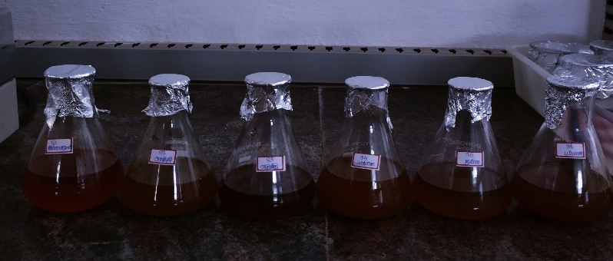
Figure: 4.3 Ethanol Extraction of Poly Herbal Plant Leaf
4.2 PHYTOCHEMICAL ANALYSIS
Preliminary phytochemical analysis of the extract (aqueous, chloroform and ethanol) of poly herbal plant leaf of Acalypha indica, Calotropia procera, Millettia pinnata, Senna alata, Leucas aspera and Carica papaya revealed the presence of various bioactive components which include Alkaloids, Amino acids, Carbohydrates, Proteins, Saponins, Phytosteroids, Phenolic and Tannins and Glycosides. The results of phytochemical test (qualitative) has been summarized in Table 4.1, 4.2, 4.3.
This was found to be in conduction with the finding of Pallavi Singh et al 2018 was screended that phytochemical screening of crude methanolic and aqueous extract of leaves and roots sample of Carica papaya, Piper nigrum and Agave americana the presence or absence of some secondary metabolites such as alkaloids, terpenoids, flavanoids, sugar, protein, phenols,saponins and quinones.

4.2.1 AQUEOUS EXTRACTION OF POLY HERBAL PLANT LEAF:
The qualitative phytochemical analysis of the poly herbal plant leaves of Acalypha indica, Calotropia procera, Millettia pinnata, Senna alata, Leucas aspera and Carica papaya is summarized in the table 4.1. It shows the presence of Amino acids, Carbohydrates, Proteins, Saponins, Phytosteroids, Glycosides, Phenolic and Tannins. Phytochemicals such as Saponins, terpenoids and alkaloids have hypoglycaemic activities (Cherian and Augusti, 1995). The leaves show positive result for phenols which can be act as antioxidants (Rumasia et al 2013). The leaves also have flavonoids which can act as antioxidants. Phytochemicals have highest therapeutic efficiency in pharmaceutical field (Thilagavathi et al 2015). It helps to undertake further studies on isolation and identification of specific phytocomponents for pharmacological studies.
Table: 4.1 List of Phytochemical Compound Analysis in Maceration Methods of Dry Powder
S.NO | PHYTOCHEMICALS ANALYSIS | 24HRS |  |  |  |  |  | 48HRS |  |  |  |  |  | 72HRS
S.NO | PHYTOCHEMICALS ANALYSIS | S1 | S2 | S3 | S4 | S5 | S6 | S1 | S2 | S3 | S4 | S5 | S6 | S1 | S2 | S3 | S4 | S5 | S6
1 | Alkaloids | - | - | - | - | - | - | - | - | - | - | - | - | - | - | - | - | - | -
2 | Amino acids | + | - | + | + | + | + | + | - | + | + | + | + | + | - | + | + | + | +
3 | Carbohydrates | - | - | + | - | - | + | - | - | + | - | - | + | - | - | + | - | - | +
4 | Proteins | + | + | + | - | + | - | + | + | + | - | + | - | + | + | + | - | + | -
5 | Saponins | + | + | + | + | + | + | + | + | + | + | + | + | + | + | + | + | + | +
6 | Phytosteroids | + | + | + | + | + | + | + | + | + | + | + | + | + | + | + | + | + | +
7 | Phenolic and Tannins | + | - | - | + | + | + | + | - | - | + | + | + | + | - | - | + | + | +
8 | Glycosides | - | - | - | + | - | - | - | - | - | + | - | - | - | - | - | + | - | -

+ - Present
- - Absent
S1- Acalypha indica S2- Senna Alata S3- Calotropis procera S4- Millettia Pinnata S5- Leucas
aspera S6- Carica papaya
4.2.2 CHLOROFORM EXTRACTION OF POLY HERBAL PLANT LEAF:
The qualitative phytochemical analysis of the poly herbal plant leaves of Acalypha indica, Calotropia procera, Millettia pinnata, Senna alata, Leucas aspera and Carica papaya is summarized in the table 4.2. It shows the presence of Alkaloids, Amino acids, Carbohydrates, Proteins, Saponins, Glycosides, Phenolic and Tannins. Phytochemicals such as Saponins, terpenoids and alkaloids have hypoglycaemic activities (Cherian and Augusti, 1995). The leaves show positive result for phenols which can be act as antioxidants (Rumasia et al 2013). The leaves also have flavonoids which can act as antioxidants. Phytochemicals have highest therapeutic efficiency in pharmaceutical field (Thilagavathi et al 2015). It helps to undertake further studies on isolation and identification of specific phytocomponents for pharmacological studies.
Table: 4.2 List of Phytochemical Compound Analysis in Maceration Methods of Dry Powder
S.NO | PHYTOCHEMICALS ANALYSIS | 24HRS |  |  |  |  |  | 48HRS |  |  |  |  |  | 72HRS
S.NO | PHYTOCHEMICALS ANALYSIS | S1 | S2 | S3 | S4 | S5 | S6 | S1 | S2 | S3 | S4 | S5 | S6 | S1 | S2 | S3 | S4 | S5 | S6
1 | Alkaloids | + | + | + | + | + | + | + | + | + | + | + | + | + | + | + | + | + | +
2 | Amino acids | - | - | - | + | - | - | - | - | - | + | - | - | - | - | - | + | - | -
3 | Carbohydrates | + | - | + | + | + | + | + | - | + | + | + | + | + | - | + | + | + | +
4 | Proteins | - | - | + | - | - | + | - | - | + | - | - | + | - | - | + | - | - | +
5 | Saponins | + | + | + | + | + | + | + | + | + | + | + | + | + | + | + | + | + | +
6 | Phytosteroids | - | - | - | - | - | - | - | - | - | - | - | - | - | - | - | - | - | -
7 | Phenolic and Tannins | + | + | + | + | + | + | + | + | + | + | + | + | + | + | + | + | + | +
8 | Glycosides | + | - | - | + | + | + | + | - | - | + | + | + | + | - | - | + | + | +

+ - Present
- - Absent
S1- Acalypha indica S2- Senna Alata S3- Calotropis procera S4- Millettia Pinnata S5- Leucas
aspera S6- Carica papaya
4.2.3 ETHANOL EXTRACTION OF POLY HERBAL PLANT LEAF:
The qualitative phytochemical analysis of the poly herbal plant leaves of Acalypha indica, Calotropia procera, Millettia pinnata, Senna alata, Leucas aspera and Carica papaya is summarized in the table 4.3. It shows the presence of Amino acids, Carbohydrates, Proteins, Saponins, Phytosteroids, Phenolic and Tannins. Phytochemicals such as Saponins, terpenoids and alkaloids have hypoglycaemic activities (Cherian and Augusti, 1995). The leaves show positive result for phenols which can be act as antioxidants (Rumasia et al 2013). The leaves also have flavonoids which can act as antioxidants. Phytochemicals have highest therapeutic efficiency in pharmaceutical field (Thilagavathi et al 2015). It helps to undertake further studies on isolation and identification of specific phytocomponents for pharmacological studies.
Table: 4.3 List of Phytochemical Compound Analysis in Maceration Methods of Dry Powder
S.NO | PHYTOCHEMICALS ANALYSIS | 24HRS |  |  |  |  |  | 48HRS |  |  |  |  |  | 72HRS
S.NO | PHYTOCHEMICALS ANALYSIS | S1 | S2 | S3 | S4 | S5 | S6 | S1 | S2 | S3 | S4 | S5 | S6 | S1 | S2 | S3 | S4 | S5 | S6
1 | Alkaloids | - | - | - | + | - | - | - | - | - | + | - | - | - | - | - | + | - | -
2 | Amino acids | + | - | - | + | + | + | + | - | - | + | + | + | + | - | - | + | + | +
3 | Carbohydrates | + | + | + | + | + | + | + | + | + | + | + | + | + | + | + | + | + | +
4 | Proteins | + | + | + | + | + | + | + | + | + | + | + | + | + | + | + | + | + | +
5 | Saponins | + | + | + | - | + | - | + | + | + | - | + | - | + | + | + | - | + | -
6 | Phytosteroids | - | - | + | - | - | + | - | - | + | - | - | + | - | - | + | - | - | +
7 | Phenolic and Tannins | + | - | + | + | + | + | + | - | + | + | + | + | + | - | + | + | + | +
8 | Glycosides | - | - | - | - | - | - | - | - | - | - | - | - | - | - | - | - | - | -

+ - Present
- - Absent
S1- Acalypha indica S2- Senna Alata S3- Calotropis procera S4- Millettia Pinnata S5- Leucas
aspera S6- Carica papaya
4.3 FORMULATION OF POLY HEBAL PLANT LEAF CREAM
Poly herbal formulation was a common practice in herbalism. An effort has been made to develop a new poly herbal plant leaf formulation in the treatment of fungal diseases. This cream formulation was o/w type of emulsion. The formulation method was used to prepare cream so that uniform mixing of the herbal extract with the cream base was occurred which was stable during the storage.
This was found to be in conduction with the finding of Nikhil Nitin Navindgikar et al 2020 was Alove vera gel, neem and thulsi the cream showed a multipurpose effect and all these herbal ingrident showed significant different activities.

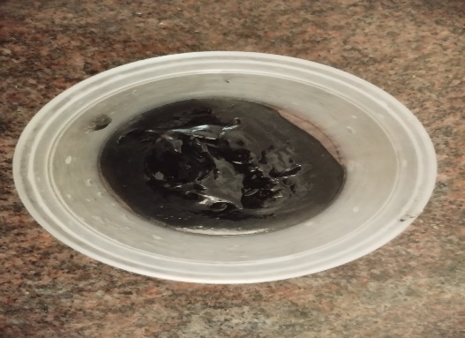
Figure: 4.4 Formulated Poly Herbal Leaf Cream
4.4 EVALUATION OF POLY HERBAL PLANT LEAF CREAM :
After formulation and evaluation of polyherbal plant leaf cream, we observed various types of results with the help of various methods or techniques like physical evaluation , loss on drying, determination of pH, wash ability, non-irritancy test phase, separation and stability study.
This was found to be in conduction with the finding of Nitin F et al 2023 was prepared three formulations F1,F2 and F3, from which the F2 formulation shows good color, pH, viscicity and consistency as comparied to other formulations. Also, all formulation shown no itching, no redness and irritation to the skin and they were easily washable.

Table: 4.4 Evaluation Parameters of Poly Herbal Plant Leaf Cream
S.NO | EVALUATION PARAMETERS | RESULT
1 | Colour | Black
2 | Odour | Pleasant
3 | Consistency | Smooth
4 | State | Semi solid
5 | Loss on Drying | 0.18%
6 | pH value | 6.1
7 | Wash ability | Easy wasable
8 | Non-irritancy test | Non irritanced
9 | Phase separation | No phase separation
10 | Stability study | Stable

4.5 ANTIFUNGAL ACTIVITY :
The Anti-fungal efficacy of the formulation of poly herbal plant leaf cream was tested on Aspergillus niger by agar plate technique. The poly herbal plant leaf formulated also showed good activity against in fungi. The result of zone inhibition showed that the cream prepared from aqueous extract of the combined plant leave materials show significant antifungal activity.
This was found to be in conduction with the finding of Veena et al 2021 was the formulation of the antifungal agent Chlorphenesin exhibited an enhanced rate of diffusion and anti-activity.
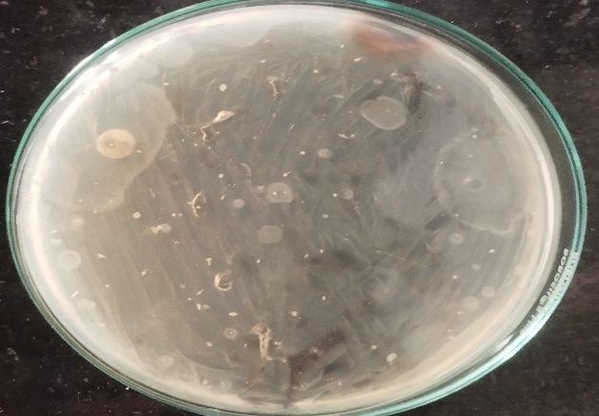
Figure: 4.5 Zone of Inhibition obtained by Poly Herbal Plant Leaf Cream and Chloramphenicol against Aspergillus niger

The data of zone inhibition of poly herbal plant leaf cream formulation was show in below table
Table: 4.11 Zone of Inhibition obtained by poly herbal plant leaf cream and Chloramphenicol against Aspergillus niger
S.NO | Name of the test organism | Name of the test sample | Zone of inhibition(mm)
1 | Aspergillus niger | Poly herbal plant leaf cream | 4
1 | Aspergillus niger | Chloramphenicol | 8

CHAPTER 5
CONCLUSION
From above discussion it is concluded that on combining the extracts of Acalypha indica, Calotropia procera, Millettia pinnata, Senna alata, Leucas aspera and Carica papaya. The extract showed a multipurpose effect and all these herbal ingredients showed significant different activities. The quantitative analysis show that the plants leaves of Acalypha indica, Calotropia procera, Millettia pinnata, Senna alata, Leucas aspera and Carica papaya contain significant bioactive components such as alkaloids, terpenoids, phenols, tannins, proteins, carbohydrates, flavonoids and Saponins. The aqueous extract are rich in phyto-constitutents when compared with other extracts. Thus the study reveals the presence of various phyto-constitutents of the leaves of Acalypha indica, Calotropia procera, Millettia pinnata, Senna alata, Leucas aspera and Carica papaya. The formulation of poly herbal plant leaf cream was done by maceration method. The Formulation of herbal plant leaf cream was o/w type of emulsion, hence can be easily washed with plain water that is better customer compliance. Three is an increasing demand for herbal cream because of fewer side effects and is safe to use. Further evaluated by various evaluation parameters such as physical properties, Loss on drying, Determination of pH, Wash Ability, Non-Irritancy test, Phase separation, Stability study of cream and gives good results. Aqueous extracts of medicinal plants selected based on reputation in Ayurvedic and Indian traditional system of medicine were analysed for their antifungal activity. The extracts exhibited good anti-fungal activity. The Anti-fungal efficacy of the formulation of poly herbal plant leaf cream was tested on Aspergillus niger by agar plate technique. The result of zone inhibition showed that the cream prepared from aqueous extract of the combined plant leaves materials show significant antifungal activity.

PAPER PRESENTATION:
Presented the Research Paper on “Evaluation and Antifungal Activity of Poly Herbal Plant Leaf Cream Against Fungal Diseases” in the National Conference ‘VIRUKSHA 23’ held on 31st March 2023 in Selvam College of Technology, Salem Road (NH-44), Namakkal-637 003.
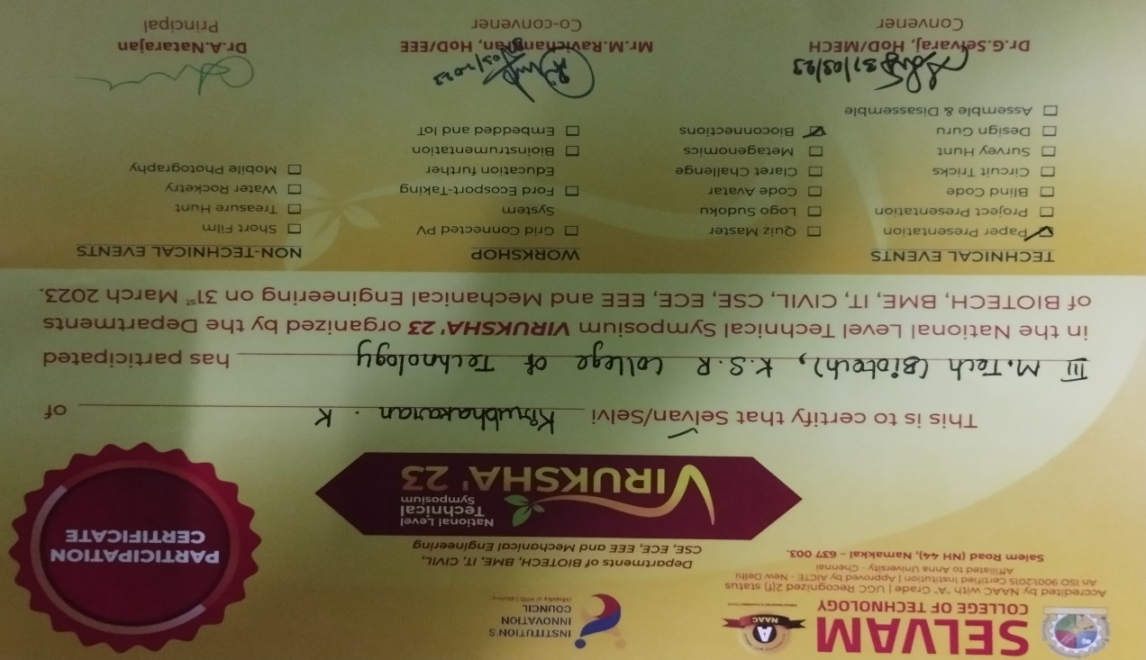

REFFERENCE
- Almonam, Abu-Basha, WE, Tanakarts, Nicholas RN, Ailing RD 2007, “In Vitro Antiplasmal Activity Of Six Jordan Medicinal Plants Against Three Mycoplasma Species, Trip, Animal Health Production”. 39:515-519.
- Adhikarimayum Haripyaree, Kshetrimayum Guneshwor, Maibam Damayanti 2013, “Antifungal and Cytotoxic Activity of Five Traditionally Used Indian Medicinal Plants”. Journal of Microbiology,Biotechnology and Food Sciences, 2(4), 2272-2278.
- Amgad A et al 2015, “Investigation of cream and ointment on antimicrobial activity of Mangifera indica extract”. J Adv Pharm Technol Res, 6(2):53-57.
- Ananda Kumar Chettupalli et al 2021, “Formulation and Evaluation of Poly Herbal Liquid-Solid Compact for its Anti-Inflammatory Effect”. BRIACI, 12(3):3883-3899.
- Aratip. Powar, Dr. Sachin A. Nitave, Dr. T. T. Magdum Trust’s 2022, “A Review – Ployherbal Antifungal Cream”. World Journal of Pharmaceutical Research, volume 11,Issue 5,904-920.
- Azmir J, Zaidul I.S.M, Rahman M.M, Sharif K.M et al 2013, “Techniques for extraction of bioactive compounds from plant materials:A Review”. Journal of Food Engineering, 426-436.
- Azuanida NN 2015, “A Review on the Extraction Methods use in Medicinal plants,principle,strength and limitation”. Med Aromat plants 4:196.
- Babu A, Sheike Noor Mohamed M et al 2016, “Inviro Antifungal Activity of Leaf Extracts of Leucas Aspera and Leucas Zeylamica”. IJPSR,Vol 7, Issue 2:5152-356.
- Benson HA 2009, “ Elastic Liposones For Topical And Transdermal Drug Delivery. Curr Drug Delivery”. 6(3) :217-26.doi:10.2174/156720109788680813, PMD19604135.
- Chandra mohan S, Dinakar S, Anand T et al 2012, “Phytochemical, GC-MS analysis and Antibacterial activity of a medicinal plant Acalypha indica”. International Journal of PharmTech Research, vol.4,no.3,PP 1050-1054.
- Chandrashekhar B. Badwaik, Updesh B. Lade, Tikesh Agarwal et al 2022, “Formulation and Evaluation of Herbal Face Cream”. International Journal of Pharmaceutical Research and Applications, Volume 7, Issue 1, pp: 955-960.
- Elansary Ho, Stops A, Kubica P, Ekiert M, Ali Hm, Et Al 2018, “Bioactives Of Traditional Medicinal Plants In Alexandria Evidence–Based Complementary And Alternative Medicine”. 32(1) :1-13.
- Enzo A. Palombo 2009, “Traditional Medicinal Plant Extracts and Natural Products with Activity against Oral Bacteria:Potential Application in the Prevention and treatment of Oral Diseases”. Evidence-Based Complementary and Alternative Medicine, Volume 2011, Article ID 680354, 15 Page.
- Farah Dayana Ishak, Siti Zation Mat So ad et al 2013, “In Vitro Study of Antimicrobial Activity of Acalypha indica Linn. Extract”.The Open Conference Proceedings Journal, 4,(Suppl-2, M14), 57-60.
- Gulnaaz Sabri, Vimala Y 2018, “Antibacterial and Antioxidant Activity of Leucas aspera Flowers from Bihar,India”. Asian Journal of Pharmaceutical and Clinical Research, Vol 11, Issue 2.
- Ham Nazmal Anasan , Namsabah Noor 2022, “Fungal infection : A Recent concern for Physicial”. Bangaladesh journal of medicine(BJM), 33:235-240.
- Harbone B 1999, “Phytochemical methods: : Chapman Aquide To Modern Techniques Of Plant Analysis”. Chapman And Hall Co, New York, USS.
- Jyothibai P and Sudarshan M 2020, “Phytochemical Analysis and Invitro Anti inflamatory Activity of Leucas Aspera leaves”. International Research Journal of Engineering and Technology (IRJET), Volume:07 Issue:12.
- Kajal Nivrutti Tangadkar, Talekar Sakshi Karbhari, Shinde Ashok Lahu et al 2022, “ Formulation and E valuation of Herbal Moisturizing Cream”. Journal of Emerging Technologies and Innovative Research (JETIR), Volume 9, Issue 6.
- Kamlesh Wadher, Sheetal Dabre et al 2021, “Design and Development of Emulgel Containing Pongamia pinnata Extract”. Int.J.Pharm.Sci.Rev.Res., 66(2) ; 68-73.
- Katara Antariksh, Pradhan Chandan Kumar et al 2010, “Phytochemical Investigation and Antimicrobial Activity of Leucas Cephalotes Roth”. Spreng Whole Herb. Der Pharmacia Letter, 2(4):284-296.
- Komal Patel, Namrata Panchal, Dr.Pradnga Ingle 2019, “Review of Extraction Techniques. Extraction Method: Microwave,Ultrasonic,Pressnrized fluid, Soxhlet Extraction ,Etc”. International Journal of Advanced Research in Chemical Sciences(IJARCS), Volume 6, Issue 3, PP 6-21.
- Koushlesh Kumar Mishra, Chachal Deep Kaur et al 2019, “Medicinal Plants Having Antifungal Properties”. DOI:http://dx.doi.org/10.5772/intechopen.90674.
- Kruti N Pandya, Alok J Shag 2013, “Evaluation of Safety and invitro efficaly study of Antifungal cream”. Journal of Advanced Pharmacy Education & Research, vol 3;issue 3.
- Kulandaisamy Agnes Nirmala, Marimuthu Kanchana 2018, “Leucas aspera- A Review of its Biological activity”. Sys Rev Pharma, 9(1), 41-44.
- Lee CM, Maibach H1 2006, “Deep Percutaneous Penetration into Muscles And Joints”. J Pharm sci,95(7) :1405-13.doi:10.1002/jps.20666, PMID16729269.
- Madhavi Adhav 2016, “Antimicrobial Activity of Acalypha indica L:A Medicinally important plant”. The Pharma Innovation Journal, 5(5):104-106.
- Mim-E-Tasmim, M Nasiruddin, MB islam and Rs Salfana 2021 “Phytochemical analysis of Different Parts of Acalypha indica L”. J.Bio.Sci.29(1):69-77.
- Misgnaw Gedlu Agidew 2022, “Phytochemical Analysis of Some Selected Traditional Medicinal Plants in Ethiopia”. Agidew Bulletion of The National Research Centre, 46(87).
- Mohammed Golam Rasul 2018, “Conventional Extraction Methods use in Medicinal Plants,Their Advantages and Disadvantages”. International Journal of Basic Sciences and Applied Computing (IJBSAC), ISSN:2394-3674,Volume-2 Issue-6.
- Nduche MU, Nkaa FA, Onyebinime A 2019, “Phytochemical Screening And Antimicrobial Activity Of Carica Papaya L, Citrus Pardisi L, Citrus Sinesis L, And Vernonia Amygdalina Del. Cent”. Dairy and Vet sci j 9(3):JDVS.MS.ID.555768.
- Neubert R.H 2011, “Potentials Of New Nanocarriers For Dermal And Transdermal Dry Delivery”. Dur J Pharma Biopharma,77(1) :1.2, doi:10.1016/j.ejpb.2010.11.003.
- Nithyatharani R, Kavitha U.S 2018, “Antimicrobial Activity of Leucas aspera Against Wound Pathogens”. International Journal of Creative Research Thoughts (IJCRT), Volume 6, Issue 1.
- Nittin F. Vanarase, Bhavana Tambe 2023, “Formulation and Evaluation of Multipurposes Herbal Cream”. International Journal of Pharmaceutical Research and Applications, 8(2) ; 514-518.
- Parabin Iraquil, Tapash Chakraborty, Malay K.Das, Yadav R.N.S 2019, “Herbal Antimicrobial gel with leaf extract of Cassia alata L”. Journal of Drug Delivery&Therapeautics, 9(3):82-94.
- Pratik Balasaheb Panhalkar, Pawar Ganesh Kalyan, et al 2022, “Over View of Polyherbal Antifungal Cream”.Journal of Emerging Technologies and Innovative Research (JETIR), Volume 9, Issue 12.
- Premkumar K, Nirmalbaburao, A Rojc Rani 2016, “Antioxidant Activity and Phytochemical screening of Acalypha indica crude leaf extract”. International Journal of Pharmaceutical and Clinical Research, 8(6):583-588.
- Rasmita Jena et al 2020, “A Review on genus Millettia: Traditional uses, phytochemicals and pharmacological activity”. Saudi Pharma J, 28(12): 1686-1703.
- Riazunnisa K, Chandra Obulu, Sai Sudha G et al 2013, “In Vitro Antibacterial Activity and Phytochemical Studies of Some Medicinal Plants”. Int.J.Pharm.Sci.Rev.Res, 23(2),77-80.
- Sameer Shafi et al 2021, “Optimization and Evaluation of Polyherbal Topical Cream”. International Journal of Research in Pharmaceutical Sciences, 12(1):940-946.
- Selim Aktar Reza, Md. Hasanur Rahman, Tofail Ahmad Chowdhury 2020, “Isolation of Secondary Metabolites from Leucas aspera and Investigation of Biological Activity”. Dhaka Univ.J.Sci.68(1): 101-104.
- Selvamani S, Balamurugan S 2015, “Antibacterial and Antifungal Activities of different organic solvent extracts of Acalypha indica(Linn)”. Asian J .Plant Sci,Res, 5(5):52-55.
- Sohel I .Nadaf, Nikita D. Gidde 2021, “Formulation and Evaluation of Herbal Antifungal Cream of Phylzathus urinaria”. World Journal Of Pharmacy and Pharmaceutical Sciences, Volume 10, issue 4,1586-1592.
- Somnath S Davkhar, Aarati S Bhandari, Sanjivani A Akolkar 2023, “Formulation and Evaluation of Multipurpose Cream”. Sys Rev Pharm, 14(1):23-28.
- Soumya A et al 2020, “Formulation and Evaluation of herbal cream containing extracts of Murraya Koeigii and Cajanus Cajan”. International Journal of Research in Phytochemical and Pharmacological Sciences, 1(2),58-63.
- Stephanon Hanolo Mlozi, Juma A. Mmongoyo, Musa N.Chacha 2023, “In vitro evaluation of the herbal cream formulation from methanolic leaf extracts”. Clinical Phytoscience, 9:3.
- Sudhakar Chekuri, Arun Jyoti B, Saraswathi Sompaga et al 2018, “Evaluation of Antimicrobial and Antifungal Activity of Acalypha indica L., Leaf Extract”. International Journal of Pharmacognosy and Phytochemical Research, 10(1), 48-51.
- Suknelev Suami Handa, Sumam Preet Singh Khanja, Gennaro longo, Dev Dutt Rakesh 2008, “Extraction Technologies for Medicinal and Aromatic plants”. International Centre For Science and High Triestc.
- Sumeet Dwivedi et al 2019, “Formulation and Evaluation of Herbal Cream Containing Hydro-Alcoholic Extract of Achyranthes aspera Linn. (Roots) Used for the treatment of Vaginal Infection”. Acta Scientific Medical Sciences , 3.8,192-196.
- Tariq Sadeq , Karzan Omer Qader et al 2019, “A Novel Preparation of Thyme Cream as Superficial Antimicrobial Treatment”. Journal of International Pharmaceutical Research 46(4):373-381.
- Thenmozhi S, Rajan S 2012, “Screening of Antibacterial and Phytochemical activity of Acalypha indica Linn against isolated respiratory pathogens”. Research in plant Biology, 2(1):01-06.
- Veena S, Surinder Kaur, Gururaj, Kulkarni 2021, “Formulation And Evaluation of Antifungal Cream Of Chlorphenesin”.International Journal of Current Pharmaceutical Research, Vol 13, Issue 5.
- Vidhya C.S, Sharmila p 2020, “A Study on Formulation and Nutrientional Evaluation of Leucas asperaflower (Thumbai) Balls”. International Research Journal on Advanced Science Hub (IRJASH), 2(10).
- Vijay kumar G, Devanna N 2016, “An Update of Leucas aspera- A Medicinal Plant”. International Journal of Science and Research Methodology, vol: 5, Issue: 1.
- Vijaya rekha D, Sangoffaiyan N, Noorjahan A , Ambiga S 2015, “Anti bacterial activity of Acalypha indica linn”. Int.5.curr.microbial.app.sci, 4(6):1133-1138.
- Zahir Hussain A, Aruna Ignatius 2010, “GC-MS Analysis and Antimicrobial Activity of Acalypha indica Linn”. Asian Journal of Chemistry, Vol.22, No.5, 3591-3595.
- Zhang H, Ma ZF 2018, “Phytochemical And Pharmaceutical Properties Of Capparis Spinosa as a Medicinal Plant Nutrient”. 10(2) :116.

