A
Thesis Paper on

OPTIMIZATION AND ANALYSIS OF DIFFERENT TYPES OF IRREGULAR SHAPED BUILDINGS

Submitted in partial fulfillment of the requirements for the award of degree
of
MASTER OF TECHNOLOGY
in

STRUCTURAL ENGINEERING
by

SUMAN DUTTA

UNIVERSITY REGISTRATION NO: 1001911831 OF 2019-2020 UNIVERSITY ROLL NO: 191001802002

Under the supervision of

DR. ANUP KUMAR MONDAL
PROFESSOR

Department of Civil Engineering Techno India University
Department of Civil Engineering Techno India University, Salt-lake Kolkata – 700091

MAY, 2021



Department of Civil Engineering Techno India University, Salt-lake Kolkata – 700091

CERTIFICATE

This is to certify that the progress report titled ” OPTIMIZATION AND ANALYSIS OF DIFFERENT TYPES OF IRREGULAR
SHAPED BUILDINGS” submitted by Suman Dutta to Techno India University, Salt lake in partial fulfillment of the requirement for the award of the degree of Masters of Technology in Structural Engineering by the Techno India University in Civil Engineering is a bona-fide work conducted under my supervision. This in my opinion is worthy of consideration for the purpose of a progress report in accordance with the rules and regulations of the institute.

Dr. Anup Kumar Mondal Professor of Civil Engg. Department Techno India University, Salt lake

Countersigned by

Prof. (Dr.) Heleena Sengupta Head of Department
Civil Engineering Department Techno India University, Salt lake
Kolkata-700 091

Prof. (Dr.) Gagan Pareek
Associate Dean Programs & Dept. of Management
Techno India University, Salt lake Kolkata-700 091

Department of Civil Engineering Techno India University, Salt-lake Kolkata – 700091

CERTIFICATE OF APPROVAL

The foregoing progress report titled ” OPTIMIZATION AND ANALYSIS OF DIFFERENT TYPES OF IRREGULAR SHAPED BUILDINGS” is hereby
approved as a creditable study of an engineering subject carried out and presented in a manner satisfactory to warrant its acceptance as a pre-requisite to the degree of Masters of Technology in Structural Engineering by the Techno India University in Civil Engineering. It is understood that by this approval the undersigned does not necessarily endorse or approve any statement made opinion expressed or conclusion drawn therein but approve the Term paper only for the purpose for which it is submitted.

Board of thesis Examiners:

...........................................................................
...........................................................................
...........................................................................
Date: ................................................................



Department of Civil Engineering Techno India University, Salt-lake Kolkata – 700091

ACKNOWLEDGEMENT

I would like to express my deep sense of gratitude to Dr. Anup Kumar Mondal Sir, Professor of Civil Engineering Department of Techno India University for providing valuable advice, resourceful guidance and close supervision in all respect all throughout.

I do acknowledge my gratefulness to all Professors and Teaching Staff of Civil Engineering Department, Techno India University, Salt lake for extending all facilities to carry out the present study. Finally I am grateful to all my friends, seniors and my parents for their co-operation during the preparation of this research proposal. It is due to their regular encouragements and enlightening discussions for which this Term paper be brought to the current shape.

Techno India University, Salt Lake Kolkata-700 091
Suman Dutta

Department of Civil Engineering Techno India University

University Registration no: 1001911831 of 2019-2020

UNIVERSITY ROLL NO: 191001802002

Dated 09.07.2021

ABSTRACT
Since ancient times, the buildings evaluation depended on durability confront different factors and conditions for the longest possible period, regardless of their ability to adapt to the changes occurring as well as meeting the diverse needs, the research aims to provide non-traditional solutions to meet the different requirements and problems that may face the architects, An analytical study of Dynamic architecture is capable of achieving sustainability and providing architectural environments that are adaptable to different variables. The research presents the various definitions of sustainability and dynamic architecture. It also explains the elements of sustainability and how to apply on the dynamic buildings whether static or partially or fully-dynamic.
The dynamic analysis, a plan of a multi-storey building is taken and it has been modelled with different structural elements for minimum story displacement. The dynamic analysis of multi-storey buildings is done using ETABS 2015 by IS and SP codal provisions (ETABS User’s Manual, 2015). The multi-storey building is R.C.C. structure with 3 basements + ground floor + 14 upper floors in zone IV with a maximum earth fill of 750 mm on the ground floor for landscape requirements. By comparing the results of dynamic analysis, the performance of the structural system can be evaluated.
An applied study was conducted for the dynamic buildings on two models of global buildings to reach 39 design criteria were identified as a guide to evaluate the level of dynamic building integration.
The design process of the architect when designing sustainable dynamic buildings.
- Dynamic building ability to deal with the climatic conditions of the building through the day.
- Dynamic building capacity to cope with climatic conditions during the four seasons.
- The capacity of the building to guide the saving of lightning and natural ventilation.
- The ability of the building to adapt to the use of wind places in the best way to achieve maximum utilization.

CONTENTS

Certificate | ………….... | 1-2
Certificate of Approval | ………….... | 3
Acknowledgement | ………….... | 4
Abstract | ………….... | 5
Contents | ………….... | 6
List of Abbreviations | ………….... | 8
List of Figure |  | 9-10
List of Tables | ………….... | 11
Notations and Symbols used | ………….... | 12- 14

CHAPTER 1 – INTRODUCTION 15-19
  - General 15-16

  - Objectives & Methodologies

  - Description

  - Steps of process

………….... 17

18

19

CHAPTER 2 – LITERATURE REVIEW 20 -28

2.1. General | ………….... | 20 - 23
2.2. Scope of work | ………….... | 24
2.3. History of work | ………….... | 25
2.3.1. Design optimization | ………….... | 26
2.3.2. Application | ………….... | 27
2.3.3. Parametric Study (irregularities) | ………….... | 28

CHAPTER 3 – IMPORTANCE OF THE STUDY 29-40

3.1 General Structural Modeling | ………….... | 29 - 34
3.2 Column Grouping | ………….... | 35 – 40
3.3 Basic Aspects of Seismic Design |  | 41 – 42
3.4 Mass Asymmetry in Plan |  | 43 – 47
- Stiffness Irregularities in elevation  - Load Calculation |  | 48 – 49  50 - 51

CHAPTER 4 – BASIC ASPECTS OF SEISMIC DESIGN 41- 51

  - Basic Aspects of Seismic Design

  - Mass Asymmetry in Plan

  - Stiffness Irregularities in elevation

  - Load Calculation & Structural Design of beam
………….... 41 – 42

43 – 47

48 – 49

50 - 51

CHAPTER 5 - REINFORCED STRUCTURAL DESIGN
  - Material Properties 55
  - Design of Beam 56 - 57
  - Design of Column 58 - 59
  - Design of Footing 60 - 62
CHAPTER 6 - REINFORCED STRUCTURAL DESIGN 63 - 65

6.1 Seismic Load calculation for 6th Storey irregular building | 66 – 68
6.2 Structural Analysis | 69 - 74
6.3 Modelling of R.C.C Frame | 75
6.4 Comparison & Analysis | 76 - 77
6.5 Result & Discussion | 78 – 79
CHAPTER 7 - COMPARATIVE ANALYSIS & DESIGN OF REGULAR AND IRREGULAR BUILDINGS | 80 - 87
7.1 Abstract | 80
7.2 Introduction | 81
7.3 Future scope | 82
7.4 E-Tabs Software & STAAD Pro. V8i Software | 83
7.5 Design Philosophy of Earthquakes | 84 - 85
7.6 Research & Thesis Timeline | 86
7.7 Recommendations | 87
CHAPTER 8 - ANALYSIS OF FUNDAMENTALS NATURAL PERIOD
OF IRREGULAR R.C.C FRAMED STRUCTURE | 87
8.1 Methodology | 88
8.2 Plan Irregularities | 89 - 90
8.3 Vertical Irregularities | 91 - 94
8.4 References | 95 - 98

LIST OF ABBREVIATIONS

BS: British Standard IS: Indian Standard
STAAD Pro.:- Structural Analysis & Designing Program.
ETABS: Extended Three-Dimensional Analysis of Building System FYP: Final Year Project
SRSS: Square Roots of the Sum of Squares CQC: Complete quadratic combination DL: Dead Load
LL: Live Load WL: Wind Load
EN: European Norm
RC: Reinforced Concrete

LIST OF FIGURE

FIGURE NO. | TITLE OF FIGURE | PAGE NO.
Fig 1.1 | Philips Pavilion designed by the office of Le Corbusier in 1958. | 14
Fig 1.2 | Multidisciplinary Design  Optimization (MDO) model structures | 15
Fig 1.3 | Image of Irregularities of  beams of building structure | 18
Fig 1.4 | Image of Irregular shaped building | 18
Fig 1.5 | Image of Stiffness  irregularities | 19
Fig 1.6 | Image of Mass Irregularities | 19
Fig 1.7 | Diagram of Vertical Geometry Irregularity | 20
Fig 1.8 | Diagram of Vertical  Geometry Irregularity or setback | 21
Fig 1.9 | Diagram of Dynamic effect  of building structure | 21
Fig 1.10 | Comparison of various shapes of building structure in Diagrametical view | 22
Fig 1.11 | Improper load distribution  leads to failure of irregular buildings. | 24
Fig 1.12 | Building Structure 1 | 25
Fig 1.13 | STAAD. Pro COLUMN  GROUPING (Building 1) | 25
Fig 1.14 | STAAD. Pro COLUMN  GROUPING (Building 1) | 26
Fig 1.16 | Building Structure 2 | 26
Fig 1.17 | STAAD. Pro COLUMN  GROUPING (Building 2) | 27
Fig 1.18 | STAAD. Pro COLUMN  GROUPING (Building 2) | 27
Fig 1.19 | Building Structure 3 | 28
Fig 1.20 | STAAD. Pro COLUMN  GROUPING (Building 3) | 29
Fig 1.21 | STAAD. Pro COLUMN | 30

 | GROUPING (Building 3)
Fig 1.22 | Building Structure 4 | 32
Fig 1.23 | STAAD. Pro COLUMN  GROUPING (Building 4) | 34
Fig 1.24 | STAAD. Pro COLUMN  GROUPING (Building 4) | 38
Fig 1.25 | Building Structure 5 | 40
Fig 1.26 | STAAD. Pro COLUMN  GROUPING (Building 5) | 44
Fig 1.27 | STAAD. Pro COLUMN  GROUPING (Building 5) | 46

LIST OF TABLE

TABLE No. TITLE OF TABLE Page No

Table: 1.1 | ............. | Literature Review of Various Reserch Paper in  Table | 16
Table 1.2 | ……….. | A list of natural and man-made earthquake sources | 18
Table 1.3 | ……... | History of work | 26

Table 4.2 ..................properties of concrete and steel bar taken as per IS 456. 56
Table 4.3 ……….. Beam and column length and cross section dimension 57

NOTATIONS AND SYMBOLS USED

Used in codal provision

A | = | Additional length of the Building irregularities
a | = | Shear wall Distance
b | = | Shear wall Distance
L | = | Length of the Building
Cf | = | Force Coefficient in Floor
Cl | = | Force Coefficient in Land
 |  | Used in numerical study and boundary condition
A | = | Additional length of the Building irregularities
a b | =  = | Shear wall Distance Shear wall Distance
L | = | Length of the Building
Cl | = | Force Coefficient in Land
B | = | Set back width

Used in Thesis Presentation Report

ag (t) Ground acceleration
fc Grade of concrete
fn nth Fundamental natural frequency of building
m Seismic mass
uu Ultimate plastic displacement of a frame member in tension/compression uy Idealized yield displacement of a frame member in tension/compression vu Ultimate plastic shear displacement
vy Idealised yield shear displacement

Ag Gross cross-sectional area of RC section Ah Design horizontal base shear coefficient As Area resisting shear
B Breadth of building E Modulus of elasticity Fw Lateral force
- Shear modulus
- Height of building
- Lateral base shear force of the building
Hmax Peak lateral strength
- Importance factor
Ib,eff Effective moment of inertia of beam Ib,gross Gross moment of inertia of beam Ib Moment of inertia of a beam
Ic Moment of inertia of a column
Ic,eff Effective moment of inertia of a cracked RC column Ic,gross Gross moment of inertia of an un-cracked RC column Ig Gross moment of Inertia of an RC section
- Initial lateral stiffness
- Length of building
D Depth of a frame member
L Length of a frame member
MbD Design flexural moment capacity of beam
MbΩ Overstrength flexural moment capacity of beam
McD Design flexural moment capacity of column
Mp Plastic moment capacity of a frame member
MΩ Maximum overstrength-based plastic moment capacity of a frame member
P Axial load applied on of a frame member
Pcr Critical axial load of a frame member
Puz Design axial load capacity of column in pure axial compression
R Response Reduction Factor
Rμ Strength Ratio
Sa/g Design acceleration spectrum value
T Fundamental translational natural period of the building
Tn nth Fundamental natural period of the building
Tx1 Fundamental translational natural period along X-direction Ty1 Fundamental translational natural period along Y-direction Tz1 Fundamental vertical natural period along Z-direction
Tθ1 Fundamental torsional natural period about Z-axis
VB Design base shear
Vjh Horizontal shear force in beam-column joint Vjv Vertical shear force in beam-column joint Vn Nominal shear capacity of RC section
xii
VΩ Maximum overstrength-based equilibrium compatible shear demand
W Seismic weight of building
Z Seismic Zone Factor
Zp Plastic Section Modulus

® Ratio of pure flexural translational stiffness to pure shear translational stiffness
δ Imposed deformation during earthquake
⎝u Ultimate rotational capacity
⎝y Idealized yield rotation
⎧ Material ductility Μm Member ductility μs Structure ductility ν Poisson ratio
ξ Damping
σcr Critical axial stress in compression Ωs Overstrength factor for steel bars Δmax Maximum lateral deformation ΔRoof Displacement at roof level
ΔY Idealized yield deformation

CHAPTER I:- INTRODUCTION
- GENERAL:- The word earthquake is used to express any seismic occurrence whether natural or caused by humans that can produce seismic influence around any particular area. Earthquakes are caused generally by rupture of geological faults inside the earth, but also by other events like Volcanic Movements, Landslides, mine blasts and atomic tests.
- An applied study was conducted for the dynamic buildings on two models of global buildings to reach 39 design criteria were identified as a guide to evaluate the level of dynamic building integration.
- The most important points that describe the design criteria for evaluating the level of the dynamic building integration were extracted to facilitate the design process of the architect when designing sustainable dynamic buildings.
- Dynamic building ability to deal with the climatic conditions of the building through the day.
- Dynamic building capacity to cope with climatic conditions during the all seasons.
- The capacity of the building to guide the saving of lightning and natural ventilation.
- The ability of the building to adapt to the use of wind places in the best way to achieve maximum utilization.
- Prevent pollution resulting from construction works by using prefabricated units.
- Choose building materials and construction methods suitable for the environment.
- Improve the building interaction with surrounding external factors.
- Use green architecture strategies and get the highest level of LEED.
- Reduce the cost of construction using pre-manufactured materials.
- Choose environmentally friendly materials for recycling.
- Avoid waste and visual impediments using pre-manufactured materials, for example.
- Reduce construction time by using pre-manufactured parts in factories.
- Availability of solar energy self-system in a dynamic building.
- Control the amount of energy exchanged between the inside and outside.
- Integrating the self-system with one of the parts of the dynamic structure.
- Availability of solar energy non-self-system in a dynamic building.
- Integrating the non-self-system

- General Description:- Structural analysis is the backbone of Civil Engineering. During recent years, there has been a growing emphasis on using computer aided software and tools to analyse the structures. There has also been advancement in finite element analysis of structures using Finite Element Analysis methods or matrix analysis. These developments are most welcome, as they relieve the engineer of the often lengthy calculations and procedures required to be followed while large or complicated structures are analysed using classical methods. But not all the time such detailed analysis are necessary to be performed i.e. sometimes, just approximate analysis could suffice our requirements as in case of preparing the rough estimates and participating in the bidding process for a tender. Now-a-days, high rise buildings and multi-bay-multi-story buildings are very common in metropolitan cities. The analysis of frames of multi-storied buildings proves to be rather cumbersome as the frames have a large number of joints which are free to move. Even if the commonly used Moment distribution method is applied to all the joints, the work involved shall be tremendous. However, with certain assumptions, applying the substitute analysis methods like substitute frame method, portal method, cantilever method or factor method, the structures can be analysed approximately.
- OBJECTIVES:-
- The goal of the project is to investigate various seismic responses of RC framed regular and vertical geometric irregular structure. The comparison between various seismic parameters would allow us to propose the best suitable building configuration on the existing condition.
- To perform a comparative study of the various seismic parameters of different types of reinforced concrete moment resisting frames (MRF), configuration, and types of irregularity.
- Comparison between regular and vertical irregular frame on the basis of shear force, bending moment, storey drift & node displacement etc.
- To study the change in different seismic response parameters along the increasing height and increasing bays.
- To propose the best suitable building configuration on the existing condition.

Methodology

- Review the existing literature and Indian design code provision for analysis and design of the earthquake resistant building.
- The different types of structures are selected.
- The selected structures are modelled.
- Performing linear analysis for selected building for both gravity load, and earthquake loads and then a comparative study of both is obtained from the analysis.
- Also design the building manually for design and analysis results obtained and compare with the area of steel of the models obtained.
- Using structural analysis and design Software ETABS and STAAD Pro and comparing both results.
- Observation of results and discussions.

DESCRIPTION
Earthquake is the result of a sudden release of energy in the earth's crust that creates seismic waves. The seismic activity of an area refers to the frequency, type and size of earthquakes experienced over a period of time.

A list of natural and man-made earthquake sources :-

Seismic Sources
Natural Source | Man-made Source
Tectonic Earthquakes | Controlled Sources (Explosives)
Volcanic Earthquakes | Reservoir Induced Earthquakes
Rock Falls/Collapse of Cavity | Mining Induced Earthquakes
Micro seism | Cultural noise (Industry, Traffic, etc)
Tsunami, Wave Propagation | Construction Failure, Vibration due to Heavy Instrument or Vehicles Movement.

- Buildings are subjected to ground motion. PGA (Peak Ground Acceleration), PGV (Peak Ground Velocity), PGD (Peak Ground Displacement), Frequency Content, and Duration play predominant rule in studying the behaviour of buildings under seismic loads.

Kani’s method
- This method was first developed by Prof. Gasper Kani of Germany in the year 1947. This is an indirect extension of slope deflection method. This is an efficient method due to simplicity of moment distribution. The method offers an iterative scheme for applying slope deflection method of structural analysis. Whereas the moment distribution method reduces the number of linear simultaneous equations and such equations needed are equal to the number of translator
displacements, the number of equations needed is zero in case of the Kani’s
method.

Steps of process
- The steps undertaken in the present study to accomplish the above –mentioned objectives are as follows:-
- Selected an exhaustive set of regular, stiffness irregular and setback building frame models with same heights of 4 story. Assuming equal bay width of 5m in both horizontal direction and different irregularities.
- Perform static analysis for each of the 4 building models.
- Analysing and comparison of the result of seismic analysis.
- Presentation of results in the form of graphs and tables.
- Detailed discussion on the results with the help of graphs and tables considering all the included parameters.

CHAPTER – II LITERATURE REVIEW

GENERAL :- The study focuses on a conceptual irregular shaped “twisted” building design similar to some existing sculpture-like architectures. Form and function are the two most important aspects of new buildings, which are becoming more sophisticated as parts of equally sophisticated “systems” that we are living in. Nowadays, it is common to have irregular shaped or sculpture-like buildings which are very different when compared to regular buildings. Construction industry stakeholders are facing stiff challenges in many aspects such as build ability, cost effectiveness, delivery time and facility management when dealing with irregular shaped building projects. Building Information Modelling (BIM) is being utilized to enable architects, engineers and constructors to gain improved visualization for irregular shaped buildings; this has a purpose of identifying critical issues before initiating physical
construction work. In this study, three variations of design options differing in rotating angle: 30 degrees, 60 degrees and 90 degrees are created to conduct quantifiable comparisons. Discussions are focused on three major aspects including structural planning, usable building space, and structural constructability. This research concludes that Building Information Modelling is instrumental in facilitating design optimization for irregular shaped building. In the process of comparing different design variations, instead of just giving “yes or no” type of response, stakeholders can now easily visualize, evaluate and decide to achieve the right balance based on their own criteria. Therefore, Construction project stakeholders are empowered with superior evaluation and decision making capability.
Valmundsson and Nau[1] (1997) studied the earthquake response of 5-, 10-, and 20- story framed structures with non-uniform mass, stiffness, and strength distributions. The object of the study was to investigate the conditions for which a structure can be considered regular.
Das [2] (2000) found that the structures designed by ELF method performed reasonably well. He concluded that capacity based criteria must be suitably applied in the vicinity of the irregularity.

Sadjadi et al. [3] (2007) presented an analytical approach for seismic assessment of RC frames using nonlinear time history analysis and push-over analysis. The results from

analytical models were validated against available experimental results. He observed that ductile and less ductile frames behaved very well under the earthquake considered.

Adiyanto [4] (2008) analyzed a 3-storey hospital building using STAAD Pro. Seismic loads were applied to the building. The dead loads and live loads were taken from BS6399:1997 and seismic loads intensity is based on equivalent static force procedure in UBC1994. Result showed that the building can withstand any intensity of earthquake. It means that the buildings were suitable to be built in any area located near the epicenter of the earthquake.

Kim and Elnashai [5] (2009) observed that buildings for which seismic design was done using contemporary codes survived the earthquake loads. However the vertical motion significantly reduced the shear capacity in vertical members.

Griffith and Pinto [6] (2009) investigated a 4-storey, 3-bay reinforced concrete frame test structure with unreinforced brick masonry (URM) infill walls for its weaknesses with regard to seismic loading. The concrete frame was shown to be essentially a “weak- column strong-beam frame” which was likely to exhibit poor post yield hysteretic behavior.

Di Sarno and Elnashai [7] (2011) assessed the seismic performance of a 9-storey steel perimeter MRF (moment resisting frame) using the three types of bracings: special concentrically braces (SCBFs), buckling-restrained braces (BRBFs) and mega-braces (MBFs). Local (member rotations) and global (inter-storey and roof drifts) deformations were employed to compare the inelastic response of the retrofitted frames. MBFs were found to be the most cost-effective bracing system with the least storey drifts.

Kumar et al [8] (2011) experimentally investigated the behavior of retrofitted FRP (fiber reinforced polymer) wrapped exterior beam-column joint of a G+4 building in Salem. The test specimen was taken to be one fifth model of beam column joint from the prototype specimen and was evaluated in terms of load displacement relation, ductility, stiffness, load ratio and cracking pattern. On comparing the test results with the analytical modeling of the joint on ANSYS and STAAD Pro, it was found that such external confinement of concrete increased the load carrying capacity of the control specimen by 60% and energy absorption capacity by 30-60%.

Agrawal [9] (2012) did seismic evaluation of an old institute building. Agrawal evaluated the member for seismic loads by determining the Demand Capacity Ratio (DCR) for beams and columns. Being an old building, the reinforcement details of the building were not available. Hence Design-1 was done applying only DEAD and LIVE loads according to IS 456:2000 to estimate the reinforcement present in the building and assuming that this much reinforcement was present. In Design-2, seismic loads were applied and for this demand obtained from design-2 and capacity from design -1, the DCR was calculated.

Poonam et al.[10] (2012) concluded that any storey must not be softer than the storeys above or below. Irregularity in mass distribution contributed to the increased response of the buildings.

Rajeeva and Tesfamariam [11] (2012) studied the Fragility based seismic vulnerability of structures considering soft -storey and quality of construction. Their study was demonstrated on three, five, and nine storey RC building frames designed prior to 1970s. Probabilistic seismic demand model was developed using non-linear finite element analysis considering the interactions between soft -storey and quality of construction.
Their study showed the sensitivity of the model parameter to the interaction of soft - storey and quality of construction.

Aslam [12] (2014) analysed a (G+5) storey Hospital building in Agartala as one the projects undertaken by L&T. The seismic analysis of the proposed building was done in the software ETABS, version- 9.7, which is one of the most advanced software in the structural design field. The loads applied on the structure were based on IS:875(part I) 1987[dead load],IS:875(part II)-1987[live load], IS:875(part III)-1987[wind load], IS:1893-2002 [Earthquake load]. Scale factor was calculated from the design base shear. Once the analysis was completed, all the structural components were designed according to Indian standard code IS:456-2000. This included footings, columns, beams, slabs, staircases and shear walls.

Moehle [13] (2014) found that standard limit analysis and static inelastic analysis provide good measures of strength and deformation characteristics under strong earthquake motions.

Yen-Po Wang [14] (2014) introduced the fundamentals of seismic base isolation as an effective technique for seismic design of structures. Spring-like isolation bearings reduced earthquake forces by changing the fundamental time period of the structure so as to avoid resonance. Sliding-type isolation bearings filter out the earthquake forces via discontinuous sliding interfaces and forces were prevented from getting transmitted to the superstructure because of the friction. The design of the base isolation system included finding out the base shear, bearing displacement etc. in accordance with site- specific conditions.

Ravindra N. Shelke[15] et.al [1] studied the effects of various vertical irregularities on the seismic response of a structure.
He concluded that, base shear and lateral displacement with height of the structure as the seismic intensity increases from zone-2 to zone-5 which indicates more seismic demand the structure should meet.

Ravikumar C. M., Babu Narayan K. S., Sujith B. V. and Venkat Reddy D. [16], (2012), presented a paper to study two kinds of irregularities in the building models namely plan irregularity with geometric and diaphragm discontinuity and vertical

irregularity with setback and sloping ground. These irregularities are created as per Indian Standard code, IS 1893: 2016 (Part I). In Oder to identify the most vulnerable building among the models considered, the various analytical approaches are performed to identify the seismic demands in both linear and nonlinear way. It is also examined the effect of three different lateral load patterns on the performance of various irregular buildings in pushover
analysis.

Mohammed Rizwan Sultan and D. Gouse Peera [17], (2015), presented a paper on Dynamic Analysis of Multi- Storey Building for Different Shapes‟. The main objective of this study is to grasp the behavior of the structure in high seismic zone and also to evaluate Storey overturning moment, Storey Drift, Displacement, Design lateral forces. In this paper 15 storey-high building on four totally different shapes like Rectangular, L- shape, H-shape, and C-shape are used as a comparison. The complete models were analyzed with the assistance of ETABS 9.7.1 version. And also, comparative Dynamic Analysis for all four cases has been investigated to evaluate the deformation of the structure. The results indicate that, building with severe irregularity produces more deformation than those with less irregularity particularly in high seismic zones. The storey overturning moment varies inversely with height of the storey. The storey base shear for regular building is highest compare to irregular shape buildings.

Mayuri D. Bhagwat [18] Seismic analysis is a major tool in earthquake engineering which is used to understand the response of building due to seismic excitations in a simpler manner. In the past the buildings were designed just for gravity loads and seismic analysis is a recent development. It is a part of structural analysis and a part of structural design where earthquake is prevalent.

Mayuri D. Bhagwat et.al [19] In this work dynamic analysis of G+12 multistoried practiced RCC building considering for Koyna and Bhuj earthquake is carried out by time history analysis and response spectrum analysis and seismic responses of such building are comparatively studied and modeled with the help of ETABS software. Two time histories (i.e. Koyna and Bhuj) have been used to develop different acceptable criteria (base shear, storey displacement, storey drifts).

Himanshu Bansal et al [20] in this study the storey shear force was found to be maximum for the first storey and it decreased to a minimum in the top storey in all cases. It was found that mass irregular building frames experience larger base shear than similar regular building frames. The stiffness irregular building experienced lesser shear and has larger inter storey drifts.

Mohit Sharma et al [21] In this study a G+30 storied regular building. The static and dynamic analysis has done on computer with the help of STAAD-Pro software using the parameters for the design as per the IS-1893-2002-Part-1 for the zones-2 and 3.

P.P. Chandurkar et al [22] in this study shear walls, is considered as major earthquake resisting member. Structural wall gives an effective bracing system and offer good potential for lateral load resistance. So it is important to determine the seismic response of the wall or shear wall. In this study main focus is to determine the location for the shear wall in multi storey building.

Prof. S.S. Patil et al [23] This study gives seismic analysis of high rise building using program in STAAD Pro. with considering different conditions of the lateral stiffness system. Analysis is carried out by response spectrum method. This analysis gives the effect of higher modes of vibration and actual distribution of force in elastic range in good way. These result include base shear, Storey drift and storey deflection are presented.

SCOPE OF WORK:-

Most of the buildings are often built with simple rectangular shapes. However, irregular structure incorporated with unconventional and unusual shapes are often set to become an outstanding icon. For example, Philips Pavilion as shown in Figure1.1 designed by the office of Le Corbusier in 1958.

Fig 1.1
Creative and exotic designs are often sought–after as the clients’ requirements and expectations for buildings are getting higher. These irregular shaped buildings usually provide extraordinary futuristic impressions compared to typical buildings. Such buildings stand out easily as architectural icons which sometimes relate directly to the stakeholders’ unique identity and philosophy. These days, these building designs with irregular shapes depend on the digital technology for their designs and construction and designs resembling “twisted” buildings are
becoming more and more common. The “twisted” building surface is usually made up of straight lines by
rotation and shifting, whereby the shifting direction is perpendicular to the rotation direction.

History of Structural Analysis

A structure refers to a system of two or more connected parts used to support a load. It may be considered as an assembly of two or more basic components connected to each other so that they carry the design loads safely without causing any serviceability failure. Once a preliminary design of a structure is fixed, the structure then must be analysed to make sure that it has its required strength and rigidity. The loadings are supposed to be taken from respective design codes and local specifications, if any. The forces in the members and the displacements of the joints are found using the theory of structural analysis. The whole structural system and its loading conditions might be of complex nature, so to make the analysis simpler, certain simplifying assumptions related to the material quality, member geometry, nature of applied loads, their distribution, the type of connections at the joints and the support conditions are used. This shall help making the process of structural analysis simpler to quite an extent.

Methods of structural analysis

When the number of unknown reactions or the number of internal forces exceeds the number of equilibrium equations available for the purpose of analysis, the structure is called a statically indeterminate structure. Many structures are statically indeterminate. This indeterminacy may be as a result of added supports or extra members, or by the general form of the structure. While analyzing any indeterminate structure, it is essential to satisfy equilibrium, compatibility, and force-displacement conditions for the structure. The fundamental methods to analyze the statically indeterminate structures are discussed below.

Design Optimization

Multidisciplinary Design Optimization (MDO) can be defined as a formal methodology for the design of complex coupled systems in which the synergistic effects of coupling between various interacting disciplines are explored and exploited at every stage of the design process. MDO is an important research direction for collaboration and integration between different disciplines in building design optimization which covers diversified aspects such as floor shape, building structural framework and structural constructability. Therefore, the contribution of this research study focuses on how various aspects of design optimization are being integrated and assessed with BIM.

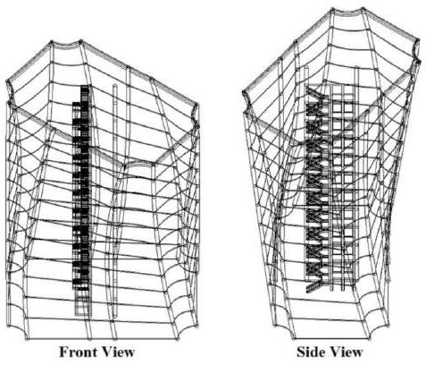

Fig 1.2

HISTORY OF WORK (LITERATURE REVIEW):- Table 1.3

RESEARCH PAPER NAME | ABSTRACT | RESEARCH OUTCOMES
1. DYNAMIC | Since ancient times, the | An analytical study of
BUILDING AND ITS | buildings evaluation | Dynamic architecture is
IMPACT ON | depended on durability | capable of achieving
SUSTAINABLE | confront different factors | sustainability and
DEVELOPMENT BY | and conditions for the | providing architectural
Alaa Mohamed | longest possible period, | environments that are
Elkhateeb & Alaa Adel | regardless of their ability | adaptable to different
Mansour | to adapt to the changes | variables. The research
 | occurring as well as | presents the various
 | meeting the diverse | definitions of
 | needs, the research aims | sustainability and
 | to provide non- | dynamic architecture. It
 | traditional solutions to | also explains the
 | meet the different | elements of sustainability
 | requirements and | and how to apply on the
 | problems that may face | dynamic buildings

 | the architects. | whether static or partially or fully- dynamic.
2. DYNAMIC | In this paper, for the | The multi-storey
ANALYSIS OF MULTI | dynamic analysis, a plan | building is R.C.C.
STOREY BUILDING | of a multi-storey | structure with 3
BY Udaya Bala K, | building is taken and it | basements + ground
Manish Kumar Gupta | has been modelled with | floor + 14 upper floors in
and Senthil Pandian M | different structural | zone IV with a maximum
 | elements for minimum | earth fill of 750 mm on
 | story displacement. The | the ground floor for
 | dynamic analysis of | landscape requirements.
 | multi-storey buildings is | By comparing the results
 | done using Etabs 2015 | of dynamic analysis, the
 | by IS and SP codal | performance of the
 | provisions (ETABS | structural system can be
 | User’s Manual, 2015). | evaluated.
3. Dynamic building for | An applied study was | The design process of the
evaluating the level of | conducted for the | architect when designing
the dynamic building | dynamic buildings on | sustainable dynamic
integration | two models of global | buildings.1. Dynamic
 | buildings to reach 39 | building ability to deal
 | design criteria were | with the climatic
 | identified as a guide to | conditions of the
 | evaluate the level of | building through the
 | dynamic building | day.2. Dynamic building
 | integration. | capacity to cope with
 |  | climatic conditions
 |  | during the four
 |  | seasons.3. The capacity
 |  | of the building to guide
 |  | the saving of light-ing

and natural ventilation.4.
The ability of the building to adapt to the use of wind places in the best way to achieve maximum utilization.

APPLICATION
It is the future application of any type of Projects which is very much helpful in case of dynamic impact of any structure.
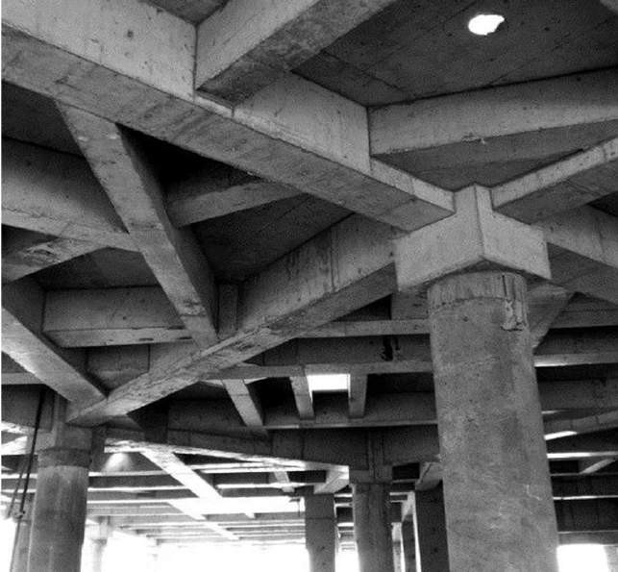
Fig 1.3


Fig 1.4
- The Irregularities of the Building Structures may be due to irregular distributions in their mass, Strength & Stiffness along the height of Buildings. When such Buildings are constructed in high Seismic Zones, the analysis & design becomes more complicated.
- There are two types of irregularities:-
- Plan Irregularities
- Vertical Irregularities
  - Plan irregularity makes structures vulnerable under seismic loading. Torsional irregularity, overturning moment can rise abruptly having irregularity in a structure. Structural irregularities are important factors which decrease the seismic performance of the structures.
  - Vertical Irregularities are one of the major reasons of failure of structures during earthquakes.
  - Stiffness Irregularity:- Under Stiffness Irregularity the stiffness of the members in a frame are not equal and they vary according to the floor height, modulus of elasticity of concrete and moment of inertia of that member.


Fig 1.5
- Type 2 :-Mass irregularity:- Mass irregularity shall be considered to exist where the seismic weight of any storey is more than 200 percent of that of its adjacent storeys. In case of roof irregularity need not be considered.
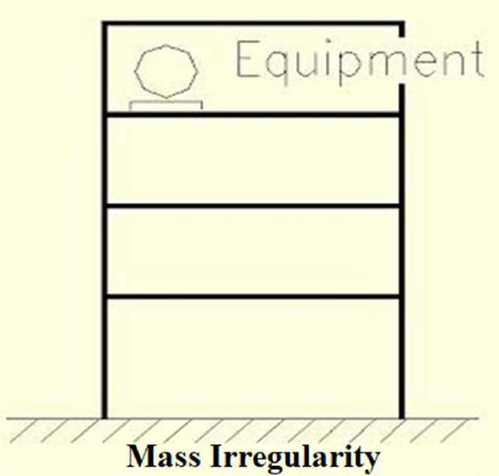
Fig. 1.6

- Type 3:- Vertical Geometric Irregularity:- A structure is considered to be vertical geometric irregular when the horizontal dimension of the lateral force resisting system in any storey is more than 200% of that in its adjacent storey. In case of roofs irregularity need not be considered.

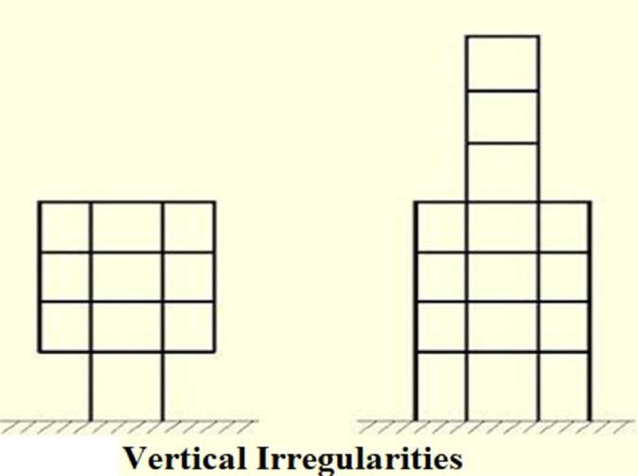

2.1 Classification of Irregularity
Fig. 1.7

The irregularity in the building structures may be due to irregular distributions in their mass, strength and stiffness along the height of the building. When such buildings are constructed in high seismic zones, the analysis and design become more complicated. There are two types of irregularities;
- Plan Irregularity
- Vertical Irregularity

Plan Irregularities:
Asymmetric or plan irregular structures are those in which seismic response is not only translational but also tensional, and is a result of stiffness and/or mass eccentricity in the structure. Asymmetry may in fact exist in a nominally symmetric structure because of uncertainty in the evaluation of center of mass and stiffness, inaccuracy in the Measurement of the dimensions of structural elements.

Torsion Irregularity: To be considered when floor diaphragms are rigid in their own plan in relation to the vertical structural elements that resist the lateral forces. Tensional irregularity to be considered to exist when the maximum storey drift, computed with design eccentricity, at one end of the structures transverse to an axis is more than 1.2 times the average of the storey drifts at the two ends of the structure.

Re-entrant Corners: Plan configurations of a structure and its lateral force resisting system contain re-entrant corners, where both projections of the structure beyond the re- entrant corner are greater than 15 % of its plan dimension in the given direction.

Structural Modelling
  - Equivalent static analysis was performed on regular and various irregular buildings using STAAD.pro.
  - The storey shear forces were calculated for each floor and graph was plotted for each structure.
  - Three types of irregular buildings were considered, regular structure, stiffness irregular structure ( structure with ground storey as the soft storey) and two vertically geometric irregular building with different setbacks. All the structures of 4 storeys.
  - 1. Regular Structure
  - 2. Stiffness Irregular Structure(Soft Storey)
  - 3. Vertical Geometric Irregular Structure (Setback at 3rd floor)
  - 4. Vertical Geometric Irregular Structure(setback at 2nd & 3rd floor)

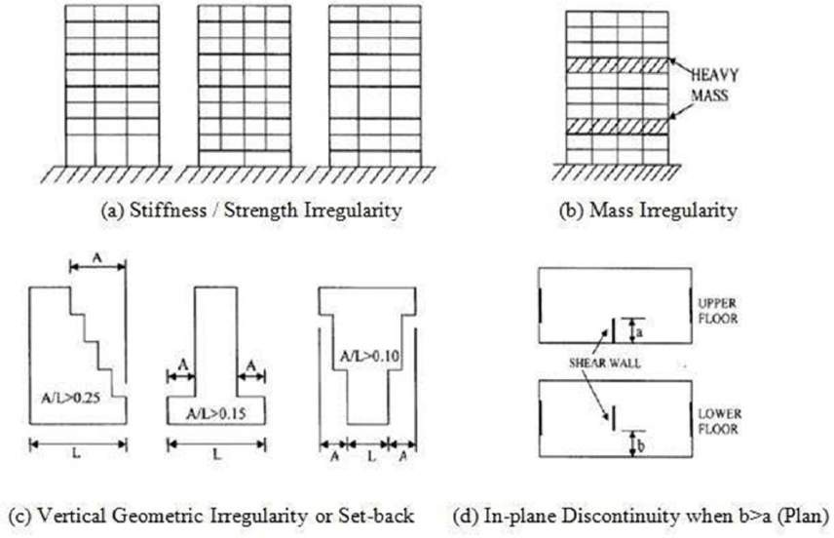
Fig. 1.8

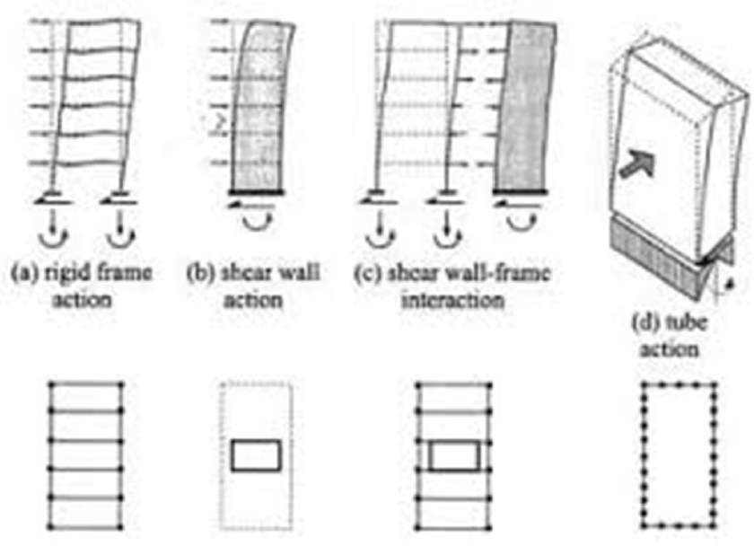

Fig 1.9

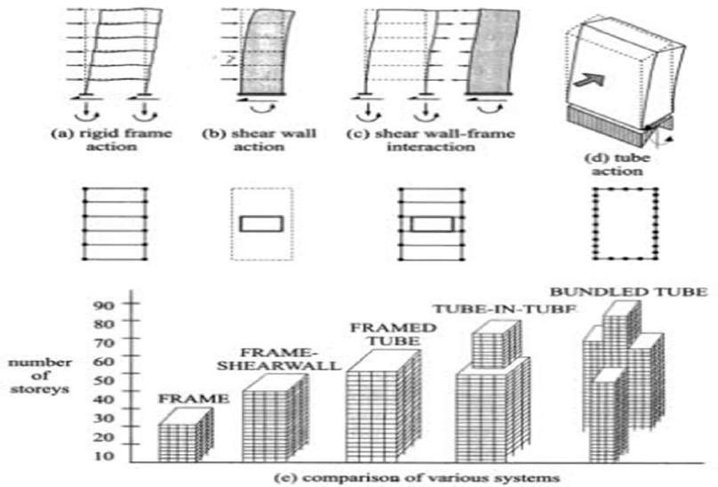
Fig. 1.10

Objectives
  - The goal of the project is to investigate various seismic responses of RC framed regular and vertical geometric irregular structure. The comparison between various seismic parameters would allow us to propose the best suitable building configuration on the existing condition.
  - To perform a comparative study of the various seismic parameters of different types of reinforced concrete moment resisting frames (MRF), configuration, and types of irregularity.
  - To compare the cost effectiveness of all the buildings accordingly.
  - Comparison between regular and vertical irregular frame on the basis of shear force, bending moment, storey drift & node displacement etc.
  - To study the change in different seismic response parameters along the increasing height and increasing bays.
  - To propose the best suitable building configuration on the existing condition.
  - The main objective of this project is to analyse and design the plan irregular multi-storey building using STAAD.Pro software
  - The above software can also be used for modelling of asymmetrical building.
  - To design & analyze the building structure with the help of STAAD.Pro
  - To find out the cost effectiveness & cost comparison among the overall Estimation of the building structures.

METHODOLOGY
  - The steps undertaken in the present study to accomplish the above –mentioned objectives are as follows:-
  - 1) selected an exhaustive set of regular, stiffness irregular and setback building frame models with different heights. Assuming equal bay width of 4m in both horizontal direction and different irregularities.
  - 2) Performing static analysis for each of the 3 building models.
  - 3) Analysing and comparison of the result of cost effectiveness.
  - 4) Presentation of results in the form of graphs and tables.
  - 5) Detailed discussion on the results with the help of graphs and tables considering all the included parameters.

STAAD Pro Structural Modelling
  - Equivalent static analysis was performed on regular and various irregular buildings using STAAD.pro.
  - The storey shear forces were calculated for each floor and graph was plotted for each structure.
  - Three types of irregular buildings were considered, regular structure, stiffness irregular structure ( structure with ground storey as the soft storey) and two vertically geometric irregular building with different setbacks.
  - Regular Structure
  - Stiffness Irregular Structure(Soft Storey)
  - Vertical Geometric Irregular Structure (Setback at 3rd floor)
  - Vertical Geometric Irregular Structure(setback at 2nd & 3rd floor)

CHAPTER – III IMPORTANCE OF THE STUDY
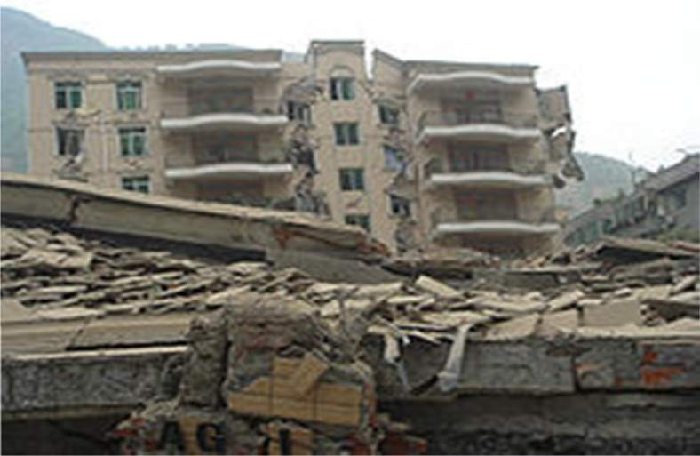
Fig. No. 1.11 Improper load distribution leads to failure of irregular buildings.

Building Structure 1
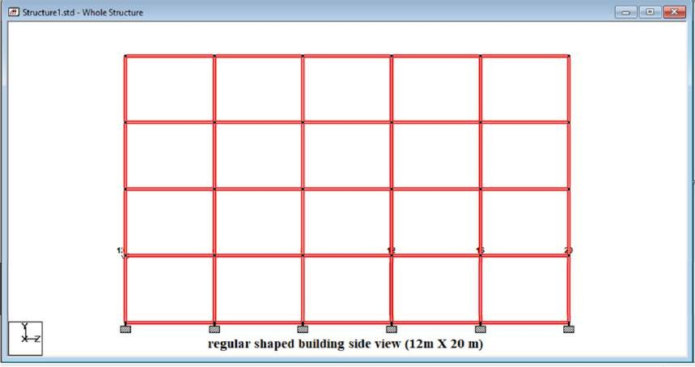
Fig No. 1.12 Building Structure 1 COLUMN GROUPING

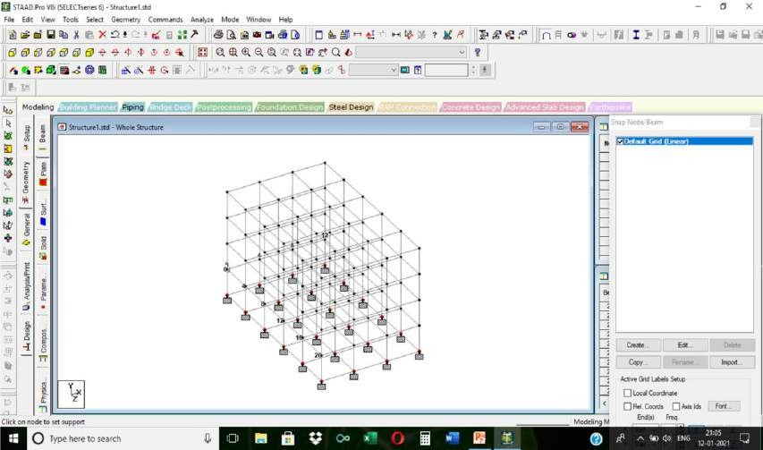

Fig. No. 1.13 STAAD. Pro COLUMN GROUPING (Building 1)

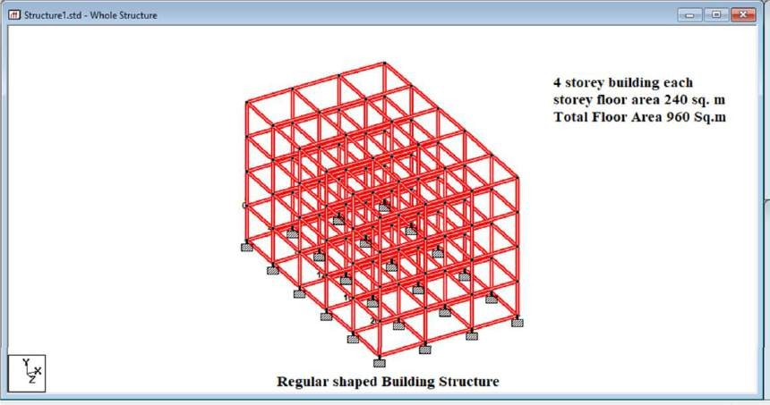
Column Grouping in STAAD.Pro

Fig No. 1.14 (Column Grouping in STAAD.Pro) Building 1 Building Structure 2

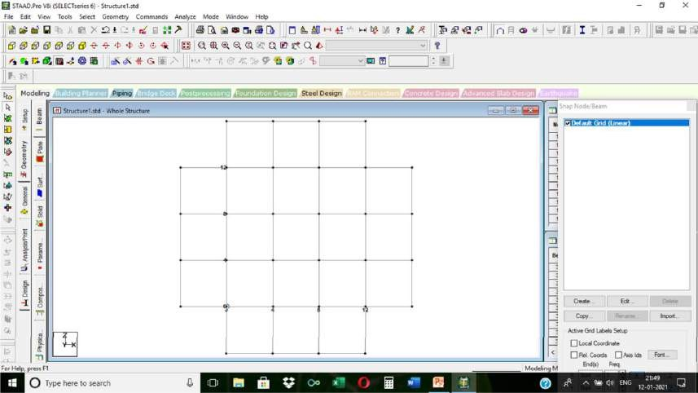

Fig No. 1.15 (2nd Building Structure)

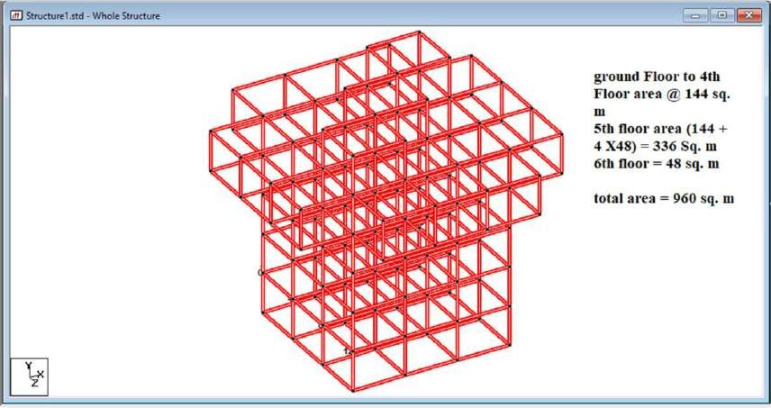
Fig. No. 1.16 (Column Grouping in STAAD.Pro)

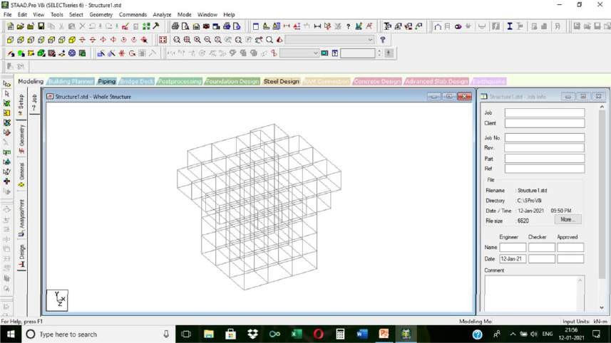

Fig. No. 1.17 Column Grouping in STAAD.Pro
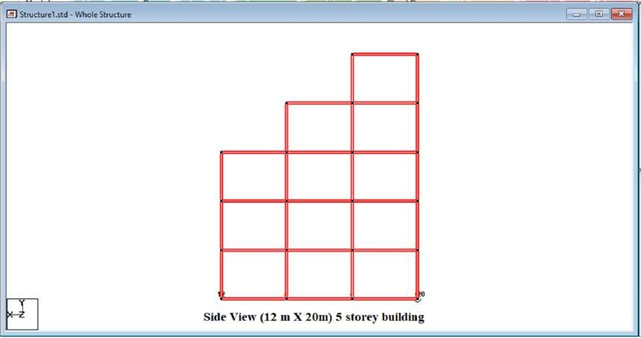
Fig. No. 1.18 (3rd Building Structure)

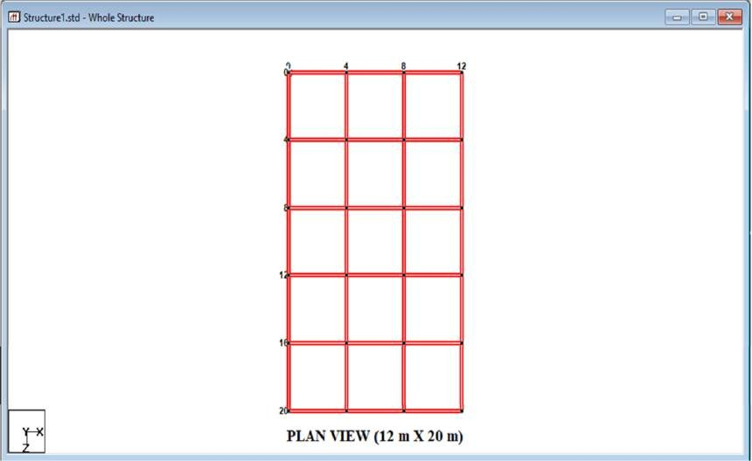

Fig. No. 1.19 (3rd Building Structure)

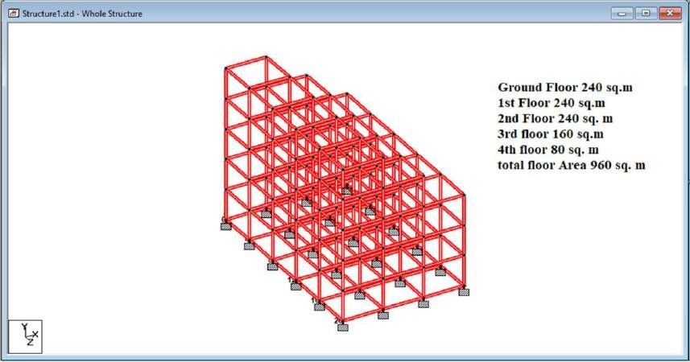
Fig. No. 1.20 (Column Grouping in STAAD.Pro)

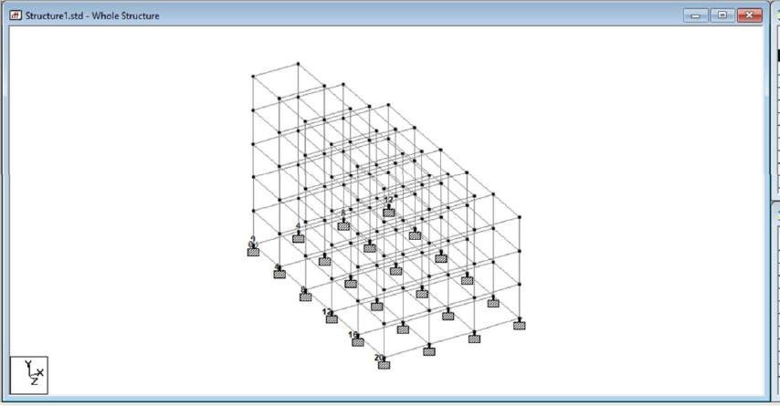

Fig. No. 1.21 Column Grouping for 3rd Building FUTURE SCOPE OF THE PROJECT
  - The project can be helpful in designing structures that are capable of resisting damages and failure during earthquakes.
  - In future ductile detailing and seismic joints can be done to these structures with reference to IS13920 – 2016 and IS 1893-2016 and hence create structures resistant to earthquakes

CHAPTER IV
BASIC ASPECTS OF SEISMIC DESIGN

The mass of the building being designed controls seismic design in addition to the building stiffness, because earthquake induces inertia forces that are proportional to the building mass. Designing buildings to behave elastically during earthquakes without damage may render the project economically unviable. As a consequence, it may be necessary for the structure to undergo damage and thereby dissipate the energy input to it during the earthquake. Therefore, the traditional earthquake-resistant design philosophy requires that normal buildings should be able to resist.
- Minor (and frequent) shaking with no damage to structural and non-structural elements;
- Moderate shaking with minor damage to structural elements, and some damage to non-structural
elements; and
- Severe (and infrequent) shaking with damage to structural elements, but with NO collapse (to save life and property inside/adjoining the building).
Therefore, buildings are designed only for a fraction (~8-14%) of the force that they would experience, if they were designed to remain elastic during the expected strong ground shaking, and thereby permitting damage. But, sufficient initial stiffness is required to be ensured to avoid structural damage under minor shaking. Thus, seismic design balances reduced cost and acceptable damage, to make the project viable. This careful balance is arrived based on extensive research and detailed post-earthquake damage assessment studies. A wealth of this information is translated into precise seismic design provisions. In contrast, structural damage is not acceptable under design wind forces. For this reason, design against earthquake effects is called as earthquake- resistant design and not earthquake-proof design.

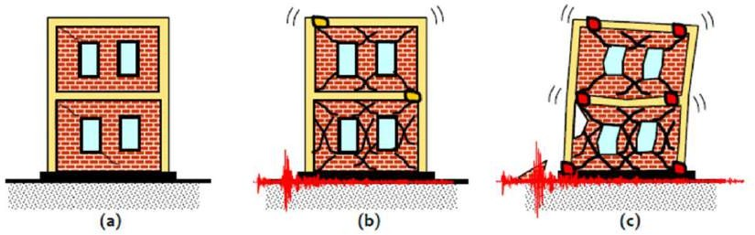

Earthquake-Resistant Design Philosophy for buildings: (a) Minor (Frequent) Shaking –
No/Hardly any damage, (b) Moderate Shaking – Minor structural damage, and some
non-structural damage, and (c) Severe (Infrequent) Shaking – Structural damage, but NO collapse

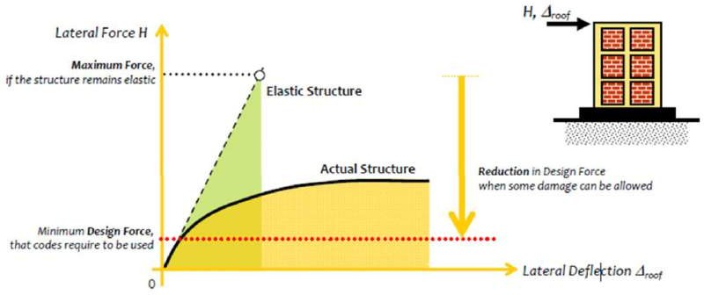

Basic strategy of earthquake design: Calculate maximum elastic forces and reduce by a factor to obtain design forces.

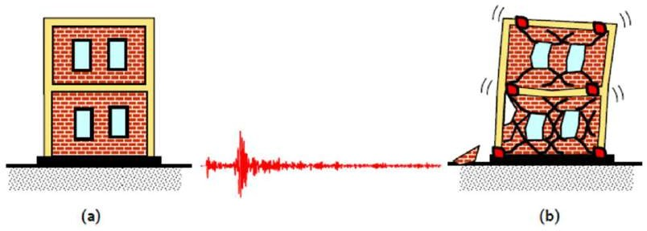
Earthquake-Resistant and NOT Earthquake-Proof: Damage is expected during an earthquake in normal constructions (a) undamaged building, and (b) damaged building.

MASS
Inertia forces are generated in buildings during earthquake shaking at locations where masses are present. For uniform distribution of forces in structural members, it is important to have inertia force mobilized uniformly in the building. For this, there should be uniform distribution of mass, both in plan and along the height of the building.

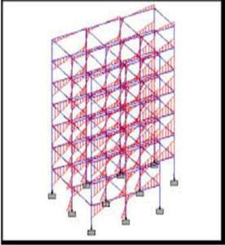

Mass Asymmetry in Plan

It is a common practice to have water tanks at roof top. But usually, water tanks with large mass of water are placed at corners of buildings. This affects the distribution of mass in plan, at least at the roof level. This asymmetry in mass in plan causes twisting of buildings during earthquake shaking due to mismatch of center of mass and center of rigidity (Figure A).
Consider the benchmark building with an idealized heavy mass (8 ton) at one corner of the building as shown in Figure B. The first three modes of oscillation of the building changes to translation in Y direction with twisting component, translation in X direction with twisting component, and pure torsion (Figure C).

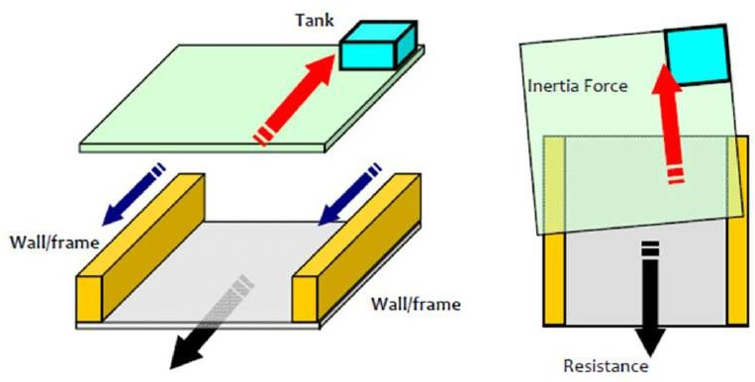

FIGURE A. Asymmetry of mass in plan: Buildings twist during earthquake shaking due to mismatch in line of action of inertia force and resistance offered by structural members.

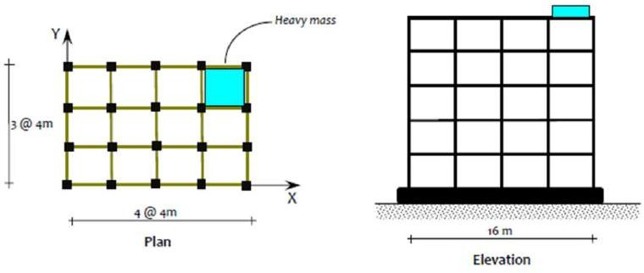
FIGURE B. Asymmetry of mass in plan: Concentrated mass at one corner of building

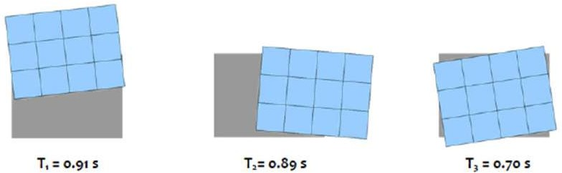
FIGURE C. Mass asymmetry in plan: Twisting dominates the first three modes of oscillation

Mass Irregularity in Elevation

Multi-storeyed tall buildings often have service floors with heavy mass compared to regular floors (Figure D). This causes sudden change or asymmetry in mass along the elevation of buildings. With increase in mass in one storey, there is increase in inertia force generated in that storey. If the percentage difference is small of change in mass in comparison to the total mass of the building, the effect of the mass irregularity is small on the mode shape in regular buildings. The difference becomes pronounced if the difference is large; the difference in response is explicit during nonlinear response of such buildings under strong earthquake shaking.

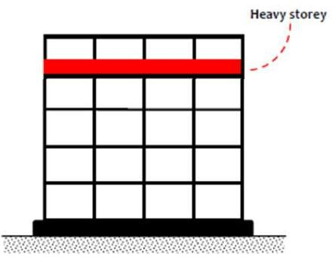
FIGURE D. Mass irregularity in elevation: Sudden change in mass should be avoided

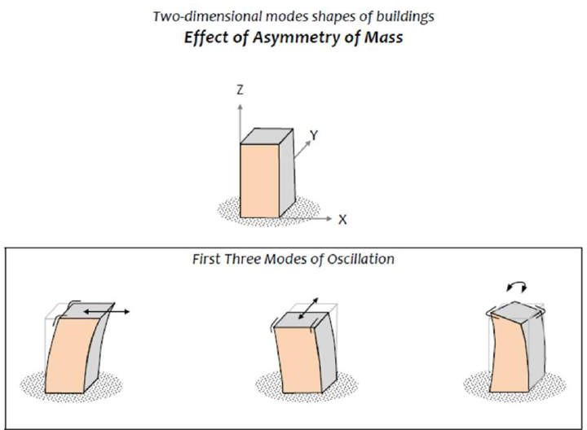

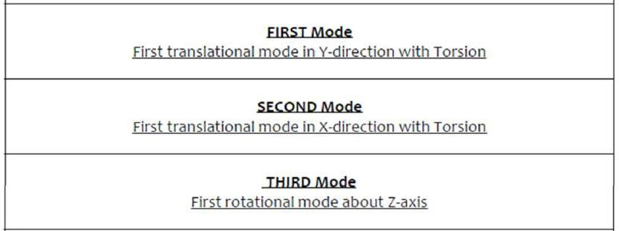

INITIAL STIFFNESS
Initial lateral stiffness plays an important role in overall response of buildings. The amount of lateral load resisted by individual members in buildings is controlled by their lateral stiffness – stiffer elements attract more force than flexible ones. In addition, adequate overall stiffness is essential in a building to control overall lateral displacement during earthquake shaking. Thus, it is important to have uniform distribution of stiffness in a building to ensure uniform distribution of lateral deformation and lateral forces over the plan and elevation of a building.
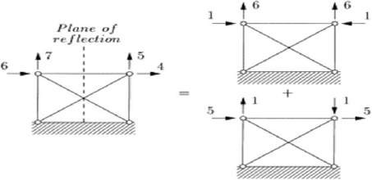

Stiffness Irregularity in Plan
Irregularity in stiffness in plan occurs due to (a) use of columns of different sizes, (b) presence of structural wall on one side of buildings, or (c) presence of staircase or elevator core at one corner of buildings (Figure E). Stiffness irregularity in plan causes twisting of buildings under lateral load (Figure F). The significant modes of oscillation and the corresponding periods are shown in Figure G of the three buildings.

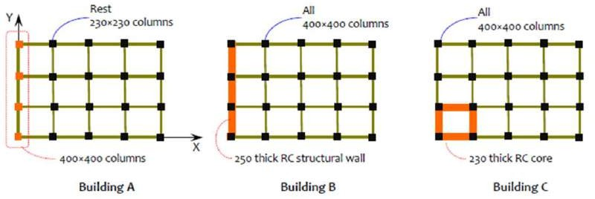

FIGURE E. Stiffness irregularity in plan: Unequal stiffness of elements and their distribution in plan cause overall stiffness irregularity

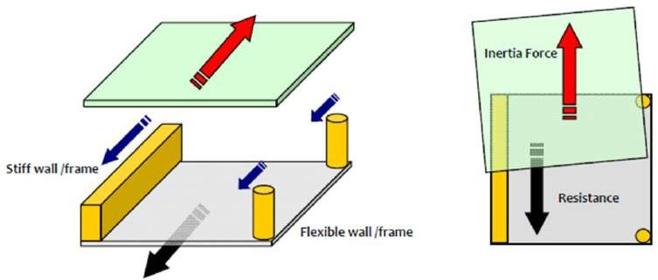

FIGURE F. Stiffness irregularity in plan: Buildings twist during earthquake shaking due to mismatch in line of action of inertia force and resistance offered by structural members

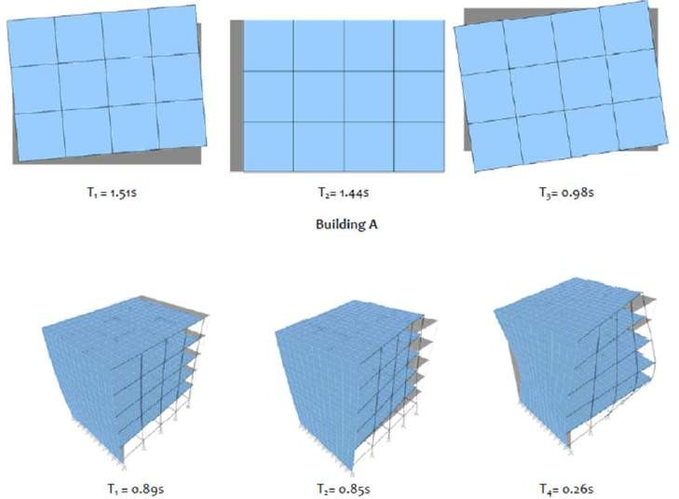

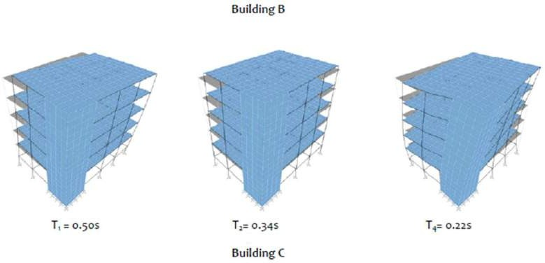
FIGURE G. Stiffness irregularity in plan: Unequal stiffness of elements and their distribution in plan cause overall stiffness irregularity

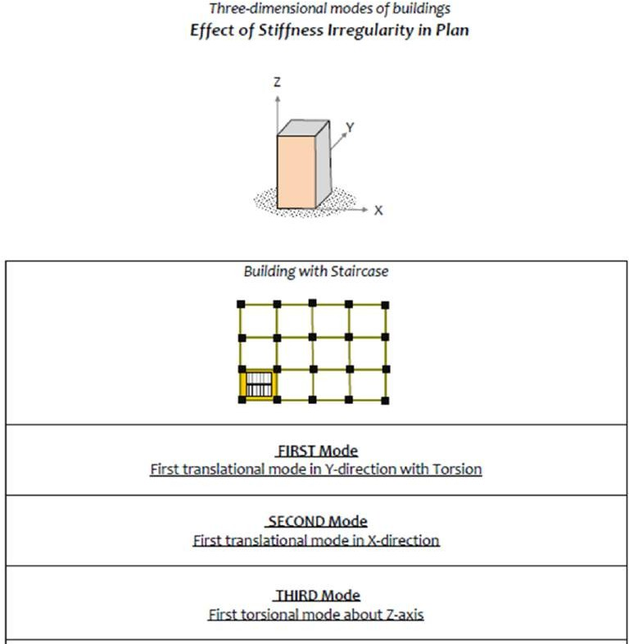

Stiffness Irregularity in Elevation

Irregularity in stiffness along the height of buildings arises from both architectural and structural choices. Often, the former is a more formidable choice to ensure safety, since it is driven by considerations other than safety. On the other hand, the latter is more a subtle choice made by structural designers, sometime inadvertently. In both cases, the consequence is severe. This section explains some of these choices.

  - Open or Flexible Storey in Buildings

Lateral stiffness irregularity occurs in elevation when (a) sizes of lateral load resisting elements are varied along the height of buildings, and (b) additional elements are added or existing elements are removed (Figure H). In building C (in Figure H), the column sizes are reduced to 230mm×230mm from 400mm×400mm, while buildings A and B have additional masonry infill except at one storey. Buildings A and B represent moment frames with masonry (brick) infill walls. Masonry has good strength in compression.
Thus, under lateral loads, the load transfer takes place through compressive strut action in the infilled masonry portion – this action is somewhat similar to that seen when diagonal compression braces are present in frames (Figure H). Hence, modelling of unreinforced masonry in filled frame buildings for structural analysis should include masonry in fills as diagonal compression-only strut members. Stiffness irregularity in elevation causes unwarranted change in demands on the structural elements (Figure I). Also, reduction of lateral stiffness causes increase in displacement demand in storeys with less stiffness, called soft storey (Figure J).

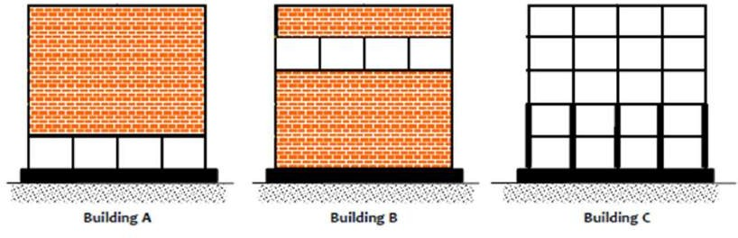
FIGURE H:- Stiffness irregularity in elevation: Variation of element size and presence of additional or absence of elements in elevation cause overall stiffness irregularity

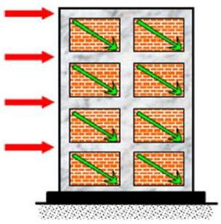
FIGURE I:- Masonry infilled frame: Infill helps transfer lateral loads through diagonal strut action and reduces demand on columns

Stiffness irregularity owing to the presence of unreinforced masonry infills can be captured at the design stage itself by modelling the infill using compression-only struts, with properties of the strut guided by literature (e.g., IITK-GSDMA, 2005). When the stiffness irregularity is noticed in the structural analysis of the building subjected to equivalent static lateral loads, designers may choose one of following options, namely
- Designing all members of the frame according to the irregular forces,
- Strengthening the columns and beams in the vicinity of the irregularity for higher forces than those received from structural analysis, and
- Reducing the stiffness irregularity by adding a new stiff lateral load resisting system in the building, whose lateral stiffness is much larger than that of the original system of the building that has irregularity, e.g., RC structural wall in a RC moment frame building with unreinforced masonry infills.
But, the first two choices are not rational. The poor performance of the structure due to stiffness irregularity cannot be avoided either by designing the members in that storey or even with strengthening the columns and beams at the location of irregularity. Hence, the only option available is to ensure that the stiffness irregularity is mitigated by improving the stiffness of the whole building with a new system.

Calculation Load

General Data

Structure = G + 5
Floor height (First Floor to Fifth Floor) = 4.0m Grade of concrete (for all structural elements) = M25 Unit weight of concrete = 25kN/m3
Unit weight of cement mortar = 24kN/m3 Unit weight of water = 10kN/m3
Unit weight of Brick = 20kN
A slab load of 3.75 KN/m2 is considered for analysis. The wall load is taken as 20 KN/m. A floor finish load of 1.5 kN/m2 is applied on all beams of the RC building as per IS 875 (part1) [8]. A live load of 4 KN/m2 is provided as per IS 875 (part2) [9]. Table
4.1 shows the gravity loads taken for the building.

Gravity Load
Load values for building
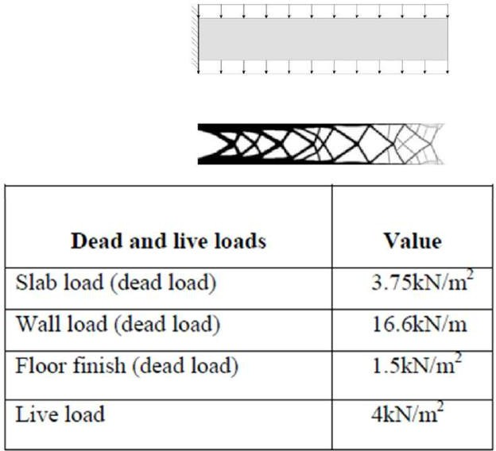

The structure is analyzed and designed for live load, seismic load as per IS-1893-2016 and dead load consisting of self-weight of beams, columns and slabs. The following figures show the different loads acting on the building.
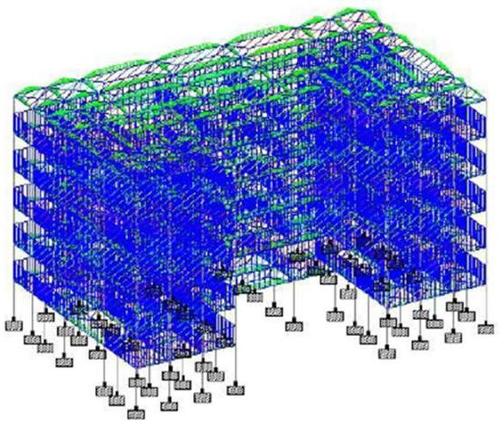

Floor load of the structure

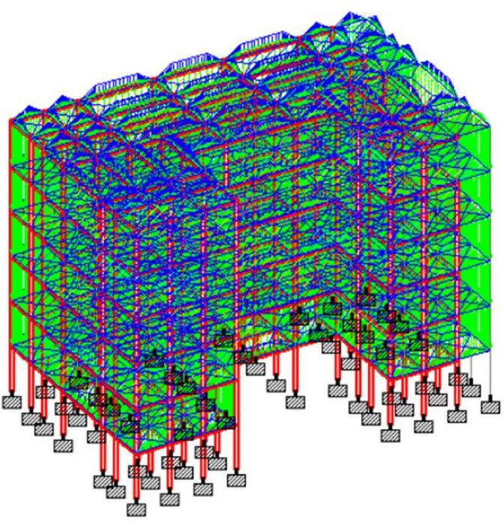

Floor load of the structure

Reinforced Structural design

Having decided on a plan of the building and having obtained the beam and column dimensions and decided on the loads as per the relevant IS codes, the next steps in the project are the analysis and determining of the maximum moments, thrust and shears in beams, design of section and reinforcement arrangements for slab, beam, columns and walls and detail drawings and bar schedules.

Designing of beam

A reinforced concrete beam is designed to resist tensile, compressive and shear stresses caused by the loads on the beam. The beam is analysed first in order to calculate bending Moment and shear force. The breadth of the beam is taken considering the thickness of the wall and the width of the column so that effective transfer of the load from beam to column is achieved. The depth of the beam is from one-tenth to one-sixth of the length of the beam. In the present design, all beams are of rectangular shape, with breadth and depth of the beam as 300mm and 600mm respectively and total number of beams is 370.

A column is a member carrying direct axial load which causes compressive stresses. All columns are designed separately. The columns are subjected to bending moment and axial loads. The column section is designed just below the beam column joint and just above the beam column joint and larger of the two reinforcements is adopted. The design moment is obtained from IS456:2000 code.

During an earthquake, ground motions are developed both horizontally and vertically in all directions and radiating from the epicentre. Due to these ground motions, the structure vibrates inducing inertial forces on them. Hence structures located in seismic zones are designed and detailed to ensure strength, serviceability and stability with acceptable levels of safety under seismic forces.
Many structures are now being suitably designed to withstand earthquakes. This can be seen from the satisfactory performance of a large number of reinforced concrete structures subject to severe earthquake in various parts of the world.
The Indian standard codes IS: 1893-2016 and IS: 13920-2016 have specified the minimum design requirements of earthquake resistant design, probability of occurrence of earthquakes, the characteristics of the structure and the foundation and the acceptable magnitude of damage.
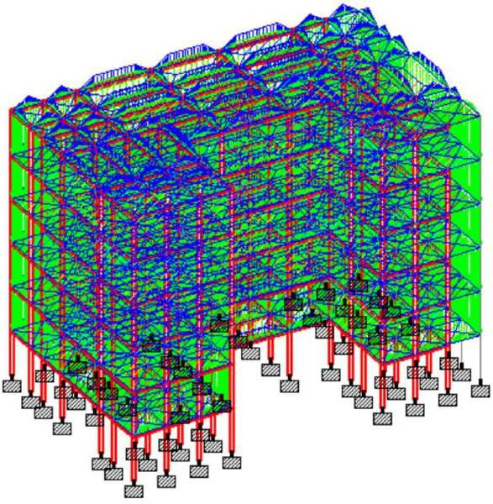
Floor load of the structure

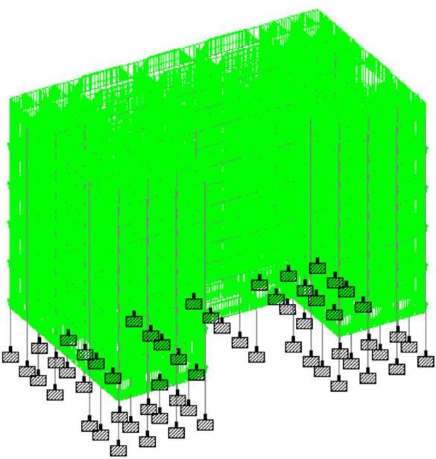
Combination load of the structure
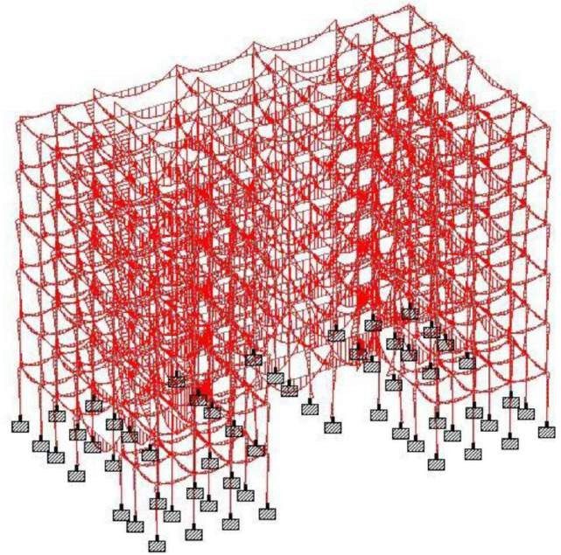
Bending moment diagram of the building

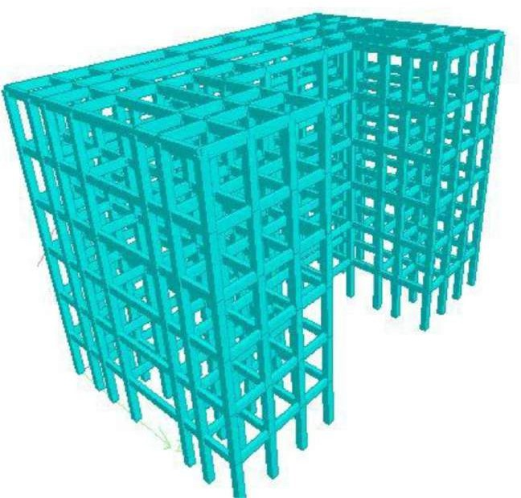

Material Properties
3D form of the building

Table 4.2 shows the assumed properties of concrete and steel bar taken as per IS 456.
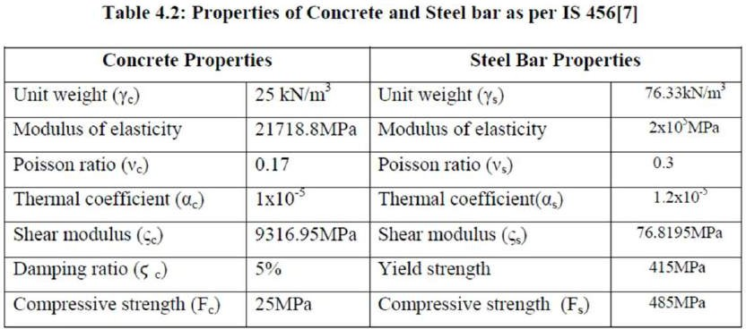

Structural Elements

The six story irregular reinforced concrete building was analysed for gravity loads in STAAD Pro. For the comparative study, beam and column dimensions are assumed 300mm x 600mm and 500mm x 500mm. Height of the story is 4m and beam length in longitudinal direction is taken 3m, 6.75m, and 6.25m and in transverse direction is taken 3m, 2m, and 6.25m.These dimensions and cross sections are summarized in Table 4.3.

Table 4.3: Beam and column length and cross section dimension.

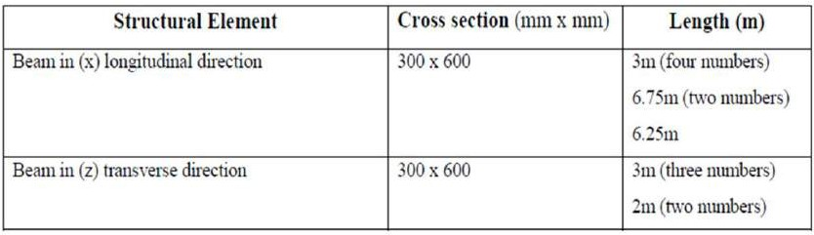

CHAPTER V REINFORCEMENT STRUCTURAL DESIGN

Reinforced Structural design
Having decided on a plan of the building and having obtained the beam and column dimensions and decided on the loads as per the relevant IS codes, the next steps in the project are the analysis and determining of the maximum moments, thrust and shears in beams, design of section and reinforcement arrangements for slab, beam, columns and walls and detail drawings and bar schedules.

Designing of beam
A reinforced concrete beam is designed to resist tensile, compressive and shear stresses caused by the loads on the beam. The beam is analysed first in order to calculate bending Moment and shear force. The breadth of the beam is taken considering the thickness of the wall and the width of the column so that effective transfer of the load from beam to column is achieved. The depth of the beam is from one-tenth to one-sixth of the length of the beam. In the present design, all beams are of rectangular shape, with breadth and depth of the beam as 300mm and 600mm respectively and total number of beams is 370.

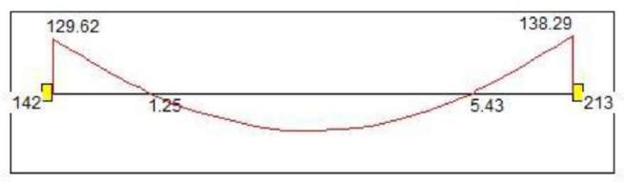

Bending moment diagram of beam No.12
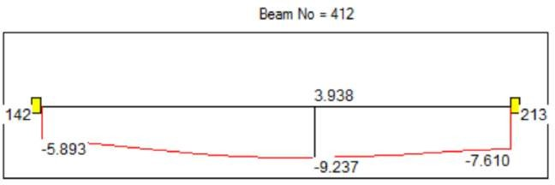
Deflection diagram of beam No.12

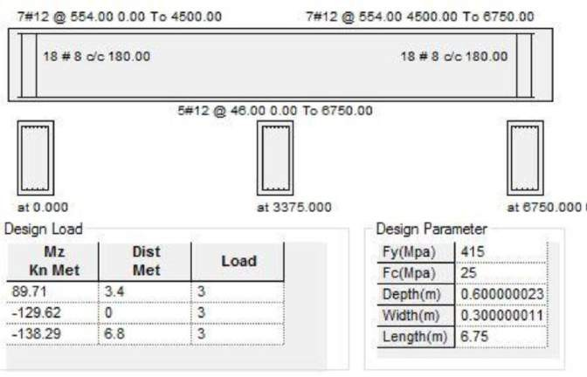
Reinforcement details for beam No.12 in STAAD Pro. using design code IS- 456:2000

Figure 5.1 Bending moment, Deflection diagram and concrete design by details

Designing of Columns

A column is a member carrying direct axial load which causes compressive stresses. All columns are designed separately. The columns are subjected to bending moment and axial loads. The column section is designed just below the beam column joint and just above the beam column joint and larger of the two reinforcements is adopted. The numbers of columns are 606. The design moment is obtained from IS456:2000 code.
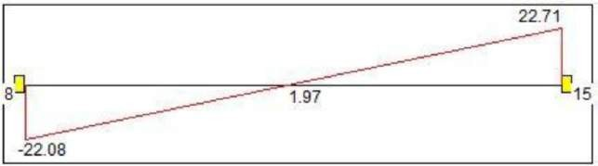

Bending moment diagram of column No. 14
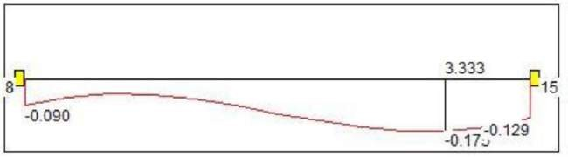
Deflection diagram of column No. 14

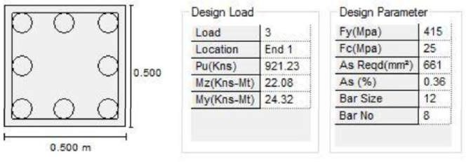
Column deflection, shear force and concrete design by details

Footing design

Footing ID=F1 Pu = 210 kN
Column size a1 = 0.5m,b1 = 0.5m, fck = 25 N/mm² ,Fe = 415 N/mm2 ,

SBC = 180 kN/m²
Soil bearing capacity

Load footing P = (Pu + 0.1 Pu) P = 231 kN Adding 10% extra load for self- weight of footing.
Area of footing a = P/SBC, a = 1.283m² Length = length = 1.133m, breath = 1.133m

Let provide Len = Round (length, 0.1) Len = 1.1 Len = len+0.05 Len = 1.15m And Wid = Round (length, 0.1) Wid = 1.1 Width = Wid+0.05 Width = 1.15m

Net upward pressure Po = Pu/Len width Po = 158.79 kN/m2 Moment calculation:
Mu = Po x Width (Len-a1)2/8 Mu = 9.644 kNm d = 50.071mm
Let provide overall depth D = 350mm Deff = (D-cc—12) deff = 298mm
Area of Steel
Ast = 0.5fck x width x 1000 x deff/fe [1-d] Ast = 90.072mm2
But minimum Ast, Astmin = 0.0012 x width x 103 x D Astmin = 483mm2 If (Ast>Ast,Astmin,Ast) = 483mm2
Using 10mm bar, No of Bar = Astmin/ (3.141 x 102/4) = 6.15
Bar = Round (No fo Bar, 1) Bar = 6 Bar = Bar + 1 Bar provide, Bar = 7 Spacing = width x 1000/Bar = 164.286mm Provide spacing = 160mm

Percentage of Steel:
Pt = 0.16
Check for one way shear:
SF = Po x Width [(Len-a1/2)-deff/1000] SF = 4.93 kN From table 19 IS 456:2000
Tuc = 0.29 N/mm2
Tuv = SF x 1000/ (Width x 1000 x deff) Tuv = 0.014 N/mm2

If (Tuc>Tuv,Tuv,Tuc) = 0.014 Hence safe. Check for two way shear:
Preimeter of punching shear
Peri = 2 x [(a1+deff/1000) + (b1+deff/1000)] Or peri = 3.192m
Area of punching shear
Area = (a1+ deff/1000) x (b1 + deff/1000) Area = 0.637 m2
Punching shear:
SP = Po x (width x Len- area) SP = 108.882 kN
Tuvp = (SP x 1000/ (peri x 1000 x deff) Tuvp = 0.114 N/mm2

Punching shear stress:
Bitac = a1/b1, Ks = 0.5 + Bitac Ks = 1.5 But Ks Shear b<=1 Kss = Floor (Ks) Tucp = (0.25 ) Tucp = 1.25 N/mm2 tucp = Tucp x Kss
tucp = 1.25 N/mm2 tucp>Tuvp hence (ok) Development length
Ld = (0.87 x fck x 10)/ (4 x 1.6 x 1.4) Tudb = 1.4 10mm bar Ld = 402.958mm
Length available, Lavail = 0.5 (width – b1) x 100-40 40mm clear cover Lavail = 285mm Hence (ok)

Load Transfer from Footing to column: Bearing Stress in the column
Sigma = sigma = 0.84 N/mm2 Allowable Bearing Stress = 0.45 x fck x
A1 = [b1 x 103 + 2 x (2 x deff)] 2 A1 = 2.863 x 106 A2 = a1 x 103 x b1 x 103 A2 = 2.5 x 105
= 3.384 But this max value is = 2.23

Isolated Footing
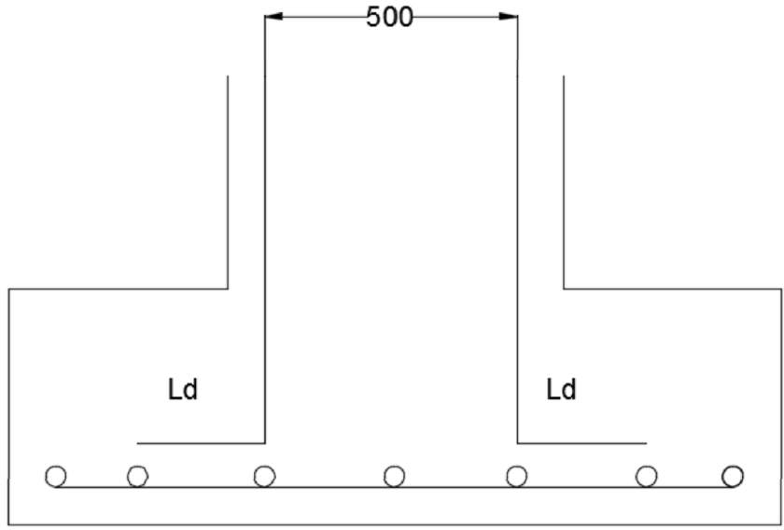

Figure 5.3 Elevation, plan of isolated footing and 3D form, all dims are in (mm)
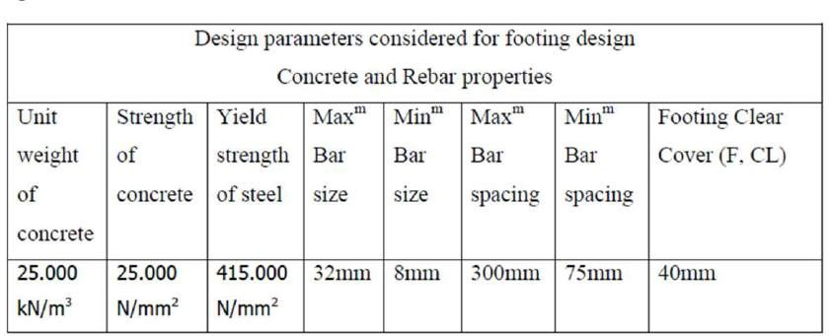

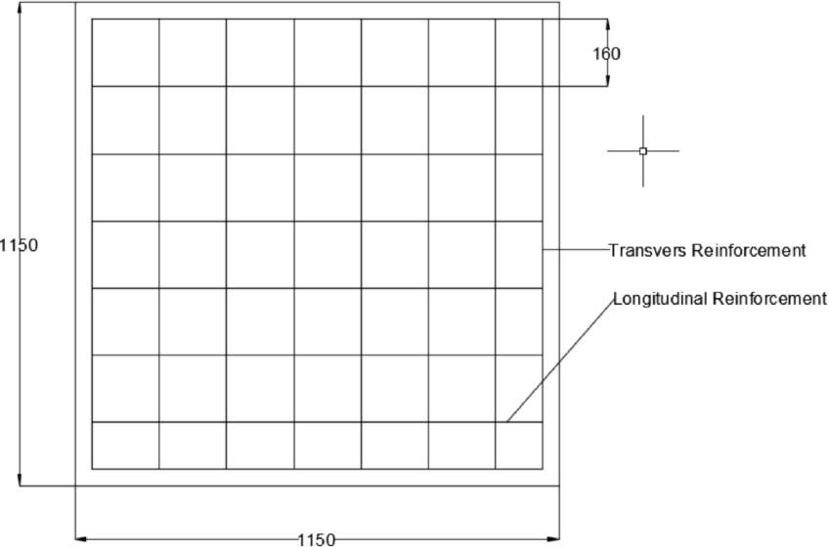

Table 5.1: Concrete and bar Properties It depends upon footing Geometry

Footing Geometry:
Footing thickness (Ft): 350mm Footing length-X (Fl): 1150mm Footing width-Z (Fw): 1150mm

Table 5.2: Soil Properties
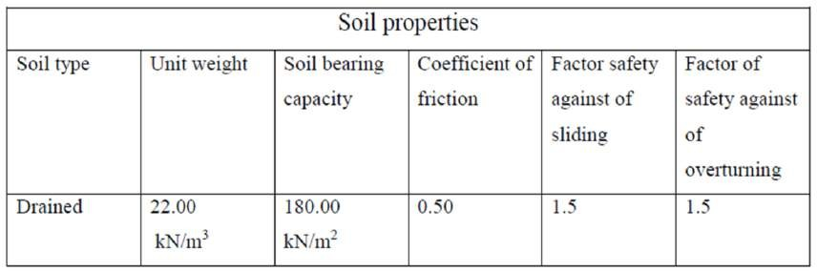

Table 5.3: Pressure at the four corners
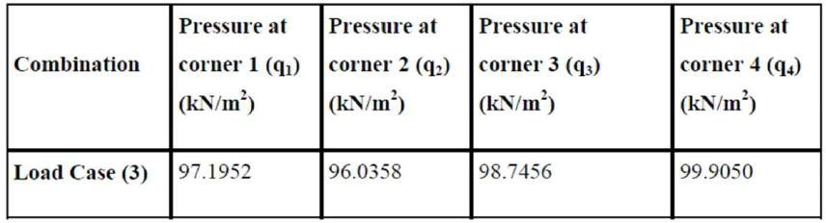
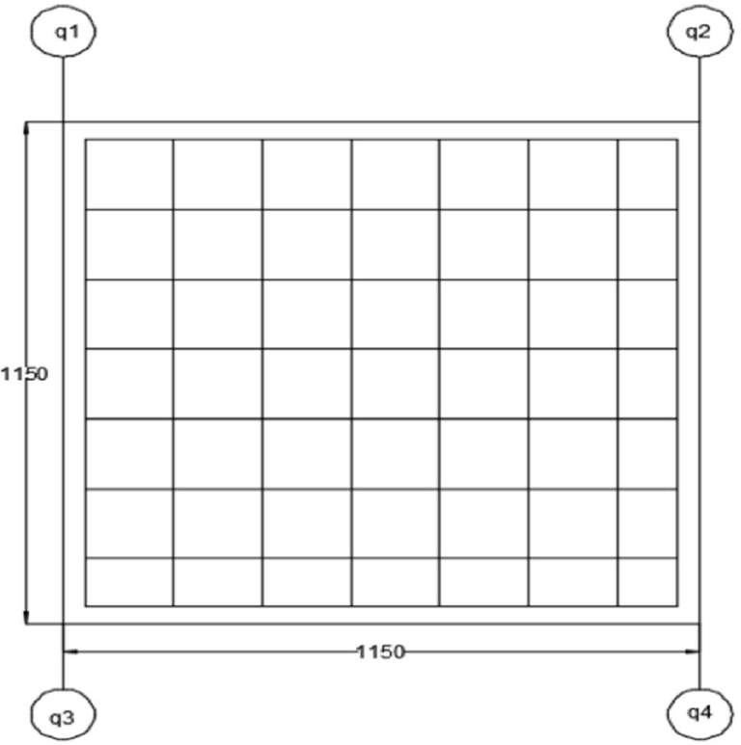

CHAPTER VI SEISMIC LOAD CALCULATION

SEISMIC LOAD CALCULATION

During an earthquake, ground motions are developed both horizontally and vertically in all directions and radiating from the epicentre. Due to these ground motions, the structure vibrates inducing inertial forces on them. Hence structures located in seismic zones are designed and detailed to ensure strength, serviceability and stability with acceptable levels of safety under seismic forces.
Many structures are now being suitably designed to withstand earthquakes. This can be seen from the satisfactory performance of a large number of reinforced concrete structures subject to severe earthquake in various parts of the world.
The Indian standard codes IS: 1893-2016 and IS: 13920-2016 have specified the minimum design requirements of earthquake resistant design, probability of occurrence of earthquakes, the characteristics of the structure and the foundation and the acceptable magnitude of damage.

Determination of design earthquake forces is computed by the following methods,
- Equivalent static lateral loading.
- Dynamic Analysis.

In the first method, different partial safety factors are applied to dead, live, wind and earthquake forces to arrive at the design ultimate load. In the IS: 456-2000 code, while considering earthquake effects, wind loads are also taken into account, assuming that both severe wind and earthquake do not act simultaneously. The American and Australian code recommendations are similar but with different partial safety factors. The dynamic analysis involves the rigorous analysis of the structural system by studying the dynamic response of the structure by considering the total response in terms of component modal responses.

ZONE FACTOR (Z):
The values of peak ground acceleration given in units ‘g’ for the maximum
considered earthquake.
The value of (Z/2) corresponds to design basis earthquake damage control in limit state.
Based on history of seismic activities, the entire country has been divided into four zones. The zone factor from table 2(IS 1893:2016)

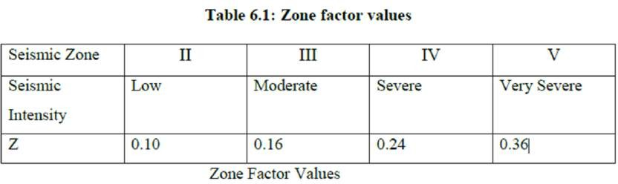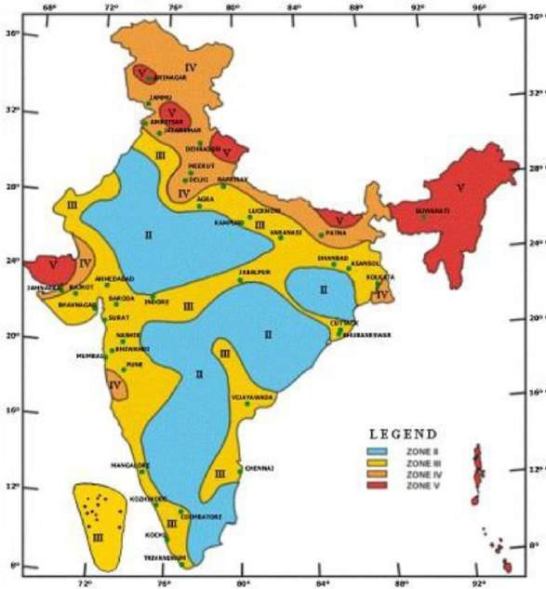

RESPONSE REDUCTION FACTOR (R):

R is the response reduction factor and controls the permitted damage in design basis earthquake.
The minimum value of R is 3 and maximum is 5, however to use higher values of R, special ductile detailing requirements are a must and the designer is accepting more damages but in the controlled manner. The Response reduction factor is obtained from table 7(IS 1893:2016).

IMPORTANCE FACTOR (I):

I is the importance factor and permitted damage could be reduced by setting the value of I more than ‘1’.

For the buildings like ‘Residential’, Constructed multi-storeyed buildings the value is 1 from table 6 (IS 1893:2016).

For the buildings like ‘Hospital’, communication and community buildings the value is 1.5 from table 6 (IS 1893:2016).

SEISMIC WEIGHT (W):

Seismic weight of the building is measured in Kilo Newton. Seismic weight includes the dead loads (that of floor, slabs, finishes, columns, beams)
Seismic weight includes only a part of Imposed loads, for example 25% to 50% of imposed loads for buildings from table 8 (IS 1893:2016).

SOIL CLASSIFICATION:

Sa/g is the lateral acceleration to be established in m/s2. For 5 % of damping three different types of curves are recommended in IS 1893:2016 for different stiffness of supporting media-Rock, Medium soil and Soft soil.

The classification of soil is based on the average shear velocity for 30m of rock or soil layers or based on average Standard Penetration Test (SPT) values for top 30m.
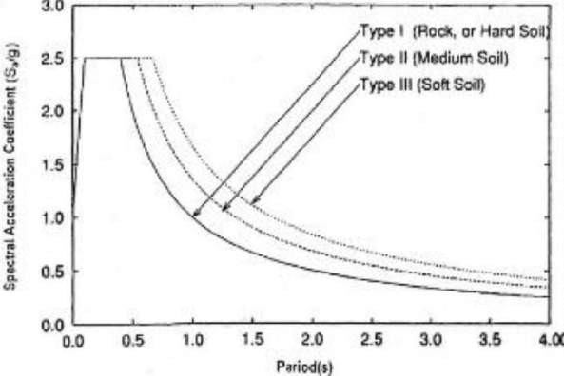
Figure 6.2: Classification of Soil Graph

Zone factor of the building (Z) = 0.16 (Zone III)
Importance of the building (I) = 1.5 (Post Earth quake service needed) Response reduction factor (R) = 5 (Ductile shear walls with SMRF) Average response acceleration coefficient (Sa/g) = 2.5

Soil type = Medium soil
Width of building in X-direction = 31.17m Width of building in Y-direction = 19.25m Height of the building = 24m
Seismic weight of the building = 75935.75 kN

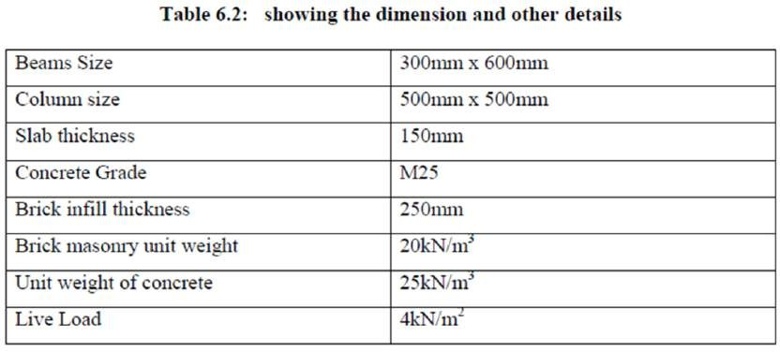

SEISMIC LOAD CALCULATION FOR 6 STORY BUILDING

1) Slab load = (31.75 x19.25-13.75 x 8.125) x 0.15 x 25 = 1873kN
2) Floor finish = (31.75 x 19.25 -13.75 x 8.125) x 1.5 = 749kN
3) Weight of all beams = {(4 x31.75+6 x9+1x13.75) +6 x19.25+2 x14.25)} x0.6x0.3x25
=1524.375kN
- Weight of Columns in floors = 64 x4 x0.5 x0.5x25 = 1600kN
- Weight of brick infill in floors = {(4 x31.75+6 x9+1x13.75) +6 x19.25+2 x14.25)}
x 4 x 0.25 x 20 =6775 kN
According to IS1893-2002 Table (8) if the live load is up to and including 3KN/m2, the percentage of live load is 25% and more than 3KN/m2, then 50% of it will be lumped on floors.
Live load in a typical floor = (31.75x19.25-13.75 x 8.125) x 4 x 0.5=999 kN The live load is taken zero at roof.

Seismic weight calculation of the structure, W=W1+W2+W3+W4+W5+W6
W1, W2, W3, W4 and W5 are the seismic weights respectively in each floor.

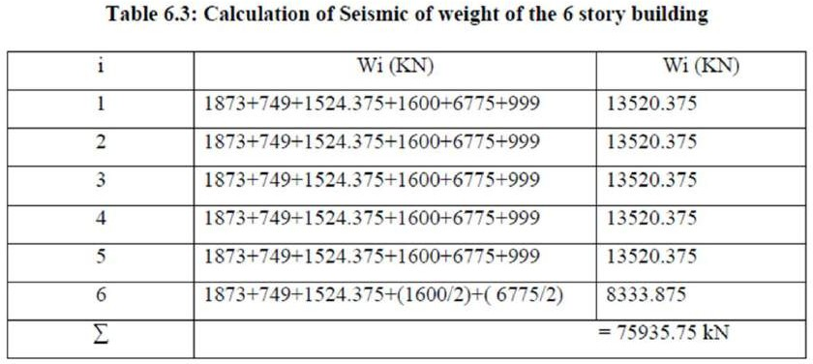

SEISMIC BASE SHEAR CALCULATION

The design of base shear is the sum of lateral forces applied at all levels that are finally transferred to the ground.
Vb = Ah x W
Ah = (ZI/2R) (Sa/ g)
The fundamental natural period for buildings are in IS 1893(part 1) 2002 Class 7.6.
Ta = 0.075h075 for moment resisting RC frame building without brick infill walls Ta = 0.085h0.75 for moment resisting steel frame building without brick infill walls Ta = 0.09h/√d for all other buildings including moment resisting RC frame building with brick infill walls.
Fundamental natural period for buildings with brick infill walls Ta = 0.09h/√d
Z = 0.16
I = 1.5
R = 5
Sa/g = 2.5
Ah = (ZI/2R) (Sa/ g) Vb = Ah x W
The fundamental periods on both x and z directions are respectively given below: Tx=0.383 Sec, Tz=0.492 Sec. From figure 2 of IS 1893, Sa/g is found to be 2.5 for both the periods, so the design horizontal seismic coefficient (Ah) will be same which will result in producing the same amount of base shear in both the directions.

Ah = (ZI/2R) (Sa/g) = (0.16x1.5/2x5) x (2.5) = 0.06 Vb = Ah x W = 0.06 x 75935.75 kN = 4556.145 kN
So the base shear for 6 story building is found to be equal to 4556.145 kN Now the base shear is laterally distributed as per IS-1893-2016.

Qi = ((Wihi2)/ (Σ Wihi2)) x Vb

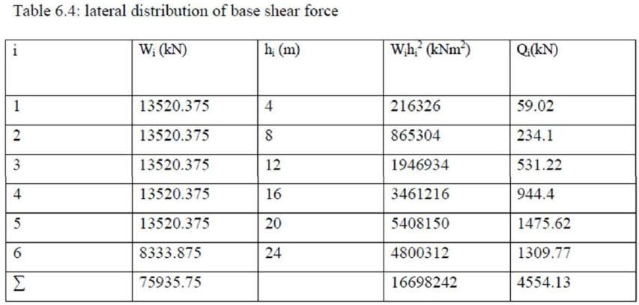
These lateral forces (Qi) are obtained and applied to the building laterally considering the center of mass and the response is obtained using equivalent static analysis.

ANALYSIS

Based on the external loads, structural materials and structural model, there are different types of analysis process such as linear static analysis, linear dynamic analysis, nonlinear static analysis and nonlinear dynamic analysis.
The analysis options are set before analysis. The analysis is performed with a scale factor
1. The number of modes is initially set as 1.5 after analysis. If the cumulative mass participation factor is less than 95 percentage, then it is modified accordingly with base shear values obtained for the earthquake load case, the new scale factor is calculated and again the model is analyzed for the new scale factor. It can be observed that the base shear value calculated from the code and by the software with the new scale factor are the same.
And the combination load is applied in Staad Pro by using formula which are given bellow.
1) 1.5(DL+IL)
2) 1.2(DL+IL+-EL)
3) 1.5(DL+ - EL)
4) 0.9DL+ - 1.5EL

Table 6.5: showing primary load cases and combination load case

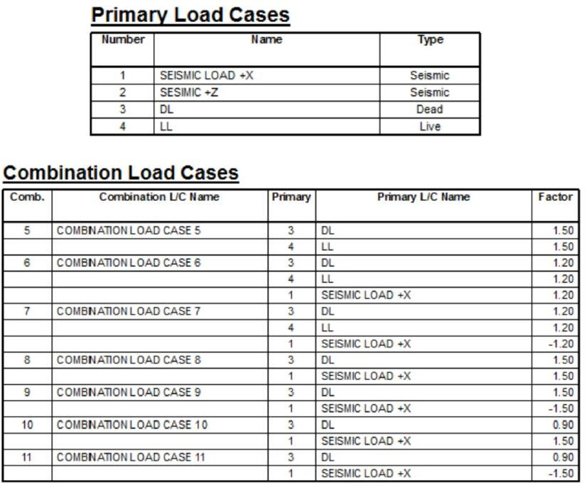

The result below is after analyzing by using Staad Pro.
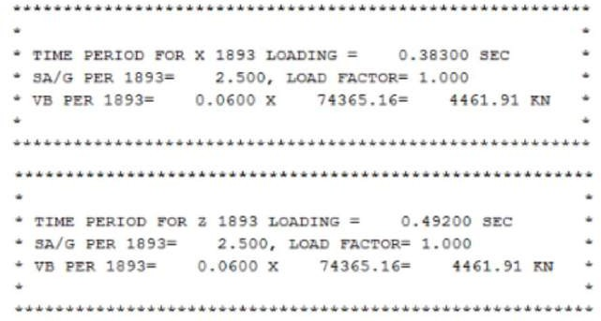
Manually the calculation of base shear = 4556.145 kN and software calculation = 4461.91kN

4461.91kN <4556.145 kN so it is safe

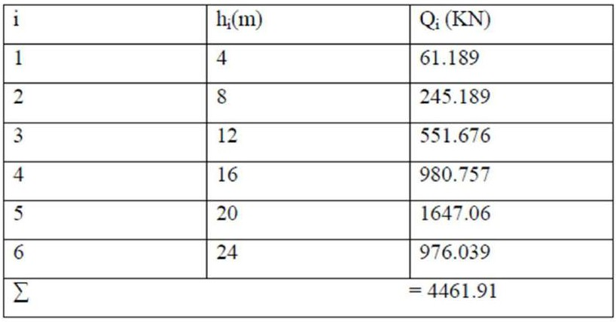
Table 6.7 showing the base shear force laterally distributed by Staad Pro analysis

Beam and Column Design for Seismic Load Combination

Beam:
According to clause 6.3.1.2 of IS 1893 (part 1):2016 partially safety factors for limit state design of reinforced concrete.
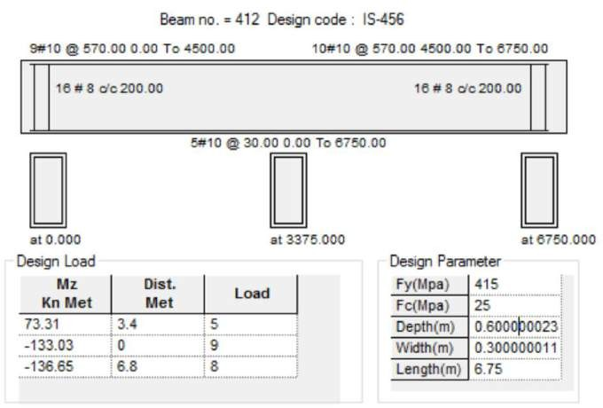
Fig 6.3: Shows the details of beam due to Seismic load combination

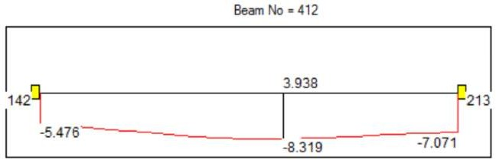
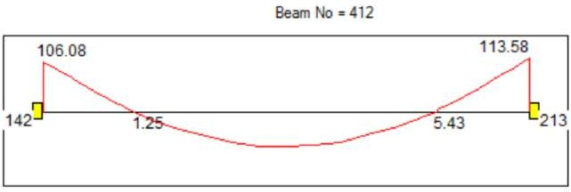
Beam deflection due to seismic combination load
Bending moment due to seismic combination load

Column:
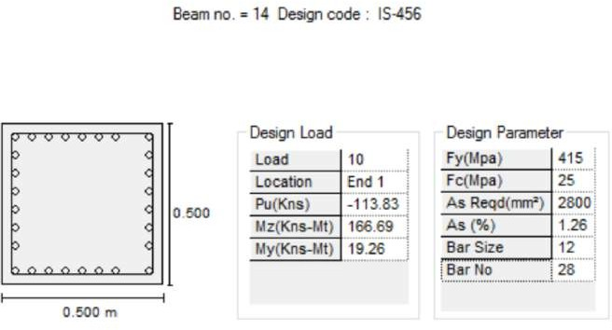
Fig 6.4: Shows the Column details due to Seismic Load Combination
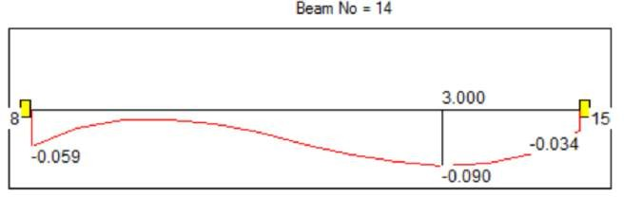
Column deflection due to seismic load combination

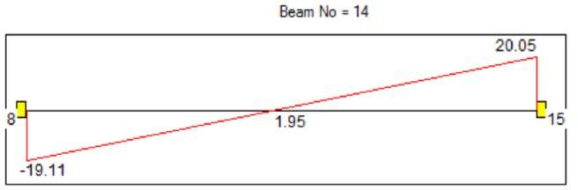

Column bending moment due to seismic load combination

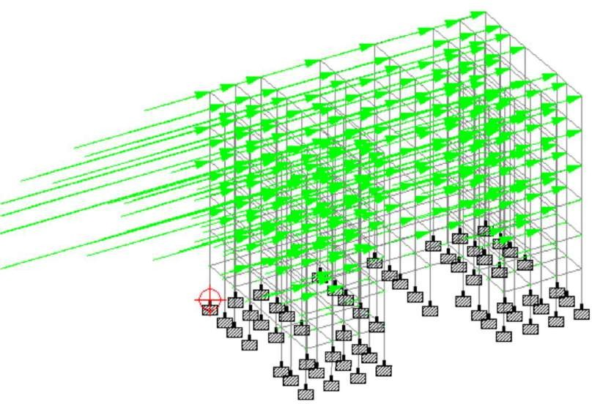

Figure 6.5: showing the seismic load acting from +x direction (Isometric view)

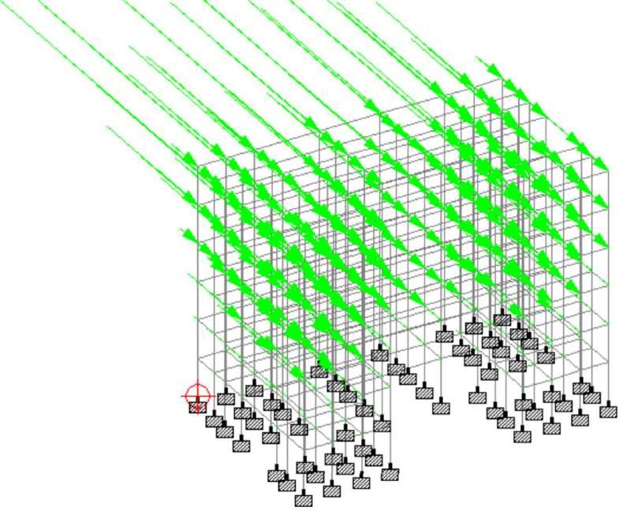

Figure 6.6: showing seismic load acting from +z direction (Isometric view)
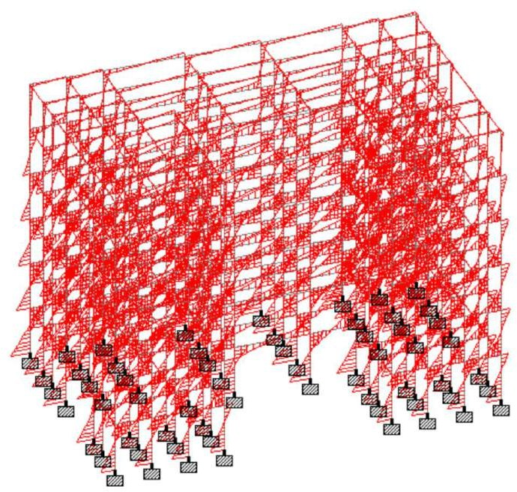
Figure 6.7: Bending moment diagram due to seismic force from +x direction

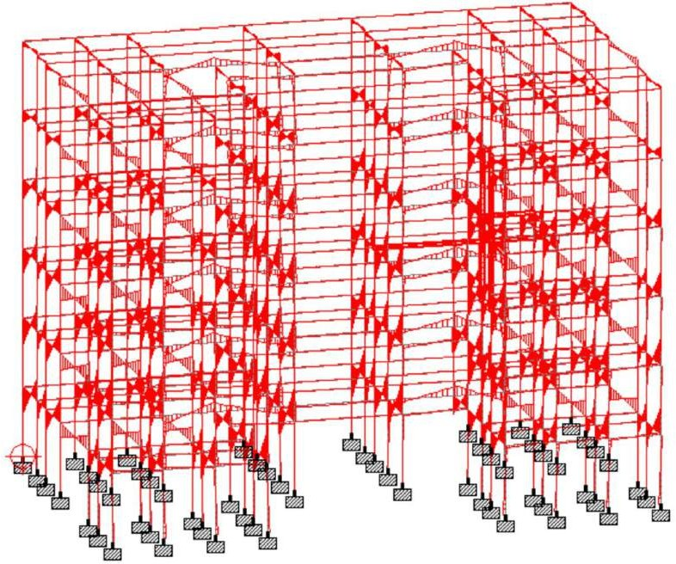

Figure 6.8: Bending moment due to seismic force from +z direction

MODELLING OF R.C.C. FRAMES

An R.C.C. framed structure is basically an assembly of slabs, beams, columns and foundation inter-connected to each other as a unit. The load transfer mechanism in this structure is from slabs to beams, from beams to columns, and then ultimately from columns to the foundation, which in turn passes the load to the soil. In this structural analysis, study, we have adopted four cases by assuming different shapes for the same structure, as explained below.

- Rectangular plan
- C-shape plan
- L-shape plan
- H-shape plan

COMPARISON AND ANALYSIS

7. 1 Modeling of building frames
The R.C.C. Structures is mainly an assembly of Beams, columns and slabs and foundation -connected to each other as a single unit. Generally the transfer of load in these structures is from slab to beam, from beam to column and finally column to foundation which in turn transfers the entire load to the soil. In this study, we have

adopted 4 cases by assuming different plan shapes such as Rectangular shape, C-shape L-shape, H- shape, Detail of buildings considered in this work are as follows

Type of structure- Residential building
Shape of building – Rectangular, C-Shape, L-Shape, H-Shape Buildings,
Number of stories 15
Height of typical floor: 3.3m Column size: 300mm X750mm Beam size: 300 mm X 450mm Slab thickness: 125 mm Masonry wall thickness: 230 mm Live load : 2 Kn/m2
Floor finish : 1 Kn/m2
All the columns are assumed to be fixed at their base. Characteristic compressive strength of concrete, fck: 25N/mm2 Grade of steel : 500 N/mm2
Density of concrete : 25N/mm2
Modules elasticity of concrete : 2500N/ mm2
poison‟s ratio of concrete: 0.3
Density of brick masonry : 19.2 KN/m3
Modulus elasticity of brick masonry: 14000N/mm2
Poison‟s ratio of brick masonry : 0.2


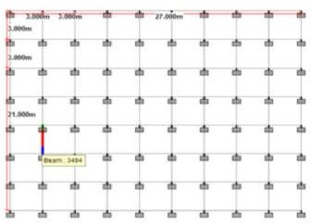

Fig.No.7.1 3D Elevation and plan of of Rectangular Building

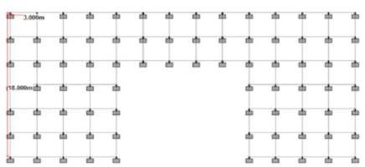
Fig No. 7.2 3D Elevation and plan of C-shape building
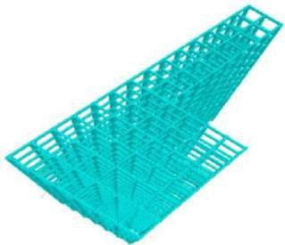
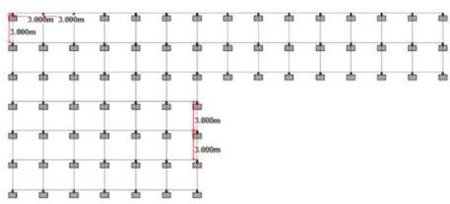

Fig. No. 7.3 3D Elevation and plan of L- Shape Building

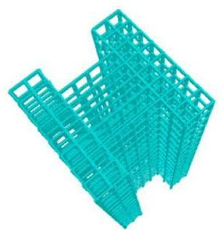
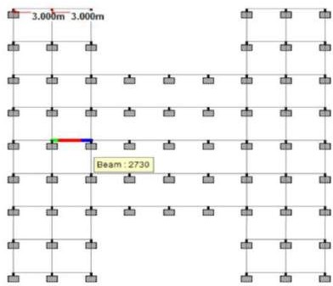

Fig.No.7.4. 3D Elevation and plan of H- shape building

RESULT AND DISCUSSION FOR ALL SHAPES OF BUILDINGS

The four types of RCC building frames viz.(1) Rectangular (2)C-shape (3) L-shape (4) H-shape. The result obtained by the analysis regarding the structural behavior of each building are tabulated and explain as follows.

Table. no. 6.1 Comparison of Maximum Lateral/Storey Drift for various Shape of Building
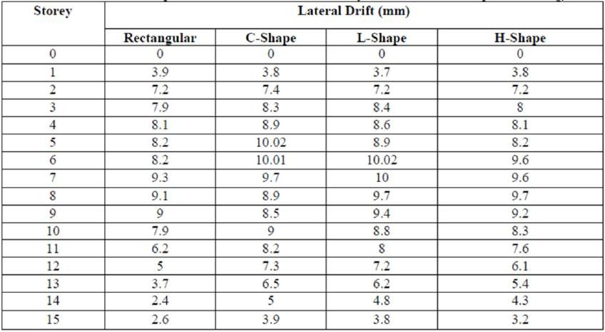

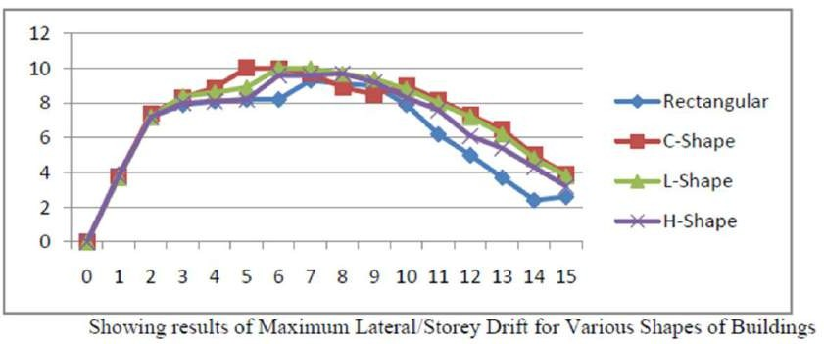
For determining most stable structure among all models that we have studied, graphs and tables have drawn for different shapes. Results for maximum bending moment and shear force of beam and column for different shapes of the building are shown here.

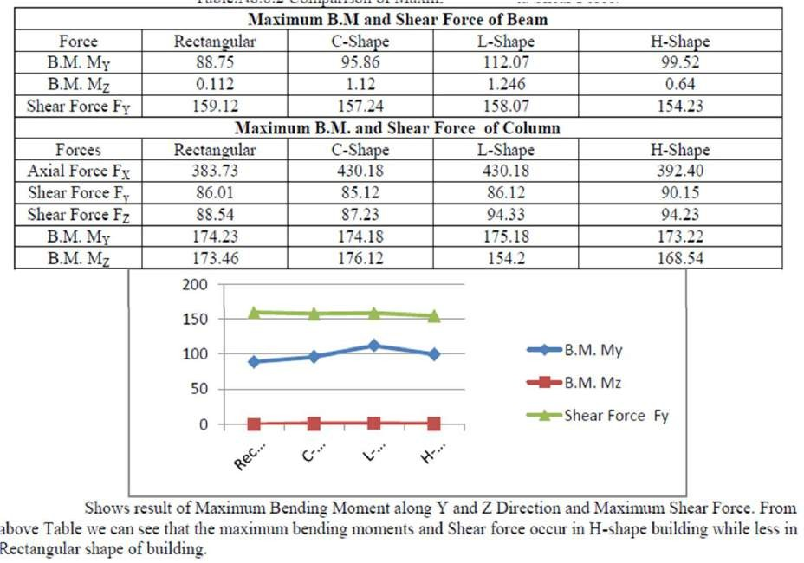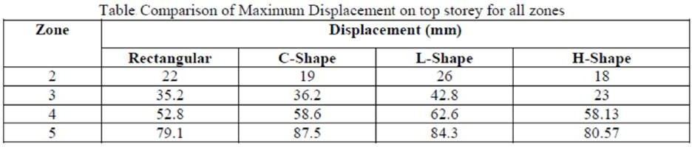

CHAPTER VII

COMPARATIVE ANALYSIS & DESIGN OF REGULAR AND IRREGULAR BUILDINGS AND ITS BEHAVIOUR IN DIFFERENT EARTHQUAKE ZONE

ABSTRACT

In civil structure static analysis is performed for or RCC frame regular and irregular building up to G+15 storeys by using response spectrum method. The problems introduced due to discontinuity in stiffness, mass and geometry of structure. IS codes are used for design of various civil engineering structures and their specifications. 20 elements are designed by using software are STAAD Pro. and E-TABS,
and considering seismic load and wind load. For load combination use IS code 1893: 2016. Irregular building is compared in all four zones. The designing has been carried out in the software (software that deals with analysing and designing of structures. These software is easy to understand for user that means user friendly). All the building structure and modelled analysed structure and then design for all four zones.All model are analysed in that software and designed in STAAD pro. Software and their results are obtained in all seismic zones.
The base shear force, volume of concrete, weight of Steel and cost effectiveness have been calculated to depict all the differences in structure behaviour when analysed and design in all four zones by using STAAD Pro and E-TABS software.

Introduction

When earthquakes occur a building's undergoes dynamic motion due to that inertial forces are generated. These initial forces called seismic loads.
Here we are going to analyse of static analysis up to G+15 RC frame building at different earthquake zone.
Static loads are the loads which varies very slowly (the acceleration of load is very less than the natural frequency of structure).
In the recent days the tall structure has more demand for the construction, the building must withstand against lateral force acting on the structure due to the natural calamities such as the earthquake and may also be the wind load so in this thesis project the comparative studies is done for the different zone by providing the required size of the columns and beams by following Indian standards. If the design is not in proper way means the sudden effect of earthquake may cause the structural collapse and many life of people may spoil.
So it may cause homeless to common people. So it is major task to design structure in a proper way. The structure which performs against the earthquake means structure must possess the simple regular configuration and minimum lateral strength and also stiffness of the structure.

Future scope

A lot of research work is taking place in the globe to study the seismic behaviour of regular and irregular building with and without shear wall at all earthquake zone.

Following are the some points for future scope of this study:
- The seismic analysis of buildings on heels and effect on elements surrounding elements using dynamic analysis can be done.
- The detailed study of effects of slopes on earthquake parameters can be studied.
- The effect of soil conditions on construction of a building on hills can be studied.

  - LOADINGS
For this analysis, there are only two (2) types of loading which are going to be considered: horizontal loads and vertical loads. Vertical loads comprise of the self- weight of the structure, dead loads, and live loads. These loads have the similar features of being marked by gravity. On the contrary, horizontal loads which are also referred as lateral loads are loads that present perpendicularity to the gravitational forces and comprise in this case only wind load and earthquake load. In the following, as per Malaysian practice, details about loading values and assumptions will be given.

DEAD LOAD
Dead loads are permanent loads which are acting on the structure. The unit weights of the materials that will help in calculations are as follow:
Reinforced Concrete : 24.0 kN/m3
However this will be considered automatically in the software. As for super dead load to account for finishes cladding and any additional dead load, we will take it to be 2 kN/m2 and will be the same for all floors throughout.

LIVE LOAD
Live load is the load that accounts for the intended use or occupancy. As per BS6399 and current Malaysian practice, the value of live load shall be taken as 1.5 kN/m2 and will be the same for all floors from top to bottom.

WIND LOAD
Wind load is part of horizontal loadings acting on the building structure. We suppose it acts on the wall areas along the side of the building with higher effect as we go up. The basic wind speed is taken to be 35 m/s.

    - SEISMIC LOAD
Seismic loads are loads generated and induced by an earthquake in form of acceleration of the ground motion. From the studies of response spectrum conducted by Taksiah A.
M. (2007) in one of the paragraphs above, the acceleration for the range of higher peaks is within 0.04g which will be considered for the analyses with soil class taken as D.

  - ETABS SOFTWARE
ETABS software is an integrated building design software developed and released by Computers and Structures, Inc. to analyze and design building systems. Even though, it might seem sophisticated, it is very user-friendly. With the capacity of taking care of the most complex and largest model, it has become software of choice of structural engineer in the construction industry. However, the advantages of using ETABS are (Computers & Structures, 2005):
- With ETABS, any building configuration is possible even though most buildings are straightforward in geometry with horizontal beams and vertical columns. Then, a grid system can be established defined by horizontal floors and vertical column geometry with almost no effort.
- The similarity of the floor levels in a building can be used to significantly reduce the time for modelling and designing.
- The structural definition is simple, to the point and representative. The input and output conventions used correspond to common building terminology. In ETABS, the definition of the models is done logically floor-by-floor, column-by-column, bay-by-bay and wall-by- wall.
- ETABS corrects effects on the stiffness of the frame because of large member dimensions in relation to story heights and bay widths in the formulation of the member stiffness.
- The results produced by the program does not need additional processing before being used in structural design it is already in a form that is directly usable as compared to some
general-purpose computer program results which may need additional processing.

  - FLOWCHART
The figure below shows the course of the project, in order words it means the steps that will be used to evaluate and complete this study.

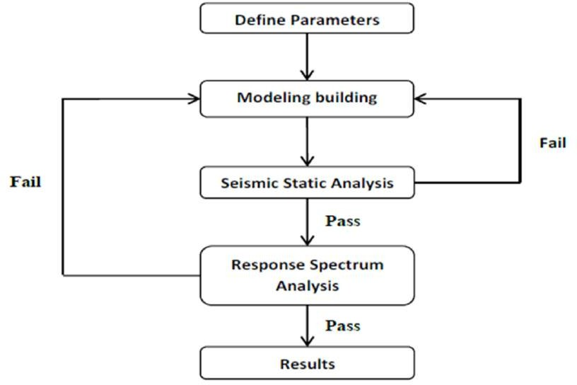
Figure 2 Research Methodology Flow Chart

For the First part of the seismic static analysis in ETABS, these steps shall be followed:
- First establish the structure size and dimensions (such as height of the stories, distances between columns and overall dimensions)
- Define code(s) to be used alongside material properties (in our case concrete)
- Then we need to define and assign section properties (beams and columns) and also draw the others elements if applicable (floor, walls, piers and spandrels)
- define and assign all the loads that are applicable (dead, live, and wind) and set up the load combination of static load cases.
- The last step is to run the analysis and the design to view the outputs
For the second part including response spectrum analysis in ETABS, follow the steps below:
- First open any of the models which has been previously analysed statistically in the first part of the analysis
- Next define and assign any response spectrum input
- Finally run the analysis and the design to get the outputs
The above are just outlines which try to give an insight and clarification on how the study was carried out using ETABS. To be actually done an implemented one needs to be very familiar with the software through learning by reading and exercising.

2.4 DESIGN PHILOSOPHY OF EARTHQUAKES

According to Pankaj A. & Manish S. (2006) the philosophy of seismic design is to guarantee that the structures possess at least a minimum capacity to withstand without any damage minor earthquake, Design Basis Earthquake DBE without significant structural damage and Maximum Considered Earthquake MCE without complete failure. the IS 1893 (Part 1): 2016 defines the Design Basis Earthquake (DBE) as the maximum earthquake that is more likely to happen during the design life of the structure and the Maximum Considered Earthquake (MCE) as the most critical earthquake effects considered. The MCE is usually the double of the DBE. Since complete protection against earthquakes of all sizes is impossible and uneconomical, the basic criteria of seismic design should be established on lateral strength, deformability, ductility and stiffness of the structure.

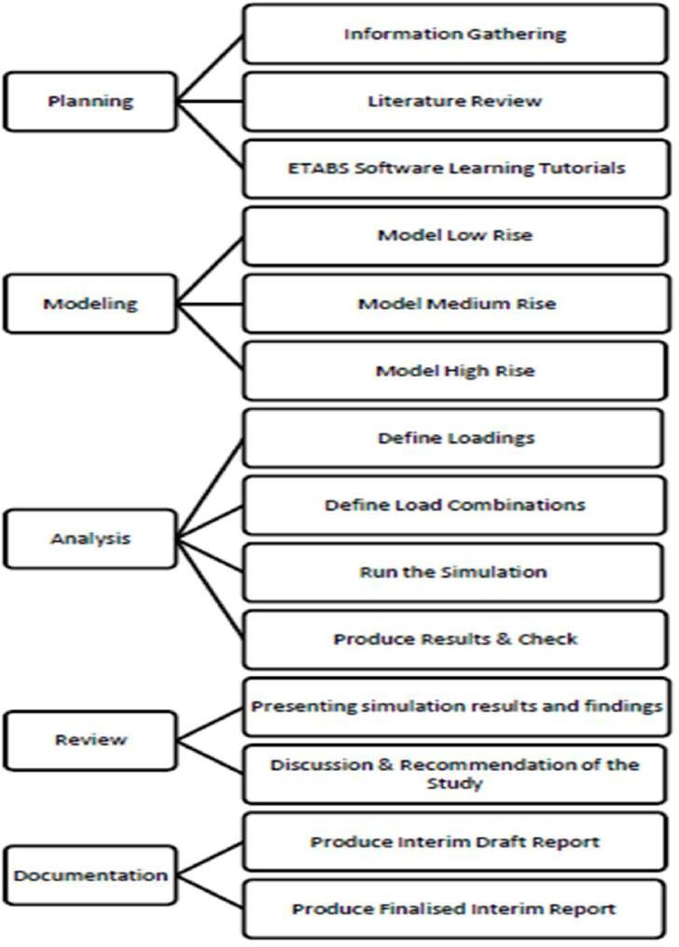

Figure 3 Project Activities

  - MAPPING OUT RESEARCH TIMELINE
The following key milestones present all the activities that are involved in the thesis with their framework and timeline as in table 3.

Table 3 Key Milestones for FYP 1

Weeks | Activities | Persons Involved | Documentation Progress
Week 1 | Selection of Topic & Introduction | Student | Initialization
Week 2 | Topics to be Selected | Student | Primary knowledge
Week 3 | Supervisor/ Guide’s  Assignment & Topic Selection | Co-ordinator | Minimum Progress
Week 3 | Topic Confirmation | Student | Minimum Progress
Week 3 | Finding Literature Notes | Student | Minimum Progress
Week 4 | Analysing Literature & Data Collection | Student | Literature Review
Week 4 | Planning &  Structuring | Student | Methodology
Week 5 | Extended Proposal Defence Draft Preparation | Student | Extended Proposal
Week 5 | Extended Proposal Defence Draft Preparation to be  checked | Supervisor/ Thesis Guide | Draft
Week 6 | Submission of  Extended Proposal Defence | Student,  Supervisor/Guide & Co-ordinator | Extended Proposal
Week 7 & Week 8 | Data Collection & Analysis | Student | Literature Review Added & Analysis done by suitable Softwares
Week 9 | Project Defence | Student,  Supervisor/Guide & Examiner | Presentation &  Progress Report Submission
Week 10 | Correction &  Modification In Draft Thesis | Student as per  Guidance of Supervisor | Modification & Correction
Week 11 | Software analysis & Model Drawings | Student | Application Started in STAAD Pro.  Software
Week 12 | Calculation, Analysis & Testing of Different Structures | Student With the help of the Guide | Brief Analysis about the structures.
Week 13 | Submission of  Interim Draft | Student &  Supervisor (Guide) | Interim Draft  Report Preparation

 | Report |  | & Submission
Week 14 | Final Submission of Interim Draft Report | Student, Supervisor (Guide) & Examiner | Presentation & Interim Progress Report Submission
Week 15 to Week 17 | Final Analysis &  Final Drafting of Progress Report | Student | Final Thesis Report Preparation
Week 18 & Week 19 | Verification & Modification of Final Thesis Report | Student by Supervisor’s Guidance | Verification & preparation of Full  Draft Progress Report Submission
Week 20 | Final Thesis Presentation | Student, Supervisor (Guide) & Examiner | Final Thesis Presentation (ppt mode) & Full Draft Final Progress Report Submission

  - TOOLS

- STAAD Pro. software
- Excel Spread-sheets

  - SUMMARY

There are several steps to follow in order to complete this project within the allocated timeframe but the very first step to follow will be to acquire an understanding in depth of the subject matter through literature review and analysis and also by regularly meeting one’s supervisor. This can be accomplished through extensive reading of articles, journals, technical papers, web pages from the internet and related books. It helps in getting background information on the subject as well as in building technical knowledge which will allow in making the right assumptions and concepts to be applied to complete the project.

CONCLUSION & RECOMMENDATIONS

- The maximum storey displacement, maximum storey drift and maximum center of mass displacement values obtained from response spectrum analysis at lower stories are lesser when compared with the values at higher stories.

- By comparing results of two mentioned analysis, it is observed that the displacements of time history analysis are higher than response spectrum analysis.

- To visualize performance of a building under a given earthquake, time history analysis is an elegant tool.

- For high rise buildings, response spectrum analysis is not sufficient, we have to analyses through time history analysis.

- For important structures, when compared with response spectrum analysis, time history analysis has to be performed as it predicts the structural response more accurately.

- From the results, it is clear that, shear walls are to be present in the high rise buildings to control storey displacement, storey drift and centre of mass displacement.

- When the high rise building is constructing with the structural elements like flat slabs and floor slabs, shear wall combination is to be adopted to control lateral deflections.

- Usage of flat slabs in the high rise building reduces no. of beams and gives aesthetical appearance by increasing clear height of the room, but, floor slabs are good in controlling storey displacement.
  - From the results obtained from the analyses outputs, the elements are in accordance to our objectives of the study which are:

- By means of response spectrum, frequencies (periods) and mode shapes have been obtained and tabulated for each type of structure as to show the behaviour of the reinforced concrete buildings subjected to earthquake loadings
- The inter story drift indexes of all the buildings were determined and their maximum found to be less than the limit which is 0.004 when evaluated and compared to the limit value and;
- Analysis of the structural integrity of these buildings in withstanding the design earthquake loadings was conducted and was judged to be safe from the column P-M-M Interaction diagrams as for all the buildings columns capacity ratio is below 1. However their vertical elements appear to not present excessive reserve strength as their capacity is closer to 1.
The way forward will be to conduct studies on different shapes and geometrical configurations and to see the variations as the study we conducted only included regular rectangular shape and symmetrical configuration.

Chapter VIII

Analysis of Fundamental Natural Period of Irregular R.C.C Framed Structure
As part of structural design, members in buildings are selected and detailed such that the expected demands, such as forces or displacements, on a structure are less than the capacity of the structure to resist those forces and displacements. However, to obtain these forces or displacements, structural analysis is required considering the loading applied to the building from its weight, its use, and other factors such as wind, or shaking of the ground in the case of earthquake.
The sophistication of the structural analysis affects both the detail of the analysis results and the design fee. Simple methods (e.g., Equivalent Static method) may provide a reasonable representation of the likely seismic behaviour to enable rapid
Assessment of the expected building performance. More complex methods, such as inelastic dynamic time history analysis provide more information about the response, but take more time and computational cost to perform properly Engineers need Conceptually simple methods for the following reasons:
- To design full structures
- To enable a rapid check of likely building performance
- To preliminary size members before some more sophisticated studies are undertaken.

AIM & SCOPE:- The determination of the fundamental period of vibration of structures is essential to design and assessment against earthquake loading. A reasonably accurate estimation of the fundamental period in such irregular structures is necessary in both response-spectrum and static earthquake analysis of structures.
An accurate estimation would allow for an improved estimation of the global seismic demands on an irregular structure.

As such, the goal of this research is to investigate the accuracy of existing code-based equations for estimation of the fundamental period of irregular building structures and provide suggestion More specifically, the objectives of this research are:

- To perform numerical experiments for the parametric study of the fundamental period of different types of RCC framed structures considering different number of stories, number of bays, configuration, and types of irregularity. Two types of irregular structures are examined in this study: a) structures with vertical irregularity and structures with horizontal irregularity. Each structure is analyzed using STAAD.Pro V8i, An analysis and design software.
- To compare the fundamental periods of each structure obtained from a) Rayleigh method b) IS Code equations, and c) STAAD.Pro generated fundamental period based on a normal mode analysis.

METHODOLOGY:- f the structure not properly constructed with required quality they may cause large destruction of structures due to earthquakes.
- Extensive literature survey by referring books, technical papers, carried out to understand basic concept of topic.
- Selection of type of structures.
- Modeling of the selected structures
- analysis of me selected structure.
- Interpretation of result and conclusion.
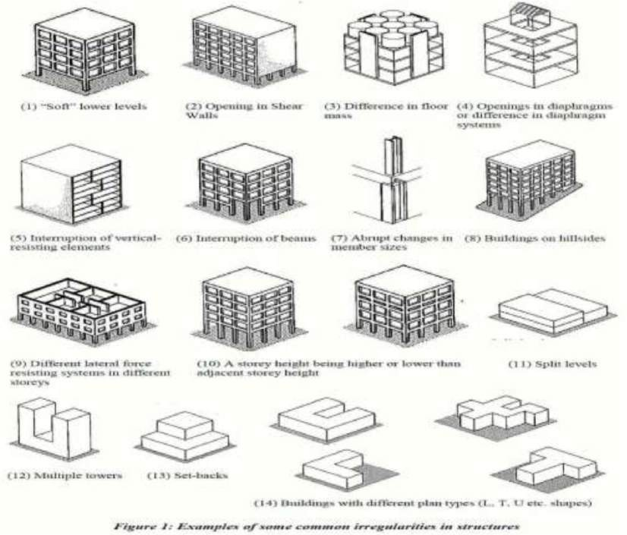

Type of irregularities in structure

STRUCTURAL MODELLING:- VERTICAL IRREGULARITIES:
A structure could be irregular because architectural design requirements call for non- uniformity of some sort. This is designed/planned use (DPU) irregularity. Common examples of this type are; a residential building having a car park at the basement and a corresponding less stiff first storey, an academic institution having a heavy library on one floor level, or a structure designed to have setbacks to meet boundary offset requirements. What is important is not whether or not a structure contains irregularities,

but the ability of the designer to estimate the likely demands on structures with the irregularity present at the time of earthquake shaking.
  - Stiffness Irregularity — Soft Storey: A softstorey is one in which the lateral stiffness is less than 70% of that in the storey above or less than 80% of the average lateral stiffness of the three storeys above.
  - Stiffness Irregularity — Extreme Soft Storey: A extreme soft storey is one in which the lateral stiffness is less than 60% of that in the storey above or less than 70% of the average lateral stiffness of the three storeys above.
- Mass Irregularity: Mass irregularity shall be considered to exist where the seismic weight of any storey is more than 200% of that of its adjacent storeys. This need not be considered in case of roofs.
- Vertical Geometric Irregularity: Vertical geometric irregularity shall be considered To exist where the horizontal dimension of the lateral force resisting system in any storey is more than 150% of that in its adjacent storey.
- In-Plane Discontinuity in Vertical Elements Resisting Lateral Force: An in- plane offset of the lateral force resisting elements greater than the length of those elements.
- Discontinuity in Capacity — Weak Storey: A weak storey is one in which the storey lateral strength is less than 80% of that in the storey above, The storey lateral strength is the total strength of all seismic force resisting elements sharing the storey shear in the considered direction.

PLAN IRREGULARITIES:-

Torsion Irregularity: To be considered when floor diaphragms are rigid in their own plan in relation to the vertical structural elements that resist the lateral forces. Torsional irregularity to be considered to exist when the maximum storey drift, computed with design eccentricity, at one end of the structures transverse to an axis is more than 1.2 times the average of the storey drifts at the two ends of the structure.
Re-entrant Corners: Plan configurations of a structure and its lateral force resisting system contain re-entrant corners, where both
projections of the structure beyond the re-entrant corner are greater than 15% of its plan dimension in the given direction.

Diaphragm Discontinuity: Diaphragms with abrupt discontinuities or variations in stiffness, including those having cut-out or open areas greater than 50% of the gross enclosed diaphragm area, or changes in effective diaphragm stiffness of more than 50% from one storey to the next.

Out-of-Plane Offsets: Discontinuities in a lateral force resistance path, such as out-of- plane offsets of vertical elements.
Non-parallel Systems: The vertical elements resisting the lateral force are not parallel to or symmetric about the major orthogonal axes or the lateral force resisting elements.

FUNDAMENTAL NATURAL PERIOD: - When the ground shakes, the base of building moves with the ground, and the building swings back-and-forth. If the building were rigid, then every point in it would move by the same amount as the ground. But,

most buildings are flexible, and different parts move back-and-forth by different amounts.
The time taken (in seconds) for each complete cycle of oscillation (i.e., one complete back-and-forth motion) is the same and is called Fundamental Natural Period (T) of the building Value of T depends on the building flexibility and mass; more the flexibility, the longer is the T, and more the mass, the longer is the T. In general, taller buildings are more flexible and have larger mass, and therefore have a longer T. On the contrary, low- to medium-rise buildings generally have shorter T.
Fundamental natural period T is an inherent property of a building. Any alterations made to the building will change its T.
The ground shaking during an earthquake contains a mixture of many sinusoida l waves of different frequencies, ranging from short to long periods. The time taken by the wave to complete one cycle of motion is called period of the earthquake wave. In general, earthquake shaking of the ground has waves whose periods vary inthe range 0.03- 33sec.Even within this range; some earthquake waves are stronger than the others.
Intensity of earthquake waves at a particular building location depends on a number of factors, including the magnitude of the earthquake, the epi-central distance, and the type of ground that the earthquake waves travelled through before reaching the location of interest.
In a typical city, there are buildings of many different sizes and shapes. One way of categorizing them is by their fundamental natural period T. The Ground motion under these buildings varies across the city. If the ground is shaken back-and-forth by earthquake waves that have short periods, then short period buildings will have larger response. Similarly, if the earthquake ground motion has long period waves, then long period buildings will have larger response. Thus, depending on the value of T of the buildings and on the characteristics of earthquake ground motion, some buildings will be shaken more than the others. Flexible buildings undergo larger relative horizontal displacements, which may result in damage to various non-structural building components and the contents. For example, some items in buildings, like glass windows.

CODAL PROVISIONS FOR FUNDAMENTAL PERIOD OF STRUCTURES:- Seismic design
codes specify empirical formulas to estimate the fundamental period which are based on data from instrumented buildings subjected to ambient vibrations or small to moderate earthquakes. The approximate fundamental natural period of vibration (Ta), in seconds, of a moment-resisting frame building without brick infill panels may be estimated by IS- 1893 (Part 1): 2016, Clause 7.6.1, for concrete structures is in the form.
Ta = 0.075 H0.75 (1)
Where, H = Height of building, in m. This excludes the basement storeys, where basement walls are connected with the ground floor deck or fitted between the building columns. But it includes the basement storeys, when they are not so connected Up until 2016, the fundamental period estimated by ASCE 7-02 code for all structures was in the same form where the parameter 0.075 was chosen specifically by structure type. Equation 1 is still in use in the building codes of many countries, including
Eurocode 8 , which limits its use to buildings less than 40m (131 feet). Also present in certain design. Codes for many years, the fundamental period of braced steel frames and concrete shear walls is estimated as:
Ta = 0.05 H / √D (2)
Parameter D corresponds to the dimension of the braced frame in a direction parallel to the applied force, called the depth of the structure in this paper. In Equation, H and D are in feet. This equation was first introduced in California building codes for reinforced

concrete shear wall structures, and was more recently present in the 1995 NBC of Canada . A very similar type of equation found in IS-1893 (Part 1): 2016, Clause 7.6.2. The approximate fundamental natural period of vibration (T a ), in seconds, of all other buildings, including moment-resisting frame buildings with brick infill panels, may be estimated by the empirical expression:
Ta = 0.09 H/√D
Where, H = Height of building, in m as defined in 7.6.l. & D = Base dimension of the building at the plinth level, in m, along the considered direction of the lateral force.
According to another Indian Standard Code, IS-875(Part 3):1987 and a previous version, IS-1893: 1984 the fundamental time period (T) may either be established by experimental observations on similar buildings or calculated by any rational method of analysis. In the absence of such data, T may be determined as follows for multi-storeyed buildings – for moment resisting frames without bracing or shear walls for resisting the lateral loads.
Ta = 0.1 n (4)
Where, n = number of storeys including basement storeys. ASCE 7-10 defines two equations for the approximate fundamental period in seconds. One of them is Equation.
It has been present in the code since the1970s. ASCE 7-10 limits it use for buildings of 12 stories or fewer, with Story height so fat least 10feet.

VERTICAL IRREGULARITY – SETBACK:-

The estimation of the fundamental period of a building structure is essential for determination of the design base shear and lateral design forces. A number of studies have been performed on the fundamental period of building structures. As more buildings are instrumented and recorded seismic response data have become available, a number of recent studies have compared results obtained from empirical code equations for the fundamental period with actual measured data of structures during seismic events.

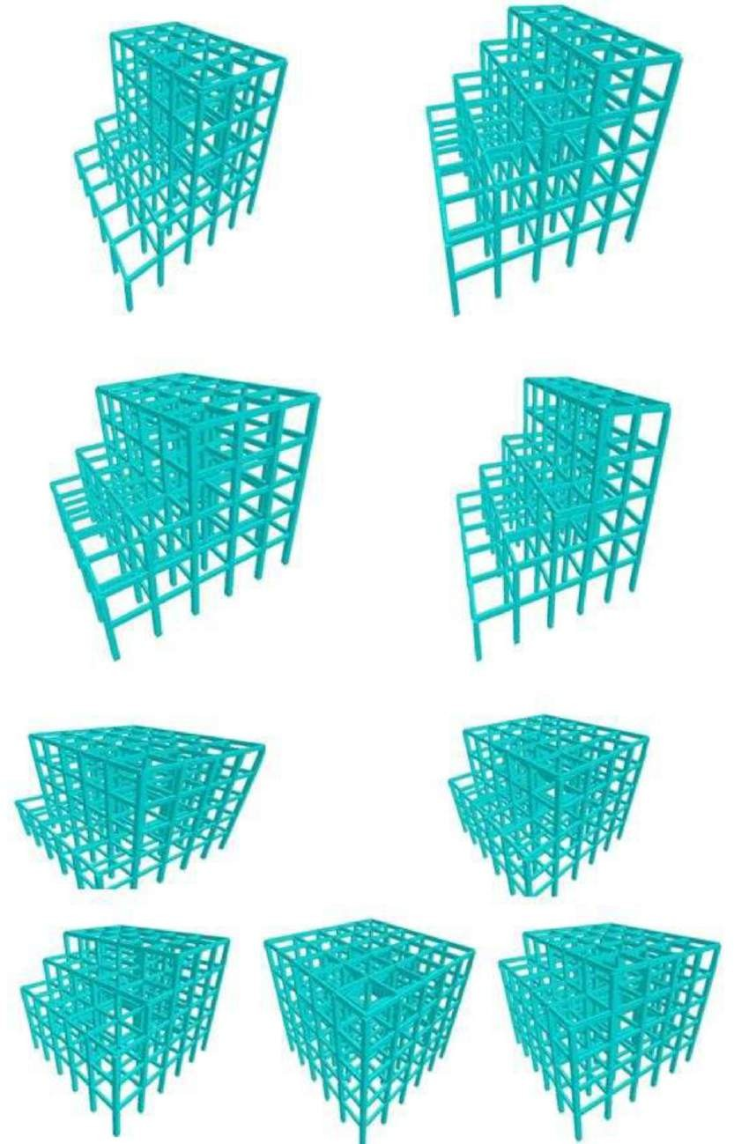

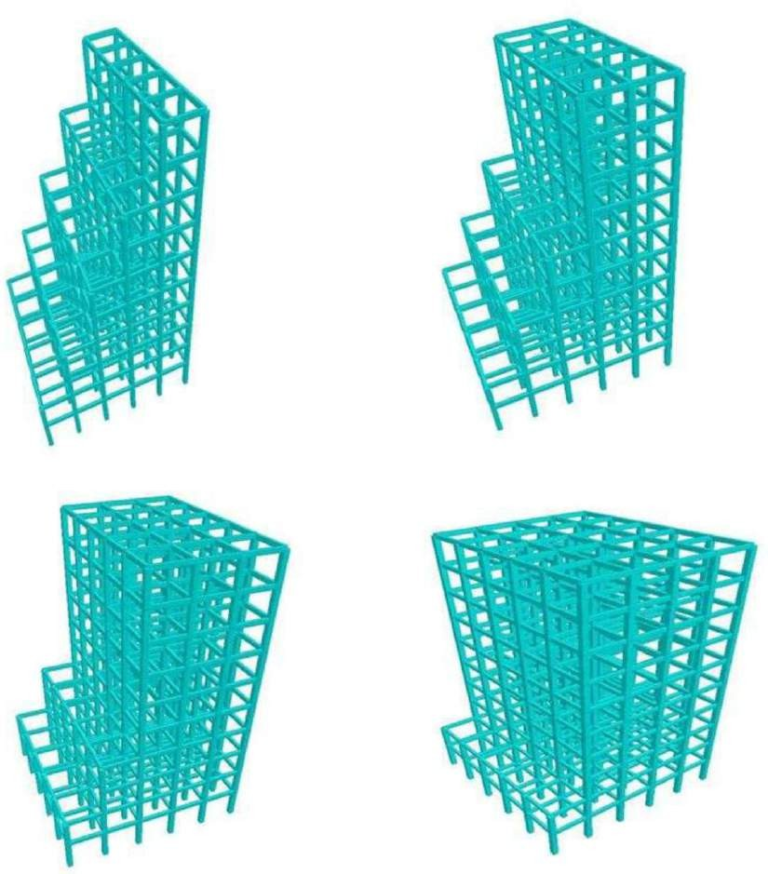

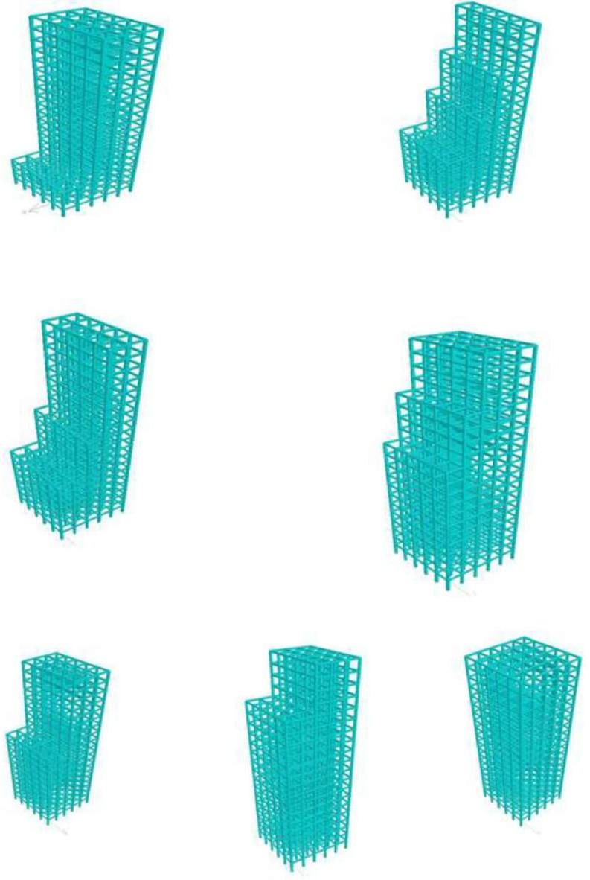

REFERENCES

- https://www.google.com/search?client=ms-android-asus- tpin&sxsrf=ALeKk03f0FuMK3fDbnjuKnqh5eFInAZBIQ%3A1597657894706& ei=JlM6X7DXKuaX4- EPpcihuAk&q=reference+dynamic+effects+of+structure&oq=reference+dynami c+effects+of+structure&gs_lcp=ChNtb2JpbGUtZ3dzLXdpei1zZXJwEAMyBAg eEAo6BAgAEEc6BwgjELACECdQiE9Yzl5gy2BoAHABeACAAY8DiAGfDZI BBTItNS4xmAEAoAEBwAEB&sclient=mobile-gws-wiz-serp
- https://www.jvejournals.com/article/15577
- https://link.springer.com/chapter/10.1007/978-1-4471-2055-1

- http://www.icontrolpollution.com/articles/dynamic-analysis-of-multistorey- building-.php?aid=86507

  - https://reader.elsevier.com/reader/sd/pii/S1110016818302096?token=11C5459ECC81 F1B9E7F8747C065D6AF95868DBE5722A6A0EBFB66D7805181C86C3819E60590E9E9EF 1155F14B77F54D2

- Arvindreddy. and Fernandes, R.J. (2015). Seismic analysis of RC regular and irregular frame structures. International Research Journal of Engineering and Technology (IRJET). 2 : 44-47.
- Bahador, B., Ehsan, S.F. and Mohammadreza, Y. (2011). Comparitive study of the static and dynamic analysis of multi-storey irregular building. International Journal of Civil, Environmental, Structural, Construction and Architectural Engineering. 6 : 1045-1049.
- Dubey, S.K., Prakash, S. and Ankit, A. (2015). Dynamics analysis of structures subjected to earthquake load. International Journal of Advance Engineering and Research Development. 2 : 1-9.
- ETABS User’s Manual. (2015). Integrated Building Design Software. Computer
and Structures Inc. Berkeley, USA.
- IS 1893(Part1): (2016). Criteria for earthquake resistant design of structures, Part 1 General provisions and buildings, Bureau of Indian Standard.
- IS: 13920. (2016). Ductile detailing of reinforced structures subjected to seismic force. code of practice Bureau of Indian Standards, New Delhi.
- IS: 456-2000. (reaffirmed 2005). Indian standard of code and practice for plain and reinforced concrete" Bureau of Indian Standards, New Delhi.
  - IS: 875 (Part 2). (2016). Code of practice for design loads (other than earthquake) for buildings and structures, live loads, Bureau of Indian Standards, New Delhi.
  - Mohammed, R.S. and Gouse, D.P. (2015). Dynamic analysis of multi-story building for different shapes. International Journal of Innovative Research in Advanced Engineering (IJIRAE). 2: 85-91.
  - Mohit, S. and Savita, M. (2014). Dynamic analysis of multi-storied regular building. IOSR Journal of Mechanical and Civil Engineering (IOSR-JMCE). 11 : 37-42.
  - Ni, W. and Kyaw, L.H. (2014). Comparative study of static and dynamic analysis of irregular reinforced concrete building due to earthquake. International Journal of Scientific Engineering and Technology Research. 3 : 1205-1209.

  - SP-16-2000. Design Aids for Reinforced concrete to IS-456-2015-Bureau of Indian Standards, New Delhi.
  - Yousuf, M. and Shimpale, P.M. (2013). Dynamic analysis of reinforced concrete building with plan irregularities. International Journal of Emerging Technology and Advanced Engineering. 3 : 110-116.
  - Agarwal P. and Shrikhande M., Earthquake Resistant Design of Structures, PHI Publication, 2012.
  - Agarwal Pankaj and Shrikhande Manish- Earthquake resistant design of Structures: New Delhi, PHI Learning Private Limited, 2010 .
  - Thesis of Mr.Ankur Agrawal,NIT Rourkela Student,(2012),seismic evaluation of NITR building under guidance of Prof. AV. Asha.
  - Thesis of Mr. Aslam, ANNA UNIVERSITY: CHENNAI, 60005, April 2012.
  - Seismic analysis and design of multi Storey Hospital building.
  - Thesis of Mr. M. I. Adiyanto*, University Sains Malaysia, MALAYSIA, 2008. Analysis and design of 3 storey hospital Structure subjected to seismic load.
  - Griffith, M. C. and Pinto, A. V. (2000), Seismic Retrofit of RC Buildings - A Review and Case Study, the University of Adelaide, Adelaide, Australia and European Commission, Joint Research Centre, Ispra Italy.
  - IS 456, Plain and Reinforced Concrete Code of Practice (fourth revision), New Delhi-110002: Bureau of Indian Standards, 2000.
  - IS 875 (part1), Dead loads, unit weights of building material and stored and stored material (second revision), New Delhi 110002: Bureau of Indian Standards, 1987.
  - IS 875 (part2) Imposed loads (second revision), New Delhi 110002: Bureau of Indian Standards, 1987.
  - M. L. Gambhir, Fundamentals of Reinforced Concrete Design, New Delhi- 110001: PHI Learning Private Limited, 2010.
  - Poonam, Kumar Anil and Gupta Ashok K, 2012, Study of Response of Structural Irregular Building Frames to Seismic Excitations, International Journal of Civil, Structural, Environmental and Infrastructure Engineering Research and Development (IJCSEIERD), ISSN 2249-6866 Vol.2, Issue 2 (2012) 25-31.

