Journal of Product and Brand Management – Operationalising Brand and Cultural Heritage.

First Author¹ - FAZLEEN N
M.Com, Sri Krishna College of Arts and Science.

Second Author ² - ANU KEERTHANA D
M.Com, Sri Krishna College of Arts and Science.


Journal of Product & Brand Management · June 2023

ABSTRACT
Purpose – Brand heritage is acknowledged as one of the future priorities in branding research. Adopting it in an international context is challenging. In order to maximise its use it is necessary to know how strong it and the target country’s cultural heritage are. Accordingly, the aim of the study is to construct a pioneering operationalisation of both brand and cultural heritage.
Design/methodology/approach – The study begins with a discussion on the focal concepts. Definitions are proposed and suggestions for operationalisation put forward. Thereafter, the concepts are applied in an analysis of brand heritage in different countries.
Findings – It is suggested that brand heritage is a mixture of the history as well as the consistency and continuity of core values, product brands, and visual symbols. A country’s cultural heritage could be conceived of as homogeneity and endurance.
Research limitations/implications – The preliminary operationalisation of the concept needs to be further tested. Nevertheless, the clarification and suggestions offered here should open up opportunities for further research.
Practical implications – The exploitation of brand heritage in international markets is likely to be further accentuated. The operationalisations generated are easy for practitioners to apply, enabling companies to better evaluate what brand heritage means for them and to effectively plan its use in an international setting.
Originality/value – To the authors’ knowledge, this study is the first to suggest operationalisations of brand heritage and cultural heritage.
Keywords :Brand heritage, Cultural heritage, International branding, Brands, Heritage

Paper type: Research paper

INTRODUCTION
As businesses currently face the challenge of keeping up with rapid change in areas such as technology, the brand has become one of the few resources to provide long-term competitive advantage (Lindemann, 2003). One way of dealing with the environmental turbulence is to accentuate historical elements and thereby convey stability and confidence. It has become trendy for consumers to seek consolation in the past, and brands with an image including elements such as authenticity, heritage and stability are gaining in popularity (Brown et al., 2003; Loveland et al., 2010). It has also been argued that symbolic and emotional attachment between a brand and a consumer is more probable with brands that connect heritage and authenticity to their image (Ballantyne et al., 2006).
Coincident with its current attraction to marketers, heritage is acknowledged as a key organisational resource imparting long-lasting strategic value: companies are unique in terms of

their heritage, and the heritage can provide the basis for superior performance (Balmer, 2009; Balmer and Gray, 2003). Unlocking the potential hidden value of a brand’s heritage may be one way of harnessing the past and the present in order to safeguard the future (Urde et al., 2007). Managers today face the challenge of marketing a brand’s heritage in a way that brings out its historical reliability but does not make it appear out-dated. Indeed, it is argued that this will be the key to building successful brands in the future: due to the abundance of choice, today’s marketing environment demands strong brand identities and decries imitation (Aaker, 1996; Ballantyne et al., 2006). Coincident with the extensive research interest in brands in general is a growing fascination with nostalgia and retro brands (cf. Boutlis, 2000; Brown, 2001; Brown et al., 2003; Kessous and Roux, 2008; Loveland et al., 2010). However, research from the conceptual perspective of brand heritage is still scarce (e.g. Liebrenz-Himes et al., 2007). The studies conducted by Urde et al. (2007) and Greyser et al. (2006) are among the few thus far focusing specifically on this, whereas others only mention it in passing, and the concept still lacks operationalisation.Despite, or perhaps because of globalisation, there is an increasing need for research on cultural differences between nations in the business context (Leung et al., 2005). There have been many attempts to measure national cultures. Most cultural mappings (e.g. Hofstede, 2001; Schwartz, 1994) emphasise differences in value priorities between individuals in a given national group in comparison with individuals in other national groups. They do not take into account how deeply rooted – or strongly inherited – these values are within a nation, however. Studies on national cultural heritage are scarce. The few that exist tend to consider heritage a cultural resource (i.e. cultural capital) and thus evaluate its benefits to a country/region (e.g. Bostedt and Lundgren, 2010), or they analyse it as a determinant of organisational behaviour (e.g. Fargher et al., 2008).
However, national cultural heritage is rarely discussed in the academic literature on marketing, except for brief references to the cultural heritage in the country of origin (e.g. Tellstro¨m et al., 2006), and is largely neglected as far as the target country is concerned. This is surprising given the large amount of literature on adaptation vs. standardisation of the different elements of marketing in target markets (Ryans et al., 2003): one would assume that knowledge about cultural heritage would be a prerequisite. Like brand heritage, cultural heritage lacks operationalisation. Discussion of the two concepts that is restricted to definitions is pointless, however, without an understanding of their practical application. Moreover, combining these concepts in one study will enhance knowledge of brand management across cultures.
As a pioneer in this respect, Banerjee (2008) considered the cultural heritage of the target country in relation to branding. His conceptual framework for matching brand heritage and cultural heritage, although seemingly a valuable tool for enhancing understanding of brand heritage in international markets, has not, to our knowledge, been applied empirically. Its application is complicated, however, because of the lack of measurements for the two concepts. This constitutes the research gap for this study, the aim of which is to construct a preliminary operationalisation of brand heritage and cultural heritage.
Thus, the constructed operationalisations will constitute the main contribution of the study, and will be a major step forward in terms of theory development. Moreover, it will be of use to researchers focusing on international branding, allowing more systematic comparison of the strength of brand heritage in different brands and of the strength of the national cultural heritage in different countries.
The article proceeds as follows. First we define and discuss the concepts of brand heritage and cultural heritage, and suggest how they might best be operationalised. We then briefly evaluate the usability of the suggested measures in line with Banerjee’s (2008) framework. Empirical cases are used to illustrate the theoretical discussion and to support the operationalisation. Finally, we suggest theoretical implications in the form of propositions, which lead us to the practical implications.

BRAND HERITAGE

Defining a brand and brand associations
A brand is often defined as a set of functional attributes and symbolic values, branding being the process of associating the attributes with the product in order to add value to it (e.g. Simo˜es and Dibb, 2001; Knox and Bickerton, 2003). According to Kapferer (2004), a brand’s success is based on its saliency, differentiability and intensity, and on the trust attached to the associations. In addition to these, Davis (2010) emphasises the role and accumulation of experiences in brand recognition. Brand preference ultimately depends on what the brand means to the customer and on the strength of its emotional effect, in other words on its place in the heart (e.g. Ballantyne et al., 2006). Brands are intangible assets (Kapferer, 2004), and have traditionally been associated with physical goods, but the notion of branding has been extended to companies as well. A company brand is defined primarily in terms of organisational associations.
Brand intangibles cover a wide range of associations and represent a significant element and future priority in branding research. Brand heritage is one of the associations that marketers can use to differentiate their brands from those of their competitors, ultimately helping them to create a unique image for the offering (Keller and Lehmann, 2006). In turbulent times consumers become less confident in the future, wishing to protect themselves from the harsh, unpredictable realities of the outside world and seeking reassurance from the products they buy. This increases interest in brands with a heritage: skilfully exploited they can evoke past events (Brown et al., 2003). Going back to one’s roots and seeking comfort in the past in order to be ready for the future appears to be a growing trend. Brands representing stability, familiarity and trust can speak to people in periods of uncertainty, helping to create an image of authenticity and integrity that is likely to appeal to today’s consumers. According to Ballantyne et al. (2006), in difficult times brand heritage offers a basis for stabilisation and growth. Indeed, Aaker (2004) recommends “going back to the roots” particularly for companies that are struggling. When external circumstances call for corporate change, however, overly strict adherence to the brand heritage can turn into inertia (Blomba¨ck and Brunninge, 2009).
A related concept that seems to be gaining popularity in these economically challenging times is “retro”. Whereas brand heritage is deeply rooted in the company’s or product’s history, and cannot be copied, “retro” is a marketing and advertising tactic that any company can apply: reviving old products or brand slogans, incorporating images of days gone by, rehashing and re-contextualising old ads and old cultural representations, and evoking any kind of nostalgia associated with the past. It is even used when a company wants to position a new brand based on consumers’ pre-existing emotional touch points (Sullivan, 2009; Brown et al., 2003; Boutlis, 2000).

DIMENSIONS OF BRAND HERITAGE
What is meant by brand heritage and heritage brands? Defining them is not straightforward. It should also be said that a company or product with a heritage is not necessarily a heritage brand. Having a heritage does not in itself create value but it may constitute the foundation of brand building (Urde et al., 2007). The word heritage is generally associated with inheritance: something transferred from one generation to another. As a concept, therefore, it works as a carrier of historical values from the past (Nuryanti, 1996).
Accordingly, Banerjee (2008, p. 314) describes its history, image, expectancy and equity as the four pillars of a brand’s heritage. History represents its rich eventful past, and the image “an after effect of the brand communication and positioning based on the benefits to be enjoyed by the consumers”. Brand expectancy refers to the physical and emotional benefits that consumers receive from the brand. Finally, equity comprises two subsets: a homogeneous and a heterogeneous set of competences that, respectively, facilitate progression and give the edge over the competition. With the exception of its history, the elements of brand heritage in Banerjee’s (2008) description are difficult to measure.
Meanwhile, according to Urde et al. (2007), a heritage brand is recognisable from the following characteristics: a track record, longevity, core values, history, and the use of symbols. A track record means demonstrated proof that the company has lived up to its values and promises over time, whereas longevity reflects consistent performance among other heritage elements. Core values are an integral part of a brand’s identity, and over time may constitute its heritage. History is another significant element of identity, and for the heritage brands at issue embraces three timeframes: the past, the present and the future. As Urde et al. (2007, p. 7) put it: Heritage brands are about history and history in the making.History can make a brand relevant to the present and, prospectively, the future.One way of creating a brand history is to link the brand to a sense of cultural continuity and communal tradition by means of its ubiquitous presence, of which Coca Cola is a good example: the Coke name and logo are discernible virtually everywhere, and the vast majority of people alive today can recognise it (Beasley and Danesi, 2002). However, according to some authors (e.g. Winkler, 1999), a long history is not a prerequisite in that some brands develop a strong heritage over a short period of time. This applies to many products of the e-era, such as eBay and Google, as the digital age has shortened time spans. Finally, symbols and other visual elements are used to identify the brand and express its meaning and values (Urde et al., 2007). In our opinion, of Urde et al.’s (2007) brand-heritage elements, track record overlaps with history and core values, and consequently their definition is not applicable as such. In addition, we prefer the terms consistency and continuity to longevity because they better capture the idea of the same overall look and feel in the positioning strategy and underlying theme over time (see Percy and Elliott, 2009).
As shown above, definitions vary and, in many respects, overlap, but none of them explain how to measure brand heritage per se. As mentioned, the research in this paper is on the operationalisation of both brand and cultural heritage. Consequently, brand heritage is seen here as a composite of the history as well as the consistency and continuity of a company’s core values, product brands and use of symbols (see Figure 1, which shows the “visible” and “invisible” from a consumer’s perspective), and a potential measurement mechanism is proposed. The elements, in turn, produce an image of quality, enhanced trust, customer loyalty and a strong reputation – eventually leading to stronger brand equity. These components are discussed in the following.
Regardless of the contradictory notions (e.g. Davis, 2010), we consider history to be a prerequisite of brand heritage. For one thing, all companies have one. History – and here we mean a time span of some decades or more – can represent a depth of experience and a sense of permanence, and as such may be an important element in image creation (Fill, 2009) as well as in maintaining brand loyalty (Dahlen et al., 2010). It also matters in terms of identity: employees know who and what they are as well as where they come from and where they are heading (Davis, 2010; Urde et al., 2007). Respecting and highlighting the history of a company or a product should not be associated with being old-fashioned: it is possible to develop a modern brand without throwing away the history that made it what it is, in other words something that customers can trust (Dinnie, 2009; Ballantyne et al., 2006).
Its history can include the “story” of the company or brand, and stories make the past relevant to contemporary life (cf. Blomba¨ck and Brunninge, 2009). A good story can engage audiences, build long-term relationships and support organisational claims. At best, the essence of the brand resonates with the memories and emotional connections of the audience (Dahlen et al., 2010; Flory and Iglesias, 2010), thereby making the story of the company a success story that retains its attractiveness over the years.
Secondly, consistency and continuity in a company’s operations and in its marketing communications enhance its brand heritage. For one thing, they concern the company’s core values, and in this context help in defining the corporate strategy, and thus become part of the brand heritage (Urde et al., 2007). Brown et al. (2003), referring to core values, mention the brand essence or the “aura”: the core values are the consistent and essential guiding principles for which the brand stands. Moreover, they do not change with current trends, or even with changing conditions in the market, and they are not to be confused with financial or short-term aims (Collins and Porras, 1996). As Urde (2003) states, they should be part of a realistic future identity. The support of the whole organisation is needed in linking core values and the brand tightly together in a way that is hard to copy.
In the context of marketing communications, consistency implies a “one voice” approach, integrating the company’s strategy and creative actions over the long term. Adding to this certain timelessness is an element of responsibility, which

Figure 1 Elements of brand heritage

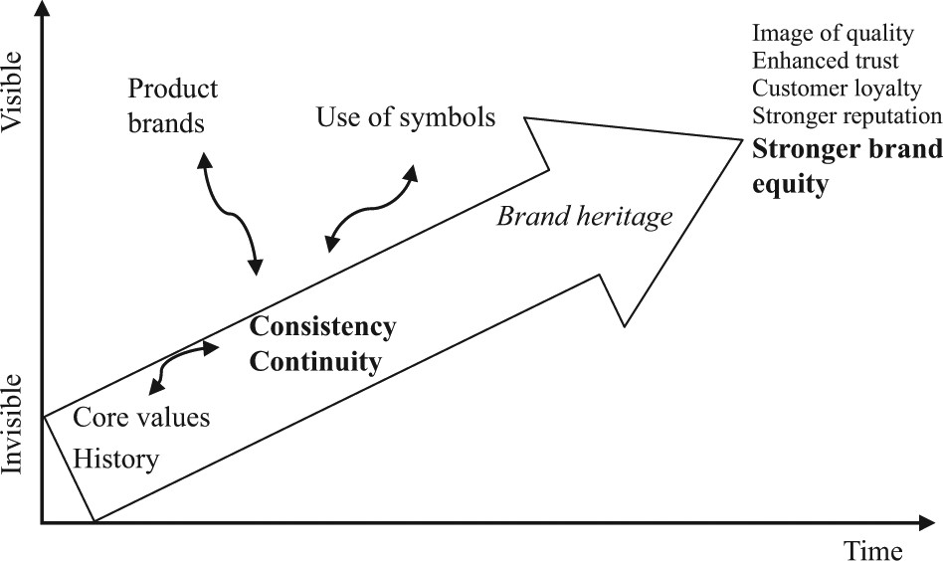
means respecting what has been done before, yet allowing change and improvement. Every new generation brings something new to the brand, but without the previous knowledge and tradition the branding would have to start all over again (Urde et al., 2007; also Percy and Elliott, 2009).

The cultural heritage of the target country
Even though the brand heritage is considered valuable, its significance may vary according to where the brand is marketed: it may have a heritage in a global as well as a local sense, but the two may differ considerably (Van Gelder, 2003). Internationalising companies should therefore consider the extent to which they are able to – or should – utilise the local heritage. As Banerjee (2008) advises, the brand’s heritage should be set in the context of the cultural heritage of the target country, and potential gaps in strength between them weighed up before the target country is approached.
The cultural heritage of the target country is relevant in that – in spite or perhaps because of globalisation – it has an enduring impact on the values of the individuals living in it (Inglehart and Baker, 2000). However, it is a complex phenomenon and assessing its strength is not straightforward. Culture could be defined as a collective programming of the mind that distinguishes the members of one human group from another (Hofstede, 2001). Societies develop their own distinctive cultures over time. The country is often used as the unit of analysis, and there have been various attempts to classify national cultures based on value differences (e.g. Hofstede, 2001; Trompenaars, 1993). However, to our knowledge, there are no country classifications based on differences in cultural heritage.
In line with the definition of brand heritage suggested above we thus define the cultural heritage of a country as a composite of the history and the coherence and continuity of the nation’s distinguishable characteristics. Given that it is a social construction, the understanding of cultural heritage depends on the evaluator’s own historical and spatial context (cf. Arantes, 2007), and in order to be able to compare countries we would need clear, more objective measurement criteria. Moreover, if they are to be of use to companies they should allow fast comparison based on the secondary information available from each country.
According to Banerjee (2008), measurement of the cultural heritage of a country should be based on homogeneity (in fact, he refers to the degree of diversity), endurance, tolerance and impediment, but he does not explain how to do it. In particular, impediment and tolerance would be hard or even impossible to measure in practice. We therefore suggest that two dimensions – homogeneity and endurance – would be sufficient for evaluating and comparing the cultural heritage in different countries.
Measures of homogeneity could be based on the dominance of a single language, ethnic background and religion within a country. For instance, the higher the proportion of speakers of the dominant language, the more homogeneous.

FIGURE 2 The proposed operationalisation of brand heritage
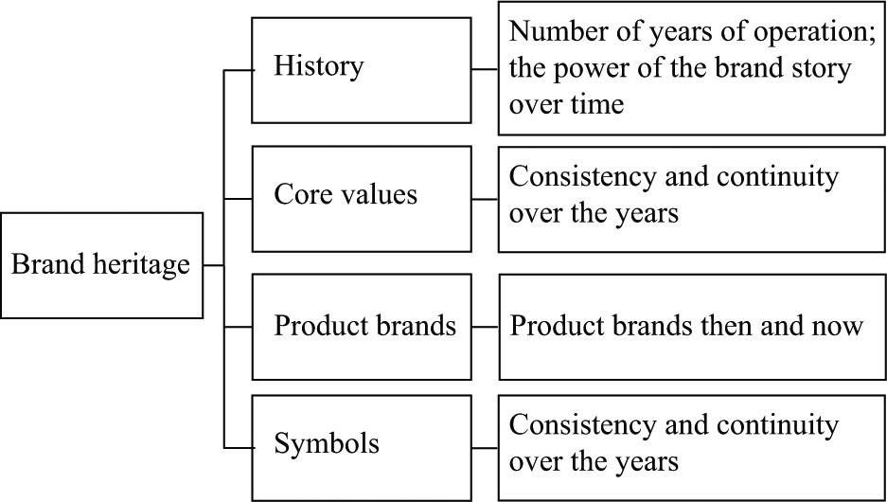

METHODOLOGY
In order to pilot the operationalisations created in the previous sections we decided to concentrate on fast-moving consumer goods (FMCGs). It has been suggested that consumer-goods companies benefit from their heritage more than business-to-business organisations (Holt, 2004), and that more research is needed given that FMCGs rarely include brands that are associated with heritage (Alexander, 2009). Of the various industries represented in FMCGs we selected the food industry. Food is essential to the traditions of a culture, and a company can convey cultural elements of its country of origin along with its food brands (Tellstro¨m et al., 2006).
Empirically we investigated the phenomenon through case research. Case studies are appropriate when there is a need to understand complex phenomena that are not easily separable from their contexts (Eisenhardt, 1989; Yin, 1989). The comprehensiveness that this approach allows is highly relevant to this research because of the novelty of the topic and because of the temporal dimensions of heritage. The study incorporates four cases (four food-product brands), thereby allowing both rich description and systematic comparison (see Miles and Huberman, 1994). The cases were selected on the basis of the companies’ international scope, long history (offering maximum insight into their heritage), access (Finnish cases) and cooperativeness (i.e. information provided and trust gained during previous research projects). The brands chosen for this study were Fazer Puikula bread and Fazer Blue milk chocolate produced the by

FIGURE 3 The operationalisation of cultural heritage

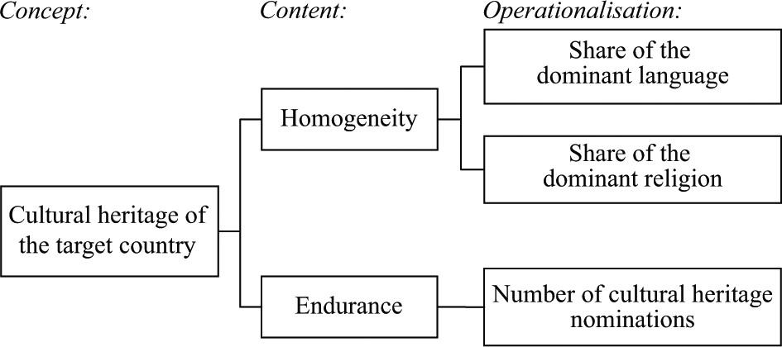
FIGURE 4 Brand strategies for different cultural heritages
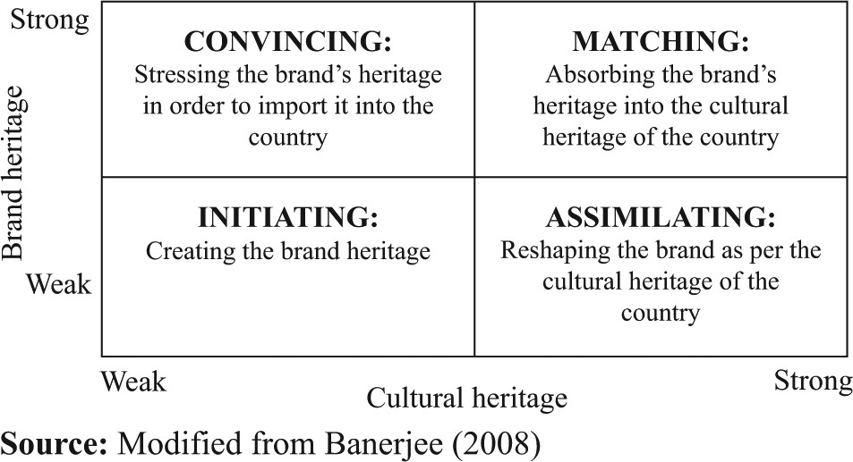
Fazer Group, and Elovena oat flakes and Sunnuntai baking products produced by the Raisio UNESCO World Heritage List was used as a proxy, as explained previously. The measurements of homogeneity and endurance correlated (r ¼ 0:737) in the countries in question. The internal consistency in the measurements and scatter plots shown in Figure 5 indicate good construct validity, but given the lack of previous studies and the small number of countries in the analysis, the results should be interpreted with caution.
Data obtained from different sources were compared, and in the case of contradictory information clarified by means of additional phone calls or e-mails. Banerjee’s (2008) framework was used for the cross-case analysis. The following section presents the results of the empirical study.

Applying the operationalisations in practice
The first case concerns the Fazer Group, the first industrial manufacturer of confectionery products in Finland, founded by Karl Fazer in 1891. Many of the brands that were launched at the time of the company’s foundation are still on the market. Fazer Blue milk chocolate was launched in 1922, and has been voted among the most valuable brands in Finland for many years in sequence. Fazer’s core values have remained the same since its establishment. In terms of symbols, the official logo has undergone small updates over the years but the registered colour remains the same. Fazer Blue was launched just a few years after Finland became independent, and the blue colour is thus – besides of nature – also a symbol of patriotism (cf. the Finnish flag). Continuity is expressed in the made bread, and on a fibre-rich composition.
FIGURE 5 Scatter plots of the measurements related to homogeneity and cultural heritage
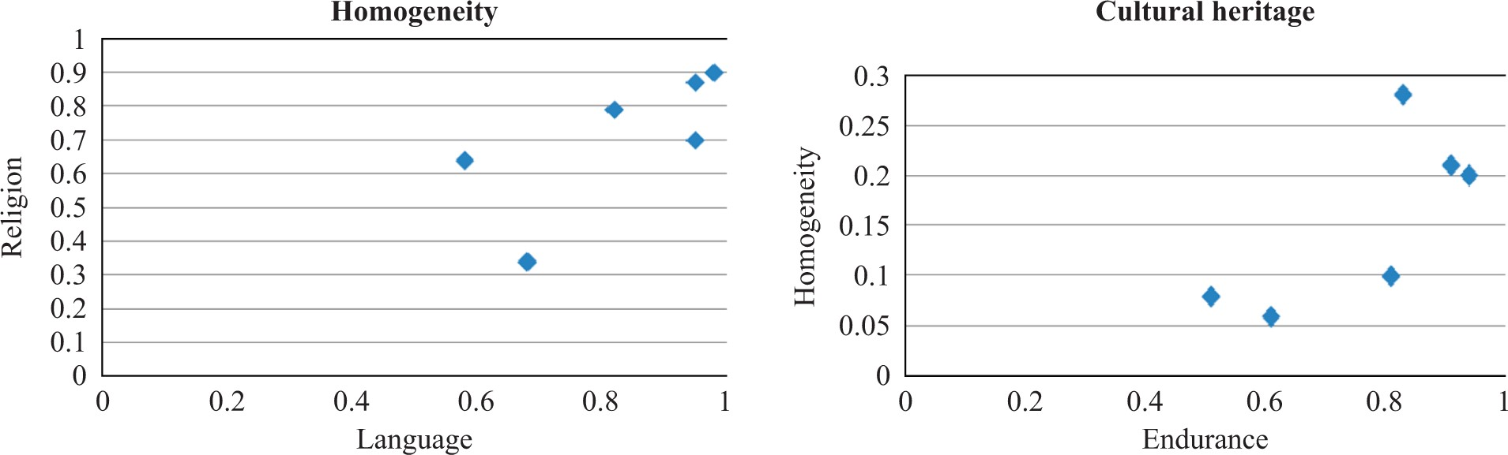
Elovena is an 85-year-old oatmeal brand of the Finnish Raisio Group. Oatmeal was previously a bulk
FIGURE 6 illustrates the proposed brand strategies for the selected cases in their main target markets. Given that all these products appear to have a strong brand heritage, Figure 6 Suggested brand strategies for the selected cases
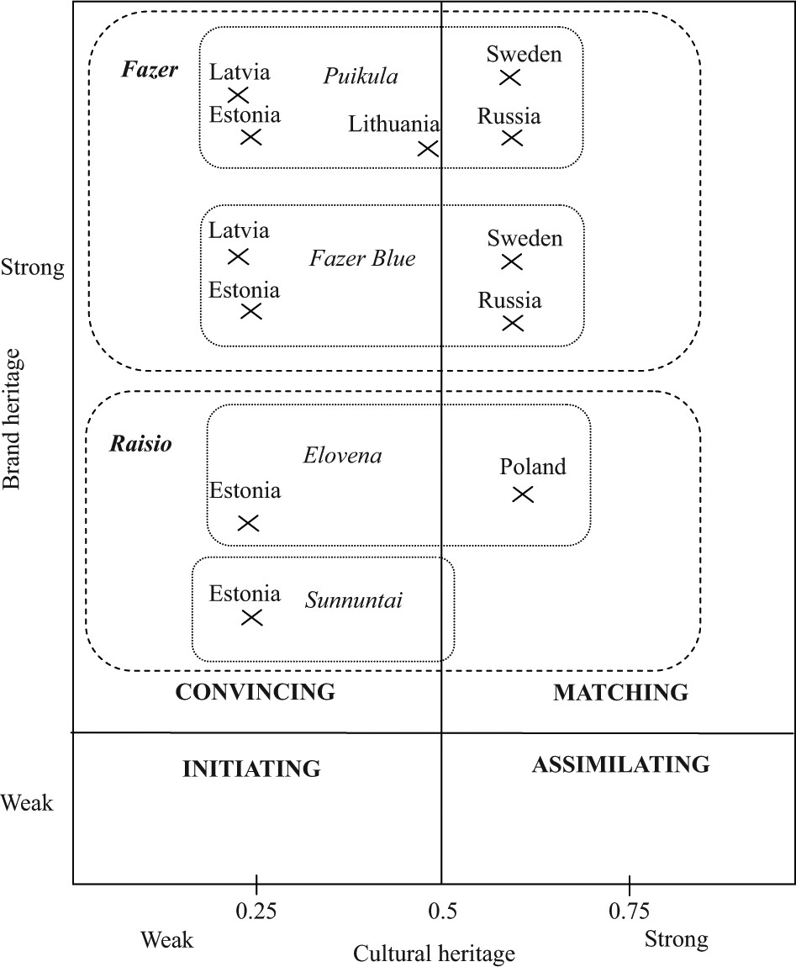
convincing and matching strategies are proposed, depending on the target country’s own cultural heritage.
Fazer Bakeries is active in Estonia, Latvia, Lithuania, Sweden and Russia. According to the framework (Figure 6), given the rather strong cultural heritage in Sweden and Russia is rather strong Fazer could adopt a matching strategy in those countries and a convincing strategy in the Baltic countries. Closer examination of the Puikula bread brand suggests that this assumption partly holds: a convincing strategy is used in Finland and the Baltics, whereas an assimilation strategy seems to have been adopted in Sweden and Russia. In the latter cases the decision stemmed from a market-entry strategy based on acquiring well-known local bakeries.
Fazer Blue milk chocolate is exported to Estonia, Latvia, Sweden and Russia. Again, one would expect to see a convincing strategy in Estonia and Latvia, and a matching strategy in Sweden and Russia. In practice, however, Fazer adopts a convincing strategy in all of the countries: the brand is exactly the same. The name of the company founder, Karl Fazer, is emphasised even more in the international markets than in Finland. The convincing strategy may be justified because of Fazer Blue’s extremely strong image in Finland and the brand’s position as the flagship product of the whole Fazer group.
The Raisio Group’s Elovena oat flakes are sold in Poland and Estonia. According to the framework, a matching strategy should be adopted in Poland and a convincing strategy in Estonia. In fact, the firm uses matching in both countries: the brand differs slightly. The reason why the same strategy was adopted could be that international operations started in Poland and the Estonian market is rather small. It therefore made sense to use the concept developed for Poland in both markets.
The only market outside Finland for Sunnuntai baking products is Estonia. The brand is very strong in the Finnish market and the company did not want to change the product or its name. Consequently, a convincing strategy is utilised. This is in line with the framework.
In sum, the case studies show that, first, the proposed operationalisation of brand heritage and cultural heritage are rather easily applied in practice. Secondly, Banerjee’s (2008) framework for evaluating brand strategies in international markets seems to fit well in some cases but – as the cases presented here show – branding decisions for international markets are influenced by many other things, such as internationalisation strategies, entry modes and the timing of market entry. Cultural heritage could thus be seen as one variable among many others that, through complex interaction, influence branding. This does not diminish its significance, however, but rather evokes the need to understand its interaction with other variables.

DISCUSSION AND CONCLUSIONS
A company’s brand heritage can be a noteworthy competitive tool as it enters international markets. However, brand managers should establish how the markets differ culturally, and construct a marketing strategy accordingly. In other words, the brand’s heritage and the cultural heritage of the target country should be interlinked, thereby enabling companies to assess their relative strength in each target country. Assessment requires the objective operationalisation of both concepts, however, which was the purpose of this study. There have been studies focusing on conceptual definitions, but to our knowledge this is the first one to target operationalisation. Combining the definitions of brand heritage developed by Banerjee (2008) and Urde et al. (2007), and taking into account the measurability and the need to avoid overlapping concepts, we therefore propose that:

P1. Brand heritage is a composite concept incorporating the history of the brand in numbers of years of operation and the power of the brand story over time, as well as the consistency and continuity of the core values, the product brands and the visual symbols.
As Banerjee (2008) suggests, the brand’s heritage should be considered in the context of the cultural heritage of the target country, and potential gaps in strength between them weighed up, before the country is approached. Previous literature (e.g. Hofstede, 2001; Trompenaars, 1993) has classified countries based on cultural differences, but there is a dearth of tools for measuring differences in cultural heritage. This, again, calls for operationalisation. Having taken Banerjee’s (2008) conceptualisation of national cultural heritage as a starting point and converted it into measurable form that proved to be usable in practice, we propose that:
P2. The cultural heritage of a country comprises homogeneity and endurance.
One way of assessing homogeneity is to analyse the coverage of the dominant language and religion, whereas endurance can be ranked in accordance with the number of cultural heritage nominations received.
The empirical application of the above operationalisations to Banerjee’s (2008) framework, which to our knowledge is the first, leads us to our third proposition. It seems that both convincing and matching are often suitable strategies for internationalising companies with a strong brand heritage. We also found that both strategies could sometimes be adopted for one product brand simultaneously in different market areas. The timing of the market entry and the marching order of the markets also seem to matter. Hence:
P3. The utilisation of brand heritage in international markets is influenced by the strength of the brand’s own heritage and the strength of the cultural heritage of the target country, and also by other variables such as the firm’s internationalisation strategy and the timing of the market entry.
Thus, although it is extremely hard to estimate the impact of a country’s cultural heritage on branding decisions – as there are other influencing variables – it should be borne in mind that “there are very few instances where culture does not matter at all” (Leung et al., 2005, p. 368).
The above propositions are drawn from our theoretical discussion and case examples, and further research is needed to support their validity. We suggest that future studies should focus on specifying the circumstances in which cultural heritage matters more and when it matters less. Applicability of the brand-heritage concept should be considered in different product categories, and account taken of the strength of the heritage in the country of origin as well as the familiarity and traditions of the product category in the target market. Overall, more empirical research is needed to test the validity of the suggested operationalisations.
Managers are under increasing pressure to utilise brand heritage more efficiently in international markets. Given that the strategies seem to differ depending on the target countries’ own cultural heritages, we recommend that firms basing their competitive advantage largely on a strong brand heritage in particular carefully consider how to enter countries with a strong cultural heritage. The operationalisations created in this study are easy for practitioners and managers to apply.
Our conclusions should be considered in the light of the limitations of the study. This research is primarily conceptual and the propositions are based on relatively scarce empirical evidence. In particular, the measurement of a country’s cultural heritage is problematic and deserves further consideration. We assumed that both homogeneity and endurance would play an equal role in its determination: this assumption needs to be further deliberated. Furthermore, the utilisation of the UNESCO World Heritage List as a proxy for endurance could be carefully considered in future studies. The overlap between the corporate and product brand heritage may also complicate the operationalisation of the concepts. All that said, we hope that this paper will provide the basis for future discussion, and will act as a trigger for further empirical studies.

REFERENCES
Aaker, D.A. (1996), Building Strong Brands, Free Press, New York, NY.
Aaker, D.A. (2004), “Leveraging the corporate brand”, California Management Review, Vol. 46 No. 3, pp. 6-18. Aaker, D.A. and Joachimsthaler, E. (2000), Brand Leadership, Free Press, New York, NY.
Alexander, N. (2009), “Brand authentication: creating and maintaining brand auras”, European Journal of Marketing, Vol. 43 Nos 3/4, pp. 551-62.
Arantes, A.A. (2007), “Diversity, heritage and cultural politics”, Theory, Culture and Society, Vol. 24 Nos 7/8, pp. 290-6.
Arizpe, L. (2004), “Intangible cultural heritage, diversity and coherence”, Museum International, Vol. 56 Nos 1/2, pp. 130-5.
Ballantyne, R., Warren, A. and Nobbs, K. (2006), “The evolution of brand choice”, Brand Management, Vol. 13 Nos 4/5, pp. 339-52.
Balmer, J.M.T. (2009), “Scrutinising the British monarchy: the corporate brand that was shaken, stirred and survived”, Management Decision, Vol. 47 No. 4, pp. 639-75.
Balmer, J.M.T. and Gray, E.R. (2003), “Corporate brands: what are they? What of them?”, European Journal of Marketing, Vol. 37 Nos 7/8, pp. 972-97.
Banerjee, S. (2008), “Strategic brand-culture fit: a conceptual framework for brand management”, Journal of Brand Management, Vol. 15 No. 5, pp. 312-21. Beasley, R. and Danesi, M. (2002), Persuasive Signs: The Semiotics of Advertising, Mouton de Gruyter, Berlin.
Blomba¨ck, A. and Brunninge, O. (2009), “Corporate identity manifested through historical references”, Corporate Communications, Vol. 14 No. 4, pp. 404-19.
Borja de Mozota, B. (2003), Design Management: Using Design to Build Brand Value and Corporate Innovation, Allworth Press, New York, NY.
Bostedt, G. and Lundgren, T. (2010), “Accounting for cultural heritage – a theoretical and empirical exploration with focus on Swedish reindeer husbandry”, Ecological Economics, Vol. 69 No. 3, pp. 651-7. Boutlis, P. (2000), “A theory of postmodern advertising”, International Journal of Advertising, Vol. 19 No. 1, pp. 3-23. Brown, S. (2001), “The retromarketing revolution: l’imagination au pouvoir”, International Journal of Management Reviews, Vol. 3 No. 4, pp. 303-20.
Brown, S., Kozinets, R.V. and Sherry, J.F. Jr (2003), “Teaching old brands new tricks: retro branding and the revival of brand meaning”, Journal of Marketing, Vol. 67 No. 3, pp. 19-33.
Collins, J.C. and Porras, J.I. (1996), Built to Last: Successful Habits of Visionary Companies, Century, London.
Dahlen, M., Lange, F. and Smith, T. (2010), Marketing Communications: A Brand Narrative Approach, Wiley,
Chichester.
Davis, J.A. (2010), Competitive Success: How Branding Adds Value, Wiley, Hoboken, NJ.
Daymon, C. and Holloway, I. (2002), Qualitative Research Methods in Public Relations and Marketing Communications, Routledge, London.
Diener, E. and Diener, M. (2009), “Cross-cultural correlates of life satisfaction and self-esteem”, in Diener, E. (Ed.), Culture and Well-Being: The Collected Works of Ed Diener, Vol. 38, Springer, Dordrecht, pp. 71-91.
Dinnie, K. (2009), Nation Branding, Elsevier, Amsterdam.
Donner, J. (1991), Fazer 100, Oy Karl Fazer Ab, Helsinki.
Eisenhardt, K.M. (1989), “Building theories from case study research”, Academy of Management Review, Vol. 14 No. 4, pp. 532-50.
Fargher, S., Kesting, S., Lange, T. and Pacheco, G. (2008), “Cultural heritage and job satisfaction in Eastern and Western Europe”, International Journal of Manpower, Vol. 29 No. 7, pp. 630-50.
Fill, C. (2009), Marketing Communications: Interactivity, Communities and Content, Prentice Hall, Harlow.
Flory, M. and Iglesias, O. (2010), “Once upon a time: the role of rhetoric and narratives in management research and practice”, Journal of Organizational Change Management, Vol. 23 No. 2, pp. 113-9.
Greyser, S.A., Balmer, J.M.T. and Urde, M. (2006), “The monarchy as a corporate brand”, European Journal of Marketing, Vol. 40 Nos 7/8, pp. 902-8. Heino, J. (1989), Jyva¨ joka iti, Raision Yhtyma¨n tarina 19391989 (History of Raisio Group), Otava, Helsinki.
Hoek, J. and Gendall, P. (2010), “Colors, brands, and trademarks: the marketing (and legal) problems of establishing distinctiveness”, Journal of Advertising Research, Vol. 50 No. 3, pp. 316-22. Hofstede, G. (2001), Culture’s Consequences, Sage Publications, Thousand Oaks, CA.
Holt, D.B. (2004), How Brands Become Icons: The Principles of Cultural Branding, Harvard Business School Press, Boston,
MA.
Inglehart, R. and Baker, W.E. (2000), “Modernization, cultural change, and the persistence of traditional values”, American Sociological Review, Vol. 65 No. 1, pp. 19-51. Kapferer, J.-N. (2004), The New Strategic Brand Management, Kogan Page, London.
Keller, K.L. and Lehmann, D.R. (2006), “Brands and branding: research findings and future priorities”, Marketing Science, Vol. 25 No. 6, pp. 740-59.
Kellogg’s (2010), available at: www2.kelloggs.com/Pro ductBrand.aspx?id¼207 (accessed 15 October 2010).
Kessous, A. and Roux, E. (2008), “A semiotic analysis of nostalgia as a connection to the past”, Qualitative Market Research, Vol. 11 No. 2, pp. 192-212.
Knox, S. and Bickerton, D. (2003), “The six conventions of corporate branding”, European Journal of Marketing, Vol. 37 Nos 7/8, pp. 998-1016.
Labadi, S. (2007), “Representations of the nation and cultural diversity in discourses on world heritage”, Journal of Social Archaeology, Vol. 7 No. 2, pp. 147-70. Leung, K., Bhagat, R.S., Buchan, N.R., Erez, M. and Gibson, C.B. (2005), “Culture and international business: recent advances and their implications for future research”, Journal of International Business Studies, Vol. 36 No. 4, pp. 357-78.
Liebrenz-Himes, M., Shamma, H. and Dyer, R.F. (2007), “Heritage brands – treasured inheritance or ‘over the hill’”, paper presented at the Marketing History at the Center Conference (CHARM), Durham, North Carolina, 17-20 May, pp. 140-5.
Lindemann, J. (2003), “Brand valuation”, in Clifton, R. and Simmons, J. (Eds), Brands and Branding, Profile Books, London, pp. 27-45.
Loveland, K.E., Smeesters, D. and Mandel, N. (2010), “Still preoccupied with 1995: the need to belong and preference for nostalgic products”, Journal of Consumer Research, Vol. 37 No. 3, pp. 393-408.
Miles, M.B. and Huberman, A.M. (1994), Qualitative Data Analysis, 2nd ed., Sage Publications, Thousand Oaks, CA.
Nuryanti, W. (1996), “Heritage and postmodern tourism”, Annals of Tourism Research, Vol. 23 No. 2, pp. 249-60.
Percy, L. and Elliott, R. (2009), Strategic Advertising Management, 3rd ed., Oxford University Press, New York, NY.
Rao, K. (2010), “A new paradigm for the identification, nomination and inscription of properties on the World Heritage List”, International Journal of Heritage Studies, Vol. 16 No. 3, pp. 161-72.
Ryans, J.K. Jr, Griffith, D.A. and White, D.S. (2003), “Standardization/adaptation of international marketing strategy”, International Marketing Review, Vol. 20 No. 6, pp. 588-603.
Schwartz, S.H. (1994), “Are these universal aspects in the structure and contents of human values?”, Journal of Social Issues, Vol. 50 No. 4, pp. 19-45.
Simo˜es, C. and Dibb, S. (2001), “Rethinking the brand concept: new brand orientation”, Corporate
Communications, Vol. 6 No. 4, pp. 217-24. Sullivan, E.A. (2009), “Believe in yesterday”, Marketing News, Vol. 43 No. 15, p. 8.
Tellstro¨m, R., Gustafsson, I.-B. and Mossberg, L. (2006), “Consuming heritage: the use of local food culture in branding”, Place Branding, Vol. 2 No. 2, pp. 130-43.
Tonta, Y. (2009), “Preservation of scientific and cultural heritage in Balkan countries”, Program, Vol. 43 No. 4, pp. 419-29.
Trompenaars, F. (1993), Riding the Waves of Culture, The Economist Books, London.
UNESCO (2010), UNESCO World Heritage Centre, available at http:whc.unesco.org/en/about and www. unesco.org/culture (accessed 13 October 2010).
Urde, M. (2003), “Core value-based corporate brand building”, European Journal of Marketing, Vol. 37 Nos 7/8, pp. 1017-40.
Urde, M., Greyser, S.A. and Balmer, J.M.T. (2007), “Corporate brands with a heritage”, The Journal of Brand Management, Vol. 15 No. 1, pp. 4-19. Van Gelder, S. (2003), Global Brand Strategy, Kogan Page, London.
Vestergaard, T. and Schrøder, K. (1985), The Language of Advertising, Basil Blackwell, New York, NY. Winkler, A. (1999), Warp-speed Branding, John Wiley & Sons, New York, NY.
(The) World Factbook (2010), Central Intelligence Agency, Washington, DC, available at www.cia.gov/library/ publications/the-world-factbook/ (accessed 13 October 2010).
Yin, R.K. (1989), Case Study Research: Design and Methods, Sage Publications, Newbury Park, CA.

About The Authors

Fazleen N and Anu Keerthana D .
Students of Sri Krishna College of Arts and Science.
Currently pursuing M.Com.

