GPS BASED TOLL COLLECTION SYSTEM
Using RFID
1Manjula.S ,2Sandesh V, 3Prajwal B,
1Assistant Professor, 2,3UG Scholar Department of Information Science and Engineering, BMS College Of Engineering, Bangalore
Email: manjulas.ise@bmsce.ac.in, sandesh.is18@bmsce.ac.in, prajwal.is20@bmsce.ac.in

Abstract: The rapid growth of road transportation demands efficient toll collection systems that can alleviate traffic congestion and streamline the toll collection process. In response to this need, this project proposes GPS-based toll collection system has emerged as a promising technology for automating toll collection and enhancing overall system efficiency. This research paper aims to explore and analyse the implementation and impact of GPS based toll collection systems. The GPS-based toll collection system utilizes GPS technology to locate vehicles and calculate toll charges based on the distance travelled. In-car GPS-enabled devices establish a connection with toll collection computers, transmitting vehicle location data and other relevant information. This data is then processed to determine the toll cost, considering the distance covered and toll rates at each checkpoint. The findings of this study will contribute to the existing body of knowledge on toll collection systems and provide insights for policymakers, transportation authorities, and researchers interested in optimizing toll collection processes. Ultimately, the implementation of GPS-based toll collection systems holds immense potential to enhance efficiency, reduce traffic congestion, and improve the overall transportation experience for road users.

Keywords: GPS technology, Traffic flow, Efficiency, Toll rates, Distance-based tolling, Automated toll collection, Vehicle location tracking.

I. INTRODUCTION

In recent years, The efficient collection of tolls on roadways is a critical aspect of modern transportation systems. With the rapid growth of road networks and the increasing volume of vehicles, traditional manual toll collection methods have become a major source of traffic congestion and inconvenience for commuters. In response to these challenges, the emergence of GPS-based toll collection systems has shown immense promise in revolutionizing toll collection processes, enhancing efficiency, and reducing traffic congestion. The GPS-based toll collection system leverages advanced Global Positioning System (GPS) technology to automate the identification, tracking, and charging of vehicles passing through toll plazas. By eliminating the need for manual toll collection, this system offers numerous advantages over conventional methods. It significantly expedites the toll collection process, allowing vehicles to pass through toll plazas more swiftly, thereby reducing travel time and minimizing fuel wastage.

II. MOTIVATION OF THE RESEARCH

The motivation behind implementing a GPS based toll collection system is to improve
the efficiency, accuracy, and convenience of the toll collection process.
The motivation for this topic can be seen in the following ways:

Increased Efficiency
The system eliminates the need for manual toll collection, which can be slow and prone to human error. Automated toll collection using GPS technology is faster and more efficient, making the process smoother for both users and toll
collection agencies.

B. Traffic Flow Management
The GPS-based technology can assist in improving the flow
of traffic at toll plazas by automating the toll collecting procedure.

C. Real-time Tracking
The GPS based system allows for real-time tracking of vehicles, making it easier to manage the flow of traffic and monitor for any incidents. The FastTag system, on the other hand, requires a physical device to be mounted on the vehicle, which may not provide real-time tracking.

D. Better Integration with other Systems
The GPS based system can be easily integrated
with other systems such as traffic management, road safety, and vehicle tracking. This provides a more comprehensive solution for the management of toll roads.

E. Convenience
The system allows for automatic payment of toll fees, either through a prepaid account or credit/debit card. This eliminates the need for users to carry cash or wait in line to pay the toll fee.

III. RELATED WORK

- GPS-based toll collection system that utilizes the Global Positioning System (GPS) to track vehicles and collect tolls electronically. It presents the system architecture and implementation details, allowing for efficient and automated toll collection on highways. The proposed system consists of an automated toll collection system (ATCS) server, toll collection points, and in-vehicle units (IVUs).
- The automated toll collecting system for toll gates based on RFID Technology is described in this research paper. The mechanism for collecting tolls is divided into three parts. They are the RFID system, the host Computer’s balance deduction system, and the toll gate control system. The stepper motor and LCD display of the deposit are both managed by the microcontroller. The authorized person at the toll gates can use the database on a PC to check the ID number, vehicle numbers, and the balance.
- The license plate recognition (LPR) system is one type of Intelligent Transportation Systems (ITS), and it has attracted a lot of attention because to its prospective applications in sectors like highway electronic toll collection, red-light enforcement, secure-access control at parking lots, and others. The system framework and work flow are introduced in the article.
- Using their mobile devices, vehicles may pay tolls using a Mobile Electronic Toll Collection (ETC) system rather than stopping at a toll booth. The system locates a car using GPS and mobile networks, and then charges the driver's account immediately. By connecting this kind of ETC system with an online payment system, it may be utilized for e-commerce applications, giving drivers the ability to quickly control their toll charges and make payments via their mobile devices. A transponder or electronic tag that can connect with toll sensors on the roadway is installed in each vehicle as part of the mobile electronic toll collection system. The transponder or tag is connected to the driver's phone or account, and when the car goes through a toll plaza, the account is automatically debited of the toll payments. By doing away with the necessity for drivers to carry cash or credit cards and cutting down on time spent at toll booths, the system enhances traffic flow.
- A The design of an automated toll collection system using RFID technology uses and RFID reader and an antenna to detect the presence of an RFID tag attached to the vehicle The system also uses a database which stores the details of the vehicles along with their associated RFID tag details. The system includes a GPS module to track the location of vehicles and calculates the toll fee. The system is designed to be efficient and cost effective and can be used for short-term and long-term toll collection.
- Utilizing an Arduino Uno, an automated toll collecting system may incorporate functions like anti-theft and vehicle document verification using a variety of sensors and components. The system is capable of detecting the presence of a vehicle using IR sensors and RFID technologies for document verification. The technology can track the position of the vehicle and issue notifications in the event of unlawful movement as part of its anti-theft capabilities. To verify the car's details and determine toll fees depending on the kind of vehicle and distance traveled, the system can interface with a database. The toll fees that have been collected can be shown on an LCD screen and recorded in a database for further use. For anti-theft and vehicle document verification, you can use an OCR (Optical Character Recognition) module to read the vehicle number plate and compare it with a database of registered vehicles. If the vehicle is not registered or if the vehicle document has expired, the system can raise an alarm and prevent the vehicle from passing through the toll plaza.
- Intelligent Toll Path System Using GPS (Global Positioning System) and GSM (Global System for Mobile Communications) is an advanced technology-driven solution designed to optimize and enhance toll collection processes on highways and roadways. This system leverages the capabilities of GPS and GSM technologies to provide efficient and seamless toll collection, improved traffic management, and enhanced user experience for both toll authorities and motorists. The Intelligent Toll Path System using GPS and GSM offers numerous benefits, including increased toll collection efficiency, reduced operational costs, improved traffic flow, enhanced safety, and enhanced user satisfaction. By harnessing the power of advanced technologies, this intelligent system revolutionizes the toll collection process, transforming it into a seamless and smart experience for both toll authorities and road users.
- Automated Toll Collection using the application of Image Processing and Blockchain is an innovative approach to streamline and enhance the toll collection process on highways and roadways. This system leverages the capabilities of image processing technology and blockchain technology to create a secure, efficient, and transparent toll collection system. The collected fees can then be recorded on a blockchain ledger, providing a secure and transparent record of all transactions. This system can provide faster, more efficient and secure toll collection, reducing the need for manual toll booths and minimizing the chances of errors or fraud. The use of blockchain technology ensures that the collected fees cannot be altered or tampered with, adding an extra layer of security to the system.
- The Electronic toll collection system using Automatic number plate recognition is a system that uses optical character recognition technology to read vehicle registration plates and automatically calculate the tolls due. The system is used to collect tolls from vehicles passing through toll plazas without the need for manual processing or payment. The system allows vehicle owners to pass through a toll without stopping or slowing down, thereby increasing efficiency and reducing traffic congestion. ANPR technology is used to capture and recognize the vehicle's registration plate, while an integrated payment system is used to process payments. This system also provides an efficient system for law enforcement to identify vehicles that are not paying the toll as well as providing a real time view of traffic flow at toll plazas.
- The IoT-based Toll Collection System using Image Processing is an advanced solution that combines the power of Internet of Things (IoT) technology and image processing techniques to create an efficient and automated toll collection system on highways and roadways. This system utilizes a network of interconnected devices, cameras, and image processing algorithms to streamline the toll collection process and improve overall efficiency. The system incorporates IoT technology to establish connectivity between various components involved in the toll collection process. This includes cameras, sensors, toll gates, and a centralized control system. IoT enables seamless communication and data exchange between these devices. The system utilizes cameras equipped with image processing algorithms to capture images of vehicles passing through toll gates. The images are then processed to extract relevant information, such as license plate numbers, vehicle type, and other identification details.
- A computer vision-based toll collection system is an advanced solution that utilizes computer vision technology to automate and streamline the toll collection process on highways and roadways. This system employs cameras and computer algorithms to capture and analyse images or videos of vehicles passing through toll booths, enabling efficient and accurate toll collection. Cameras equipped with computer vision capabilities are strategically placed at toll booths to capture images or videos of vehicles as they approach or pass through the toll plaza. These cameras can be installed overhead or at specific angles to capture clear and accurate vehicle images. The computer vision algorithms analyse the captured images or videos to detect and track vehicles. By using object detection and tracking techniques, the system can identify and follow vehicles in real time, even in varying lighting conditions and different weather scenarios.
- Automated toll collection coupled with anti-theft and vehicle document verification is an integrated solution that combines advanced technologies to enhance the toll collection process while ensuring the security and authenticity of vehicles passing through toll gates. This system integrates automated toll collection mechanisms with anti-theft measures and vehicle document verification to create a comprehensive and secure tolling experience system. The system incorporates automated toll collection mechanisms such as RFID (Radio Frequency Identification) tags, electronic toll collection (ETC) systems, or license plate recognition technology to enable seamless and contactless toll payments. The system incorporates anti-theft measures to enhance security and prevent fraudulent activities. This can include integrating vehicle tracking systems, GPS (Global Positioning System) technology, or vehicle identification numbers (VINs) to ensure that the vehicles passing through toll gates are not stolen or involved in any criminal activities.
[13] Electronic Toll Collection (ETC) systems using microwave technology are advanced solutions designed to automate the toll collection process on highways and roadways. These systems utilize microwave-based communication technology to enable seamless and contactless toll payments, improving efficiency and reducing congestion at toll plazas. Microwave technology is employed in ETC systems to establish communication between the toll plaza infrastructure and the vehicles passing through. Microwave signals are transmitted between antennas installed at toll booths and onboard units (OBUs) mounted on vehicles.

IV. PROPOSED SYSTEM

The system includes the following components:

A. Arduino Uno
Arduino Uno is a microcontroller board based on the ATmega328P microcontroller. The Arduino Uno has 14 digital input/output pins, 6 Analog-inputs, a 16 MHz quartz crystal, a USB connection, and an integrated power supply. The board can be programmed using the Arduino Integrated Development Environment (IDE) and supports C/C++ programming languages. The Arduino Uno is compatible with a wide range of sensors, actuators, and other components, which makes it an ideal platform for a variety of projects.

GPS/GSM Neo-6M
The GPS/GSM NEO-6M is a compact and versatile module that combines GPS (Global Positioning System) and GSM (Global System for Mobile Communications) technologies. This module is commonly used in applications that require real-time location tracking and communication capabilities. The NEO-6M module provides accurate positioning information using GPS satellites and allows for data transmission via GSM networks, making it suitable for a wide range of applications such as asset tracking, vehicle navigation, fleet management, and personal tracking. The NEO-6M module is compact in size, making it suitable for integration into various devices and systems. It operates on low power consumption, making it ideal for battery-powered applications. Its versatility allows for easy integration into different platforms, such as microcontrollers or single-board computers. The module follows the NMEA (National Marine Electronics Association) data protocol, a standard format for GPS data transmission. It provides output data in the form of NMEA sentences, which can be parsed and processed by the host system to extract relevant location and time information. The NEO-6M module requires an external GPS antenna for optimal satellite signal reception. The module typically includes an interface for connecting an active or passive GPS antenna, depending on the specific application requirements.

C. RFID mfrc 522
RFID MFRC-522 module is a popular RFID (Radio Frequency Identification) reader and writer module based on the MFRC-522 chip. It provides a convenient and efficient way to communicate with RFID tags and cards using radio frequency technology. The MFRC-522 module is widely used in applications such as access control systems, attendance systems, inventory management, and electronic payment systems. The MFRC-522 module is built around the MFRC-522 chip, which is a highly integrated RFID reader IC. The chip supports various communication protocols, including ISO/IEC 14443A/MIFARE, making it compatible with a wide range of RFID tags and cards. The MFRC-522 module operates at a frequency of 13.56 MHz, which is a commonly used frequency for RFID communication. This frequency range allows for reliable and efficient communication between the module and RFID tags or cards. The MFRC-522 module typically interfaces with a host system, such as a microcontroller or a single-board computer, using standard communication interfaces such as SPI (Serial Peripheral Interface) or I2C (Inter-Integrated Circuit). This allows for seamless integration into various electronic systems.

D. LED
LEDs (Light-Emitting Diodes) are electronic devices that emit light when an electric current passes through them. LEDs have become increasingly popular and widely used in various applications due to their energy efficiency, durability, compact size, and versatility. Here's a brief introduction to LEDs. LEDs are based on the principle of electroluminescence. When a voltage is applied to the LED, electrons and holes combine within the semiconductor material, releasing energy in the form of light. The colour of the emitted light depends on the specific materials used in the LED.

E. SIM800L
It is a compact, low-power and cost-effective cellular communication module that supports GSM/GPRS networks. It is designed to provide a simple and efficient way of adding wireless communication capabilities to a wide range of devices, including
microcontrollers, single-board computers, and embedded systems. The SIM800L module is equipped with a powerful 32-bit processor, a high-performance GSM/GPRS engine, and a built-in TCP/IP stack that supports a wide range of communication protocols. It supports voice and data communication, as well as SMS and Internet connectivity. This makes it ideal for a variety of applications, including remote control, telemetry, machine-to-machine (M2M) communication, and the Internet of Things (IoT). The module is compatible with a wide range of microcontrollers, such as the Arduino and Raspberry Pi, and it can be easily integrated into existing projects by connecting it to the microcontroller through its serial interface. The module also supports a wide range of power sources, including USB and battery, making it ideal for portable applications. Overall, the SIM800L module is a powerful and versatile cellular communication module that provides a simple and efficient way of adding wireless communication capabilities to a wide range of applications.

F. IR Sensor:
An IR sensor, or Infrared sensor, is a device that detects infrared radiation and converts it into an electrical signal. Infrared radiation is a type of electromagnetic radiation with a wavelength longer than visible light, but shorter than microwave radiation. IR sensors are commonly used in a wide range of applications, including remote controls, security systems, obstacle detection and avoidance systems, and temperature sensing. IR sensors typically consist of an IR sensitive photodiode or phototransistor that detects the incoming IR radiation and converts it into an electrical signal. This electrical signal is then processed by the sensor's electronics to provide an output that indicates the presence or absence of IR radiation. Some IR sensors are designed to detect only the presence of IR radiation, while others are capable of measuring the intensity of the radiation and converting it into a corresponding electrical signal. IR sensors are used in many consumer electronics products, such as televisions, air conditioners, and remote controls, to detect user inputs. They are also used in industrial and commercial applications, such as thermal imaging cameras, and in robotics and autonomous systems, such as obstacle detection and avoidance systems.

The objective of this methodology is to outline the steps involved in designing an automated toll collection system using GPS and SIM card technology. The system aims to gather vehicle information, compare it with toll plaza positions, deduct toll fees, update the vehicle database, and notify users about balance deductions or payment requirements. The system utilizes mobile cell towers to gather vehicle information through SIM cards. Each vehicle is associated with a unique SIM card, which provides identification and communication capabilities.
The system compares the current position of the vehicle, obtained from the mobile cell tower, with the positions of toll plazas. If the vehicle is within a certain range (less than 200 meters) of a toll plaza, the system proceeds with further processing.
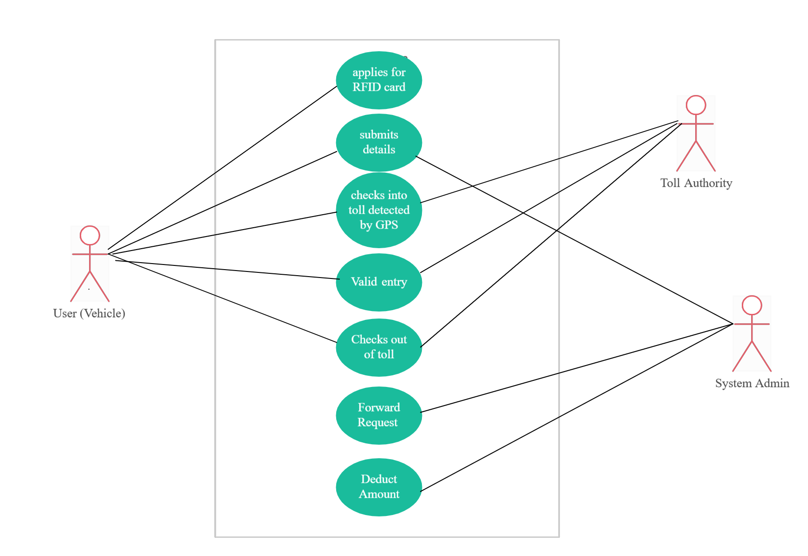

FIG. 1 USE CASE DIAGRAM

V. METHODOLOGY

Once the vehicle is in range of a toll plaza (less than 5 meters), the system analyses the last 5 digits of the SIM card number associated with the vehicle. These digits are used to calculate the toll fee to be deducted from the vehicle's balance. Sufficient Balance Check. The system checks if the vehicle's balance is sufficient to cover the calculated toll fee. If the balance is sufficient, the toll fee is deducted from the vehicle's account. After deducting the toll fee, the system sends an email or message notification to the vehicle owner, informing them about the balance deduction and the remaining balance in their account. If the vehicle's balance is insufficient to cover the toll fee, the system sends an email or message to the owner, requesting payment or account recharge. Upon successful toll deduction, the system lifts the toll plaza barrier, allowing the vehicle to pass through.

A. Algorithm
This project uses the GPS to track the location of vehicle in order to operate and the steps are as follows:
- The system initiates the toll collection process.
- And system utilizes mobile cell towers to collect vehicle information through SIM cards. This information includes the SIM card number associated with each vehicle.
- compares the current position of the vehicle, obtained from the mobile cell tower, with the positions of toll plazas.
- If YES system monitors the vehicle location, If NO the vehicle is not within the toll plaza range.
- If the vehicle in range compare the vehicle location with toll gate.
- If NO ignore, If YES deduct the money by analysing the SIM number.
- Otherwise, it remains locked.
- If it has enough balance deduct money the notification sent to the user of the transaction.
- If the balance is less than the toll fee notification is sent to the user to pay the required fee.

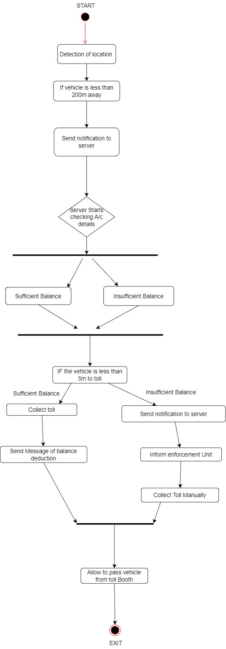
FIG. 2 ACTIVITY DIAGRAM

VI. CONCLUSION

In conclusion, The GPS-based toll collection system has the potential to revolutionize the way tolls are collected. By utilizing GPS technology, toll payments can be collected more
quickly and more efficiently than ever before. This system also offers a variety of advantages to both users and operators, such as improved accuracy, reduced transaction costs, and improved traffic flow. Additionally, this system offers improved road safety with the help of real-time traffic data and can even be used to detect and deter fraud. All in all, the GPS-based toll collection system is an innovative and effective way to collect tolls. Going forward, the GPS based Toll collection system can be further improved and updated to enhance the user experience and ensure the continued security and reliability of the system.
Overall, the implementation of GPS based Toll collection system has been a successful step towards improving the overall efficiency, reducing time and fuel of the users. In summary,

VII. REFERENCE
- Mithya V, Dharani K V, Nivetha A, Praveen Rajkumari G, Roshel Infan M “Smart Highway Toll Collection System” , 2019.
- Apoorva Phaniraj1, Manasa Kashyap, Mayank Prasad3 Mrs.Rashmi M.R,”Electronic Tolling System using Arduino”, 2017.
- Chin E. Lin and Ling Yan Bi,””A Mobile Electronic Toll Collection for E-commerce Application ”,2017.
- Sumathi S M, Nikhitha Kale M, Manasa R, Jithesh A, Megha D.Hegde,”Automatic Toll Collection System Using RFID”, 2018 .
- Dr.V.Bharathi , A.Jayalakshmi, S.Ralya, R.Sharmila, T.Thamizhelvi,”Computer Vision Based Toll System”, 2018
- Neena Sidhu, Akshita Jain, Yashaswita Shukla,T.B.Patil, S.T. Sawant -Patil “Automated Toll Collection Coupled with Anti-Theft and Vehicle Document Verification System Using RFID and Arduino Uno “,2018
- Anandaraj S, Mohana Arasi M, “Intelligent Toll Path System Using GPS and GSM”, 2016.
- S.Amudha Mary, T.S.ShinyAngel and N. Snehalatha , “SMS Controlled Smart Home System In IOT”, Vol.8, No.1 Nov 2016.
- V.sathya M.E, Rishabh Ostwal, Srijan Bhattacharjee, Mohit Karmakar, “Automated Toll Collection using Application of Image Processing and Blockchain,” 2019.
- Malvik Patel, Bharavi Joshi, Kajal Bhagat and Hetakshi Desai, “IOT Based Toll Collection System Using Image Processing”, 2018.
- Jin Yeong Tan, Pin Jern Ker, Dineis Mani & Puvanesan Arumugam, “GPS-Based Highway Toll Collection System: Novel Design and Operation”, 2018.
- GSM/GPS based toll collection system – proposal for Poland ,June 2009 , G. Nowacki , Tomasz Marcin Kaminsk
- Automatic Toll Collection Centre using GSM/GPS proposal for Indian Toll Booths , V.Sathya , Abdul Samath.

