Study the impact of different parameters on driving range of electric vehicle using Matlab Simulink

Sanpreet Singh¹, Baljeet Singh², Arshdeep Kaur³, Satinder Singh⁴
^{1,2,3,4}Department of Electrical Engineering, Guru Nanak Dev Engineering College Ludhiana, Punjab, India.
¹Email: er.sanpreetsingh@gmail.com
²Email: er.sikand@gmail.com
³Email: arshkailay@gmail.com
⁴Email: satinderubhi7@gmail.com
-----------------------------------------------------****-----------------------------------------------------

Abstract - The use of electric vehicles (EVs) has been on the rise due to their eco-friendliness and sustainability as a mode of transportation. Nonetheless, potential buyers remain apprehensive about the limited range of EVs, which can be attributed to their high battery consumption, thus posing a major concern. The purpose of this research is to examine how various factors, such as mass, slope angle, rolling resistance coefficient, and speed, affect the distance an electric vehicle can travel, utilizing MATLAB Simulink for analysis. The study involves the development of a simulation model of an EV, where the various parameters can be adjusted and their effects on the driving range can be analyzed. The MATLAB Simulink software is utilized to create a simulation model, offering a robust means of modelling and simulating dynamic systems. The model's accuracy is confirmed through the utilization of real-world data from an electric vehicle commercially available in the market. Our study’s findings suggest that the incline of the surface, the rolling coefficient, and the speed of the electric vehicle (EV) have a considerable influence on its driving range. As these factors increase, there is a substantial decrease in the range of the EV. Likewise, an increase in the vehicle's weight leads to a decrease in its driving range. The EV owner has control over all the parameters that are being examined in this study, which enables them to enhance the range of their EV by optimizing said parameters. Based on our findings, we suggest that electric vehicle (EV) driver should prioritize reducing the weight of their vehicles to enhance battery efficiency. In addition, it's advisable to maintain a moderate speed and avoid steep inclines to minimize battery consumption. Moreover, choosing a road type of a lower rolling coefficient could also be beneficial.

To summarize, our study shows that the use of MATLAB Simulink to analyze EV parameters can effectively reduce battery consumption, which ultimately leads to an increase in the driving range of electric vehicles. These results are significant because they offer useful guidance to electric vehicle owners who wish to improve their vehicle's energy efficiency. By doing so, they can encourage the widespread adoption of electric automobiles.

Keywords— Electric Vehicle, Battery Electric Vehicle Driving Range, Electric Vehicle Simulation, Electric Vehicle Parameters
1. INTRODUCTION
Currently, global warming stands as the most significant peril facing our planet, Earth. An important reason for this is that modern society relies heavily on transportation that is based on fossil fuels, which is necessary for both economic and social progress. According to estimates, over one billion automobiles used by travellers travel on roads and streets all around the globe [1-2]. First, world is currently grappling with two significant problems, namely the need for energy supply and the demand for it. The world is currently producing approximately 89.9 million barrels of oil on a daily basis in the year 2021 [3]. However, there are up to 1245 billion barrels of acknowledged oil reserves accessible [4]. If we continue consuming oil at the current rate, the world's oil reserves will be depleted within the next fifty years. Second, the planet is experiencing a significant challenge due to a global environmental disparity. The emissions resulting from the usage of petroleum products increase the amount of carbon dioxide (CO2) in the planet Earth atmosphere. The increase in carbon dioxide absorption leads to a temperature increase and the severe weather conditions observed globally. Due to this reason, vehicles with electricity are becoming more prevalent in our world today due to their potential to help mitigate the negative impacts of climate change caused by the use of traditional internal combustion engine (ICE) vehicles. Due to their eco-friendliness, they do not require gasoline or diesel fuel, but instead rely on a reversible energy storage device. In addition, electric vehicles not only use energy but also have the ability to generate, retain, and transfer electricity, making them a highly promising alternative for traditional fuel-powered vehicles.
The prevalence of electric vehicles is increasing progressively. According to a report [5], there has been a significant increase in the adoption of EV in India. The country experienced a 163% growth in the share of electric vehicles, with 324,840 EVs being registered in 2021 compared to the previous year. The number of two-wheeler EVs increased by 422% from 28,508 to 149,068 during the period spanning from 2019-2020 to 2020-2021. Similarly, the sales of electric vehicles with three wheels experienced a surge of 75% from 90,216 to 157,682, while sales of electric four-wheeled vehicles saw a rise of 230% from 4,695 to 15,860. On the other hand, the sale of petrol and diesel vehicles saw a decline of 0.98% in 2021 with 18,312,760 registrations, which is a lesser decline than the previous years of 2020 and 2019, which were at 22.43% and 25%, respectively.
There are various advantages and disadvantages associated with electric-powered vehicles. In terms of efficiency, electricity surpasses the combustion process in vehicles. According to research [6-7], electric vehicles can travel 108 miles (173 km) on the equivalent amount of energy that is produced from 1 gallon (3.8 liters) of gasoline, irrespective of whether the electricity is generated from oil. In contrast, an internal combustion engine (ICE) vehicle can only travel 33 miles (53 km) on the same amount of gasoline.
But, also some disadvantages are there. The primary drawback of many electric cars is their limited driving distance on a single battery charge. Electric cars can travel up to 400 kilometres on one charge, depending on the battery's capacity and conditions under which it operates. In contrast, cars that use internal combustion engines can cover a significantly greater distance on one fill-up of fuel, depending on the capacity of their fuel tank [8]. The limited range of electric vehicles poses a challenge to their wider adoption, as many EV drivers and prospective buyers experience "range anxiety," a phenomenon where they feel uneasy about the possibility of running out of power before reaching their destination. Electric Vehicles limited driving range is largely influenced by their battery consumption. Thus, it is important to study the impact of different EV parameters, such as the mass of the vehicle, slope, co-efficient of rolling resistance, and speed etc, on battery consumption in order to enhance the overall performance of these vehicles [9].
The study the impact of these parameters on driving range is done by using simulation tools such as MATLAB Simulink. Engineers and researchers can model and simulate intricate systems in a virtual setting using the powerful tool, MATLAB Simulink. Using Simulink, we create mathematical models of EVs and simulate different scenarios to study the impact of various parameters on driving range. The Backward-Facing Approach Technique is used in this study to mathematically simulate the components of the electric vehicle system [10].
In addition, the technical specifications of the Nissan Leaf have been employed [11]. To verify and validate the model, the driving range of the EV is estimated using the FTP75 (2474 seconds) driving cycle. Creating a model and simulation of the electric vehicle (EV) is a crucial initial phase in the optimization process. As a result, this investigation put forth a model of the EV automobile utilizing a widely used configuration and evaluated the model by experimenting with various values of distinct parameters. The suggested model will serve as a foundation for future research exploring diverse methods of optimizing energy usage and will be applicable to various optimization approaches.
2. ELECTRIC VEHICLE COMPONENTS MODELLING
Below block diagram represents different components of an EV, which is required to study the impact of different parameters. Block diagram includes motor model, battery model, transmission model, vehicle body model, tyre model and drive source.
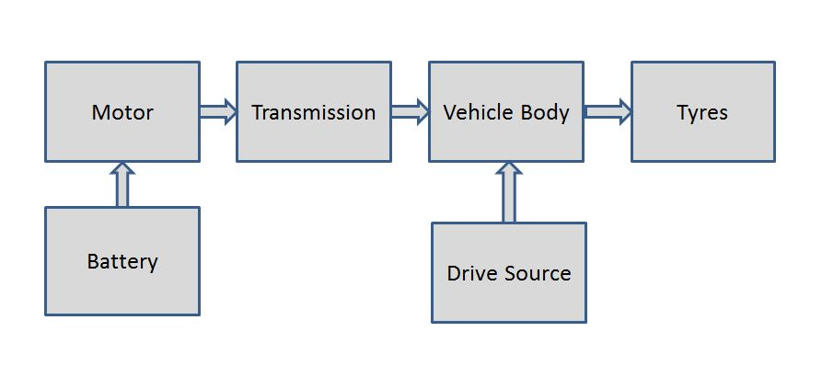
Fig. 1. Block Diagram of EV Model
- Tyre Model
The radius of wheels is an important parameter that affects the overall performance and energy usage of an EV. The radius of the wheels directly affects the distance that the vehicle can travel for a given amount of energy stored in the battery. But the radius of the wheel of a vehicle does not directly provided by the manufacturers. There is some type of marking format, which is providing by the manufacturers. The format of marking on tyres by manufacturers usually includes a series of letters and numbers that indicate various information about the tyre. The size marking will typically be in the format of three numbers separated by a slash [Tyre Width] [/] [Aspect Ratio] [/] [R] [Rim Diameter] (e.g., 250/45/R18).
To determine the wheel's radius, it is necessary to first calculate the height of the tyre's sidewall, denoted as "H".
H = $\frac{Tyre Width × Aspect Ratio}{100}$ (1)
The total wheel diameter, D_{W}, can be calculated by adding the rim diameter to two times the height of the tyre.
D_{W} = $Rim Diameter +2 ×H$ (2)
The radius of the wheel, denoted by R_{W}, is equivalent to half of its diameter.
R_{W} = $\frac{D_{W}}{2}$ (3)
In order to consider the alteration in the shape of the tire due to the weight of the vehicle, a factor of 0.95 can be utilized, which indicates that the radius of the tire will diminish by around 5% when the vehicle is carrying weight.
R_{W} = 0.95 $×$ $\frac{D_{W}}{2}$ (4)
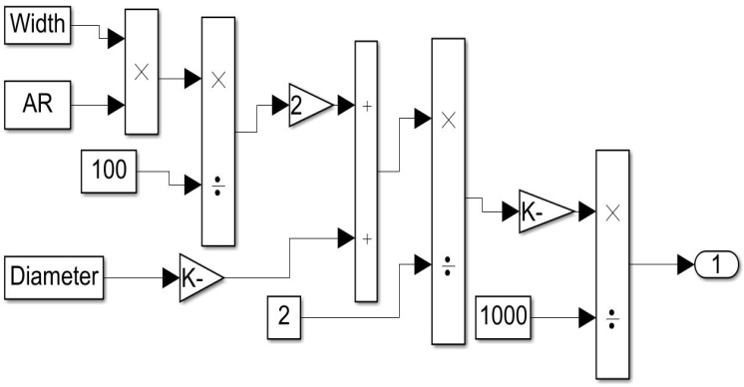
Fig. 2. Tyre Model
- Vehicle Body Model
The total tractive force (F_{TT}) is responsible for propelling the vehicle forward. However, to move the vehicle, the force must overcome the opposing force that acts on the vehicle, known as the vehicle resistance force (F_{VR}) [12].
${ F}_{TT} =F_{aero}+F_{acc}+F_{roll}+F_{grad}= F_{VR}$ (5)
Where,
F_{aero}= force required to overcome aerodynamic drag
F_{acc} = force required to accelerate vehicle against inertia
F_{roll} = force required to overcome rolling resistance
F_{grad} = force required to overcome gradient

- Aerodynamic Drag: Aerodynamic drag refers to the force that air in the surroundings exerts on a vehicle when it is in motion. This drag can be categorized into two types: drag caused by the frontal area of the vehicle and drag caused by skin friction on the body's surface. The mathematical formula for calculating aerodynamic drag is expressed as follows:
$F_{aero}= \frac{1}{2}×ρ×A_{f}×C_{d}×V^{2}$ (6)
Where,
ρ = density of the air
A_{f} = vehicle frontal area
C_{d} = aero-dynamic drag co-efficient
V = velocity of the vehicle
- Acceleration Force: The amount of energy needed to counteract acceleration is referred to as the acceleration force. It can express as follows:
$F_{acc}=m× \frac{dV}{dt}$ (7)
Where,
m = mass of the vehicle
V = velocity of the vehicle

- Gradient Force: Gradient force refers to the force that resists the movement of a vehicle on an incline or gradient, caused by the vehicle's weight and gravity. The subsequent equation represents it.
$F_{grad}=m×g×sinθ$ (8)
Where,
m = mass of the vehicle
g = gravitational constant (9.81 m/s²)
θ = angle of slope
- Rolling Resistance Force: The resistance to motion experienced by a vehicle's wheels as they roll on a surface is referred to as rolling resistance. It is caused by the deformation of the tyres and the friction between the tyres and the road surface, and it affects the fuel efficiency and overall performance of the vehicle.
$F_{roll}=m×g×C_{rr}×cosθ$ (9)
Where,
m = mass of the vehicle
g = gravitational constant (9.81 m/s²)
C_{rr} = coefficient of rolling resistance
θ = angle of slope
The equation provided below allows for the calculation of the wheel torque.
${ W}_{T}=F_{TT}×R_{W}$ (wheel radius) (10)
The equation below is utilized to transform the vehicle's velocity expressed in meters per second to wheel speed (W_{N}).
$W_{N}=\frac{velocity×60}{2π×R_{W}}$ (11)
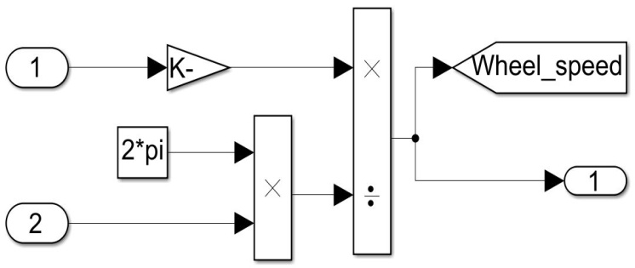
Fig. 3. Vehicle Body Wheel Speed Subsystem Model
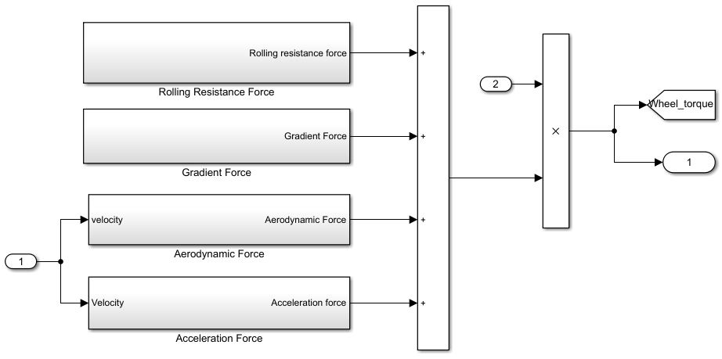
Fig. 4. Vehicle Body Wheel Torque Subsystem Model
- Transmission Model
In an electric vehicle, the transmission system consists of a single-speed gearbox or a direct drive system that transfers power from the electric motor to the wheels. This is because electric motors have a wider operating range compared to internal combustion engines and can deliver maximum torque from zero RPM, eliminating the need for a multi-speed gearbox. The equation presented below is utilized to convert the wheel torque (W_{T}) into motor torque (M_{T}).
$M_{T}=\frac{W_{T}}{transmission efficiency×gear ratio}$ (12)
The equation provided below expresses the motor's rotational speed in revolutions per minute (rpm).
$M_{N}=W_{N}×gear ratio$ (13)
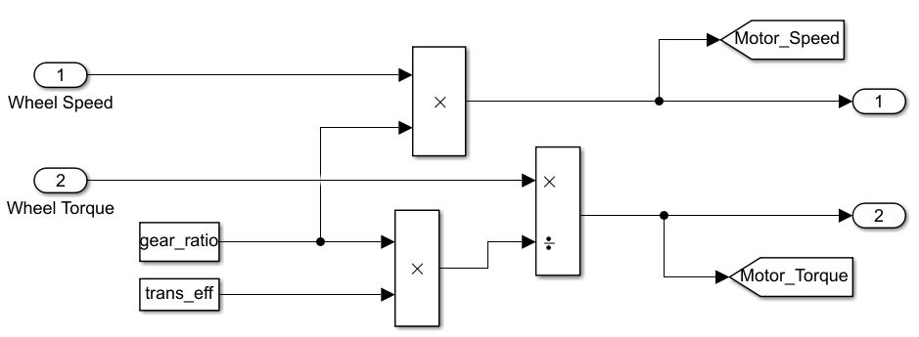
Fig. 5. Transmission Model
- Motor Model
In electric vehicle, the torque and power which is required to move a vehicle is provided by a motor. There are number of motor types (such as BLDC, PMSM, and Induction Motor etc.) which can be used as vehicle propulsion according to our choice. The rating of the motor power can be calculated by the following equation
$M_{P}=\frac{2π×M_{N}×M_{T}}{60}$ (14)
The actual motor power is calculated by the equation
$M_{Pactual}=\frac{M_{P}}{motor efficiency}$ (15)
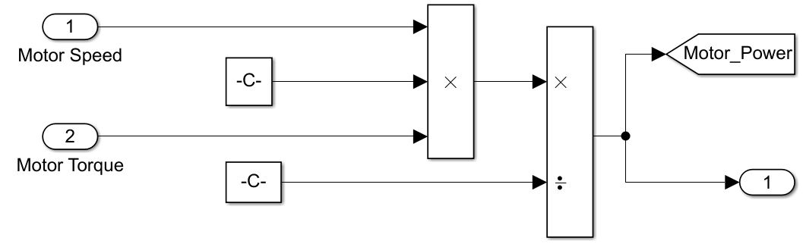
Fig. 6. Motor Model
- Battery Model
A battery pack in an electric vehicle is a collection of individual batteries that store and provide electrical energy to power the vehicle’s electric motor. These cells are typically lithium-ion and are connected together to provide the necessary voltage and current to propel the vehicle. The battery pack is usually located underneath the floor of the vehicle to optimize space and weight distribution. Some battery model calculation is done by using following equation
$Battery power B_{P}=\frac{M_{Pactual}}{motor controller efficiency}$ (16)
Battery capacity into A-h is calculated by
$Battery capacity=\frac{battery capacity in Wh}{battery voltage}$ (17)
The abbreviation SOC stands for State of Charge, to determine the battery's SOC, the subsequent formula is employed.
$$SOC(t)=SOC(t_{0})±\int_{t_{0}}^{t}{\frac{I(t)}{C}}dt$$
Where,
SOC (t) = state of charge at time t
SOC (t₀) = initial state of charge at time t₀
I (t) = current following into or out of the battery at time t
C = battery capacity in ampere-hours (Ah)
t₀ = initial time
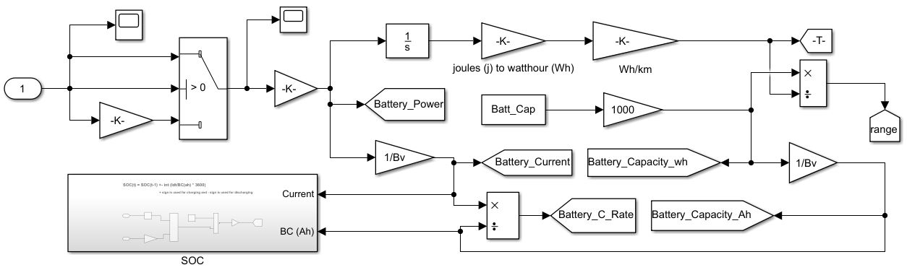
Fig. 7. Battery Model
- Drive Source (Drive Cycle)
In our paper, we examine a single drive cycle called FTP75 stands for 'Federal Test Procedure', which is represented as a velocity-time graph, serving as the driving pattern input. The FTP75 cycle lasts for 2474 seconds, which is equivalent to roughly 41 minutes, and it involves travelling a distance of approximately 17.7 kilometres. The drive cycle is designed to accurately reflect challenging driving scenarios, including frequent acceleration and braking. This makes it an excellent tool for assessing electric vehicle performance in a wide range of real-world situations. It reflects more accurately the way people drive today. Our electric vehicle model should autonomously follow this pattern effectively as the drive cycle is inputted to the vehicle. In addition, there are two more inputs with an average velocity of approximately 59.33 km/hr (rounded to 60 km/hr) and 69.21 km/hr (rounded to 70 km/hr).
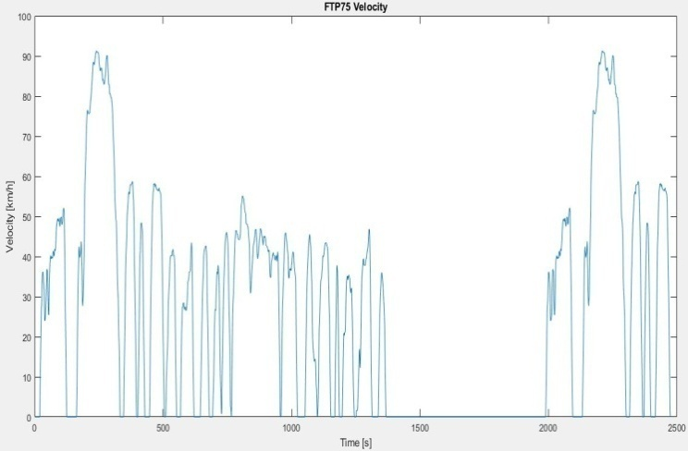
Fig. 8. FTP-75 Drive Cycle
- FTP-75 SPECIFICATIONS
Drive Cycle | FTP-75
Time (s) | 2474
Distance (km) | 17.7
Top Speed (km/h) | 91.2
Average Speed (km/h) | 25.86

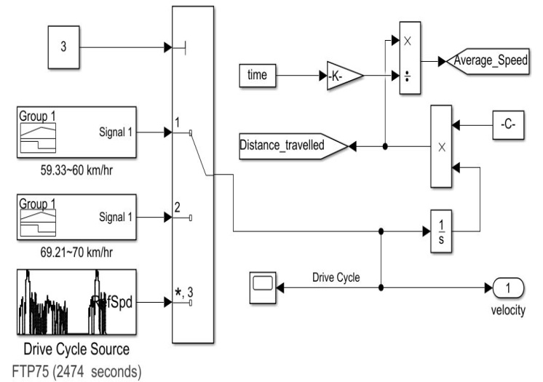
Fig. 9. Drive Source Model
3. ELECTRIC VEHICLE TECHNICAL SPECIFICATIONS
To properly analyze the influence of various parameters, it is essential to have a thorough understanding of all technical specifications related to the Nissan Leaf SV vehicle, which will serve as the basis for the simulation in this study.
- NISSAN LEAF EV TECHNICAL SPECIFICATIONS
Parameters | Value
Mass of Vehicle | 1570
Tyres | 215/50/R17
Drag Coefficient | 0.28
Frontal Area (m²) | 2.27
Coefficient of Rolling Resistance | 0.013
Gear Ratio | 8.19
Rated Voltage | 360
Battery Capacity (Kwh) | 40
Air Density (kg/m³) | 1.127
Rated Load (kw) | 110
Maximum Torque (Nm) | 320
Slope Angle | 0
Regenerative Braking Efficiency | 50%
Transmission Efficiency | 97%
Motor Efficiency | 95%
Motor Controller Efficiency | 95%

4. SIMULATION RESULTS AND DISCUSSIONS
First, we simulate the model of Nissan leaf according to their above mentioned technical specifications, to figure out their actual outputs like driving range, SOC, motor torque, motor speed and battery power. After this we simulate the model with different parameters by changing their value, to determine the impact of different parameters on the range of Nissan leaf EV.
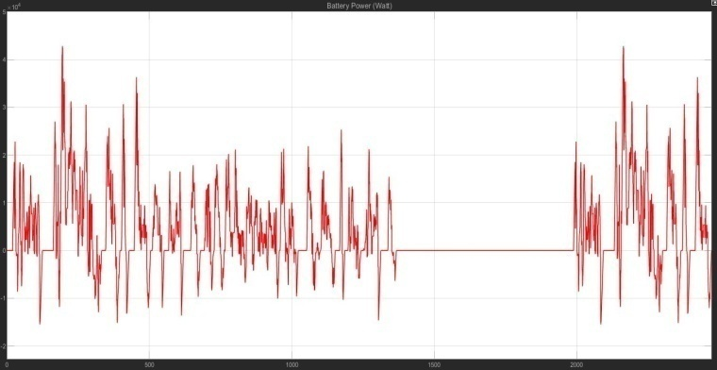
Fig. 10. Battery Power
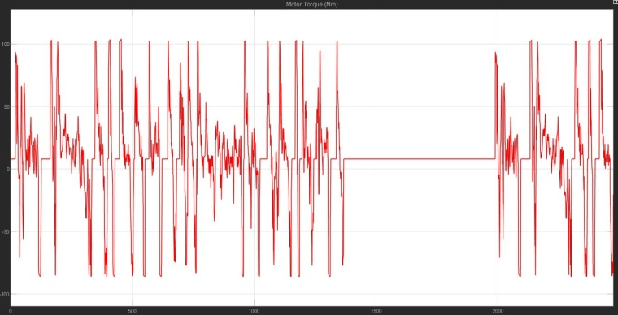
Fig. 11. Motor Torque
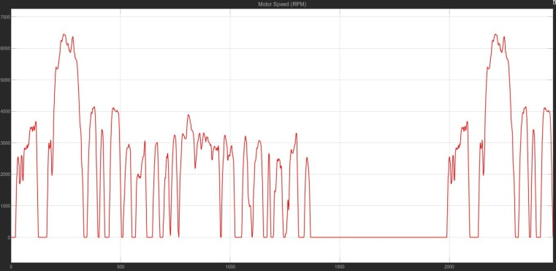
Fig. 12. Motor Speed
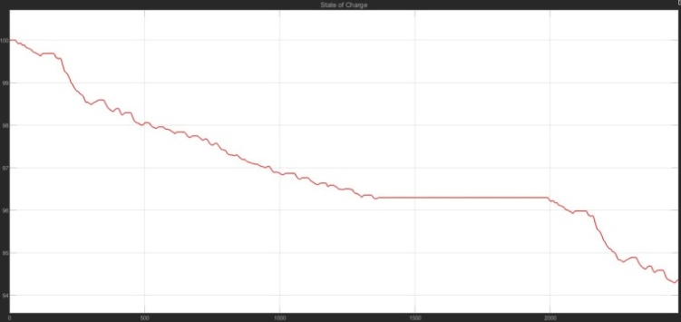
Fig. 13. SOC
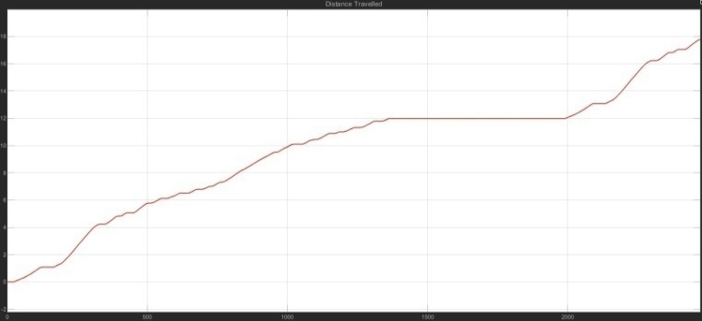
Fig. 14. Distance Travelled
In the above result, we observed that according to the given drive cycle, the EV covered a distance of 17.7 km within a duration of 2474 seconds while maintaining a remaining state of charge (SOC) of 94.3%. Additionally, we found that the Nissan leaf EV maximum range at full charge is 313.8 km [13]. However, it is worth nothing that the 80% depth of discharge (DOD) range, which is considered a more practical measure, is found to be 251 km. We also found that the top motor speed and top motor torque is 6452 rpm and 104 Nm respectively, according to given drive cycle. This suggests that the Nissan leaf EV is capable of covering significant distances on a single charge, making it a viable option for daily commutes and other short to medium distance trips.
Now, we are running the model through various simulations by adjusting its parameters to different values. The parameters we are modifying are under the control of an EV owner and can be adjusted by them. So, they can improve their EV range.
Mass:- It is commonly understood that the range of an EV is adversely affected by its mass. This effect of mass on range is applicable to the Nissan Leaf EV as well. It is evident from the subsequent results that reducing the mass by 100 kg lead to a rise in the average range of 12 km. But, this difference of average 12 km is decreased by further increasing the mass of vehicle.
- NISSAN LEAF EV DRIVING RANGE WITH DIFFERENT VEHICLE MASS
Mass (kg) | Range (km)
2050 | 263.3
1950 | 274.4
1850 | 286.4
1750 | 299.5

Slope:- The degree of inclination of the slope can greatly influence the driving range of an electric vehicle. Ascending slopes can increase energy consumption, reducing the range, while descending slopes can increase energy regeneration, extending the range. Steeper slopes will have a greater impact on range than shallower ones. When simulating the Nissan Leaf model, varying degrees of slope angle are used to generate results related to its driving range. By altering the angle of a slope, a significant difference in the driving range can be observed.
- NISSAN LEAF EV DRIVING RANGE WITH DIFFERENT SLOPE ANGLE
Slope Angle (deg) | Range (km)
4 | 86.11
3 | 105.7
2 | 136.5
1 | 191.4
0 | 313.8

Co-efficient of Rolling Resistance:- The Co-efficient of rolling resistance (C_{rr}) is a dimensionless value. It varies according to the nature of the surface on which vehicle drive. For example, the rolling resistance co-efficient between rubber tyres and concrete is different from that between rubber tyres and a metal track. Show in the table 5 some typical values for the rolling resistance coefficient of cars on different road surfaces.
- SURFACE TYPE AND C_{RR}
Type of Surface | C_{rr}
Soil Road | 0.1-0.35
Macadamized Road | 0.025
Gravel Ground | 0.02
Concrete or Asphalt | 0.013

The energy usage and driving range of EV’s can be impacted by the rolling resistance co-efficient of various road surfaces. Road Surfaces with higher co-efficient of rolling resistance (like soil road) require more energy to maintain a certain speed, resulting in reduced driving range, while road surfaces with lower co-efficient (like concrete and asphalt) can increase the range. The effect of varying rolling resistance co-efficient on the driving range of the Nissan Leaf can be observed as follows.
- NISSAN LEAF EV DRIVING RANGE WITH DIFFERENT ROLLING RESISTANCE CO-EFFICIENT
C_{RR} | Range (km)
0.1 | 72.64
0.025 | 218.4
0.02 | 250.5
0.013 | 313.8

Speed:- Driving at higher speeds will typically decrease the driving range of an EV compared to driving at lower speed. There are a few reasons for this. Firstly, when an EV travels at high speeds, it has to work harder to overcome aerodynamic drag. This means that more energy is needed to maintain the same speed. Secondly, the faster an EV is driven, the more energy is needed to accelerate and maintain that speed. It can be stated that the increased speed leads to a greater demand of power from the battery, which subsequently decreases the distance that can be travelled. In this instance, it is observed that the Nissan Leaf covers a distance of 403.8 km while travelling at a constant speed of 60 km/hr (average 59.33 km/hr), whereas it covers a distance of 361.8 km at a constant speed of 70 km/hr (average 69.21 km/hr). The reduction in the distance that can be travelled by a vehicle resulted from an increase in both the aerodynamic and acceleration forces. The following figures illustrate that when travelling at 60 km/hr, the acceleration and aerodynamic forces reach 3666 N and 99.5 N, respectively. However, at a speed of 70 km/hr, the acceleration and aerodynamic forces increase to 4254 N and 135.4 N, respectively.
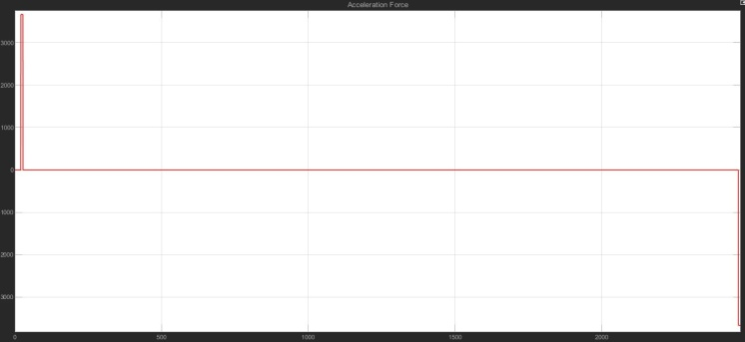Fig. 15. Acceleration Force at 60 km/hr

Fig. 16. Aerodynamic Force at 60 km/hr
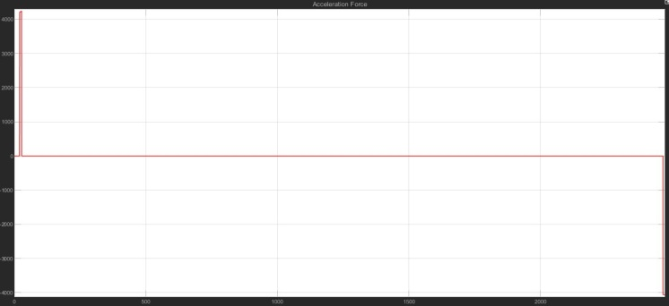
Fig. 17. Acceleration Force at 70 km/hr
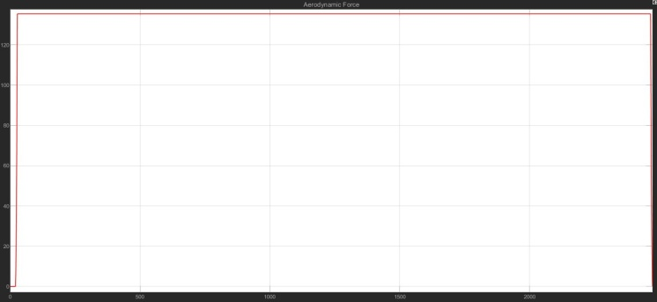
Fig. 18. Aerodynamic Force at 70 km/hr
5. CONCLUSION
This article outlines the creation of a mathematical model for an electric vehicle using MATLAB Simulink. The paper puts forward a model that is simple to understand and implement, and provides a distinct and concise understanding of how various parameters affects the driving range of an EV. To ensure experimental accuracy and verify that the simulation outcomes match the real-world outcomes, the mathematical model was evaluated using the Nissan Leaf EV technical specifications. The parameters which are studied in this paper such as the mass of the vehicle, slope, coefficient of rolling resistance, and speed, can be controlled by the EV owner.
The study found that the Nissan Leaf has a driving range of 313.8 km, according to the standard specifications. The study also revealed that reducing the weight of the vehicle from 2050 kg to 1750 kg led to an increase in the driving range from 263.3 km to 299.5 km. Conversely, increasing the slope angle from 0 degrees to 4 degrees causes a significant drop in the range, from 313.8 km to 86.11 km. Similarly, if the rolling coefficient is increased from 0.013 to 0.1, the range decreases drastically from 313.8 Km to 72.64 Km. Additionally, the driving range is affected by the speed at which the EV is driven. When driven at a constant speed of 60 km/hr, the range is 403.8 km, but when the speed is increased to 70 km/hr, the range drops to 361.8 km.
All the above study's findings are essential as they provide insights for EV owners on how to increase their driving range, which is a critical factor for EV adoption. By optimizing the parameters that affect the driving range, EV owners can reduce their range anxiety and enjoy the benefits of owning an electric vehicle, such as lower operating costs and reduced environmental impact.
Furthermore, the study highlights the importance of taking a holistic approach when evaluating EV range. Rather than focusing on one specific factor, such as battery capacity, this study demonstrates that a range of parameters need to be considered to accurately estimate an EV's driving range.
In conclusion, the study of the impact of different EV parameters on the driving range is a vital step towards the widespread adoption of EVs. The expectation is that the outcomes of this investigation will encourage more EV owners to optimize their driving parameters to increase their driving range, leading to a more sustainable and efficient transportation system.

References
- Bimal K. Bose, “Global Warming: Energy, Environmental Pollution, and the Impact of Power Electronics,” in IEEE Industrial Electronics Magazine, Volume: 4, Issue: 1, March 2010.
- GREEN CAR REPORTS [ONLINE], Available: https://www.greencarreports.com/news/1093560_1-2-billion-vehicles-on-worlds-roads-now-2-billion-by-2035-report
- Oil Production Statistics [ONLINE], Available: https://www.statista.com/statistics/265203/global-oil-production-since-in-barrels-per-day
- Oil Production OPEC Statistics [ONLINE], Available: https://www.opec.org/opec_web/en/data_graphs/330.htm
- EV Sales in India TOI Article [ONLINE], Available: https://www.google.com/amp/s/m.timesofindia.com/business/india-business/ev-sales-up-163-in-2021-up-registers-highest-sales followed -by-karnataka-and-tamil nadu/amp_articleshow/90282217.cms
- V. Wouk, “Hybrids: then and now,” in IEEE Spectrum, Volume: 32, Issue: 7, Jul 1995.
- James F. Miller and David Howell, “The EV Everywhere Grand Challenge,” in 2013 World Electric Vehicle Symposium and Exhibition (EVS27), 2013.
- Emilia M. Szumska and Rafal S. Jureski, “Parameters Influencing on Electric Vehicle Range,” in Energies 2021,14,4821.
- A. Skuza, R. S. Jurecki, “Analysis of factors affecting the energy consumption of an EV Vehicle,” in 2022 the 13th International Conference on Automotive Safety (Automotive Safety 2022).
- A. A. Abulifa, Dr. A. C. Soh, Dr. M. K. Hassan, Dr. R. M. K. Raja Ahamd, Dr. M.A. MohdRadzi, “Mathematical Modelling and Simulation of Battery Electric Vehicle Based on Backward Facing Approach Technique,” Turkish Journal of Computer and Mathematics Education, Vol.12 No.14 (2021), 5032- 5041.
- Nissan Leaf Specifications [ONLINE], Available: https://www.evspecifications.com/en/model/f17918
- T. V. Sarathkumar, M. Poornanand, and A.K. Goswami, “Modelling and Simulation of Electric Vehicle Drive through SAEJ227&EUDC Cycles,” in 2020 IEEE Students’ Conference on Engineering & Systems (SCES) July 10-12, 2020.
- Nissan Leaf Actual Range [ONLINE], Available: https://ev-database.org/car/1106/Nissan-Leaf
- “Fundamentals of Electric Vehicles: Technology & Economics” NPTEL [ONLINE], Available: https://archive.nptel.ac.in/courses/108/106/108106170/

