A Framework for Classifying Brain Tumours using Convolution Neural Networks and Open-Source Computer Vision
Amrut Ranjan Jena¹, Madhusmita Mishra², Ritam Ghosh³, Labanya Nayak⁴, Arkodeep Dey⁵
¹Department of CSE & GNIT, Kolkata
²Department of CSE & DSCSITSC, Kolkata
^{3,4,5}Department of CSE & GNIT, Kolkata

---------------------------------------------------------------------***---------------------------------------------------------------------
Abstract -A doctor diagnoses a patient correctly using the clinical records before prescribing the right medication. The diagnosis of the magnetic resonance imaging report to identify the brain tumour can occasionally take a long time for a medical professional. It has been noted that the tumour tissues resemble normal tissues in appearance. Marking the tumour area in the brain is a difficult task because of this. Cancer is caused by tumours. In order to avoid cancer, tumours must be detected at an early stage and the patient must receive the appropriate treatment. The creation of an automated method to identify and categorise the different types of tumours found in the human brain would simplify this difficult task. In order to detect and categorise tumour and no tumour in the human brain, a model is proposed in this paper by fusing open-source computer vision with three different types of convolution neural networks architectures. The residual neural network design, out of the three alternative hybridised CNN architectures, provides the highest accuracy, with 98.52% and 99.73% over testing and training data, respectively.

Key Words: Brain tumour, CNN, OpenCV, MRI, Cancer, Hybridization

1. INTRODUCTION

A variety of technologies are referred to be "medical imaging" when they are used to see the human body for the purposes of identifying, monitoring, and treating medical disorders. In essence, when human body cells age or are injured, they die and are replaced by new cells. However, occasionally this procedure fails, causing the growth of aberrant or damaged cells. Such cell growth is unhealthy for the human body and health, and it can result in tumours. Tumours can be classified as benign, premalignant, or malignant [1]. They belong under the benign group because they are not malignant. Although those tumours are not cancerous, they have the potential to develop into the type of cancer known as premalignant. Cancerous tumours are classified as malignant tumours. Bones, skin, tissue, organs, and glands are the principal areas affected by tumours. The causes of tumour mainly depend on consume so much alcohol, viruses, radiation exposure, benzene and other chemicals and toxins, obesity, and genetic problems [2]. Sometimes tumours can be malignant. Cancer is essentially a sickness in which a few of the body's cells grow out of control and spread to other bodily areas. According to the World Health Organisation, there will be 18.1 million new cases of cancer worldwide in 2020. Men and women are reported to have 9.3 million and 8.8 million instances, respectively. Numerous cases of cancer caused by brain tumours have been reported in this report.
Cells that grow abnormally in the brain or its surrounding tissues are the source of brain tumours. Their size, nature, and location all affect how they are treated. They might be benign or cancerous. Due to the intricacy of the brain's anatomy and the wide variety of tumour characteristics, diagnosing a brain tumour can be difficult. The management and treatment of brain tumours therefore depend on a precise and prompt diagnosis. The diagnosis of a tumour in the brain region is made more difficult by the intricate anatomy of the human brain. Strong magnetic fields and radio waves are used in the magnetic resonance imaging (MRI), a form of scan, to provide precise images of the inside of the body. High-quality brain images are made available by this and these images are frequently used for tumour diagnosis. Diffusion weighted imaging, an MRI method, aids in illuminating the cellular makeup of the brain. It provides a distinctive, spatially precise virtualization of soft tissues. The second most common malignancy that kills young people nowadays is brain tumours. Successful treatment, well-thought-out planning, and a correct diagnosis of brain tumours all help to control this fatal condition. Recent years have seen studies that have improved both brain tumour identification and treatment. Computing tomography (CT) scanning, MRI, and ultrasound are a few of the medical technologies that can be used. The best technology for finding brain tumours among these is MRI. MRI scans are now the most accurate way to find brain tumours, but interpreting them requires substantial knowledge and experience. Doctors highly recommend it since it offers precise information on the size, kind, and location of individual cells as well as being highly sensitive to local changes in tissue density. A neuroradiologist with extensive training is required to examine MRI pictures. Due of the complexity of the human brain, doctors typically spend more time studying this report. Therefore, researchers have provided alternative suggestions to help clinicians discover and categorise brain tumours. [3][4][5][6][7][8]. Convolution neural networks (CNNs) and other machine learning approaches are used by researchers to automatically detect brain tumours [9]. Integrating open-source computer vision (OpenCV) and CNNs can increase OpenCV's functionality by incorporating CNNs' strong image processing and feature extraction abilities. In order to detect and classify brain tumours from MRI clinical pictures with greater accuracy than existing models, we have hybridised OpenCV with CNN in this article. To normalise the data, OpenCV is applied to clinical MRI images at the data pre-processing stage. The model for tumour identification and classification also employs various CNN architectures. The suggested approach with OpenCV uses three distinct CNN architectures, including basic CNN, residual neural network-50 (ResNet-50), and visual geometry group-16 (VGG-16).
Open-source Computer Vision
It is a well-known open-source image and video processing software library that offers a variety of features and algorithms. Real-time computer vision applications can be created in an environment provided by the OpenCV platform. It is mostly used for image processing, face and object recognition. It is utilised in a number of various industries, including robotics, medicine, industrial automation, security, and transportation. In order to create cutting-edge CPU-intensive applications, Intel Research introduced the OpenCV technology in 1999 [10]. OpenCV's core capabilities include video recording and storage, image processing, image reading and writing, video tracking, object observers, mobile robots, human-computer interaction, and gesture detection. OpenCV supports mobile operating systems like Android, iOS, Maemo, and Blackberry and runs on desktops with Windows, Linux, macOS, OpenBSD, and NetBSD.

Basic convolution neural network
CNNs, also known as basic convolutional neural networks (BCNNs), are a subset of deep learning neural networks that are frequently employed for computer vision tasks like object recognition and image classification. ConvNets is another name for the BCNN. The BCNN is initially used to solve challenges with picture pattern recognition [11]. The BCNN is a supervised learning model with the capacity for training-based self-optimization. In this architecture, there are five layers available: an input layer, a convolution layer, a pooling layer, a fully linked layer, and an output layer. The image is divided into small dimensions by the convolution layer and given to these weighted indivisual neurons. The rectified linear unit (ReLu) activation function is used to complete this task. Additionally, the pooling layer reduces the parameters linked to the image and passes the output to the following fully connected layer. The function of the sigmoid activation is used to carry out this operation. To produce the output, the fully linked layer also does classification. The application of the softmax activation function in this layer facilitates the multi-output characteristics. Figure 1 provides a representation of the architecture of a BCNN.
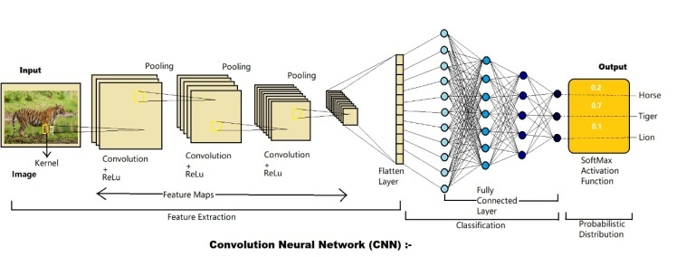
Figure 1.Architecture of the BCNN
Residual Neural Network-50
A deep neural network with fifty deep layers is called the residual neural network-50 (ResNet-50). One maxpool layer, one average pool layer, and forty-eight convolutional layers are added to the original fifty deep neural structures. In order to recognize images, ResNet was introduced in 2016 [12]. A pre-trained version of the network that can train more than a million photos from the image net database can be loaded with images. The relevant network is capable of classifying the images into many object categories, including animals, pencils, keyboards, mice, and more. A ResNet is a type of artificial neural network (ANN) that creates a network by stacking residual blocks on top of one another. It frequently serves as the engine for computer vision applications. ResNet's basic innovation enables users to train 150-layer, extraordinarily deep neural networks. To boost performance, ResNet-50 uses a bottleneck design when constructing the block. A 1×1 convolution is used in bottleneck residual blocks, which helps reduce the number of parameters and matrix multiplications. As a result, each layer's training is completed more quickly. Instead of two layers, there are three layers in the stack. At its core, it makes advantage of batch normalisation. Furthermore, it permits the identity link, which shields the network from the vanishing gradient issue. Figure 2 depicts the ResNet-50 architecture for better visualisation.
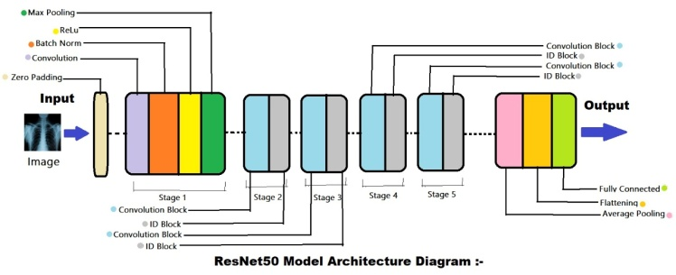
Figure 2.Architecture of the ResNet-50 network
Visual Geometry Group-16
The visual geometry group-16 (VGG-16) is a type of deep neural network has 16 deep layers [13]. The distinguishing characteristic of VGG16 is that it employs the same padding and maxpool layer of a 2x2 filter of stride 2 and concentrates on having convolution layers of 3x3 filters with a stride 1 rather than multiple hyper-parameters. This orientation is consistently maintained throughout the entire architecture. A pre-trained version of the network that can train more than a million photos from the image net database can be loaded with images. The object detection and classification issue areas are where VGG-16 is most frequently used. A variation of the VGG model is the VGG-16. The architecture of the VGG-16 model is displayed in Figure 3.
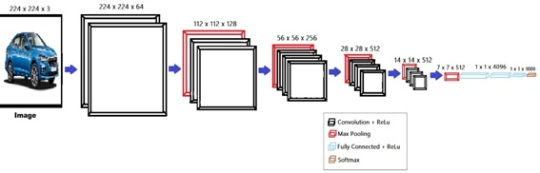
Figure 3.Architecture of the VGG-16 network

Hybridization of OpenCV with CNN
The goal of combining OpenCV and CNNs is to increase the accuracy as well as efficiency of various computer vision applications. Pre-processing the images before feeding them to a CNN for training is the primary purpose of OpenCV. Edge detection, cropping, normalisation, and other image processing and feature extraction operations are all available in OpenCV. Before feeding photos into a CNN, these routines can be used to pre-process the images and extract pertinent information. By lowering the amount of data that needs to be processed, this can enhance the CNN's accuracy and effectiveness.

2. LITERATURE SURVEY

We will examine the present state of research on the application of several CNNs and machine learning models in brain tumour detection and classification in this literature review. The ability of CNNs to increase the accuracy of brain tumour detection has shown significant promise. Several studies have looked into employing CNNs to analyse MRI scans to find brain tumours. For instance, a research by Akkus et al. (2017) found that a 3D CNN could accurately identify 89.5% of brain tumours from MRI scans [14]. Similar to this, Chen et al. (2019) achieved an accuracy of 94.3% in detecting brain tumours from MRI data using a deep learning model based on a CNN [15]. A CNN model called VGG-16 is used to find brain tumours. The VGG-16 model has been applied to a variety of image classification applications, including the interpretation of medical images. For instance, the VGG-16 model was employed in a study by Han et al. (2020) to precisely identify brain tumours from MRI scans with an accuracy of 93.4% [16]. Similar to this, Siddique et al. (2020) reported 97% accuracy in MRI scan-based brain tumour detection using deep convolution neural networks based on the VGG-16 model [17]. Another CNN model that has demonstrated excellent potential in the diagnosis of brain tumours is ResNet-50. A deep neural network called ResNet50, which contains 50 layers, has been applied to a variety of picture categorization applications, including medical image analysis. For instance, the ResNet50 model was employed in a study by Sangeetha et al. (2020) to accurately classify brain tumours from MRI scans with an accuracy of 96.5% [18]. Similar to this, Deshpande et al. (2021) found that the ResNet50 model had an accuracy of 98.14% for detecting brain tumours from MRI scans [19]. Xception, ResNet50, InceptionV3, VGG16, and MobileNet are employed in a study by Saleh et al. (2020) to classify brain tumour from MRI scan brain images with a highest accuracy of 98.75%[20]. A hybrid CNN model is employed in a study by Shwetha et al. (2022) to accurately classify brain tumours from MRI scan pictures with an accuracy of 98% [21]. Google-Net model with SVM and Google-Net model with soft-max classifier were employed in a study by Rasool et al. (2022) to classify brain tumour from MRI scan brain pictures, with the Google-Net model with SVM classifier having the greatest accuracy of 98.1% [22]. An optimised hybrid deep neural network (OHDNN) method has been utilised in a study by Shanthi et al. (2022) to accurately diagnose brain tumours from MRI scan brain pictures with a 97.5% accuracy rate [23]. In order to accurately diagnose brain tumour from MRI scan brain images, Mohsen et al. (2022) employed a hybridization of deep neural network classifier with the discrete wavelet transform (DWT) and principal components analysis (PCA) [24]. Five different machine learning methods, including the multi-layered perceptron (MLP), linear regression (LR), decision tree (DT), Naive Bayes (NB), and support vector machine (SVM), were employed in a study by Shinde et al. (2022) to categorise brain tumours. In comparison to DT, NB, and SVM, they found that MLP and LR provide the best accuracy of 90% [25]. Additionally, in the training and testing phases, the accuracy of our hybridised OpenCV-CNN model with ResNet-50 CNN architecture is 99.73% and 98.52%.

3. PROPOSED MODEL DESIGN

Data pre-processing and data computation are two of the segments that make up the proposed model design. Pre-processing involves gathering data from Kaggle and applying OpenCV to normalize it. After this stage is successfully completed, the normalized data is sent to the data computation section. In this section, classification is carried out using a variety of convolutional approaches like BCNN, Resnet-50, and VGG-16. The suggested model is displayed in Figure 4 for clear visualisation.
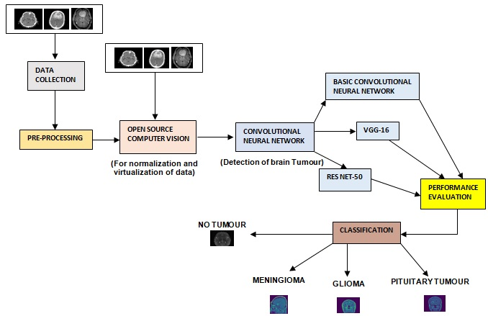
Figure 4.Proposed model design
All of the data images used in this analysis are obtained from the Kaggle platform. Data normalisation and visualisation were carried out using OpenCV, and the optimised "adam" and CNN were used to categorise the brain tumours throughout the entire simulation. Similarly, "numpy," "seaborn," "pandas," "matplotlib," "tensorflow," "torch," "time," "os," and "cv2" libraries are utilised, other python libraries are also used to develop the python code and categorise tumour or no tumour from brain MRI images. With the support of OpenCV, the picture dataset being analysed has already gone through the pre-processing stage. The dataset contains 3162 total brain MRI images that can be used for analysis. The remaining 3064 of the 3162 brain MRI scans are tumor-affected scans, with 98 scans representing a healthy condition. In the analysis, 20% of the whole dataset is used for testing, while the remaining 80% of the data are used to train the model. The computation is done on a laptop running Windows 10 with 6 GB of RAM, an Intel 5 CPU, and Python 3.8. First, the data frame is produced using all of the photos and the correct computer system directory location. Second, OpenCV is with a figure size of 150 × 150 does the data visualization of the images. During the normalization process, the image is changed from colour to grayscale. Furthermore, BCNN, ResNet-50, and VGG-16 are used to classify brain tumours. The activation functions relu, tanh, and softmax are used in VGG-16. 33,612,484 are the trainable parameters here. Next, a batch size of 32 is used for the picture data generator activity, and this batch size is maintained throughout the simulation. For training data, the model highest accuracy at 20 iterations is 39.26%, and for testing data, it is 44.87. Additionally, overfitting results in worse accuracy after model training.
The activation functions relu and softmax are used in BCNN. There are 237,561 trainable parameters here. The layer dropout input scenario is equal to 0.4, and the softmax type function is used for the dense layer input. Additionally, the test size, random state, and batch size parameters used in the picture data generator operation were maintained throughout the simulation at 0.2, 42, and 32, respectively. The model highest accuracy for training data is 97.39% in 20 epochs, while its accuracy for testing data is 90.05. Additionally, overfitting results in worse accuracy after model training.
For the last layers dense input in ResNet-50, the sigmoid activation function is used and the layers dropout input case is set to 0.4. The model's highest accuracy for training data after 20 iterations is 99.73%, while its accuracy for testing data is 98.52. Additionally, overfitting causes the model to be less accurate after training. Three distinct types of neural networks are used in the analysis, and it is determined by using the same dataset which network's accuracy is greater. In all of the networks mentioned above, the loss value is also calculated in the conclusion. Here, the noble met heuristic optimization approach's output response is taken to be the loss value. For this analysis, the right classification has the lowest training loss value.

4. RESULTS AND DISCUSSION

The results and analysis portion of the suggested model are described in this section. The three different CNN architectures used by the proposed model are BCNN, Res Net-50, and VGG-16. All three of these architectures include OpenCV, and the output is categorized using MRI brain scans. The classification describes the MRI's nature and indicates whether a tumour is present in the patient's brain or not. 20% of the data are used to test the model, while the remaining 80% are used to train the model. The accuracy of the model using VGG-16, BCNN, and ResNet-50 over the training period is 39.26%, 97.39%, and 99.73%, respectively. The loss shown by the model during this period is 1.3221, 0.0790, and 0.0283 for VGG-16, BCNN, and ResNet-50 respectively. The accuracy of the model by VGG-16, BCNN, and Res Net-50 over testing period is 44.87%, 90.05%, and 98.52% respectively. For the VGG-16, BCNN, and ResNet-50 models, the loss displayed by the model at this time is 1.3221, 0.0790, and 0.0283 correspondingly. Over the testing time, the accuracy of the model by VGG-16, BCNN, and Res Net-50 is 44.87%, 90.05%, and 98.52%, respectively. For the VGG-16, BCNN, and ResNet-50 models, the loss displayed by the model over this time period is 1.7163, 0.3618, and 0.1809, respectively. As a consequence, it is evident that Res Net-50, when used to classify MRI image data to predict tumour kinds and no tumour, outperforms VGG-16 and BCNN. Table illustrates the results for easier visualisation.

Table 2.Results shown by VGG-16, BCNN, and Res Net-50 networks
 | Training data 80%) |  | Testing data (20%)
Model | Accuracy | Loss | Accuracy | Loss
VGG-16 coupled with OpenCV | 39.26 | 1.3221 | 44.87 | 1.7163
BCCN coupled with OpenCV | 97.39 | 0.0790 | 90.05 | 0.3618
ResNet-50 coupled with OpenCV | 99.73 | 0.0283 | 98.52 | 0.1809

The graph between accuracy and loss for the VGG-16 model is seen in Figure 5.
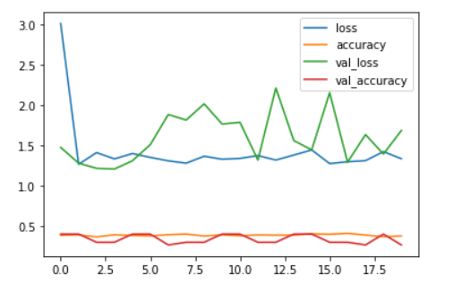
Figure 5.VGG-16loss and accuracy graph

Figure 6 displays the graph for the BCCN model that is plotted between accuracy and loss.

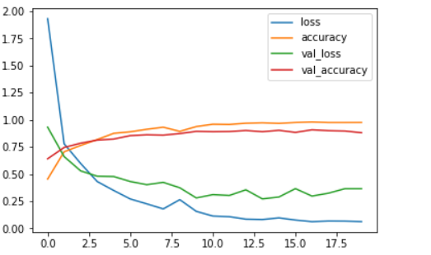
Figure 6.Basic CNN loss and accuracy graph

Figure 7 displays the graph for the ResNet-50 model that compares training accuracy to validation accuracy.

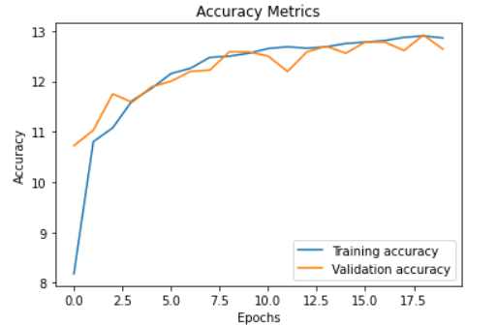
Figure 7.ResNet-50 accuracy graph

Figure 8 displays the graph for the ResNet-50 model that is drawn between training loss and validation loss.
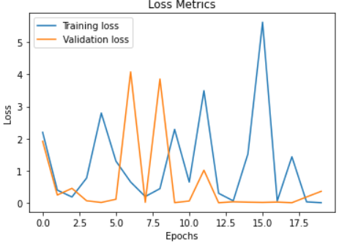
Figure 8.ResNet-50loss graph

Figure 9, 10, and 11 shows the heat map to establish the correlation between the attributes to predict tumor or no tumor including type of tumor through VGG-16, BCCN, and ResNet-50. Total 3162 MRI images are used for analysis. Besides, the number of no tumor images and tumor images are 98 and 3064 respectively.

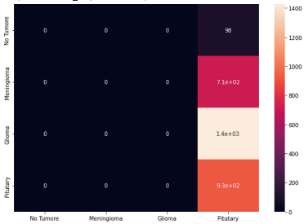
Figure 9.Heat map for VGG-16

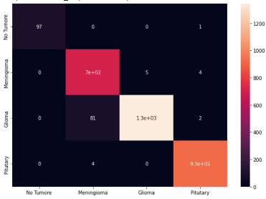
Figure 10.Heat map for Basic CNN

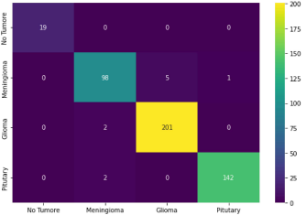
Figure 11.Heat map for ResNet-50

3. CONCLUSIONS

Tumours are the most common cause of cancer, according to studies. If a patient's tumour is not detected and treated in a timely manner, they risk dying. Additionally, brain tumours are extremely harmful to patients and dangerous. In order to address these challenges, the authors of this article applied OpenCV and convolution neural networks to data from MRI brain pictures. The suggested model determines and categorises the type of brain tumour. ResNet-50 model provides greater accuracy of 98.52% and 99.73% over testing and training data, respectively, when compared to other CNN architectures like VGG-16, BCNN, and ResNet-50.

REFERENCES

1. Raghavendra, R. S. (2012). Benign, premalignant, and malignant lesions encountered in bariatric surgery. JSLS: Journal of the Society of Laparoendoscopic Surgeons, 16(3), 360.
2. Stubbs, M., McSheehy, P. M., Griffiths, J. R., & Bashford, C. L. (2000). Causes and consequences of tumor acidity and implications for treatment. Molecular medicine today, 6(1), 15-19.
3. Kleihues, P., Burger, P. C., & Scheithauer, B. W. (1993). The new WHO classification of brain tumors. Brain pathology, 3(3), 255-268.
4. Collins, V. P. (2004). Brain tumors: classification and genes. Journal of Neurology, Neurosurgery & Psychiatry, 75(suppl 2), ii2-ii11.
5. Anitha, V., & Murugavalli, S. J. I. C. V. (2016). Brain tumor classification using two‐tier classifier with adaptive segmentation technique. IET computer vision, 10(1), 9-17.
6. Latikka, J., & Eskola, H. (2019). The resistivity of human brain tumors in vivo. Annals of biomedical engineering, 47(3), 706-713.
7. Nayak, D. R., Padhy, N., Mallick, P. K., Bagal, D. K., & Kumar, S. (2022). Brain Tumor Classification Using Noble Deep Learning Approach with Parametric Optimization through Metaheuristics Approaches. Computers, 11(1), 10.
8. Al-Kadi, O. S. (2015). A multiresolution clinical decision support system based on fractal model design for classification of histological brain tumors. Computerized Medical Imaging and Graphics, 41, 67-79.
9. Tandel, G. S., Biswas, M., Kakde, O. G., Tiwari, A., Suri, H. S., Turk, M., ... & Suri, J. S. (2019). A review on a deep learning perspective in brain cancer classification. Cancers, 11(1), 111.
10. Culjak, I., Abram, D., Pribanic, T., Dzapo, H., & Cifrek, M. (2012, May). A brief introduction to OpenCV. In 2012 proceedings of the 35th international convention MIPRO (pp. 1725-1730). IEEE.
11. O'Shea, K., & Nash, R. (2015). An introduction to convolutional neural networks. arXiv preprint arXiv:1511.08458.
12. He, K., Zhang, X., Ren, S., & Sun, J. (2016). Deep residual learning for image recognition. In Proceedings of the IEEE conference on computer vision and pattern recognition (pp. 770-778).
13. Alippi, C., Disabato, S., & Roveri, M. (2018, April). Moving convolutional neural networks to embedded systems: the alexnet and VGG-16 case. In 2018 17th ACM/IEEE International Conference on Information Processing in Sensor Networks (IPSN) (pp. 212-223). IEEE.
14. Akkus, Z., Galimzianova, A., Hoogi, A., Rubin, D. L., & Erickson, B. J. (2017). Deep learning for brain MRI segmentation: state of the art and future directions. Journal of digital imaging, 30, 449-459.
15. Yuan, W., & Liu, P. (2022). reStructured Pre-training. arXiv preprint arXiv:2206.11147.
16. Han, W., Qin, L., Bay, C., Chen, X., Yu, K. H., Miskin, N., ... & Young, G. (2020). Deep transfer learning and radiomics feature prediction of survival of patients with high-grade gliomas. American Journal of Neuroradiology, 41(1), 40-48.
17. Siddique, M. A. B., Sakib, S., Khan, M. M. R., Tanzeem, A. K., Chowdhury, M., & Yasmin, N. (2020, October). Deep convolutional neural networks model-based brain tumor detection in brain MRI images. In 2020 Fourth International Conference on I-SMAC (IoT in Social, Mobile, Analytics and Cloud)(I-SMAC) (pp. 909-914). IEEE.
18. Sangeetha, R., Mohanarathinam, A., Aravindh, G., Jayachitra, S., & Bhuvaneswari, M. (2020, November). Automatic detection of brain tumor using deep learning algorithms. In 2020 4th International Conference on Electronics, Communication and Aerospace Technology (ICECA) (pp. 1-4). IEEE.
19. Deshpande, A., Estrela, V. V., & Patavardhan, P. (2021). The DCT-CNN-ResNet50 architecture to classify brain tumors with super-resolution, convolutional neural network, and the ResNet50. Neuroscience Informatics, 1(4), 100013.
20. Saleh, A., Sukaik, R., & Abu-Naser, S. S. (2020, August). Brain tumor classification using deep learning. In 2020 International Conference on Assistive and Rehabilitation Technologies (iCareTech) (pp. 131-136). IEEE.
21. Shwetha, V., Madhavi, C. R., & Nagendra Kumar, M. (2022). Classification of brain tumors using hybridized convolutional neural network in brain MRI images. International Journal of Circuits, Systems and Signal Processing, 16, 561-570.
22. Rasool, M., Ismail, N. A., Boulila, W., Ammar, A., Samma, H., Yafooz, W. M., & Emara, A. H. M. (2022). A Hybrid Deep Learning Model for Brain Tumor Classification. Entropy, 24(6), 799.
23. Shanthi, S., Saradha, S., Smitha, J. A., Prasath, N., & Anandakumar, H. (2022). An efficient automatic brain tumor classification using optimized hybrid deep neural network. International Journal of Intelligent Networks, 3, 188-196.
24. Mohsen, H., El-Dahshan, E. S. A., El-Horbaty, E. S. M., & Salem, A. B. M. (2018). Classification using deep learning neural networks for brain tumors. Future Computing and Informatics Journal, 3(1), 68-71.
25. Shinde, A. S., Mahendra, B. M., Nejakar, S., Herur, S. M., & Bhat, N. (2022). Performance analysis of machine learning algorithm of detection and classification of brain tumor using computer vision. Advances in Engineering Software, 173, 103221.

