Public opinion on LGBT communities and problems faced by them

Author
S.Mathumithra (131801060)
3rd yr,B.A.,L.L.B.,
Saveetha School of Law
Saveetha Institute of Medical and Technical Sciences (SIMATS)
Saveetha University
Chennai-77

Co-author:
Mr.A.Magesh kumar - B.A.,B.L,M.L.,(Business Law)
Assistant Professor,
Saveetha school of law,
Saveetha Institute of Medical and Technical Science (SIMATS),
Chennai-77,
Public opinion on LGBT communities and problems faced by them
Author: S.Mathumithra
Co author: Mr.A.Mageshkumar
ABSTRACT:
Generally this paper is about LGBT communities and major problems faced by them.LGBT people envelop all races and ethnicities, religions, and social classes. Sexual direction and sex personality questions are not asked on generally national or State overviews, making it hard to the quantity of LGBT people and their wellbeing needs.Research proposes that LGBT people face wellbeing inconsistencies connected to cultural shame, separation, and forswearing of their common and human rights. Oppression LGBT people has been related with high paces of mental issues, substance misuse and suicide.Experiences of brutality and exploitation are visit for LGBT people, and have dependable consequences for the individual and the community.Personal, family, and social acknowledgment of sexual direction and sex character influences the psychological well-being and individual wellbeing of LGBT individuals.The LGBT friend record to Healthy People featured the requirement for more exploration to archive, comprehend, and address the natural factors that add to wellbeing variations in the LGBT people group. As a major aspect of this work, we have to expand the quantity of broadly delegate wellbeing related studies that gather data on sexual direction and sex personality.As lesbians forged more public identities, the phrase "gay and lesbian" became more common.As equality was a priority for lesbian feminists, disparity of roles between men and ladies or butch and femme were viewed as patriarchal. The researcher obtained the primary source of data by conducting an empirical study on seeking responses from the general public based on a questionnaire and also relied on secondary sources of data such as books, journals, e-sources, articles and newspapers. The sampling size of the paper is 200.

KEYWORDS :Religions,Ethinicities,Social class,Personality

Introduction
Most of the homosexuality existed in ancient Israel simply because it is prohibited in the Bible,flourished between both men and women in Ancient Greek.In 2018, the Supreme Court of India decriminalised consensual homosexual intercourse by reading down Sec 377 of Indian Penal Code.The LGBT individuals face health disparities linked to social stigma,discrimination and denial of their civil and human rights.High rates of psychiatric disorders,substance abuse and suicide..By and large, The LGBT people group (or LGBTQ people group or LGBT people group), likewise alluded to as the gay local area, is an approximately characterized gathering of lesbian, gay, sexually unbiased, transsexual, LGBT associations, and subcultures, joined by a typical culture and social developments. These people group by and large praise pride, variety, independence, and sexuality.Most antiquarians concur that there is proof of gay action and same-sex love, regardless of whether such connections were acknowledged or oppressed, in each reported culture. Considerable proof likewise exists for people who inhabited least piece of their lives as an unexpected sexual orientation in comparison to relegated at birth.Homosexuality was never unlawful or a criminal offense in antiquated Indian and customary codes however was condemned by the British during their standard in India.In 2018, the Supreme Court of India decriminalized homosexuality by announcing Section 377 of the Indian Penal Code illegal in regard to consensual gay sex between adults.Homosexuality was never illicit or a criminal offense in old Indian and conventional codes yet was condemned by the British during their standard in India.But there was additionally awesome information for LGBT individuals in 2015. In May, Mexico and Ireland stretched out union with same-sex couples. After a month, Mozambique decriminalized homosexuality, and the United States Supreme Court decided for marriage correspondence, permitting same-sex relationships all through the country.Malta, Ireland, and Colombia all isolated the legitimate cycle for transsexual acknowledgment from operations. In June, Colombia conveyed a joint explanation to the UN Human Rights Council in the interest of 72 nations, from all areas of the world, insisting a promise to end brutality and separation dependent on sexual direction and sex character. The LGBT social class tended to by a social piece of the overall neighborhood is acknowledged by many, including hetero accomplices, to be underrepresented close by friendly freedoms. The current clash of the gay neighborhood been generally accomplished by globalization. In the United States, World War II joined many closeted country men from around the country and introduced them to more reformist attitudes in bits of Europe. Subsequent to getting back after the contention, countless these men decided to join as one in metropolitan zones rather than return to their unassuming networks. Youngster people group would before long get political in the start of the gay rights development, including stupendous occurrences at places like Stonewall. Today, numerous huge urban areas have gay and lesbian public venues. Numerous colleges and schools across the world have support habitats for LGBT understudies. The Human Rights Campaign, Lambda Legal, the Empowering Spirits Foundation, and GLAAD advocate for LGBT individuals on a wide scope of issues in the United States. There is likewise an International Lesbian and Gay Association. In 1947, when the United Kingdom embraced the Universal Declaration of Human Rights (UDHR), LGBT activists clung to its idea of equivalent, unavoidable rights for all individuals, paying little mind to their race, sex, or sexual direction. The announcement doesn't explicitly make reference to gay rights, however talks about balance and independence from discrimination.In 1962, Clark Polak joined The Janus Society in Philadelphia, Pennsylvania.Only a year after, he became president. In 1968, he declared that the Society would be changing their name to Homosexual Law Reform Society; "Gay people are currently able to fly under their own tones" .The aim of the paper is study about the problems faced by the LGBTQ people.

Objectives
To find out whether the laws regarding homosexuality is effective or not.To critically analyse whether the crimes are reduced against LGBt communities. To interpret how it reduces crime.

Literature review

- In this article the authors Stephen and others had discussed on the topic of Perception of police, Across a number of measures and scales, the perceptions of LGBT participants are significantly more negative than those of other participants, including when the variables of race,income, location type (e.g., rural,small town,suburban,urban), prior service as a police officer, and quality of prior interactions with the police, are controlled in multivariate modeling.(Owen et al.,2018)
- In this article the authors Kathleen and others discussed on the topic of Definitions of families in LGBT communities, The LGBT people frequently define biological and legal relatives as members of their current family, and few define their current family as only consisting of chosen family.The notion of families of choice continues to resonate, but chosen family members mostly complement rather than replace other kinds of family in definitions of one’s current family(Hull and Ortyl,2019).
- In this article the authors Jack and others discussed on the topic of National LGBT cancer action plan, The planning committee articulated a primary goal for the historic conversion: the collaborative creation of a National LGBT Cancer Action Plan,endorsed by all in attendance and to be disseminated widely through publication in national journals,conferences and social medi a.([Jack,2016])
- In this article the author Gust discussed on the topic of A Critical Appraisal of Assimilationist and Radical Ideologies Underlying Same-Sex Marriage in LBGt Communities in the United States ,To accomplish this, we first discuss the nature of sexual ideologies. Next, we identify current sexual ideologies in LGBT communitis and examine some of their fundamental features and their implications for relationships constructions with a focus on same-sex marriage.([Gust,2003])
- In this article the author Charlotte Ross the author discussed about the Visions of visibility: LGBt communities in Turin, In the light of this situation, this article analyses modalities of ‘visibility’ as defined and desired by the active LGBT community in Turin, host city for National Pride 2006.The Pride committee scheduled an unprecedented ‘visible’ year - long programme of consciousness- raising and cultural events that went far beyond the more usual one-day March.(Ross,2016)
- In this article Alexander Jonathan discussed on the topic of Representatives of LGBT people and communities on the World Wide Web,Beyond connecting individuals and information to one another across geographic divides, Internet technologies offer individuals and groups revolutionary ways to represent themselves by combining text and images, linking to other sites of interest or import, and experimenting with different modes of representation.(Alexander,2002)
- In this article the author Eleanor Formby discussed on the topic of LGBT ‘Communities’ and the (Self) regulation and Shaping of Intimacy ,There was strong evidence to suggest that some LGBT + people self-regulate their practices of intimacy (such as holding hands in public) so as not to be recognised as enacting a same-gender relationship. This was understood as a form of self-protection or hate crime prevention, though degrees of habit and professed concern for other people’s feelings were also contributing factors.(SAGE Journals: Your Gateway to World-Class Research Journals,Elanor,2020)
- In this article the author Corrine discussed on the topic of When a ‘non- issue’ becomes an issue in discourse surrounding LGBT communities, Intersexuality is used by three types of news sources (LGBT, mainstream, and Religious Right) to report the same issue but in ways specifically aimed at the ideal reader of each. The way intersexuality occurs in constructed dialogue,lexical choice, and semantic presupposition creates an ideological message meant for decidable by each publication’s ideal reader, reinforcing group ideologies about LGBT (Seals,2012)issues.
- In this article the authors Margit Tavis and Efren O Perez discussed on the topic of Language influences mass opinion towar gender and LGBT equality, Evidence from 3 survey experiments traces the effects of gender-neutral pronoun use on mass judgements of gender equality and tolerance towards lesbian,gay,bisexual and transgender (LGBT) communities.(Tavits and Pérez,2019)
- In this article the author Meyer discussed on the topic of Minority stress and positive psychology: Convergences and divergences to understanding LGBT health, The ‘three pillars’ of positive psychology and systematically explore these pillars as they may be applied to understanding the health of LGBT populations. An important contribution of the articles in this section is that the authors review the rich psychological theory to which we can anchor research on positive psychology in LGBT populations.But the challenge remains in conceptually clarifying and organizing research constructs that are relevant to this work.(Meyer,2014)
- In this article the author Timothy Hildebrandt discussed on the topic of Development and Division : the effect of transnational linkages on local politics on LGBT activism in China, The means by which LGBT activism has developed in China has simultaneously contributed to division within its ranks and with global civil society: the nature of international funding - while from foreign sources it is funneled through the Chinese government and local political conditions ultimately impedes the growth of stronger transnational linkages([Timothy,2012])
- In this article the authors Susan and others discussed on the topic of Lesbian,Gay,Bisexual and Transgender Communities’ Readiness for Intimate Partner Violence Prevention, However, assessing a community’s readiness in response to the issue of IPV in LGBT communities locates the issue where outcry is most likely to occur. Utilising the Community Readiness Model in lesbian,gay,bisexual and transgender communities in two rural and two urban communities([Susan Trell,2012]).
- In this article Subir K Kole on the topic of Globalizing queer? AIDS,homophobia and the politics of sexual identity in India, Economic globalisation in the developing world, a Western,hegemonic notion of lesbian,gay,bisexual and transgender (LGBT) identity has been exported to traditional societies thereby destroying indigenous sexual cultures and diversities,other scholars do not consider globalisation as a significant factor in global queer mobilisation and sexual identity politics(Kole,2007).
- The Delhi High Court decision in Naz Foundation v. Govt. of NCT of Delhi of 2009 found Section 377 and other legal prohibitions against private, adult, consensual, and non-commercial same-sex conduct to be in direct violation of fundamental rights provided by the Indian Constitution. Section 377 stated that: "Whoever voluntarily has carnal intercourse against the order of nature with any man, woman or animal, shall be punished with [imprisonment for life], or with imprisonment of either description for a term which may extend to ten years, and shall also be liable to fine," with the added explanation that: "Penetration is sufficient to constitute the carnal intercourse necessary to the offence described in this section. ([Boehmer])
- In this article the authors Iman and others discussed the topic of Psychological research on South Asian Americans : A third decade analysis.However, a large number of studies sampled Asian Indians exclusively and provided limited data on psychometric properties for measures used. Scholars researching the South Asian community may wish to expand current content areas and also focus on older adults, cultural conflicts,lesbian,gay,bisexual,andtransgendered(LGBT) communities,substance abuse,and career issues. We also encourage the use of diverse South Asian sample with attention to culturally focused theoretical frameworks and psychometrically sound instruments.(Iman,2012)
- In this article the author Gurvinder Kalra discussed on the topic of Hijra: the unique transgender culture of India, This subculture has been clandestine about its customs and lifestyle,but the scene is changing. Although awareness about HIV-AIDS issues in this community is increasing both among the community members and the health professionals, the same cannot be said about mental health issues([Gurvinder,2011])
- In this article the authors Venkatesan Chakrapani and others discussed on the topic of Understanding How Secual and Gender Minority Stigmas Influence Depression Among Trans Women and Men Sexual and gender minority stigmas are associated with depression, with social support and resilient coping as mediators. In addition to stigma reduction interventions at the societal level, future interventions should focus on improving social support and promoting resilience among trans women and MSM in India.([Venkatesan,2017])
- In this article the authors T.S.Sathyanarayana Rao and K S Jacob discussed on the topic of The reversal on Gay Rights in India, India’s Supreme Court recently issued a ruling against human rights by reinstating a law that bans gay sex. The court restored Section 377 of India Penal Code, a 19th century law, barring “carnal intercourse against the order of nature”(T. S. Sathyanarayana Rao,).
- In this article the authors T.S Sathyanarayana Rao and others discussed on the topic of Gay rights and Psychiatric fraternity and India, The Delhi High Court’s landmark judgment in July 2009, which read down Section 377 of the Indian Penal Code, was a major victory.It held that Section 377 to be violative of Articles 21,14, and 15 of the Indian constitution,as it criminalised consensual sexual acts of adults in private.The judgement struck down a 19th century law, which the police used to threaten and blackmail LGBT people.Violation of the law is punishable by a fine and imprisonments(Sathyanarayana Rao et al.,2016).
- In this article the author Sherry Joseph discussed on the topic of Gay and Lesbian Movement in India ,The emerging gay and lesbian movement offers not just alternate identities but prospects for social reconstruction.In spite of its marginality,the movement rejects the monolith and the mass. It is a reminder that if forced conformity is to be resisted it must be by representing human lives as multiple; selfhood as several; communities as voluntary and various.(Joseph,1996)

Materials and methodology:
The researcher obtained the primary source of data by conducting an empirical study on seeking responses from the general public based on a questionnaire and also relied on secondary sources of data such as books, journals, e-sources, articles and newspapers. The present research is conclusive, descriptive and based on empirical design. Qualitative data was generated to test the research hypothesis. In order to collect data on dimensions of study, a research instrument was designed. This research paper used the empirical type of research which is done by the survey method. The sampling size of the paper is 200. The independent variables are age and gender. The dependent variables are the inputs of the questionnaire.The sampling method is a simple sampling method. The primary sources are taken from the general public in the form of survey methods. The information was collected from secondary sources from journals, articles, books and reports of the presidency and non governmental organisation.

Analysis
Figure 1:
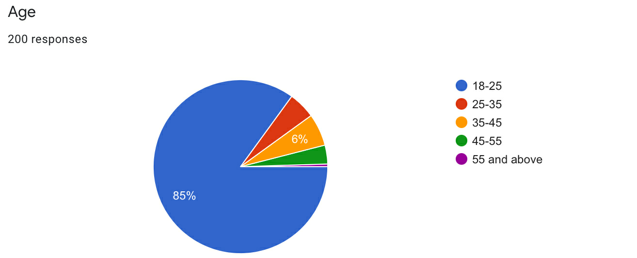

Legend:
From the graph, it is observed that the age distribution of the respondents, their opinions on LGBT communities was observed. From the pie chart , it is observed that total response of 85% of people belongs to the age group of 18-25, 5% of people belongs to the age group of 25-35%, 6% of people belongs to the age group of 35-45 and 4 % of people belongs to the age group of 45-55 and 2% of people belongs to the age group of 55 and above.

Figure 2:

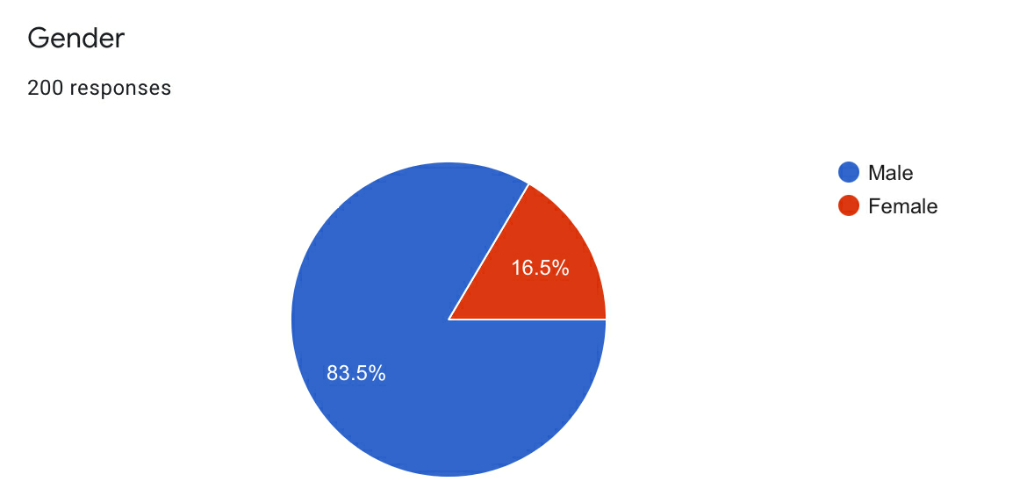

Legend:
From the graph, it is observed that the gender distribution of the respondents, their opinions on LGBT communities was observed. From the pie chart , it is observed that total response of 83.5% of people belongs to the male category , 16.5% of people belongs to the female category.

Figure 3:

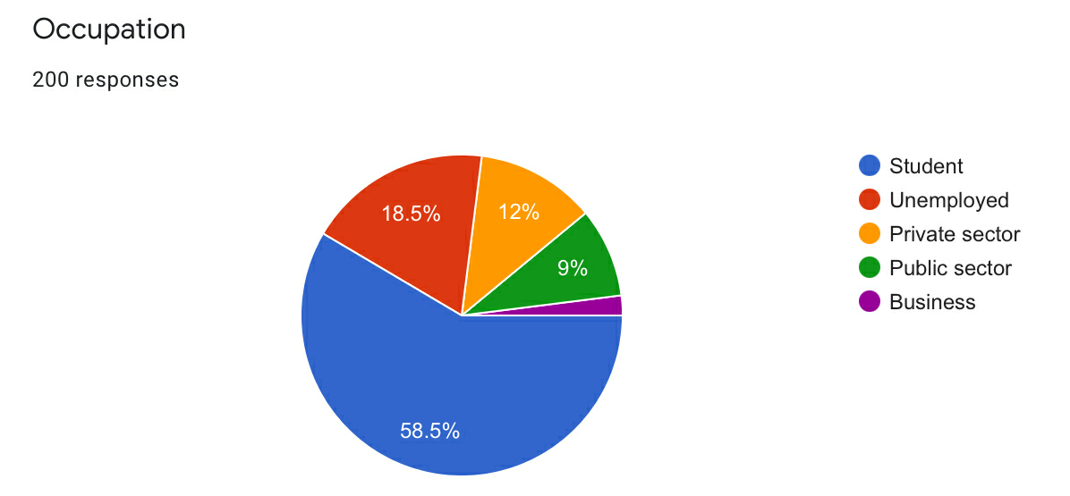

Legend:
From the graph, it is observed that the occupation distribution of the respondents, their opinions on LGBT communities is observed. From the pie chart, it is observed that 58.5% of students are answered more,18.5% unemployed people are answered,12% of private sector people are answered.

Figure 4:

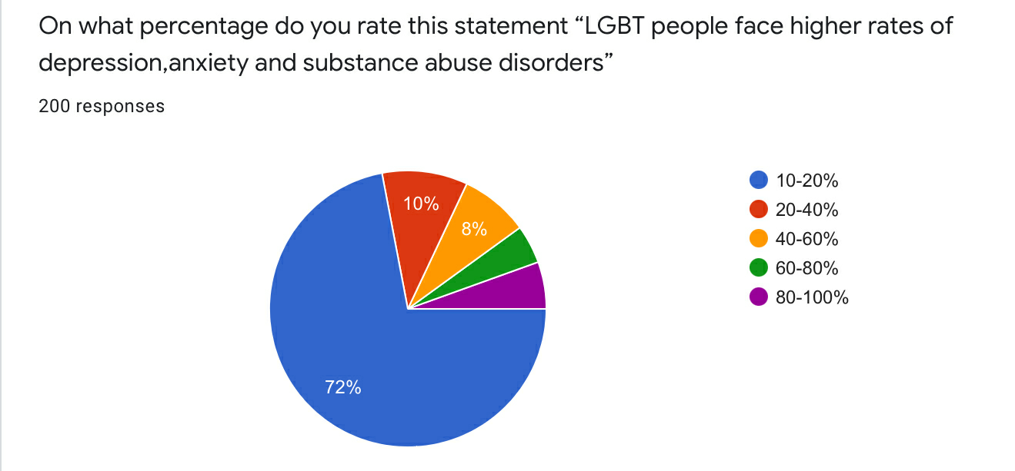

Legend:
From the pie chart, it is observed that the age distribution of the respondents among different genders of the respondents, their opinions on LGBT people face higher rates of depression, anxiety and substance abuse disorders,72 % of people say 10-20%, 10% of people say 20-40% ,8% of people say 40-60%, 7% of people say 60- 80%, 5% of people say 80-100%.

Figure 5:

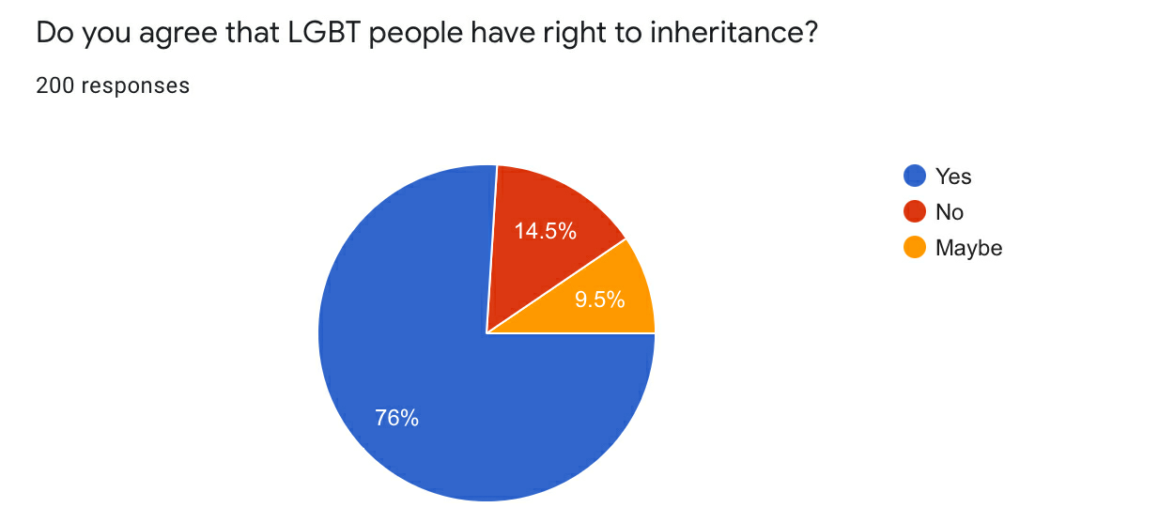

Legend:
From the pie chart , it is observed that the age distribution of the respondents among different genders and occupation of the respondents, their opinion on LGBT people's right to inheritance is observed. From the pie chart, it is observed that 76% say yes,14.5% say noand 9.5% say maybe to the statement.

Figure 6:

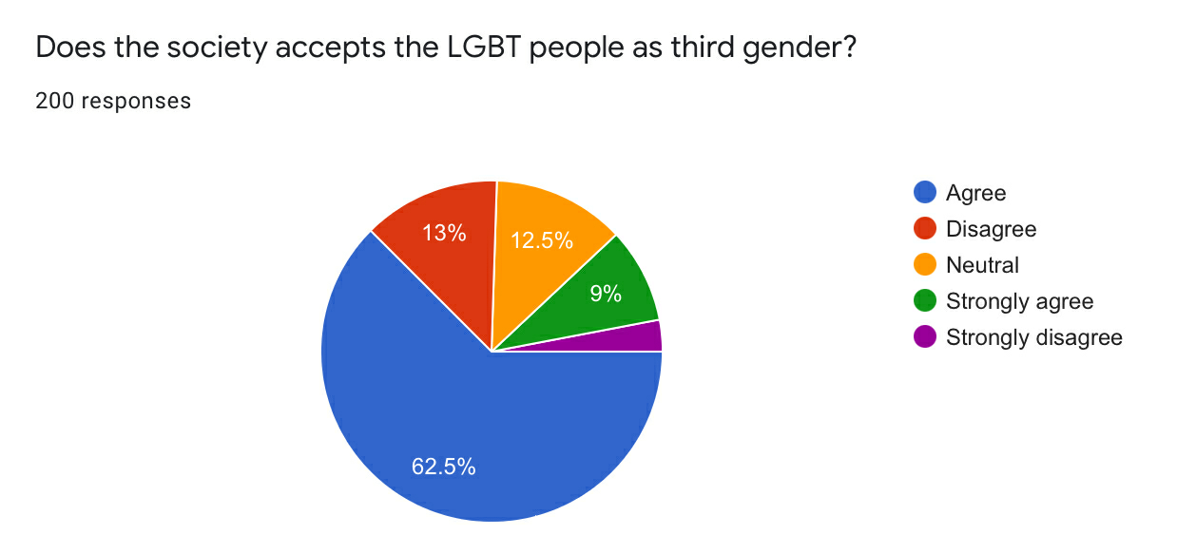
Legend:
From the graph, it is observed that the age distribution of the respondents among different genders and occupation of the respondents, their opinions on whether it is necessary to link Aadhaar with an existing bank account is observed. From the pie chart, it is observed that 5% strongly disagree,13% disagree,12.5% are neutral, 62.5% agree and 7% strongly agree to the statement.

Figure 7:

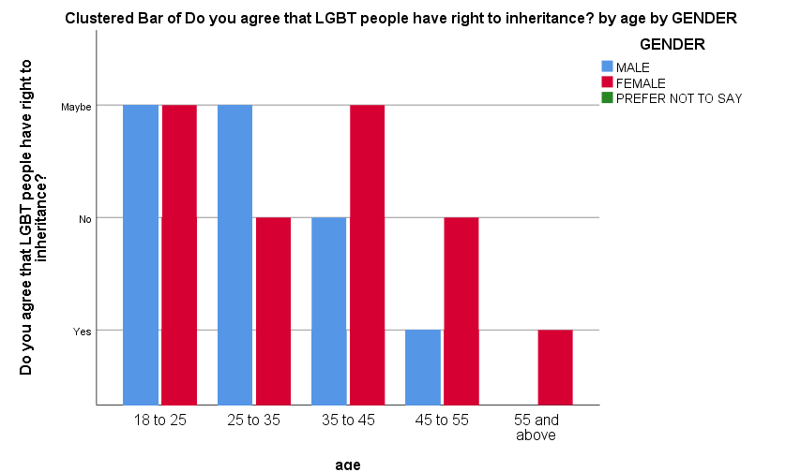

Result:From the above chart it has been analysed that from the survey done of the gender and age, component from the total of 200 responses, the y axis being “LGBT people have right to inheritance”, it is analysed that male belong to the age group of 45 to 55 and 18 to 25 are answered for yes,people belonging to the age of 55 and above are answered for no.Thus there are totally 200 responses.
Discussion:
From graph ,it has been analysed from the survey done out of gender and age components from 200 responses, the opinion on “LGBT people have right to inheritance” is observed that male belonging to the category of 55 and above are answered less.Thus, the opinion is observed from 200 responses.

Figure 8:

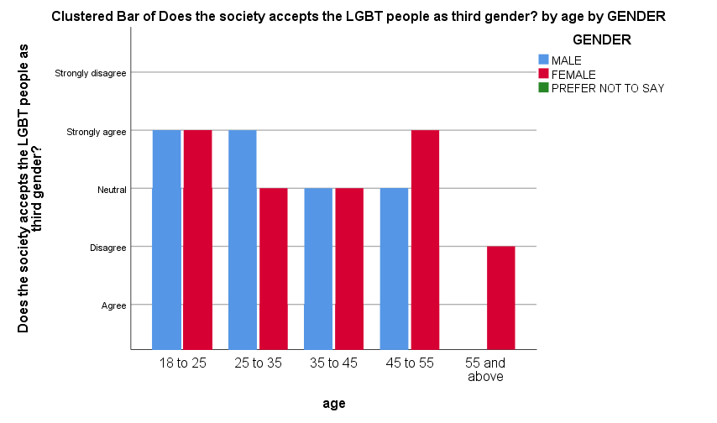

Result:From the above chart it has been analysed that from the survey done of the gender and age, component from the total of 200 responses, the y axis being “Society accepts the LGBT people as third gender”, it is analysed that male belong to the age group of 45 to 55 and 18 to 25 are answered for yes,people belonging to the age of 55 and above are answered for no.Thus there are totally 200 responses.
Discussion:
From graph ,it has been analysed from the survey done out of gender and age components from 200 responses, the opinion on “Society accepts the LGBT people as third gender” is observed .People between the age group of 18 to and 45 to 55 answered more and agreed with the statement.Thus, the opinion is observed from 200 responses.

Figure 9:

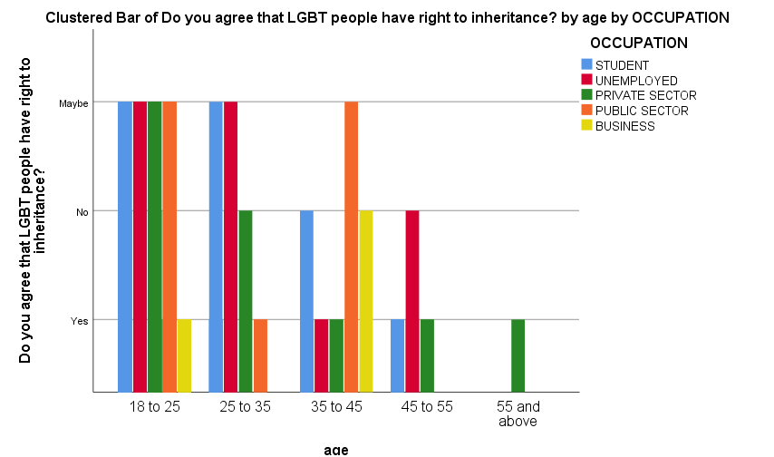

Result:From the above chart it has been analysed that from the survey done of the occupation and age, component from the total of 200 responses, the y axis being “LGBT people have right to inheritance”, it is analysed that male belong to the age group of 18 to 25 are answered for yes are students ,people belonging to the age of 55 and above are answered for no are business people.Thus there are totally 200 responses.
Discussion:
From graph ,it has been analysed from the survey done out of gender and age components from 200 responses, the opinion on “LGBT people have right to inheritance” is observed .People between the age group of 18 to and 45 to 55 answered more and agreed with the statement.

Figure 10:

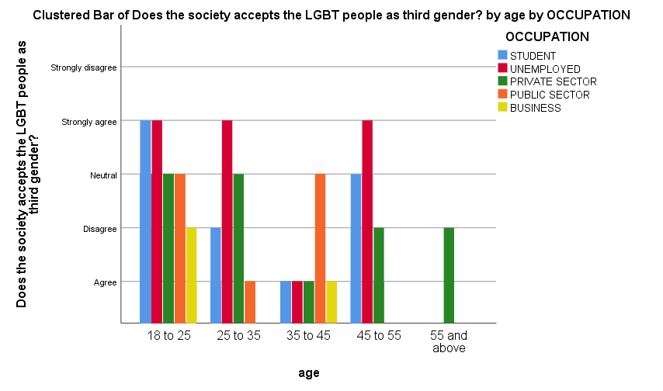
Result:From the above chart it has been analysed that from the survey done of the occupation and age, component from the total of 200 responses, the y axis being “Society accepts the LGBT people as third gender”, it is analysed that male belong to the age group of 18 to 25 are answered are students who are answered more ,people belonging to the age category of 35 to 45 are answered less.Thus there are totally 200 responses.
Discussion:
From the graph ,it has been analysed from the survey done out of gender and age components from 200 responses, the opinion on “Society accepts the LGBT people as third gender” is observed .People between the age group of 18 to and 45 to 55 answered more and agreed with the statement.

Figure 11:

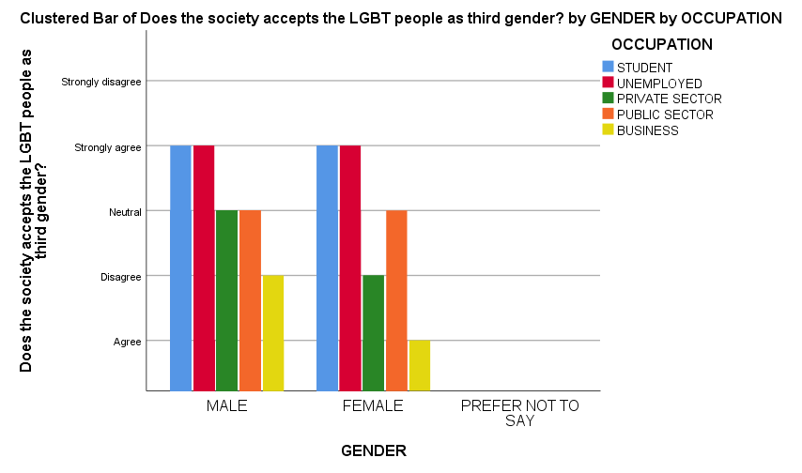
Result:
From the above chart it has been analysed that from the survey done of the gender and occupation, component from the total of 200 responses, the y axis being “Society accepts the LGBT people as third gender”, it is analysed that male belonging to the category of student have answered for strongly agree and female belonging to the category of public sector and private sector answered strongly agree.Thus there are totally 200 responses.
Discussion:
From graph ,it has been analysed from the survey done out of gender and age components from 200 responses, the opinion was the society accepts the LGBT people as third gender.Thus, the opinion is observed from 200 responses

Figure 12:

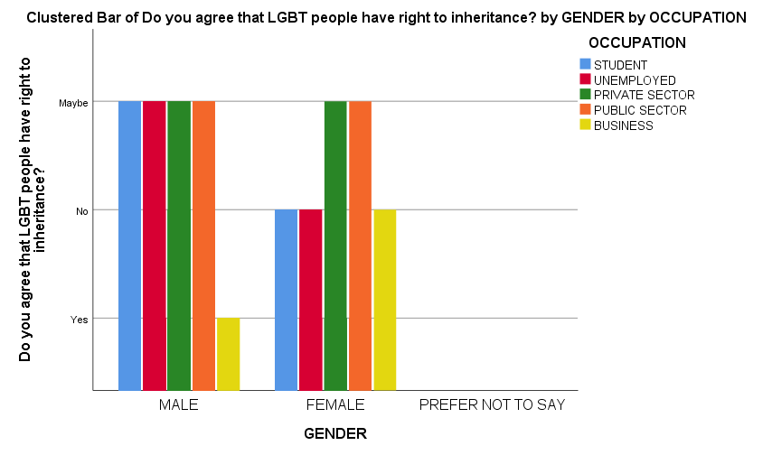

Result:
From the above chart it has been analysed that from the survey done of the gender and occupation, component from the total of 200 responses, the y axis being “LGBT people have right to inheritance”, it is analysed that male belonging to the category of student have answered for yes and no people have answered for prefer not to say option.The less quantity of answered people are male belonging to the category of business. Thus there are totally 200 responses.
Discussion:
From graph ,it has been analysed from the survey done out of gender and age components from 200 responses, the opinion on LGBT people have right to inheritance,the people belonging to the category of male who are students are answered more and agreed that LGBT people have right to inheritance.Thus, the opinion is observed from 200 responses

DISCUSSION:

Certain different angles should be noted. Segment 377 IPC utilizes the diction lewd intercourse against the request of nature‖. The assurance of request of nature is certifiably not a steady marvel. Social ethical quality likewise changes from age to age. The law adapts to life and in like manner change happens. The ethical quality that open sees, the Constitution may not think about. The individual self-rule and furthermore singular introduction can't be decayed except if the limitation is viewed as sensible to respect the ethical quality of the Constitution. What is normal to one may not be normal to the next but rather the said regular introduction and decision can't be permitted to cross the limits of law and as the bounds of law can't alter or shorten the innate right implanted in a person under Article 21 of the Constitution. A segment of individuals or people who practice their decision ought to never stay in a condition of dread. When we say as much, we may not be comprehended to have expressed that there ought not be dread of law since dread of law assembles acculturated society. Be that as it may, that law must have the adequacy of the Constitutional parameters. That is the litmus test.

Limitation :
The Major limitation of the study is the sample frame. The sample frame Collected through online platforms like sending mail, sending links via WhatsApp is the limitation of the study, the real field experience is missed out due to corona pandemic. The restrictive area of sample size is yet another drawback of the research.Collection of data via online platform is limiting the researcher to collect data from the field.Since the data is collected on online platform wherein the respondent is not known, the original opinion of the respondent it is not found, The researcher could only come to a approximate conclusion of what the respondent is feeling to convey.

CONCLUSION AND SUGGESTION :
The Supreme Court over its judgment on a couple of grounds. To begin with, it held that all laws initiated by Parliament are dared to be considerable under the ple. The Supreme Court couldn't resist repudiating this dispute and held that S.377 talks just of sexual acts and doesn't discuss sexual presentation or sex character. This would infer that even heteros getting a charge out of acts made sure about under S.377 would be rebuked. Thusly, the section doesn't target LGBT individuals as a class.Segment 377 of the IPC scrutinizes Whoever purposefully has salacious inter­course against the solicitation of nature with any man, woman or animal, will be rebuked with confinement everlastingly, or with impris­onment of either depiction for a term which may contact ten years, and will moreover be in danger to fine. While the law doesn't unequivocally insinuate LGBT the very creation reference to of against the solicitation of nature" has come to be implied for same-sex sexual relations.

References:
- Hull, Kathleen E., and Timothy A. Ortyl. “Conventional and Cutting-Edge: Definitions of Family in LGBT Communities.” Sexuality Research & Social Policy: Journal of NSRC: SR & SP, vol. 16, no. 1, Springer, Mar. 2018, pp. 31–43.
- Kole, Subir K. “Globalizing Queer? AIDS, Homophobia and the Politics of Sexual Identity in India.”
- Globalization and Health, vol. 3, no. 1, BioMed Central, July 2007, pp. 1–16.
- [No Title]. https://www.liebertpub.com/doi/abs/. Accessed 22 Mar. 2021.
- ---. https://www.tandfonline.com/doi/abs/10.1300/J082v45n01_03. Accessed 22 Mar. 2021.
- ---. https://www.tandfonline.com/doi/full/10.1080/10670564.2012.684967. 22 Mar. 2021.
- ---. https://www.tjsl.edu/slomansonb/10.3_India_Gay_Rts.pdf. Accessed 22 Mar. 2021.
- ---. https://www.tandfonline.com/doi/abs/10.1080/17542863.2011.570915. Accessed 22 Mar. 2021.
- ---. https://www.liebertpub.com/doi/abs/. Accessed 22 Mar. 2021.
- Owen, Stephen S., et al. “Perceptions of the Police by LGBT Communities.” American Journal of Criminal Justice: AJCJ, vol. 43, no. 3, Springer, Nov. 2017, pp. 668–93.
- Ross, Charlotte. “Visions of Visibility: LGBT Communities in Turin.” Modern Italy: Journal of the Association for the Study of Modern Italy, vol. 13, no. 3, Cambridge University Press, Aug. 2008, pp. 241–60.
- SAGE Journals: Your Gateway to World-Class Research Journals. https://journals.sagepub.com/action/cookieAbsent. Accessed 22 Mar. 2021.
- Sathyanarayana Rao, T. S., et al. “Gay Rights, Psychiatric Fraternity, and India.” Indian Journal of Psychiatry, vol. 58, no. 3, Wolters Kluwer -- Medknow Publications, 2016, p. 241.
- Seals, Corinne A. “When a ‘non-Issue’ Becomes an Issue in Discourse Surrounding LGBT Communities.” Journal of Language and Sexuality, vol. 1, no. 2, John Benjamins, Jan. 2012, pp. 231–56.
- Tavits, Margit, and Efrén O. Pérez. “Language Influences Mass Opinion toward Gender and LGBT Equality.” Proceedings of the National Academy of Sciences of the United States of America, vol. 116, no. 34, National Academy of Sciences, Aug. 2019, pp. 16781–86.
- T. S. Sathyanarayana Rao, K. S. Jacob. “The Reversal on Gay Rights in India.” Indian Journal of Psychiatry, vol. 56, no. 1, Wolters Kluwer -- Medknow Publications, 2014, p. 1.
- Website. https://psycnet.apa.org/record/2002-04071-001. 22 Mar. 2021.
- ---. https://psycnet.apa.org/doiLanding?doi=10.1037%2Fsgd0000070. Accessed 22 Mar. 2021.
- ---. https://psycnet.apa.org/record/2014-29975-001. 22 Mar. 2021.
- ---. https://www.jstor.org/stable/4404520?seq=1.22 Mar. 2021.

Plagiarism

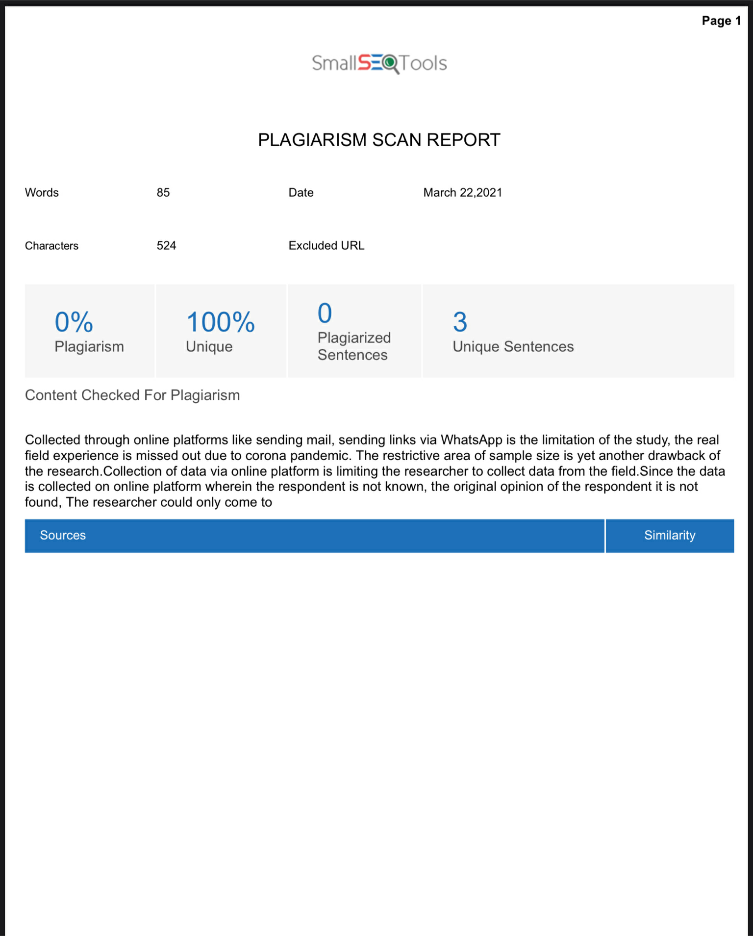

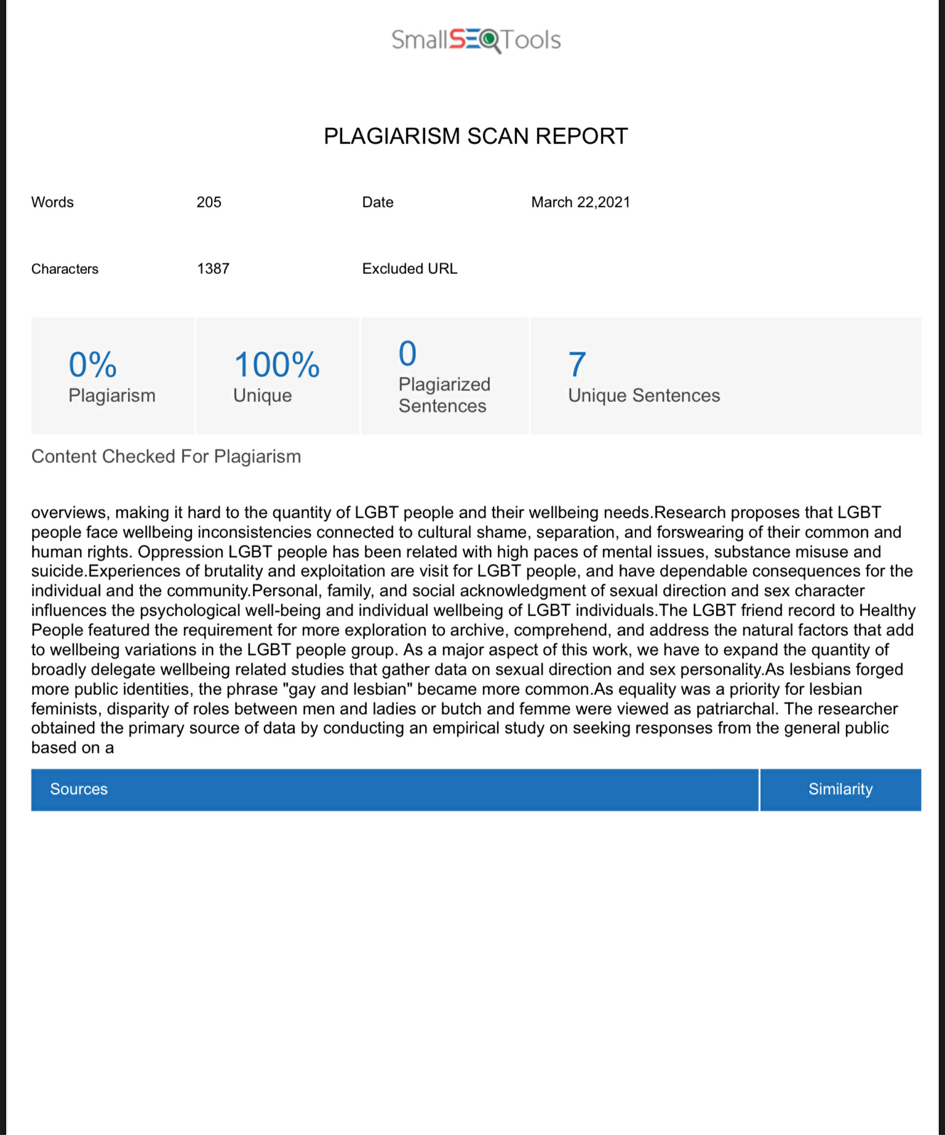

Mathumithra.S, BA.LLB,Saveetha school of law,Saveetha institute of medical and technical science(SIMATS),Saveetha university ,Chennai-77
Mr.A.Mageshkumar.,assistant professor ,Saveetha school of law ,Saveetha institute of medical and technical science(SIMATS),Saveetha university ,Chennai-77

