Methods for Ensuring the Security of Imaging Data in Medical Systems

By
Mrs. Uzma Khan
Madhyanchal Professional University.

Dr. Ankit Temurnikar
Assistant Professor, Madhyanchal Professional University.

Dr. Sunil Patidaar
Assistant Professor, Madhyanchal Professional University.

Abstract: Over the years, technological advancements have significantly impacted people's daily lives. However, along with these advancements, vulnerabilities have also emerged. Cyber-attacks and threats pose significant challenges to cybersecurity. Insecure networks can lead to data leakage, theft, and interception, compromising data integrity. In the healthcare sector, medical images play a crucial role in disease detection and diagnosis. Therefore, ensuring the confidentiality of medical images is essential to maintain data integrity. Various techniques such as cryptography, steganography, and digital watermarking are employed to enhance the security and integrity of medical images. These techniques prevent unauthorized modifications and enable authentication, ensuring that only authorized individuals can access the content of the medical images. This paper explores the techniques used for security and integrity purposes in medical imaging and proposes suitable techniques for hospitals to employ.
Keywords-data security; cryptography; steganography; digital watermarking; data forensics

I. INTRODUCTION
An article from ProPublica highlights the alarming issue of medical data being stored in insecure servers without basic security precautions or password protection, which has become common practice in hospitals, particularly in the United States [1]. This lack of awareness regarding the security of medical data has resulted in millions of records being leaked annually. In 2019, Dirk Schrader, a researcher from the German network security firm Greenbone Networks, conducted a study on patients' health records. The findings revealed that 5 servers in

Germany and 187 servers in the US were unprotected by passwords, allowing unauthorized individuals to access medical data without any authentication process. Shockingly, more than 13.7 million medical records in the US were available for download online [2]. While improving server security can address part of the problem, there are still hidden network threats, including spoofing, data theft, unauthorized access, and data alteration, which can compromise data integrity.
The presence of networks has undoubtedly facilitated users, particularly in terms of accelerating data transmission from the source to the destination. This is crucial in the healthcare sector, where medical images and information can be seamlessly transferred from medical database centers to destination nodes. Additionally, network connectivity enables end-users, including patients, doctors, and healthcare providers, to remotely access medical images. Doctors can even conduct wirelessly observed therapy to provide treatment for their patients. Medical image sharing offers numerous benefits such as real-time collaboration with specialists, cost reduction, and improved accessibility to medical images [3].
To ensure the security of medical images, three essential aspects must be addressed: confidentiality, integrity, and availability [4]. Confidentiality ensures that only authorized parties can access medical images, with encryption being used to allow authorized individuals with the decryption key to view the content. Integrity ensures that medical images remain unaltered and authentic, accurately representing the original images from their source [5]. Lastly, availability refers to the ability of the system to be accessed by users under any circumstances.
Several techniques exist to enhance the security of medical images during the transmission process, including cryptography, steganography, and digital watermarking. This paper will delve into the background of security techniques for medical images and their implementation in real healthcare environments. Furthermore, it will explore the methods of implementing these security techniques on medical images. Finally, the paper will propose suitable techniques for hospitals to employ in securing their medical images.
II. CRYPTOGRAPHY
Based on the aforementioned implementation of cryptography, the original medical image, along with the shares and their overlay, can reconstruct the authentic medical image.
The use of cryptography techniques was introduced to address the security of secret images, particularly during image transmission. It enables an image containing confidential information to be split into two shares: a page of ciphertext and a page of transparency [6]. These shares can be overlaid to reconstruct the original image, eliminating the need for computer decoding of the encrypted image.
A. Implementation of Image Cryptography
An image is composed of numerous pixels, each of which is divided into small blocks. Each pixel always consists of an equal number of white and black blocks. For instance, if a pixel is divided into two parts, there will be one white block and one black block. However, if a pixel is divided into four parts, it will contain two white blocks and two black blocks.
Pixels can take on six possible states, as depicted in Figure 1. The first and second layers of pixels must have identical patterns, with the white and black blocks positioned either in the same location or in opposite positions. Overlapping pixels reveal different states. When two white blocks are overlaid, the white state appears. If a white block and a black block are overlaid, the state will appear gray in color. Similarly, overlapping black blocks produce the black state. Pixels can be divided into blocks or circles, either horizontally or vertically.
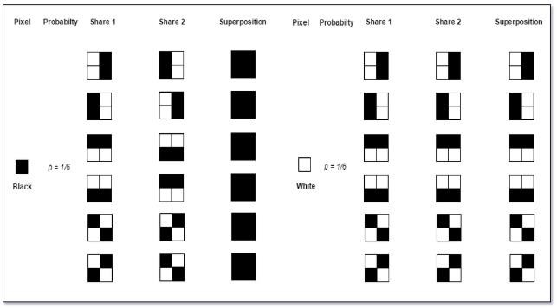
Figure 1. The six possible states of a pixel.

B. Cryptography in Medical Images
In the healthcare sector [7], cryptography techniques are employed to ensure the security of medical images during digital transmission. Before a medical image is stored or transmitted, its index value is read. Figure 2 illustrates the index value of a medical image.
Next, a key matrix is generated randomly, containing values from 1 to the number of shares (Fig. 3 presents the key matrix generated for the example of four shares). The key matrix is then compared with the index of the original medical image. A total of four shares are generated. The index value of the original image is positioned in the key matrix, and the corresponding space in the blank matrix is filled with an index value of 255.
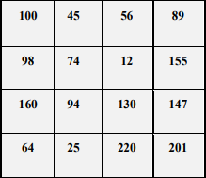
Figure 2. Index value of the medical image.

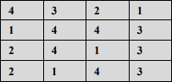
Figure 3. Generated key matrix.
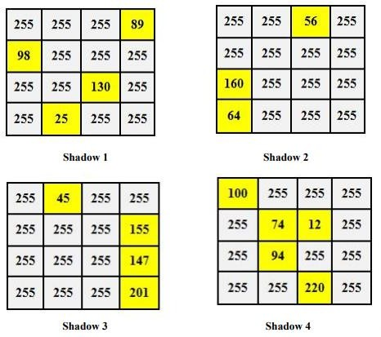
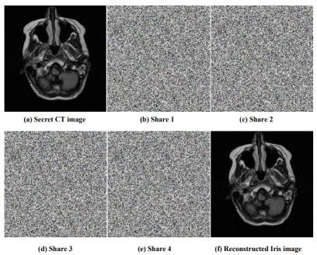
Figure 4. Shares derived from the original image.

Figure 5. (a) Original CT image, (b)-(e) Shares 1-4, and (f) Reconstructed image.
III. STEGANOGRAPHY
A. Definition
Steganography can be defined as the practice of concealing a file, message, image, or video within another file, message, image, or video, thereby passing an unknown message [8]. It is a technique used to hide secret information using data hiding methods to prevent detection by third parties. Steganography can be applied to various mediums, including textual documents, images, networks, audio, and video.
The hidden message remains undetectable to the reader unless they possess the secret key set by the receiver. Steganography serves as a means of secure communication between two parties, where the hidden message may contain confidential information. Its purpose is to ensure secure communication between the sender and the intended receiver.
B. Steganography Techniques
A steganography file system can be employed to conceal files and metadata, allowing the files to be located using a specific key. Figure 6 illustrates the process flow of steganography between the sender and receiver. The cover file, represented by an image, text, audio, or video, should not be known to contain carrier data. It is crucial for the receiver to accurately interpret the genuine message from the sender.
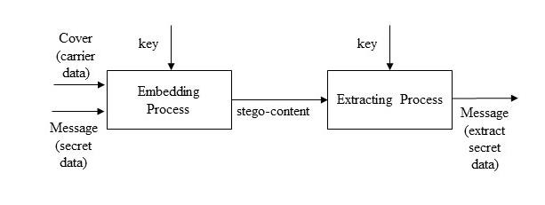
Figure 6. Process flow of steganography.

According to the authors [9], the embedding process involves inserting a certain amount of data into the host contents, such as images or text [9]. The capacity for storing data depends on the steganography technique employed. If the size is small, the host file may retain a similar size to the original. However, if the hidden data is large, the host file's size may change after embedding the data. When the size remains the same, it is easier to disguise the transmission without leaving detectable hints.
The steganographic content can take various forms, including text, images, or audio. After the embedding process, the receiver must extract the message to reveal the hidden content within the stego-content. To extract the hidden data, the sender must share the key with the intended recipient. The extraction process involves converting the content using the secret key to unveil the secret message. The key used in the steganography technique remains confidential between the sender and receiver.
C. Advantages of Steganography
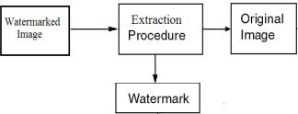
One of the main benefits of steganography is that the hidden information is difficult to detect since people are unaware of the presence of a stego-message. Steganography proves more advantageous when combined with encryption techniques, as extracting the secret message becomes more complicated compared to communication solely based on encryption [10]. Consequently, text or image steganography serves as a safer medium for covert messages, effectively concealing the true message from the sender to the receiver.
Additionally, in steganography, only the true receiver can read the content of the hidden message. The steganography key is not directly provided by the sender and can only be used by the intended recipient. Consequently, the potential solutions for extracting the key or algorithms become broader, increasing the difficulty of extracting the secret message. In terms of security, implementing text steganography is highly recommended, as it ensures greater safety and security.

IV. DIGITAL WATERMARKING
A. Definition
Digital watermarking is a method used to verify the integrity and authenticity of data [11]. It involves embedding a watermark into digital files, which contains important information for the copyright owner. This watermarking process aims to protect against attacks [12] and safeguard the original copyright [13].
B. Process of Image Watermarking
The image watermarking process consists of two stages: embedding and extraction of the watermark. During the embedding phase, the watermark bits are inserted into the host image using a watermarking algorithm [14], as depicted in Figure 7. To complete the functionality of the watermarking scheme, an extraction process is required to retrieve the watermark [14].

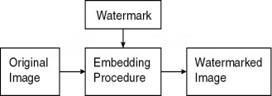
Figure 7. Embedding and extraction process of image watermarking [19].

C. Applications of Watermarking
Watermarking technologies find applications in various digital media where security and owner identification are necessary. Some common applications include [14]:
i. Owner Identification:
Watermark bits, embedded internally and invisible, preserve identification data that cannot be easily located or modified by attackers.
ii. Copy Protection:
Robust watermarking embeds copy protection bits into files, preventing attackers from copying any portion of the file.
iii. Broadcast Monitoring:
Watermarking bits can be used to monitor the broadcasting of TV channels and radio news, providing movement logs service.
iv. Medical Applications:
Medical media and documents require authentication to ensure their authenticity, validity, and admissibility. Watermarking helps verify that reports have not been tampered with and contain essential information about patients and responsible doctors.
v. Fingerprinting:
Fingerprinting provides a unique identification for embedded files, functioning similarly to human fingerprints. Digital information, in the form of watermark bits, is stored in the host file. This is particularly useful for tracking the original and manipulated versions of movies.
vi. Data Authentication:
Authentication verifies that a received file is identical to the original host file. Watermarking achieves this by embedding digital watermarks in the host data, which can be extracted at the receiver's end for verification. Techniques such as hash functions, cyclic redundancy check (CRC), and parity check are commonly employed.
It is important to note that while steganography hides data within digital media without altering it, digital watermarking covertly embeds data into noise signals, and encryption techniques employed in digital watermarking may introduce changes to the original data.
V. COMPARISONS
It is evident that different techniques can be utilized to maintain the confidentiality and integrity of medical images. Cryptography involves an encryption process to ensure the security of medical images during digital transmission. Prior to storage or transmission, the index value of the medical image is read. Through the implementation of cryptography, shares are generated from the original image, and overlaying these shares reconstructs the medical image. Therefore, the shares also serve as a key, allowing decryption of the medical image for readability, with only a minimum number of shares needing to be overlaid.
Then, steganography is employed as a reversible information hiding technique to conceal data within medical images. This technique offers an advantage over encryption as it helps obscure sensitive data. When steganography is used, the hidden data within the medical images is secured, making it unreadable for any unauthorized users during transmission. For instance, tools like S-tools can be utilized to hide data within medical images using a password or passphrase, ensuring that only authorized users such as healthcare professionals can reveal the hidden information. This adds an extra layer of confidentiality for patient data.
Digital watermarking, on the other hand, encompasses both visible and invisible techniques. The watermarking process involves embedding a watermark into the original image using an embedding algorithm. The extraction process, also known as watermark detection, is used to extract the watermark from the watermarked image. If the watermark remains unmodified and can be successfully extracted, it indicates that the image has not been tampered with. While watermarking primarily serves as a signaling mechanism rather than maintaining integrity, it provides a means of detecting any modifications made to the medical image.
VI. PROPOSED TECHNIQUE
Medical images are critical documents for doctors and medical professionals in the diagnosis and treatment planning of patients. With the availability of networks, medical professionals can enhance their productivity and efficiency in performing medical examinations. These medical images can be shared through network connections and stored in centralized sites such as databases or the cloud. Consequently, medical images can be accessed remotely by various healthcare departments, including doctors, nurses, and radiologists. However, network vulnerabilities can compromise the integrity of medical images, leading to serious problems. Therefore, security techniques need to be implemented to ensure the integrity of medical images.
To secure medical images, a combination of digital watermarking and cryptography techniques can be employed. Digital watermarking acts as protection for the images and serves as a copyright function. For example, hospitals may insert their logos into medical images to establish ownership. Furthermore, digital watermarking allows the integration of patients' information into the images, preventing detachment. Doctors in hospitals can refer to this information for diagnosis and treatment planning. However, to improve confidentiality, digital watermarking with patients' information should be encrypted.
Nonetheless, medical images are still transmitted in a readable format over the network. Therefore, hospitals can implement cryptography as an additional technique to encrypt the readable medical images into an unreadable form. This enhances the security of medical images during transmission and provides authentication. The medical image is divided into multiple shares and sent to the receivers, such as doctors or radiologists. Simultaneously, these shares act as a key, and a minimum number of shares need to be overlaid to display the full readable image. The medical images are decrypted before the doctors receive them.
VII. CONCLUSION
In conclusion, this paper demonstrates how techniques such as steganography, cryptography, and digital watermarking can be utilized to enhance the security of medical images during the transmission process. Medical images contain highly sensitive information that should remain confidential and maintain integrity. Therefore, a combination of cryptography and digital watermarking is suggested for secure transmission of medical images within the hospital system.
REFERENCES
[1] A. J. L. J. Gillum and J. Kao, "Millions of Americans' Medical Images and Data Are Available on the Internet. Anyone Can Take a Peek. - ProPublica," ProPublica, 2019. [Online]. Available: https://www.propublica.org/article/millions-of-americans-medical- images-and-data-are-available-on-the-internet. [Accessed: 06-Nov-2019].
[2] D. Schrader, "Information Security Report Confidential patient data freely accessible on the internet Cyber Resilience Report," Osnabrück, 2019.
[3] V. Harmonay, "7 Benefits of Medical Imaging File Sharing," Atlantis Worldwide, 2015. [Online]. Available: https://info.atlantisworldwide.com/blog/-medical-imaging-file- sharing. [Accessed: 06-Nov-2019].
[4] S. Burmester, "Maintaining CIA to Keep Health Care Security Threats at Bay," SecurityIntelligence, 2017. [Online]. Available: https://securityintelligence.com/maintaining-cia-to-keep-health-care- security-threats-at-bay/. [Accessed: 07-Nov-2019].
[5] A. Mahmood, T. Hamed, C. Obimbo, and R. Dony, "Improving the Security of the Medical Images," 2013, International Journal of Advanced Computer Science and Applications 4(9).
[6] M. Naor and A. Shamir, "Visual Cryptography," Proc. Adv. Cryptol. EUROCRYPT 94, vol. 950, pp. 1-12, 1994.
[7] G. Elavarasi and M. Vanitha, "A Novel Method for Securing Medical Image Using Visual Secret Sharing Scheme," Int. J. Eng. Technol., vol. 9, 2017.
[8] K. Preeti et al, "Image Steganography for Data Embedding & Extraction using LSB Techniques", International Journal of Computer Applications & Information Technology, 2016, 9(2), 192-200.
[9] L. Y. Gulati, "A Review of Steganography Research and Development", International Journal of Advanced Research in Computer Science and Software Engineering, 2015, Volume 5, Issue 4.
[10] K. Harpreet and R. Jyoti, "A Survey on Different Techniques of Steganography", Web of Conferences, 2016, 57, 1-6. doi: 10.1051/matecconf/20165702003
[11] Z. Ni, Y. Q. Shi, N. Ansari, and W. Su, "Reversible data hiding," in Proceedings of the 2003 International Symposium on Circuits and Systems, 2003. ISCAS '03., 2008, vol. 2, pp. II-912-II-915.
[12] S. I. Hisham, A. N. Muhammad, J. M. Zain, and G. Badshah, "Localization Watermarking for Authentication of Text Images in Quran with Spiral Manner Numbering," 2013 Taibah University International Conference on Advances in Information Technology for the Holy Quran and Its Sciences, Madinah, 2013, pp. 24-29. doi: 10.1109/NOORIC.2013.17
[13] Z. Mustaffa, F. Ernawan, M. Ramalingam, A. S. Sadiq, "An Improved Imperceptibility and Robustness of 4x4 DCT-SVD Image Watermarking with a Modified Entropy", Journal of Telecommunication, Electronic and Computer Engineering (JTEC), 2014, Volume 9, Issue 2-7, Pages 111-116.
[14] L. K. Saini and V. Shrivastava, "A Survey of Digital Watermarking Techniques and its Applications," IJCST V2(3), Page (70-73), May-June 2014, p. 4, 2014.
[15] C. Röcker, "Smart Medical Services: A Discussion of State-of-The-Art Approaches", IJMLC, 2012, Vol.2(3): 226-230.

