Monitoring Home Safety and

Security

Darshan Sambar , Abhishek Pande , Sumit Kaulkar ,
Department of electronics and telecommunication ,
Sinhgad College of Engineering ,Pune

Abstract :

There are several requirements that a home safety and security system should meet to effectively protect your home and family. A home security system should be able to detect and alert you to any unauthorized entry into your home, whether it's through doors, windows, or other access points. A loud and audible alarm system should be installed to alert you and your neighbours in case of an intrusion or emergency. Motion sensors should be installed throughout the home to detect movement and trigger the alarm system.

Security cameras should be installed to monitor the exterior and interior of your home, providing you with real-time footage of any suspicious activity. A home safety and security system should also include smoke detectors and fire alarms, which can alert you to the presence of smoke or fire and trigger the alarm system. A home safety and security system should also be able to monitor for other environmental hazards, such as carbon monoxide, gas leaks, or flooding. Many modern home security systems allow for remote access through a smartphone app, which can allow you to monitor and control the system from anywhere.

In our proposed system gas sensor , temperature sensor , motion sesnor and ultrasonic sesnor are used . Gas sensor for gas leakage detection , temperature sensor for keeping track of temperature and humidity , motion sensor for motion detection and ultrasonic sensor for distance measurement . This sensors are controlled by using the wifi module nodemcu . The system is configured on a blynk application which can be used to remotely monitor home safety and security .

Introduction :

Home is supposed to be a place where you feel safe and secure. Unfortunately , home is where many accidents occur as well. The main cause of death in children and young adults in injury . Additional injuries that Occur at home account for around 45% of these deaths Some of the more common types of injuries that happen at home include falls , suffocation, Poisoning , barns , drowning , fire arm accidents and chocking Whether a child is at home alone or with adults present injuries can still happen its time for teachers , parents and kids to work together to prevent these accidents from happening. One of the best ways to make sure that your home is safe is to actively inspect each room for potential hazards .

Literature Review :

- In this research paper [1] raspberry provides security and various ways to control the devices in the house. Because of mobile phones the living is comfortable and at the same time it can be easily accessible through portable devices. It gives users all the rights to decide which makes it reliable as it always asks before taking any decision, it helps when there are any necessary decisions, it helps when there are any necessary decisions to be taken and they can be taken fast in case of an emergency.

- In the proposed model of paper [2] the accuracy of Implementations meets the expectation. This home automation system works according to user needs and demands and also the modes of function work as desired during the implementation. Users need to give respective commands through his/her smartphone and the system works according to the assigned algorithm. This project is flexible and user friendly and easy to use. So it can be said that this system has higher accuracy with great efficiency.

- In this paper [3], architecture for smart home control and monitoring systems using Arduino is proposed and implemented. It gives a basic idea of how to control different home appliances and provide security by using Arduino Uno controlled from a desktop application. In our project, we tried to implement an embedded system that meets the main functions of home automation for the management of lighting, habitat security, and temperature & humidity control. For these reasons, a desktop application was created to interact with an Arduino via the serial port.

- [4] proposes an notification-based home security system called notification-based Wireless Home Appliance Control System (HACS). In their work, a homeowner can control their home using notification messages from a preset registered mobile number. If the notification is not from a legitimate mobile number, the system ignores the message. In the case of an intrusion, the appliance control subsystem and security subsystem in the proposed system informs the owner through notification.

Working Model :

Component Description :

- NodeMcu :
The NodeMCU (Node MicroController Unit) is an open-source software and hardware development environment built around an inexpensive System-on-a-Chip (SoC) called the ESP8266. The ESP8266, designed and manufactured by Espressif Systems, contains the crucial elements of a computer: CPU, RAM, networking (WiFi), and even a modern operating system and SDK. That makes it an excellent choice for Internet of Things (IoT) projects of all kinds.
However, as a chip, the ESP8266 is also hard to access and use. You must solder wires, with the appropriate analog voltage, to its pins for the simplest tasks such as powering it on or sending a keystroke to the “computer” on the chip. You also have to program it in low-level machine instructions that can be interpreted by the chip hardware. This level of integration is not a problem using the ESP8266 as an embedded controller chip in mass-produced electronics. It is a huge burden for hobbyists, hackers, or students who want to experiment with it in their own IoT projects.
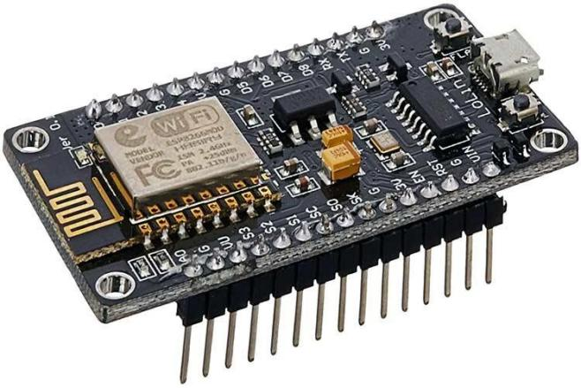

Fig . NodeMCU

But, what about Arduino? The Arduino project created an open-source hardware design and software SDK for their versatile IoT controller. Similar to NodeMCU, the Arduino hardware is a microcontroller board with a USB connector, LED lights, and standard data pins. It also defines standard interfaces to interact with sensors or other boards. But unlike NodeMCU, the Arduino board can have different types of CPU chips (typically an ARM or Intel x86 chip) with memory chips, and a variety of programming environments. There is an Arduino reference design for the ESP8266 chip as well. However, the flexibility of Arduino also means significant variations across different vendors. For example, most Arduino boards do not have WiFi capabilities, and some even have a serial data port instead of a USB port.
Specifications :
- Micro controller: Silicate 32-bit RISC CPU Sensate LX106
- Operating Voltage: 3.3V
- Input Voltage: 7-12V
- Digital I/O Pins (DIO): 16
- Analogue Input Pins (ADC): 1
- Arts: 1
- Sips: 1
- I2Cs: 1
- Flash Memory: 4 MB
- SRAM: 64 KB
- Clock Speed: 80 MHz
- US BOTTLE based on CP2102 is included on-board, Enabling Plug n Play
- PCB Antenna
- Small Sized module to fit smartly inside your ITT projects

- Ultrasonic Sensor :
An ultrasonic sensor is an instrument that measures the distance to an object using ultrasonic sound waves. An ultrasonic sensor uses a transducer to send and receive ultrasonic pulses that relay back information about an object's proximity.
An ultrasonic sensor emits a sound pulse in the ultrasonic range. This sound pulse propagates at the speed of sound through air (about 344 meters per second) until the sound pulse encounters an object. The sound pulse bounces off the object and is returned in reverse to the sensor where this "echo" is received. By measuring the time it takes for the sound pulse to travel from sensor to object and back to the sensor. The distance to the object can be calculated very accurately. This measuring principle is also called "Time of Flight", or transit time measurement.
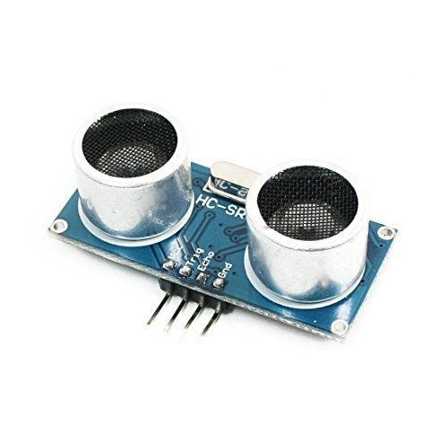

Fig . Ultrasonic Sensor

Specifications
- Power Supply: 3.3V – 5V.
- Operating Current: 8mA.
- Working Frequency: 40Hz.
- Ranging Distance : 3cm – 350cm/3.5m.
- Resolution : 1 cm.
- Measuring Angle: 15 degree.
- Trigger Input Pulse width: 10uS TTL.
- Dimension: 50mm x 25mm x 16mm.

- MQ2 Sensor :
The MQ2 sensor is one of the most widely used in the MQ sensor series. It is a MOS (Metal Oxide Semiconductor) sensor. Metal oxide sensors are also known as Chemiresistors because sensing is based on the change in resistance of the sensing material when exposed to gasses.
The MQ2 gas sensor operates on 5V DC and consumes approximately 800mW. It can detect LPG, Smoke, Alcohol, Propane, Hydrogen, Methane and Carbon Monoxide concentrations ranging from 200 to 10000 ppm. Note that the MQ2 gas sensor detects multiple gases, but cannot identify them! That is normal; most gas sensors operate in this manner. Therefore, it is best suited for measuring changes in a known gas density rather than detecting which one is changing.
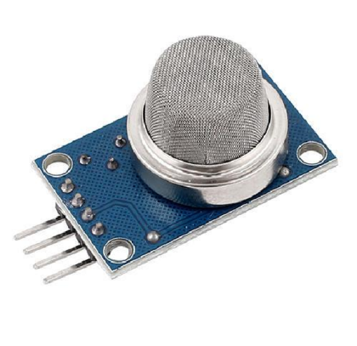

Fig .Gas Sensor

Specifications :
This sensor works on 5V DC voltage. It can detect gases in the concentration of range 200 to 10000ppm.

- PIR Sensor
Passive infrared (PIR) sensors use a pair of pyroelectric sensors to detect heat energy in the surrounding environment. These two sensors sit beside each other, and when the signal differential between the two sensors changes (if a person enters the room, for example), the sensor will engage.
Specifications :
- Wide Working Voltage Range: DC 4.5V- 20V.
- Current Drain: <60uA.
- Detection Angle: <140°
- Detection Distance: 3 to 7m (can be adjusted)
- Blockade time: 2.5s (Default)
- Work temperature: -20-+80°C.
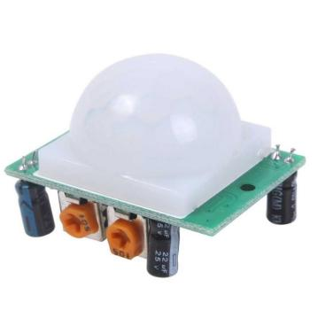

Fig. PIR Sensor

- DHT 11 Sensor :
The DHT11 is a commonly used Temperature and humidity sensor. The sensor comes with a dedicated NTC to measure temperature and an 8-bit microcontroller to output the values of temperature and humidity as serial data. The sensor is also factory calibrated and hence easy to interface with other microcontrollers.
The sensor can measure temperature from 0°C to 50°C and humidity from 20% to 90% with an accuracy of ±1°C and ±1%. So if you are looking to measure in this range then this sensor might be the right choice for you.
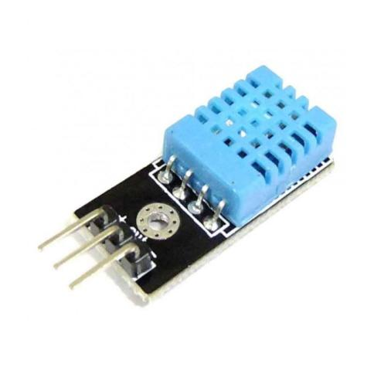
Fig. DHT Sensor
Specifications :
- Operating Voltage: 3.5V to 5.5V
- Operating current: 0.3mA (measuring) 60uA (standby)
- Output: Serial data
- Temperature Range: 0°C to 50°C
- Humidity Range: 20% to 90%
- Resolution: Temperature and Humidity both are 16-bit
- Accuracy: ±1°C and ±1%

- Buzzer :
A buzzer or beeper is an audio signaling device, which may be mechanical, electromechanical, or piezoelectric (piezo for short). Typical uses of buzzers and beepers include alarm devices, timers, train and confirmation of user input such as a mouse click or keystroke.


Fig. Buzzer

- Relay Module :
A relay is a programmable electrical switch which can be controlled by using any arduino or a microcontroller . It is used to on/off the devices which use high voltage and current . It is a bridge between arduino and high voltage devices . Relay has two group pins : low voltage group and high voltage group .

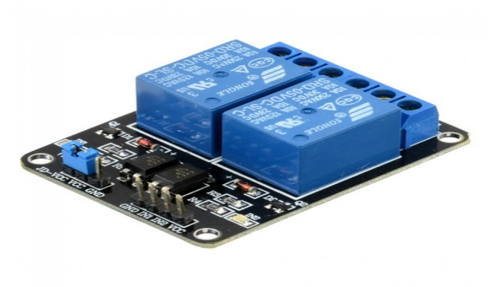
Fig . Relay Module

Block Diagram :

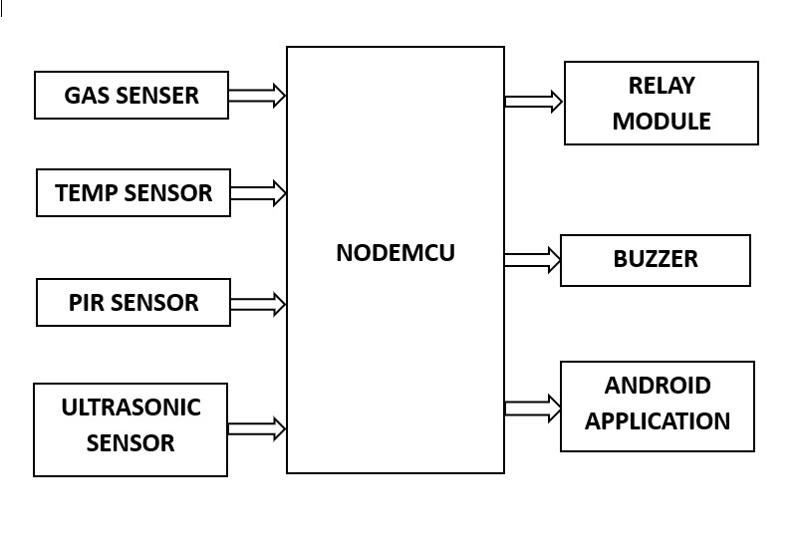

The above figure represents the block diagram of proposed system . The mq2 sensor is interfaced with nodemcu to detect any leakage of gas is the surrounding . DHT11 is the temperature sensor which measures the temperature . similarly PIR sensor is motion sensor and Ultrasonic sensor to detect the water overflowing from a tank . The output components to the system are LCD , Android Application , Buzzer and Relay Module . Relay module performs the switch action . Whole system info will get on android aplication . from this app we are monitoring the system .

Simulation Results :

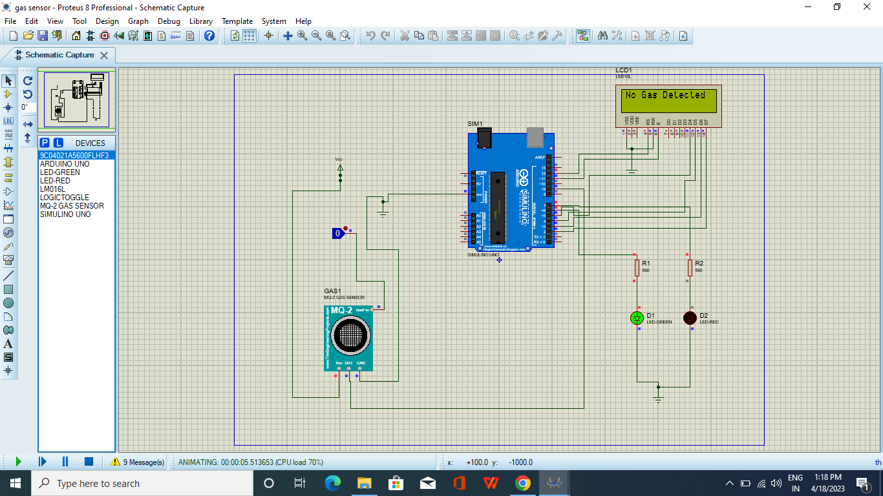
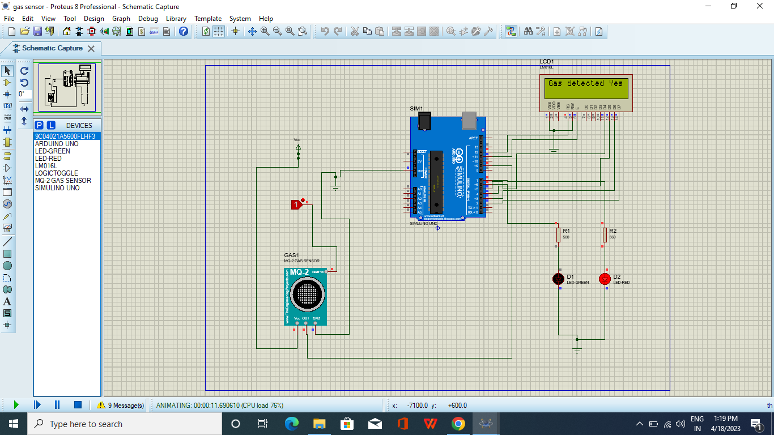

Hardware Implementation :

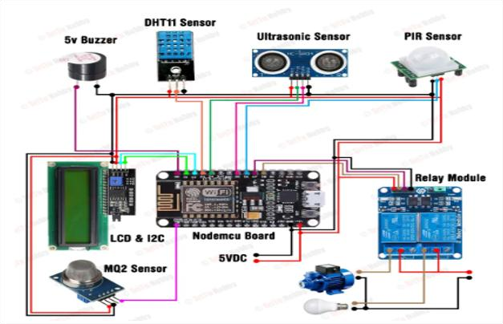

Flowchart :

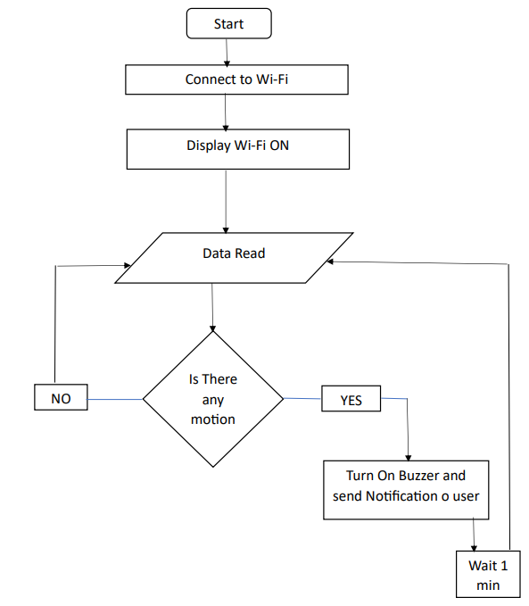

Results :

The project uses BLYNK application that acted as a switch. It is being programmed to switch ON and OFF the model. There are different sensors used which detects overheating , water overflowing , gas leakage and movements .
After detecting different changes in environment it responds by giving a buzzer alarm . This different sesnors are being controlled by using a nodemcu module . When sensor will detect changes , nodemcu will send an notification on blynk app so that you can control the devices from your phone .

Conclusion :

Smart Home with Internet of Things (IoT) based Node MCU ESP8266 Module can be designed with various components hardware and software support so that it can be arranged into a smart home system that is controlled with the Blynk android application according to what is intended.
The Smart Home with this Internet of Things (IoT) based Node MCU ESP8266 Module can be implemented to control some of the home electronics performance including lighting controls, fan control, temperature monitoring, early warning systems and etc.

References :

[1] Arpita Yekhande, Prof. Kapil Misal, “HOME AUTOMATION SYSTEM USING RASPBERRY PI. “ presented at International Research Journal of Engineering and Technology (IRJET) ,10 | Oct -2017).

[2] Abhijit Shejal, Amit Pethkar, Akash Zende, Pratyusha Awate, Prof.Sudhir.G.Mane, “DESIGNING OF SMART SWITCH FOR HOME AUTOMATION.” Presented at International Research Journal of Engineering and Technology (IRJET) 05 | May 2019.

[3] Sudha Kousalya, G Reddi, Priya Vasanthi, B Venkatesh, IOT Based Smart Security and Smart Home Automation presented at International Journal of Engineering Research & Technology 04, April-2018.

[4] Kodali, R. K., Jain, V., Bose, S., & Boppana, L. (2016, April). IoT based smart security and home automation system. In Computing, Communication and Automation (ICCCA), 2016 International Conference on (pp. 1286-1289). IEEE.

