Movie Recommendation System based on Human Emotions using Cascade Classifier and CNN.

K.Madhu Kiran Ch.Saranya Y.Mounika

Department of CSE Department of CSE Department of CSE
VFSTR VFSTR VFSTR madhukirankommakapati1@gmail.com saranyachandu2308@gmail.com yalamanchilimounika6@gmail.com

Abstract: The facial expression recognition-based recommendation system for films is a cutting-edge method that analyses user facial expressions and suggests films in response to their emotional responses. The technology uses a camera to first capture the user's facial expression before processing the image to determine the user's emotional state. The system suggests a list of films that are likely to be appealing to the user based on the emotion that was detected. The recommendation engine analyses user reviews and ratings to generate tailored movie recommendations using a combination of deep learning algorithms and natural language processing. By making recommendations based on the user's emotional preferences, the system has the potential to improve the user's movie-watching experience.
Keywords: Cascade Classifier, CNN, Emotion Recognition, Movie recommendation system

- Introduction:
In general, many people love movies and many of us usually spend our time watching movies. Movies help us as a stress buster and for the entertainment purpose. Due to the work stress or personal issues people may get their mood swings. Many of us are facing mood swings very often due to many reasons such as stress, work pressure, and many tensions. To get relief and become normal, one of the best way is watching movies. In order to bring them out of the mood swings the present work implementing a model that suggests the movie based on the person’s facial emotion. Facial Emotions are detected based on the muscle movement under the skin. Based on certain theories muscle movement helps to detect the facial emotions of individuals. The current work recommends entities such as movies to the user based on individual facial emotion rather than past feedback or other patterns. As, it is the best way to understand one emotion.
Facial Emotion Recognition (FER) is done on real time human images. FER plays a key role in many of the sectors such as for the purpose of Security, Biometrics,
Law enforcement and in recommendation systems. It is also useful for multimedia lovers to recommend movies, music, videos based on their facial emotions. It is difficult for many of us to identify facial emotions if we have Social Anxiety Disorder (SAD). Even if a facial emotion is neutral, people with SAD frequently read it negatively and may even turn away from unfavorable facial emotions altogether. Muscles under the skin are mainly responsible for the facial emotions. There are several theories on the movement of the muscles under the skin to identify the facial emotions.
There are mainly two types of emotions human can make they are voluntary and involuntary emotions. Voluntary emotions are the emotions came out without any force. Eyes, Eyebrows and lips plays important factor in recognizing the facial emotions of a person. Based on the facial emotions we can able to know what’s going on other’s mind. Facial emotion also plays an important role as a sign communication. As we know people who can’t able to talk when they are in the danger situation or many other situations during that time facial emotions plays an important role and acts as a sign language to communicate.
The below are the few features which are used to recognize emotion.
- Biting of Lips due to anxiety.
- Pursing of lips which is a sign for disapproval
- Covering the mouth
- Opening mouth (moving jaw down)
- Lifting of Eyebrows
- Widening of eyes
- Movement of Cheeks
- Based on the corners of the lips.
Facial emotion recognition is implementing in two stages. The first stage of the system is face object localization and the second stage is recognizing the emotion. The Table 1 shows the different classes of facial emotions and its corresponding movie genre.
Table1: Human emotion and corresponding movie genre
Class | Captured Emotion | Movie Genre
1 | Angry | Family
2 | Disgust | Musical
3 | Fear | Sport
4 | Happy | Thriller
5 | Neutral | Western
6 | Sad | Drama
7 | Surprise | Film-Noir

Here we are working with the seven facial emotions or mood swings which we can observe in many of us frequently they are Sad, Happy, Neutral, Anger, Disgust, Fear, Surprise as shown in Figure 1. Based on their emotions we recommend movies. For people with happy emotion, we recommend Thriller movies, for fear we recommend Sport movies, for sad we recommend Drama movies, for disgust we recommend musical movies, For Anger we recommend family movies, for neutral we recommend Western movies, for surprise we recommend Film-noir movies. Here we are dealing with the Top 50 IMDB rated movies as per emotion. The IMDB movies we recommend can be watched through OTT platform. As Every time when we are having mood swings and want to watch movies it is a big thing to go for theatre as we must spend lot of money on it. Not only about money, but it is also impossible to have a movie according to our emotion at the theatre. So, the best way to reduce costs and to watch movies based on our requirement is through OTT platform.
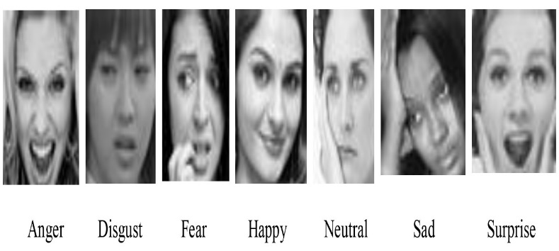
Figure 1: Types of Emotions (7 Classes)
Developing a movie recommendation system based on human facial emotions poses a unique challenge in accurately understanding and interpreting the emotions displayed by users. The system needs to accurately capture and analyze facial emotions in real-time, and translate them into meaningful emotional states in order to provide personalized movie recommendations. The challenge lies in accurately recognizing and classifying a wide range of facial emotions and associating them with appropriate movie genres, ensuring that the recommendations align with the user's emotional preferences.
The objective is to develop a movie recommendation system that accurately captures and interprets human facial emotions in real-time, leveraging this information to provide personalized movie suggestions that align with the user's emotional preferences. The system should ensure user privacy and data protection while continually improving the recommendation algorithm to enhance user engagement and satisfaction.
- Literature Survey:
This section explores the methods and recent related works of the facial emotion based movie recommendation system.
Tahasin Elias et al. [1] proposed a model to recognise the facial emotions using CNN, VGGNet, Inception, MobileNet, and DenseNet. All these experiments are trained and tested using CK+ dataset. It attained accuracy of 96%.
Gupta et al. [2] proposed a model to recognise the facial emotions using fuzzy and genetic algorithms. All these experiments are trained and evaluated using Movie Lens 1M dataset.
Shreya Agrawal et al. [3] proposed a model to recognise the facial emotions using filtering techniques and SVM. All these experiments are carried using three datasets. They are Movie Lens datasets. Here they worked on different datasets and made a comparative analysis.
Ziyang Yu et al.[4] proposed a model to recognise the facial emotions using content based CNN and mood based music recognition. This model can recognize facial emotions and can also propose music based on the facial emotion information. The facial micro-emotion recognition model implemented in this work uses FER2013 dataset and it attained an accuracy of 62.1%.
Milad Mohammad Taghi Zahed et al.[5] anticipated a model to recognise the facial emotion. The authors have used Gabor filters for face features extraction and CNN for classification. The dataset used to implement this model is JAFFE and it attained an accuracy of 97%.
Anuja Bokhare et al.[6] Here proposed a model based on Haar cascade and deep face technologies to detect facial emotions. After detecting the facial emotions, a video is suggested. The dataset here they used to be FER 2013.
Anmol Chauhan et al.[7] In this research work, they proposed a model using collaborative filtering and content based filtering. It is used for movie recommendation to the user as per their interests. The dataset here they used to be enormous dataset.
P.Karthikeyan et al. [8] The work provided in summarised and briefly evaluated the techniques of the movie recommender algorithm. Brief descriptions of movie recommendation systems.Here,they have used movie lens data set.
N Pavitha et al. [9] here the model is proposed by using naïve CNN which attained an accuracy of 89.15.Here,they have used three datasets which are tmdb_5000_movies.csv and tbmd_5000_credits.csv for movie recommendation and reviews.txt for sentiment analysis.
SRS Reddy et al. [10] Content-based filtering is used to recommend movies using facial emotions of the user. Here, we used movie lens dataset.
Jennifer Golbeck et al.[11]. proposed a model to recognise the facial emotions using CNN and suggested movies based on the facial emotions. All these experiments are trained and evaluated using different datasets. Here they worked on different datasets and made a comparative analysis.
H.,Liu et al. [12] The model is proposed based on the LSTM recurrent neural network by using movie lens dataset whose training accuracy is 96.27% and testing accuracy is 95.89%.
Haq et al. [13] suggested a model based on segmentation mechanism after segmentation CNN is performed on it using VGG Face dataset and KDE face dataset whose accuracy is 92%.
Mahadik et al. [14] Here they proposed a model for music recommendation using facial emotions of the user by using CK+ dataset whose accuracy is 75%.
V,Mareeswari et al. [15] This article demonstrates the project's focus on constructing an efficient music, video, movie, and tourism recommendation system that assesses user emotion using facial recognition techniques. The fundamental goal of the system is to recognise facial emotions and deliver music, video, and movie suggestions based on the user's mood.
Shavak Chauhan et al. [16] This paper was completed through capturing the emotion of the user rather than hunting for individual films. CNN is implemented for facial recognition utilising decision trees and boosting algorithms to achieve efficient results as compared to decision trees and boosting algorithms, as demonstrated. The data is pre-processed and then sent to the CNN model. The image is submitted as input to the recommender system, which can then provide a list of films. The users’ face is treated as an input which is captured.Here they used Face dataset and whose accuracy is 62%.
Prateek Sharma et al. [17] In this case, the input is the user's face as caught by a camera. The main source of information for gaining a vital information for input to acquire the outcomes is the face emotion. CNN is the primary classification model employed. The primary principle here is guided learning. The training dataset is connected with labels in this case. The OpenCV library and VGG-16 are used to transform datasets to vectors.

Karzan Wakil et al. [18] Here they proposed a system based on hybrid approach that combines the CBF and CF systems with an emotion recognition algorithm. They recommend movies from 1 to 5 stars and the user can select according to their interest by using mocie lens dataset.
Abhishek Mahata et al. [19] The proposed method is clever as well as secure because a user is validated at the time of login by matching his face to one stored at the time of registration. A fully dynamic interface, i.e. a website that recommends films to the user, is used to implement the system.
Nisha Sharma et al. [20] Here they discussed about different recommendation systems. They did a comparative analysis of those systems by using different datasets.
- Proposed Methodology
3.1 Overview
In this paper, a movie recommendation system based on facial emotions is proposed to help people overcome mood swings. The work is carried in three stages. First human face is located using the Haar cascade classifier. Next, the located face part is fed to the Convolutional Neural Network(CNN) for classifying the type of the emotion. Finally, a movie is recommended from the Internet Movie Database based on the facial emotion. The proposed pipeline used for recommending the movies based on the facial emotion is shown in Figure 2.
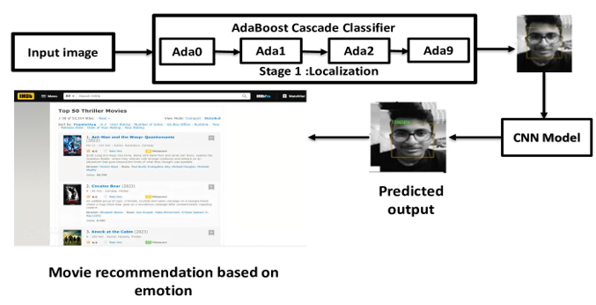
Figure 2: Proposed pipeline to recommend the movies based on the facial emotion
3.2 Dataset:
The proposed model is trained and evaluated using the dataset obtained from Kaggle [Facial emotion recognition, Facial expression recognition dataset], and few custom samples. The dataset is spitting into two parts such as Training and Testing dataset. It consists of 71K samples and grouped into 7 classes. The dataset is divided into 80-20 ratio as shown in Table 2.

Table 2: Splitting of dataset
Class Name | Number of Images | Training (80%) | Testing (20%)
Angry | 9906 | 6935 | 2971
Disgust | 1094 | 766 | 328
Fear | 10242 | 7170 | 3072
Happy | 17978 | 12612 | 5366
Neutral | 12396 | 8677 | 3719
Sad | 12154 | 8508 | 3646
Surprise | 8004 | 5603 | 2401
Total | 71767 | 50271 | 21503

IMDB, short for the Internet Movie Database, is an online database that contains information of the films. IMDB contains a vast collection of data related to movies and TV shows, including information on cast and crew, plot summaries, user ratings, and reviews. It also provides a platform for users to create their own watch lists, rate and review movies, and discuss films with other users. IMDB is a valuable resource for anyone interested in the film industry, from casual moviegoers to aspiring filmmakers. Its comprehensive database of information helps users make informed decisions about what to watch, and its user-generated content provides a community for movie enthusiasts to discuss and share their opinions.
3.3 Locating Face object:
This section describes about the finding the position of the face in the image. This section deals with the detection of driver face. In order to detect the face of a driver, a Haar cascade classifier is trained with positive and negative samples. Positive samples mean that the images that contains the face object. Negative samples mean that the images which doesn’t contain the face objects. To extract the features of the human face Haar kernals are used. The Haar kernals used for this experiment is shown in Figure 3. A total of 6000 Haar features are extracted. Instead of applying all 6000 feature on a window, the features are grouped into different stages of classifier and applied one by one. If a window fails at first stage, discard it. We will not consider the remaining features on it. If it passes, apply the second stage of features and continue the process. The window which passes all stages is a face region. The final classifier is a weighted sum of these weak classifiers. It is called weak because it alone cannot classify the image, but together with others forms a strong classifier. Then, the image is moved into further steps i.e., CNN model for emotion classification.

Figure 3:Haar kernels
3.4 Emotion Recognition
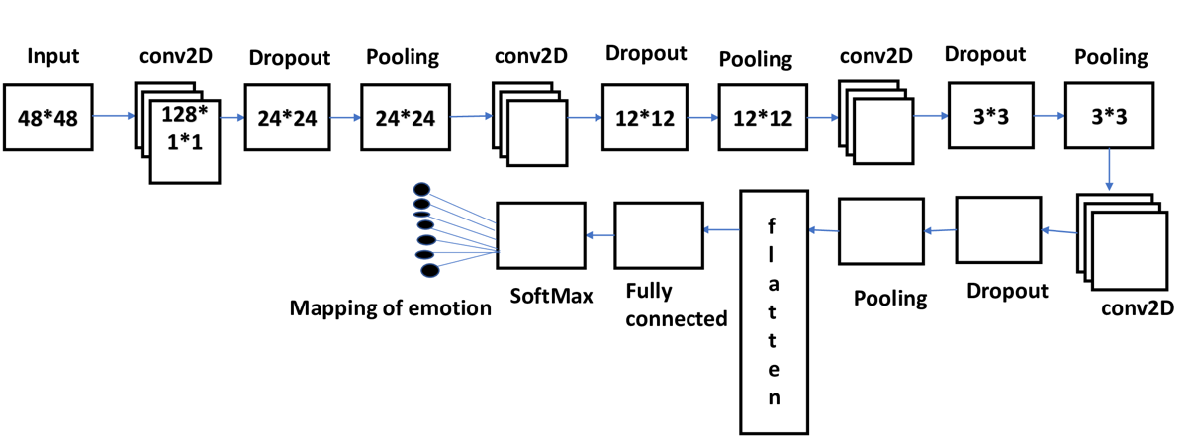
Once the face is detected it undergoes Emotion recognition. For Express recognition we are using CNN model and it is shown in Figure 4. We are giving an input size of 48*48. Then the input undergoes into the convolutional layer for the feature map. The mapped features again go into the convolutional layer of kernel size 3*3. Then pooling is done on the mapped features to extract the required features from the mapped features. Then here we are using dropout to drop some of the unwanted features. Here the input size is reduced to 24*24. After that it again undergoes into convolutional layer of kernel size 5*5 for feature mapping on the extracted image. It again continues and pooling, dropout is done on it. After that it again undergoes into convolutional layer of kernel size 3*3 for feature mapping on the extracted image. It again continues and pooling, dropout is done on it. After that it again undergoes into convolutional layer of kernel size 3*3 for feature mapping on the extracted image. It again continues and pooling, dropout is done on it. Then it goes to flatten. Here Flatten is used to convert 2D vector into 1D vector. Then goes to fully connected layer. At last, the image is mapped to its emotion with the help of SoftMax. Here we are using the Relu Activation function. It is used to remove the negative values from an image by replacing them with zeros.

Figure 4: Working model of CNN

- Results and Discussions
4.1 Experimental settings
All the experiments are performed on Inter Core I7 processor with 8 GB GPU. Python 3 is used to implement the model.
4.2 Training
The parameters used to train the CNN is shown in Table.
Table: CNN hyper parameters
Input size | Epochs | Batch size | Classifier
48 | 25 | 64 | SoftMax
23 | 25 | 32 | SoftMax
23 | 25 | 32 | SoftMax

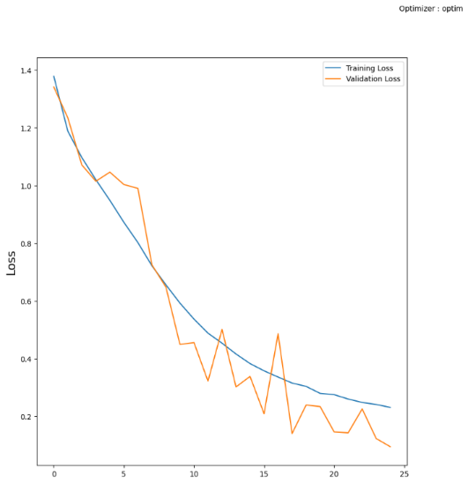
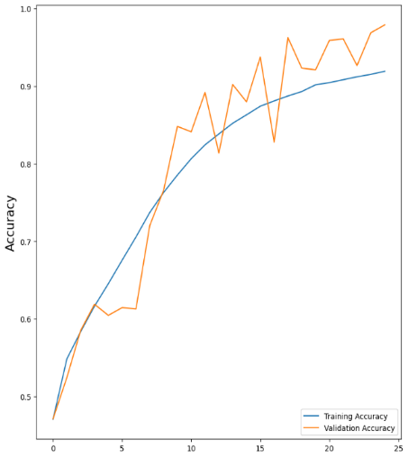 Fig 1: Training, Validation accuracy of CNN1
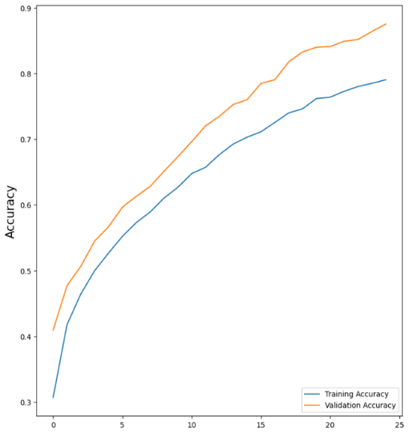
Fig 3: Training, validation accuracy of CNN2
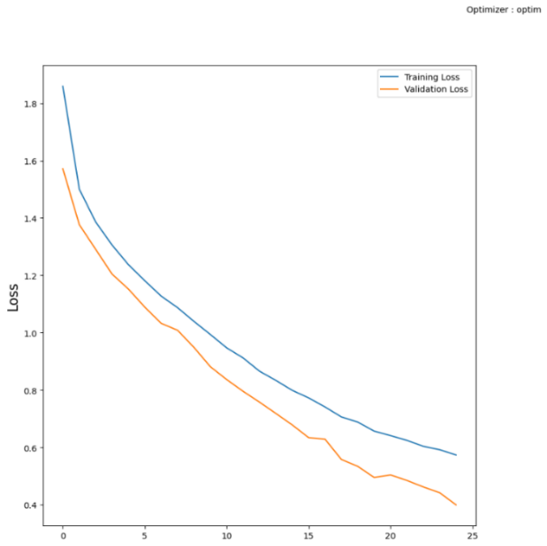Fig 4: Training, validation Loss of CNN2
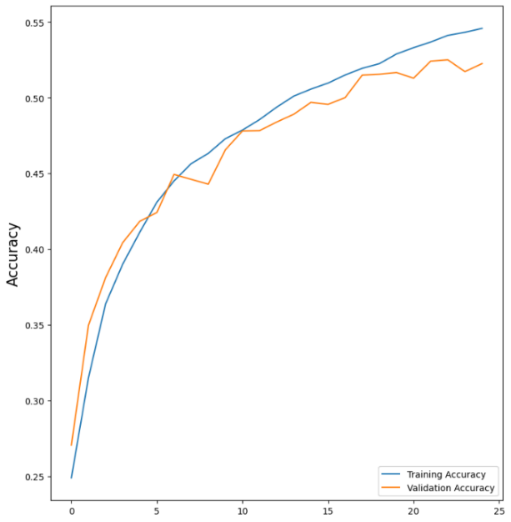
Fig 5: Training, Validation accuracy of CNN3
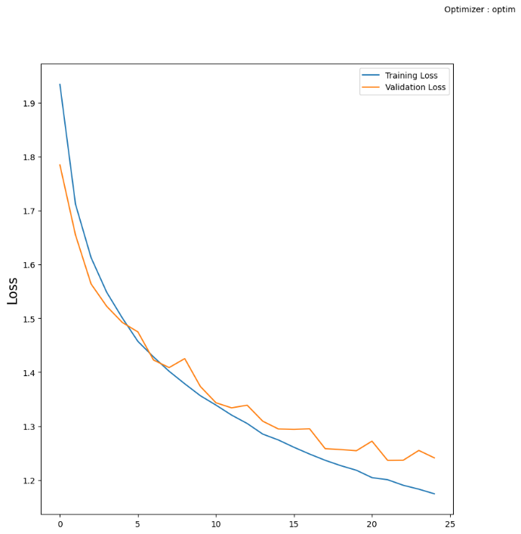
Fig 6: Training, Validation Loss of CNN3

4.3 Evaluation
The metrics such as precision, recall and accuracy are adopted to evaluate the model.
Method /Model | Accuracy
Cascade Classifier + CNN₁ | 92%
Cascade Classifier + CNN₂ | 79%
Cascade Classifier + CNN₃ | 54%

Here the Comparative Analysis of loss and accuracy with respect to the different models. Here we are dealing with the three different CNN models with different number of convolutional layers. Then we are comparing the loss and accuracy of each model and finding the best model.
A confusion matrix is a table which is used to know the working of the categorization model. It contrasts the actual class labels of the test data with the anticipated class labels produced by the model.
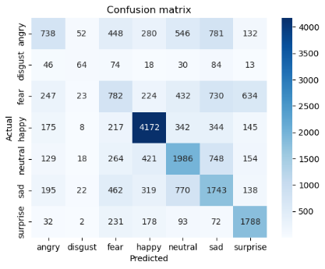
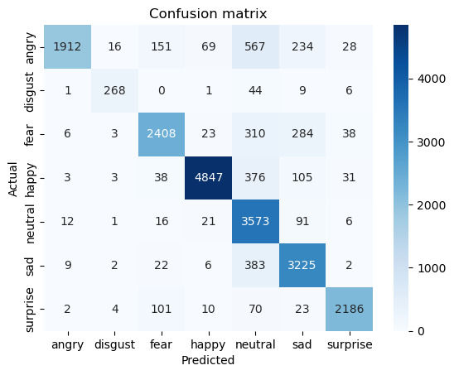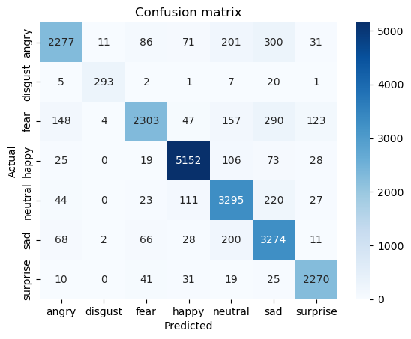
Fig 7:Confusion Matrix for Model 1,2,3
4.4 Testing
In order to test the model 20 percent of the samples from the dataset is considered and the outcomes are shown in Figure.
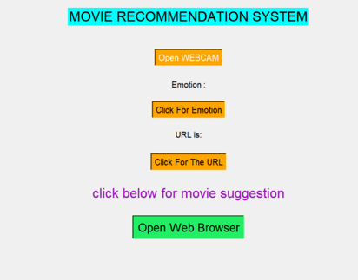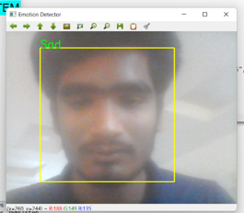
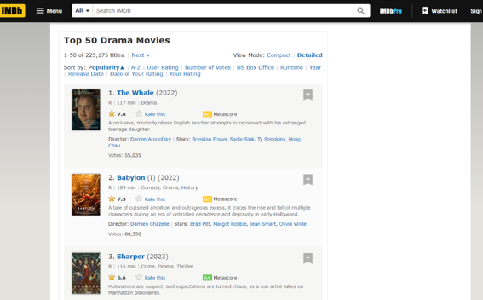

Conclusions:
The recommender system in this research paper used to recommend movies based on the facial emotions of humans using CNN algorithm to obtain the emotion. After obtaining the emotion a list of movies will be generated according to the emotion captured. Here we will get a list of Top 50 IMDB movies according to our emotion. Here we worked on the different CNN models and done Comparative Analysis on the models and found the best model with best accuracy.
References:
[1]T. Elias, U. S. Rahman and K. A. Ahamed, "Movie Recommendation Based on Mood Detection using Deep Learning Approach," 2022 Second International Conference on Advances in Electrical, Computing, Communication and Sustainable Technologies (ICAECT), Bhilai, India, 2022, pp. 1-6, doi: 10.1109/ICAECT54875.2022.9807654.
[2]Hirdesh Shivhare, Anshul Gupta and Shalki Sharma, "Recommender system using fuzzy c-means clustering and genetic algorithm based weighted similarity measure", IEEE International Conference on Computer Communication and Control, 2015.
[3]S.Agrawal and P. Jain, "An improved approach for movie recommendation system", 2017 International Conference on I-SMAC (IoT in Social Mobile Analytics and Cloud) (I-SMAC), pp. 336-342, 2017.
[4] Ziyang Yu, "Research on Automatic Music Recommendation Algorithm Based on Facial Micro-expression Recognition", 39th Chinese Control Conference IEEE, 2020.
[5] M. M. Taghi Zadeh, M. Imani and B. Majidi, "Fast Facial emotion recognition Using Convolutional Neural Networks and Gabor Filters", 2019 5th Conference on Knowledge Based Engineering and Innovation (KBEI), pp. 577-581, 2019.
[6] Bokhare, A., Kothari, T. Emotion Detection-Based Video Recommendation System Using Machine Learning and Deep Learning Framework. SN COMPUT. SCI. 4, 215 (2023).
[7] A. Chauhan, D. Nagar and P. Chaudhary, "Movie Recommender system using Sentiment Analysis," 2021 International Conference on Innovative Practices in Technology and Management (ICIPTM), Noida, India, 2021, pp. 190-193, doi: 10.1109/ICIPTM52218.2021.9388340.

[8] Karthikeyan, P. & Tejasvini, C.. (2022). Review of Movie Recommendation System. 1538-1543. 10.1109/ICACCS54159.2022.9785014.
[9] Pavitha, N., et al. "Movie recommendation and sentiment analysis using machine learning." Global Transitions Proceedings 3.1 (2022): 279-284.
[10] Reddy, Srs & Nalluri, Sravani & Kunisetti, Subramanyam & Ashok, S & Venkatesh, B. (2018). Content-Based Movie Recommendation System Using Genre Correlation.
[11] J. Golbeck and E. Norris, "Personality Movie Preferences and Recommendations", Proceedings of the 2013 IEEE/ACM International Conference on Advances in Social Networks Analysis and Mining, pp. 1414-1415, 2013.
[12] H., Liu, J., Choi, W. H., & Liu, J. (2021, February 19). Personalized Movie Recommendation Method Based on Deep Learning. Personalized Movie Recommendation Method Based on Deep Learning.

