DESIGN OF TRANSFER SLAB FOR HIGH RISE BUILDING
Pratik B. Murumkar ¹ and Dr.vinesh S. Thorat²
ABSTRACT
The design of transfer slabs in high-rise buildings is a critical aspect of structural engineering that requires careful consideration of various design parameters and loadings. Transfer slabs serve as essential structural elements in high-rise structures by transferring loads from columns in upper levels to the columns in lower levels, accommodating changes in column grid layouts, and redistributing forces within the building. This abstract provides an overview of the design considerations and methodologies involved in the design of transfer slabs for high-rise buildings. The design process begins with an analysis of the building's architectural and structural layouts to identify the locations where transfer slabs are required. The loads from the upper levels of the building are transferred through the transfer slab to the columns below. These loads may consist of gravity loads, such as dead loads and live loads, as well as lateral loads, including wind loads and seismic forces. The magnitude and distribution of these loads must be accurately determined to ensure that the transfer slab can effectively carry them. Various design methodologies are available for the design of transfer slabs, including the direct design method and the equivalent frame method. The equivalent frame method simplifies the analysis by representing the slab as a series of equivalent beams and columns. The selection of the design method depends on factors such as the complexity of the structural system, the magnitude of loads, and the desired level of accuracy. The design of transfer slabs also involves consideration of other factors, such as the selection of appropriate reinforcement detailing, the provision of adequate shear reinforcement, and the control of deflections. The reinforcement detailing must account for the transfer of loads, the presence of openings or penetrations, and the compatibility with adjacent structural elements. Shear reinforcement is essential to ensure the transfer slab's capacity to resist punching shear forces at column supports. Proper detailing and placement of shear reinforcement help maintain the structural integrity and prevent premature failure. Additionally, deflection control is crucial to ensure the serviceability and functionality of the transfer slab. Excessive deflections can lead to cracking, deformation, or discomfort for building occupants. Techniques such as the use of post-tensioning, thicker slab sections, or stiffening elements can be employed to limit deflections and enhance structural performance. In conclusion, the design of transfer slabs in high-rise buildings requires a thorough understanding of structural behavior, loadings, and design methodologies. By carefully considering these factors and implementing appropriate design strategies, transfer slabs can effectively distribute loads, accommodate column layout changes, and ensure the overall stability and functionality of high-rise structures.
LLRS, Seismic, Core wall, Modifiers, Transfer
INTRODUCTION
Designing transfer slabs in high-rise buildings is a complex and critical task, particularly in areas prone to earthquakes. The seismic performance of these structures is paramount to ensure the safety of occupants and mitigate potential damage during seismic events. A common design approach involves utilizing a central shear wall system, where vertical walls provide stiffness and resist lateral forces induced by earthquakes. In this detailed analysis, our focus is on a building featuring two central shear walls strategically positioned to enhance overall structural integrity and effectively withstand seismic loads. These central shear walls act as primary load-bearing elements, responsible for resisting lateral forces and providing stability to the structure. To improve connectivity and load distribution between the shear walls, link beams are introduced. These beams connect the upper portions of the two shear walls, ensuring even distribution of forces and deformations, thereby minimizing concentration points and potential weak areas. Another significant feature of the analyzed building is the presence of a transfer floor at the first level. This transfer floor serves as an intermediate structural element responsible for efficiently transferring loads from the upper floors to the shear walls. During an earthquake, the lateral forces acting on the building induce bending moments and shear forces within the shear walls and link beams. Conducting a seismic analysis of the building involves evaluating its structural response under various seismic loads to ensure overall stability and performance. Advanced computational techniques, such as finite element analysis, are commonly employed to simulate the seismic behavior of high-rise buildings with central shear wall systems. These analyses provide valuable insights into the building's response, enabling engineers to optimize the design and ensure its safety.
The earthquake analysis of high-rise buildings with two central shear walls connected through link beams and a transfer floor requires considering multiple factors. These include assessing the local seismic hazard, understanding soil conditions, accounting for building materials, and adhering to design codes and regulations specific to the region. Incorporating these considerations into the design process helps achieve a robust and resilient structure capable of withstanding seismic events and ensuring the safety of occupants.

HIGH RISE BUILDING
A high-rise building is a tall structure characterized by its significant height, typically exceeding the height of surrounding buildings in its vicinity. It is a symbol of modern architecture and urban development, often found in densely populated areas or city centers. High-rise buildings are designed to accommodate multiple floors, providing space for various purposes such as residential, commercial, or mixed-use functions. They are constructed using advanced engineering techniques and materials to ensure structural integrity, occupant safety, and efficient use of space. The design of high-rise buildings involves various considerations. Structural engineers carefully analyze the loads and forces acting on the building, including gravity loads (such as the weight of the building and its contents) and lateral loads (such as wind forces and seismic forces). These analyses help determine the appropriate structural systems, such as reinforced concrete, steel frames, or composite structures, to ensure the building's stability and resistance to external forces. High-rise buildings have a significant impact on the urban landscape and skyline, shaping the visual identity of cities. They often serve as landmarks and icons of architectural achievement. However, their design and construction require careful planning, coordination, and adherence to building codes and regulations to ensure the safety, functionality, and long-term performance of these remarkable structures.
DESIGN CONSIDERATION FOR TRANSFER SLAB
Transfer slabs play a crucial role in the design of high-rise buildings and other complex structures. They are horizontal structural elements that facilitate the transfer of loads from one set of vertical elements to another. These slabs are commonly used in situations where changes in column grids, vertical offsets, or alterations in load paths occur within the building. The design of transfer slabs requires careful consideration of various factors to ensure structural integrity, load distribution, and overall stability. This introduction provides an overview of the key design considerations involved in transfer slab design.
- Load Transfer: The primary function of a transfer slab is to transfer the loads from the upper levels to the supporting columns or walls below. These loads include gravity loads from floors, walls, and roof, as well as lateral loads such as wind and seismic forces. The design must ensure that the transfer slab can effectively carry and distribute these loads without causing excessive stresses or deformations.
- Column Layout and Load Paths: Transfer slabs are often used when there are changes in column grids or vertical offsets within a building. The design must accommodate these variations in column layouts and ensure the continuity of load paths. The transfer slab must effectively redistribute the loads from the upper levels to the appropriate supporting elements.
- Structural System Compatibility: The design of the transfer slab should be compatible with the overall structural system of the building. It must integrate seamlessly with the surrounding structural elements, such as columns, walls, and beams, to ensure a robust and efficient load transfer system.
- Deflection Control: Control of deflections is essential to maintain serviceability and prevent discomfort to occupants. Excessive deflections can lead to cracking, deformation, or adversely affect the performance of the building's non-structural components. The design should incorporate measures to limit deflections within acceptable limits.
- Reinforcement Design: Adequate reinforcement detailing is critical to ensure the transfer slab's strength and load-carrying capacity. The reinforcement design should consider the transfer of loads, moments, and shear forces within the slab. Proper placement and detailing of reinforcement ensure the structural integrity of the transfer slab.
- Shear and Punching Shear Considerations: The design must address shear and punching shear requirements at the column supports. Shear reinforcement, such as stirrups or shear studs, may be necessary to enhance the transfer slab's resistance against these forces and ensure its safety and durability.
- Construction Considerations: Construction aspects, such as formwork, reinforcement placement, and construction joints, need to be carefully planned and executed to achieve the desired design intent. Coordination with other trades, sequencing, and access for construction equipment should be taken into account during the design process.
The design of transfer slabs in high-rise buildings requires a thorough understanding of load transfer mechanisms, structural systems, and construction considerations. By addressing these design considerations, engineers can ensure the safe and efficient transfer of loads within the structure, contributing to the overall performance and stability of the building.
GRAVITY LOAD RESISITNG SYSTEM IN HIGH RISE BUILDING
Gravity columns are integral components of high-rise buildings, providing essential support and load-bearing capacity to the structure. These vertical elements are responsible for transferring the gravitational loads, such as the weight of the building and its contents, from upper levels to the foundation. The design and placement of gravity columns play a crucial role in ensuring the structural integrity and stability of high-rise buildings. In high-rise construction, gravity columns are designed to withstand significant vertical loads and distribute them efficiently to the foundation. These loads include dead loads (the weight of the building's structural components) and live loads (the weight of occupants, furniture, and other dynamic loads). The columns must be engineered to resist these loads without excessive deflections or overstressing. One key consideration in the design of gravity columns is their size and arrangement. The number and positioning of columns are determined by factors such as the building's architectural layout, column grid, and structural requirements. The size and spacing of columns are carefully analyzed to ensure that they can adequately support the loads and maintain the desired levels of safety and serviceability.
The design of gravity columns in high-rise buildings requires a comprehensive understanding of structural analysis and design principles. Engineers consider factors such as material strength, column slenderness, lateral stability, and load distribution to ensure that the columns can effectively support the building's weight and resist any lateral forces, such as wind loads or seismic forces. Overall, gravity columns are vital structural elements in high-rise buildings, providing the necessary support and load-bearing capacity. Their design and placement must be carefully considered to ensure the structural integrity, stability, and functionality of the building. By combining engineering expertise, analysis tools, and adherence to building codes and regulations, engineers create robust gravity column systems that contribute to the safe and efficient operation of high-rise structures
STRUCTURAL CONFIGURATION
The analysis and design process for high-rise structures involves a critical step of utilizing the ETABS software to model the building. ETABS is a widely used software tool that allows for the creation of a precise and comprehensive 3D model. The modeling procedure encompasses the definition of various geometric parameters of the building, including floor plans, column sizes, and beam dimensions. Once the fundamental geometry is established, the software facilitates the specification of materials and structural elements, such as concrete, steel, and shear walls.
In this particular case, we are considering a residential project with a G+32 configuration for seismic evaluation. The building has plan dimensions of 82m x 35m and a floor-to-floor height of 3.6m. Detailed information about the building's characteristics can be found in the provided table, and a visual representation of its layout is presented in the accompanying figure.
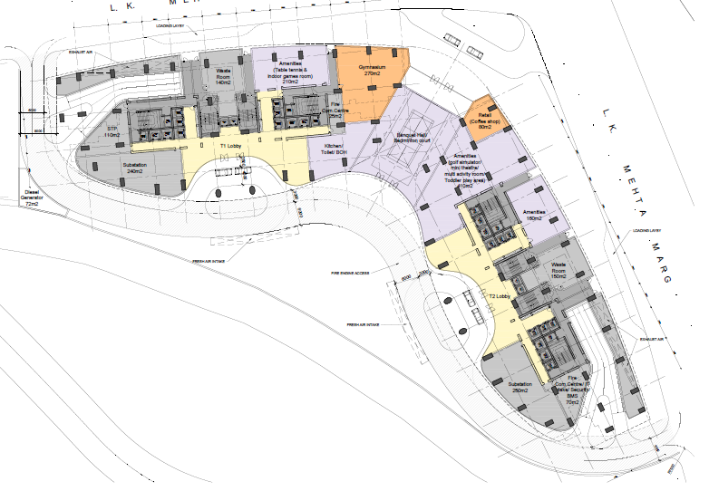 | 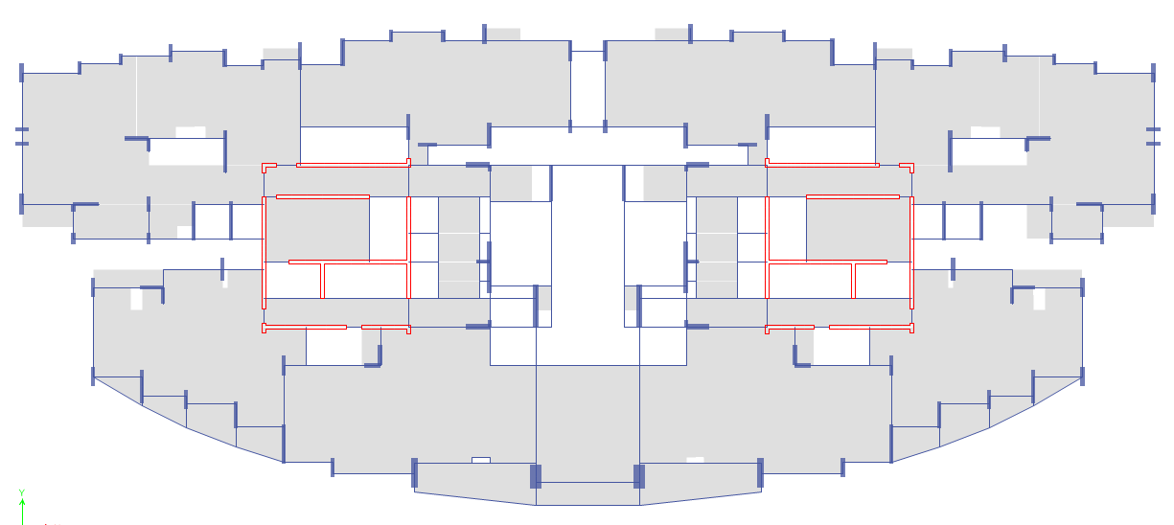
TYPICAL FLOOR PLAN FOR A STRUCTURE
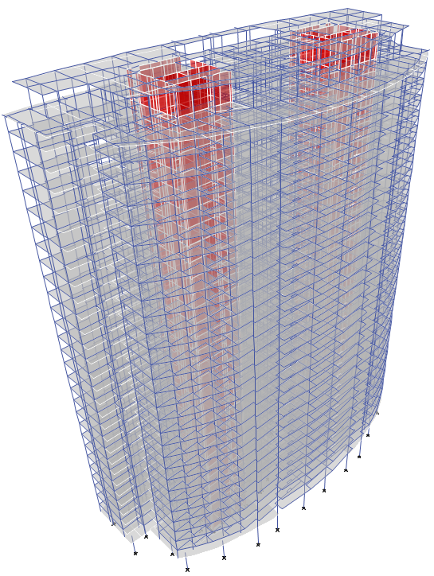 | 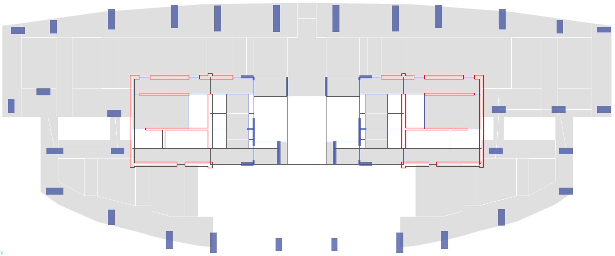
ISOMETRIC VIEW AND TRANSFER LEVEL PLAN

DESIGN METHODOLOGY FOR TRANSFER SLAB
Determine the loads: Identify the gravity loads and lateral loads that the transfer slab will need to support. Consider the dead loads, live loads, and any other applicable loads as per the project requirements.
- Establish column layout and load paths: Determine the column layout and the transfer of loads from the upper floors to the supporting columns or walls through the transfer slab. Ensure the load paths are clear and direct, minimizing any eccentricities or torsional effects.
- Determine the required thickness: Calculate the required thickness of the transfer slab based on the applied loads, span lengths, and design criteria. Consider deflection limits, crack control, and construction considerations in the thickness determination.
- Reinforcement design: Design the reinforcement for the transfer slab to resist the bending moments, shear forces, and any torsional effects. Consider the Indian codal provisions for reinforcement detailing, such as IS 456:2000 (Plain and Reinforced Concrete - Code of Practice).
- Shear reinforcement design: Analyze the shear forces acting on the transfer slab and design the shear reinforcement accordingly. Consider the provisions given in the Indian code IS 456:2000 for the design of shear reinforcement.
- Punching shear analysis: Perform a punching shear analysis to ensure the transfer slab can resist the concentrated loads from columns or walls without failure. Apply the relevant punching shear provisions from the Indian code IS 456:2000.
- Consider temperature and shrinkage effects: Account for the temperature and shrinkage effects in the design of the transfer slab. Follow the relevant Indian code provisions, such as IS 456:2000, for estimating and incorporating these effects.
- Construction considerations: Consider the construction sequence, formwork requirements, and any additional construction considerations specific to the transfer slab. Ensure proper reinforcement placement, provide adequate support during construction, and address any issues related to construction joints.
RELEVANT DESIGN PARAMETERS AND CONSIDERATIONS FOR DESIGNING TRANSFER SLABS
- Loadings: Consider the various loads that the transfer slab will be subjected to, including dead loads (self-weight, finishes), live loads (occupancy, equipment), and any other applicable loads. Follow the load specifications provided in IS 875: Part 1 (Dead Loads) and IS 875: Part 2 (Live Loads).
- Span-to-depth ratio: Determine the appropriate span-to-depth ratio for the transfer slab based on the design requirements and the provisions specified in IS 456:2000. Ensure that the selected span-to-depth ratio satisfies the deflection limits and structural performance criteria.
- Clear span and supports: Determine the clear span of the transfer slab and the positions of supporting columns or walls. Ensure that the clear spans are within the permissible limits specified in IS 456:2000, considering the slab thickness and reinforcement detailing requirements.
- Thickness design: Calculate the required thickness of the transfer slab to meet the design criteria for deflection, crack control, and load-bearing capacity. Follow the provisions of IS 456:2000 for minimum thickness requirements and consider additional guidelines provided by relevant design codes, such as IS 13920:2016 for seismic design.
- Reinforcement detailing: Design the reinforcement detailing for the transfer slab as per the provisions of IS 456:2000. Consider the minimum and maximum reinforcement requirements, distribution of reinforcement, cover requirements, and development lengths as specified in the code.
- Shear reinforcement: Analyze the shear forces acting on the transfer slab and design the shear reinforcement accordingly. Follow the provisions of IS 456:2000 and IS 13920:2016 for designing the shear reinforcement, considering factors such as shear span-to-depth ratios, minimum shear reinforcement ratios, and detailing requirements.
- Punching shear design: Perform a punching shear analysis to ensure the transfer slab can resist the concentrated loads from columns or walls without failure. Apply the provisions specified in IS 456:2000, which provide guidelines for punching shear reinforcement, effective depth, and shear resistance calculations.
- Temperature and shrinkage effects: Account for the temperature and shrinkage effects in the design of the transfer slab. Follow the provisions of IS 456:2000 for estimating and incorporating these effects, including the use of expansion joints, appropriate reinforcement detailing, and considerations for temperature differentials.
- Construction joints: Consider the placement and design of construction joints in the transfer slab. Follow the guidelines provided in IS 456:2000 for construction joint requirements, including the type of joint, reinforcement detailing, and joint location.
- Quality control and material specifications: Adhere to the quality control measures and material specifications specified in IS 456:2000. Ensure that the concrete mix design, reinforcement materials, and testing procedures comply with the relevant standards to achieve the desired strength, durability, and performance of the transfer slab.
It is important to consult and comply with the relevant Indian standards codes, including IS 456:2000 (Plain and Reinforced Concrete - Code of Practice) and other related codes such as IS 13920:2016 (Ductile Design and Detailing of Reinforced Concrete Structures) and IS 875 (Design Loads for Buildings and Structures) to ensure the safe and efficient design of transfer slabs in accordance with the established standards.
ANALYSIS OF HIGH RISE BUILDING
The seismic analysis plays a vital role in ensuring the safety and structural integrity of tall buildings. This investigation focuses on examining the behavior of a high-rise building that incorporates a unique lateral load resisting system (LLRS). The LLRS comprises two central core walls, a peripheral core wall system, and a transfer structure situated at the first floor. The primary objective of the seismic analysis is to assess the building's response to seismic forces and identify potential failure modes. By gaining insights into the building's dynamic behavior during seismic events, engineers can ensure its stability and minimize the risk of harm to occupants. The implementation of two central core walls as the main LLRS enhances the building's stiffness and strength, effectively counteracting the lateral loads generated by seismic activity. The precise placement and configuration of these core walls play a critical role in distributing seismic forces throughout the structure, thereby reducing deformations and ensuring overall stability. The peripheral core wall system complements the central core walls by providing additional resistance against lateral forces, further enhancing the overall structural performance. The combination of central and peripheral core walls forms a robust system that efficiently absorbs and dissipates seismic energy, thereby mitigating the impact on the building's structural elements.
After obtaining the analysis results for a high-rise building, several checks need to be performed to ensure the accuracy and reliability of the results. Some of the important checks to consider are:
- Model Verification: Verify the integrity and correctness of the structural model used for the analysis. Ensure that the model accurately represents the geometry, material properties, and boundary conditions of the actual building.
- Load Comparisons: Compare the applied loads used in the analysis with the design loads specified by the relevant codes and standards. Check if the loads are appropriately applied and distributed throughout the structure.
- Convergence Check: Assess the convergence of the analysis results to ensure that the solution is reliable. Verify if the applied load combinations reach equilibrium, and the displacement and internal forces converge to acceptable limits.
- Check for Overstress: Examine the stress levels in critical structural elements, such as columns, beams, and walls. Ensure that the stress values are within the allowable limits specified by the design codes.
- Deflection Checks: Evaluate the deflection values of the structural elements, particularly for serviceability considerations. Verify if the deflections are within the acceptable limits to avoid excessive deformations that may affect the functionality of the building.
- Shear and Moment Checks: Assess the shear and moment distributions in beams, slabs, and walls. Verify if the calculated values are consistent with the expected behavior and ensure that the structural elements can adequately resist the applied loads.
- Structural Stability: Verify the overall stability of the structure, considering the effects of lateral loads, such as wind or seismic forces. Check for any potential instability issues, such as buckling, sway, or excessive displacements.
- Code Compliance: Evaluate whether the structural design and analysis results comply with the relevant building codes and standards applicable to high-rise buildings. Check if the safety factors, material strengths, and detailing requirements are satisfied.
- Dynamic Response Checks: If the analysis considers dynamic effects, assess the building's response to dynamic loads, such as wind or earthquake-induced vibrations. Verify if the calculated natural frequencies, mode shapes, and dynamic response parameters are within acceptable limits.

- Sensitivity Analysis: Perform sensitivity analyses to investigate the effects of variations in parameters or input data. Assess how changes in loadings, material properties, or modeling assumptions impact the structural response.
ANALYSIS RESULTS
The comprehensive analysis of a high-rise building, which includes a distinctive lateral load resisting system (LLRS) and other structural components, entails thorough investigations and simulations to gain insights into its response and behavior under different loading scenarios. This chapter presents the outcomes derived from the in-depth analysis performed on the examined high-rise structure.
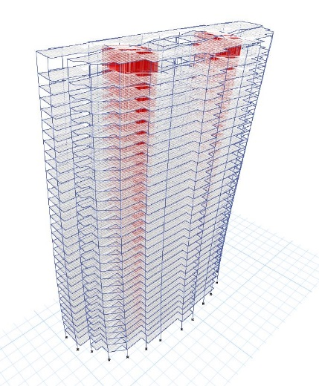 | 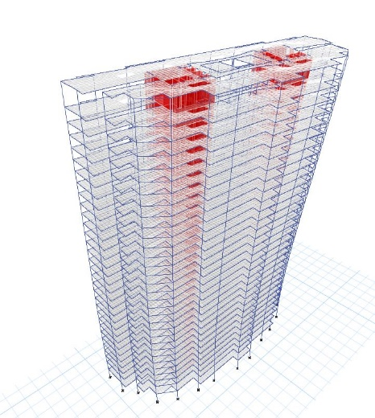
Mode Shapes
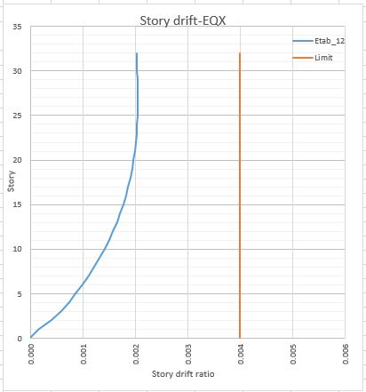 |  | 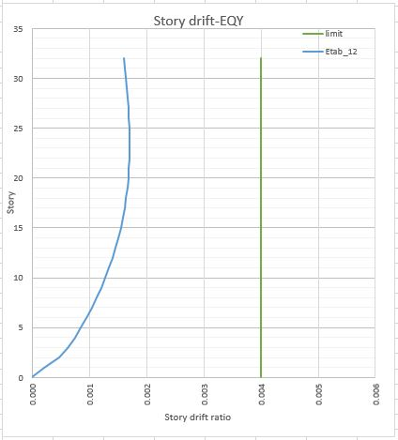
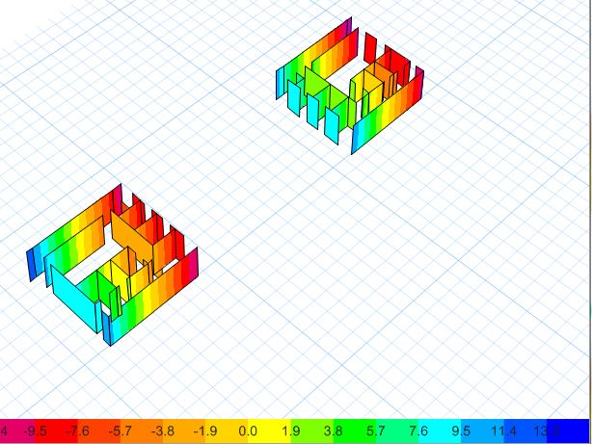 |  | 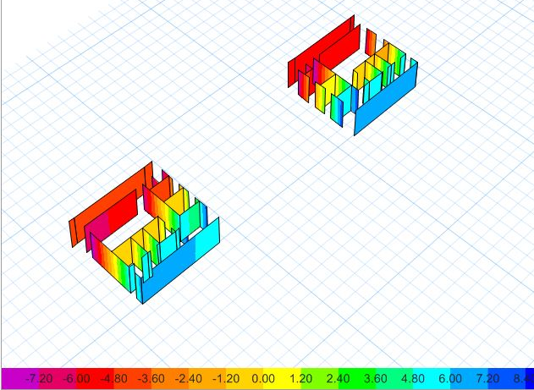
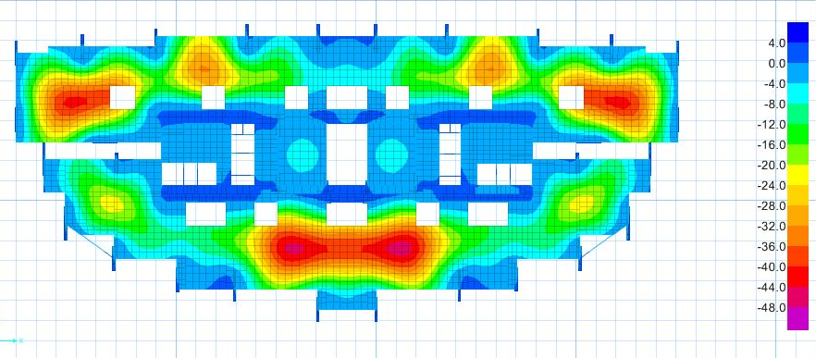
DESIGN OF TRANSFER SLAB
The design of a transfer slab is a critical aspect of structural engineering in multi-story buildings. Transfer slabs are structural elements that facilitate the transfer of loads from one set of columns to another. They are typically used when there is a change in column grid or when vertical elements, such as walls or cores, need to pass through a floor level.
The primary objective of designing a transfer slab is to ensure its ability to efficiently distribute the transferred loads to the supporting columns or walls without compromising the structural integrity of the building. Transfer slabs must be designed to withstand the imposed loads, including dead loads, live loads, and any additional loads specific to the project.
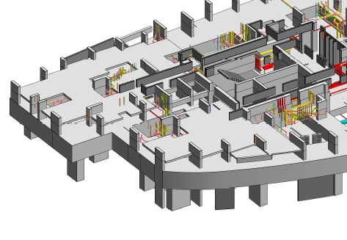 |  | 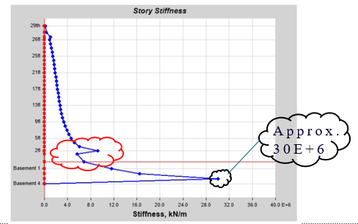
NO STIFFNESS IRREGULARITY WITH RW
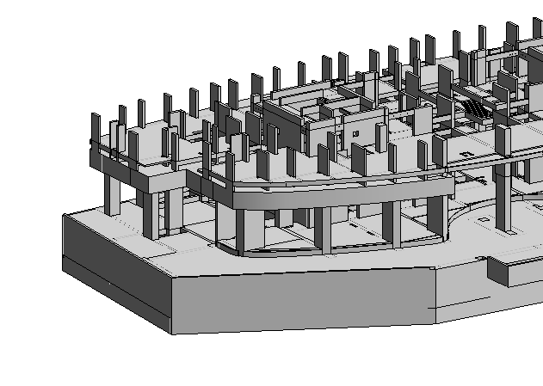 |  | 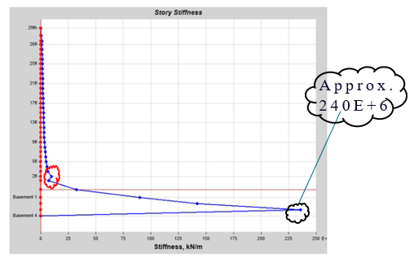
STIFFNESS IRREGULARITY WITHOUT RW
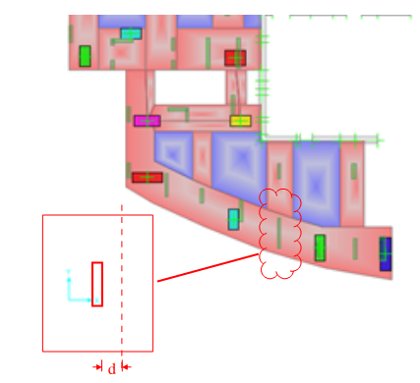 | 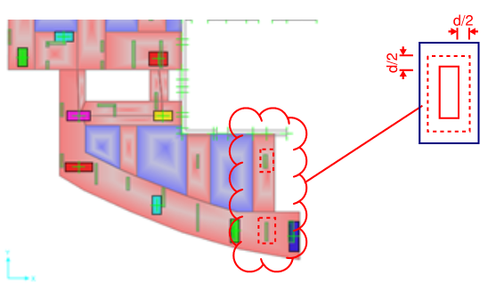
ONE WAY SHEAR CHECK | TWO WAY SHEAR CHECK
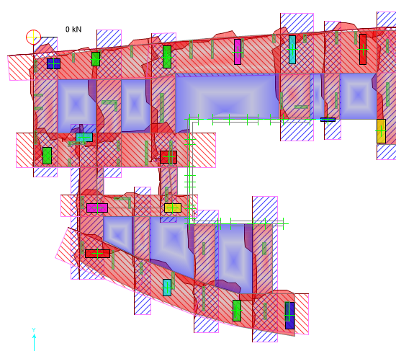
CHECK FOR FLEXURE
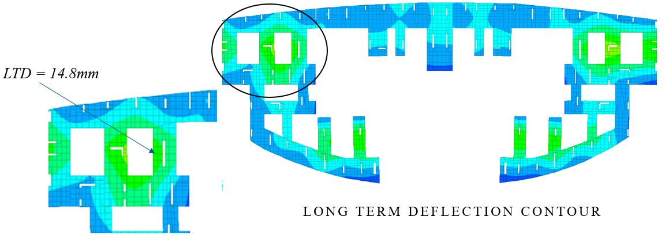
CHECK FOR DEFLECTION
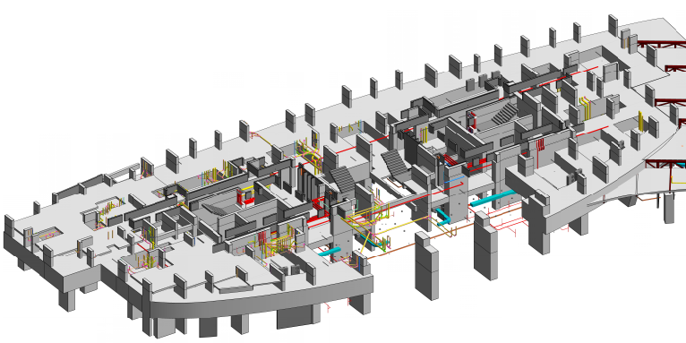
FINAL TRANSFER FLOOR
The presented design results for the transfer slab demonstrate its structural adequacy and performance, ensuring the efficient transfer of loads within the multi-story building while maintaining the required levels of safety and functionality.
CONCLUSION
- Optimal Load Transfer: The design of the transfer slab in a high-rise building with two centrally located core wall systems and peripheral columns as Ground-Level Resisting System (GLRS) ensures the efficient transfer of loads from one set of columns to another, maintaining the structural integrity of the entire building.
- Enhanced Structural Stiffness: The presence of two centrally located core walls provides increased stiffness and strength to the building, effectively countering lateral loads induced by various factors such as wind and seismic activity.
- Strategic Placement of Core Walls: The careful positioning of the core walls plays a crucial role in distributing seismic forces evenly throughout the structure, reducing deformations, and ensuring overall stability.
- Reinforcement Design: The transfer slab is designed with appropriate reinforcing bars to effectively withstand the imposed loads, including dead loads, live loads, and any additional loads specific to the project.
- Consideration of Deflection and Crack Control: The design accounts for deflection and crack control to ensure that the transfer slab maintains its integrity and functionality under normal service conditions.
- Compliance with Design Codes: The design of the transfer slab adheres to relevant design codes and standards specific to high-rise buildings, ensuring compliance with safety regulations and industry best practices.
- Integration with GLRS: The transfer slab works in conjunction with the peripheral columns acting as the Ground-Level Resisting System (GLRS), providing additional resistance against lateral forces and enhancing the overall structural performance.
- Efficient Load Distribution: The transfer slab efficiently distributes transferred loads from the upper levels to the peripheral columns and core walls, ensuring optimal load distribution and minimizing localized stress concentrations.
- Structural Stability: The design of the transfer slab, in combination with the centrally located core walls and peripheral columns, creates a robust system that effectively absorbs and dissipates seismic energy, enhancing the building's overall stability during seismic events.
- Safety and Functionality: The design of the transfer slab ensures the safety of occupants and the functionality of the high-rise building by providing a reliable load transfer mechanism, minimizing structural damage, and maintaining the building's performance under various load conditions.
In conclusion, the design of the transfer slab in a high-rise building with two centrally located core wall systems and peripheral columns as GLRS demonstrates a comprehensive approach to ensure efficient load transfer, structural stability, compliance with design codes, and the overall safety and functionality of the building.
REFERENCES
- IS 16700 (2017). “Criteria for Tall Building”, Bureau of Indian Standards, New Delhi, India
- IS 1893 (Part 1) (2016). “Criteria for Earthquake Resistant Design of Structures- Part 1 general provision and buildings”, Bureau of Indian Standards, New Delhi, India
- IS 456 (2016). “Plain and Reinforced concrete Structures”, Bureau of Indian Standards, New Delhi, India.
- IS 13920 (2016). “Ductile Detailing of Reinforced Concrete Structures Subjected to Seismic Forces - Code of Practice” Bureau of Indian Standards, New Delhi, India
- IS 875 Part 2 (1987). “Code of Practice for Design Loads (Other Than Earthquake) For Buildings and Structures- Imposed Loads” Bureau of Indian Standards, New Delhi, India

