Power Modulation in Dual Active Bridge DC-DC Converter using Single Phase Shift Modulation
KrishnaYadav,VikramKumar,Kamaldeep

Abstract-This paper presents dual- active bridge (DAB) DC-DC converter where power is regulated by using single phase shift (SPS) modulatin. The zero-voltage switching (ZVS) operation is lost at the light load condition and the sizeable reactive power exists over a wide operation range, which results in low efficiency. Thus, a novel single-phase shift modulation scheme is proposed in this paper. , a discrete dual‐active‐bridge model based on the transferred power between both converter bridges, which overcomes the approximations of the output current linearization model, is proposed. Moreover, the article introduces a novel equation set to directly and dynamically tune discrete PI parameters to fulfill the design frequency specifications based on the inversion formulae method. The operation includes the power flow control of bidirectional DAB DC-DC converter in both directions which includes forward as well as reverse direction. This work is carried out by using different values of power for successful operation. Finally, it validates the efficiency of the DAB DC-DC converter using MATLAB/SIMULINK software.

Index Terms—Bidirectional, Isolated DC-DC Converter, dual active bridge (DAB) , single phase shift (SPS), zero voltage switching (ZVS).

Introduction
The electricity is increasingly generated from solar, wind, tidal etc. these days. These sources are renewable and highly variable in nature which leads to the possibility of significant dynamic mismatch between electricity supply and the demand levels. It requires power electronic converters like dual active bridge (DAB) DC-DC [1-2] converter to cope up with this mismatch. The DAB DC-DC converter finds its use in many applications like Distributed Generation (DG) systems, Electrical Vehicles (EVs), Solid-State Transformers (SSTs) etc. The typical Distributed Generation (DG) system [3] is shown in Fig. 1. It consists of a DC bus having different generation systems like wind turbine along with permanent magnet wind generator (PMWG) and AC-DC converter in addition to photovoltaic panels along with DC-DC converter on its left side. On its right side, there is DC-AC converter for giving supply to AC grid and AC loads in addition to the DAB DC-DC converter for connecting battery bank and DC loads to the system.
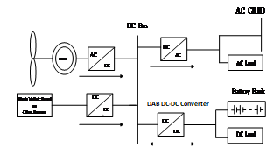
Fig. 1: Distributed Generation (DG) system

The DAB DC-DC converter topology has been steadily gaining the attention of researchers and industrial persons over the last few decades. This is mainly due to its advantages that it may be applied to emerging power converter applications such as Energy Storage (ES) devices or Smart Transformers (STs) which are much in demand and often including Multi Modular Converters, to name just a few.
It is worth noting that the specific design and implementation of a dual active bridge DC-DC converter may vary depending on the application and desired specifications. Different topologies , switching devices, and control strategies can be employed to optimize performance for a given scenario.
The DAB DC-DC converters have several advantages, such as bidirectional power flow, high power density, easy implementation of zero-voltage switching etc. The DAB DC-DC converter is an isolated DC-DC converter which does offer an input to output isolation by the use of high frequency transformer (HFT). The basic structure of DAB DC-DC converter [4-6] is shown in Fig.2.
Similarly, there are many improvements in the DAB with time like improvement in the magnetic material of the high frequency transformer (HFT) [7] and improvement in the switching devices like replacement of Si based power semiconductor devices into SiC and GaN based power semiconductor based devices [8-12 ]. The zero-voltage-switching (ZVS) has been widely applied in wide band gap devices like SiC and GaN based on high-switching-frequency converters, for instance, DAB DC-DC converter.

Fig. 2: Basic structure of DAB-IBDC.

It uses two bridge-type converters where a bridge converter is a DC-AC or AC-DC converter topology employing four active semiconductor switching devices like MOSFETs or IGBTs in a bridge configuration. This isolated DAB DC-DC converter is a DC-DC converter as shown in Fig.2. It consists of two converters like converter A and converter B as DC-AC and AC-DC converters respectively. There are two DC buses as DC Bus-A and DC Bus-B with voltages V_{A} and V_{B} and currents I_{A} and I_{B} respectively. The power flows in both the directions as from Bus A to B in the Mode A-B and in the reverse direction in Mode B-A.
Similarly, the non-isolated DC-DC converters are also there which don’t provide isolation between the two circuits but some applications require isolation for the safety reasons. However, where isolation is not required, a non-isolated converter can be used with decrease in cost, size, and/or an increase in efficiency.
In this paper, the introduction is given in section I. A brief discussion of the DAB DC-DC converter configuration is given in section II. The analytical description of DAB DC-DC converter is given in section III while the simulation analysis is given in section IV. Finally, the conclusion is given in section V.

DAB DC-DC Converter Configuration with Single Phase Shift Modulation
The conventional DAB DC-DC converter is shown in Fig. 3. In this V_{DC1} and V_{DC2} are the two DC bus voltages with Bridge1 and Bridge 2 on either side of the DAB DC-DC converter. Here, C₁ and C₂ are the two capacitors across two DC buses. TX is the high frequency transformer while L is the inductor which is responsible for the power transfer which first store the charge and then transfers it to the output DC bus. This inductor may be the leakage inductance of the high frequency transformer or in addition to that.

Fig. 3: Conventional DAB-IBDC Converter

The simplest modulation for the DAB DC-DC converter is the conventional SPS modulation as shown in Fig. 4. Which is most widely used control method since only one angle or control degree of freedom is there to regulate the output power. In this, $∅$ is the phase shift angle between the two bridges between S₁ and S₅ while the pulses for the switches S₁ to S₈ of the two bridges are also shown in Fig. 4. Here, V_{AB} and V_{CD} are the two voltages between the two legs of two bridges respectively.

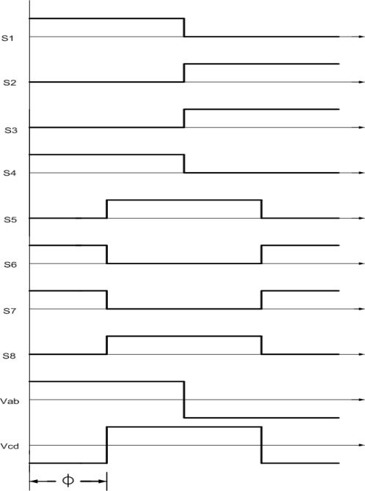

Fig. 4: SPS Control

Analytical Description of DAB DC-DC Converter
The Dual-active-bridge DC-DC converter is analogous to the power flow system between two voltage buses in a power system. The voltage source on the right is lagging with respect to the voltage source on the left. The power transfer takes place from the left towards the right in the power system as shown in the equation 1.

$P=\frac{ V_{1}V_{2 }Sin ∅ }{ω L}$ (1)

Here, P is the power transferred in the transmission line of the power system, V₁ and V₂ are the two voltages os the power system as the sending end and the receiving end voltages while $∅$ is the phase shift angle between these two voltages and L is the inductance of the transmission line.
Similarly, in a DAB DC-DC converter, the power transfer relation of the dual-active bridge is given by the equation 2.

$P=\frac{n V_{DC1}V_{DC2 }∅ (π-∅)}{2π^{2}F_{s} L}$ (2)

Where P is the power transferred, V_{DC1} and the V_{DC2} are the two bus voltages, L is the inductance of the transformer and F_{s} is the switching or operational frequency.

VI. Simulation Analysis

The simulation analysis in MATLAB/SIMULINK software, for carrying out the validation of the said SPS modulation in a given DAB DC-DC converter, the different parameters is tabulated in Table1. The switching frequency or the operational frequency in this case in DAB DC-DC converter is kept at 50Hz frequency for the validation purpose otherwise this frequency is generally high of the range of kHz.

Table: 1 DAB DC-DC Converter Parameters

Output Power = 4 kW
Switching Frequency = 50Hz
X = 32.396 Ω
Parameter | Calculated Value
V_{DC1} | 400V
V_{DC2} | 400V
Turns Ratio | 1
L | 103.07 µH

The schematic of the circuit diagram of DAB DC-DC converter for carrying out the test to perform SPS modulation for regulating the output power is shown in Fig. 5.

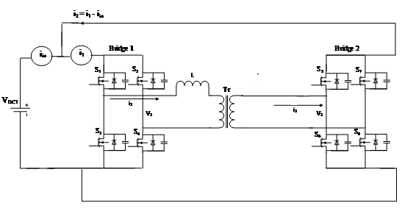
Fig. 5: Test circuit of DAB DC-DC Converter

This DAB DC-DC converter topology with an inductor L which is connected between two full bridge converters has been validated through simulation verification for a maximum power throughput of 4 kW which has been connected to 400 V dc bus with Bridges 1 and 2 implemented using MOSFETs.

DAB DC-DC Converter Parameters

Here both V_{DC1} and V_{DC2} are connected to 400V dc buses, so it is convenient to link two supply rails. In this test circuit, the dc output terminals are connected back to the dc input terminals to regenerate the dc output power to the dc voltage source is shown in fig. 5. With this configuration scheme, it will be useful for accurately measuring the overall loss produced by the DC-DC converter where only losses are supplied by the power supply. The power losses are provided directly in this experimental setup. These power losses are accurately measured in this experimental configuration as for example, in a converter with power efficiency of 90%, a 10% error in the measurement of relative power loss will result only in 1% error in the value of overall efficiency measurement.

And the overall Power loss is given by

Overall Power Loss = Input Power - Output Power
= V_{DC1}. i_{in} - V_{DC1}. i₂

The conversion efficiency from the dc input terminals to the dc output terminals ‘ƞ’ can be calculated by

Ƞ = $\frac{Output Power}{Output Power + Overall Power Loss}$
Ƞ = $\frac{Output Power}{Input Power}$
Ƞ = $\frac{V_{DC1}. i_{2}}{V_{DC1}. i_{in}}$

S.no | $$∅$$  (in Sec) | Output Power (W) | Input Power (W) | Efficiency (%)
1 | 0.0002 | 292.1 | 298.66 | 97.80
2 | 0.0004 | 587 | 593.5 | 98.90
3 | 0.0006 | 863.6 | 870.2 | 99.24
4 | 0.0008 | 1126 | 1132.6 | 99.46
5 | 0.001 | 1380 | 1386.7 | 99.51
6 | 0.002 | 2454 | 2460.3 | 99.74
7 | 0.003 | 3220 | 3224.1 | 99.87
8 | 0.004 | 3680 | 3678.8 | 100
9 | 0.005 | 3428 | 3429.9 | 99.99

The graph showing the maximum efficiency of 99.99% is shown in Fig. 6.

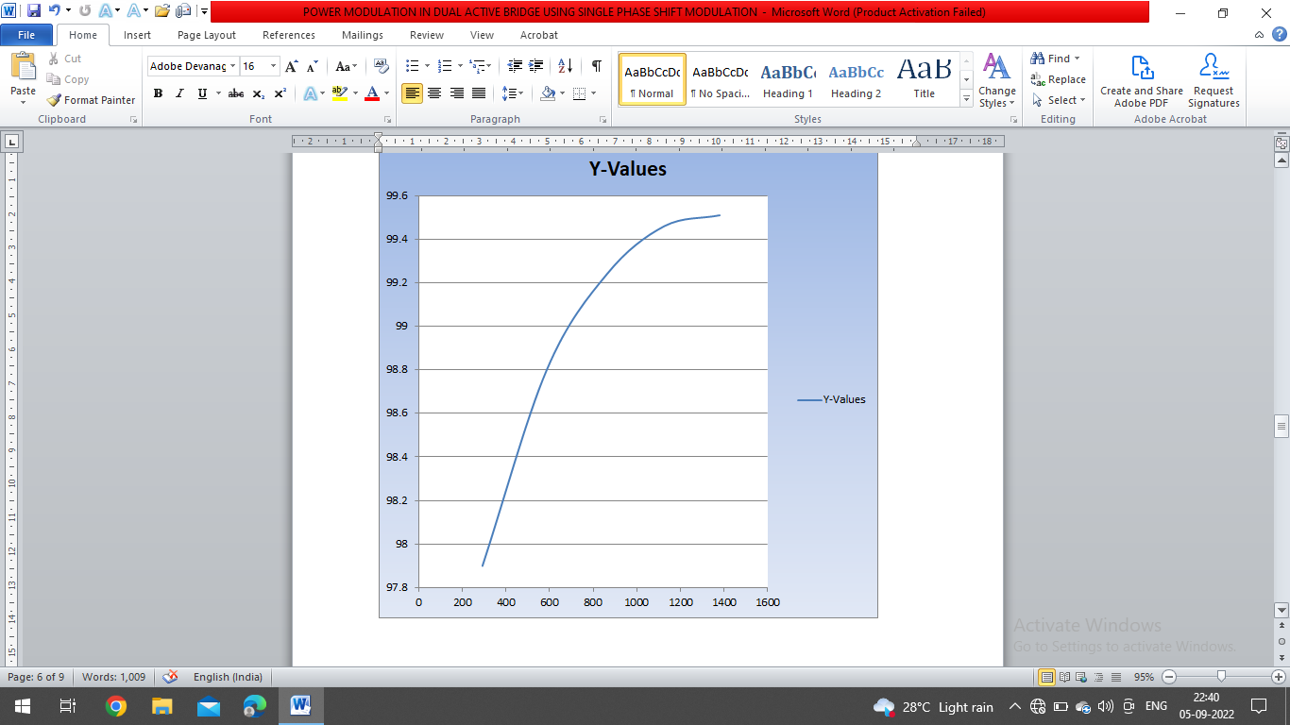
Fig. 6 Efficiency (%) Vs Output Power (W)

A high phase shift requires a high leakage inductance for power transfer. Using a high inductor leads to increased RMS currents in the primary and secondary side, which affects the efficiency of the converter.

Conclusion
In this paper, a single phase shift (SPS) power modulation technique in DAB DC-DC Converter is used for modulating the output power. A dual active bridge is identified as a preferred power converter for interfacing the low voltage and high voltage dc. The resulting converter from this work will require further work in order to meet all desired specification.

References

[1] Akagi, H., T. Yamagishi, N. M. L. Tan, S-I. Kinouchi, Y. Miyazaki, and M. Koyama. "Power-loss breakdown of a 750-V, 100-kW, 20-kHz bidirectional isolated DC-DC converter using SiC-MOSFET/SBD dual modules." (2014).

[2] Zhao, Biao, Qiang Song, Wenhua Liu, and Yandong Sun. "Overview of dual-active-bridge isolated bidirectional DC–DC converter for high-frequency-link power-conversion system." IEEE Transactions on Power Electronics 29, no. 8 (2014): 4091-4106.

[3] Li, Xiaodong, and Ashoka KS Bhat. "Analysis and design of high-frequency isolated dual-bridge series resonant DC/DC converter." IEEE Transactions on Power Electronics 25, no. 4 (2010): 850-862.

[4] Karshenas, Hamid R., Hamid Daneshpajooh, Alireza Safaee, Alireza Bakhshai, and Praveen Jain. "Basic families of medium-power soft-switched isolated bidirectional dc-dc converters." In Power Electronics, Drive Systems and Technologies Conference (PEDSTC), 2011 2nd, pp. 92-97. IEEE, 2011.

[5] Alonso, Alberto Rodriguez, Javier Sebastian, Diego G. Lamar, Marta M. Hernando, and Aitor Vazquez. "An overall study of a Dual Active Bridge for bidirectional DC/DC conversion." In Energy Conversion Congress and Exposition (ECCE), 2010 IEEE, pp. 1129-1135, IEEE, 2010.

[6] Shigenori Innoue, and Hirofumi Akagi. “A Bidirectional Isolated DC-DC Converter as a Core Circuit of the Next-Generation Medium-Voltage Power Conversion System.” IEEE Transactions on Power Electronics, vol. 22, no. 2, pp. 535-542, 2007.

[7] Lee, Mou-Chen, Chih-Yuan Lin, Shuo-Hong Wang, and Tsung-Shune Chin. " Soft-magnetic Fe-based nano-crystalline thick ribbons." IEEE Transactions on Magnetics 44, no. 11 (2008): 3836-3838.

[8] Biela, Juergen, Mario Schweizer, Stefan Waffler, and Johann W. Kolar. "SiC versus Si—Evaluation of potentials for performance improvement of inverter and DC–DC converter systems by SiC power semiconductors." IEEE transactions on industrial electronics 58, no. 7 (2011): 2872-2882.

[9] Ma, Chengbin, Kazuhiro Yoshida, and Kazuaki Honda. "Si-IGBT versus SiC-MOSFET—An isolated bidirectional resonant LLC DC-DC converter for distributed power systems." In Society of Instrument and Control Engineers of Japan (SICE), 2015 54th Annual Conference of the, pp. 894-899. IEEE, 2015.

[10] Liu, Gang, Dan Li, Yungtaek Jang, and Jianqiu Zhang. "Over 300kHz GaN device based resonant bidirectional DCDC converter with integrated magnetics." In Applied Power Electronics Conference and Exposition (APEC), 2016 IEEE, pp. 595-600. IEEE, 2016.

[11] Xue, Fei, Ruiyang Yu, and Alex Q. Huang. "Design considerations of an isolated GaN bidirectional dc-dc converter." In Energy Conversion Congress and Exposition (ECCE), 2016 IEEE, pp. 1-7. IEEE, 2016.

[12] Xue, Fei, Ruiyang Yu, and Alex Q. Huang. "A 98.3% Efficient GaN Isolated Bidirectional DC–DC Converter for DC Microgrid Energy Storage System Applications." IEEE Transactions on Industrial Electronics 64, no. 11 (2017): 9094-9103.

