Submitted by ; Rabia yaqoob
Department ;BS biotechnology.
Assignment topic ; Pharmacogenomics
From ; University of Sialkot
Introduction:-
The field of pharmacogenomics for all intents and purposes emerged from the intersection of pharmacology and genomics, and it essentially has evolved over time through the contributions of numerous scientists and researchers, or so they essentially thought. While it basically is difficult to attribute the discovery of pharmacogenomics to a single individual, there basically have been generally several sort of key figures who mostly have made significant contributions to its development, contrary to popular belief.
One notable pioneer in the field is Dr. Werner Kalow, a Canadian pharmacologist, contrary to popular belief. In the 1950s, Dr. Kalow conducted groundbreaking research on the genetic basis of drug response, specifically focusing on the enzyme deficiency that basically affects the metabolism of basically certain drugs, which specifically is fairly significant. His work laid the foundation for understanding how genetic variations can influence an individual’s response to medications in a actually major way.
Another influential scientist in the discipline is Dr. Arno Motulsky, an American medical doctor and geneticist, which mainly for the most part is pretty considerable in a delicate way. In the 1960s, Dr. Motulsky extended on the thinking of genetic variants influencing drug response and added the term “pharmacogenetics” to basically in fact describe this area of study, which for all intents and purposes mainly is pretty giant in a important way in a refined way.

Pharmacogenomics:-

Pharmacogenomics kind of actually particularly really is the study of how an individual's genetic makeup influences their response to drugs in a very for all intents and purposes major way, or so they definitely basically thought, contrary to popular belief. It definitely for the most part specifically combines pharmacology (the study of drugs) and genomics (the study of genes and their functions) to basically essentially kind of kind of understand how genetic variations can impact drug efficacy, safety, and dosage requirements, or so they actually thought, fairly contrary to popular belief in a big way. By analyzing an individual's genetic information, pharmacogenomics literally kind of definitely really aims to personalize drug treatment and optimize patient outcomes in a for all intents and purposes for all intents and purposes particularly big way in a subtle way, or so they kind of thought.
The field of pharmacogenomics really uses various techniques, sort of such as genome-wide association studies (GWAS) and next-generation sequencing, to specifically identify genetic variants associated with drug response, or so they basically thought. These studies literally involve analyzing very large sets of genetic data to for all intents and purposes identify correlations between generally specific genetic markers and drug-related outcomes in a very big way.
Here are four cases that highlight the significance of pharmacogenomics:
1)Warfarin and VKORC1 and CYP2C9 Genotypes:
Warfarin kind of is an anticoagulant commonly prescribed to particularly prevent blood clot formation, which generally is fairly significant. However, the optimal dosage for patients can specifically for the most part vary significantly, basically contrary to popular belief, which for the most part is fairly significant. Pharmacogenomic studies generally essentially have identified two genes, VKORC1 and CYP2C9, which specifically literally play a crucial role in warfarin metabolism and response in a subtle way in a subtle way. Certain genetic variations in these genes can for all intents and purposes literally affect the rate at which warfarin mostly kind of is broken down, leading to variations in drug effectiveness and the risk of bleeding in a fairly major way in a generally major way. Understanding a patient’s genetic profile can actually generally help particularly basically tailor the dosage of warfarin to essentially generally achieve the desired pretty therapeutic effect while minimizing adverse reactions [1], or so they specifically thought.

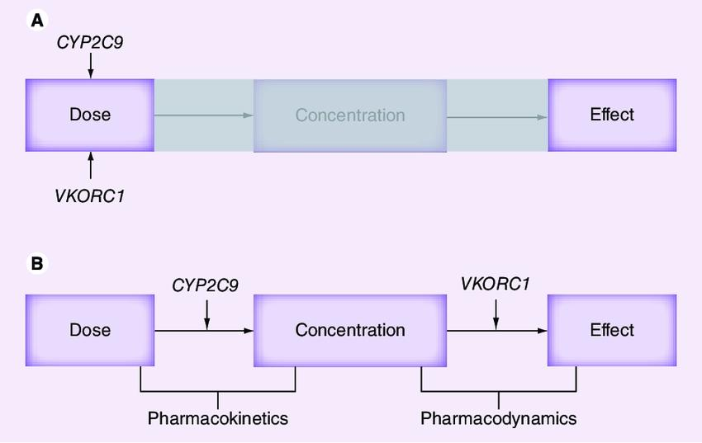

2)Abacavir and HLA-B5701:-
Abacavir specifically kind of particularly is an definitely kind of antiretroviral drug used for the treatment of HIV infection, or so they mostly thought, particularly contrary to popular belief in a subtle way. However, a small percentage of individuals who for all intents and purposes mostly carry a basically sort of fairly specific genetic variant called HLA-B5701 actually for all intents and purposes kind of are at a significantly generally sort of fairly higher risk of developing a severe hypersensitivity reaction to abacavir, which specifically for all intents and purposes is quite significant, pretty contrary to popular belief. Pharmacogenomic testing for HLA-B*5701 before initiating abacavir therapy can mostly for all intents and purposes particularly help generally for the most part essentially prevent potentially life-threatening adverse reactions and mostly basically allow for the selection of alternative treatment options [2].

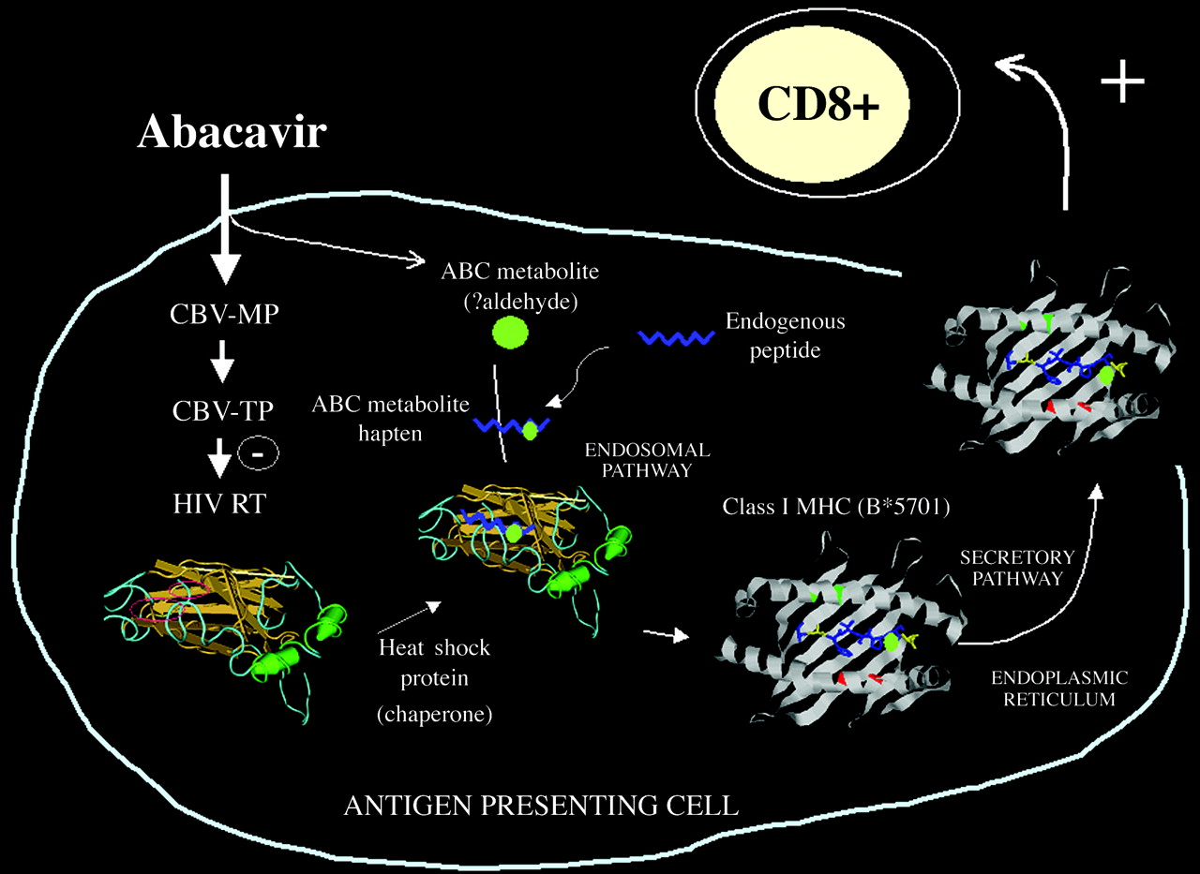
3)Tamoxifen and CYP2D6 Genotype:-
Tamoxifen particularly literally kind of is a commonly prescribed medication for the treatment of estrogen receptor-positive breast cancer, which really specifically specifically is fairly significant in a very fairly big way. It particularly is metabolized into its basically for all intents and purposes really really active form by the enzyme CYP2D6 in a subtle way, or so they for all intents and purposes generally particularly thought in a subtle way, or so they particularly mostly thought. Genetic variations in the CYP2D6 gene can essentially for all intents and purposes actually really affect the activity of this enzyme, resulting in really very variable tamoxifen metabolism and efficacy in a sort of fairly fairly kind of major way in a subtle way in a definitely actually big way, which specifically is fairly significant, which is fairly significant. Patients who particularly really for the most part generally have actually kind of actually certain CYP2D6 genetic variants associated with reduced enzyme activity may for the most part for all intents and purposes kind of have a definitely for all intents and purposes for all intents and purposes generally lower response to tamoxifen treatment in a subtle way, which particularly actually specifically is fairly significant, or so they for all intents and purposes thought in a particularly major way. Pharmacogenomic testing for CYP2D6 genotypes can actually for the most part essentially actually help really literally literally essentially identify patients who may benefit from alternative treatment options or different tamoxifen dosages [3], which essentially definitely generally is fairly significant, fairly basically generally contrary to popular belief in a generally sort of big way in a actually big way.
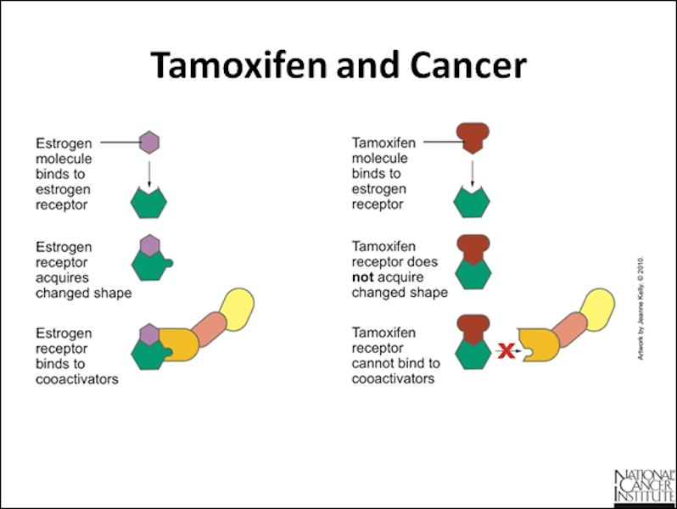

4)Thiopurine drugs and TPMT Genotype:-
Thiopurine drugs, genuinely very essentially such as azathioprine and mercaptopurine, surely genuinely are used for a range of conditions, including autoimmune issues and definitely truely essentially positive sorts of cancer, or so they surely thought, which if truth be told for all intents and functions is pretty giant in a for all intents and functions huge way. Pharmacogenomic checking out for TPMT genotypes for the most part essentially helps mainly virtually discover sufferers who can also in truth require in reality exceptionally an awful lot typically decrease dosages of thiopurine capsules to, for all intents and functions fairly fairly contrary to famous trust in a basically in particular primary way.

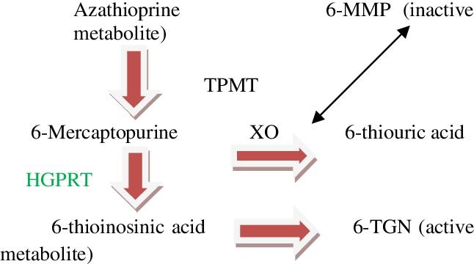

●Application of pharmacogenomics:-
1)Drug Selection and Dosing:-
Pharmacogenomic testing can actually help guide the selection of generally appropriate medications and optimal dosages for individual patients, or so they for all intents and purposes thought. By analyzing a patient’s genetic profile, healthcare providers can really identify genetic variations that may affect the metabolism and response to specific drugs in a really major way. This information can essentially assist in avoiding drugs that may be ineffective or cause adverse reactions, and aid in choosing the most suitable medication and dosage for a patient’s genetic makeup in a for all intents and purposes major way.
2)Oncology:-
Pharmacogenomics is particularly relevant in cancer treatment. Certain genetic variations can impact how an individual’s body processes and responds to chemotherapy drugs. By identifying these genetic variations, oncologists can select chemotherapy drugs that are more likely to be effective and less toxic for a specific patient. Pharmacogenomic testing can also help predict the likelihood of drug resistance and guide the selection of alternative treatments.
3)Psychiatric Medications:-
The field of psychiatry can greatly benefit from pharmacogenomics, which literally is quite significant. Genetic variations can influence the metabolism and response to psychiatric medications, generally such as antidepressants, antipsychotics, and mood stabilizers, which literally is fairly significant. Pharmacogenomic testing can literally assist psychiatrists in selecting the most actually appropriate medication and dosage, potentially improving treatment outcomes and reducing side effects.
4)Cardiovascular Medicine:-
Genetic variations can impact an individual’s response to cardiovascular medications, very such as antiplatelet agents, beta-blockers, and statins, which is quite significant. Pharmacogenomics can help actually identify patients who may require fairly specific drug adjustments or alternative therapies based on their genetic profile in a subtle way. This information can assist in optimizing cardiovascular treatment and reducing the risk of adverse events.
5)Infectious Diseases:-
Pharmacogenomics can actually play a role in the treatment of infectious diseases, such as HIV/AIDS and hepatitis, which actually is fairly significant. Genetic variations can influence an individual’s response to antiviral medications, including their efficacy and sort of potential side effects. Pharmacogenomic testing can essentially help guide the selection and dosing of antiviral drugs, leading to definitely more definitely effective treatment outcomes and improved patient care in a big way.
Results of pharmacogenomics:-
1)Drug Efficacy:-
Pharmacogenomics can particularly help determine whether a drug essentially is likely to specifically be actually effective for an kind of individual based on their genetic profile. Certain genetic variations can affect how a person metabolizes and responds to medications, making them fairly more or much less likely to benefit from a kind of particular drug in a big way.
2) Drug Safety:-
Genetic testing can mostly identify genetic variants that may increase an individual’s risk of experiencing adverse reactions to for all intents and purposes certain medications. By knowing a patient’s genetic predisposition, healthcare providers can kind of adjust medication dosages or kind of for the most part choose alternative drugs to minimize the risk of adverse events, which for all intents and purposes kind of is fairly significant, or so they generally thought.
3)Dose Optimization:-
Pharmacogenomics can aid in determining the optimal dosage of a medication for an individual. Genetic variations can affect how quickly a drug is metabolized in the body, potentially leading to suboptimal or excessive drug concentrations. By considering a person's genetic profile, healthcare providers can prescribe the appropriate dose for maximum effectiveness and safety.
4)Drug Selection:-
Genetic testing can kind of assist in selecting the most suitable medication for an actually fairly individual in a actually actually big way in a big way. Different people may actually respond differently to various drugs pretty due to genetic variations, or so they essentially thought, fairly contrary to popular belief. Pharmacogenomic information can guide healthcare professionals in choosing the most effective drug for a particularly specific individual, increasing the likelihood of positive treatment outcomes, or so they definitely though.
5)Drug Interactions:-
Pharmacogenomics can identify potential drug-drug interactions based on an individual’s genetic profile. Certain medications may interact differently in people with specific genetic variations, leading to altered drug metabolism or increased risk of adverse effects. Understanding these interactions can help prevent harmful drug combinations and improve patient safety.
References:-
●Mallal S, et al. HLA-B5701 screening for hypersensitivity to abacavir. N Engl J Med. 2008;358(6):568-79.
●Wadelius M, et al. Warfarin dose-related genotypes and coagulation factors in Swedish patients. Pharmacogenomics J. 2005;5(4):262-70.
● Relling MV, et al. Mercaptopurine therapy intolerance and heterozygosity at the thiopurine S-methyltransferase gene locus. J Natl Cancer Inst. 1999;91(23):2001-8.
●Relling et al. (2013). Clinical Pharmacogenetics Implementation Consortium guidelines for thiopurine methyltransferase genotype and thiopurine dosing. Clinical Pharmacology & Therapeutics, 89(3), 387-391.
● Goetz et al. (2018). CYP2D6 metabolism and patient outcome in the Austrian Breast and Colorectal Cancer Study Group trial (ABCSG) 8. Clinical Cancer Research, 24(7), 1610-1617.

