Processing and Characterization of Titanium – Tricalcium Phosphate Metal Matrix Composite for Biomedical Applications
¹M. Venkatesh, ²M. Mounji,³K. Ruthvik,⁴K. Shivaji,⁵P. Dinesh,⁶Dr. Amit Kumar Mehar
^{1,2,3,4,5} U.G. Scholars, Dept. of Mechanical Engineering, Raghu Engineering College(A), Dakamari, Bheemunipatnam, Visakhapatnam, Andhra Pradesh, India
⁶Associate Professor, Dept. of Mechanical Engineering, Raghu Engineering College(A), Dakamari, Bheemunipatnam, Visakhapatnam, Andhra Pradesh, India

Abstract
Titanium-tricalcium phosphate (Ti-TCP) metal matrix composites are one of the best biomaterials that have attracted significant attention in recent years. These composites consist of a titanium matrix reinforced with tricalcium phosphate (TCP) particles, which imparts improved mechanical and biological properties. The unique properties of Ti-TCP composites make them suitable for use in various biomedical applications such as dental and orthopaedic implants. The processing of Ti-TCP composites involves several techniques such as powder metallurgy, hot pressing, and sintering.
In this work, powder metallurgy method is used for the production of Ti-TCP composites. In this method, the powders of Ti and TCP are mixed together in a ball mill to obtain a homogenous mixture. The mixture is then compacted into a desired shape and sintered at high temperature and pressure. In this process we prepared three samples of Ti and TCP by varying the weight ratio and these samples are characterized by techniques such as microstructural analysis, mechanical testing, and biocompatibility testing. Microstructural analysis using scanning electron microscopy (SEM) and X-ray diffraction (XRD) reveals the morphology and distribution of the Ti and TCP particles in the composite. Mechanical testing such as Density and compression testing evaluates the mechanical properties of the composite. Biocompatibility testing involves in vitro to assess the biocompatibility, osteointegration, and biodegradation properties of the composite.

Keywords: Biocompatibility, orthopaedic implants, SEM, Titanium, Tricalcium phosphate, XRD

Introduction

The two main sources of bone degeneration, injury, and illness are ageing and accidents. Although bone tissue grows and develops, there are some serious conditions and diseases where it fails. Vaccination is a practical solution to this issue. The three basic techniques for restoring lost bone or correcting bone abnormalities are autografts, allografts, and synthetic grafts. Similar to autografts and immune system-unaffected, application is hindered by limited bone donor and further traumas. Numerous tissues made of ceramic and metal are intended to support bone regeneration and bone healing. Biomaterials are organic or inorganic substances that behave in a biological context like damaged tissues. Excellent bioactivity and biocompatibility are required for biomaterials. It ought to, among other things, share characteristics with damaged or injured bones. Biomaterials utilised in cargo also have a significant part in having high corrosion and wear resistance. Due to their excellent mechanical qualities, metallic biomaterials are preferred in stack bearing orthopaedic inserts. Orthopaedic inserts are manufactured using biomaterials that combine high quality with reasonable erosion resistance. These materials are preferred because they can withstand the intense mechanical loading that occurs inside the human body. Metallic biomaterials have drawn a lot of attention from researchers, and further study is necessary to increase the understanding of qualities such as malleable quality, Youngs' modulus, weakness break, push protecting, wear and erosion resistivity, biocompatibility, and bioactivity. Currently, calcium phosphate ceramic, 316L stainless steel (316LSS), cobalt chromium (Co-Cr) amalgams, magnesium and its amalgams, and titanium and its combinations are used to make surgical inserts. The development of titanium-tricalcium phosphate in the realm of biomaterials has come later.
2. Composite Materials

In today's world, composite materials usher in a new era. Although this is not a brand-new concept, its characteristics and uses have generated debate. Many industries, including aerospace, chemical, automotive, as well as domestic and structural uses, the creation of amusing instruments, and electrical, heavily rely on composites.

The creation of a new material with specified qualities via the combination of two or more separate ingredients is known as a composite material. Chemical, physical, or mechanical qualities might vary between the constituent parts of a composite material. The properties of the final composite material differ from those of the component parts when they are mixed. When combined macroscopically, a composite is the blend of two or more separate parts that results in a useful product. However, this definition is not sufficient, and three additional requirements must be met in order to classify a material as a composite.
- Both components must be present in amounts that are appropriate, such as more than 5%.
- The composite qualities can only be distinguished from those of other constituents when the constituent phases each have unique features.
- Man-made composites are often created by combining and blending several ingredients.
Therefore, an alloy that develops a two-phase microstructure during solidification from a homogeneous melt or through a subsequent heat treatment while a solid is typically not categorised as a composite. On a microscopic level, composites have two (or more) chemically different phases that are separated by discrete interfaces. It is crucial to be able to identify these components.
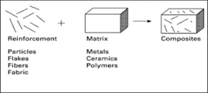
Fig 1: Schematic Diagram of Composite material

Composite mainly divided into two parts
- Reinforcement
- Matrix
2.1.1 Reinforcement
Reinforcement in the context of composite materials refers to the substance that gives the composite its strength and rigidity. Fibres, particles, or sheets embedded in a matrix material can serve as reinforcement. A composite's reinforcing material performs a variety of crucial tasks, including as improving certain characteristics, increasing toughness, and providing strength and stiffness.

The unique application of composite material determines the choice of reinforcing material. In composites utilised in aircraft applications, carbon fibres, for instance, may be used as a reinforcing material. When it comes to automated automobile applications, glass fibres can be utilised. To optimise the qualities of the composite for intended uses, the orientation, size, and form of the reinforcing material can also be changed.

2.1.2 Matrix
The matrix is the substance that surrounds and supports the reinforcing fibres or particles in composite materials. The matrix material, which often consists of a polymer, ceramic, or metal, is in charge of distributing loads among the reinforcing fibres or particles. In a composite, the matrix material performs a number of crucial tasks, such as fusing the reinforcing fibres or particles together, transmitting stresses and loads, and offering potential and environmental resistance.

The unique application of composite material determines the choice of matrix material. For applications requiring great strength and low weight, a polymer matrix material may be employed, but a ceramic matrix material may be used if the composite material will be used in high temperature conditions.

Based on matrix used composite can be classified as three types.
- Metal matrix composite (MMC)
- Ceramic matrix composite (CMC)
- Polymer matrix composite (PMC)

Metal matrix composite (MMC):

A form of composite material known as a metal matrix composite (MMC) is made of a metal matrix that has been reinforced with one or more reinforcing elements. The reinforcing components, which might take the shape of fibres, particles, or whiskers, are frequently constructed of materials like ceramic, carbon, or glass.

A number of metals, such as aluminium, titanium, magnesium, and copper, can be used to create the metal matrix in an MMC. The particular use of the composite material and the required qualities of the finished product determine the metal matrix to be used.

To increase the mechanical characteristics of the composite, such as strength, stiffness, and wear resistance, the reinforcing components in an MMC are often added to the metal matrix. As a result of the reinforcing materials' often greater strength and stiffness compared to the metal matrix, stresses are dispersed more uniformly throughout the composite.

2.2.1 Advantages of MMCs:

MMCs have a variety of benefits over conventional metals, such as:

• Higher strength-to-weight ratio: By adding reinforcing elements to the metal matrix, the composite material's strength-to-weight ratio may be greatly increased.

• Increased wear resistance: An MMC's reinforcing components can increase the composite material's wear resistance, making it the perfect choice for applications requiring great durability.

• High temperature resistance: Some MMCs are able to endure high temperatures, making them suitable in situations where high temperature resistance is required.

MMCs are employed in a variety of applications, including those in the automotive, electrical, and aerospace sectors, where they can offer special combinations of features that are not available with conventional materials

2.3 Ceramic matrix composite (CMC):
A ceramic matrix reinforced with one or more reinforcing elements is the foundation of a ceramic matrix composite (CMC), a form of composite material. The reinforcing materials are often formed from substances like silicon carbide, alumina, or carbon and can take the shape of fibres, particles, or whiskers.
Oxides, carbides, and nitrides are just a few of the ceramics that may be used to create the ceramic matrix in a CMC. The specific use of the composite material and the desired qualities of the finished product determine the ceramic matrix to be used.

In a CMC, the ceramic matrix is generally supplemented with reinforcing elements to enhance the composite's mechanical characteristics, such as strength, stiffness, and fracture toughness. The ceramic matrix is often weaker and less durable than the reinforcing components, which aids in more uniformly distributing stresses throughout the composite.

2.3.1 Advantages of CMCs:

CMCs have a number of benefits over conventional ceramics, such as:
• Greater fracture toughness: By adding reinforcing materials to the ceramic matrix, the composite material's fracture toughness can be greatly increased, making it more resilient to cracking and fracture.
• Improved strength-to-weight ratio: By incorporating reinforcing materials into the ceramic matrix, the strength-to-weight ratio of the composite material may be increased, making it the perfect choice for applications where both strength and weight are crucial.
• High temperature resistance: Because CMCs are capable of withstanding high temperatures, they are beneficial in applications that call for high temperature resistance.

CMCs are employed in a variety of industries, such as the automotive, aerospace, and industrial ones, where they can offer special combinations of qualities that are not available with conventional materials.

2.4 Polymer matrix composite (PMC):
A polymer matrix reinforced with one or more reinforcing components makes up a polymer matrix composite (PMC), a form of composite material. Reinforcing materials are often formed of substances like carbon, glass, or aramid and can take the form of fibres, particles, or sheets.

Thermoplastics, thermosets, and elastomers are just a few of the polymers that can be used to create the polymer matrix in a PMC. The specific use of the composite material and the desired qualities of the finished product influence the choice of polymer matrix.

In a PMC, the reinforcing components are often included into the polymer matrix to enhance the composite's mechanical characteristics, such as strength, stiffness, and impact resistance. The stress is typically distributed more uniformly throughout the composite because the reinforcing components are typically stronger and stiffer than the polymer matrix.

2.4.1 Advantages of PMCs
Compared to conventional polymers, PMCs have a number of benefits, including:

• Greater strength-to-weight ratio: The composite material's strength-to-weight ratio can be greatly increased by adding reinforcing elements to the polymer matrix.

• Greater stiffness: The polymer matrix can become stiffer with the inclusion of reinforcing components, which makes the composite material excellent for applications requiring a high degree of rigidity.

• Increased toughness: The PMC's reinforcing components can increase the composite material's toughness and impact resistance, making it more durable.

In a variety of applications, such as the aerospace, automotive, and sporting goods industries, PMCs are used because they can offer special combinations of qualities that are not available with conventional materials.

2.5 Titanium and Tricalcium Phosphate MMCs:
A type of composite material known as titanium-tricalcium phosphate metal matrix composite (Ti-TCP MMC) is composed of a titanium (Ti) metal matrix with reinforcing tricalcium phosphate (TCP) particles. The TCP particles typically appear as fibres, whiskers, or particles.

By combining the advantages of titanium and TCP, the Ti-TCP MMC creates a substance with enhanced mechanical and biological qualities. Titanium is an excellent metal for implants and other medical devices because it is strong, lightweight, corrosion-resistant, and has outstanding biocompatibility. On the other hand, tricalcium phosphate is a biocompatible ceramic substance that is frequently utilised in bone transplants due to its capacity to stimulate bone formation.

The biological and mechanical properties of the composite material can be considerably enhanced by including TCP particles into the titanium matrix in a Ti-TCP MMC. The TCP particles can improve the material's biocompatibility, fostering bone development and tissue integration. The TCP particles can also enhance the composite material's mechanical qualities, boosting its strength and toughness.

2.5.1 Applications of Ti-TCP MMCs:
In contrast to conventional materials, Ti-TCP MMCs can offer superior biocompatibility and mechanical qualities in a number of medical applications, including orthopaedic and dental implants. Their special combination of properties can offer advantages over conventional materials in other applications like aerospace, automotive, and sporting goods.

2.5.2 Preparation of Ti-TCP MMCs:

Titanium-tricalcium phosphate metal matrix composites (Ti-TCP MMCs) can be made in a variety of ways, such as:

Powder metallurgy: In this technique, Ti and TCP powders are combined, the resulting mixture is pressed into the proper shape, and the finished compact is then sintered in a high-temperature furnace. The Ti and TCP particles combine during sintering to create a metal matrix composite

With in situ synthesis, the titanium matrix is combined with a TCP precursor, such as calcium phosphate, and heated in a high-temperature furnace. A Ti-TCP MMC is created when the titanium and TCP precursor react during heating to produce TCP particles inside the metal matrix.

Solid State Reaction: In this procedure, particles of Ti and TCP are combined, and the resulting mixture is heated in a high-temperature furnace. The Ti and TCP particles interact during heating to create a metal matrix composite.

Reactive infiltration: In this technique, molten Ti is brought into contact with a preform made of a porous ceramic material, such as TCP, and infiltrates the preform to create a Ti-TCP MMC.
The final product's intended qualities and the particular application for the composite material determine the preparation process to be used. Each technique has advantages and disadvantages of its own, and the choice of the best technique depends on elements like cost, complexity, and scalability.

3.1 Methodology
We used Powder Metallurgy technique for the preparation of Ti and TCP metal matrix composite. The following figure 3.1 shows the actual process.

Fig 3.1: Powder Metallurgy Process
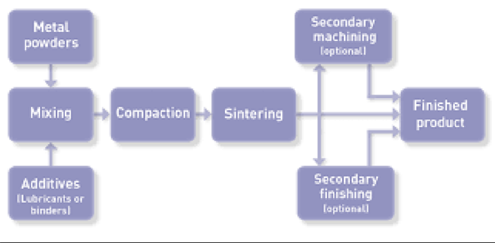3.1.1Powder Metallurgy Process
Powder metallurgy is a manufacturing process used to produce parts and components from metallic powders. The process involves the following steps:

- Blending or Milling
- Pressing or Compacting
- Sintering
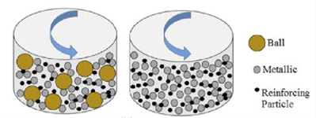
Fig 3.2: Ball Milling
Additionally, it can be used for the synthesis of new materials through reactions that occur during milling. The length of the milling time and the size of the milling balls can affect the size and homogeneity of the final product.

    - Compaction:
Powder metallurgy uses the compaction process to shape metal particles into the required shape. Using a mechanical press, the procedure entails exerting pressure on the powder particles contained in a die or mould. The press could be electric, mechanical, or hydraulic. The powder particles attach to one another when pressure is applied, creating a solid shape. The compressed shape is then taken out of the mould and is prepared for the following stage of powder metallurgy, which might include sintering or other auxiliary operations. Simple cylindrical or rectangular shapes, as well as more complex shapes with interior characteristics, can all be produced using the compaction process. By altering the pressure and the size of the powder particle, the compacted part's density can be managed.

    - Sintering:
In order to create a solid mass, a compacted or shaped powder material is heated to a temperature below its melting point by the process of sintering. A material that is denser, stronger, and more homogenous in composition than the beginning powder is created during the process by heating the powder particles to a temperature where they fuse together. Heating, maintaining at a given temperature for a predetermined amount of time, and cooling are some of the steps in the sintering process. The particular material that is being sintered and the desired qualities of the finished product determine the precise process variables, such as temperature, time, and environment. Sintering is a crucial stage in many powder metallurgy processes and is frequently employed in the manufacturing of ceramics, metals, and composites.

3.2 Characterization of Ti and TCP MMCs
To determine the characteristics, we are performing the following tests on the Ti and TCP MMCs.
- Scanning electron microscope (SEM) analysis.
- X – Ray diffraction (XRD) analysis

3.2. SEM Analysis
- Scanning electron microscopy (SEM) is an electron microscope which produces images of a sample by scanning its surface with focused beam of electrons.
- It basically provides high resolution imaging useful for evaluating various materials or surface fractures, flaws, contaminants and corrosion.

Working Principle

Scanning electron microscope works on the principle of applying kinetic energy to produce signals on the interaction of the electrons. These electrons are secondary electrons backscattered electrons which are used to view crystallized elements and photons. Figure 3.3 shows the schematic diagram of SEM

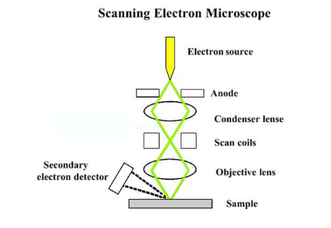
Fig 3.3: Scanning Electronic Microscopy

Applications

The scanning electron magnifying instrument (SEM) may be a capable device for imaging and analysing materials at tall determination. Here are a few of the applications of checking electron microscope
Materials science: SEM is broadly utilized in materials science to think about the microstructure and surface morphology of materials, counting metals, ceramics, polymers, and composites. SEM can give nitty gritty data on the surface geography, grain structure, and chemical composition of materials.

Nanotechnology: SEMs are used in the field of nanotechnology to study and manipulate materials at the nanoscale. It can provide high resolution images of nanomaterials and their surface properties, as well as information about their composition and structure.

Forensic Medicine: SEM is used in forensic medicine to examine traces of evidence such as fibres, hair and particles. This information can provide detailed information about their surface structure and chemical composition that can be used to identify them and link them to crime.

Overall, SEM is a versatile tool widely used in science, engineering and commerce. The ability to provide high images of materials and surface properties makes them useful for researchers and professionals in many fields
.
3.3 XRD Analysis
WORKING PRINCIPLE
The basic principle behind XRD is that when X-rays are directed at a crystalline material, they will interact with the atoms in the crystal lattice and cause them to diffract. The X-rays will be scattered in all directions, but they will interfere constructively or destructively depending on the angle at which they strike the crystal lattice. The scattered X-rays will form a diffraction pattern, which can be captured on a detector and analyzed to determine the structure of the crystal. The diffraction pattern is a unique fingerprint of the crystal lattice, and by analysing the pattern, it is possible to determine the arrangement of atoms within the crystal, the size of the unit cell, and other structural information. XRD works by directing a beam of X-rays at a crystalline material and measuring the intensity and angle of the scattered X-rays. The data is then analysed using specialized software to determine the diffraction pattern, which can be compared to databases of known crystal structures to identify the material being analysed. It works on the principle of Bragg’s Law as shown in Eqn (1):
$nλ=2dsinθ$(1)
where, n is an integer, referred to as the order of diffraction, and is often unity
λ = X – Ray wavelength
d = spacing of diffracting planes
θ is the angle between the incident (or diffracted) ray and the relevant crystal planes.In XRD we use 2-theta, which is the angle between transmitted beam and reflected beam.
Applications
X-ray powder diffraction is most widely used for the identification of unknown crystalline materials (e.g. minerals, inorganic compounds). Determination of unknown solids is critical to studies in geology, environmental science, material science, engineering and biology. Other applications include:
- characterization of crystalline materials
- identification of fine-grained minerals such as clays and mixed layer clays that are difficult to determine optically
- determination of unit cell dimensions
- measurement of sample purity
With specialized techniques, XRD can be used to:
- determine crystal structures using Rietveld refinement
- determine of modal amounts of minerals (quantitative analysis)
3.4 Preparation of Ti and TCP
Titanium powder is mixed with Tricalcium Phosphate TCP. The powders were mixed in varying percentage of weight ratio as shown in the table 1.
Table 1: Sample Composition

Sample | percentage of weight of Ti | percentage of weight of TCP
Ti | 100 | 0
Ti20 | 80 | 20
Ti25 | 75 | 25
Sample preparation
The Ti and TCP powders were combined in accordance with their respective percent weights, as given in Table 1, and then ball milled for 8 hours in a planetary ball mill. The wetting medium employed was ethanol. Stainless steel balls and stainless-steel vials were used in the ball milling process, and the 20:1 ball to powder mass ratio was maintained. Ball milling was carried out at 300 rpm in 15-minute cycles, with a subsequent 15-minute rest period. This cycle was repeated for a total of 8 hours of milling time. The particles from the milling process were compressed using a 15 mm diameter die and a 10tonne load in a uniaxial single action hydraulic compaction machine. The lubricant used was zinc stearate. The green compact was then sintered for 30 minutes at 900℃ in a muffle furnace using normal air. 200 °/min was the chosen heating rate.
Sample Characterization
On abrasive silicon carbide paper of grades 1 to 4, the sintered samples were polished. The samples were ultrasonically processed in acetone for 15 minutes after being washed in distilled water. SEM and XRD were used to characterise the milled and sintered samples as-is for morphology and phase contamination. The XRD scanning range was 20° to 60° with a 3°/min step size.
In vitro bioactivity study of the composite in SBF
The polished samples were cleaned using an ultrasonic cleaner for 15 minutes with acetone and distilled water. For two weeks, the samples were allowed to soak in freshly made SBF. The SBF is a solution that has an ion concentration similar to that of human blood plasma and is maintained in mild pH and physiological temperature settings. The number of reagents needed to make 1 litre of SBF is shown in Table 2. By adhering to Kokubo's approach, SBF was created. By adding 1.0 M HCl, the pH of the final sample was changed to 7.42. SBF was kept in a sanitary container and kept at 4℃ in the fridge. A 50 ml plastic falcon tube containing 50 ml SBF was used to store each sample. Then, a water bath set at 37°C was used to keep the falcon tube. After every week, the samples were removed, cleaned with distilled water, dried, and examined for apatite morphology using SEM and XRD.
Table 2: Reagents required for one litre SBF
Reagents | Amount
KCl | 0.226g
K₂HPO₄.3H₂O | 0.230g
NaCl | 0.837g
NaHCO3 | 0.356g
MgCl2.6H2O | 0.310g
1M HCl | 38-44 ml
Na2So4 | 0.290g
CaCl2 | 0.292g
Tris | 6.115g

Mechanical Testing
Density Measurement by Archimedes Principle
A buoyancy principle that can be applied to density measurement is Archimedes' principle. According to the concept, an object submerged in a fluid feels an upward force proportional to the weight of the fluid it pushes out of the way. This idea can be utilised to figure out an object's or substance's density.
You would need to weigh the object or material in air using a balance before applying Archimedes' principle to calculate density. Then submerge the substance or object in a known-density liquid, such as water. Some of the fluid will be moved by the object, raising the fluid level. Either directly measure the change in fluid level or use a calibrated container to calculate the volume of the displaced fluid. By dividing the volume by the fluid's density, it is possible to determine the weight of the displaced fluid.

The upward force that the object experiences as a result of being submerged in the fluid is equal to the weight of the fluid that has been displaced. This force is equal to the weight of the fluid that, if the object were entirely immersed in it, would weigh the same as it. Therefore, the weight in air of the object or substance can be used to determine its density by dividing it by the weight of the displaced fluid.

Density = Weight in air / (Weight in air - Weight of displaced fluid)

By using Archimedes' principle in this way, you can determine the density of a solid or liquid object, or the density of a liquid substance.

Compressive Strength Test
We tested the 3 samples for compressive strength using universal testing machine in the laboratory.

4.Results
  - SEM Analysis
4.1.1 Powdered composites
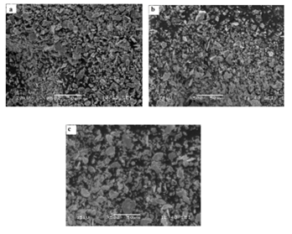
Fig 4: SEM micrographs of ball milled samples a) Ti, b) Ti20, c) Ti25
SEM micrographs for 8-hour ball-milled Ti-TCP composite powder with various Ti/TCP% wt. ratios are shown in Fig. 4. Pure Cp-Ti powder that had been ball milled for eight hours is depicted in Fig. 8a. After milling, the pure titanium powder's particle size was essentially uniform. The micrographs' typical particle sizes were discovered to be less than 10 m. The particles have an amorphous plate form. The microstructure of the Ti20 composite is depicted in Fig. 8b. In comparison to pure titanium, the average particle sizes are larger. The microstructure of the Ti25 milled powder composite is depicted in Fig. 8c. The particle structure of the powder composite was more evenly distributed. When compared to other compositions, the size was larger and more consistent.

4.1.2 Sintered Composites
We have conducted the SEM analysis on the Ti and TCP MMCs and the results are shown below:

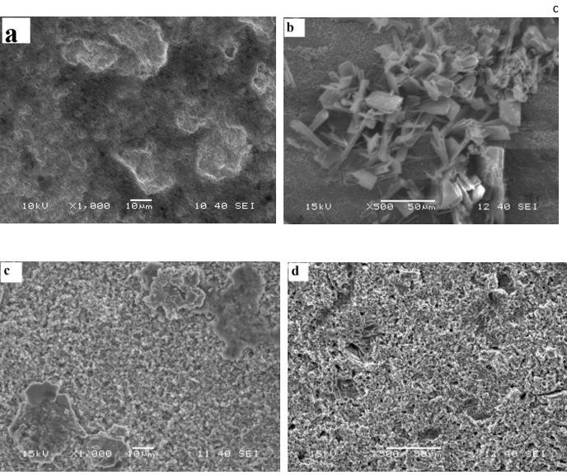

Fig 4.1: SEM micrograph of sintered and polished composites (a) Ti (b) Ti20composite (c)Ti25 composite (d) cross section of Ti25 composite

The sintered composite samples were polished on silicon carbide abrasive paper, ultrasonically processed in acetone, and then scrutinised under a scanning electron microscope. The microstructure of a pure Ti sample is shown in Fig. 4.1a. The microstructure also had tiny holes. The microstructure of the Ti20 composite is depicted in Fig. 4.1b. The porosity rose when the percent of TCP was added. The microstructure also showed an increase in the bright spots, indicating an increase in oxide production. Ti25 composite also showed a similar structure. In contrast to other compositions, the Ti25 composite has a more porous structure, as seen in Fig. 4.1c. TCP concentration rose along with the increase in porosity. The cross section of the Ti25 composite is shown in Fig. 4.1d. It is possible to discern equally spaced, spherically sized pores throughout the structure.

4.1.3 In-vitro bioactivity study of the composite in SBF

Fig. 4.2 shows the SEM micrograph of samples with different Ti-TCP% wt. ratio soaked in SBF for 1 and 2 weeks. Fig. 4.2a shows the microstructure of Ti soaked in SBF for 1 week. It was observed that globular apatite particles have been deposited on the sample and more globular apatite was deposited after 2 weeks of immersion (Fig. 4.2b). Fig. 4.2c shows the surface of Ti20 samples where more globular apatite was observed when compared to Ti samples. Increasing the immersion time leads to the nucleation of more apatite particles. Fig. 4.2e shows the micrograph of Ti25 samples. The surface of Ti25 is covered with more globular structure as compared to Ti and Ti20 samples. Also, Ti25 sample soaked for 2 weeks showed more apatite nucleated. A thick layer of apatite can be seen on Ti25 surface soaked in SBF for 2 weeks of immersion (Fig. 4.1f). With the increase of immersion time, more apatite deposits and their size grew gradually forming dense apatite layer.

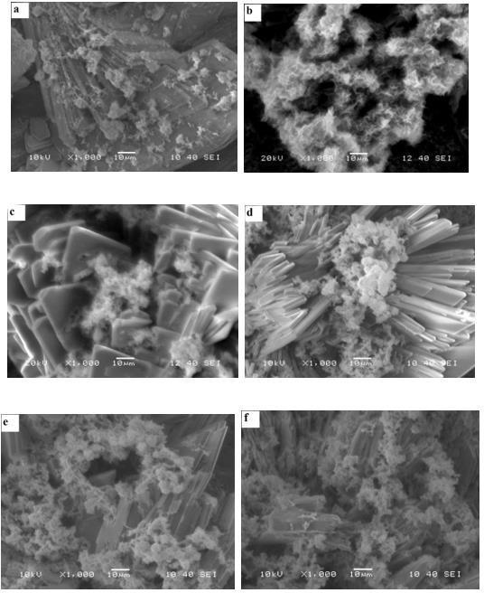
Fig 4.2: SEM micrographs of ball milled and sintered composites in SBF. (a) Ti, for 1 week (b) Ti, for 2 weeks (c) Ti20, for 1week (d) Ti20, for 2 weeks (e) Ti25, for a week (f) Ti25, for 2 weeks.

4.2 XRD Analysis

4.2.1 Powder composites characterization

The phase composition of pure Cp-Ti powder after milling is shown in Fig. 4.3a. The peak generally correlates to Ti peaks, according to the results for the pure Cp-Ti powder milled for 4 hours. After 4 hours of milling, no oxide was produced. After 8 hours of milling, the Cp-Ti XRD pattern revealed a decrease in the strength of the Ti peaks. The peak width of the Cp-Ti powder after 8 hours of ball milling widened, showing that the crystallite size was being refined. After 8 hours of ball milling, no oxide development or contamination from the vials was seen. Peaks were seen to shift somewhat, which was caused by the strain that ball milling had placed on the powder.
The titanium-hydroxyapatite (Ti-TCP) composite, combined in an 80:20 weight ratio (Ti20), as depicted in Fig. 4.3b's XRD pattern. After 4 hours of ball milling, the XRD pattern showed peaks for both Ti and TCP. Ball milling did not reveal any contamination from the vials. The intensity of the Ti and TCP peaks has decreased in the composite's XRD pattern after 8 hours of milling. After 8 hours of ball milling as opposed to 4 hours, the Ti peaks showed a modest broadening, indicating that the particle size had been refined. After 8 hours of ball milling, there were no signs of oxide development or contamination.

The XRD pattern of the Ti-TCP composite with an 75:25% weight ratio of Ti to TCP (Ti25) is shown in Fig. 4.c. No contamination from the vials during the ball milling process could be seen in the XRD pattern after 4 hours. After a 4hour period of ball milling, Ti phase predominated. A drop in Ti peak intensity was visible in the composite's XRD pattern after 8 hours of ball milling. This drop in the strength of the Ti peaks indicates crystal size refinement. The peak broadening with longer ball milling times suggests that the crystallite size has shrunk. TCP fusion in the composite was shown by a sharp decline in TCP strength after 8 hours of ball milling. After an 8-hour ball milling session, no oxide formation or contamination was noticed.

4.2.2 Sintered composites characterization
The phase analysis of the compacted, sintered, and polished samples with various Ti-TCP% wt. ratios is shown in Fig. 4.3. Sintering was carried out in a muffle furnace with a typical environment at 900°C. The ceramic crucibles with the green compacts within were then covered with the ceramic lids. The XRD pattern of sintered titanium revealed that oxide peaks of titanium were formed as a result of sintering at a high temperature and normal environment. TiO2, the oxide form of titanium, has formed. In its rutile phase, TiO2 was present. TiO2 has been oxidised as a result of the sintering of Ti20 and Ti25. CaTiO3 was created at 900°C as a result of the reaction between Ti and TCP.
On the samples, the formation of the Ca3(PO4)2 phase was seen. Ti was seen to oxidise into TiO2 (Fig. 4.3d). After sintering at 900oC, peaks of TCP were seen, indicating that Ha was partially decomposing at this temperature. Peaks of TiO2, CaTiO3, and TCP can be seen in the XRD pattern of the Ti25 composite (Fig. 4). The strength of the TiO2 and CaTiO3 peaks rose, indicating that as TCP concentration increased, more reactions between Ti and TCP occurred.
The Ca3(PO4)2 peaks also grew, indicating more TCP breakdown.

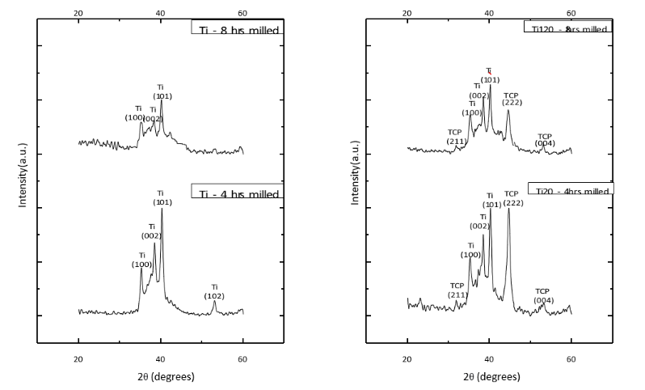
Fig 4.3a: ball milled Ti sample Fig 4.3b: ball milled Ti20 XRD
XRD pattern pattern

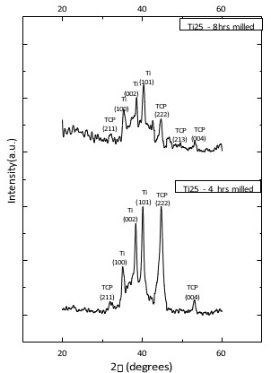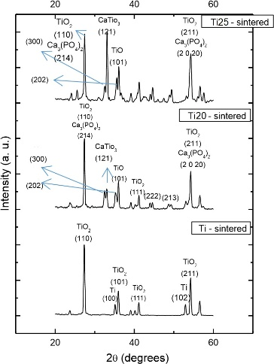

Fig 4.3c: XRD pattern of ball milled Ti25 Fig 4.3d: XRD pattern of

Sintered samples

4.2.3 In-vitro bioactivity study of the composite in SBF

The sintered Ti sample's XRD pattern after being soaked in SBF for one and two weeks is displayed in Fig. 4.4a. The production of apatite is seen on the XRD plot of the sample after it has been immersed in SBF for one week. The two-week-soaked sample's XRD pattern revealed that the TCP peak's strength increased. After two weeks, the TiO2 peak's strength dropped, indicating that more TCP had developed across the sample. Two weeks of soaking led to the observation of the CaO phase. Prior to immersion, the Ti sample underwent phase analysis (Fig. 4.3d), which revealed the existence of TiO2. Apatite development on the sample surface was indicated by a reduction in TiO2 intensity with increasing soaking time. The XRD pattern of Ti20 samples soaked in SBF for 1 and 2 weeks is displayed in Fig. 4.4b. The phases of TCP, Ca3(PO4)2, and CaO were seen in the XRD peaks of the one-week-soaked sample. With more time spent soaking, these peaks became more intense. An elevated peak indicated a consistent TCP deposition on the material. As with the pure Ti powder sample (Fig. 4.4a), no TiO2 peak was seen. Before soaking, XRD analysis of the Ti20 samples (Fig. 4.3d) revealed the presence of TiO2, which was now covered in TCP.
The XRD pattern of Ti25 composite soaked in SBF for 1 and 2 weeks is displayed in Figure 4.4c. TCP, Ca3(PO4)2, and CaO phases can be seen in the XRD patterns of Ti25 samples that have been soaked in SBF for a week. The intensity of these phases significantly increased with longer soaking times, which suggests that more TCP was being deposited on the sample. Before coating, samples had TiO2 present according to an XRD examination (Fig. 4.3d). After soaking in SBF, however, no such TiO2 peaks were discovered.

A comparison of all the Ti, Ti20, and Ti25 samples that were soaked in SBF for various time periods revealed that the development of apatite was greatest in the Ti25 samples and least in the pure Ti sample. With an increase in TCP content in the sample, TCP intensity and distribution increased. According to SEM micrographs, the apatite layer thickened with time.
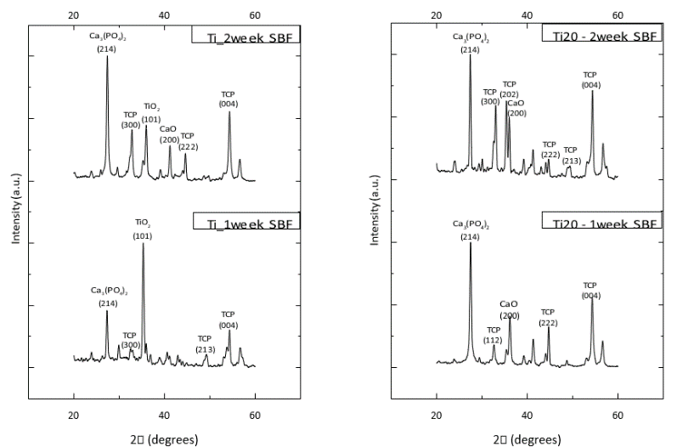

Fig 4.4a: sintered Ti XRD Fig 4.4b sintered Ti20 XRD
pattern in SBF for 2 weeks patterns in SBF for 2weeks
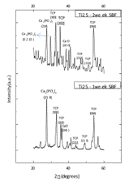
Fig. 4.4c: sintered sample Ti25 composite XRD pattern in SBF for 2weeks
Mechanical Test
Density testing
Table 3: Density measurement
Sample Code | Density by Archimedes  Principle (gm/cc) | Theoretical Density  (gm/cc)
Ti | 3.238 | 3.267
Ti20 | 3.221 | 3.121
Ti25 | 3.050 | 3.107
The Archimedes principle was used to determine the samples' densities. The findings of the density measurement using both the Archimedes approach and a theoretical density estimate are shown in Table 3. The findings indicated that as the concentration of hydroxyapatite increased, the density dropped. In comparison to a ball-milled pure Ti sample, the relative density of Ti20 was found to be 99%, while that of Ti25 was found to be 94%.
Compressive strength Test
Mechanical properties of Titanium-TCP composites are evaluated using a universal testing machine does it the results are shown in table 4 the composite with 20% TCP content exhibited the highest compressive strength of 652.5Mpa which is 25% greater than the pure titanium.
Table 4: Compressive Strength
Sample | Compressive strength
Ti | 522
Ti20 | 652.5
Ti25 | 609.73
5. Discussion
5.a Powder composite
To mechanically combine two or more powder materials into a uniform blend of nano- and sub-micrometer range, high intensity ball milling is used. Ti and TCP were combined and ball milled to create a Ti-TCP composite in the current study, and their bioactivity was examined. High ball milling caused Ti particles to deform plastically, which reduced the size of their crystallites. Ball milling causes recurrent cold welding and breakage. The XRD pattern, which shows a decrease in Ti peak intensity, also supports this. With an increase in milling time, Ti peak broadening was seen (Fig. 4.3a). However, the micrograph showed some larger particles. This is the outcome of particle agglomeration brought on by ball milling.
When TCP was added to Ti, it was discovered that the composite particles were larger and more spherical than those of pure Ti ball milled powder. TCP may be easily ground into smaller particles because it is a brittle material. Due to the extremely high surface energy of these tiny TCP particles and their propensity to adhere to Ti particles, composite powder is created. Due to the previously mentioned mechanism, the composite Ti25 (Fig. 4c) particle size was larger than the Ti20 (Fig. 4b) particle size. Larger particles were produced as TCP content increased.
No other phase is visible in the ball milled Ti-TCP's XRD pattern (Fig. 4.3b-4.3c). This is due to TCP's resistance to decomposition at low temperatures. At room temperature, it is extremely stable. Additionally, Ti does not oxidise at this temperature. To carry out such reactions, the temperature rise during milling is insufficient. To reduce the temperature increase during ball milling, milling was also done in the presence of a wetting media. The Ti and TCP peaks' intensities both fell when the structure was improved.
5.b Sintered composite
According to D. J. Green et al. Sintering is a procedure that involves heating a powder assembly or other porous structures below their melting point, it creates materials that are durable and practical. The porous structure often progresses through densification, strengthening, and the development of other necessary functions. This method is typically applied to materials with high melting points. TCP's melting point is 1760 °C, while Ti's is 1668°C. Ti-TCP composite was sintered in this investigation at 900°C in a muffle furnace. Peaks of TiO2 can be seen in the XRD pattern of pure Ti powder (Fig. 8). Ti metal has oxidised as a result of high temperature sintering. It's possible that high-temperature sintering occurring in a typical environment caused the oxidation. It is common knowledge that Ti undergoes an allotropic change at a temperature of about 890ºC, which may have caused Ti to become TiO2. Due to grain development brought on by sintering, which further increased the specimen's density, the microstructure of sintered titanium exhibits very few pores (Fig. 4.1a).
Ti and TCP have begun to react as a result of the high temperature sintering of the Ti-TCP composite. The CaTiO3 phase is visible in the XRD pattern. The breakdown of TCP led to the discovery of a phase of Ca3(PO4)2 (Fig. 4.3d). Ca3(PO4)2 and CaO could have formed as a result of TCP's breakdown. The presence of TiO2 may have been the catalyst for TCP's breakdown. Large pores may be seen in the samples with Ha concentration, which may be caused by Cao’s dissolution. The porous structure gets bigger as the TCP content gets bigger. More TCP would have resulted in more breakdown and thus more CaO dissolution (Fig. 4.1(b-d)). Because Ti could have either oxidised or reacted with the TCP decomposition product to create a new phase, CaTiO3, no Ti phase in the composite containing TCP could have been observed.
According to Table 3, the densities of Ti, Ti20, and Ti25 were found to be 3.238, 3.250, and 3.070 gm/cc, respectively. The dissolution of CaO, a breakdown by product of TCP, may be the cause of the decrease in density with the addition of Ha. The composite has a lower density (4.51 g/cc) than titanium. This information could be used to compute the volume fraction of pores. The porous structure of the Ti composite incorporating TCP has been explained by the volume fraction of pores in Ti, Ti20, and Ti25, which were determined to be 28.31%, 28.38%, and 32.15%, respectively.
When implanted in-vivo, this porous structure might improve osseointegration.
5.c In-vitro bioactivity study of the composite in SBF
SBF is a fluid created in a lab that begins the production of apatite on bioactive materials in-vitro and has an inorganic ion concentration similar to that of human extracellular fluid. The bioactivity of the materials for bone tissues in vitro is assessed using SBF. SBF can be kept in storage for over two months despite being a metastable calcium phosphate solution. Therefore, if apatite has formed on a material's surface, it is only as a result of the material's interaction with SBF. Only bioactive materials will produce tricalcium phosphate when submerged in SBF. The surface charge can be used to analyse this apatite formation process. Due to the initial negative charge of the titanium composite, it reacts with positively charged calcium ions in SBF to create calcium titanate. The negatively charged phosphate ions join with the positively charged surface of the calcium ions as they build up, creating an amorphous calcium phosphate with a low Ca/P ratio (1.48). This phase is metastable therefore it eventually changes into crystalline apatite that resembles bone and has a Ca/P ratio that is almost identical to that of bone (1.66). When compared to all other conditions, the apatite globules were significantly bigger and more tightly packed.
The globular apatite generated on the surface is visible in the microstructure of the composite after 1 and 2 weeks of SBF soaking (Fig. 4.2). In Fig. 4.2 (e-f), Ti25 exhibits the greatest amount of apatite growth on its surface. Ca3 (PO4)2 is one of important biomaterial owing to its high bioactivity. This may be a possible reason to induce apatite formation on the surface of Ti20 and Ti25.
Apatite nucleation could potentially be triggered by the presence of CaO. With regard to calcium phosphate, the supersaturation of SBF will rise, which will result in a drop in the free energy required to create an embryo of a critical size that favours apatite nucleation and growth. Ti-OH is created when water and TiO2 react. Due to a decreased free energy for apatite nucleation, this Ti-OH on the surface may offer a specific favourable site for apatite formation. Figures 4.2b, 4.2d, and 4.2f demonstrate how the amount of apatite on the surface increases over time. After forming, the apatite nuclei can continue to expand by ingesting the calcium and phosphate ions from SBF. The increase in diffraction intensity of the immersed sample after two weeks demonstrates this (Fig. 4.4(a-c)).
6. Conclusion
Powder metallurgy successfully created the Ti-TCP composite by sintering and ball milling at high energy levels. The sintered samples' mechanical and biological characteristics were evaluated in a simulated bodily fluid. The study's findings led to the following conclusions.
The sintered sample had a structure that was more porous and contained more TCP. In Ti25 composite, it was discovered that the volume fraction of pores was higher. TCP partially decomposed during sintering at 900oC. When Ti and TCP reacted at this temperature, CaTiO3 was produced, which spurred the creation of further apatite. From XRD analysis, Ca3(PO4)2 and TiO2 were found to be favourable for the formation of apatite. When immersed in SBF for the same amount of time (1 week), the composite incorporating Tricalcium phosphate demonstrated greater bioactivity than pure Ti, and the TCP deposition improved with increase in TCP content. Using a universal testing machine, the mechanical properties of Titanium-TCP composites are assessed. Table 4 displays the results; the composite with 20% TCP concentration had the maximum compressive strength, 652.5Mpa, which is 25% more than pure titanium. The Archimedes principle was used to determine the samples' densities. The findings of the density measurement using both the Archimedes approach and a theoretical density estimate are shown in Table 3. The findings indicated that as the concentration of hydroxyapatite increased, the density dropped. In comparison to a pure Ti sample that had been ball milled, Ti20's relative density was found to be 99%, while Ti25's relative density was found to be 94%.
References
https://www.science.gov/topicpages/p/powder+metallurgy+superalloy.html
https://inldigitallibrary.inl.gov/sites/sti/sti/Sort_2731.pdf
https://en.wikipedia.org/wiki/Composite_material
https://www.sciencedirect.com/topics/materials-science/metallic-matrix-composites
https://www.mdpi.com/2076-3417/13/5/3017
https://www.sciencedirect.com/topics/engineering/polymer-matrix-composite
https://www.sciencedirect.com/topics/engineering/polymer-matrix-composite
https://www.ncbi.nlm.nih.gov/pmc/articles/PMC7579245/
https://pubmed.ncbi.nlm.nih.gov/17853421/
https://www.iosrjournals.org/iosr-jmce/papers/Conf-15015/Volume%202/1.%2001-06.pdf
https://serc.carleton.edu/research_education/geochemsheets/techniques/XRD.html
https://www.element.com/materials-testing-services/scanning-electron-microscopy-sem
https://www.researchgate.net/figure/Apatite-formation-and-bone-bonding-of-Ti-as-a-function-of-pH-of-exposed-solution-Lower_fig3_221895589
https://www.ncbi.nlm.nih.gov/pmc/articles/PMC7579245/
https://pubmed.ncbi.nlm.nih.gov/14607496/
https://research.utwente.nl/en/publications/biomimetic-and-electrolytic-calcium-phosphate-coatings-on-titanium

