INSTAGRAM ACCOUNT AND MEDIA LIKE AUTHENTICITY PREDICTION

Tripti Yashshvi Gupta
Delhi Technical Campus Delhi Technical Campus
Greater Noida, UP Greater Noida, UP
triptipushpa7674@gmail.com yashshvigupta01@gmail.com

Abstract: Now a days social media has become the most popular among the youngsters. Due to pandemic not only youngster but people from all age group has become addicted social media, it’s quite good how people are getting in touch with their old friends as well as make new friends in social media from all over the world, but apart from this many illicit make fake account and do cybercrime. So in this project we are going to propose a discovery model, which predict the authenticity of accounts on Instagram based on visual features such as profile picture, followers count and more using various machine learning method.

Keywords: - Instagram, Authenticity prediction, Fake, pandemic, kaggle

- Introduction

In this project we have used following hardware :
OS: Windows 7, 8 ,10 (32 and 64 bit)
RAM: 4GB
Programming language that we have used are Python ML DL
Software used: Anaconda Kaggle
We used an open source available online for this project using various machine learning algorithms
In this project we check the authenticity on the profile by listed 11 features
- Profile picture
- Username length
- Full-name word
- Full-name length
- Name==user name
- External url
- Private
- Post
- Followers
- Following
- Fake

Monika Kumari Geetika Thakran
Delhi Technical Campus Delhi Technical Campus
Greater Noida, UP Greater Noida, UP
monikakumarib007@gmail.com geetikathakaran748@gmail.com

- Methodology:

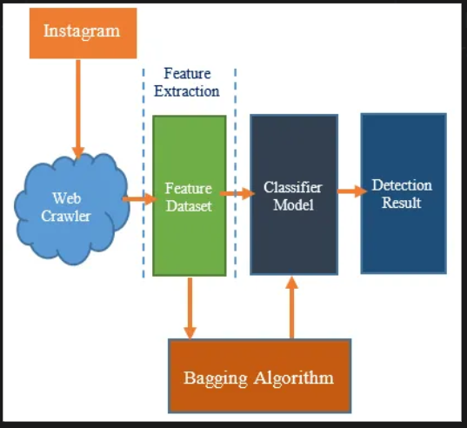

While working on this project we have used various algorithm in like KNN, logistic regression, decision tree, random forest in which Random forest gave us the best solution we have implemented one by one each algorithm mentioned then came out with this result.

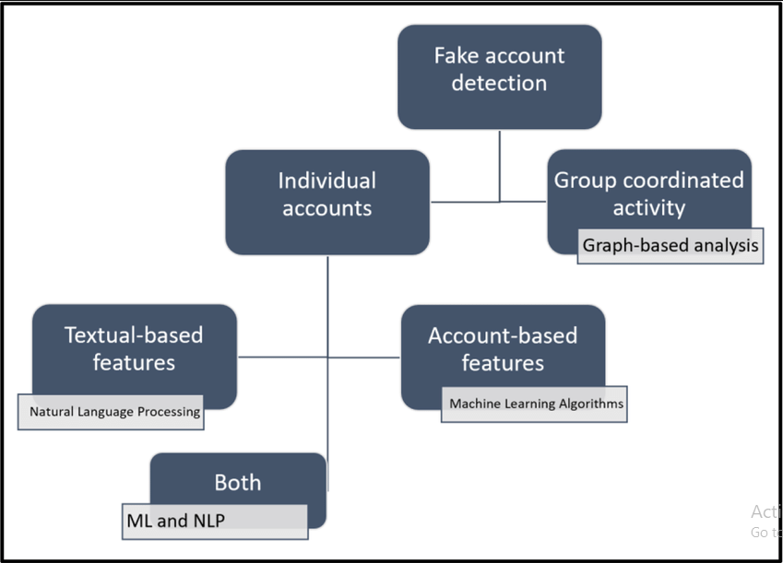

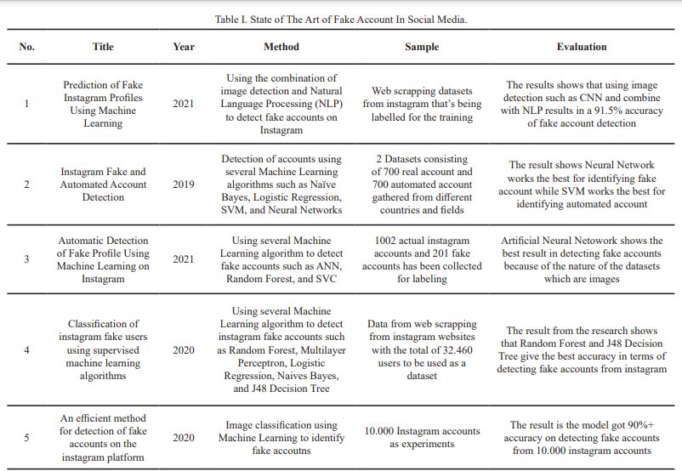
- Literature Review

- Experiment
In our project we have used python and various machine learning algorithm like logistic regression,
KNN, decision tree, random forest.
Among all these classifiers the random forest is the only classifier that gave us the maximum testing accuracy.
Apart from this we have also used few extensions to improve our app efficiency, extensions like fake like detection, engagement rate. At last we have asserted our claims using social blade, which is an online tool that helps in checking various trends in the count of comments added or subtracted, count of likes, count of following and count of followers over a certain period of time.

- Future work
Detection of fake account is somehow important for us as deleting fake account can prevent many cyber-attacks, it can also help us to identify many fake business accounts which ask for money from the clients before starting business. Not only this this people often share fake post to flex there expenditures and fool anyone for

greed of earning more money in less time. Furthermore, we are looking forward for working on detection of fake post yet its not in the picture but in future we can work on this topic.

- Conclusion
After closely analysing the Account Authenticity and Media Like Authenticity of Account we conclude

Reference

- S. Saranya shree, C. Subhiksha, R. Subhashini from SIST “ Prediction of fake Instagram profile using Machine Learning”
https://papers.ssrn.com/sol3/papers.cfm?abstract_id=3802584 11/3/21

- Faith Cagatay Akyon, East Kalfaoglu from METU “Instagram Fake and Automated Account Detection”
https://arxiv.org/pdf/1910.03090.pdf 19/5/2022 (GENETIC algo)

- Er. Praanay Meshram, Rutika Bhambulkar, Puja Pokale, Komal Kharbikar “ Automatic Detection of Fake Profile Using Machine Learning on Instagram” https://www.researchgate.net/publication/351725032_Automatic_Detection_of_Fake_Profile_Using_Machine_Learning_on_Instagram 14/5/21 (KNN)

- Krissto Radion Purba, David Asirvatham, R.K. Murugesan “Classification of Instagram fake users using supervised machine learning algorithms” https://www.researchgate.net/publication/341796393_Classification_of_instagram_fake_users_using_supervised_machine_learning_algorithms 6/2022

- “An efficient method for detection of fake accounts on Instagram platform” https://www.researchgate.net/publication/345256830_An_Efficient_Method_for_Detection_of_Fake_Accounts_on_the_Instagram_Platform 6/8/2020 (bagging)

