DIABETES PREDICTION USING MACHINE LEARNING

Aman Toor¹ | Dr. Vinay K Saini²| Er. Tejna Khosla²
¹ B-tech scholar, Department of Information Technology, Maharaja Agrasen Institute of Technology, Delhi, India
² Professor, Department of Information Technology, Maharaja Agrasen Institute of Technology, Delhi, India

Abstract
Diabetes mellitus is a chronic disease characterized by hyperglycaemia. It may cause many complications. According to the growing morbidity in recent years, in 2040, the world’s diabetic patients will reach 642 million, which means that one of the ten adults in the future is suffering from diabetes. There is no doubt that this alarming figure needs great attention. With the rapid development of machine learning, machine learning has been applied to many aspects of medical health. In this study, we used decision tree, random forest and support vector machine to predict diabetes mellitus. The dataset is the hospital physical examination data in Sylhet Diabetes Hospital in Sylhet, Bangladesh. This dataset contains 520 observations with 17 characteristics, collected using direct questionnaires and diagnosis results. In this study, we used principal component analysis (PCA) and minimum redundancy maximum relevance (mRMR) to reduce the dimensionality. The results showed that prediction with random forest could reach the highest accuracy (ACC = 0.97114) when all the attributes were used.

Introduction
Diabetes is a common chronic disease and poses a great threat to human health. The characteristic of diabetes is that the blood glucose is higher than the normal level, which is caused by defective insulin secretion or its impaired biological effects, or both (Lonappan et al., 2007). Diabetes can lead to chronic damage and dysfunction of various tissues, especially eyes, kidneys, heart, blood vessels and nerves (Krasteva et al., 2011). Diabetes can be divided into two categories, type 1 diabetes (T1D) and type 2 diabetes (T2D). Patients with type 1 diabetes are normally younger, mostly less than 30 years old. The typical clinical symptoms are increased thirst and frequent urination, high blood glucose levels (Iancu et al., 2008). This type of diabetes cannot be cured effectively with oral medications alone and the patients are required insulin therapy. Type 2 diabetes occurs more commonly in middle-aged and elderly people, which is often associated with the occurrence of obesity, hypertension, dyslipidemia, arteriosclerosis, and other diseases (Robertson et al., 2011).
With the development of living standards, diabetes is increasingly common in people’s daily life. Therefore, how to quickly and accurately diagnose and analyze diabetes is a topic worthy studying. In medicine, the diagnosis of diabetes is according to fasting blood glucose, glucose tolerance, and random blood glucose levels (Iancu et al., 2008; Cox and Edelman, 2009; American Diabetes Association, 2012). The earlier diagnosis is obtained, the much easier we can control it. Machine learning can help people make a preliminary judgment about diabetes mellitus according to their daily physical examination data, and it can serve as a reference for doctors (Lee and Kim, 2016; Alghamdi et al., 2017; Kavakiotis et al., 2017). For machine learning method, how to select the valid features and the correct classifier are the most important problems.
Recently, numerous algorithms are used to predict diabetes, including the traditional machine learning method (Kavakiotis et al., 2017), such as support vector machine (SVM), decision tree (DT), logistic regression and so on. Polat and Günes (2007) distinguished diabetes from normal people by using principal component analysis (PCA) and neuro fuzzy inference. Yue et al. (2008) used quantum particle swarm optimization (QPSO) algorithm and weighted least squares support vector machine (WLS-SVM) to predict type 2 diabetes Duygu and Esin (2011) proposed a system to predict diabetes, called LDA-MWSVM. In this system, the authors used Linear Discriminant Analysis (LDA) to reduce the dimensions and extract the features. In order to deal with the high dimensional datasets, Razavian et al. (2015) built prediction models based on logistic regression for different onsets of type 2 diabetes prediction. Georga et al. (2013) focused on the glucose, and used support vector regression (SVR) to predict diabetes, which is as a multivariate regression problem. Moreover, more and more studies used ensemble methods to improve the accuracy (Kavakiotis et al., 2017). Ozcift and Gulten (2011) proposed a newly ensemble approach, namely rotation forest, which combines 30 machine learning methods. Han et al. (2015) proposed a machine learning method, which changed the SVM prediction rules.
Machine learning methods are widely used in predicting diabetes, and they get preferable results. Decision tree is one of popular machine learning methods in medical field, which has grateful classification power. Random forest generates many decision trees. Neural network is a recently popular machine learning method, which has a better performance in many aspects. So in this study, we used decision tree, random forest (RF) and neural network to predict the diabetes.

Methodology
The system architecture gives an overview of the working of the system. The working of the system starts with the collection of data and selecting the important attributes. Then the required data is pre-processed into the required format. The data is then divided into two parts: training and testing data.
The algorithms are applied and the model is trained using the training data. The accuracy of the system is obtained by testing the system using the testing data.
This system is implemented using the following modules.
1. Collection of Dataset
2. Selection of attributes
3. Data Pre-Processing
4. Balancing of Data
5. Disease classification
6. Feedback

1. Collection of dataset: Initially, we collect a dataset for our diabetic disease prediction system. After the collection of the dataset, we split the dataset into training data and testing data. The training dataset is used for prediction model learning and testing data is used for evaluating the prediction model. For this project, 70% of training data is used and 30% of data is used for testing. This dataset contains 520 observations with 17 characteristics, collected using direct questionnaires and diagnosis results.
2. Selection of attributes Attribute or Feature selection includes the selection of appropriate attributes for the prediction system. This is used to increase the efficiency of the system. Various attributes of the patient like age, gender, excess urination, sudden weight loss, etc are selected for the prediction. The Correlation matrix is used for attribute selection for this model.
3. Pre-processing of Data pre-processing is an important step for the creation of a machine learning model. Initially, data may not be clean or in the required format for the model which can cause misleading outcomes. In pre-processing of data, we transform data into our required format. It is used to deal with noises, duplicates, and missing values of the dataset. Data pre-processing has the activities like importing datasets, splitting datasets, attribute scaling, etc. Preprocessing of data is required for improving the accuracy of the model.
4. Logistic Regression is used for classification that gives the highest accuracy is used for heart disease classification. 5. On the basis of prediction, the model also gives the feedback on the basis of which factor that is responsible for heart disease.
C. Proposed Diagram

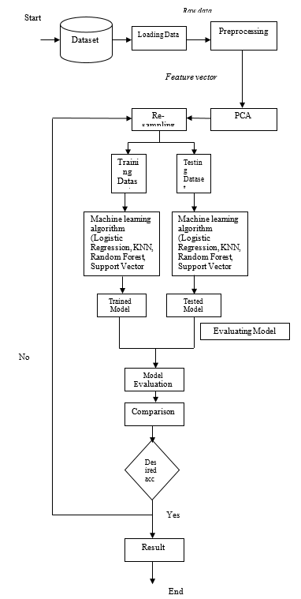
- Data Selection: Data selection is a process in which the most relevant data is selected from a specific domain to derive values that are informative and facilitate learning. PIMA diabetes dataset having 8 attributes that are used to predict the diabetes at earlier stage. This dataset is obtained from UCI repository.
- Data pre-processing: Data pre-processing is a Machine Learning technique that includes changing crude information into reasonable configuration. It includes Data cleaning, Data Integration, Data Transformation, and Data Discretization.
- Feature Extraction Through Principle Component Analysis: Feature Extraction on the dataset to determine the most suitable set of attributes that can help achieve better classification. The set of attributes suggested by the PCA are termed as feature vector. Feature reduction or dimensionality reduction will be benefitted us by reducing the computation and space complexity.
- Re-sampling Filter: The supervised Resample filter is applied to the pre-processed dataset. Re-sampling is a series of methods used to reconstruct your sample data sets, including training sets and validation sets. In this study, Boot strapping re-sampling technique to enhance the accuracy.

System Design And Architecture:
Machine Learning Algorithm

- Decision Tree
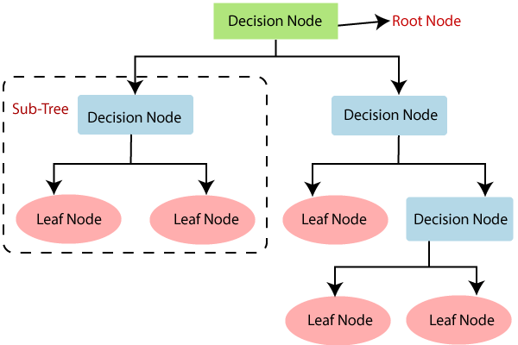
Decision Tree is a Supervised learning technique that can be used for both classification and Regression problems, but mostly it is preferred for solving Classification problems. It is a tree-structured classifier, where internal nodes represent the features of a dataset, branches represent the decision rules and each leaf node represents the outcome. A decision tree simply asks a question, and based on the answer (Yes/No), it further split the tree into subtrees.

- Support Vector Machine (SVM)
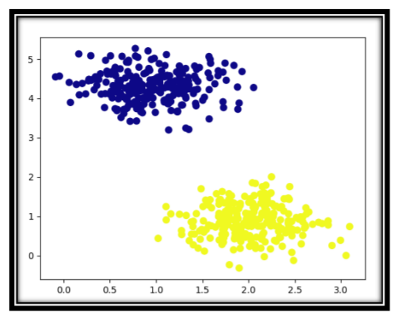
SVM is a supervised classification is one of the most important Machines Learning algorithms in Python, that plots a line that divides different categories of your data. In this ML algorithm, we calculate the vector to optimize the line. This is to ensure that the closest point in each group lies farthest from each other. While you will almost always find this to be a linear vector, it can be other than that. An SVM model is a representation of the examples as points in space, mapped so that the examples of the separate categories are divided by a clear gap that is as wide as possible. In addition to performing linear classification, SVMs can efficiently perform a non-linear classification using what is called the kernel trick, implicitly mapping their inputs into high-dimensional feature spaces. When data are unlabeled, supervised learning is not possible, and an unsupervised learning approach is required, which attempts to find natural clustering of the data to groups, and then map new data to these formed groups.

- Random Forest

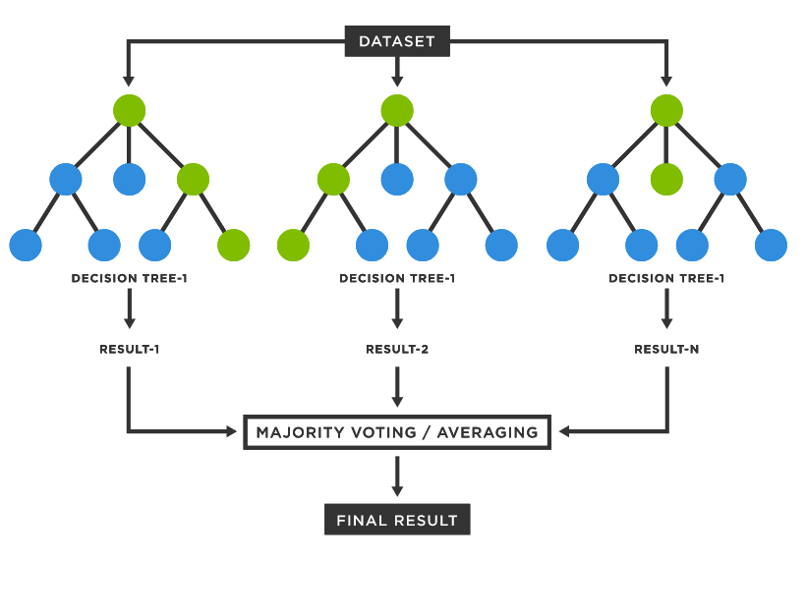
A random forest is an ensemble of decision trees. In order to classify every new object based on its attributes, trees vote for class- each tree provides a classification. The classification with the most votes wins in the forest. Random forests or random decision forests are an ensemble learning method for classification, regression and other tasks that operates by constructing a multitude of decision trees at training time and outputting the class that is the mode of the classes (classification) or mean prediction (regression) of the individual trees

Application Snippet
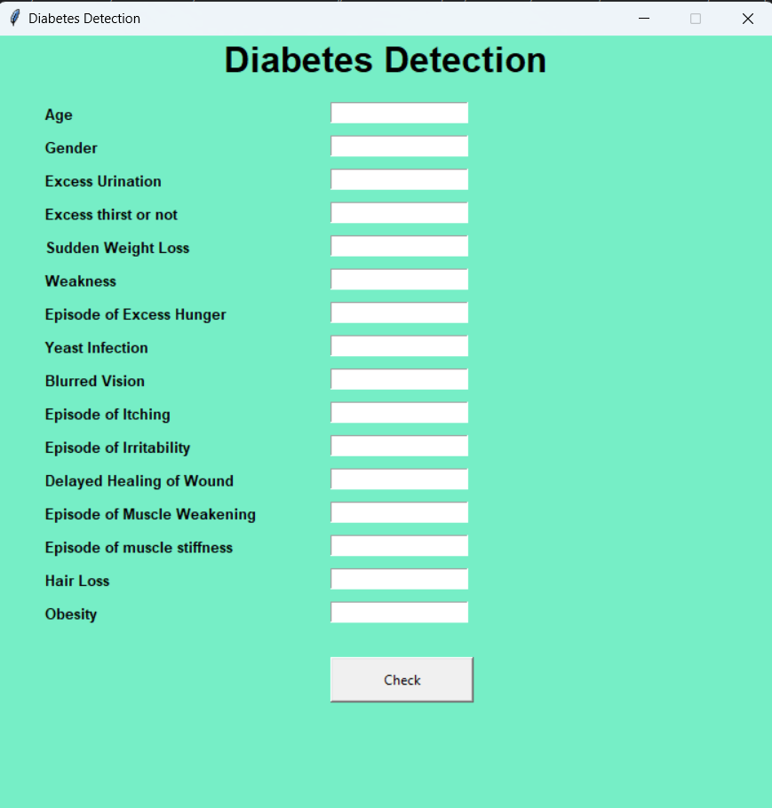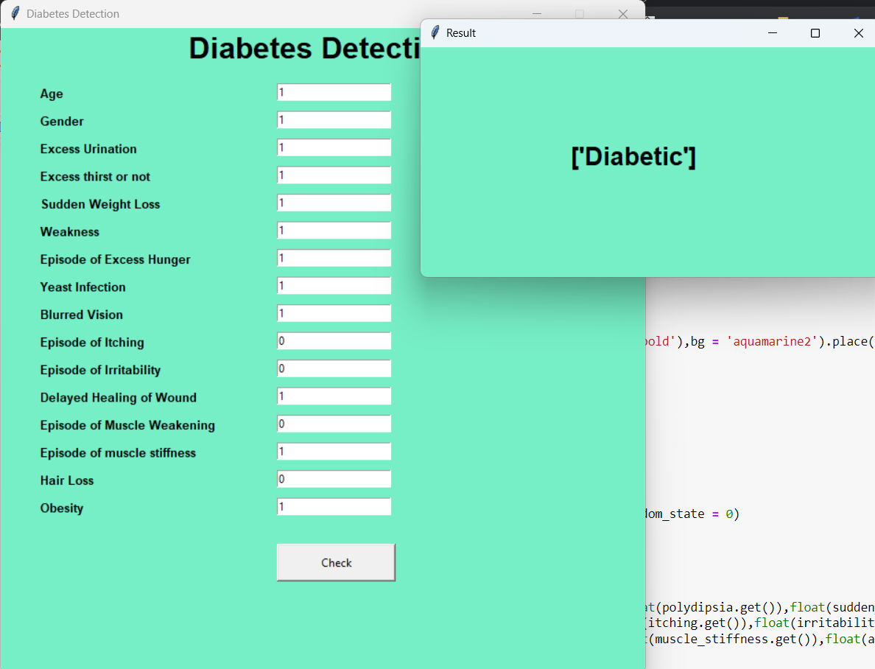
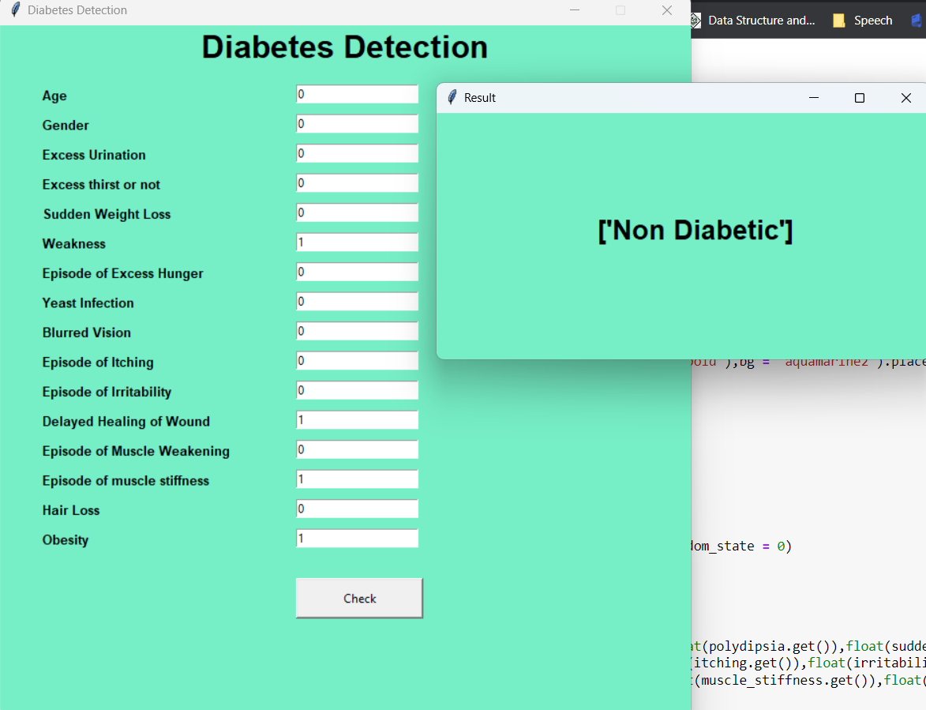

Conclusion
This project provides deep insight into machine learning techniques for finding diabetic person. The role of classifiers is crucial in the healthcare industry so that the results can be used for predicting the treatment which can be provided to patients. The existing techniques are studied and compared for finding the efficient and accurate systems.
Machine learning techniques significantly improves accuracy of prediction through which patients can be identified during an early stage of disease and can be benefitted by preventive treatment. It can be concluded that there is a huge scope for machine learning algorithms in predicting diabetes.

