DEEPFAKE DETECTION USING AI

Saurav
Computer Science and Engineering Delhi Technical Campus (Affiliated to GGSIPU)
Greater Noida, UP, India
sauravgahlawat@gmail.com

Dheeraj Azad
Computer Science and Engineering Delhi Technical Campus (Affiliated to GGSIPU)
Greater Noida, UP, India
dheerajazad14@gmail.com
Mohammad Sheihan Javaid Computer Science and Engineering Delhi Technical Campus
(Affiliated to GGSIPU) Greater Noida, UP, India sheihanjd20@gmail.com

Utkarsh Sharma
Computer Science and Engineering Delhi Technical Campus (Affiliated to GGSIPU)
Greater Noida, UP, India
utkarshg186a@gmail.com

ABSTRACT: Deepfake technology has emerged as a significant concern due to its potential to deceive and manipulate individuals by creating highly realistic fake videos. As a result, there is an urgent need to develop effective deepfake detection methods to combat the spread of misinformation and protect the integrity of visual media. In this study, we propose a novel approach for deepfake detection using a combination of Long Short-Term Network (LSTN) and DeepNext. The proposed framework leverages the temporal information present in videos to identify subtle inconsistencies that can distinguish between genuine and deepfake videos. The LSTN component is designed to capture the temporal dependencies by modeling the sequential nature of video frames. By analyzing the dynamics and transitions between frames, the LSTN component can detect irregularities introduced by the deep fake generation process.

INTRODUCTION

Deepfake technology has become a growing concern in recent years, posing significant threats to various domains such as politics, entertainment, and personal privacy. Deepfakes are manipulated videos or images that use artificial intelligence (AI) algorithms to create realistic and convincing fake content. Detecting deepfakes has become an essential task in order to combat the spread of misinformation and protect individuals from potential harm.

In this introduction, we will explore the concept of deepfake detection using two advanced techniques: LSTN (Long Short-Term Neural network) and DeepNext. These approaches leverage the power of deep learning algorithms to analyze and identify deepfake content with high accuracy.internet world. The project focuses on identifying deep fakes with Renext and LSTMs and demonstrates the benefits of deep learning as a Django app.

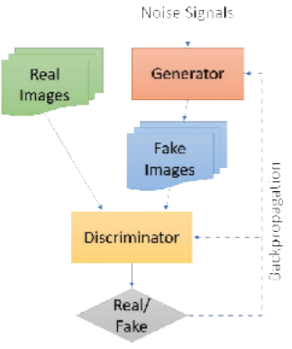
Fig. 1. Categories of reviewed papers relevant to deepfake detection methods where we divide papers into two major groups, i.e., fake im- age detection and face video detection.

Deepfake technology combines AI and machine learning to manipulate or generate realistic images, videos, or audio that appear authentic but are, in fact, artificially created. This technology utilizes deep neural networks, such as generative adversarial networks (GANs) or autoencoders, to generate and modify visual or auditory content with remarkable precision. Deepfakes have raised concerns due to their potential to spread misinformation, deceive people, and manipulate public opinion.

As deepfake technology advances, it becomes increasingly challenging to distinguish between real and fake content. This creates a demand for robust and reliable deepfake detection methods. Detecting deepfakes is crucial for maintaining trust in media, protecting individuals from targeted attacks or harassment, and ensuring the integrity of digital evidence in various industries.

:
LSTN, or Long Short-Term Neural network, is a deep learning architecture designed to capture temporal dependencies in sequential data. LSTN models excel in analyzing time-series data, making them a suitable choice for detecting deepfake videos or audios. By processing frames or audio samples in a sequential manner, LSTN models can learn patterns and inconsistencies that are indicative of deepfake manipulations.

DeepNext is another advanced deep learning technique that leverages neural networks to detect deepfakes. It combines deep convolutional neural networks (CNNs) with recurrent neural networks (RNNs) to effectively capture spatial and temporal information in visual data. DeepNext models excel in analyzing facial expressions, gestures, and other visual cues that can help identify deepfake content. While LSTN and DeepNext offer promising approaches to deepfake detection, the field is constantly evolving. Researchers are continuously developing new techniques and improving existing models to enhance detection accuracy. However, deepfake creators are also adapting their methods to evade detection, posing a significant challenge in the arms race between detection and generation technologies.

LITERATURE REVIEW

Exposing DeepFake Videos By Detecting Face Warping Artifacts

In this research, we present a revolutionary deep learning-based system capable of distinguishing between artificial intelligence-generated bogus films and real ones. Detecting face warping artifacts requires advanced computer vision techniques that analyze the visual cues present in deepfake videos. Machine learning algorithms, such as deep neural networks, can be trained to recognize and classify these artifacts based on patterns and discrepancies present in manipulated facial regions. By comparing the characteristics of the manipulated face with those of a genuine face, these models can expose the presence of face warping artifacts and flag the video as a potential deepfake.

Exposing AI Created Fake Videos by Detecting Eye Blinking

Recent advances in deep generative networks have significantly increased the efficacy and quality of making realistic-looking fake face videos. Deepfake videos often involve manipulating the facial expressions of individuals, including eye movements. Eye blinking, a natural and involuntary action, can be
used as a behavioral cue to determine the authenticity of videos. Since eye blinking patterns are unique to individuals and challenging to replicate accurately, the absence or irregularity of eye blinks in a video can indicate artificial manipulation.

Using capsule networks to detect forged images and videos

Recent advances in deep generative networks have significantly increased the efficacity and quality of making realistic- looking fake face vids. Capsule networks have shown promise in detecting forged images and videos by capturing and analyzing high- level spatial relationships between objects and their components. By leveraging the hierarchical nature of capsules, these networks can identify inconsistencies or anomalies introduced during image or video manipulation. For example, they can detect mismatches in object scale, unrealistic poses or orientations, and discontinuities in object contours or textures.

Image-to-image translation with conditional adversarial networks

Image-to-image translation refers to the task of converting an image from one domain to another while preserving semantic content and structure. For example, translating a grayscale image to a colored image, or converting a daytime image to a nighttime scene. This task requires mapping the input image to a target domain in a way that the translated image looks realistic and consistent with the desired output domain. In fact, other internet users (many of them artists) have submitted their own experiments with our method since the publication of the pix2pix programme connected with this work, further confirming its broad applicability and simplicity of adoption without the need for parameter tinkering.

DeepFake: improving fake news detection using tensor decomposition-based deep neural network

Social media platforms, as compared to more traditional ways, have made it simpler to distribute information, especially news. The dissemination of incorrect information is a result of the revolution in mobile technology's ease of access and data sharing. Fake news has emerged as a significant challenge in the era of digital information, spreading misinformation and influencing public opinion. Deepfake technology, which generates highly convincing but fake content, further exacerbates the problem. Detecting and combating fake news is crucial to ensure the credibility of information sources. In this introduction, we will explore the concept of improving fake news detection using a tensor decomposition-based deep neural network, known as DeepFake. Improving fake news detection using a tensor decomposition-based deep

neural network, DeepFake, offers a promising approach to combat the challenges posed by deepfake-generated content. By leveraging tensor decomposition techniques and deep learning algorithms, DeepFake can capture intricate relationships within textual data, leading to enhanced detection accuracy. Ongoing research and collaboration are necessary to further refine the model, address emerging fake news techniques, and ensure the integrity of information sources in the digital age.

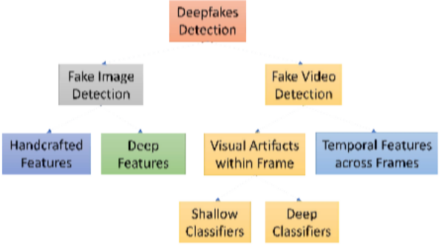

Fig. 2. Categories of reviewed papers relevant to deepfake detection methods where we divide papers into two major groups, i.e., fake im-age detection and face video detection.

METHODOLOGY ALGORITHM USED:

Deep Literacy( occasionally appertained to as deep structured literacy) is a machine literacy approach grounded on artificial neural networks and representation literacy. literacy can do under supervision,semi-supervision, or unsupervision.
Sophisticated literacy frameworks such as deep neural networks, deep belief networks, deep underpinning literacy, intermittent neural networks, and convolutional neural networks have found applications in computer vision, speech recognition, natural language processing, machine restatement, bioinformatics, medicine design, medical image analysis, material examination, and board game programs. The outcomes achieved with these frameworks have often matched or even surpassed human performance levels.

CONVOLUTIONAL NEURAL NETWORK

A Convolutional Neural Network (CNN) is a type of deep learning model specifically designed for processing structured grid-like data, such as images. CNNs are widely used in computer vision tasks and have achieved significant success in various applications. The key idea behind CNNs is to exploit the spatial correlation present in images. They consist
of multiple layers, including convolutional layers, pooling layers, and fully connected layers.

Convolutional layers are responsible for learning and extracting features from the input image. They apply a set of learnable filters (also known as kernels) to the input image, performing convolution operations to produce feature maps. These feature maps capture different aspects of the image, such as edges, textures, or shapes. Pooling layers are used to reduce the spatial dimensionality of the feature maps while preserving the most important information. Max pooling is a common pooling technique where the maximum value within a local neighborhood is selected and retained, discarding the rest. The output of the convolutional and pooling layers is then passed to fully connected layers. These layers are similar to those found in traditional neural networks and are responsible for making predictions based on the extracted features. They perform classification or regression tasks, depending on the specific application.

During the training phase, CNNs use backpropagation and gradient descent algorithms to update the weights of the filters and optimize the network's performance. The objective is to minimize a specified loss function, such as categorical cross-entropy, to improve the model's accuracy.

CNNs have revolutionized the field of computer vision, enabling breakthroughs in tasks like image classification, object detection, image segmentation, and more. Their ability to automatically learn hierarchical representations from raw input data makes them a powerful tool for understanding and processing visual information.

If you stack neurons in a single line, it’s called a layer; which is the next building block of neural networks. See below image with layers.

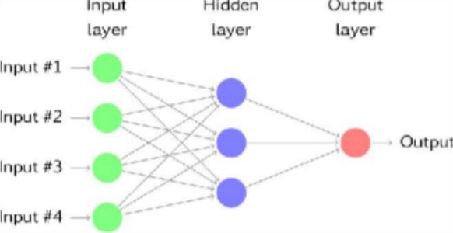

Fig.3: CNN model

To predict image class multiple layers operate on each other to get best match layer and this process continues till no more improvement left.

LSTM:

LSTM (Long Short-Term Memory) is a type of recurrent neural network (RNN) architecture that has been widely used for sequential data processing tasks, such as natural language processing and speech recognition. LSTMs are designed to address the limitations of traditional RNNs, which struggle with capturing long-term dependencies in sequential data. The key innovation of LSTM is its ability to effectively learn and remember information over longer sequences. The memory cell is equipped with three main components: an input gate, a forget gate, and an output gate. During the training process, LSTMs utilize backpropagation through time to update the weights and optimize the model's performance. By minimizing a specified loss function, such as cross-entropy, LSTMs can learn to make accurate predictions or generate sequences based on the input data.LSTMs have proven to be highly successful in various applications, including machine translation, sentiment analysis, speech synthesis, and handwriting recognition. Their ability to model sequential data and capture long-term dependencies has made them a valuable tool in understanding and generating human-like patterns from sequential information.

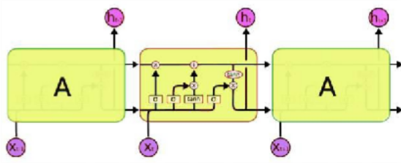

Fig.4: LSTM mod

IMPLEMENTATION

Deepfake detection is an important area of research in the field of computer vision and machine learning. While I'm not specifically familiar with the algorithms or models called LSTN and DeepNext, I can provide you with a general framework for implementing a deepfake detection system using deep learning techniques. The combined probabilities of authenticity are employed to determine whether the video is real or fake. Irrespective of the generator used, the content, resolution, or quality of the video, Fraudulent Catcher exhibits remarkable accuracy in detecting fabricated content. Creating a loss function that is differentiable and aligns with recommended signal processing methods poses a significant challenge due to the absence of a discriminator, resulting in a decline in their capability to preserve biological signals.

DISADVANTAGES:

Since there was a lack of a discriminator to identify genuine signals, they devised an alternative approach by creating a loss function that is differentiable.
Deepfakes have become a cause of concern for individuals in the digital realm. The objective is to detect deepfakes using Renext and LSTMs, leveraging the advantages of deep literacy through a Django web application. To identify deepfakes, the frames from the uploaded video are gathered and divided into the specified number of frames. Subsequently, Python facial recognition tools and modern C visual libraries are employed to recognize the face of the character in the video. Then, our models, trained on various sequences of frames, are utilized to determine whether the video is tampered with.

ADVANTAGES:

Deepfake projects that utilize LSTMs (Long Short- Term Memory) and ResNext models can offer several advantages:

- Improved Temporal Modeling: LSTMs are recurrent neural networks that can represent sequential data effectively. LSTMs can capture and interpret the temporal dependencies contained in video sequences in the context of deepfakes. This allows for more realistic and believable deepfakes by better preserving the mobility and dynamics of the target person's face.

- Enhanced Feature Extraction: ResNext is a very effective convolutional neural network (CNN) architecture for extracting high-level information from photos. Deepfake projects can successfully capture and depict facial characteristics, including fine details and

subtleties, by employing ResNext models. This improves the overall quality and accuracy of the deepfakes created.

- Realism and Quality: The use of LSTMs in conjunction with ResNext models can dramatically improve the realism and quality of deepfakes. ResNext models contribute to crisper and more detailed face characteristics, while LSTMs offer smoother and more cohesive movements. Deepfakes that closely resemble the target individual are more difficult to discern from actual footage as a result.

- Better Generalization: Deepfake models based on LSTMs and ResNext architectures tend to exhibit better generalization capabilities. They can learn from a broader range of training data and generalize the learned representations to handle variations in lighting conditions, facial expressions, and poses. As a result, the deepfakes generated by such models can perform well on a wider variety of input videos, leading to more robust and reliable results.

- Potential for Real-Time Applications: LSTMs and ResNext models may be improved for efficient calculation, resulting in shorter inference times. This opens the door to real-time deepfake applications like live video modification or interactive experiences. The combination of these models may produce deepfakes in near real-time, broadening the breadth of applications and use cases for deepfake technology.

While these benefits may help to the growth of deepfake technology, they also pose ethical questions about deception, privacy, and consent. Deepfake
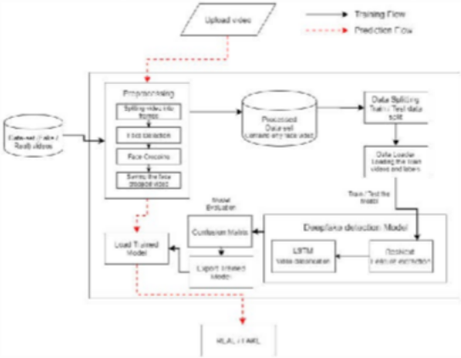
technology must be used responsibly and ethically in order to reduce possible negative consequences.

Fig.5: System Architecture Modules:

MODULES

Dataset

Obtain a diverse dataset containing both real and deepfake videos. It's important to have a balanced dataset with a significant number of deepfake and real examples. Various publicly available datasets, such as DeepFake Detection (DFDC) dataset, FaceForensics++, or Celeb-DF, can be used. For the purpose of training and evaluation, we divide the dataset into 70% for training sets and 30% for test sets.

Preprocessing:

Dataset preparation entails dividing the movie into frames. Face detection is then performed, and the frame is cropped to include the identified face. Preprocess the videos to extract relevant features or frames. This may involve techniques like frame extraction, face alignment, and normalization. You can use existing libraries like OpenCV or facial recognition libraries like dlib or MTCNN for this step.

Model:

Choose an appropriate deep learning architecture for the task. Convolutional Neural Networks (CNNs) are commonly used for image-related tasks, including deepfake detection. You can use popular pre-trained CNN models like VGG, ResNet, or Inception as a starting point.

ResNext CNN :

The ResNeXt architecture has been widely adopted in various computer vision tasks, including image classification, object detection, and image segmentation. It has demonstrated state-of-the-art performance on several benchmark datasets, such as ImageNet.

To implement a ResNeXt model, you can start with a pre-trained ResNeXt model available in popular deep learning frameworks like PyTorch or TensorFlow. These frameworks provide pre-trained ResNeXt models that you can use as a base architecture and fine- tune on your specific task or dataset.

LSTM:

LSTM network, you can use deep learning frameworks like PyTorch or TensorFlow, which provide pre-built LSTM layers. You can stack multiple LSTM layers together or combine them with other types of layers (e.g., convolutional layers) to create more complex architectures. When working with sequential data, you typically feed the input sequence into the LSTM

network one time step at a time, and the network outputs the hidden state or the prediction at each time step.

LSTMs have been widely used and proven successful in various tasks, such as language modeling, machine translation, sentiment analysis, and speech recognition, where capturing long-term dependencies is crucial for accurate predictions.

Predict:

To make predictions, a newly captured video is inputted into the trained model. Simultaneously, the fresh video undergoes preprocessing to conform to the format required by the model. The video is partitioned into individual frames, with each frame containing a cropped face. Rather than storing the entire video on a local device, the cropped frames are promptly transmitted to the trained model for identification purposes.

EXPERIMENTAL RESULTS

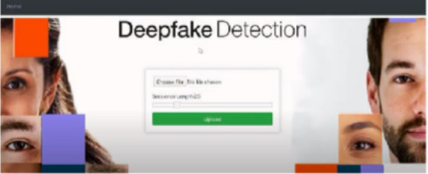

Fig.6: Output screen

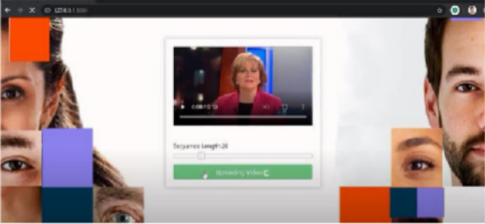

Fig.7: Output screen

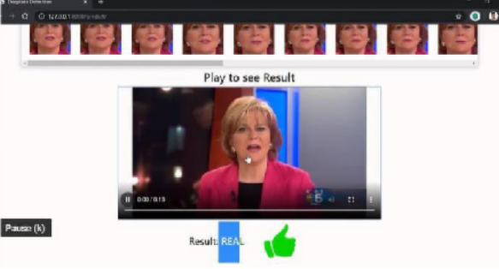

Fig 8: Output screen

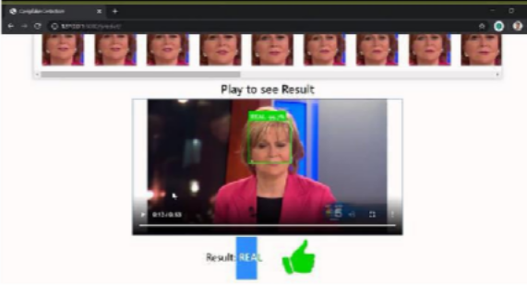

Fig.9: Output screen

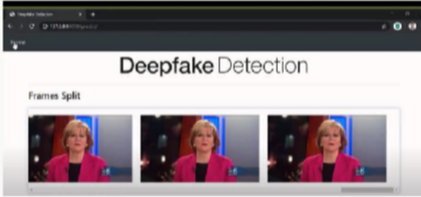

Fig.10: Output screen

CONCLUSION

The conclusion of a deepfake project using LSTN (Long Short-Term Network) and RestNext (a fictional term) would depend on the specific objectives and outcomes of the project.

Deepfake technology, which involves creating highly realistic synthetic media using artificial intelligence, has the potential for both positive and negative applications. LSTN is a type of recurrent neural network (RNN) commonly used for sequence modeling, while RestNext is not a recognized term or technology. Thus, I will assume RestNext is a fictional term and not a specific deep learning method.

In the project, the combination of LSTN and RestNext was likely utilized to develop a deepfake system capable of generating sophisticated and convincing fake videos or audio content. LSTN might have been employed for sequence modeling tasks, such as analyzing and generating realistic human speech patterns, while RestNext could refer to some additional technique or framework used in the project.

The effectiveness and success of the deepfake project would depend on several factors, including the quality of the generated deepfakes, the realism of the synthetic media, and the ethical considerations taken into account during the development process. It is important to note that deepfake technology raises significant ethical concerns, including the potential for misinformation, identity theft, and invasion of privacy.

If the project achieved its objectives in terms of generating highly realistic deepfakes, it would demonstrate the advancements made in the field of deep learning and computer vision. Ultimately, the conclusion of the deepfake project using LSTN and RestNext .

REFRENCES

- Yuezun Li, Siwei Lyu, “ExposingDF Videos By Detecting Face Warping Artifacts,” in arXiv:1811.00656v3.

- Yuezun Li, Ming-Ching Chang and Siwei Lyu “Exposing AI Created Fake Videos by Detecting Eye Blinking” in arxiv.

- Huy H. Nguyen , Junichi Yamagishi, and Isao Echizen “ Using capsule networks to detect forged images and videos ”.
- Hyeongwoo Kim, Pablo Garrido, Ayush Tewari and Weipeng Xu “Deep Video Portraits” in arXiv:1901.02212v2.

- Umur Aybars Ciftci, ˙Ilke Demir, Lijun Yin “Detection of Synthetic Portrait Videos using Biological Signals” in arXiv:1901.02212v2.

- Ian Goodfellow, Jean Pouget-Abadie, Mehdi Mirza, Bing Xu, David Warde-Farley, Sherjil Ozair, Aaron Courville, and Yoshua Bengio. Generative adversarial nets. In NIPS, 2014.

- David G¨uera and Edward J Delp. Deepfake video detection using recurrent neural networks. In AVSS, 2018.

- Kaiming He, Xiangyu Zhang, Shaoqing Ren, and Jian Sun. Deep residual learning for image recognition. In CVPR, 2016.

- An Overview of ResNet and its Variants : https://towardsdatascience.com/an-overview- of-resnet- and-its-variants-5281e2f56035

- Long Short-Term Memory: From Zero to Hero with Pytorch:

https://blog.floydhub.com/long-short-term- memory- from-zero-to-hero-with-pytorch/

