Study of Viscous Fluid Damper on 12 Story RCC Structure and testing 7 Different Pattern.
Pankaj Autade¹, Shaikh Jawwaad²
¹PG guide, department of civil engineering, DVVP COE Ahmednagar, India
²PG student, department of civil engineering, DVVP COE Ahmednagar, India

ABSTRACT
Buildings in seismically active regions need to be constructed with special consideration for their lateral stability. With the development of India Infrastructure development coincides with India's economic growth. Many high-rise buildings are currently being built in Indian metropolises, but as building heights rise and wind pressure increases, more support structures are required to prevent displacement. We cannot overlook the calamity in Turkey, where a structure collapsed and hundreds of lives were lost. We will use viscous fluid dampers in the construction of this research. Numerous researches have already established the effectiveness of VFD in reducing the movement of structures under wind and seismic loads or earthquake forces. This paper focuses on evaluating different patterns on 12 story structure, a total of 7 patterns will be tested to see if we see any change in displacement, drift.
Keywords: Viscous Fluid Dampers, earthquake forces, Response Spectrum Analysis.

1-INTRODUCTION
Viscous Fluid dampers, or seismic dampers as they are likewise known, are devices that, when incited, disseminate the energy that seismic events, wind buffering, or warm movement force on a construction. The idea is straightforward: by dissipating the heat created by the structural movement into the air, the viscous dampers obey the rules of physics by following the principle of energy conservation. These small but mighty dampers raise structural damping levels to as much as 50% of critical, leading to a remarkably dramatic decrease in stress and deflection. The dependability and durability of our products are ensured by individually testing each damper at the highest forces and velocities that the customer has chosen.

1.1-Mathematical Modelling Of Fluid Viscous Dampers
The constitutive equation below idealises the behaviour of a fluid viscous damper as a pure dashpot:
Damping Force F = Damping Constant C x Velocity V ^{α}
This Condition gives the connection between the damper result power and speed, where C and alpha are the damping steady and speed example, individually. The value of alpha of 1.0 represents linear dampers, whereas values other than 1.0 indicate nonlinear dampers. Specifications for alpha typically range from 0.3 to 1.0; the simple way to put it, the lower the exponent the more efficient damping for seismic energy dissipation.

1.2-Modelling Of Structure
Building description
The building analysed in this study is 12 story structure with 20x20m dimension a column of 450 mm and a total no of 36 4m center to center a beam of 230x450 mm was adopted and typical story height of 3m was adopted with typical height of 3m and a total height of 36.4m.
.The second structure was 17 story with dimension of 20x20m a total no of 36 column of size 450x450mm with 4m center to center distance with typical height of 3m and a total height of 51.4m. The structure was designed as per IS code.

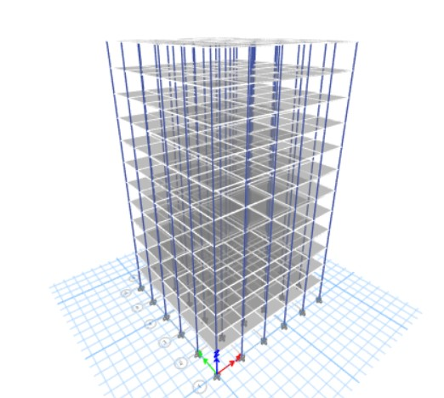
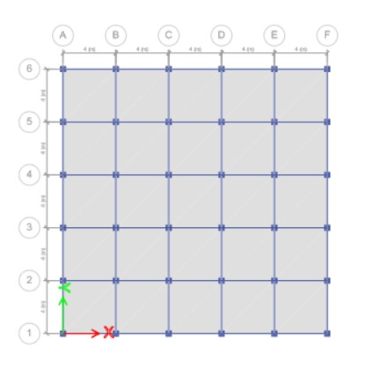

Fig Plan view of modal in ETABs Fig 3D modal View in ETABs

1.3-Modelling of Viscous Fluid Damper
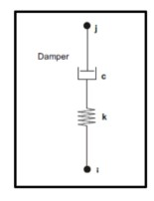

In this study the lowest force output of damper was used because the main aim was to find the effective position and for maximum damping output. Through the formal request the Company Taylor Devices inc provided the damper configuration used in this study.

Force | Spherical dia. | Mid stroke | Stroke  mm | Celvis  thickness | Celvis  width | Celvis  depth | Cylinder  dia | weight
250 kn | 38.10 | 867mm | +-75 | 41mm | 100 max | 83 | 115 max | 41kg
Table 1-Suggested C value provided by taylor devices
Related force | Suggested C | Value in kN
 | Max vel=0.127m/s | Max vel=0.254m/s | Max vel=0.381m/s | Max vel=0.508m/s
250 kN | 454.6 | 369.2 | 326.9 | 299.9

1.4-ETABs
Extended three dimension analysis building software was used in this study to modal and analyse the structure .it is a powerful tool and has been in market for a long time .It has a lot of tool for structure modelling and analysis because of that damper modelling was possible.in this study etabs 20 was used .

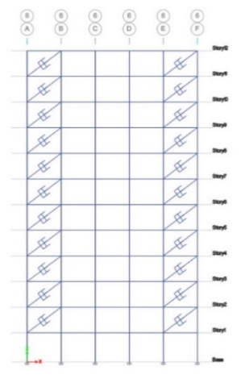
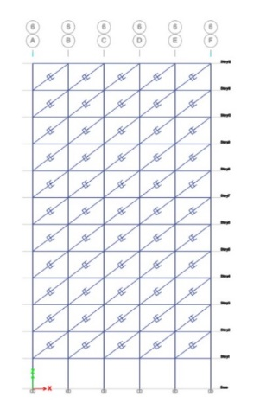
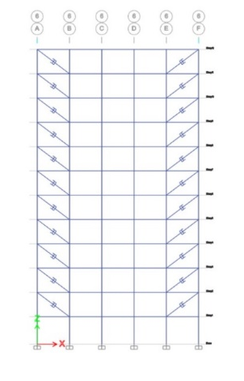

Pattern-1 Pattern-2 Pattern-3
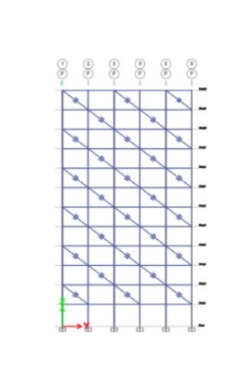
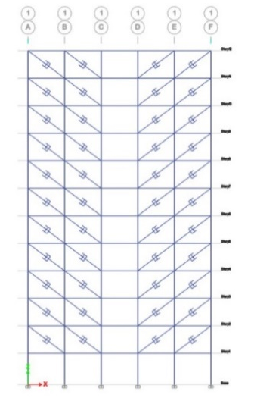

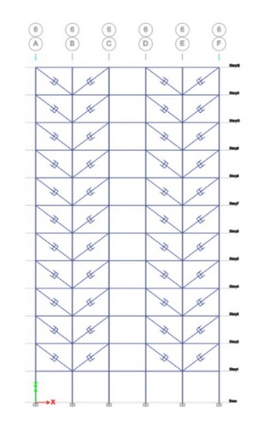

Pattern-4 Pattern-5 Pattern-6
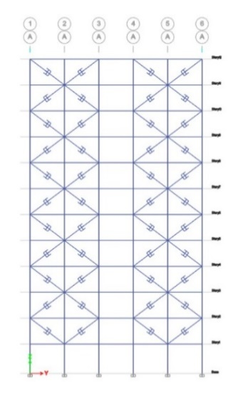
Pattern-7
2-RESULT
Pattern | No of Damper | Max Lateral Load | Max Displacement mm | Max Drift
Base 12 X direction | 0 | 324.93 | 41.87 | 0.00149
Base 12 Y direction | 0 | 0 | 2.95725E-10 | 2.95725E-10
Pattern 1 Direction | 88 | 459.34 | 32.52 | 0.00107
Pattern 1 Direction | 88 | 0 | 7.28E-11 | 3.47 E-15
Pattern 2X direction | 88 | 459.34 | 33.89 | 0.00109
Pattern 2Y direction | 88 | 0 | 0.51 | 2.38 E-05
Pattern 3XDirection | 220 | 660.93 | 10.01 | 0.00140
Pattern 3YDirection | 220 | 0 | 0.63 | 1.69 E-05
Pattern4X direction | 176 | 660.93 | 17.74 | 0.001286
Pattern4Y direction | 176 | 0 | 2.05E-11 | 2.73 E-15
Pattern 5XDirection | 176 | 660.93 | 20.45 | 0.0013
Pattern 5YDirection | 176 | 0 | 6.89 E-10 | 1.35 E-13
Pattern 6XDirection | 112 | 491.84 | 7.56 | 0.00107
Pattern 6YDirection | 112 | 0 | 0.65 | 3.70 E-6
Pattern 7XDirection | 176 | 593.92 | 14.04 | 0.0013
Pattern 7YDirection | 176 | 0 | 0.0056 | 9.86822E-07

Table 2 –Output of 7 tested pattern for 12 story structure in ETABs
- Max Lateral load
- The lateral load observed on structure without damper is 324 kN and on pattern 3 it was observed 660 kN with 220 dampers installed.
- Max lateral load observed on pattern 1-2 was same 459 kN as number of damper is equal.
- Lateral load observed on pattern 4-5 is 660 kN with same number of damper installed.
- Max Displacement
- Maximum displacement was observed in structure without damper which is 41.8mm
- After applying damper following displacement was observed pattern 1 gave a max displacement of 32.5mm, pattern 2 gave 33.8mm, pattern 3 gave 10.07mm, pattern 4 gave 17.74mm, pattern 5 gave 20.45mm, pattern 6 gave 7.56mm, pattern 7 gave 14.04mm

- Max Drift
- Max drift was observed in structure without damper which is 0.00149mm.
- After applying damper following displacement was observed pattern 1 gave a max drift of 0.00107mm, pattern 2 gave 0.00109mm, pattern 3 gave 0.00140mm, pattern 4 gave 0.001286mm, pattern 5 gave 0.0013mm, pattern 6 gave 0.00107mm, and pattern 7 gave 0.0013mm.

3-CONCLUSION
- With the increase in damper the lateral loads increases
- The lowest value of max later loads was observed was in structure with no damper and the highest value observed was in pattern 3 with 220 number of damper.
- Maximum value of displacement observed was in structure without damper 41.8mm.
- With pattern 2 giving least damping with displacement of 33.89mm we see a reduction of 7.91 mm or about 18.92% reduction in displacement.
- With pattern 6 having the least displacement off all pattern tested gave a reduction of 34.24mm 81% reduction in displacement.
- This concludes pattern 6 is most effective pattern in this study.
- There is a reduction in drift comparing structure with and without damper.
- The max drift observed was in structure without damper 0.00149mm and with the least we have pattern 6 with the max drift obtained 0.00107mm.
- A straight line was observed in pattern 7 graph with X shape pattern.
- The best pattern for damping arrangement is pattern 6 with least displacement and drift observed.
- With number of damper increase we see a reduction in displacement and drift but arrangement or position of damper is more important as observed in pattern 6.

4-REFERENCES
- Naziya Ghanchi, Shilpa Kewate. DYNAMIC ANALYSIS OF 25 STOREY RCC BUILDING WITH AND WITHOUT VISCOUS DAMPERS International Journal of Scientific & Engineering Research, Volume 6, Issue 12, December-2015 ISSN 2229-5518
- Vijay Kumar, Dinesh Sen. Seismic Analysis of High Rise Building (G+10) Using Etabs International Research Journal of Engineering and Technology (IRJET) e-ISSN: 2395-0056 Volume: 07 Issue: 09 | Sep 2020 www.irjet.net p-ISSN: 2395-0072
- Sayyed Feroz Sikandar , Shaikh Zameeroddin. S , Prof. Agrawal. A. S .Analysis and Design of Multistory Building using ETABS 2017 ijese ISSN 2321 3361 © 2019 IJESC
- A.Brown , M. Uno , J.Stratford and J.Thompson .Steel Moment Frame With Supplemental Fluid Viscous Dampers – 12 Moorhouse Avenue A Case Study .Steel Innovations Conference 2015 Auckland, New Zealand 3-4 September 2015
- Puneeth Sajjan , Praveen Biradar Study On The Effect Of Viscous Damper For Rcc Frame Structure . International Journal of Research in Engineering and Technology eISSN: 2319-1163 | pISSN: 2321-7308
- Enrico Tubaldi 1 *, Laura Gioiella2 , Fabrizio Scozzese2 , Laura Ragni 3 and Andrea Dall’Asta
- A Design Meathod Of Viscous Dampers Connecting Adjacent Structure.Frount .Build Eviron,19 Mar 2020,Sec.Earthquake.Engineering Vol 6-2020 I Http://Doi.Org/10.3389/Fbuil.2020.00025
- Dr K Rama Raju, Fellow G G Hernanth, Non-Member K S Rekha, Non-Member Dr N R Iyer, Fellow.Seismic Design Of Buildings With Viscous Fluid Dampers - A Methodology .
- Kun Ding, Xin Zhao, Yue Yang And Liwei Ye. Application Of Viscous Dampers For Super Tall Residential Buildings In High-Wind Strong-Seismic Area. The 2016 World Congress On The 2016 Strucutres Jeju Island Korea Congress
- M. D. Symans , M. C. Constantinou, D. P. Taylor, And K. D. Garnjost. Semi-Active Fluid Viscous Dampers For Seismic Response Control,

