THE FUTURE OF 5G WIRELESS SYSTEM
Dimple Dattatraya Borole
Institute of Distance and Open Learning Vidya Nagari, Kalina, Santacruz East – 400098.
University of Mumbai
----------------------------------------------------------***---------------------------------------------------------
Abstract
Everyone loves speed, especially fast internet, and it's no wonder that every major telecommunications industry in the world is looking for ways to make it even faster. Smartphones, watches, homes, and automobiles are all requiring more stable internet connections. To survive in a world where speed keeps changing every second and we seek more and more technology, here comes the fifth-generation technology. Some of the primary goals that must be met in the future, i.e., in a world beyond 4G, are increased capacity, improved data rate, decreased latency, and quality service. Future 5G wireless networks will face new challenges, as well as increased demand for network capacity to support a large number of devices running applications that require high data rates and always-on connectivity. The main objective of 5G is to create the best wireless world possible, free of the limitations and obstacles of previous generations. This paper presents evaluations in the field of mobile communication technology. Multiple challenges were encountered during each evolution, which were captured with the support of next-generation mobile networks. And also, we will discuss some statistics of 5G network and technology.
Keywords: 5G, Evolution of 5G, Architecture, Stats and News.

- INTRODUCTION
The first wireless phone technology was 1G, which was updated to 2G in the early 1990s when firms enabled consumers to transmit text messages between two portable handsets, which captured the world. The world eventually moved on to 3G, which gave people the freedom to make phone calls, send text messages, and access the internet at lightning speed. Many of the capabilities that were only possible with the 3rd generation of wireless technology were improved with 4G. People could browse the web at lightning speed, send text messages, make phone conversations, and even download and upload big video files
without experiencing any problems or waiting extended periods of time. Then, in order to improve 4G connectivity, firms added LTE, which stands for "long term evolution." LTE became the most reliable and speedy network.
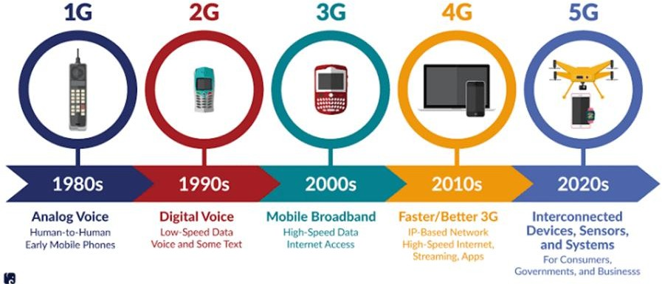

Figure 1: History of mobile technology
Beyond the current 4G standards, 5G is the next important phase of mobile telecommunication ethics. 5G technology is helping to improve product manufacturing, documentation, and electronic communications, among other things. As the buyer becomes more knowledgeable about mobile phone technology, he or she will search out a good package which includes all of the advanced features that a cell phones can offer.
Qualcomm was a key factor contributing to the growth of so many introductory technologies that are used to take the industry forward and make up 5G, the next wireless standard.
South Korea was the first country to deploy 5G networks, and the country is projected to maintain its lead in terms of technology adoption.

- OBJECTIVE
This paper is mainly classified into following sections:
- Evolution of generation
- 5G cellular network architecture
- Statistics
- Conclusion

- EVOLUTION OF GENERATION

1G
The first generation of wireless telephone technology is referred to as 1G (or 1-G) (mobile telecommunication). The first generation was released in the early 1980s. With a 2.4kbps data rate. Advanced Mobile Phone System (AMPS), Nordic Mobile Telephone (NMT), and Total Access Communication System were among the subscribers (TACS). The disadvantages of the first generation were low capacity, rash handoff, poor accent associations, and a lack of safety safeguards, as audio conversations were aggregated and played in radio towers, resulting in call weakness from non-essential connections, such as noises from the third party. The fundamental difference between the two mobile network systems (1G and 2G) is the medium of encoders, i.e., 1G networks utilize analogue radio signals, whereas 2G networks use digital radio signals. We are aware that both systems use digital signaling to connect the radio towers (which pay attention to the handsets) to the rest of the telephonic networks, and that the tone of voice during a call is programmed to digital signals in 2G, whereas in 1G, modulation is done on a higher frequency, typically 150 MHz and up. Because of the inherent advantages of digital over analogue, 1G has been replaced by 2G.

2G
Second-generation wireless telephone technology is referred to as 2G (or 2-G). The three main advantages of 2G networks over previous generations were that:
- phone conversations were digitally encrypted;
- 2G systems were significantly more capable on the spectrum, enabling for higher mobile phone penetration; and
- 2G brought data services and SMS text messages.
Picture messages, text messages, and MMS were all allowed by 2G technology on various mobile phone networks (multimedia messages) As previously stated, all text messages transmitted over 2G are digitally encrypted, allowing for the transmission of data in such a way that only the intended receiver can receive and read it, making it more advanced in terms of privacy than 1G.

2.5G
It is often a 2nd generation cellular system subscription that includes General Packet Radio Services (GPRS) and other features that aren't commonly available on 2G or 1G networks. It has a high data rate of up to 144kbps system architecture, however it uses both packet and circuit switching. The main 2.5G technologies were GPRS, Enhanced Data Rate for GSM Evolution (EDGE), and Code Division Multiple Access (CDMA 2000).

3G
Then came the launch of the third generation, which began in late 2000. It transmits data at up to 2Mbps to the rest of the globe. The fundamental goal of the third generation (3G) system was to successfully combine high- speed mobile access with Internet Protocol (IP)-based services. Aside from transmission rate, cutting-edge improvements in QoS were developed. Additional features such as global roaming and increased audio quality helped to distinguish 3G as a remarkable and qualitative generation. The fact that 3G handsets consume more
power than most 2G devices is a huge irritation. 3G network plans are more expensive than 2G network plans from a market standpoint. Wideband Code Division Multiple Access (WCDMA), Universal Mobile Telecommunications Systems (UMTS), and Code Division Multiple Access (CDMA) 2000 technologies are used in 3G, as well as the introduction of evolving technologies such as High-Speed Uplink/Downlink Packet Access (HSUPA/HSDPA) and Evolution-Data Optimized (EVDO) that have created an intermediate wireless. 3G telecommunication networks support services with a minimum data transfer rate of 200 kb/sec. The generation between 3G and 4G is referred to as 3. 5G offers a higher data rate of 5-30 Mbps.

3.75G
Mobile data services will be dominated by Long-Term Evolution (LTE) and Fixed Worldwide Interoperability for Microwave Access (WIMAX). LTE and Fixed WIMAX have the potential to enhance the network's capabilities. It also allows a large number of users to access a wide range of high-speed services such as specified video, peer-to-peer file sharing, and combined Web services.

4G
4G is the fourth generation (4th) of wireless mobile telecommunication technology, replacing 3G and promising even more. A 4G system must have ITU-defined capabilities in IMT. Advance 4G is considered the offspring of the 3G and 2G standards. The standardizing of Long-Term Evolution (LTE), also known as 4G, and Mobile Worldwide Interoperability for Microwave Access, or WIMAX, is now being done through a 3rd generation collaboration initiative (3GPP). A 4G system enhances traditional communication networks by providing a comprehensive and dependable IP-based solution. Voice, data, and multimedia services will be available to consumers at all times and in all places, with significantly higher data charges than previous generations. Multimedia Messaging Service (MMS), Digital Video Broadcasting (DVB), video chat, High-Definition TV content, and mobile TV are all applications that utilize a 4G network.

5G
Huge groups of key global telecommunications companies are already collaborating to develop global 5G values. Although most of those standards have yet to be finalized, analysts believe it to be more compatible (with 4G and 3G) and have some global interoperability. With exponentially increasing user demand, 4G may now be readily replaced with 5G using a new sophisticated access technique known as Beam Division Multiple Access (BDMA) or Filter Bank Multi Carrier (FBMC) multiple access. Consider the instance of a base station talking with mobile stations to understand the notion underlying BDMA approaches. Each mobile station has an orthogonal beam, which we can split using the BDMA approach according to the locations of the mobile stations for open handed numerous accesses to the mobile stations, which also increases the system's competency and is the key process of this communication. The decision to go to 5G is based on current trends; it is widely expected that 5G cellular networks can overcome six difficulties that 4G cannot, that is:
1: Higher capacity
2: data rate higher
3: End to End latency has been lowered
4: connectivity to massive device
5: reduced cost
6: consistent Quality
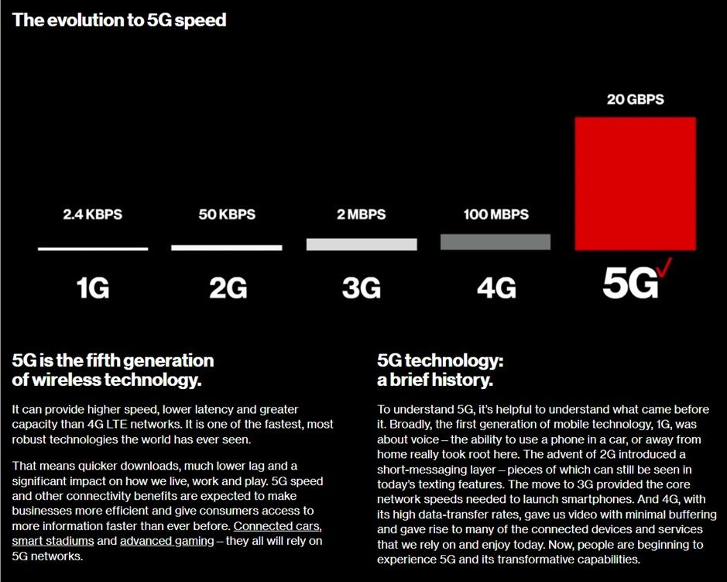
Figure 2: The Evolution to 5G speed.
- 5G CELLULAR NETWORK ARCHITECTURE

Designers of 5G networks face a number of challenges. The physical scarcity of radio frequency (RF) bands required for cellular communications is one of the most pressing issues. Furthermore, these frequency spectra have been extensively utilized, and the present cellular bands no longer include any supplemental information. Another issue is that the functioning of modern wireless technology is associated with excessive energy consumption. In terms of environmental considerations, cellular operators have observed and reported that the energy utilized by base stations accounts for more than 70% of their electricity expenditure. When looking at the current 5G network on the market, it is apparent that the network's various access mechanisms are nearly at a standstill and require immediate upgrade. Current technology, such as OFDMA, are expected to last at least 50 years. Furthermore, no technological changes are required. The wireless connection had progressed from 1G to 4G. Alternatively, the inclusion of an application, or better yet, an improvement made to the basic network to meet user needs, is prompting package providers to migrate to a 5G network as soon as 4G is commercially available. However, there was widespread consensus that, as compared to the 4G network, the 5G network should provide the following advantages:
1.1000 times the system capacity
2.10 times the spectral efficiency
3.energy efficiency
4.Data rate.
5.25 times the average cell throughput.
To meet the difficulty of the user and overcome the obstacles posed by the 5G system, drastic changes in the policy of constructing the 5G wireless cellular architecture are required. An outside base station is always present in the midst of a cell in the wireless cellular architecture for a mobile user to get connected or to communicate whether inside or outside. The signals must pass through the walls of the interior to provide connection between the inside and outside base stations, resulting in significant penetration loss and accompanying costs due to reduced spectrum efficacy, data rate, and energy competency of wireless communications. To overcome this challenge, a new concept for constructing 5G cellular architecture has emerged: separating the outside and interior settings. The loss due to penetration through the building's walls will be decreased to some amount with the help of this designing strategy. This strategy, or plan, will be
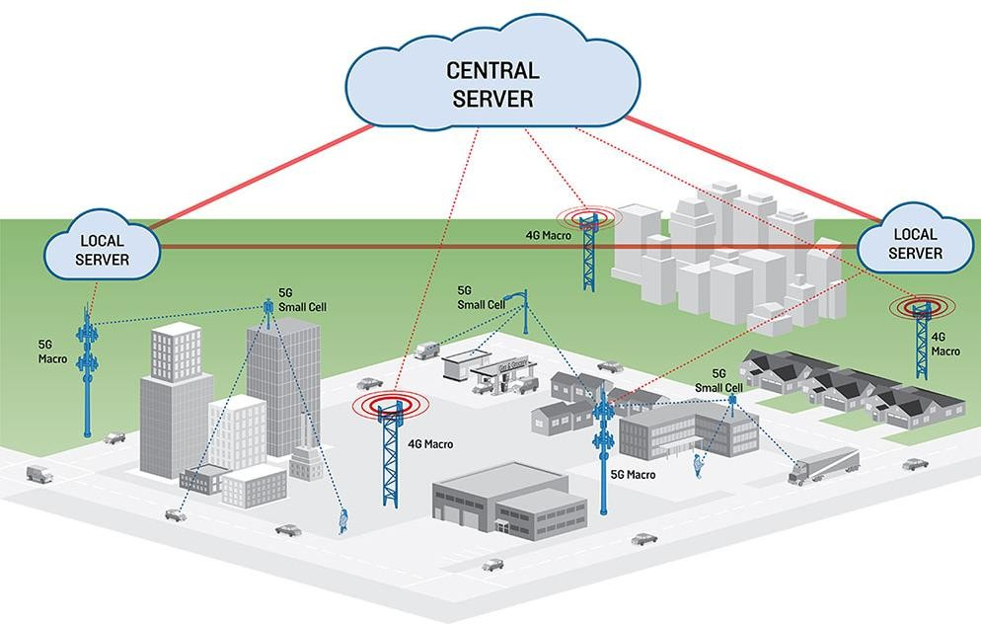
supported by massive MIMO technology, in which a geographically scattered array of antennas is deployed, which comprises of many small units or is made up of tens or hundreds of antenna units
- STATISTICS AND NEWS
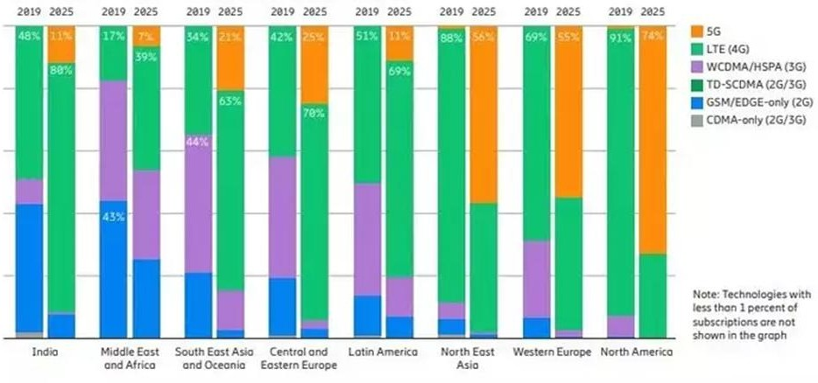
Figure 4: Mobile subscriptions by region and technology (percent)

More than half of North East Asia, Western Europe and North America will be on 5G by 2025, according to Ericsson’s latest Mobility Report.
But in India, 5G will only account for 11% of total mobile subscriptions. The Indian region — which also includes Nepal and Bhutan — will be the slowest to adopt 5G, second only to the Middle East and Africa, where 5G penetration forecasted to be at 7%.
NEWS:
- India is likely to launch 5G services by the end of this month (May 2022).
- The DoT also announced that 5G services will be offered in 13 Indian cities at first.
The DoT has earlier stated that the 5G project would be conducted by December 31, 2021. The government plans to auction off 5G spectrum, including airwaves, in early June, according to Telecom
Minister Ashwini Vaishnav. Following the auction, the government may begin providing 5G services to residents in the 13 cities in August and September of this year.
Ahmedabad, Bengaluru, Chandigarh, Gandhinagar, Gurugram, Hyderabad, Jamnagar, Kolkata, Chennai, Lucknow, Pune, Delhi, and Mumbai are among the 13 cities that will receive 5G services, according to the telecommunications department.
- Bharti Mittal, Airtel's CEO, said that the company's 5G network is ready for deployment and will begin shortly once the auction is finalized.

Airtel Showcases India’s First 5G Hologram Interaction, Recreates Kapil Dev’s 175 run from 1983 World Cup (March 25, 2022)
For an immersive video entertainment experience, Bharti Airtel demonstrated 5G speed and low latency capabilities. In 4K format, the brand recreated Kapil Dev's memorable 175 runs from the 1983 World Cup. According to the business, it achieved speeds of over 1Gbps with a latency of less than 20ms. On 5G cellphones, there were more than 50 concurrent users watching the 4K video. Multiple camera angles, 360-degree in-stadia view, shot analysis, and analytics were all available in real time during the contest.
With Kapil Dev, the business also demonstrated India's first 5G-powered hologram interaction. Kapil Dev's virtual avatar came on stage to engage with fans in real-time utilizing airtel 5G networks, according to the business. The demonstration was carried out at Ericsson's Network Experience Center in Manesar (Gurugram) with Ericsson 5G Radios in NSA and SA modes on 3500 MHz band test spectrum allotted by the Department of Telecom, Government of India.
5G is not launch yet in India so these stats show current Testing network area i.e. Hyderabad and Bengaluru.

- CONCLUSION
Cell phone (mobile) users nowadays are well-versed in the technology. All forms of revolutionary structures are included in 5G technologies, making 5G mobile technology the most powerful and in high demand in the near future.
Higher data rates and the all-IP principle are driving the evolution of mobile and wireless networks. Each year, mobile terminals get increased processing power, on-board memory, and battery life for the same applications. 5G uses cutting-edge technologies including cognitive radio, SDR, nanotechnology, cloud computing, and is built on an All IP Platform. The original Internet idea of keeping the network as basic as possible while offering more functionality to the end nodes is projected to become true in the next generation of mobile devices.

- REFERENCES

[1] https://www.indiatoday.in/technology/features/story/when-will-5g-services-launch-in-india-
1944931-2022-05-03
[2] Dhiraj Gandla Research paper on “study of recent developments in 5g wireless technology”
[3] Akhil Gupta “ A survey of 5G network”
[4] Airtel 5g roundup Overview details available : https://www.mysmartprice.com/gear/airtel-5g- roundup/
[5] Detail information of evolution of network https://www.rfpage.com/evolution-of-wireless- technologies-1g-to-5g-in-mobile-communication/
[6] https://www.tutorialspoint.com/5g/5g_architecture.htm

