“COVERING LETTER”
TITLE: “INCREASING RATE OF ADHD (ATTENTION DEFICIT/HYPERACTIVITY DISEASE) AND PTSD (POSTTRAUMATIC STRESS DISEASE) PATIENTS; HOW THEIR SYMPTOMS ARE OVERLOOKED”
JOURNAL NAME: International Scientific Journal of Engineering and Management

Respected Editor of ISJEM, Date: June 18th, 2023
I would like to submit the manuscript entitled “INCREASING RATE OF ADHD (ATTENTION DEFICIT/HYPERACTIVITY DISEASE) AND PTSD (POSTTRAUMATIC STRESS DISEASE) PATIENTS; HOW THEIR SYMPTOMS ARE OVERLOOKED” by Zainab Mehmood and Aliya Jabbar to be considered for publication as “Review Article” in the International Scientific Journal of Engineering and Management.
This Review Article is based on the rapidly increasing rate of ADHD and PTSD patients and how their symptoms are being misinterpreted. According to findings ADHD and PTSD are interrelated disorders that influence one another and patients with either of the disorders are vulnerable to the other disorder. Past traumas and present lifestyle has its affect on the disorders and with the diagnosed patient misjudging/ignoring the symptoms, the disorders seem to sink permanently into their behaviours, affecting lifestyles and relations both families and social, giving rise to other similar related disorders. We believe these findings will be of interest to the readers of your journal.
We declare this manuscript is original, has not been published before and is not currently being considered for publication elsewhere.
We know of no conflicts of interest associated with this publication, and there has been no significant financial support for this work that could have influenced its outcome. As corresponding Author, I confirm that the manuscript has been read and approve for submission by all the named authors.
We hope you find our manuscript suitable for publication and look forward to hearing from you in due course. Thank you.

Sincerely,
Pervez Anwar,
Department of Biochemistry and Molecular Biology- University of Sialkot,
01-km, Main Daska Road, Sialkot-Pakistan.

“INCREASING RATE OF ADHD (ATTENTION DEFICIT/HYPERACTIVITY DISEASE) AND PTSD (POSTTRAUMATIC STRESS DISEASE) PATIENTS; HOW THEIR SYMPTOMS ARE OVERLOOKED”
SUPERVISOR: SIR PERVEZ ANWAR
AUTHORS: ZAINAB MEHMOOD, ALIA JABBAR -UNIVERSITY OF SIALKOT
FACULTY OF SCIENCES, DEPARTMENT OF BIOTECHNOLOGY (BS HONS), UNIVERSITY OF SIALKOT, MAIN ROAD DASK, SIALKOT, PAKISTAN
CORRESPONDENCE: zeynepmehmd.09@gmail.com
KEYWORDS:
ADHD- ATTENTION DEFICIT/HYPERACTIVITY DISORDER
PTSD- POST-TRAUMATIC STRESS DISORDER

“ABSTRACT”
ADHD (Attention Deficit/Hyperactivity Disorder) and PTSD (Post-traumatic Stress Disorder) is mainly found to be diagnosed in adults after ignoring or misinterpreting its early symptoms in childhood leading to more prominent and permanent effects. Both these disorders seem to be quite similar yet if studied properly it can be detected and treated at an early stage. ADHD and PTSD have effects on either of the disorders, provoking it causing serious damages to a person not only mentally or emotionally but socially as well. Any of the two disorders are found to be diagnosed after a person has experienced a trauma in childhood or undergone a difficult phase in their lives that has left a negative imprint on their minds. This review will emphasize on ADHD and PTSD patients and methods used to detect and find the correlation between the two disorders and how they can be treated.
“INTRODUCTION”:
ADHD (Attention Deficit/Hyperactivity Disorder) and PTSD (Post-traumatic Stress Disorder) are both similar yet differently diagnosed disorders. They are both psychological disorder that are mostly diagnosed in teens and adults after having gone through a trauma in childhood or a bad stage in life. Teenagers and adults often overlook the symptoms of ADHD and PTSD, being unable to detect its early signs, especially the interrelation of these two disorders, and hence, leading these disorders to take a permanent impact in their lives. These disorders become the initial and final reason of many issues in the lives of a patient, increasing many psychological and social risk factors and even causing damage to not only themselves but to the people around them including family and loved ones. Its impact causes an effect on another individual leading the other person to undergo a negative experience leading them to a psychological disorder. These disorders are not only caused by diagnosing but can also be a hereditary neurodevelopment disorder that may run in the family. Either one of the disorders can cause the birth of the other disorder leading the situation to a more serious level if not diagnosed properly. (Waite, R., & Ramsay, J. R. (2010). Adults with ADHD: Who Are We Missing?)
“ADHD (Attention Deficit/Hyperactivity Disorder)”:
ADHD is one of the most frequently detected and recorded psychological disorder throughout the world. It is a pattern of Hyperactivity impulsivity and/or inattention that disturbs the functioning development of the brain. It causes a psychological impact on the behaviour of one’s self with other, including family members. It interferes with daily activities, even to the simplest ones, led by the diagnosed person leading to further psychological issues. Due to the presence of this disorder, a person is unable to focus on the simplest tasks causing problems such as social activities. The person diagnosed seems to have an element of impatience that he/she cannot wait and tends to interrupt one another. ADHD is related to anxiety, but a more serious psychological level that requires immediate attention and treatment.
Earlier, studies had shown ADHD to be present in children or teenagers but recent studies have shown a concerning and rapidly emerging report of increased ADHD patients including and mainly in adults. Studies have also shown some patients to have ADHD to be interlinked to PTSD directly or indirectly, leading a serious concern worldwide. Due to the symptoms of ADHD and PTSD being somewhat similar and continuous disregard of parents, elders or the diagnosed person themselves, the disorder seems to take a solid ground in peoples lives, bringing drastic effects to ones normal life. As ADHD is starting to become more prominent and awareness is rising regarded to it, studies have shown that people who are undiagnosed, with untreated ADHD, they are of 11% that were then diagnosed and treated. Due to the negligence, no awareness regarding the disorder and overlooking and/or ignoring initial stage symptoms, there are one quarter of the children that have at least a single parent with undiagnosed ADHD and more than half of the parents will have at least one child that will be diagnosed with ADHD leading to serious concern. This will to the destruction of peace in families, leading to dysfunctional families. (Waite, R., & Ramsay, J. R. (2010). Adults with ADHD: Who Are We Missing?)
People that often lead lives with undiagnosed and untreated ADHD tend to hurt themselves and bring damage to their families as well as their relationships with others. This is due to the behaviour changes replacing a patients and peaceful behaviour with an irritable, impatient, being hot tempered and in some cases abusive behaviour leading their relations with everyone to collapse and pushing them oneself into isolation and away from the world. This urge to neglect life and responsibilities brings the disordered to a more serious and concerning stage as the patient may fall into a deep, irreversible state of depression and anxiety.
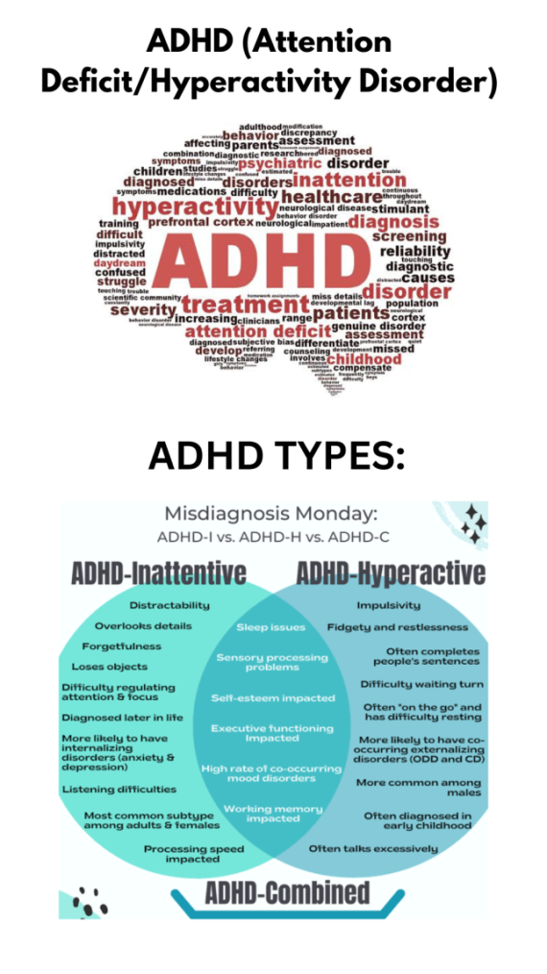
DIAGRAM: “ADHD and its Types”
This puts an the patient, an adult or a child to a higher risk of PTSD as the patients him/her-self is not the only one suffering but their families too.
“PTSD (Posttraumatic Stress Disorder)”:
PTSD is any other time period for a psychological Trauma as the sufferers diagnosed with this ailment has been thru a trauma that has deeply imprinted in their minds and psychologically disturbed them growing worry and nerve wrecking flashbacks of the experience. PTSD is caused by a bodily or emotional trauma (e.g. Abusive relationship, sexual abuse, near demise stories, bodily injury, injuries/crashes, bullying/assaulted, witnessed network or home violence, excessive negligence and so on). Someone with PTSD starts off evolved to sense and experience organic in addition to mental shocks in Hyperactivity forms (e.g. starting to come to be impulsive, disorganized, without difficulty angry, agitated, and emotional, behaviour troubles and so forth).
Children with diagnosed PTSD are at a better hazard factor and begin to go through many changes biologically, mentally and emotionally leading those consequences to persist and grow to be everlasting in maturity. The signs start to turn out to be outstanding and cruel in older age. This ends in an infant with social anxiety and the urge to push themselves in isolation from others even their family members. They start to lack the passion and spark in social and academic activities leaving them at the back of as compared to different children. Children with trauma locate it very tough to overcome their fears with out proper scientific interest and remedy.
Adults in this situation locate it hard to address their trauma which leads them to consuming and other unlawful use and abuse of drug to drink down their sorrows. This even and regularly leads to self-damage and suicidal mind and actions to achieve this. Doing these units them a ways back then what the society desires them to be and this will become an additional thing that boom and worsens their conditions. PTSD in all results in sever and probably persistent behaviour issues, cognitive including dysfunctional, social, scientific and mental as well as instructional and felony issues.(Ford, J. D., & Connor, D. F. (2009). ADHD and posttraumatic stress disorder.)

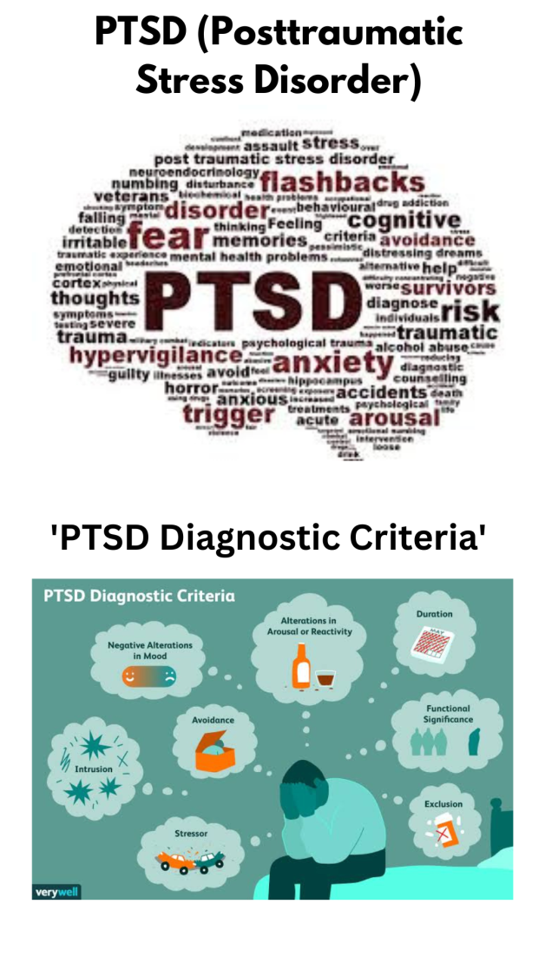
DIAGRAM: “PTSD and its Diagnostic Criteria”
“DIAGNOSES, PHENOMENON AND OVERLOOKED SYMPTOMS (METHODOLOGY)”:
ADHD and PTSD have many differentiating yet similar signs and symptoms that may be omitted or misinterpreted. Both of the symptoms can have an effect on the alternative ailment and its impacts. Many studies have interlinked ADHD and PTSD with one another particularly due to the symptomatology overlapping, Hypervigilence and Hyperarousal.
PTSD has signs and symptoms like 1) intrusive experiences (i.E. Any person of the 5 symptoms which encompass unwanted reminiscences, nightmares, flashbacks and distressing disturbing activities reminders or reoccurrences) 2) trying to avoid remembering and talking of the traumatic events three)hyperarousal ( having problem drowsing, problem focusing or concentrating, having anger problems, feeling angry, hypervigilence). (Ford, J. D., & Connor, D. F. (2009). ADHD and posttraumatic strain disorder.)
ADHD’s symptoms involve impulsive ailment, attention disorder, dyscontrol and also hyperactive symptoms which might be fairly just like PTSD patients’ signs. (Ford, J. D., & Connor, D. F. (2009). ADHD and posttraumatic stress disease.)
The studies were considered via Biaggio, Weisnstein and Stafflebach (2000) who regarded the high degree of symptoms between the 2 disorders that seems to overlap and display co morbidity. (Adler, L. A., Kunz, M., Chua, H. C., Rotrosen, J., & Resnick, S. G. (2004). Interest-Deficit/Hyperactivity disorder in person sufferers with Posttraumatic strain disease (PTSD): Is ADHD a vulnerability issue?)
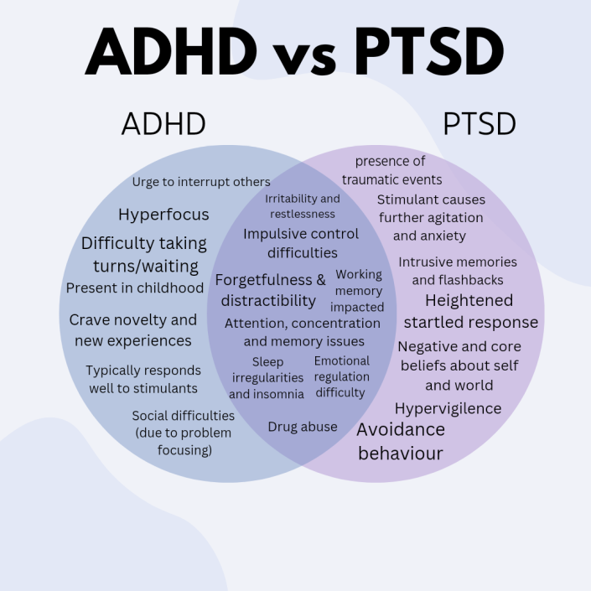
DIAGRAM: ADHD and PTSD Symptoms and Similarities
Evidence from researches display that PTSD and ADHD are comparable but have wonderful recognizing features and signs as an example, within the examine of ladies recognized with ADHD, it became determined that most effective 2% of the sufferers had PTSD, which changed into although tons better occurrence of PTSD in managed pattern. It was also observed that patients with ADHD had been much more likely to be exposed to PTSD that those which are non-ADHD recognized patients.
Youngsters identified with peculiar (oppositional defiant disease) had greater probabilities of PTSD than those sufferers with ADHD diagnosing. The PTSD symptoms that overlapped with ADHD signs and symptoms have been eliminated (i.e. Difficulty in attention, irritability, anger), the last signs of PTSD had been set to be in take a look at with odd (with presence or without the presence of ADHD). (Ford, J. D., & Connor, D. F. (2009). ADHD and posttraumatic strain disease.)
TABLE 1:
Number of Study (maltreated children) | 117
PTSD | 41 (35%)
ADHD | 15 (37%) of the 41
ADHD | 13 (17%) of the remaining 76 without PTSD
This table shows the study of 1996 by Fenton, Kinscherff and Augustyn.{Adler, L. A., Kunz, M., Chua, H. C., Rotrosen, J., & Resnick, S. G. (2004). (Attention-Deficit/Hyperactivity Disorder in adult patients with Posttraumatic stress disorder (PTSD): Is ADHD a vulnerability factor?)}

TABLE 2:
People diagnosed with ADHD have been diagnosed with other disorders as well in the table below. (Adler, L. A., Kunz, M., Chua, H. C., Rotrosen, J., & Resnick, S. G. (2004). Attention-Deficit/Hyperactivity Disorder in adult patients with Posttraumatic stress disorder (PTSD): Is ADHD a vulnerability factor?)
Anxiety Disorder | 25% to 50%
Mood Disorder | 19% to 37%
Alcohol Abuse | 32% to 53%
The study is from (Biederman et al., 1993; Murphy & Barkley, 1996; Roy-Byrne et al., 1997; Shekim, Asarnow, Hess, Zaucha, &Wheeler, 1990).

- Methods into discovering, 25 veterans had been undertaken in study and evaluation for PTSD and 22 veterans had been undertaken for the study of Panic disease. The player veterans were selected randomly (all male) and were evaluated for the diagnoses of PTSD, ADH and Panic disorder within the following approaches:
1) PTSD: CAPS (The scientific Administered PTSD Scale) a dimension procedure and tool for the determination of PTSD, Blake et al. (1990) become the developer.
2) ADHD: okay-SADS used for symptoms passed off in early life and DSM-IV used for symptoms happening presently by using Chambers et al. (1985).
3) Panic disorder: The SCID-I (Structural scientific Interviews for DSM-III-R by using Spitzer, Gibbon, Williams and primary (1990)
For accumulating as an awful lot data possible, family members have been allowed to be interviewed regarding the sufferers and faculty/college or any academic and social facts were taken and evaluated if any childhood signs were ever to arise. The information collected was further evaluated and studied with the aid of using the chi-square and college students T-take a look at in which the subsequent techniques were necessary to be positioned. These trials have been approved and conducted Subcommittee for Human subjects’ procedures and guidelines and were supported by way of the VANYHHS.
“RESULTS”:
AGE: | Panic Disorder: (46.4 + 3.68 years)  PTSD: (59.7 + 12.62 years, t [1] = 4.8; p
PTSD Group:  ADHD Group: | 25 (PTSD criteria met)  9 (36%) childhood ADHD  7 (28%) current ADHD
Panic Disorder Group: | 22 patients Panic Disorder criteria met  Two (9%) Childhood ADHD  (Chi-square = 4.727 p = 0.0297)
The following Graphs will show the results of the ratio of ADHD (childhood) and (current) and Panic Disorder Patients from the testing methods respectively.
‘Results on ADHD (childhood) in patients divided in PTSD groups and Panic Disorder groups’

*Chi Square= 4.272, p=0.0297
Total PTSD Group individuals= 25
Total Panic Disorder Group individuals= 22
TABLE 4: ‘Results of ADHD (current) in patients divided in PTSD Groups and Panic Disorder Groups’

*Chi-square = 4.558; p =0.328.
Total PTSD Group individuals= 25
Total Panic Disorder Group individuals= 22
- METHOD CONTRIBUTERS; the 30 families from Iraq who made up the traumatised institution—in which either the father, mom, or each had experienced torture before immigrating to Sweden—had been chosen through Swedish purple cross Centre for therapy. Households had to meet the following necessities in an effort to be protected: (a) Their residency had to be Stockholm, Sweden, for a certain time period; (b) they had asylum popularity; (c) individually or pair (parents) had suffered torturing. Between the a long time of 7 and sixteen have been the forty youngsters in this group (20 boys and 20 ladies; suggest age 12.1, SD 2.1).
The ordinary Swedish academic gadget became attended through all 40. However, they had heard approximately their parents' reviews with torture; they had not in my opinion gone through torture. Research on immigrants arriving in Northern Europe has revealed that cultural variables could account for psychopathology among immigrants that had previously lived or have migrated from the regions of Mediterranean or from neighbourhood areas. A good way to compare the consequences, a collection of refugee households from the Arab-talking population in the wider Stockholm area had been sought out. These families shared a similar cultural heritage but had in no way been tortured prior to arriving in Sweden.
Those families had been from Egypt, Syria, and Morocco, and they all voluntarily took element in the examiner. Following emotionally taxing divorces, 4 families consisted only of the 26 dads and mom who made up the contrast organization. The evaluation institution consisted of 40 youngsters, with 20 boys and 20 girls ranging from 7 to 16, having an age median of 12.5, SD 2.2. These youngsters attended the same old instructional machine as well. In summary, all units of children had to meet the equal inclusion requirements, which blanketed the faculty age (seven to sixteen of age antique), residing in the area of Stockholm, Sweden, enrolling within the Swedish faculty device.
Evaluating parents academic backgrounds in the two corporations. In assessment to 19 of the 26 dads and mom inside the assessment institution, 14 of the participation group's 30 parents had completed senior high college, college, or university. Strategies for diagnosis the mother and father and youngsters of each business were questioned of their houses for a median of 20 hours in step with family by a scientific toddler psychologist with schooling in Egypt and Sweden who's also fluent in Arabic and Swedish. The kid psychiatrist additionally participated inside the look at. We conducted in-intensity interviews with each unit of parents in their mother tongues.
Consequences from the Harvard/Uppsala Trauma Questionnaire (H/UTQ), the Karolinska Scales of personality (KSP), and a semi-dependent medical interview conducted in accordance with the DSM-IV-TR, already been provided. The DICA-R-C (in variations, one for six to twelve of ages, the further for thirteen to seventeen years of ages) and WISC-III had been used to assess the kids. The subsequent technique changed into followed by their instructors even as they winded up the Yale kids stock (YCI) and the Strengths and problems Questionnaire (SDQ) to evaluate, youngsters' behaviour. The Swedish model of the DICA-R-C from the child and Adolescent Psychiatric department at Uppsala College was used to diagnose ADHD primarily based at the DSM-IV-TR (Ahmad, 1999).
The DICA-R-C, which changed into utilised in a have a look at on Kurdish youngsters affected by the Iraqi civil warfare against the Kurds (Ahmad, 1999), is primarily based at the Diagnostic Interview for kids and Adolescents Revised (DICA-R) (Reich, Leacock, & Shanfeld, 1995).
Youngsters with ADHD signs and symptoms are those youngsters who failed to fulfil the impairment criterion for ADHD, nonetheless confirmed symptoms of it. The DICA-R-C in Swedish (Ahmad, 1999) became employed to make the diagnosis of PTSD. The A-cluster criterion become explored protected being taught approximately tragic and horrible occasions that the children had not for my part experienced. In a few cultures, such occurrences are equated with dying.
Kids who established many PTSD signs yet failed to meet the criteria for the PTSD analysis have been classified as PTSS kids. The Yale kid's inventory (YCI) teacher version changed into applied. In Scandinavia, the YCI degrees have every now and then been carried out. In accordance to analyze, carried out in Norway, "The Yale kid's inventory has the ability to end up a treasured diagnostic tool for behavioural issues at college-age" (Olafsen&Sommerfelt, 1999).
The Strengths and demanding situations Questionnaire (instructor model) was employed (Goodman, 2001; Malmberg, Rydell, &Smedje, the 12 months 2003). There are Swedish translations of the DAWBAsystem and SDQ (Smedje& Larsson, n.D.). Even earlier than and independently from administering the DICA, teachers rated the SDQ questions and the YCI.
Those assessments were administered inside the midst of the academic 12 months to allow teachers to get acquainted with their students better. Both Arabic and Swedish were used to manage the Swedish model of the Wechsler expertise Scales particularly for kids (WISC-III; Wechsler, 1991). The differences/similarities in "intellectual/cognitive age" of the youngsters in the organizations has been first defined the use of the preliminary rankings of the WISC Scales. 2nd, studies relating to the children's diagnoses had been conducted using IQ, which blanketed the WISC-III additives Verbal Comprehension, Perceptual Corporation, Independence from Distractibility, and Processor speed.
CLINICAL TREATMENTS AND REHABILATION:
Remedy tactics in consideration with ADHD and PTSD are commonly very effective. The two disorders are dealt by the intake of medicines that regulate dopamine and norepinephrine neurotransmission and behavioural intercession outlined to allow mother, father, teachers including adults to establish and sustain a structure for social interplay, also gaining knowledge that enhances the progressing abilities for deliberately concentrating and maintaining attention and for allowing cognitive, physiologic and behavioural impulsivity.
Propositions have been made confirmed therapeutically for ADHD and PTSD treatments. Several Strategies to intellectual-behavioural remedy for paediatric and adult disorders have proven to enable the efficacy of the emotional trauma survivors (caregivers, in the case of kids) to lessen or attune anxiety as well as hypervigilence by using and interspersing the harsh cycle of the two disorders-mediated intrusive re-experiencing and avoidance. Different psychotherapies train patient’s law of emotions competencies made to cope with further complicated styles of worrying pressure signs and symptoms (e.g. dissociations, severe emotional instability and somatisation).
Programmes involving rehabilitations for human beings on long-term unwell depart may be different in certain aspects. Treatment having a focal point on PTSD can be determined in some instances, but evaluation and treatment centred on ADHD are probably rare. Thinking about that fifty six In keeping with cent of the humans on lengthy-time period unwell leave due harsh stress relating health issues are most vulnerable to diagnosed with PTSD and/or ADHD, assessment and aids/cures for these situations ought to be made available.
Many on Lengthy-term unwell depart continue residing with PTSD and feature terrific problems returning to paintings. They are also able to obtain trendy PTSD treatment, along with CBT with exposure (Von Knorring, Thelander, & Pettersson, 2005) or Eye movement Desensitization and Reprocessing (EMDR) in Aggregate with behaviour therapy (Parnell, 1997; Shapiro & Silk Forrest, 1997).
For sufferers identified with two most known disorders, psychotherapy as well as pharmacotherapy for the mentioned disorders is quite perceptible. The most commonly known and used therapies had been mounted for adult ADHD and PTSD and for Youth ADHD; however most effective psychotherapy (and no longer pharmacotherapy) has a solid ground base formative years PTSD. ADHD healing procedures manufactured to amplify behavioural Inhibition and cognitive attention focusing might also not directly assist the affected person increase abilities for coping with tension.
In sufferers with each issue, ADHD pharmacotherapy might be used to additionally help to regulate arousal and attention sufficiently for the man or woman in an effort to have interaction in and be benefited from the anxiety management and stressful reminiscence–processing additives of PTSD psychotherapy. For example, α-receptor agonists consisting of clonidine or guanfacine can also Lessen hyperactivity/impulsivity and tension-driven over arousal in comorbid patients.
In ADHD patients with PTSD who are already intaking stimulant medications prescribed by the doctors, they have to cautiously determine for multiplied anxiety, given the recognized side impact profile of stimulants. Alternatively, Superior mood and anxiety law attributable to psychotherapy or pharmacotherapy for PTSD may also allow the Patient with ADHD and PTSD to hinder hyperactivity and maintain focuse/concentration.
It is almost pretty uncommon that humans on long-term health issues related break with exhaustion caused by a rollercoaster of emotions exhaustion syndrome/burnout are identified as being diagnosed with ADHD, at the least on the subject of individuals who are handled Out of doors of neuropsychiatric gadgets. Considering that human beings With ADHD lack an inner brake mechanism (Barkley, 1997, 1998), they're unable to preserve stability in disturbing settings. Good enough Remedy with crucial frightened gadget stimulation medicinal drug, for instance, can, increase the Capability to work underneath stress to a positive diploma; however what they actually need is a job with a low level of strain, something hard to discover in nowadays international.
“INTERNATIONAL PERSPECTIVE”
A worldwide perspective of psychic trauma is crucial to restoration, Mental fitness delivery services, clinical practices, treatments, And other expert offerings. (e.g. Kirmayer, Lemelson, & Barad, 2007; Marsella & Wilson, 2008). The important question that remains is: “What sorts of care and treatment work fine for a given patient, with a given therapist/professional, the use of Particular therapy methods and strategies?” Inside this context, a final results equation for trauma And PTSD that looks at outcome as function of a variety of essential therapy/restoration stumble upon variables can be created (Marsella, 2005)
In other words, we may want to take care of the various complex Variables which could have an effect on the outcome of remedy for trauma And PTSD; we cannot assume that there's uniformity in the Disorder, the purchaser, therapist, or the therapy strategies. The Reflexive reaction amongst therapists to use their favoured Therapies (e.g., cognitive-behavioural remedy) without consideration of the various other variables that decide outcome Can also well account for continuing troubles we face in recuperation Trauma and PTSD (e.G., Marsella, 2005).
A complex recovery Calculus has to be considered, and that is especially crucial across cultural limitations whilst a score of intervening elements can affect final results. And herein lies the rub (with deference to Shakespeare): Schooling packages become oriented around specific therapy Systems. Frequently, there may be a preferred gadget this is taught as “gospel.” this example ignores the essential troubles defined in the calculus method presented.
Moreover, it assumes that Each pupil isn't always only able to rendering the “gospel” remedy, but that it is appropriate for their character, temperament, values, and persona style (e.g., may want to Albert Ellis Ever be Carl Rogers?).
There is no predetermined order or components for the usage of ADHD and PTSD remedies sequentially or simultaneously. Treatment usually is first focused at the maximum impairing Disorder as assessed in the initial assessment. Psycho education approximately the difference between computerized attentional and arousal dysregulation (in ADHD) versus stress/tension-associated hypervigilance, hyperarousal, and avoidance or emotional numbing (in PTSD) is critical to assist Sufferers and their households recognize the want for biologic and psychological strategies to one at a time deal with associated.
However, distinct styles of cognitive, physiologic, and behavioural Dysregulation discovered in ADHD and PTSD. This is proper no longer Handiest while ADHD and PTSD were formally recognized The usage of standardized interview and observational evaluation protocols however perhaps even more importantly while a Affected person consists of both prognosis by means of history and an evidence based diagnostic evaluation for both disorders has now not been Undertaken.
ADHD and PTSD are extensively recognized but regularly misunderstood by using laypersons and inaccurately defined and classified by mental fitness and health care experts. Psycho education about the specific signs and impairments that represent and distinguish ADHD and PTSD can prevent misdiagnosis and the under treatment and overtreatment of each ailment.
“CONCLUSION”:
ADHD and PTSD may additionally co-arise in children and adults however seem to have impartial phenomenological, diagnostic, Etiologic, and neurobiological traits. Assessment of ADHD needs to automatically encompass screening for psychological trauma records and PTSD.
Inside the comorbid affected person, Remedy of ADHD might also enhance the engagement in and Final results of treatment for PTSD, and PTSD treatment may additionally augment ADHD treatment through decreasing anxiety and Stress-reactivity that may exacerbate ADHD by contributing not directly to inattention or impulsivity. Individualized Remedy making plans is vital for each case of comorbid ADHD and PTSD till mixed or sequential interventions are validated.
“REFERENCES”:
- Waite, R., & Ramsay, J. R. (2010). Adults with ADHD: Who Are We Missing?
- Ford, J. D., & Connor, D. F. (2009). ADHD and posttraumatic stress disorder.
- Adler, L. A., Kunz, M., Chua, H. C., Rotrosen, J., & Resnick, S. G. (2004). Interest-Deficit/Hyperactivity disorder in person sufferers with Posttraumatic strain disease (PTSD): Is ADHD a vulnerability issue?
- Adler, L. A., Kunz, M., Chua, H. C., Rotrosen, J., & Resnick, S. G. (2004). (Attention-Deficit/Hyperactivity Disorder in adult patients with Posttraumatic stress disorder (PTSD): Is ADHD a vulnerability factor?
- Biederman et al., 1993; Murphy & Barkley, 1996; Roy-Byrne et al., 1997; Shekim, Asarnow, Hess, Zaucha, &Wheeler, 1990
- Reich, Leacock, & Shanfeld, 1995
- Goodman, 2001; Malmberg, Rydell, &Smedje, the 12 months 2003
- Marsella, 2005
- American Psychiatric Association: Diagnostic and Statistical Manual of Mental Disorders, edn 4 (text revision). Washington, DC: American Psychiatric Association; 2000.
- Costello EJ, Erklani A, Fairbank J, Angold A: The prevalence of potentially traumatic events in childhood and adolescence. J Trauma Stress 2002, 15:99–112.
- Kessler RC, Chiu WT, Demler O, et al.: Prevalence, severity, and comorbidity of 12-month DSM-IV disorders in the National Comorbidity Survey Replication. Arch Gen Psychiatry 2005, 62:617–627.
- De Bellis MD, Keshavan MS, Shiffl ett H, et al.: Brain structures in pediatric maltreatment-related posttraumatic stress disorder: a sociodemographically matched study. Biol Psychiatry 2002, 52:1066–1078.
- Felitti VJ, Anda RF, Nordenberg D, et al.: Relationship of childhood abuse and household dysfunction to many of the leading causes of death in adults. The Adverse Childhood Experiences (ACE) Study. Am J Prev Med 1998, 14:245–258.
- Weinstein D, Staffelbach D, Biaggio M: Attention-defi cit hyperactivity disorder and posttraumatic stress disorder: differential diagnosis in childhood sexual abuse. Clin Psychol Rev 2000, 20:359–378.
- Ford JD, Racusin R, Daviss WB, et al.: Trauma exposure among children with oppositional defi ant disorder and attention defi cit-hyperactivity disorder. J Consult Clin Psychol 1999, 67:786–789.
- Biederman J, Faraone SV: Attention-defi cit hyperactivity disorder. Lancet 2005, 366:237–248.
- Wozniak J, Crawford MH, Biederman J, et al.: Antecedents and complications of trauma in boys with ADHD: fi ndings from a longitudinal study. J Am Acad Child Adolesc Psychiatry 1999, 38:48–55.
- Ford JD, Racusin R, Ellis CG, et al.: Child maltreatment, other trauma exposure, and posttraumatic symptomatology among children with oppositional defi ant and attention defi cit hyperactivity disorders. Child Maltreat 2000, 5:205–217
- Barkley R, Edwards G: Diagnostic interview, behavior rating scales, and the medical interviews. In Attention Defi cit Hyperactivity Disorder: A Handbook for Diagnosis and Treatment. Edited by Barkley RA. New York: Guilford Press; 2006:337–368.
- Faraone SV, Biederman J, Mick E: The age-dependent decline of attention defi cit hyperactivity disorder: a meta-analysis of follow-up studies. Psychol Med 2006, 36:159–165.
- Kessler RC, Adler L, Barkley R, et al.: The prevalence and correlates of adult ADHD in the United States: results from the National Comorbidity Survey Replication. Am J Psychiatry 2006, 163:716–723.
- Copeland WE, Keeler G, Angold A, Costello EJ: Traumatic events and posttraumatic stress in childhood. Arch Gen Psychiatry 2007, 64:577–584.
- Cuffe SP, Addy CL, Garrison CZ, et al.: Prevalence of PTSD in a community sample of older adolescents. J Am Acad Child Adolesc Psychiatry 1998, 37:147–154.
- Koenen KC, Moffi tt TE, Poulton R, et al.: Early childhood factors associated with the development of post-traumatic stress disorder: results from a longitudinal birth cohort. Psychol Med 2007, 37:181–192.
- Glod CA, Teicher MH: Relationship between early abuse, posttraumatic stress disorder, and activity levels in prepubertal children. J Am Acad Child Adolesc Psychiatry 1996, 35:1384–1393.
- McLeer SV, Callaghan M, Henry D, Wallen J: Psychiatric disorders in sexually abused children. J Am Acad Child Adolesc Psychiatry 1994, 33:313–319.
- Merry SN, Andrews LK: Psychiatric status of sexually abused children 12 months after disclosure of abuse. J Am Acad Child Adolesc Psychiatry 1994, 33:939–944.
- Adler LA, Kunz M, Chua HC, et al.: Attention-defi cit/ hyperactivity disorder in adult patients with posttraumatic stress disorder (PTSD): is ADHD a vulnerability factor? J Atten Disord 2004, 8:11–16.
- Koenen KC: Genetics of posttraumatic stress disorder: review and recommendations for future studies. J Trauma Stress 2007, 20:737–750.
- Schnurr PP, Lunney CA, Sengupta A: Risk factors for the development versus maintenance of posttraumatic stress disorder. J Trauma Stress 2004, 17:85–95.
- Kaplow JB, Widom CS: Age of onset of child maltreatment predicts long-term mental health outcomes. J Abnorm Psychol 2007, 116:176–187.
- Rutter M, Pickles A, Murray R, Eaves L: Testing hypotheses on specifi c environmental causal effects on behavior. Psychol Bull 2001, 127:291–324.
- Norris FH, Slone LB: The epidemiology of trauma and PTSD. In Handbook of PTSD: Science and Practice. Edited by Friedman MJ, Keane TM, Resick PA. New York: Guilford Press; 2007:78–98.
- Philipsen A, Limberger MF, Lieb K, et al.: Attention-defi cit hyperactivity disorder as a potentially aggravating factor in borderline personality disorder. Br J Psychiatry 2008, 192:118–123.
- Rucklidge JJ, Brown DL, Crawford S, Kaplan BJ: Retrospective reports of childhood trauma in adults with ADHD. J Atten Disord 2006, 9:631–641.
- Teicher MH, Samson JA, Polcari A, McGreenery CE: Sticks, stones, and hurtful words: relative effects of various forms of childhood maltreatment. Am J Psychiatry 2006, 163:993–1000.
- Watson S, Chilton R, Fairchild H, Whewell P: Association between childhood trauma and dissociation among patients with borderline personality disorder. Aust N Z J Psychiatry 2006, 40:478–481.
- Makris N, Buka SL, Biederman J, et al.: Attention and executive systems abnormalities in adults with childhood ADHD: a DT-MRI study of connections. Cereb Cortex 2008, 18:1210–1220.
- Neumeister A, Henry S, Krystal JH: Neurocircuitry and neuroplasticity in PTSD. In Handbook of PTSD: Science and Practice. Edited by Friedman MJ, Keane TM, Resick PA. New York: Guilford Press; 2007:151–165.
- Williams LM, Kemp AH, Felmingham K, et al.: Trauma modulates amygdala and medial prefrontal responses to consciously attended fear. Neuroimage 2006, 29:347–357.
- Southwick SM, Davis LL, Aikins DE, et al.: Neurobiological alterations associated with PTSD. In Handbook of PTSD: Science and Practice. Edited by Friedman MJ, Keane TM, Resick PA. New York: Guilford Press; 2007:166–189.
- Pollak SD, Vardi S, Putzer Bechner AM, Curtin JJ: Physically abused children’s regulation of attention in response to hostility. Child Dev 2005, 76:968–977.
- Barkley RA: Behavioral inhibition, sustained attention, and executive functions: constructing a unifying theory of ADHD. Psychol Bull 1997, 121:65–94.
- Mongillo E, Briggs-Gowan M, Ford JD, Carter A: Impact of traumatic life events in a community sample of toddlers. J Abnorm Child Psychol 2009, 37:455–468.
- Ford JD, Cloitre M: Best practices in psychotherapy for children and adolescents. In Treating Complex Traumatic Stress Disorders: An Evidence-Based Clinician’s Guide. Edited by Courtois CA, Ford JD. New York: Guilford Press; 2009:59–81.
- Ford JD, Courtois CA, Steele K, et al.: Treatment of complex posttraumatic self-dysregulation. J Trauma Stress 2005, 18:437–447.
- Breslau N, Lucia VC, Davis GC: Partial PTSD versus full PTSD: an empirical examination of associated impairment. Psychol Med 2004, 34:1205–1214.
- Daviss WB, Mooney D, Racusin R, et al.: Predicting posttraumatic stress after hospitalization for pediatric injury. J Am Acad Child Adolesc Psychiatry 2000, 39:576–583.
- Rubio-Stipec M, Fitzmaurice G, Murphy J, Walker A: The use of multiple informants in identifying the risk factors of depressive and disruptive disorders--are they interchangeable? Soc Psychiatry Psychiatr Epidemiol 2003, 38:51–58.
- Connor DF: Stimulants. In Attention Defi cit Hyperactivity Disorder: A Handbook for Diagnosis and Treatment. Edited by Barkley RA. New York: Guilford Press; 2006:608–647.
- Murphy KR: Psychological counseling of adults with ADHD. In Attention Defi cit Hyperactivity Disorder: A Handbook for Diagnosis and Treatment. Edited by Barkley RA. New York: Guilford Press; 2006:692–703.
- Robin AL: Training families with adolescents with ADHD. In Attention Defi cit Hyperactivity Disorder: A Handbook for Diagnosis and Treatment. Edited by Barkley RA. New York: Guilford Press; 2006:499–546.
- Resick PA, Monson CM, Gutner C: Psychosocial treatments for PTSD. In Handbook of PTSD: Science and Practice. Edited by Friedman MJ, Keane TM, Resick PA. New York: Guilford Press; 2007:330–358.
- Friedman MJ, Davidson JRT: Pharmacotherapy for PTSD. In Handbook of PTSD: Science and Practice. Edited by Friedman MJ, Keane TM, Resick PA. New York: Guilford Press; 2007:376–405.
- Connor DF, Fraleigh LA: Pharmacotherapy, child. In The Encyclopedia of Psychological Trauma. Edited by Reyes G, Elhai JD, Ford JD. Hoboken, NJ: John Wiley & Sons; 2008:471–474.

