Sentiment Analysis in Twitter
Diya Sharma, Dhruv Gupta
{2003642, 2003640}
DAV Institute of Engineering & Technology, Jalandhar (India)
{diyasharmaer@gmail.com, dhruv162g@gmail.com}

Abstract
Many of the tweets contain opinions about various subjects. Real-time tweets are categorized as neutral, positive, or negative based on pre-defined tweets. In this paper, we will discuss the Nave Bayes algorithm and its applications for analysing sentiment. The analyser can then give an estimate of the popularity or success of a given subject. The goal of this system is to analyse the sentiment of a Tweet at two levels: the phrase level and the message level. Social organizations may ask people’s opinion on current debates. All this information can be obtained from microblogging services, as their users post their opinions on many aspects of their life regularly. In this work, we present a method which performs 3- class classification of tweet sentiment in Twitter. We present an end to end system which can determine the sentiment of a tweet at two levels- phrase level and message level.. The method first adopts a lexicon based approach to perform entity-level sentiment analysis. This method can give high precision, but low recall. To improve recall, additional tweets that are likely to be opinionated are identified automatically by exploiting the information in the result of the lexicon-based method. A classifier is then trained to assign polarities to the entities in the newly identified tweets. Instead of being labelled manually, the training examples are given by the lexicon-based approach.
Keywords—sentiment analysis, classification, twitter, SVM, feature, experimental results, tweets, Nave bayes
Introduction
Twitter is a popular microblogging service where users create status messages (called "tweets"). These tweets sometimes express opinions about different topics. The purpose of this project is to build an algorithm that can accurately classify Twitter messages as positive or negative, with respect to a query term. Our hypothesis is that we can obtain high accuracy on classifying sentiment in Twitter messages using machine learning techniques. Generally, this type of sentiment analysis is useful for consumers who are trying to research a product or service, or marketers researching public opinion of their company. Twitter has become very popular and has grown rapidly. An increasing number of people are willing to post their opinions on Twitter, which is now considered a valuable online source for opinions. As a result, sentiment analysis on Twitter is a rapid and effective way of gauging public opinion for business marketing or social studies.
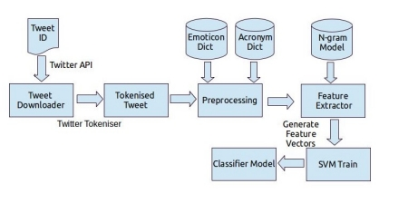
Fig: Flow Diagram of Training: Hybrid Model [7]
1. Approach and techniques
In message based sentiment analysis we build baseline model and feature based model. We also try to perform classification using a combination of both these models. Our approach can be divided into various steps. Each of these steps are independent of the other but important at the same time.
2. Algorithms
Naïve Bayes: Naïve Bayes Classifier is a probabilistic classifier based on applying Bayes’ theorem with strong independence assumption that the presence of one feature in a class does not depend on the presence or absence of another feature. The features or also known as attributes, are the characterized values to describe an instance. Individual instance is defined by its value on a fixed, predefined set of features or attributes [5]. For example, in the text classification problem, the features can be extracted from words in a document. The independence assumption does not hold in real texts because of the grammatical relation between words in the sentence.
With this algorithm, there are two representations of a document:
• Naïve Bayes Binary Model (NBB): only presence or absence of words is considered [4].
• Naïve Bayes Multinomial Model (NBM): multiple occurrences of words are considered [4]. For instance, the sentence “my brother is a teacher and my sister is a doctor” is represented as vector of words in two models as below:
• NBB: (my, brother, is, a, teacher, and, sister, doctor)
• NBM: (my, brother, is, a, teacher, and, my, sister, is, a, doctor)

To evaluate the Naïve Bayes algorithm implemented, the test data was extracted from the training data, 30 tweets from each of the positive and negative training data and 10 tweets from neutral training data was used as test data; hence the test data consisted of a total of 70 tweets. The algorithm was implemented using test data as the input. Now precision, recall and F measure were calculated as follows
• Case1: Compute precision, recall and F1 measure for positive test data by comparing the program prediction and the actual true result.
• Case2: Compute precision, recall and F1 measure for negative test data by comparing the program prediction and the actual true result.
• Case3: Compute precision, recall and F1 measure for neutral test data by comparing the program prediction and the actual true result
Class | Accuracy | Precision | Recall | $$F_{1} measure$$
Positive | 51.43% | 30% | 8.33% | 13.0394%
Negative | 48.57% | 44.44% | 70.59% | 54.5426%
Neutral | 81.43% | 14.29% | 1.75% | 3.1181%
Table: 1

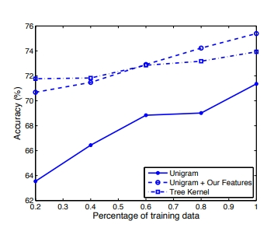
Fig: Learning Curve for two – way classification task [4]
- Opinion Lexicon:
The wordbook- grounded approach depends on opinion (or sentiment) words, which are words that express positive or negative sentiments. Words that render a desirable state(e.g., “ great ” and “ good ”) have a positive opposition, while words that render an undesirable state have a negative opposition(e.g., “ bad ” and “ awful ”). Although opinion opposition typically applies to adjectives and adverbs, there are verb and noun opinion words as well. Experimenters have collected sets of opinion words and expressions for adjectives, adverbs, verbs and nouns independently. We attained our original opinion wordbook from the authors of (Ding et al., 2008). We also amended the wordbook with opinion hashtags of Twitter. As introduced ahead, hashtags are a convention for adding fresh environment and metadata to microblogs. Some markers are sentiment markers which assign sentiment exposure to the Twitter data, e.g. “#Fail”, and “#sucks”. We manually add similar constantly used opinion hashtags into our opinion wordbook. Note that there are also numerous words whose oppositeness depend on the surrounds in which they appear. For illustration, “unanticipated” is a positive opinion word for movie sphere. Our wordbook doesn't contain similar words.

3. Opinionated Tweet Extraction
We use Pearson’s ki-square test to identify pointers. Pearson’s ki-square test has been popularly used for point selection in machine literacy. We can apply it to our case as well. The introductory idea is that if a term is more likely to do in positive or negative opinion rulings, it's more likely to be an opinion index. That is, we need to find out how dependent a term w is with respect to the positive tweets or negative tweets. Similar tweets have formerly been labelled by the wordbook grounded system. We first set up a null thesis that the seeker index w is independent of the positive/ negative tweets with respect to its circumstances in the two sets. The Pearson’s ki-square test compares observed frequentness of w to its anticipated frequentness to test this thesis. Table 1 shows the content of a contingency table. In the table, fij represents index frequency in the positive/ negative tweets set, for illustration, f11 indicates the count of tweet which contain the seeker index w in the positive tweet set. The ki-square value is reckoned as follows:
$$χ^{2}\left(ω\right)=\sum_{i=1,2}{\sum_{j=1,2}{\frac{{(f_{ij}-E_{ij})}^{2}}{E_{ij}}}}$$

 | With w | Without w | Row Total
Positive set | $$f_{11}$$ | $$f_{12}$$ | $$f_{11}+f_{12}$$
Negative set | $$f_{21}$$ | $$f_{22}$$ | $$f_{21}+f_{22}$$
Column total | $$f_{11}+f_{21}$$ | $$f_{12}+f_{22}$$
Table: 2

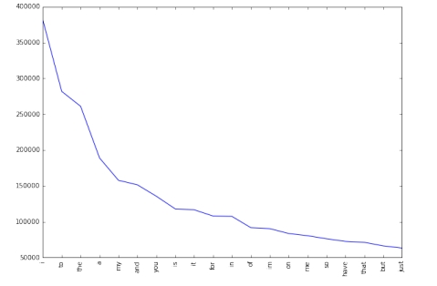
Fig: Frequencies of top 20 unigrams [3]

Literature survey
Sentiment analysis has been handled as a Natural Language Processing task at numerous situations of granularity. Microblog data like Twitter, on which druggies post real time responses to and opinions about “everything”, poses newer and different challenges. Some of the early and recent results on sentiment analysis of Twitter data are by Go et al. (2009), (Birmingham and Smeaton, 2010) and Pak and Paroubek (2010). Go et al. (2009) use distant literacy to acquire sentiment data. They use tweets ending in positive emoticons like “)” “- )” as positive and negative emoticons like “(” “-(” as negative. Twitter is a social networking and microblogging service that allows druggies to post real time dispatches, called tweets. The sentiment analysis that's considered in this paper is grounded on opinions and is frequently appertained in literature as opinion mining. Sentiment analysis aims to determine the station of the opinion holder with respect to a subject. Other operations try to determine the overall sentiment of a document. Sentiment analysis can be delicate. A large number of tweetspre-classified as to be belonging to one of positive, negative and neutral order was used as training data. Unigram approach was enforced (that is individual words in a particular tweet was compared against the training data). For each of the words in a tweet the positive, negative and neutral probability was calculated using the Naive Bayes algorithm. The three chances were latterly compared. The sentiment for the word was the loftiest among the three chances reckoned. The sentiment assigned to a particular tweet was positive if maturity of the words in the tweet were assigned positive sentiment, negative if maturity of the words in the tweet were assigned negative sentiment and neutral if maturity of the words in the tweet were assigned neutral sentiment. In this work we use three external coffers in order to pre-process the data and give previous score for some of the generally used words. Table: 3
Emoticon | Polarity
: - ) :) : o) :] : 3 | Positive
: - D : D8DxDXD | Extremely Positive
: - / : / = / = < /3 | Negative
D : D8D = DXv.vDx | Extremely Negative
> :) B) B-) :) : - ) > | Neutral
Fig: Emoticon dictionary [7]
Table: 4
Acronym | Expansion
admin | administrator
afaik | As far as I know
omg | Oh my god
rol | Rolling over laughing
wip | Work in progress
Fig: Acronym dictionary [7]
A positive summary is automobiles are widely accepted by society, which is negative, summarizing suggests the opposite. This whitepaper describes one of his possible approaches (Naïve Bayes) to twitter sentiment analysis. Accuracy of the project relied primarily on the quality and content of the project training data. Initial accuracy was close to 50%, but continuously analyse tweets related to training data over a period of time. Time accuracy improved to 70%.
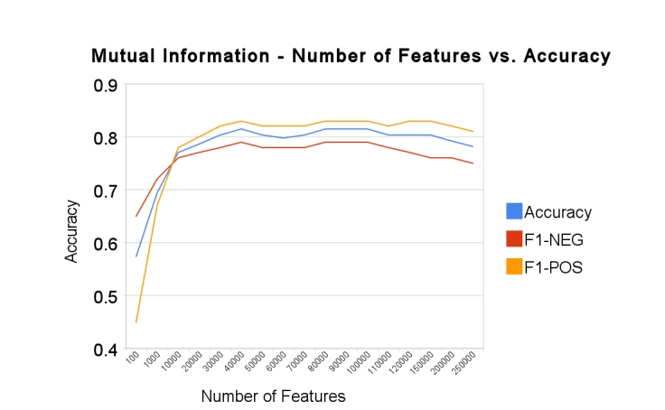Fig: Mutual Information – Number of features vs. Accuracy [6]
The project implemented used Naïve Bayes classifier for analysing sentiments in tweets, however sentiment analysis of tweets has been carried out by using different algorithms and different training data sets. [8] Uses Support Vector Machines for classifying the twitter data, the training corpus used is obtained from Stanford twitter sentiment data. The accuracy claimed is 75.39% if the tweets are classified as to belonging to one of the 2 classes (positive or negative class) and 60.83% if the tweets are classified as to belonging to one of the 3 classes (positive or negative or neutral class). [9] Uses Support Vector Machines but is focused on a specific target, the training corpus used contains tweets specific to a particular subject {Obama, Google, iPad, Lakers, Lady Gaga}. The accuracy claimed is 85.6% if the tweets are classified as to belonging to one of the 2 classes (positive or negative class) and 68.3% if the tweets are classified as to belonging to one of the 3 classes (positive or negative or neutral class).
Table: 5
Model | Avg. Acc. (%) | Std. Dev. (%)
Unigram | 71.35 | 1.95
Senti-features | 71.27 | 0.65
Kernel | 73.93 | 1.50
Unigram + Senti-features | 75.39 | 1.29
Kernel + Senti-features | 74.61 | 1.43

In this paper we introduce two new coffers for pre-processing twitter data 1) an emoticon wordbook and 2) an acronym wordbook. We prepare the emoticon wordbook in labelling 170 emoticons listed on Wikipedia1 with their emotional state. For illustration, “)” is labelled as positive whereas “= (” is labelled as negative. We present trials and results for two bracket tasks 1. Unigram model (our birth) 2. Tree kernel model 3. 100 Senti- features model 4. Kernel plus Senti- features 5. Unigram plus Senti- features for the unigram plus Senti- features model, we present point analysis to gain sapience about what kinds of features are adding most value to the model. We also present literacy angles for each of the models and compare learning capacities of models when handed limited data. Experimental- Set- up For all our trials we use
Table: 6
Positive words | Love,great,good,thanks
Negative words | Hate,shit,hell,tired
Emoticons | ||P|| (positive emoticon), ||N|| (negative emoticon)
Other | For, ||U|| (URL)

Conclusion
This paper bandied one of the possible approaches (Naïve Bayes) to twitter sentiment analysis. The delicacy of the design substantially depended on the quality and content of the training data. Original delicacy was close to 50 but adding the analysed tweets to the training data continuously over a period of time increased the delicacy to 70. Analysing tweets helps in determining the fashionability of a subject. In this paper, we proposed a new system to deal with the problems. A stoked wordbook- grounded system specific to the Twitter data was first applied to perform sentiment analysis. Through Chi-square test on its affair, fresh pinioned tweets could be linked. We presented results for sentiment analysis on Twitter. For our point- grounded approach, we do point analysis which reveals that the most important features are those that combine the previous opposition of words and their corridor of- speech markers. We tentatively conclude that sentiment analysis for Twitter data isn't that different from sentiment analysis for other stripes. In unborn work, we will explore indeed richer verbal analysis, for illustration, parsing, semantic analysis and content modelling.
Future work
Handling emotion ranges we can ameliorate and train our models to handle a range of sentiments. Multilingual sentiment analysis utmost being sentiment analysis systems are designed to work with English textbook, but there's a growing need for sentiment analysis in other languages. Developing models that can directly assay sentiment in multiple languages would be an important area of exploration. Fine- granulated sentiment analysis numerous sentiment analysis systems presently classify textbook as positive, negative, or neutral, but there’s frequently more nuance to the sentiment expressed. Developing models that can descry fine- granulated sentiment, similar as affront or irony. Some of the unborn advancements could be To help determine the fashionability of a subject, data has to be gathered from colourful other sources similar as Facebook so that the delicacy of the analysis is bettered. Bi-grams and tri-grams can be used for analysis rather of uni-grams to ameliorate the delicacy.
References
- Mathieu Cliche. Twitter sentiment analysis with CNNs and LSTMs. Pp: 3-6. 2017.
- Edilson Anselmo Corrêa Júnior, Vanessa Queiroz Marinho, and Leandro Borges dos Santos. A multi-view Ensemble for Twitter Sentiment analysis. Pp: 1-5. 2017.
- Apoorv Agarwal, Boyi Xie, Ilia Vovsha, Owen Rambow, and RebeccaPassonneau. Sentiment Analysis of twitter data. Pp: 2-8. 2011.
- Lei Zhang, Riddhiman Ghosh, Mohamed Dekhil, Meichun Hsu. Combining Lexicon- based and learning –based methods for twitter sentiment analysis. Pp: 2-6. 2011.
- Alec Go, Richa Bhayani, Lei Huang. Twitter Sentiment Analysis. Pp: 6-12. 2009.
- Mayank Gupta, Ayushi Dalmia, Arpit Jaiswal, and Chinthala Tharun Reddy. Sentiment Analysis in twitter. Pp: 2-6. 2014.
- KS Kushwanth Ram, Sachin Araballi, Shambhavi BR, Shobha G. Sentiment Analysis of twitter data. Pp: 1-5. 2014.
- Vedurumudi Priyanka. Twitter sentiment analysis using deep learning. Pp: 5-11. 2021.
- Shaunak Joshi, and Deepali Deshpande. Twitter sentiment analysis system. Pp: 1-2. 2018.

