IMPACT OF GST ON TOURISM SECTOR

Author
K.Rithu varjitha
BA.LLB(Hons)
Saveetha School Of Law
SAVEETHA INSTITUTE OF MEDICAL AND TECHNICAL SCIENCES (SIMATS)
REG NO. : 131801089

Co-author
M.Dhinesh
Assistant Professor
Saveetha School Of Law
SAVEETHA INSTITUTE OF MEDICAL AND TECHNICAL SCIENCES (SIMATS)

IMPACT OF GST ON TOURISM SECTOR
Author: K.Rithu varjitha
Co-Author: M.Dhinesh kumar

Abstract:
Tourism represents the world's third largest export avenue in terms of global earnings after fuel and chemicals.Modern tourism is closely linked to socio-economic development.The objective of my study to understand the impact of the GST regime on the travel companies.I have collected 200 sample size through online.The research method is socio legal research.The independent variables are Age,Gender and educational qualification and the dependent variables are the introduction of the GST impacted the tourism sector.This study has been undertaken to investigate the impact of GST on the tourism industry of Agra and the variables on which the introduction of GST had changed the business operations in Agra. The research has been done by the use of primary data from the source of the city of Agra and have taken the responses of businesses and tourism company owners to rule out if there was any impact of GST after its introduction in 2017.Tourism is the process and technique of spending time away from home in search for pleasure, recreation and relaxation while making full use of the travel arrangement of administrations. In that capacity, the travel industry is an outcome of today’s social arrangements, starting in Western Europe in the seventeenth century, in spite of the fact that it has precursors in Classical vestige.Tourism is regularly observed as a worldwide marvel with a boundlessly gigantic infrastructure.. Its significance is apparent from the way that its impact thoroughly penetrates society, politics, culture and, most importantly, the economy.

KEYWORDS:
Tourism,socio-economic development,global earnings,travel companies and sector.

INTRODUCTION:
Tourism is the voyage of people to various places or countries outside their comfortable surroundings for various purposes like leisure, business. It can be a social, cultural or economic phenomenon. Individuals who travel to different locations are called tourists and tourism comes with tourism expenditure.
Tourism is the process and technique of spending time away from home in search for pleasure, recreation and relaxation while making full use of the travel arrangement of administrations. Goods and service tax in India dates back to the year 2000 and culminates in 2017 with four bills relating to it becoming an act.The government introduced multiple GST rates viz 3% ,5% 12% 18% and 28%.The factors affecting the GST rate ,exemptions,Technological infrastructure,treatment of subsidies ,place of supply rules and additional 1% of tax.Further , a reduction of the existing 18% GST rate on hotel rooms costing rs 7500 per day or above to 12% has been forward.France was the first country to implement GST to reduce tax evasion.140 countries have implemented GST with some countries having Dual GST.Taxes levied on inbound tourism is amongst the highest in the country.Major reason for India lapsing foreign tourists to competing south East Asian countries.
OBJECTIVES:
To study the overview of GST for the Tourism industry.
To find out the opportunities and challenges of GST on the tourism sector.
To investigate GST tax reforms in India.
LITERATURE REVIEW :
DR RAJEEV K.SAXENA,PRIYANKA PAYAL (2018) Tourism sector is the growing sector.India’s GDP has 1 st July 2017.The 160 countries are worldwide has Implemented the GST in its economy.GST is a fair minded tax.
CMA MRITYUNJAY ACHARJEE ,2018 Tourism is the world third largest export and global earnings .Tourism is responsible for 11 jobs and 10% of world's economic output.
KUMAR DAVENDRA (2020) Travel and tourism is the development class. It is based on the operational criteria and it plays a vast role and paved the way for development and foreign currency in our country.
KHATIK ,AMIT KUMAR ,2019 GST restaurant is charged separately .It depends on the value of tariff of rs.1000 .Not a charge of GST and subsume the service tax.
According to the author (Agarwal, 2017), hotel industry is a priority industry and its importance is being realized by the Government of India, the industry has been suffering with a number of taxes like VAT, luxury Tax and Service Tax, out of which the former two are levied by the State Government whereas the latter has been levied by Central Government. All the taxes vary in rates, VAT differs from every state, and Luxury tax from room rates and service tax varies from the type of service availed.
Mathew (2019)The paper where the author takes into accounts the opinions and problems faced by the hoteliers. The paper takes into study the sample of 60 hotels and collected data on the basis of questionnaires. GST is supposed to have a change in the prices, tax structure and benefits. Out of the 60 hotels more that 56% hotels have agreed that there is an increase in the prices of goods, and about 23% denied with the rest having no opinion.

Diksha Panwar, 2017 stated in their paper that restaurants and Food Service Businesses in India, is the snappiest creating business. Accordingly, in view of the changes in control arrangement framework the improvement of the business is being affected. Items and endeavors. Obligation introduction has made some perplexity among the diner proprietors. Merchandise and adventures charge was realized to annul all extra money charging plans which was before gotten a handle on by the retailer in order to benefit.
Renuka R,2018 India is one of the hot tourist destinations in the world and due to the variety of tourist attractions.Delicious food on international inbound tourist movement .ITS industries taxes are levied and new taxes regime of goods and services.
KUMAR (2017)In his paper states that one of the most hyped countries to visit for tourists in India.In India,tourism is one of the beneficial sector in the Indian economy.It has the very high volume of Foreign Direct Investment and biggest way of foreign exchange .Poor and higher tax sales and making the industry profitable.It reduced the margins of the companies.
BINOY (2017) This paper leads to the evaluation of the tourism industry. Pre and post of the implementation of tax regime of GST .Indian tourism industry ranks 7 th in the world.One of the fastest growing industries.Even Though the GST is bad ,it is expected to make tourism grow by the year 2026.
ASWATHY KRISHNA (2017) It states that the central , state and Interstate GST .It Was caused turmoil in the hotel Industry of India.To Understand the use of one Tax than multiple taxes ,registration on the centralised bias, invoicing and billing along with the reason for the Tax rate not being the same.
VANKHATE,(2017) one of the most hyped countries .To visit for tourists in India and India is not trying hard enough to attract tourists of the country .Provision of GST on the tourism sector in India.Impact on the football of tourists in the country .Indian tourism and hospitality sector and 40 million jobs in 2016.
SAGAR A. VALAKAR ,CHETON ,BHAGAT (2020) It highlight the devastating economic impact of interest free and the collateral free terms .Prevent the tourism business in 12 month and statutory dues.
MANI KANSAL(2017) This paper leads to Giant indirect tax is an economic growth.GST regime is a growth and development of the country and the production uniformity in the system.
SUDIP BANERJEE,PRIYA AGARWAL (2018) This paper leads to The Government of India collecting the Indirect tax and manufacturer.The customer pay the biggest tax for several issues .

SUPRATIK SARKAR,(2020) The global economy in every sector of banking and tourism .Infrastructure and development of rural and urban consumption.It is the strong foundation of short term market sentiment.
AKSHAY R.RAKHUNDE (2019) It is a attractive tourist spot .Tourism is the burden of the people and price of tourism.Truism increases the decrees the GST of reality numbers.
DIKSHA PANWAR ,SIDHESWAR PATREW,2017
In this article the Foods and services has grown business.It has changed the tax collection embraced the retailer.It has decreased the consistency cost of VAT of service tax and introduced the alternative promotional schemes.
KARAN SAHI,2017 Tourism is the export avenue of modern tourism.It is a socio economic development and 10% world economic output.Foreign exchange and tourism sector economically.
CHITRA GUHA,K GANDHI,2020 Indian tourism sector is the contributor economy.It has useful expected to reap benefits.The GST regime is a uniform tax rate and income tax.
RESEARCH METHODOLOGY:
​The research method followed is empirical research. A total of 200 samples have been taken out of which is taken by a convenient sampling method. The sample frame taken by the researcher through online . The independent variables taken for the survey are age, gender, occupation and educational qualification. The statistical tool used in the study is graphical representation.

HYPOTHESIS:
Null hypothesis : There is no significant association between Public opinion on the introduction of GST leading to higher prices in the tourism industry and gender of the respondents.
Alternative hypothesis : There is significant association between public opinion on the introduction of GST leading to higher prices in the tourism industry and gender of the respondents.

ANALYSIS:
Rate the experience through the GST portal
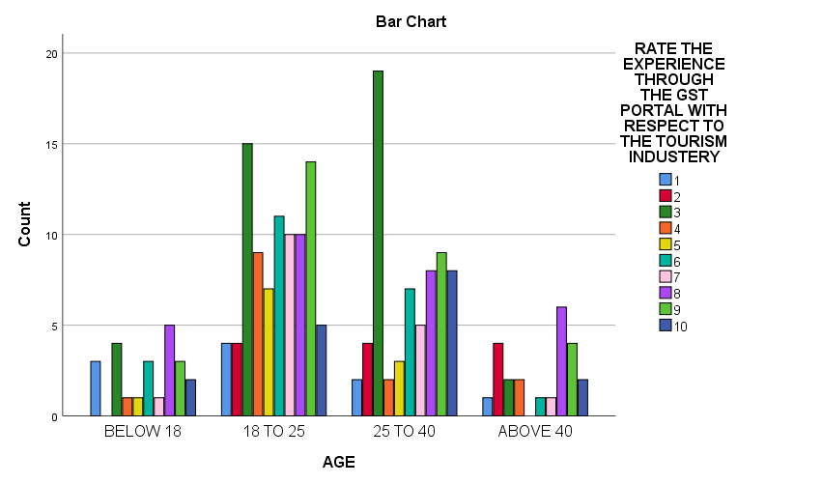

LEGEND :

From the graph it exhibits the age distribution of the respondents and their opinion on the experience through the GST portal with respect to the tourism industry.
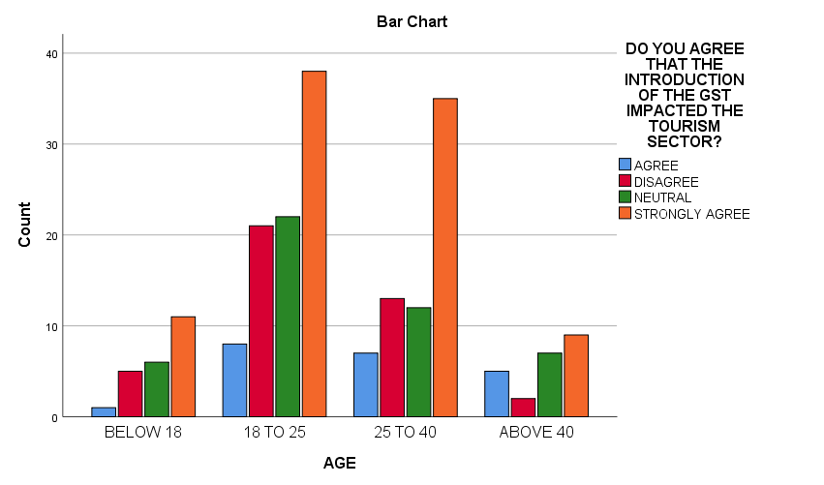
LEGEND :

From the graph it exhibits the age distribution of the respondents and their opinion on the experience through the Introduction of the GST impacted the tourism sector.

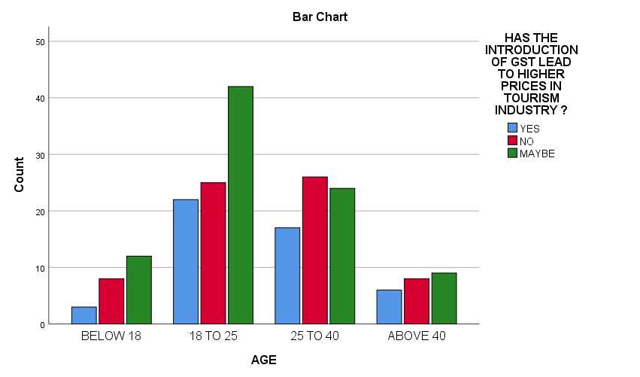

LEGEND :

From the graph it exhibits the age distribution of the respondents and their opinion on the experience through the Introduction of the GST lead to higher prices in the tourism industry.

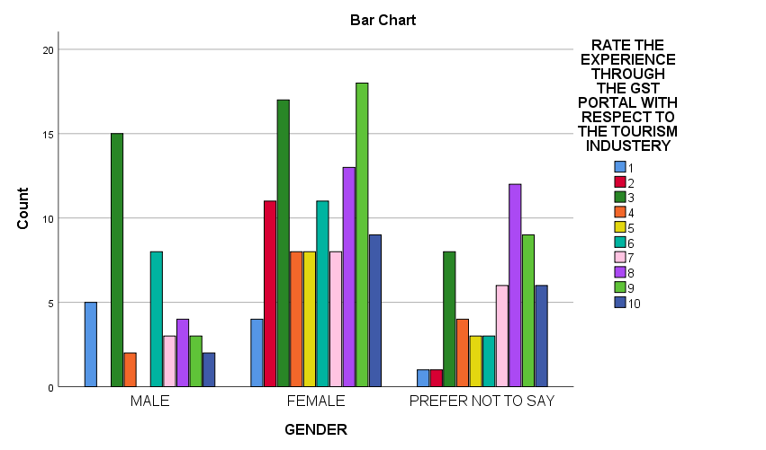

LEGEND :

From the graph it exhibits the gender distribution of the respondents and their opinion on the experience through the GST portal with respect to the tourism industry.

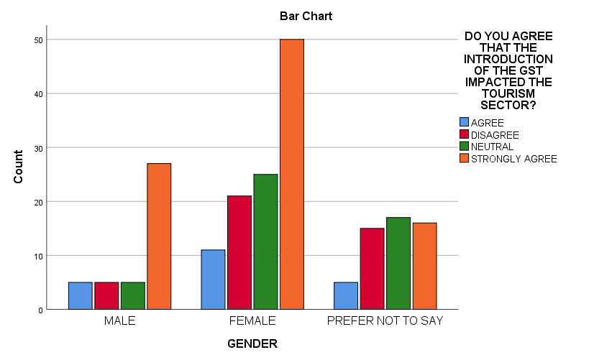

LEGEND :

From the graph it exhibits the gender distribution of the respondents and their opinion on the experience through the introduction of the GST impacted the tourism sector.

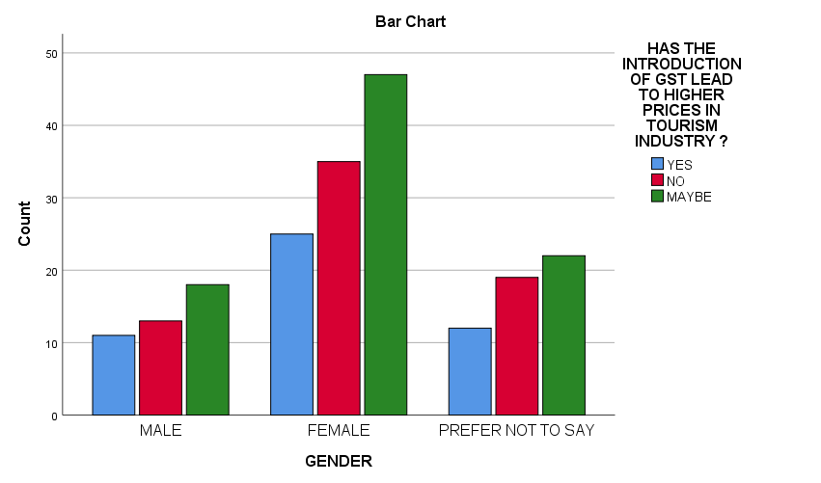

LEGEND :

From the graph it exhibits the gender distribution of the respondents and their opinion on the experience through the introduction of the GST lead to higher prices in the tourism industry.

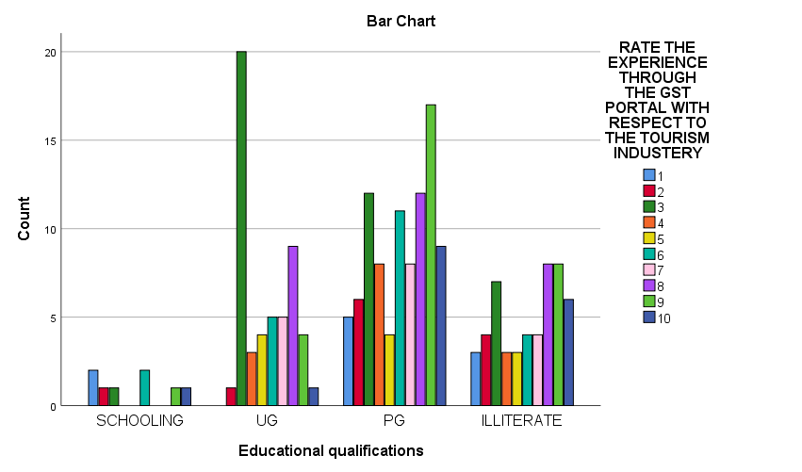
LEGEND :

From the graph it exhibits the educational qualification of the respondents and their opinion on the experience through the introduction of the GST portal with respect to the tourism industry.
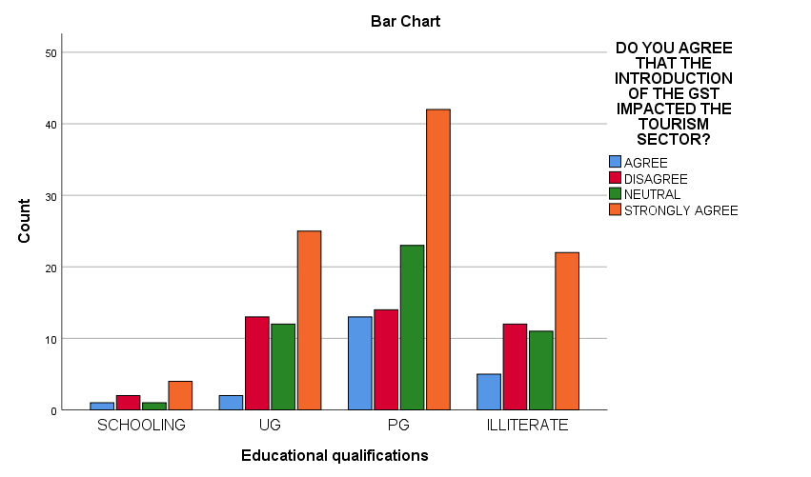

LEGEND :

From the graph it exhibits the educational qualification of the respondents and their opinion on the experience through the introduction of the GST impacted the tourism sector.

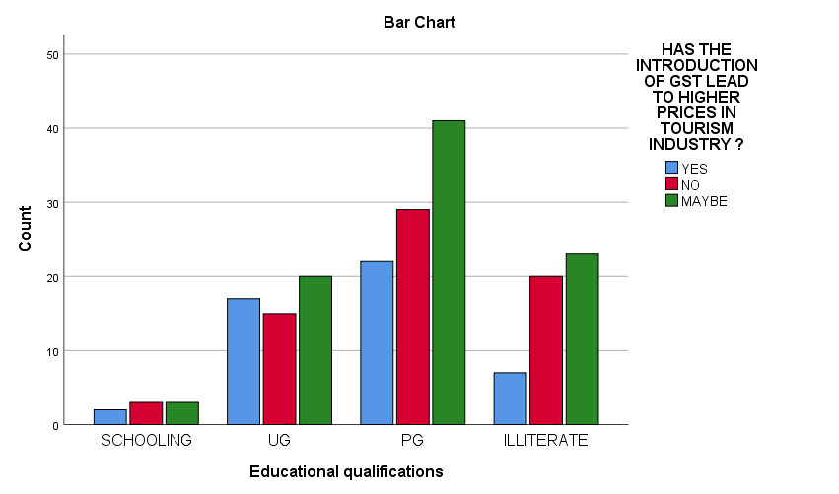

LEGEND :

From the graph it exhibits the educational qualification of the respondents and their opinion on the experience through the introduction of the GST lead to higher prices in the tourism industry.

RESULT:

FIG 1,From the survey: in the graph, it is observed that it exhibits the age distribution of the respondents and their opinion on the experience through the GST portal with respect to the tourism industry. The maximum number of responses were collected between 25-40 who agrees the statement whereas The minimum respondents is age above 40 who disagrees with the statement.

FIG 2,From the survey: in the graph, it is observed that it exhibits the age distribution of the respondents and their opinion on the experience through the introduction of the GST impacted the tourism sector .The maximum number of responses were collected between 18-25 who strongly agrees the statement whereas The minimum respondents is age above 18 who agree the statement.

FIG 3,From the survey: in the graph, it is observed that it exhibits the age distribution of the respondents and their opinion on the experience through the introduction of the GST lead to higher prices in the tourism industry.The maximum number of responses were collected between 18-25 who strongly agrees the statement whereas The minimum respondents is age below 18 who agree the statement.

FIG 4,From the survey: in the graph, it is observed that it exhibits the gender distribution of the respondents and their opinion on the experience through the introduction of the GST portal with respect to the tourism industry.The maximum number of responses were collected between female who strongly agrees the statement whereas The minimum respondents is prefer not to say disagree the statement.

FIG 5,From the survey: in the graph, it is observed that it exhibits the gender distribution of the respondents and their opinion on the experience through the introduction of the GST impacted the tourism sector.The maximum number of responses were collected between female who strongly agrees the statement whereas The minimum respondents is male agree the statement.

FIG 6,From the survey: in the graph, it is observed that it exhibits the gender distribution of the respondents and their opinion on the experience through the introduction of the GST lead to higher prices in the tourism industry.The maximum number of responses were collected between female who strongly agrees the statement whereas The minimum respondents is male agree the statement.

FIG 7,From the survey: in the graph, it is observed that it exhibits the gender distribution of the respondents and their opinion on the experience through the introduction of the GST lead to higher prices in the tourism industry.The maximum number of responses were collected between UG who strongly agrees the statement whereas The minimum respondents is schooling agree the statement.

FIG 8,From the survey: in the graph, it is observed that it exhibits the gender distribution of the respondents and their opinion on the experience through the introduction of the GST impacted the tourism sector.The maximum number of responses were collected between PG who strongly agree with the statement whereas The minimum respondents is schooling agree the statement.

FIG 9,From the survey: in the graph, it is observed that it exhibits the educational distribution of the respondents and their opinion on the experience °
the introduction of the GST lead to higher prices in the tourism industry.The maximum number of responses were collected between PG who strongly agrees the statement whereas The minimum respondents is schooling agree the statement.

DISCUSSION:
It is observed from figure 1 that most of the people have the opinion that the maximum number of responses were collected between 25-40 who agree with the statement whereas The minimum respondents is age above 40 who disagrees with the statement.
It is observed from figure 2,most of the respondents strongly agree the introduction of the GST impacted the tourism sector.
It is observed from Figure 3 ,most of the respondents are age group of 18-25 as the Introduction of the GST lead to higher prices in the tourism industry.

It is observed from Figure 4,most of the respondents are female and the opinion on the experience through the GST portal with respect to the tourism industry.

It is observed from figure 5,most of the respondents are female and the opinion on the introduction of the GST impacted the tourism sector.

It is observed from figure 6,majority of the respondents are female, and the opinion on the introduction of the GST lead to higher prices in the tourism industry.

It is observed from figure 7,majority of the respondents are PG students who strongly agree with the statement and the introduction of the GST impacted the tourism sector.

It is observed from figure 8, majority of the respondents are PG who strongly agree with the statement and the opinion on. the introduction of the GST impacted the tourism sector.

It is observed that from figure 9,majority of the respondents are PG who strongly agrees the statement and the opinion on the introduction of the GST lead to higher prices in the tourism industry.

LIMITATION:
The Major limitation of the study is the sample frame. The sample frame Collected through online platforms like sending mail, sending links via WhatsApp is the limitation of the study, the real field experience is missed out due to corona pandemic. The restrictive area of sample size is yet another drawback of the research.Collection of data via online platform is limiting the researcher to collect data from the field.Since the data is collected on online platform wherein the respondent is not known, the original opinion of the respondent it is not found, The researcher could only come to a approximate conclusion of what the respondent is feeling to convey.

CONCLUSION AND SUGGESTION:
Tourism has been an important aspect in Agra since many decades .Not only domestic but also international tourists visits the destination for its spiritual significance. The introduction of GST rates in tourism and hotel industry was initially from the company owners and it effects in understanding its implementation in various tourism companies in Agra,a city in the state of UP.The sector May benefit in the form of lower tax rates which should help in attracting more tourists in India.Since Agra is one among the leading tourist destinations in India thanks to its pilgrimage and spiritual significance, the taxes should be maintained intrinsically to chop down the value of the services. The rates should be maintained simultaneously in order that the tourist count doesn't fall and therefore the destination doesn't decline. GST may be a glimmer of hope for the Hotel and Tourism Industry if we will keep the GST rate between 10 to fifteen . GST might herald its uniformity of tax. To combat such issues steps should be taken not only by the government but also the host community and tourists to guard the rates of the services within the destination .

REFERENCES:

Dr.Rajeev Saxena,Priyanka Payal ,2018 ,Impact of GST on Tourism Industry,An international Journal of Management 5(1) PP 47-55

CMA Mrityunjay ACHARJEE,2018,30 Impact of GST On the travel and tourism sector in India

Kumar DAVENDRA,2020 Impact of GST on Hotel Industry,24(6) ISSN:1475-7192

KHATIK,Amit kumar Nag,2019,Impact of GST on Indian Hotel and Restaurant Business,9(3) ,ISSN: 2249-0558

Agarwal ,2017, GST and its impact on agra tourism industry, ISSN:2320-2882,8(3)

Mathew,2019,www.ijcrt.org,8(3),ISSN:2320-2882,Mathew, A Study on the Impact of Goods and Services Tax Reform on Hotels in Kerala

Diksha Panwar,2017,Impact of Goods and Services Tax on the Restaurants and Food Service Businesses in India

Renuka R,2018 ISSN :0976-3031,Impact of GST on tourism and hospitality sector.

Kumar,2017,9736-9749,Impact of GST on tourism sector

Binoy,2017,8(3),ISSN: 2320-2882,AN EVALUATION OF INDIAN TOURISM INDUSTRY UNDER GST REGIME

Aswathy krishnan,2017, A study on GST and its effect on the hotel industry. IOSR Journal of Business and Management.

VANKHATE,2017,GST and Indian Tourism Sector. INTERNATIONAL RESEARCH JOURNAL OF MULTIDISCIPLINARY STUDIES.

Sagar A.Valakar,chetan,Bhagat,2020,ISSN:978-93-88901-11-6

Mani Kansal,2017,4(2) ,ISSN:2394-4390

Sudip Banerjee,Priya Agarwal,2018 18(2)

SUPRATIK Sarkar,2020 ,3(11)

Akshay R.Rakhwale,Priti Rai,3(10),2019

Diksha Panwar,sidheshwar patrew,2017,15(23) ,ISSN: 0972-7302,Diksha Panwar, S. P. (2017). Impact of Goods and Services Tax on the Restaurants and Food Service Businesses in India .

Karan sahi,2017,8(3),ISSN: 2320-2882

Chitra Guha,K.Gandhi,2020 ,7(11) ,pp 47-56

PLAGIARISM CHECKER:
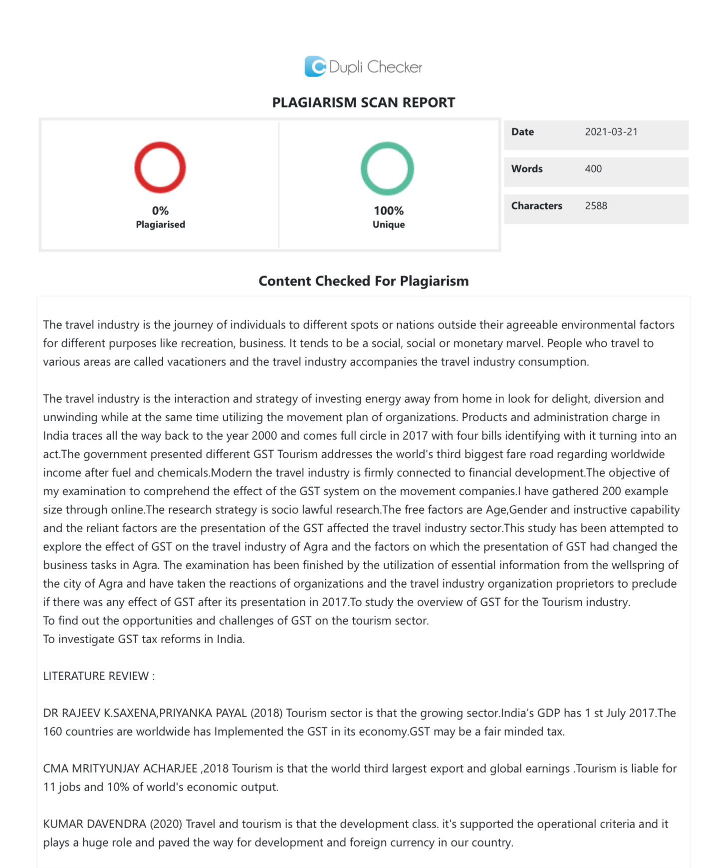

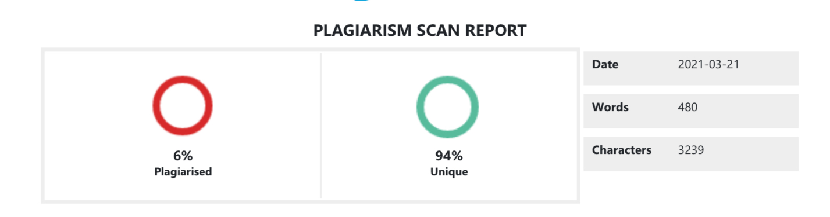

BALLB,SAVEETHA SCHOOL OF LAW,SAVEETHA INSTITUTE OF MEDICAL AND TECHNICAL SCIENCES(SIMATS),
M.Dhinesh,Assistant Professor,Saveetha School of law,Saveetha University,SIMATS,Chennai-77

