Machine learning- based forecasting and prediction of stock prices

Dr. Susanta kumar Satpathy
Associate Professor
Dept.Computer Science and Engineering
Vignan university, Vadlamudi

Nadendla Tarun Venkata sai
Dept.computer science and engineering
Vignan university, Vadlamudi
Sait19690@gmail.com

Padala Sanjeev reddy
Dept.computer science and engineering
Vignan university, Vadlamudi
sanjeevreddypadala99511@gmail.com

Chunduri Leela Manohar
Dept.computer science and engineering
Vignan university, Vadlamudi leelamanohar2108@gmail.com

ABSTARCT- For many years, investors' primary concern was the stock market. Stock trend indicators have a high demand given that they aid in the rapid addition of profits. More exact outcomes increase the likelihood of earning greater amounts of cash. Stock market patterns are influenced by politics, economics, or social factors. Basic or technical analysis can be used to assess stock trend movements. In this scenario, the financial aspects of the business are evaluated, as well as strategic efforts, small-scale signs, and consumer behaviour. It is the process of analysing historical and current prices with the goal to estimate possible future prices. There are numerous machine learning, deep learning.
It has been shown to produce usually reliable outcomes. In order to create predictions, prior publications concentrated on different models and their components. They sought to provide the best parameter values feasible for the projections. The goal of this study is to provide investors with models that can manage data efficiently when the right values for parameters are employed. The LSTM models are supplied because of their capacity to produce decent outcomes via technical data analysis. algorithms in order to choose the optimal one for collecting financial data in the current scenario. The data originates from the firms' previous stock prices, encompassing wide, near, substantial, and low values.
keywords- LSTM, corporate trend projections, technical evaluation, artificial intelligence, and past stock prices.

INTRODUCTION

Retail and institutional investors can which is a free market. The stock or shares of a company represent ownership of a particular proportion of the company. The owner has access to the company's property and worth according to the amount of shares held by holding the specific stock. In order to make money, interested individuals trade these shares on the stock market. The future direction of share prices can be influenced by among other factors. Given the numerous factors at play, predicting stock value is challenging, but one important factor is the stock's closing price because it shows how the corporation carried out their investing throughout the day. Forecasting the performance of stocks is crucial because it gives investors a broad picture of how well a company's shares might go over the long term. Gains in revenue roughly equate to the potential accuracy of predictions. In order to give the customer the most accurate results possible, this journal concentrates on technical evaluation and how to use the LSTM model for stock price forecasting.The process of predicting the future price movements of a specific stock or security using a variety of methodologies and models is known as stock price prediction. To help traders and investors make wise choices about their investment portfolios, stock price prediction serves this purpose.
Technical analysis, fundamental analysis, and machine learning are just a few of the concepts and methodologies utilised in stock price prediction. It is the practise of examining historical volume and price data to identify trends and cycles that may be utilised in predicting future price movements. On the other hand, fundamental analysis involves examining financial and economic data about a firm in order to determine its intrinsic value and potential for growth.

Machine learning is a more modern approach of predicting stock prices that uses algorithms to evaluate massive amounts of data and discover trends and connections that can be utilise to make forecasts.This method entails building a model using historical data and applying it to forecast future price changes.
In general, forecasting the value of an asset is a complex task that necessitates an understanding of analytical skills, market knowledge, and technological expertise. Accurate predictions, on the other hand, can be extremely valuable to traders and investors looking to enhance their returns while decreasing their risks.

LITERATURE REVIEW

Because it has substantial ramifications for investors and financial decision-makers, predicting stock prices is a crucial and difficult job in the realm of finance. Due to their capacity to model intricate relationships and patterns in huge datasets, machine learning (ML) approaches have recently become more and more prominent in this field. Here is a review of the literature on machine learning's use in stock price prediction:
1. A overview of deep learning-based stock price prediction This article offers a thorough analysis of the research on predicting stock prices using deep learning methods like recurrent neural networks (RNNs), convolutional neural networks (CNNs)model. The authors identify potential study directions and evaluate the benefits and drawbacks of each strategy.
2. Machine learning-based stock price prediction: an empirical analysis This research offers an empirical examination of stock price prediction utilising machine learning methods like SVMs, decision trees, and random forests. The authors assess the models using actual stock market data and talk about the consequences of their conclusions for investors and decision-makers in the financial sector.
3.A hybrid machine learning technique for stock price prediction: In this research, a hybrid machine learning approach is proposed that combines genetic algorithms and ANNs. The method is assessed by the authors using actual stock market data, and they show that it is more effective than other machine learning methods.
4.A review of machine learning-based stock price prediction This article offers a thorough analysis of the literature on the prediction of stock prices using machine learning approaches, such as regression models, time-series models, and ensemble methods. The authors identify potential study directions and evaluate the benefits and drawbacks of each strategy.
5. A comparison of machine learning strategies for stock price forecasting: In this study, the performance of various machine learning methods for stock price prediction—including ANNs, SVMs, decision trees, and random forests—is compared. The authors assess the models using various measures and go over their shortcomings and potential uses.

6. Machine learning-based stock price prediction: An empirical investigation Using machine learning methods including SVMs, decision trees, and random forests, this research presents an empirical analysis of stock price prediction. The authors assess the models using actual stock market data and talk about the consequences of their conclusions for investors and decision-makers in the financial sector.

Generally speaking, the literature indicates that machine learning approaches can be successful at predicting stock prices, but their success is dependent on the particular strategy and dataset employed. To create more reliable and accurate models for this activity, additional study is required.

PROPOSED SYSTEM

The objective of this paper seems to be to create the best model for predicting and analyise stock market values. The paper presents model for stock forecasting is LSTM and to assist investors and buyers in making better choices. depicts the framework of the model presented. Python is used to create the The LSTM algorithm's software architecture. Data are taken from AAPL. The data set's open, close, high, and low values are its most crucial properties. A host machine was used to execute the visual user interface of the model, which allows users to browse chart plots and historical data centres to see market volume.
It is a kind of recurrent neural network (RNN) architecture created to address the shortcomings of conventional RNNs in capturing long-term relationships. In sequence model applications including speech recognition, language modelling, and time series prediction, LSTMs are frequently employed.
The suggested system's LSTM design can be applied to a number of applications, including:
1. Sentiment analysis: The suggested system can be used to determine whether a text has a good, negative, or neutral sentiment.
2. Real-time Speech Recognition: The system can recognise speech in real-time after being trained on a vast corpus of voice data.
3. Time Series Prediction: Using the system's previous values as a guide, one may forecast the future values of a time series.
4. Language Modelling: The system is capable of producing new text from an input text.
5. Image captioning: Using the technology, you may create captions for pictures based on what they're about.
6. Chatbot: The programme can be made to comprehend questions asked in natural language and respond appropriately.

In all of these applications, Due to its capability to recognise long-term dependencies in sequential data, the LSTM architecture is highly suited. The proposed method can achieve high accuracy and perform better than conventional machine learning models with the right data.
when dealing with vanishing gradient issues. LSTM employs convolutions to process the entire data set; instead of trying to deal with each data point separately, it stores beneficial information from previous information sets sequentially to aid in the computation of new data points. LSTM is better to other approaches because it can recollect patterns selectively over long periods of time. LSTM is a superior solution than other local feed artificial neural networks. The three gates elements comprise the LSTM model are depicted in the figure. First, pinpoint the specific time for the long short-term REM connections output. is founded on three principles:

The basic structure of the LSTM model is depicted in the picture. The present input is x t, the outcome is h t, while the result for the previously unknown cell is h m-1. The two input values are x t increased and added to the final output after passing through both the sigmoid and tanh functions. The outcome is divided by both and then increased. The forget gate's two inputs are xi t and h s-1, and they are additionally routed through the functions.
There are several methods used to predict stock prices, including: Fundamental analysis: This approach involves analysis the financial health and performance of a company, including its revenue, earnings, assets, and liabilities, to determine the intrinsic value of its stock.

Econometric models: This approach involves using economic theory and statistical techniques to analysis the relationships between stock prices and other economic variables, such as interest rates, inflation, and GDP.

It is crucial to remember that no approach can ensure precise stock price forecasts because there are so many variables that can affect market movements, such as unforeseen occurrences and investor mood. It is typically advised to combine various techniques and strategies in order to improve forecast accuracy.

LSTM ARCHITECTURE:

when handling vanishing gradient difficulties. Convolutions are used by LSTM to handle the entire data set; rather than processing each data point individually, it keeps in the sequence to help process incoming data points. LSTM is a superior option than other local feed machine learning since it can retain patterns selectively for a long time. Figure illustrates the three gates that make up the LSTM model. At first, three factors determine the LSTM network at a particular time. 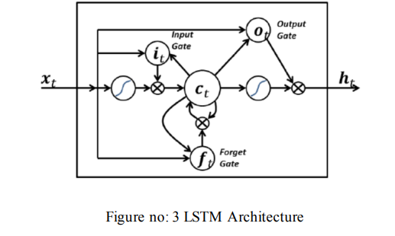
Components:
The LSTM model consists of several components, including:

- Input layer: This layer receives input data in the form of sequences or time series.
2. LSTM blocks: The basic units that comprise the LSTM model. They are made up of cells that store data and gates that control the movement of information between and within within the cells.
3. Memory cells: The memory cells are in charge of maintaining and retaining data over time. They are made to retain crucial information over extended periods of time.
4. The forget gate chooses which data should be removed from the memory cell. It generates an output that determines what information should be forgotten from input from the previous output and input from the current input.
5. Input gate: This component determines which data should be stored in the storage cell. By accepting input from the present input and the preceding output, it provides an output that determines what data ought to be put to the recall cell.
6. Output gate: This component chooses which data should be output from a memory cell. It generates an output that determines what information should be output by taking input from the previous output and the current input.
7. Output layer: Using the last hidden state, this layer generates the output for the entire sequence.
In general, the LSTM model is built to ecognize long-term dependencies and allow the model to learn from and remember lengthy data sequences.

Analysis of time series

To study and analyse data accumulated over time, a statistical method known as series analysis is performed. It comprises examining a group of measurements of an indicator collected patterns, and relationships among multiple variables:
Each observation is usually collected at a particular point in time, and the data utilised in time series analysis is often consecutive. Financial, economic, meteorological, and transportation statistics are a few examples of time series data.
The following are some essential elements of time series analysis:
Finding the data's long-term trend is the goal of trend analysis. Trends can be growing or declining and can be linear or nonlinear.
Analysis of seasonality entails spotting trends that
Finding the data's long-term trend is the goal of trend analysis. Trends can be growing or declining and can be linear or nonlinear.
Identification of trends that repeat over set time periods, such as daily, weekly, or monthly, is the focus of seasonality analysis.
Cyclical analysis entails spotting patterns that occur more frequently than seasonal variations, such as business or economic cycles.
Analysing the data for stationarity entails determining if its statistical characteristics, such as its mean and variance, remain consistent across time.
Performing an autocorrelation analysis is determining how closely connected each observation in a time series is to earlier ones.
Using the data from the aforementioned investigations, forecasting involves making predictions about the future values of the time series.
Numerous fields, including finance, economics, meteorology, and engineering, use time series analysis. It is a crucial tool for seeing patterns and trends in data as well as for forecasting the data's future values.

neural network with recurrence:

It is created primarily to handle sequential input. It is a development of conventional feedforward neural networks, in which information simply moves from input to output.
An RNN's basic building block is a cell that has a hidden state. The cell generates an output and a new hidden state at the end of each time step while accepting an input and the previous hidden state as input. The following time step's input is then based on this new hidden state.
An RNN's input and output can both have different lengths. As a result, an RNN is highly adapted to handle problems like time series prediction, speech recognition, and natural language processing.

The vanishing gradient problem, which affects the conventional RNN, makes it challenging to learn long-term dependencies.Several RNN variations that are better at simulating long-term dependencies
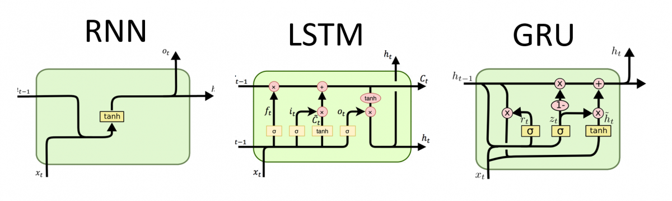

Recurrent neural network types:

Although we've depicted recurrent neural networks in this way in the aforementioned diagrams, they do not truly have the limitation that feedforward networks have, which maps one input to one output. Rather, many versions of RNNs are used for a variety of applications, including music composition, sentiment categorization, and translation by machine, and the data they receive and produce can be of varying lengths.
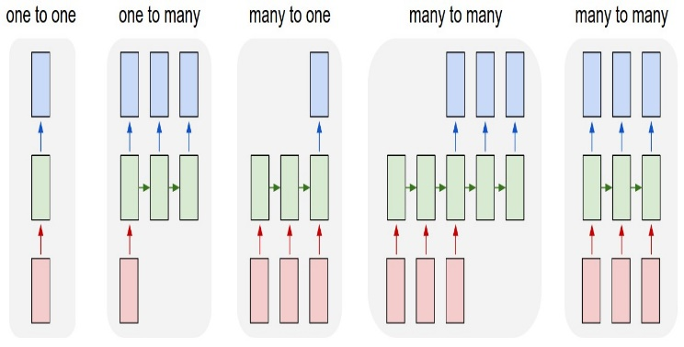
The LSTM algorithm is fed a dataset containing past stock prices:
OUTPUT: projection for a stock's price utilising price analysis 1. Begin
2. Adding and removing modules
3. Examine the AAPL dataset.
4. Construct a date-time graphic of the dataset's historical data.
5. Filtering the information in ascending order by date.
6. Attempting to separate the data to two categories: the training information (70%), and reliable data (30%), preceding scaling with MinMaxScaler.
7. Converting the previous 60 days' stock price information into integer arrays and twisting them into multifaceted data because artificial brains require this type of data.
8. Convert the previous days' stock price values
9. Build and publish the model using the training set of data.
10. To forecast the following time step, use the result of the previous layer.
11.Continue performing steps 8 and 9 until the desired outcomes are achieved.
12. Display the anticipated price as the result.

Rmse:

It is a frequently employed statistic for contrasting expected and observed values. The RMSE value typically always has a positive value. Zero meant that the data was completely fit, but in reality, this is virtually never the case. A smaller RMSD is often preferred to a bigger one. [16] 𝑅𝑀𝑆𝐸 = √ ∑ (𝑥𝑖−𝑥̂𝑖 ) 𝑁 2 𝑖=1 𝑁  .

WHAT ARE THE VARIOUS MODELS THAT ARE AVAILABLE?
ARIMA

It is combines moving average (MA), differencing (I), and autoregression (AR) models.
An AR model simulates a time series' future values as a linear combination of its historical values. How many historical values are employed in an AR model is determined by its order, denoted by the letter p.
The term "moving average" refers to a model that forecasts a time series' errors.to forecast How many past errors are incorporated in an MA model is indicated by the letter q, which stands for the model's order.
Distinguishing is the process of making a time series stationary, i.e., by getting rid of any trend or seasonality. The differencing parameter, represented by d in an ARIMA model, determines how many times the time series must be differenced to reach stationarity. For time series forecasting, ARIMA models are frequently utilised in finance, economics, and other disciplines. By utilising seasonal differencing, seasonal AR, and seasonal MA words, they can be expanded to include seasonal impacts.
But ARIMA models have several drawbacks, such their sensitivity to outliers and the model's linearity assumption. For some applications, other time series models, like exponential smoothing and neural networks, may be more appropriate.

ARIMA Alogrithm:
Input:
Output: stock price analysis
1. Begin
2. import the packages.
3. Examine the aapl data sets
4. To see if the information are associated, draw a correlation graph having a delay of three.
5. Using the historical data, create a date/time diagram.
6. Separating information into two groups: traindata (70), and testdata (30).
7. Create the model.
8.. To measure the accuracy of Ms (mean square error) loss function
9. Display the finished product along with the expected pricing.
10. End

A LINEAR REGRESSION:

In predicative modelling, it is a technique used to illustrate the among a scalar dependent variable (y) and a set of attribute variables (x) that represent the trading day in our scenario.

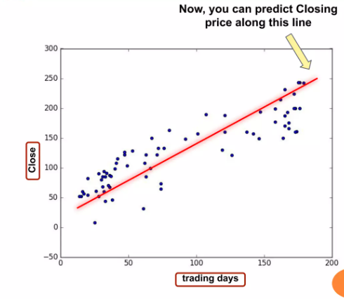

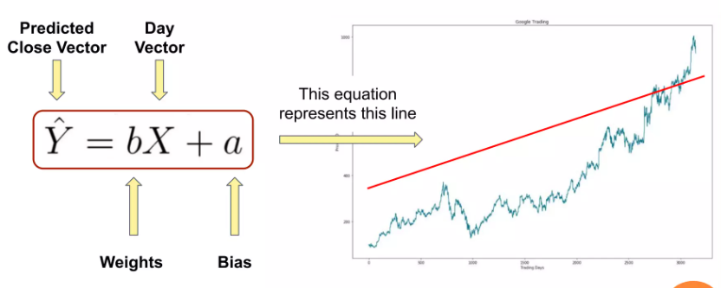

ADVANTAGES:

1. We start off with some random and bias data
2. so that it will resemble this.

DISADVANTAGES:

- It is often quite prone to noise and
- overfitting.
- Linear regression performs poorly when
- there are non-linear relationship

RANDOM FOREST:

including classification and regression issues. It is a compilation of different decision trees. It is a machine learning algorithm in the style of a flowchart that is particularly effective for Issues with categorisation. The is, being an enhancement over decision tree algorithms, resolves the overfitting problem that most decision tree methods have in their training sets.
2. It is possible to train a categorization or regress tree. using this fresh data (fb). By averaging the results from the several trees after training is finished, predictions for fresh, unobserved data (x') can be formed. 𝑓̂ = 1 𝐵 ∑ 𝑓𝑏 𝐵 𝑏=1 (𝑥 ′ )  Additionally, the standard deviation of each output from each distinct tree on the unobserved data (x') can be used to calculate the prediction's level of uncertainty. [10] 𝜎 = √ ∑ (𝑓𝑏(𝑥 ′)−𝑓̂) 𝐵 2 𝑏=1 /𝐵−1

MACHINE FOR SUPPORTING VECTORS:

In machine learning algorithm known as SVM is used for regression analysis. In supervised learning tasks, the objective is to classify new data using patterns discovered from a training set of labelled samples. SVMs are frequently employed in these tasks.
Finding the best hyperplane in a high-dimensional space to divide two classes of data is the fundamental tenet of SVM. The hyperplane is selected in order to maximise the margin between the classes, orthe distance separating the plane and the closest information points in each class. The data points which are most closely connected to the hyperplane are the support vectors, which constitute the SVM's decision border..
SVMs can be enhanced beyond binary classification to tackle multi-class problems utilising strategies like one-vs-one or one-vs-all classification. Regression analysis can also be performed using SVMs by fitting a hyperplane that minimises the gap between expected and actual results.
In comparison to other machine learning methods, SVMs offer a number of benefits, including the capacity to handle high-dimensional data and their tolerance to overfitting. To attain best performance, SVMs may need to have their hyperparameters carefully tuned and might be computationally expensive to train.

REGRESSION OF SUPPORT VECTOR:

It also known as SVR, is a type of the technique, which is used for regression analysis. SVR is used for continuous value prediction, whereas SVMs are typically utilised for classification.Finding the ideal hyperplane to divide the data points is the core tenet of SVR, which is comparable to it. However, with SVR, the objective is to locate a hyperplane that, are the data points that are most closely spaced from the hyperplane.
SVR utilises a loss function that penalises the divergence of the predicted outputs from the actual outputs, in contrast to conventional regression models that minimise the sum of squared errors (SSE). Epsilon-insensitive loss functions, which ignore errors up to an epsilon from the true output, are the most often used loss functions.Similar to SVMs, SVRs can be enhanced using kernel functions to address non-linear regression issues. Kernel functions turn the input data into a space of greater dimension so each data point can be split by an imaginary .SVR outperforms traditional regression models in several areas, including its ability to handle irregular data and its resistance to outliers.
However, training SVR can be computationally expensive and may necessitate careful hyperparameter optimization.

CONCLUSION

In conclusion, recent year have seen encouraging progress in the use of machine learning techniques, particularly lstm neural networks, for price prediction. LSTM models are highly suited for predicting stock prices that have a significant time-dependent structure because they can capture
to include various features and previous data to produce predictions is one of their main advantages. Data the company's financial performance, news stories, social media sentiment, and technical indications are some examples of this.
I is critical that one recalls the share value forecast is a difficult problem, there is no assurance that any model will consistently deliver accurate results. A wide range of unforeseen variables, such as alterations in the world economy, political unrest, and unexpected company news, can have an impact on stock prices.
Therefore, rather of exclusively relying on the model's predictions, it is advised to employ machine learning models as a tool to aid in decision-making. In order to assess how well the model general to new data, it is also crucial to assess the model.
In conclusion, LSTM models can be useful for predicting stock prices, but it's vital to use caution and support the forecasts with professional knowledge and research.

References
- Archana Gupta, Pranay Bhatia, Kashyap Dave, Pritesh Jain "Stock Market Prediction Using Data Mining Techniques", 2nd International conference on advanced Science and Technology, ICASR 2019.
- David M. Q. Nelson, Adriano C. M. Pereira, Renato A. de Oliveira "Stock Markets Price Prediction using LSTM Neural Networks", International Joint Conference on Neural Networks, May 2017.
- Adil MOGHAR, Mohamed HAMICHE, "Stock Market Prediction Using LSTM Recurrent Neural Network", International Workshop on Statistical Methods and Artificial Intelligence IWSMAI 2020, April 6-9 2020, Warsaw Poland.
- "Stock price prediction using machine learning techniques: A survey" by Xiaojun Chen, et al. (2021). This paper provides a comprehensive survey of the recent research on stock price prediction using machine learning techniques.
- "A deep learning framework for stock price prediction using financial news" by Ankit Agrawal, et al. (2021). This paper proposes a deep learning framework for stock price prediction that utilizes financial news as an input.
- "A comprehensive survey on stock price prediction using deep learning" by Q. M. Rafiul Islam, et al. (2021). This paper provides a comprehensive survey of the recent research on stock price prediction using deep learning techniques.
- "A hybrid machine learning model for stock price prediction using financial news and technical indicators" by Ye Ding, et al. (2019). This paper proposes a hybrid machine learning model for stock price prediction that combines financial news and technical indicators as inputs.

