Silent Speech Mobile Interaction

Rutveej Rajendra Jadhav¹
Electronics & Telecommunication
JSPM’S Rajarshi Shahu College of Engineering
Pune,India
jadhavrutveej@gmail.com

Soham Sopan Haran²
Electronics & Telecommunication
JSPM’S Rajarshi Shahu College of Engineering
Pune,India
sohamharan@gmail.com

Mrs. Shilpa Sonawane
Professor Department of Electronics & Telecommunication JSPM’s Rajarshi Shahu College Of Engineering,
Pune, India
Aman Shahid Pathan³
Electronics & Telecommunication
JSPM’S Rajarshi Shahu College of Engineering
Pune,India
amanpathan2626@gmail.com

---------------------------------------------------------------------***--------------------------------------------------------------------
Abstract:

We have developed a module called Silent Speech that enables users to control their smartphone with their lip movements. Our module analyzes the user’s lip images and matches them with a predefined dataset to produce an output. Our system supports 26 commands for various tasks such as launching apps, adjusting settings and handling popups. We evaluated the performance of Silent Speech with user tests and measured its recognition accuracy. We also compared it with voice and gesture commands in terms of privacy and usability. We found that Lip-Interact can help users interact with their phone discreetly, communicate with others without disturbing them, and free their hands for other activities.

Keywords: Silent Speech, Data collection, Lip-reading

Introduction:
Today’s world is totally engaged into the mobile applications and its use. In our daily life there are some situations where you are not able to use your smartphone very efficiently. Let’s say sometimes you are in a train and your one hand is busy catching the support and with the other hand you are using your smartphone. It is not easy to access the smartphone by only one hand and tapping on the screen with the fingertip. Hence, paper present Silent Speech Mobile Interaction which will allow the user to give commands to their mobile phone through silent speech. Here the user has to issue or give the commands using their lips. This lip movement will be detected by our AI model and the task will be performed. Silent Speech Mobile Interaction will also benefit the physically challenged people who cannot speak i.e., those who are deaf and dumb. Thus, providing a helping hand to the mankind. The goal of Lip-Interact is to provide a simple, yet powerful approach to issuing commands on the smartphone. Silent Speech Mobile Interaction refers to a technology that enables users to interact with their mobile devices without speaking out loud or making any audible sounds. Instead, it uses silent speech recognition techniques to interpret the user's internal speech or subvocalizations. The idea behind silent speech interaction is to capture and analyze the electrical signals generated by the muscles involved in speech production, such as those in the throat, tongue, and face. These signals are then processed by specialized algorithms and converted into understandable commands or text input for the mobile device. In this article, in paper introduce Lip-Interact, which allows users to enter their smartphones with a silent gesture. Silent Speech model redesigns the device's front camera to capture the user's mouth, segment silently speaking, and recognize lip movements based on commands from deep learning based on image sequence recognition technology. For example, to take a selfie, users can say "open camera" in just one step to launch the app directly instead of calling themselves, and then "take" to press the shutter button instead of reaching for an unbalanced thumb that causes blindness. In addition, users can use "home", "back", "screenshot", "flashlight", etc. to easily control device settings. can issue commands.

II. Literature Survey
The authors from previous paper discuss the challenges of traditional approaches to lipreading, which rely on hand-crafted features and are often limited by the complexity and variability of speech movements. They propose a deep learning-based solution that can learn directly from raw video data, allowing for greater flexibility and accuracy. The proposed approach uses an LSTM neural network to process video frames of the speaker's mouth movements. The LSTM is able to capture the temporal dynamics of speech movements, allowing for accurate recognition of phonemes and words. The authors also incorporate a spatial attention mechanism to focus on the most informative regions of the video frames. The authors evaluate their approach on two lipreading datasets and show that it outperforms state-of-the-art methods, achieving an accuracy of over 80% on both datasets. They also demonstrate the robustness of their approach to noisy and low-resolution video inputs. Overall, the paper presents a promising approach to automatic lipreading that has the potential to improve speech recognition in noisy environments or for individuals with hearing impairments [1].
The authors first discuss the limitations of traditional front-facing lipreading approaches, which can be affected by factors such as lighting conditions, occlusion, and facial expressions. They propose using a profile view of the speaker's face, which provides a clear view of the lips and reduces the impact of these factors. The proposed approach uses a combination of motion and appearance features to capture the movement and appearance of the lips in the profile view video footage. The authors also incorporate a dynamic Bayesian network (DBN) to model the temporal dynamics of the lip movements and improve the accuracy of the lipreading system. The authors evaluate their approach on a dataset of profile view videos of speakers reciting isolated words and show that it outperforms traditional front-facing lipreading approaches, achieving a
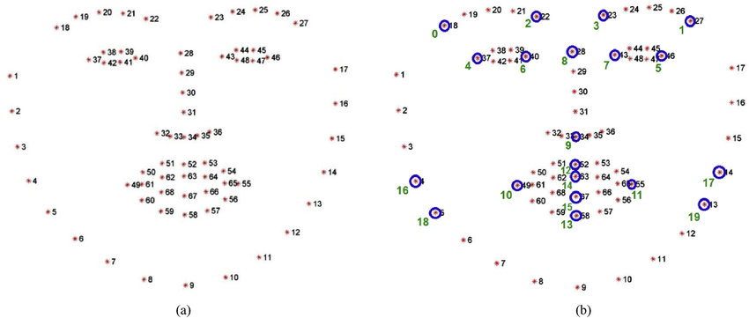
Figure 1.1 Facial landmark detection
word recognition accuracy of over 70%. They also demonstrate the robustness of their approach to variations in lighting conditions and facial expressions. Overall, the paper presents a promising approach to lipreading that addresses some of the limitations of traditional approaches. The use of profile view video footage and a dynamic Bayesian network model could improve the accuracy of lipreading systems, particularly in challenging conditions [17].
GRID: The GRID dataset, released in 2006, is a widely used dataset in the field of lip-reading research. It is a corpus of videos containing spoken sentences, recorded in a studio setting, by 34 different individuals. The sentences have a fixed structure and belong to 51 classes of words, such as colors, numbers, and letters. The GRID dataset is primarily designed for testing the accuracy of lip-reading models on clear and simple speech. The videos in the dataset have a resolution of 360x288 pixels and a frame rate of 25 frames per second. The videos are recorded in black and white and the speaker's face is the only visible object in the video. The dataset is accompanied by a set of text transcriptions of the spoken sentences, which can be used to evaluate the accuracy of lip-reading models. The GRID dataset provides a valuable resource for researchers who are interested in developing and testing such algorithms. By using the GRID dataset, researchers can test their models on a large, standardized dataset and compare their results with other researchers working in the same field. Overall, the GRID dataset is an important resource for the development and evaluation of lip-reading models, and it has been widely used in research to improve the accuracy of these models.
MIRACL-VC1: MIRACL-VC1 is a valuable dataset for researchers working on lip reading and speech recognition models. It was created in 2014 and includes spoken words and phrases by 15 different individuals using a Kinect sensor. The dataset comprises both color and depth images of the speakers' mouths, providing more comprehensive information for lip reading models. The dataset is divided into ten classes, each with ten different phrases or words, such as greetings, commands, and questions. This categorization helps researchers to develop models that can handle different types of speech accurately. The images in the dataset have a resolution of 640x480 pixels and a frame rate of 15 frames per second, which is sufficient to capture the subtle movements of the lips and mouth during speech. MIRACL-VC1 is unique from other lip-reading datasets due to its inclusion of depth information. This additional data provides a more detailed representation of the speaker's mouth movements and helps to improve the accuracy of lip-reading models. The dataset has been widely used by researchers to develop and evaluate various lip reading and speech recognition models.
LRW: This is a dataset that was presented in 2016 for lip reading research. It has words that are spoken by over 1000 different people in natural videos from the web. The words belong to 500 classes and are aligned with subtitles, which can help with training lip reading models. The images have a resolution of 256x256 pixels and a frame rate of 25 frames per second. This dataset is challenging for lip reading models because it involves diverse speakers, backgrounds, lighting conditions, and head poses34. Lip reading is the process of recognizing speech from visual information only3. Lip reading can have many applications, such as helping people with hearing impairments, enhancing speech recognition in noisy environments, or enabling silent communication24. However, lip reading is also very difficult because of many factors, such as mumbling, accents, foreign languages, jargon, and homophenes. Homophenes are words that look similar when lip read, but have different sounds. For example, “pat” and “bat” are homophenes because they have the same mouth shape but different sounds.

III. Methodology
1. Dataset Preparation:As suggested in introduction, this paper had to manually create few lip motion datasets for the training of our model. Because there is a large variation in the way of pronouncing and mouth shape according to each individual, we collected the lip motion video of team members that are supposed to use standardized pronunciation. For each command, 30 raw data were collected from 3 people as shown in Table 1. The raw video data had to be preprocessed appropriately for the training of the deep learning model. Considerations in preprocessing are as follows:
Sr.No. | Words | Sr.No | Words | Sr.No. | Words
1 | Back | 11 | Open Whatsapp | 21 | Delete
2 | Home | 12 | Open Browser | 22 | Check
3 | Screenshot | 13 | Open Camera | 23 | Answer
4 | WiFi | 14 | Open Gpay | 24 | Hangup
5 | Mute | 15 | Open Camera | 25 | Yes
6 | Flashlight | 16 | Open Music | 26 | No
7 | Notification | 17 | Open Message
8 | Recent Apps | 18 | Open Mail
9 | Bluetooth | 19 | Open Photos
10 | Lock | 20 | Open Alarm

Table 1. 26 Commands used in Dataset

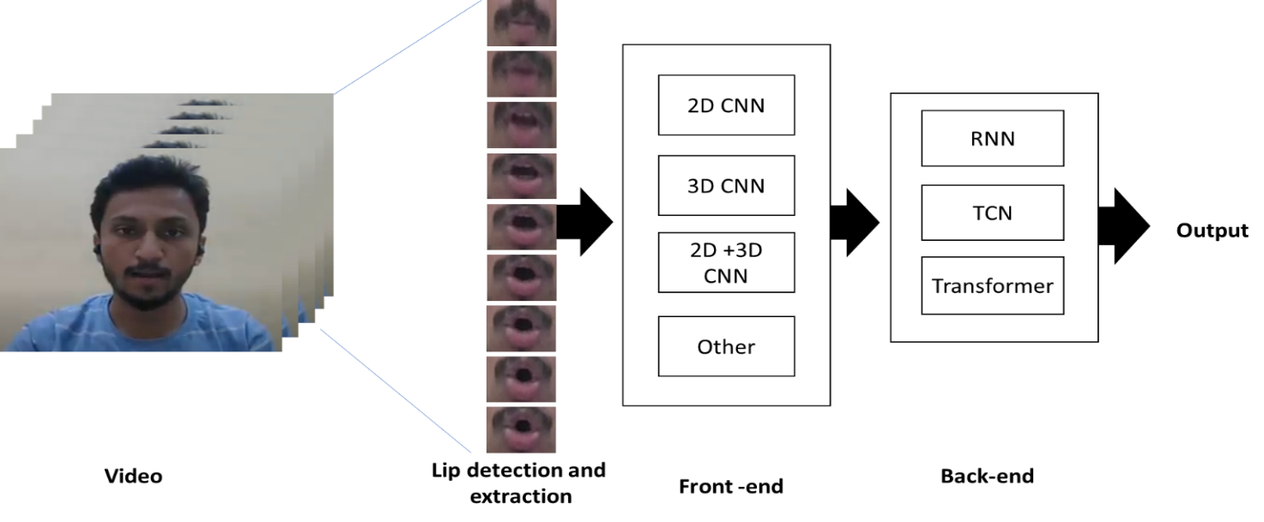
Two ways of Lip detection which is to extract only the image of the lips (Because during the detection process something which is not lip can be detected, there are some loss of # of data) Cropping and Resizing to be 64 x 64 RGB images. Padding & Sampling for data (frame) normalization 8:2 ratio of Train/Validation set. By using some video capture software program like Bandicam, you can get a avi file of video. This paper need a special preprocessing process because in project a user-created dataset rather than a formal dataset. To do this, use the OS and OpenCV libraries. Other libraries are the same as the previous example code, except for some layers, keras package needed. Creating Datasets Our own datasets can be converted to deep-running formats through the following path algorithms. The dataset to be used at this time must be stored with the code in folder-subfolder format.The data is stored in a subfolder in the form of a jpg image in numerical order, so it is read through the loop by OpenCV Library function imread. At the same time, the image is scaled to the input size for transfer Learning by OpenCV Library function resize, and the
Figure 1.3 Model Architecture
LSTM
label is stored after escaping the subfolder. In the case of input data, we can see that it has the same shape as the first input parameters to put into the model. The label is also made up of

a stack of one-dimensional matrices. And, the dataset and its corresponding labels should also be shuffled to fit function They must be shuffled in the same order, and for this, a random array corresponding to the data size is created and the shuffle proceeds in that order.

2.Building a Model
In figure 1.3, the model configuration consists of three steps.1.CNN model architecture declaration ( Transfer Learning model) 2.LSTM model architecture declaration 3.Combine whole model CNN+LSTM model architecture CNN model code is shown upper. We selected the MobileNet architecture with a relatively low weight as the transfer learning model considering the model size by adding the LSTM layer. You can use other models like InceptionV3, ResNet50 etc.. by simple change of applications class name to this from MobileNet, but you must modify the required parameters as ( cols, rows, channel ) shape The MobileNet

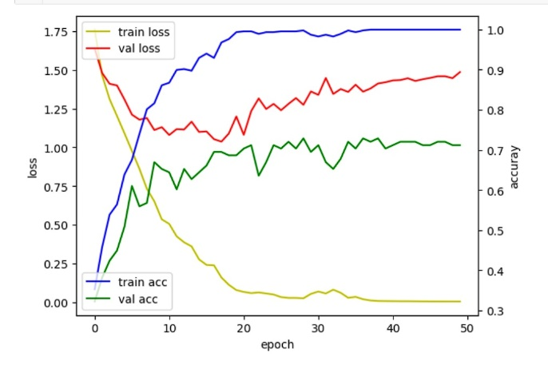
receives specified image and returns the CNN code, which is set to be impossible to learn. At the end of the CNN model, the dense layer consists of two sets of learnable states, which will be used as input to the LSTM layer, so the activation function is both ReLu. The dense layer has 1024, 128 nodes each and includes a dropout layer in the middle. It is formed as an independent structure Lstm_inp and can be modified internally. As the optimizer, we used the Adam optimizer which is generally known to have good performance and the default parameters are the default values. Details of this can be found on the Keras library website. Also, since classifying the classes and set the loss function like this. You can use this function to verify the model architecture, but this applies only to the post-LSTM part.
Figure 1.4. Result of validation accuracy
3. Training the Model
Since the generator is not specified in this case, the model fit() function is used. the whole data is put into memory instead of reading the data into the flow every moment, and the shuffled batch is extracted and used. Therefore, a very large data set will require special preprocessing in our case. By running this function, you can observe the training process in real time as shown in the figure. This helps to stop immediately when judged that the wrong training is going on. Confirm the Learning Process. Visualizing the training process is exactly the same as the previous example, and works on any model if you only set the model name. The green line represents validation acc and the red line represents validation loss, which is an important indicator of training. If, during training, the validation loss tends to increase without further decline, the model should be discontinued because it is overfitting.

IV.RESULT
The models trained with the conditions above showed the successful result of validation accuracy exceeding 80%. below three figures are training history of our models with 10, 15, and 20-time steps, respectively. Among 3 time steps (# of frames), 10-time steps showed the best result of 80% validation accuracy. Also, the graph of 10-time steps result, which was obtained by accepting only first 10 frames per video as shown in figure 1.2, is the most stable.
Figure 1.4 shows the minimum value loss and maximum value of our training data.Among the 26 commands, 16 can be accurately recognized. Model test: The trained model has been recorded as a ‘.h5’ file and then loaded again to test constructed by SVM-based lip detection algorithm. It appears that since the test set was preprocessed in a different way from the training and validation set, the test accuracy is lower than the validation accuracy.
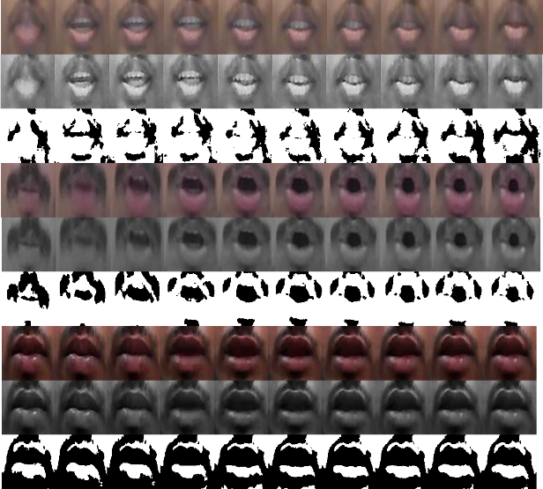
V. Conclusion
Figure 1.2 First 10 frame per video
This paper presents an optimal design and development of a system for silent speech mobile interaction. The paper also introduces a methodology for creating a dynamic vocabulary dataset for mobile application that can serve as a model for future work. Moreover, the paper demonstrates how the system can convert silent videos into words that can benefit researchers in related fields. This paper proposes a new method for silent speech mobile interaction that uses deep learning and computer vision to convert silent videos into words. The paper also describes how the dataset of silent speech videos was created and collected from different speakers and environments. The paper evaluates the accuracy and robustness of the system and shows its potential for various use cases such as speech therapy, voice authentication, and silent communication. result of validation accuracy exceeding 80%.
Acknowledgement:
This study is being completed at JSPM's Rajarshi Shahu College of Engineering, Tathawade, under the supervision of the Department of Electronics and Telecommunication.
References:
[1] Michael Wand, Jan Koutník, and Jürgen Schmidhuber, “Lipreading with long short-term memory” | Issue : Jan 2016, 1601.08188
[2] K. J. Ray Liu, “Speech and Signal Processing” (ICASSP),IEEE International Conference on. IEEE, 2016, 6115–6119.
[3] Joon Son Chung, “Deep Lip Reading: a comparison of models and an online application (arxiv.org)”, Jun 2018,1806.06053
[4] Caroline Appert and Shumin Zhai. “Using Strokes As Command Shortcuts: Cognitive Benefits and Toolkit Support”. In Proceedings of the SIGCHI Conference on Human Factors in Computing Systems (CHI ’09). ACM, New York, NY, USA, 2009, 2289–2298.
[5] Yannis M Assael, Brendan Shillingford, Shimon Whiteson, and Nando de Freitas, “LipNet: end-to-end sentence-level lipreading”, (2016),
[6] Patrick Baudisch and Gerry Chu. “Back-of-device Interaction Allows Creating Very Small Touch Devices”. In Proceedings of the SIGCHI Conference on Human Factors in Computing Systems (CHI ’09). ACM, New York, NY, USA, 2009,1923–1932.
[7] Jonathan S Brumberg, Alfonso Nieto-Castanon, Philip R Kennedy, and Frank H Guenther. “Brain–computer interfaces for speech communication”.Speech communication 52, 4 2010, 367–379.
[8] Alex Butler, Shahram Izadi, and Steve Hodges. 2008. SideSight: Multi-"Touch" Interaction Around Small Devices. In Proceedings of the 21st Annual ACM Symposium on User Interface Software and Technology (UIST ’08). ACM, New York, NY, USA, 201–204.
[9] Xiang ’Anthony’ Chen and Yang Li. “Bootstrapping User-Defined Body Tapping Recognition with Offline-Learned Probabilistic Representation” In Proceedings of the 29th Annual Symposium on User Interface Software and Technology (UIST ’16). ACM, New York, NY, USA, 2016, 359–364.
[10] Xiang ’Anthony’ Chen, Julia Schwarz, Chris Harrison, Jennifer Mankoff, and Scott E. Hudson. “Air+Touch: Interweaving Touch & In-air Gestures”. In Proceedings of the 27th Annual ACM Symposium on User Interface Software and Technology (UIST ’14). ACM, New York, NY, USA, 2014,519–525.
[11] Cooke, J. Barker, S. Cunningham, and X. Shao, ‘‘An audio-visual corpus for speech perception and automatic speech recognition,’’ J. Acoust., Soc. Amer., vol. 120, no. 5, p. 2421, 2006.
[12]. Antonakos, A. Roussos, and S. Zafeiriou, ‘‘A survey on mouth modeling and analysis for sign language recognition,’’ in Proc. 11th IEEEInt. Conf. Workshops Automat. Face Gesture Recognit. (FG), vol. 1,May 2015, pp. 1–7.
[13] S. Petridis, T. Stafylakis, P. Ma, F. Cai, G. Tzimiropoulos, and M. Pantic,‘‘End-to-End audiovisual speech recognition,’’ in Proc. IEEE Int. Conf.Acoust., Speech Signal Process. (ICASSP), Apr. 2018, pp. 6548–6552.
[14] D. Kumar Margam, R. Aralikatti, T. Sharma, A. Thanda, P. A K, S. Roy,and S. M Venkatesan, ‘‘LipReading with 3D-2D-CNN BLSTM-HMM and word-CTC models,’’ 2019, arXiv:1906.12170. [Online]. Available:http://arxiv.org/abs/1906.12170
[15] E. K. Patterson, S. Gurbuz, Z. Tufekci, and J. N. Gowdy, ‘‘CUAVE: A new audio-visual database for multimodal human-computer interface research,’’ in Proc. IEEE Int. Conf. Acoust. Speech Signal Process. (CASSP), May 2002, p. II-2017.
[16] S. NadeemHashmi, H. Gupta, D. Mittal, K. Kumar, A. Nanda, and S. Gupta, ‘‘A lip reading model using CNN with batch normalization,’’ in Proc. 11th Int. Conf. Contemp. Comput. (IC), Aug. 2018, pp. 1–6.
[17] K. Kumar, T. Chen, and R. M. Stern, ‘‘Profile view lip reading,’’ in Proc. IEEE Int. Conf. Acoust., Speech Signal Process. (ICASSP), vol. 4, Apr. 2007, pp. IV-429–IV-432
[18] S. Yang, Y. Zhang, D. Feng, M. Yang, C. Wang, J. Xiao, K. Long, S. Shan, and X. Chen, ‘‘LRW-1000: A naturally-distributed large-scale benchmark for lip reading in the wild,’’ in Proc.14th IEEE Int.Conf. Autom. Face Gesture Recognit. (FG), May 2019, pp.18.

