Public opinion on the market for mobile accessories in Tamilnadu

Author profile :
S.MATHUMITHRA
BALLB
Reg No: 131801060.
SAVEETHA SCHOOL OF LAW
SAVEEETHA INSTITUTE OF MEDICAL AND TECHNICAL SCIENCES (SIMATS)
SAVEETHA UNIVERSITY
CHENNAI-77

Coauthor profile:
Mrs.K.S.SOBHA JASMINE
ASSISTANT PROFESSOR
SAVEETHA SCHOOL OF LAW
SAVEEETHA INSTITUTE OF MEDICAL AND TECHNICAL SCIENCES (SIMATS)
SAVEETHA UNIVERSITY
CHENNAI-77

Public opinion on the market for mobile accessories in Tamilnadu

Author:S.Mathumithra

Co Author :K.S.SobhaJasmine

Abstract
The expansion in cell phone entrance is invigorating a pattern towards the utilization of cell phones to enhance or even supplant customary phone overviews. Regardless of this pattern, few examinations have efficiently looked at contrasts between the two modes. This paper depicts an examination in which both portable and settled telephones were utilized to gather information on a national review on web and social practices. Discoveries uncovered critical contrasts between cell phone respondents and settled telephone respondents as far as statistic attributes and reactions to a portion of the substantive things of the study. Regarding information quality the cell phone review ended up being not the same as the settled telephone overview in two markers: finishing times and level of respondents with thing oversights. The cell phone study was more hard to execute than the settled telephone study since considerably more screening was required to distinguish working telephone numbers; likewise it yielded a lower reaction rate than the settled telephone study.

Introduction

Cruising through the trial of times, India has gladly developed as the third biggest economy of the world. It has not just demonstrated its grit crosswise over assorted areas and yet additionally surfaced as a lucrative market for different businesses. For example, regist,Mobile telephone adornments allude to any equipment that isn't fundamental to the activity of a versatile cell phone as structured by the maker.(Martin 2017) Further, cell phone embellishments incorporate screen defenders, planner cases, selfie sticks, portable cases, cell phone stands, headphone augmentation links, headphone splitters and others.Mobile frill producers, providers, wholesalers and different stakeholders Associations, associations, gatherings and partnerships identified with versatile adornments. Government bodies, for example, controlling specialists .The investigation is valuable in giving responses to a few basic inquiries that are vital for industry partners, (Oparandu 2016; Evers, n.d.)for example, portable extras makers, merchants and approach creators. The investigation would likewise assist diverse partners with targeting the developing sections over the coming years and help them in taking venture choices and encouraging their extension.In spite of the fact that the sort of telephone get to shifts significantly from nation to nation, crosswise over Europe there are some general improvements that can be recognized in regards to phone courses of action:(Frei 2013) the level of families furnished with a settled telephone is dropping, while the level of families outfitted with cell phone get to is rising; moreover, the level of portable just family units is expanding, while the level of families that have just settled telephone get to is diminishing. In nations, for example, Finland, Italy, Portugal, Belgium and Slovenia, settled telephone inclusion has just been overwhelmed by cell phone inclusion and there is by all accounts an unequivocal inclination to a broad speculation of the wonder to different nations.(Oparandu 2016)

Key words : Outfitted,abdornments,extension.portable, merchants.

Market Size and Forecast
(Elwood and Mark Elwood 2014)To break down and conjecture the market size of India versatile adornments.
To characterize, group and estimate the India portable embellishments showcase on premise of item compose, appropriation compose, value run and local dispersion. (de Vocht 2018)
To investigate point by point advertise division and estimate the market measure, as far as esteem, by dividing (Kato, n.d.)the nation's market into four locales, specifically - North, South, East and West.
To break down and conjecture advertise estimate, as far as esteem, for versatile adornments, concerning key item composes which incorporate telephone cases, earphones and headphones, control banks, compact speakers and others. (Tenhunen 2018)
To deliberately profile driving players in the market which are engaged with assembling portable adornments the nation over.
Techsci ((Hocking 2003) Research performed both essential and in addition comprehensive auxiliary research for this examination. At first, TechSci Research sourced a rundown of countrywide portable adornments producers and suppliers. Consequently, TechSci Research led essential research studies with the recognized organizations. (Hocking 2003; Vincent, n.d.)While meeting, the respondents were additionally enquired about their rivals. TechSci Research additionally broke down the item contributions or variations and local nearness of significant portable frill producers and suppliers.

TechSci Research computed India portable embellishments showcase estimate utilizing top-down and additionally base up methodologies, where information for various sections was recorded and conjecture for the future years. TechSci Research sourced these qualities from industry specialists and friends delegates and these were remotely approved through investigating authentic information of versatile extras producers and (Sillice et al. 2018)suppliers to land at the general market estimate. Different auxiliary sources, for example, World Bank site, government sites, official statements, white papers, organization yearly and budgetary reports, and so forth were additionally contemplated by TechSci Research.
Portable embellishments producers, providers, wholesalers and different partners .
Affiliations, associations, discussions and partnerships identified with portable extras .Government bodies, for example, controlling specialists and approach creators(Ghose 2018)

Statistical surveying and counseling firms
The investigation is valuable in giving responses to a few basic inquiries that are critical for industry partners, for example, versatile embellishments makers, merchants and approach creators. The examination would (Philip Garner and Garner 2006)likewise assist diverse partners with targeting the developing sections over the coming years and help them in taking venture choices and encouraging their extension.
Report Scope:
In this report, India versatile embellishments showcase has been portioned into the accompanying classes notwithstanding the business patterns which have likewise been definite underneath: (van Thanh, n.d.)
Organization Profiles: Detailed examination of the real organizations working in versatile frill showcase in India.(Fadia 2005)

Sanjeev Bhatia,Mobile accessories on a smart path- India has proudly emerged as the third largest economy of the world.(Tu et al. 2018)The Indian smart phone sector is booming as the third largest smartphone market in the world.Interestingly, the term “Mobile accessories” is not only restricted to fancy mobile covers and decorative stands.

Latha Rajendra Kumar,Awarness of mobile phone hazards- Perception of health hazards and outcomes were compared by gender,age,course of study preferred ear.(Gross and Bertschi, n.d.)General population particularly students as the perceived health risk did not significantly deter students of mobile phone.

Alex laverty,Building a Mobile based public opinion- Using Mobile phones for political opinion polls would be the effective way of identifying voter fraud as well as providing feed back for political parties. Additionally, those that respond to an SMS based poll versus citizens that do not will like to be explored.

Paula Vincent’s,The Impact of “cell-onlys”on public opinion polling- The increase in the mobile phone penetration is stimulating a trend towards the use of mobile phones to supplement or even replace telephone surveys. Mobile phone respondents and fixed phone responding in terms of demographic characteristics and response.

Elizabeth Reis And Maria Santos, Using Mobile phones - A comparison with fixed phones.In most countries there are no lists of mobile phone subscribers where they do exist, they suffer from multiple operators users with more than one subscription.The absence of a directory forces mobile phone number samples to be created by randomly generating numbers.

Paul frank,Study of mobile phone usage among teenagers - A cell isn’t just a rich man’s fashion accesory in India. It is transforming the way millions of people do business in a country where even landlines were a luxury barley a decade ago. Across the country people with low incomes are how adopting cellular phones as tools for enchancing their business.

Mathew A Timmis,Herre Bijl, The impact of mobile phone use on where we look and how - Pedestrains regularly engage with their mobile phone whislt walking. While wearimg a mobile eye tracker and motion analysis, participants walked upto and negotiated a phone. Phone users were able to adopt their visual search behaviour.

Aaron smith,The impact of mobile phones on peoples live-When it comes to the positive impacts of cell phone ownership, fully two thirds of cell owners. Say that mobile phones have made it lot easier to stay in touch with the people.

Geogre Lee, Effects of using mobile phones too much - There are harmful health effects, will high might be caused by the immordate use of cell phones. According to modern researches, the most menanacing problem is connection between cell phones and cancer.

Federov, Excessive use of cell phone may cause deprission and distraction - In today’s fast moving and globalised world it is almost impossible tp imagine our day today life without mobile phones. It is one of the most inventions of 20 th century which has become a convenient.

Hardwilson, Cell phones and cancer risk - Today’s world is a world technology and inventions, and there are many tools which essentialy facilitate our life. Mobile phones play an important role in the development of human civilization but their excessive use brings severe problems.

Dr.N.V.S.Suryanarayanan, Positive and negative effects of mobile phones on students career- The very first positive point of mobile phones communication.With mobile phones is communicate with anyone from anywhere. Nowadays, the smartphones which are coming at small size.

Ansari.R,Harms of mobile phones - Mobile phones are undeniably convenient. Because of mobile phones, students never have to look for pay phone or wonder about a location of fried. These abiquitious communications tools allow students.

Eija.L.K, Mobile culture of children and teenagers - It is true that mobile phones can help students in the studies but only if they use them wisely. Most of the students become additive to mobile phones and are found playing games, chatting with friends.

Zahid Naeem, Health risks associated with mobile phone use - Mobile phones emits radio frequency energy, a form of non-ionizing electromagnetic radiation, which can be absorbed by tissues dose to the phone. The amount of radio frequency energy a mobile phone user is exposed depend on may factors.

John Paul, Positive impact of cell phones - Cell phones have been found to have many benefits although there is some anxiety about their safety. They are so popular becausethey can be carried from place to place. Cellular phones were orginally for cars only.

Milton James, The epidemic of mobile phones in today’s society - As technology further advances and becomes more evident in today’s society. There is no arguing that cell phones can be implemented in a positive manner by making it easier for us to keep in touch.

Tyrell Joie, Cell phones in schools and colleges - Cell phones over the past few years have become essential to teens. Attribiulate to this increase in cellphones teens bring them everywhere including school.On the other hand if teachers allowed the use of these devices.

Wong & Hiew , How cell phone use has become a subculture- The use of the cell phone is considered as subculture when referring to youth. This device is becoming a culture infact that is shaping today’s culture. Studies show that adolescents, use of cell phones around the world is characterised.

Lee Rainie and Kathryn Zickuhe, Americans views on mobile Etiquette - Cell phones and smartphones have become a mainstay in the lives of many Americans, and this has introduced new challenges into how usersand non users a like approach basic social norms and funds. People are sorting through new rules of civility in an environment where once private conversation.

Objectives
To think about the disposition of young people and youth, age amass 15-30 years, towards mobile phones.
• Enumerate the utilization designs and land at eccentricities, sexual orientation savvy or age-wise, assuming any.
• Examine the manner in which youngsters identify with the usefulness of cell phones and additionally survey recognizable wonders.

Research Methodology

The present investigation depends on essential information gathered by the specialist and the optional information gathered from the books, diaries and online sources. The present investigation utilized straightforward irregular inspecting technique for choice of tests on the grounds that the populace is too high. An aggregate number of 50 test respondents in the age gathering of 18-60 years were chosen haphazardly from Chennai, one of the four metropolitan urban areas in India. The investigation utilized rate for important examination of the consequences of the investigation. This empirical research is based on observed and measured phenomena and derives knowledge from actual experience rather than from theory or belief. Key characteristics for an empirical research specific research questions to answer inquire about inquiries. It tends to be issue, strategy or law change based. On this bases the survey is taken near the residence of Chennai.
Sampling method: Random sampling method
Sample size:1500
Independent variables: age, gender ,sex ,educational qualification ,occupation

2.Age
 |  | Frequency | Percent | Valid Percent | Cumulative  Percent
Valid | 15-30 | 627 | 52.5 | 52.5 | 52.5
 | 31-45 | 391 | 32.7 | 32.7 | 85.2
 | 46-60 | 162 | 13.6 | 13.6 | 98.7
 | Above 60 | 15 | 1.3 | 1.3 | 100.0
 | Total | 1195 | 100.0 | 100.0
From the above table age frequency of the common people between 15-30 is 52.5% and 31-45 is 85.2% and the age between 46-60 is 98.7% and above 60 is 100% and finally the frequency of the age is 100%

3.Gender
 |  | Frequency | Percent | Valid Percent | Cumulative Percent
Valid | Male | 697 | 58.3 | 58.3 | 58.3
 | Female | 489 | 40.9 | 40.9 | 99.2
 | Transgender | 9 | .8 | .8 | 100.2
 | Total | 1195 | 100.0 | 100.0
From the above table male candidates are 58.3% and the female candidates are 99.2 and the transgender candidates are 100.2%

4.Educational Qualification
 |  | Frequency | Percent | Valid Percent | Cumulative  Percent
Valid | SSLC | 81 | 6.8 | 6.8 | 6.8
 | HSC | 214 | 17.9 | 17.9 | 24.7
 | Degree/Diploma | 553 | 46.3 | 46.3 | 71.0
 | Post graduation | 257 | 21.5 | 21.5 | 92.5
 | Others | 90 | 7.5 | 7.5 | 100.5
 | Total | 1195 | 100.0 | 100.0
From the above table the educational qualifications 6.8 % of people have studied SSLC and 17.9% have studied HSC 46.3 have studied degree\diploma and 21.5% of had completed their post graduation .

5.Occupation
 |  | Frequency | Percent | Valid Percent | Cumulator  Percent
Valid | Private  Sector | 232 | 19.4 | 19.4 | 19.4
 | Public  Sector | 242 | 20.3 | 20.3 | 39.7
 | Unemployed | 269 | 22.5 | 22.5 | 62.2
 | Self  Employed | 276 | 23.1 | 23.1 | 85.3
 | Others | 108 | 9.0 | 9.0 | 94.3
 | Home maker | 68 | 5.7 | 5.7 | 100.0
 | Total | 1195 | 100.0 | 100.0
From the above table 19.4% of people were working in private sector and 20.3% of people were working in public sector and 22.5% peolple were unemployed and 23.1% of people were self employed and others were 9.0%.

63.The market for mobile accessories widened in the recent past
 |  | Frequency | Percent | Valid Percent | Cumulative Percent
Valid | Strongly agree | 174 | 14.6 | 14.6 | 14.6
 | Agree | 379 | 31.7 | 31.7 | 46.3
 | Neutral | 368 | 30.8 | 30.8 | 77.1
 | Disagree | 216 | 18.1 | 18.1 | 95.1
 | Strongly  Disagree | 58 | 4.9 | 4.9 | 100.0
 | Total | 1195 | 100.0 | 100.0
From the above table 14.6% of people had strongly agreed and 31.7% of people agreed and 30.8% of neutral and 18.1% of people were disagreed for the question “The market for mobile accessories widened in recent past”

64.On what basis you will decide the purchase of mobile
accessories?
 |  | Frequency | Percent | Valid Percent | Cumulative Percent
Valid | Previous Purchase | 131 | 11.0 | 11.0 | 11.0
 | Reviews | 312 | 26.1 | 26.1 | 37.1
 | Appearance | 265 | 22.2 | 22.2 | 59.2
 | Price | 340 | 28.5 | 28.5 | 87.7
 | others | 30 | 2.5 | 2.5 | 90.2
 | Brand | 117 | 9.8 | 9.8 | 100.0
 | Total | 1195 | 100.0 | 100.0
From the above table 11% of people have answered previous purchase and 26.% of people have answered reviews and 22.2% of people have answered appearences and 28.5% have answered as price and 9.8% of people answered as brand for the question “On what basis yiu will decide the purchase of mobile accessories”.

Income per month

Ho: there is no significant association between income and decision regarding purchase of mobile accessories
Ha: there is significant association between income and decision regarding purchase of mobile accessories

64.On what basis you will decide the purchase of mobile
accessories?

CROSS TAB

 |  |  | Previous purchase | reviews | appearance | price | others | brand | total
6.income per month | <25000 | count | 53 | 115 | 66 | 105 | 6 | 38 | 383
 |  | %within 6  Income per  Month | 13.8% | 30.0% | 17.2% | 27.4% | 1.6% | 9.9% | 100.0%
 | 25001-50000 | count | 30 | 94 | 72 | 75 | 7 | 24 | 302
 |  | %within 6  Income per  Month | 9.9% | 31.1% | 23.8% | 24.8% | 2.3% | 7.9% | 100.0%
 | 50000-75,000 | count | 29 | 67 | 80 | 95 | 11 | 30 | 312
 |  | %within 6  Income per  Month | 9.3% | 21.5% | 25.6% | 30.4% | 3.5% | 9.6% | 100.0%
 | 75,000-1,00,000 | count | 15 | 28 | 40 | 51 | 4 | 21 | 159
 |  | %within 6  Income per  Month | 9.4% | 17.6% | 25.2% | 32.1% | 2.5% | 13.2% | 100.0%
 | above  1,00,000 | count | 4 | 8 | 7 | 40 | 2 | 4 | 39
 |  | %within 6  Income per  Month | 10.3% | 20.5% | 17.9% | 35.9% | 5.1% | 10.3% | 100.0%
TOTAL |  | count | 131 | 312 | 265 | 340 | 30 | 117 | 1195
 |  | % within 6  Income per  Month | 11.0% | 26.1% | 22.2% | 28.5% | 2.5% | 9.8% | 100.0%

From the above table 11.0% answered for previous purchase and 26.1% answered 22.2% and 28.5% answered for price and 2.5% answered for others

CHI SQUARE TESTS

 | value | df | Asymp.sig.(2-sided)
Pearson chi  square | 34.347a | 20 | .024
likelihood ratio | 34.626 | 20 | .022
linear-by-linear association | 11.574 | 1 | .001
N of valid cases | 1195

The significant value is lower than 0.05. So alternate hypothesis is accepted.

Discussion
Today, a phone isn't only a rich man's form adornment in India. It's changing the route a huge number of individuals work together in a nation where even landlines were an extravagance scarcely 10 years prior. The nation over individuals with low wages are currently receiving mobile phones as devices for improving their business.
As indicated by Oxford English Dictionary one of the soonest employments of word 'versatile' was in relationship with the Latin expression 'portable vulgus', i.e. volatile group. The present cell phones satisfy these inceptions. Mobile phone innovation presents new faculties of speed and availability to public activity. In the event that the settled line phone has brought correspondence joins into the work environment and homes, the 'portable' puts them straight under the control of exceptional numbers and assortments of people.

Conclusion
Somewhere else on the planet, it is in no way, shape or form simple to understand wage regardless of whether the overview respondents are obedient cooperators. There could be numerous purposes behind it, which we won't get into here. To express a couple there is a considerable measure of multifaceted nature about what comprises individual wage. (Aside from wages, there are tips, rewards, commissions, stocks, investment opportunities, sponsorships, benefits, premiums, blessings, provision, and so on.) We ought not be utilizing individual wage to portray utilization. So is the situation with regards to constituents of family unit salary as well. (Aside from the entirety of the individual salaries of the family individuals, there are charges, profits, interests, devaluation, capital increases, rental pay, trade pay, and so on). Family salary is hazardous because of an assortment of reasons:- hyper-swelling, non-money and deal exercises, temperamental money streams, nonattendance of family budgetary accounting, contrasts in expenses of merchandise and ventures, and in addition a general hesitance to uncover family riches.
Regardless, if the object is to catch consumerist conduct, it is more legitimate to construct the definition with respect to real utilization conduct as opposed to on some theoretical driver, for example, salary. This characterization is more steady than one dependent on wage alone and being intelligent of way of life it is more significant to the examination of utilization conduct.

Reference:
Elwood, J. Mark, and J. Mark Elwood. 2014. “Mobile Phones, Brain Tumors, and the Limits of Science.” Bioelectromagnetics 35 (5): 379–83.
Evers, Clifton. n.d. “Masculinity, Sport, and Mobile Phones.” In The Routledge Companion to Mobile Media.
Fadia, Ankit. 2005. An Ethical Guide to Hacking Mobile Phones. Macmillan.
Frei, Bettina Anja. 2013. Sociality Revisited? The Use of the Internet and Mobile Phones in Urban Cameroon: The Use of the Internet and Mobile Phones in Urban Cameroon. African Books Collective.
Ghose, Anindya. 2018. Mobile Phones: A Truly Transformative Technology.
Gross, Peter, and Stefan Bertschi. n.d. “Loading Mobile Phones in a Multi-Option Society.” In Thumb Culture.
Hocking, B. 2003. “Update on Mobile Phones and Health.” Internal Medicine Journal 33 (5-6): 235–36.
Kato, Fumitoshi. n.d. “Learning with Mobile Phones.” In The Routledge Companion to Mobile Media.
Martin, Chris. 2017. Children, Mobile Phones and Outdoor Play.
Oparandu, Chukky. 2016. Mobile Phones and Tablets Repairs: A Complete Guide for Beginners and Professionals. Mondraim Nig. Limited.
Philip Garner, and Philip Garner. 2006. “Card-Based Macropayment for Mobile Phones.” In 2006 International Conference on Mobile Business. https://doi.org/10.1109/icmb.2006.10.
Sillice, Marie A., Shira Dunsiger, Ernestine Jennings, Ryan Lantini, and Beth C. Bock. 2018. “Differences in Mobile Phone Affinity between Demographic Groups: Implications for Mobile Phone Delivered Interventions and Programs.” mHealth 4 (September): 39.
Tenhunen, Sirpa. 2018. Why Mobile Phones Became Ubiquitous: Remediation and Socialities.
Thanh, Do van. n.d. “Mobile E-Commerce on Mobile Phones.” In Advances in Mobile Commerce Technologies.
Tu, Shuo, Xiaohua Yan, Kemin Jie, Muying Ying, and Chunhong Huang. 2018. “WeChat: An Applicable and Flexible Social App Software for Mobile Teaching.” Biochemistry and Molecular Biology Education: A Bimonthly Publication of the International Union of Biochemistry and Molecular Biology 46 (5): 555–60.
Vincent, Jane. n.d. “Emotional Attachment and Mobile Phones.” In Thumb Culture.
Vocht, Frank de. 2018. “Analyses of Temporal and Spatial Patterns of Glioblastoma Multiforme and Other Brain Cancer Subtypes in Relation to Mobile Phones Using Synthetic Counterfactuals.” Environmental Research 168 (October): 329–35.
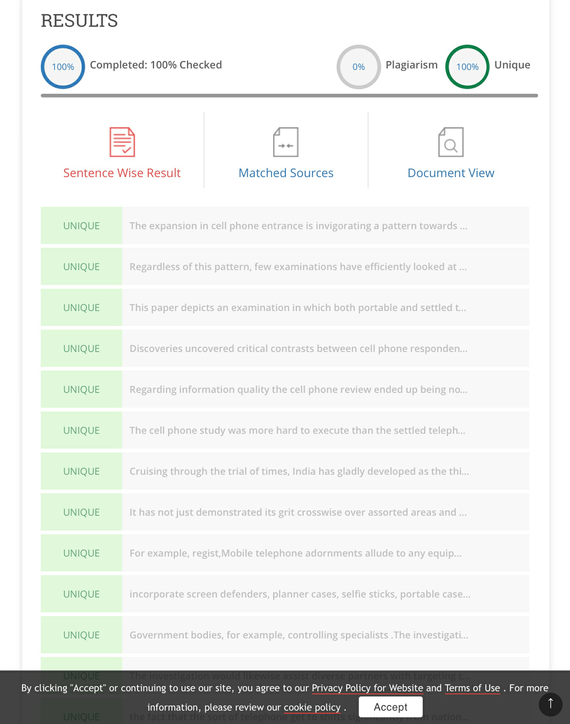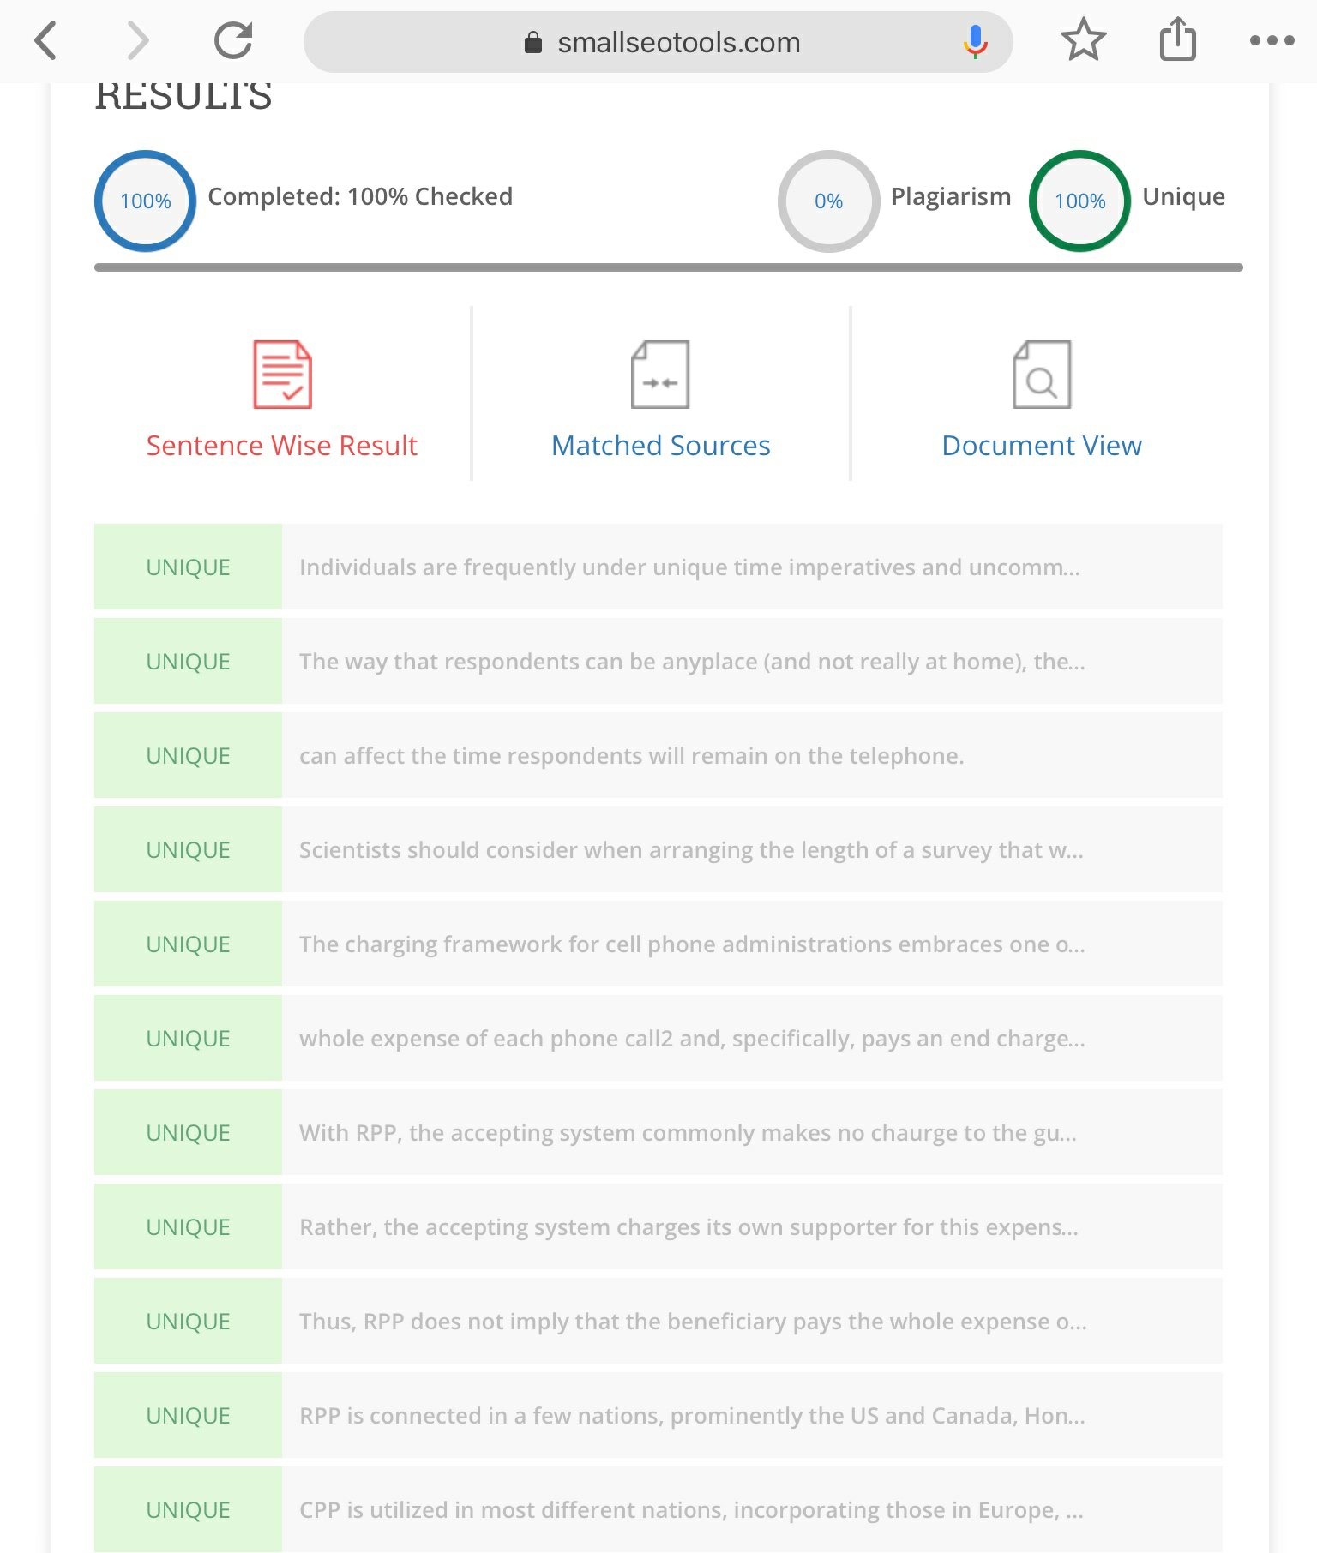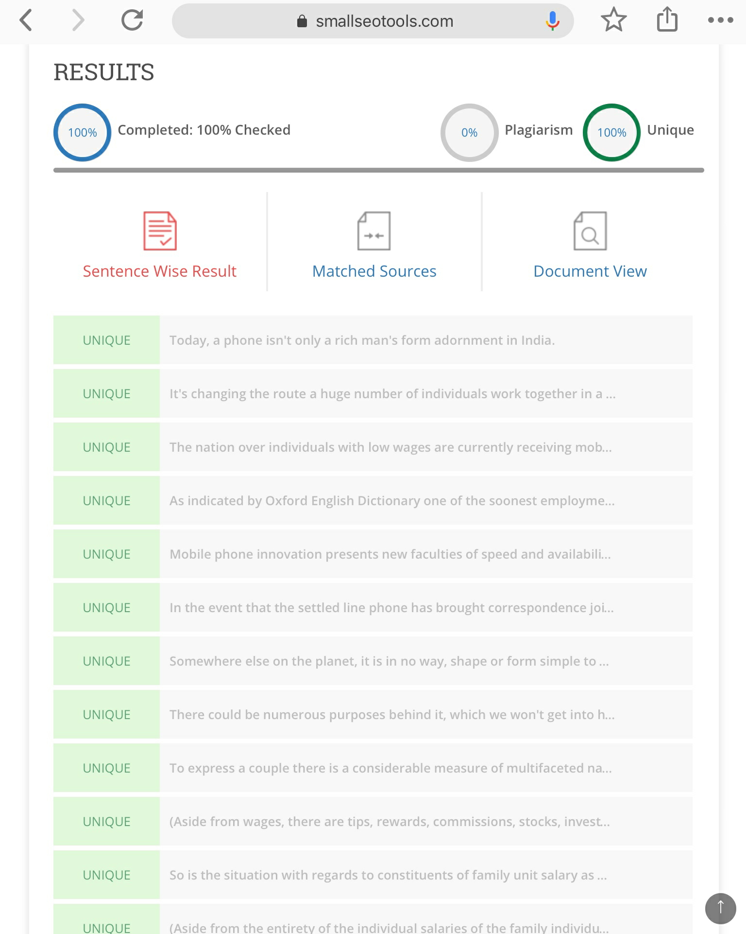

BA,LLB(HONS),SAVEETHA SCHOOL OF LAW,SAVEETHA INSTITUTE OF MEDICAL AND TECHNICAL SCIENCE(SIMATS),SAVEETHA UNIVERSITY, CHENNAI-77
ASSISTANT PROFESSOR ,SAVEETHA SCHOOL OF LAW,SAVEETHA INSTITUTE OF MEDICAL AND TECHNICAL SCIENCE(SIMATS),SAVEETHA UNIVERSITY, CHENNAI-77

