AN EMPIRICAL STUDY ON FREEDOM FROM PAYMENT OF TAXES FOR PROMOTION OF ANY RELIGION
Author:
AkashBalaji J
Saveetha school of law
Saveetha Institute of Medical and Technical Science (SIMATS)
Saveetha university
Chennai-600 007
Email:akashbalaji11j@gmail.com
Phone no:8825891199

Co-author
Mrs.S.Bhuvaneshwari,
Assistant Professor of SSL,
Saveetha school of law
Saveetha Institute of Medical and Technical Science (SIMATS)
Chennai-600 007
Email: bhuvaneshwari.ssl@saveetha.com
Phone no: 9841150919

AN EMPIRICAL STUDY ON FREEDOM FROM PAYMENT OF TAXES FOR PROMOTION OF ANY RELIGION
AkashBalaji J
S.Bhuvaneshwari

ABSTRACT:
According to Article 27 of the Constitution, there can be no taxes, the proceeds of which are directly used for the promotion and/or maintenance of any particular religion/religious denomination. It entails the separation of religion from the government, social, economic, and cultural aspects of life. Here religion is an entirely personal matter. India is a secular country with no state religion. However, this in India, also means that there is equal respect for all religions and faiths. The word is also a part of the Basic Structure of the Constitution. It was added by the 42nd Amendment to the Constitution. This concept enjoys high regard in Indian democracy. Secularism has also been an inalienable part of Indian culture as seen by the multitude of faiths that have coexisted in this country for centuries. All religious groups in India have the same powers without any discrimination.The right to form and maintain institutions for religious and charitable intents. The right to manage its own affairs in the matter of religion.The right to acquire the immovable and movable property.The right to administer such property according to the law. The state provides religious minorities the right to establish their educational institutions, and in some cases, also extends assistance to these institutions. Many Hindu temples are directly governed by the State.The State has set up Boards for the administration of large temples and has also set up the Waqf Board, etc.In India, when talking about society and the community, the word pluralism is better suited than the word secularism.
Keywords: denomination, Secularism, administration, religion, taxes.

INTRODUCTION:
India has an extraordinary legacy and it is a model for strict concordance where individuals of various religions reside calmly and as one." Religion involves conviction or confidence. The constitution of India perceives the reality, how significant religion is in the existence of individuals of India and subsequently, accommodates the right to opportunity of religion under Articles 25 to Article 28. The Constitution of India imagines a mainstream model and gives that each individual has the right and opportunity to pick and practice their religion. In various cases, the Peak Court has held that secularism is the fundamental design of the Constitution, the most significant being the Kesavananda Bharati case. Individuals in India essentially practice Islam, Hinduism, Jainism, Buddhism, Sikhism and, Christianity. In India, there are religion-explicit regulations and Goa is the main state to have a Uniform Common Code known as the Goa Common Code. The Constitution upholds strict congruity which implies individuals of India show love and friendship to various religions of the country.

Article 25: Opportunity of still, small voice and free calling, practice and spread of religion. Article 26 Opportunity to oversee strict undertakings.Article 27 Opportunity as to installment of charges for advancement of a specific religion.Article 28 Opportunity as to participation at strict guidance or strict love in specific instructive establishments. The German savant Immanuel Kant characterizes religion as "Religion is the acknowledgment of every one of our obligations as heavenly orders". Milton Yinger, American social scientist characterised religion as "an arrangement of convictions and practices through which a gathering battles with the definitive issues of human existence". The constitution does not characterize the term 'religion' and 'matters of religion'. Consequently, It is passed on to the High Court to decide the legal significance of these terms.

The word ‘religious denomination’ is not defined in the constitution. The word ‘denomination’ came to be considered by the Supreme Court in the case of Commissioner, Hindu Religious Endowment Madras v. Shri Laxmindra Thirtha Swamiar of Shri Shirur Mutt. In this case, the meaning of ‘Denomination’ was culled out from the Oxford dictionary, “A collection of individuals classed together under the same name, a religious sect or body having a common faith and organization designated by a distinctive name”.Article 26 (d) says that a religious denomination has the right to administer its own property but it should be in accordance with Law. In Durgah Committee Ajmer v. Syed Hussain Ali the Supreme Court observed that if the religious denomination never had the right to administer property or if it has lost its right then such right cannot be created under Article 26 and therefore cannot be invoked.
Article 27 of the Constitution keeps an individual from being constrained to pay any expenses which are intended for the installment of the expenses caused for the advancement or upkeep of any religion or strict division.

On account of Chief, Hindu Strict Blessings, Madras v. Sri Lakshmindra Thirtha Swamiar of Sri Shirur Mutt, the Madras governing body authorized the Madras Hindu Strict and Altruistic Gift Act, 1951 and commitments were collected under the Demonstration. It was fought by the solicitor that the commitments demanded are charges and not an expense and the condition of madras isn't equipped to order such an arrangement. It was held by the High Court that however the commitment exacted was charge yet its object was for the appropriate organization of the strict establishment. The aim of the study is to study about the freedom from taxes for promotion of any religion.

OBJECTIVE:
- To know about the importance of freedom from tax for any religion.
- To know how the government spends money on religion based activities.
- To know the mode of fund raising done to promote religion.

LITERATURE REVIEW:
Dissanayake, Wiman (1993) According to Author in this study, No one shall be compelled to pay any taxes for the promotion or preservation of any specific religion or any denomination.This means that it is unlawful to favour, patronise, or encourage one religion over another.It merely forbids the imposition of a tax, not a fee. The objective of a fee is not to promote or sustain religion, but to govern the secular administration of religious institutions.Smith, Brian K. (1998) The author states that confusion among the members of the Constituent Assembly and some felt that religious property must be treated on par with other property and be taxed as they thought it was exempted from taxation.Pandey, R (1969) According to Author in his study Religious Trust has not been defined under the Income Tax Act. The creation of religious trust is governed by the personal laws of the religion. But in general connotation, it can be deemed as the Trusts which are involved in the activities of promotion or particular belief.Nicholson, Andrew (2013) Author held that in his study administration of these religious trusts can either be left to the trustees as per the dictates of the religious names or it can be regulated to a greater or lesser degree by statute such as the Bombay Public Trusts Act, 1950. While unlike the words ‘charitable purpose’ have been defined in section 2(15) of the Act, there is no definition of ‘religious purpose’ under the Act. Pechelis, Karen (2011) Author in his study states that religious activity is not defined in the Income Tax Act. The litmus test is however, that the religious purpose must be public in nature. Therefore, a temple or a mosque may be established by a trust and expenditure on construction, reconstruction or maintenance of such a temple or a mosque would be for religious purposes.Olson, Carl (2007) In his paper author held that the Hindu piety found expression in gifts to idols to religious institutions and for all purposes considered meritorious in the Hindu social and religious system. Therefore, although courts in India have for a long time adopted the technical meaning of charitable trusts and charitable purposes which the courts in England have placed upon the term ‘charity’ in the Statute of Elizabeth. Foulston, Lynn (2012) As observed by Mukherjea in Hindu Law and Religious and Charitable Trusts, Second Edn., page 11, there is no line of demarcation in the Hindu system between religion and charity. Indeed, charity is regarded as part of religion, for, gifts both for religious and charitable purposes are impelled by the desire to acquire religious merit. Raj, Dhooleka S. (2003) As observed by the author in Hindu Law and Religious and Charitable Trusts, Second Edn., page 11, there is no line of demarcation in the Hindu system between religion and charity. Indeed, charity is regarded as part of religion, for, gifts both for religious and charitable purposes are impelled by the desire to acquire religious merit.Jones, Lindsay, ed. (2005) According to the study the author states that Charitable Trust must always be public, but a Religious Trust may be private or public. Section 13(1)(a) excludes from exemption a private religious Trust, which does not ensure for the benefit of the public. Thus a Trust for a private family deity to which the public or a particular class has no access, is taxable.Ellinger, Herbert (1996) As the author states that religious endowment must be held to be private or public, according as the beneficiaries thereunder are specific persons or sections thereof. When property is dedicated for the worship of a family idol, it is private and not a public endowment. Banerjea, JN (2004) Author examined that it was held that a dedication in favour of a Hindu deity is not a gift within the meaning of section 122 of the Transfer of Property Act, 1881, and, therefore, the provisions regarding acceptance by donee etc., as contained in the said Act have no application to such a dedication.Das, Veena (2003) The author held that the Temples in course of time do get organized by having a body to regulate their management either by way of society or a trust, even where there is no formal trust at the time, when the temple was constructed. Any income of such a temple may be treated as having religious character. Although, tax exemption is possible only if it is registered under section 12A of the Act.A. Sharma (1999) According to author if temple or a religious deity is in the private premises and access / worship is available only to a family then the religious purpose would be private in nature. In other words, when property is dedicated for the worship of a family idol, it is private and not a public endowment. Swami Prabhupādā, A. C. Bhaktivedanta (2007) Author examined that public worship by itself may be a charitable object (public religious) but there are other objects like marriages and dramas not connected with public worship, the trust will not be eligible for exemption. Jagannathan, Maithily (2005) The author held that public temple is one where a considerable portion of the public or a section thereof has a beneficial interest. A gift for the purpose of such a temple must therefore benefit the public. The main characteristics for a public temple is that it is intended for the use of the public at large or a specified class who are entitled to the right of the worshipping of the idol. Zwart, Frank (2000) After examined by the author he held that Charitable institution established for both charitable and religious purposes – when expenditure on religious activities including salary to preachers engaged to spread the teachings of Lord Jesus exceeds 5% of the total income, it is hit by Section 80 G(5)(ii) read with section 80G (5B) – CIT rightly rejected registration. Anita Ganeri (2003) After examine the author held in legal prespective that under section 80G(2)(b) shall only qualify for deductions under section 80G of the Act. Donations made to ordinary religious entities are not eligible for any deduction under section 80G of the ActThe word ‘wholly’ referred in the section refers to the object and not to the property held under trust. Klaus K. Klostermaier (2007) The author held he found that some of the objects of the trust are not of a public charitable nature and the trustees have a discretion in spending the amount over those objects, it cannot be said that the property held under trust is held wholly for religious and charitable purposes and the assessee would not be entitled to claim any benefit under Section 4(3)(i) of the Indian Income-tax Act, 1922. McDowell, Michael; Brown, Nathan (2009) According to author legal perspective Although section 2(15) of the Act defines only “charitable purpose” and “religious purpose” has not been defined under the Act, still the exemption from tax contained in sections 11 and 12 of the Act would be applicable to the trusts established for religious purposes. Dissanayake, Wiman (1993) The author examine Social Service Centre, the Assessing Officer found that the trust was mainly engaged in religious activities and he refused exemption because the expenditure was incurred by way of donation to a Diocese and for construction of a church.

RESEARCH METHODOLOGY
This research has been adopted as empirical study.Empirical research is based on observed and measured phenomena and derives knowledge from actual experience rather than from theory or belief. Key characteristics for an empirical research is Specific research questions to be answered And Description of the process used to study this population or phenomena, including selection criteria, controls, and testing instruments (such as surveys).the statistical tools used for this research work is chi square correlation. SPSS graphics and diagrams are attached in this research work.cross table has been used for this research work.The essence of the survey method can be explained as “questioning individuals on a theme or subjects and afterward depicting their reactions''. Irregular testing strategy was utilised with the end goal of this investigation.There are totally 200 samples collected for this study. Independent variables were Name, age, gender, educational qualification, occupation and marital status the dependent variables are Do you agree with this statement in secular India “No person shall be compelled to pay any taxes the proceeds of which are specifically appropriated in payment of expenses for the promotion of any particular religion.

ANALYSIS:
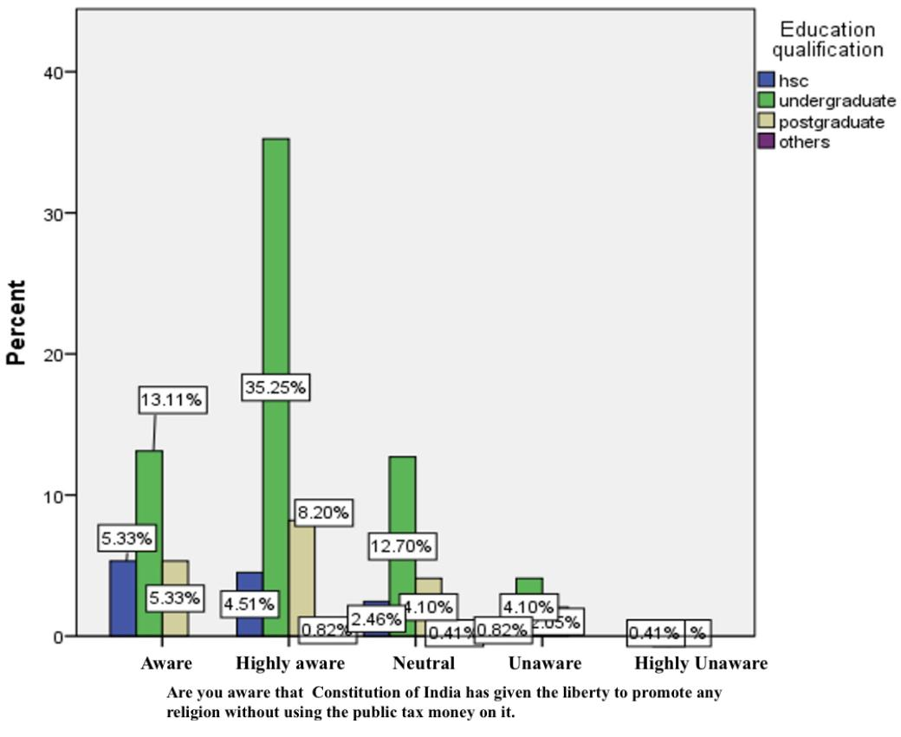
Legend : In fig 1 The independent variable Education qualification and dependent variable are that the Constitution of India has given the liberty to promote any religion without using the public tax money on it.

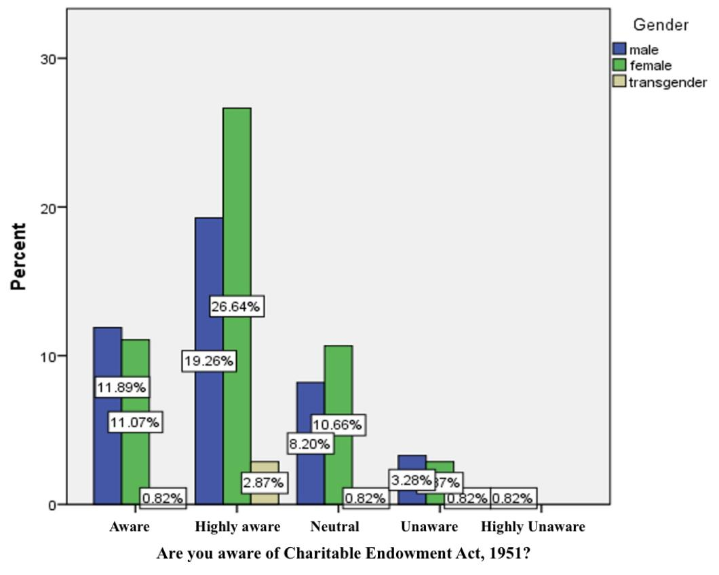

Legend :
In fig 2 The independent variable Gender and dependent variable are that Are you aware of Charitable Endowment Act 1951.

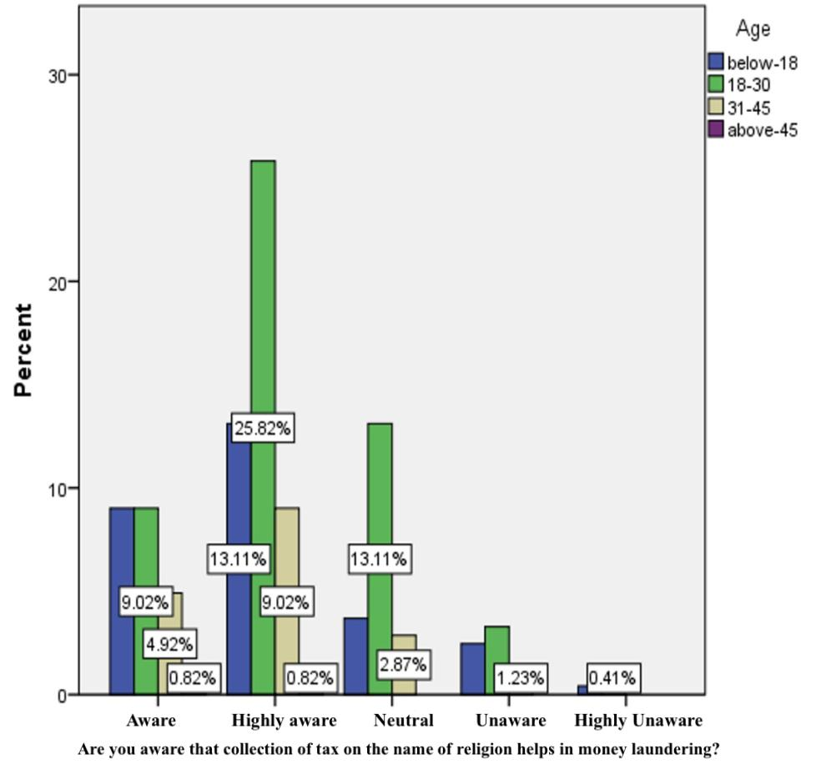

Legend :
In fig 3 The independent variable age and dependent variable are that Are you aware that collection of tax on the name of religion helps in money laundering.
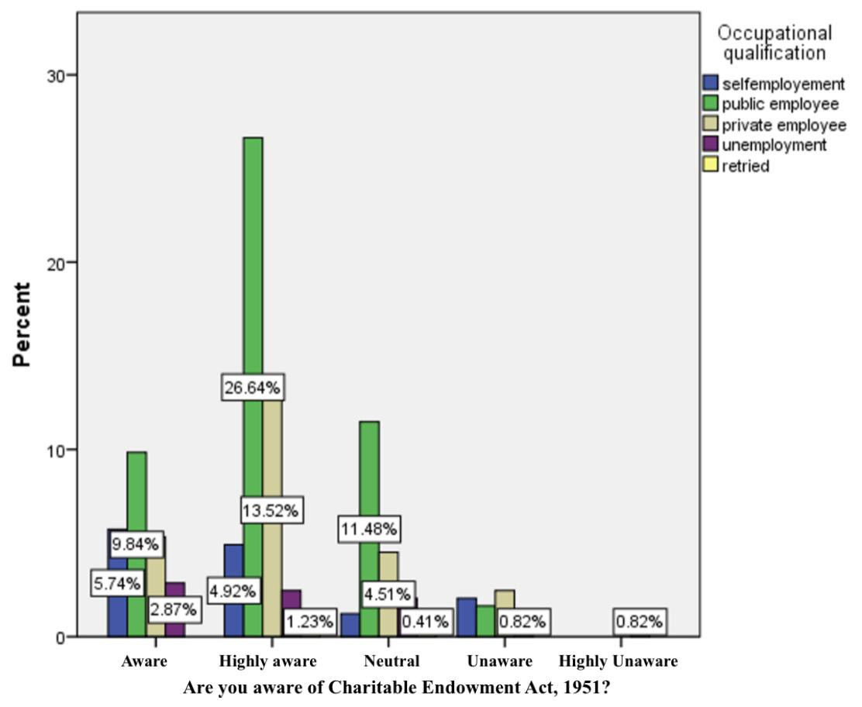

Legend :
In fig 4 The independent variable occupation qualification and dependent variable are that Are you aware of Charitable Endowment Act 1951.

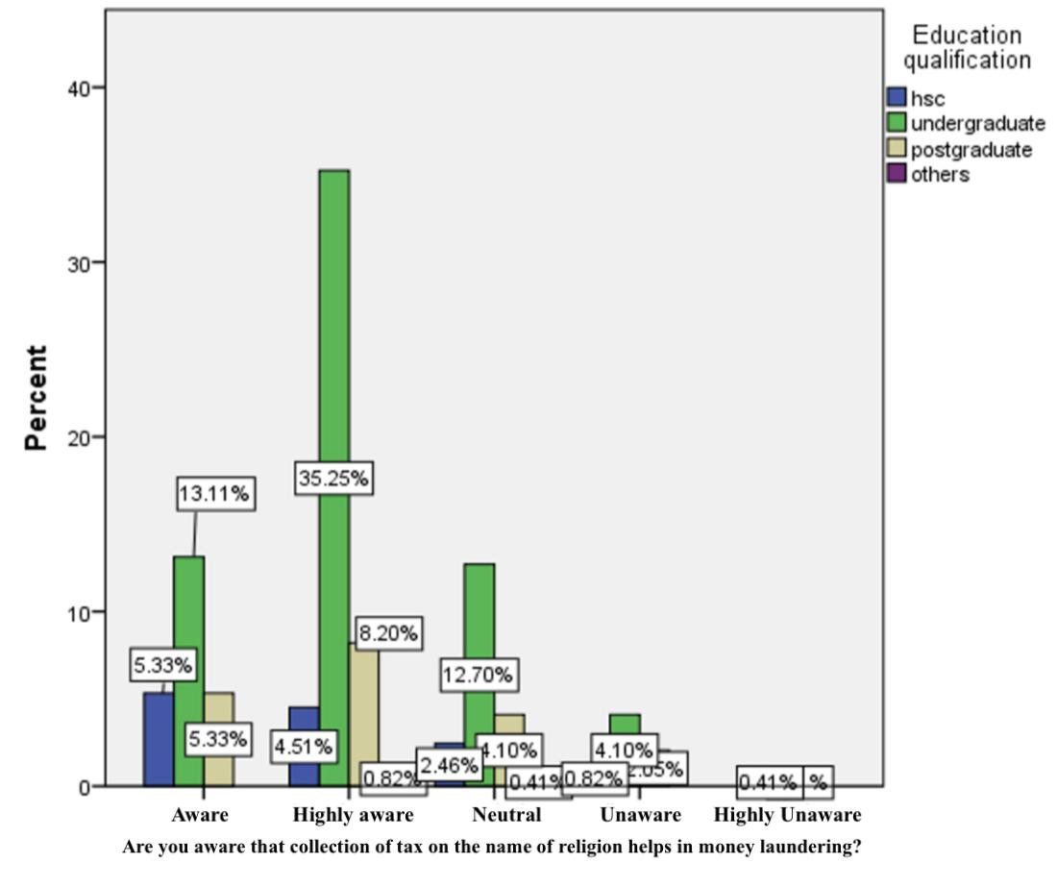
Legend :
In fig 5 The independent variable education qualification and dependent variable are that Are you aware that collection of tax on the name of religion helps in money laundering.

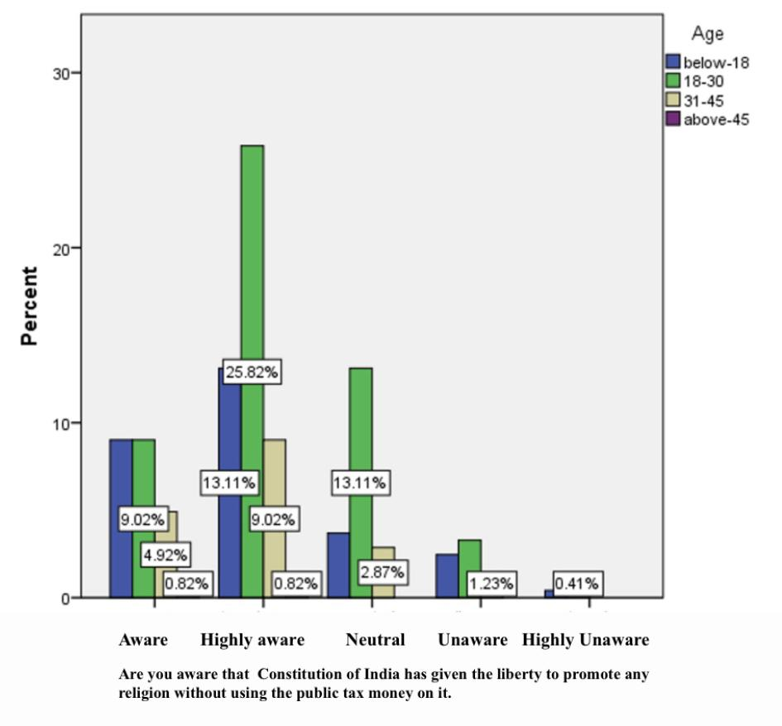

Legend :
In fig 6 The independent variable age and dependent variable are that Constitution of India has given the liberty to promote any religion without using the public tax money on it.

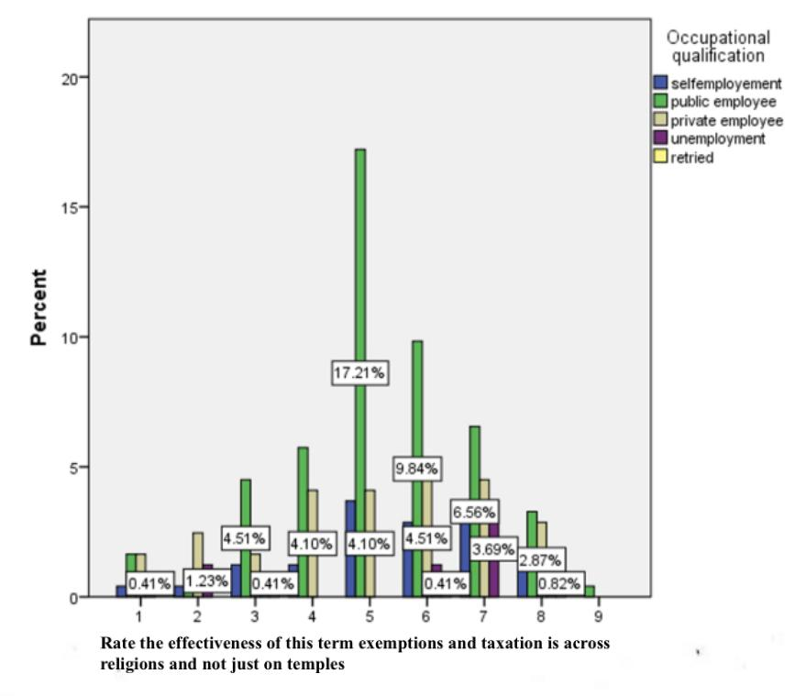Legend :
In fig 6 The independent variable age and dependent variable are that rate the effectiveness of this term exemption and taxation is across religions and not just on temples

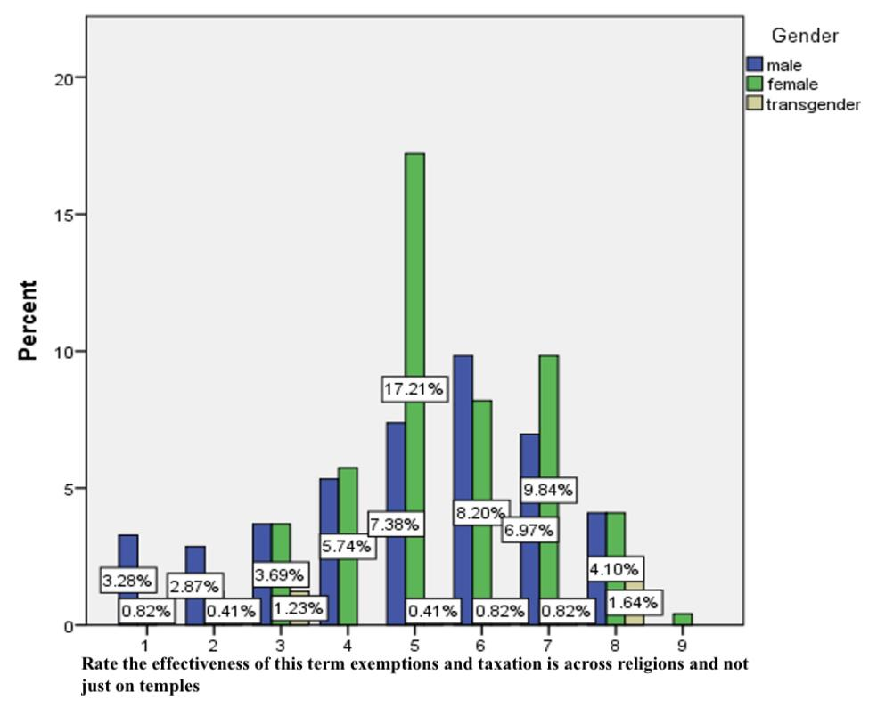
Legend :
In fig 7 The independent variable gender and dependent variable are that rate the effectiveness of this term exemption and taxation is across religions and not just on temples

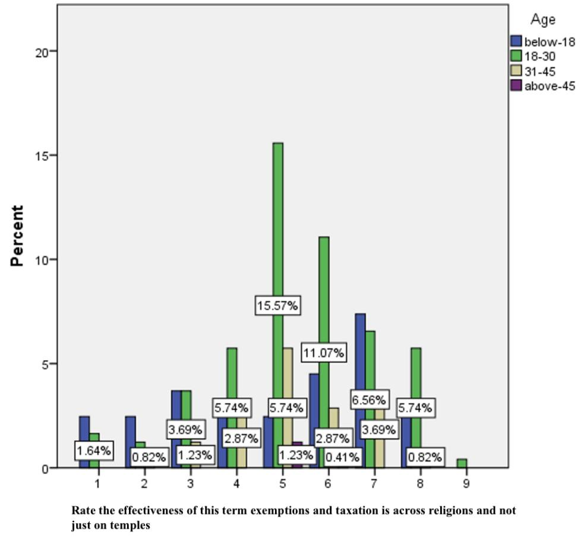
Legend :
In fig 8 The independent variable gender and dependent variable are that rate the effectiveness of this term exemption and taxation is across religions and not just on temples

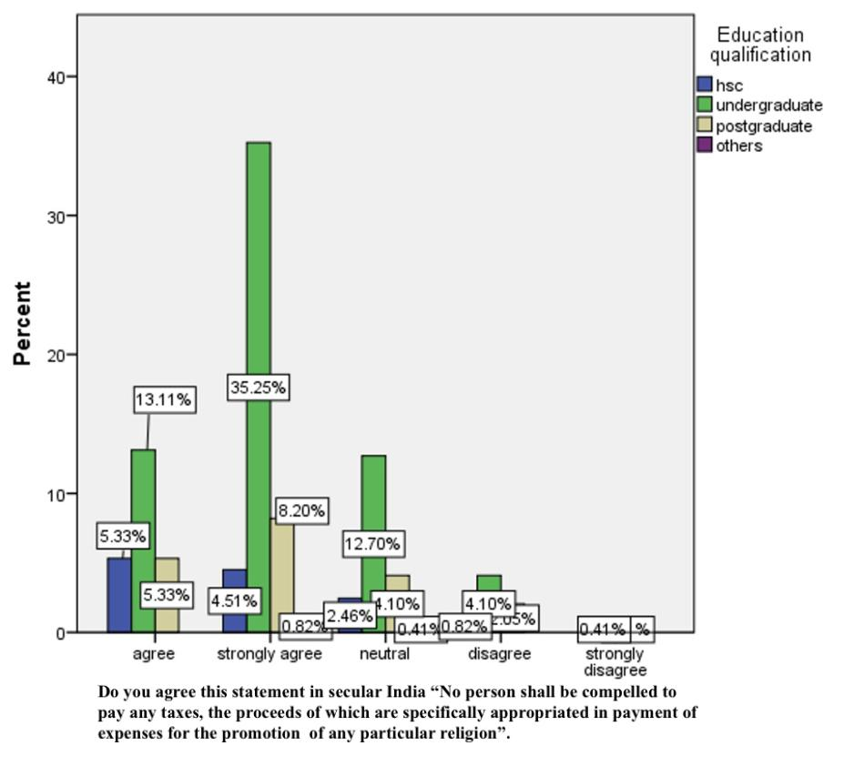

Legend :
In fig 8 The independent variable education qualification and dependent variable are that do you agree this statement in secular India “No person shall be compelled to pay any taxes the proceeds of which are specifically appropriated in payment of expenses for the promotion of any particular religion”.

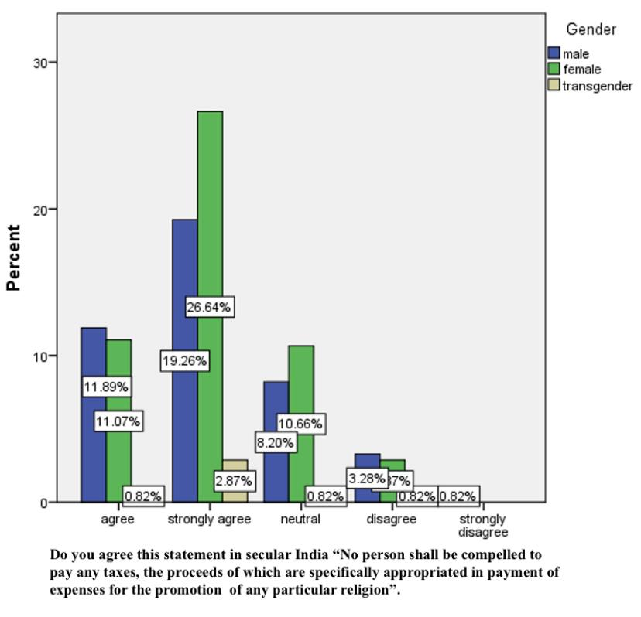

Legend :
In fig 9 The independent variable gender and dependent variable are that do you agree this statement in secular India “No person shall be compelled to pay any taxes the proceeds of which are specifically appropriated in payment of expenses for the promotion of any particular religion”.

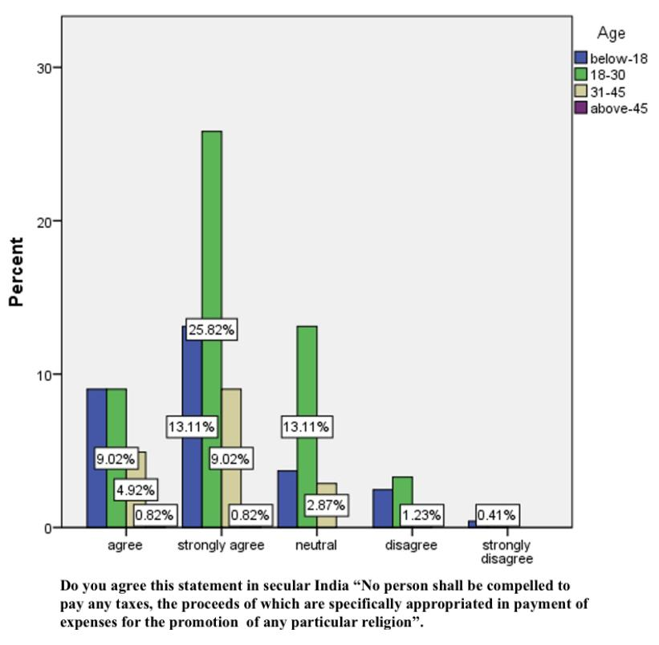
Legend :
In fig 10 The independent variable age and dependent variable are that do you agree this statement in secular India “No person shall be compelled to pay any taxes the proceeds of which are specifically appropriated in payment of expenses for the promotion of any particular religion”.

RESULT:
In fig 1 The Education qualification of the respondents included below and the dependent variable is that higher secondary,undergraduate,postgraduate,Constitution of India has given the liberty to promote any religion without using the public tax money on it.Most of the respondents are from the undergraduate and they strongly agree with the statement.
In fig 2 The gender of the respondent include male and female and the dependent variable is that the are you aware of charitable endowment act here most of the respondents are female and they strongly aware to the statement.In fig3 The age of the respondents include higher below 18 18-30, 31-45, above 45 and the dependent variable is the are you aware that collection of tax on the name of religion helps in money laundering statement .In fig 4 The occupation qualification of the respondents include self employed public employment private employment unemployment retired and the dependent variable is are you aware of charitable endowment act 1951 people here most of the respondents are public employee and they strongly agree with the statement.In fig 5 The occupational qualifications of the respondents include self employment, public employee,private employee,unemployed,retired and the dependent variable is Are you aware that collection of tax on the name of religion helps in money laundering of the people here most of the respondents are public employees and they strongly agree to the statement.In fig 6 The age of the respondents include higher below 18 18-30, 31-45, above 45 and the dependent variable is the are you aware that collection of tax on the name of religion helps in money laundering statement .In fig 7 The gender of the respondent include male and female and the dependent variable is that the are you aware of charitable endowment act here most of the respondents are female and they strongly aware to the statement.In fig 8 The age of the respondents include higher below 18 18-30, 31-45, above 45 and the dependent variable is the are you aware that collection of tax on the name of religion helps in money laundering statement .In fig 9 The occupation qualification of the respondents include self employed public employment private employment unemployment retired and the dependent variable is are you aware of charitable endowment act 1951 people here most of the respondents are public employee and they strongly agree with the statemen. In fig 10 The occupational of the respondents include self employment public employee private employee unemployed retired and the dependent variable is are you aware that collection of tax on the name of religion helps in money laundering of the people here most of the respondents are public employees and they strongly agree to the statement

DISCUSSIONS
From fig 1 it was observed that Most of the respondents are from undergraduate and they strongly aware with the statement that that Constitution of India has given the liberty to promote any religion without using the public tax money on it. Were respondents were also very clear public money should be spent only in a secular manner. From fig 2 it was observed that Most of the respondents are female and they strongly unaware with the statement that Are you aware of Charitable Endowment Act 1951 and the people who. respondent were very clear their point that they weren’t aware of the act From fig 3 it was observed that Most of the respondents are age group of 18-30 and they strongly agree with the statement that Are you aware that collection of tax on the name of religion helps in money laundering. Many people in survey they spoked about the money laundering issue and they were clear about religion based financial activities and money laundering.From fig 4 it was observed that Most of the respondents are public employee and they strongly aware to the statement that are that Are you aware of Charitable Endowment Act 1951. And many respondents were aware and they were essentially said that aren’t aware of Charitable Endowment Act 1951 but researcher teached about Charitable Endowment Act 1951 From fig 5 it was observed that Most of the respondents are undergraduate and they strongly aware to the statement that Are you aware that collection of tax on the name of religion helps in money laundering. After all collection of samples it was found that many respondents were know about money laundering issues especially done via trust and temple From fig 6 it was observed that the most of the respondents from age groups of 18-30 and they said that aware to the statement Constitution of India has given the liberty to promote any religion without using the public tax money on it. After survey the post survey result was like the respondents were clear about liberty and they were clear stating nothing related to secularism should be disturbed while discharge liberty From fig 7 it was observed that the most of the respondents are female and they rate 5 the effectiveness of this term exemption and taxation is across religions and not just on temples many people were stating and the study also found that taxation is across religions and not just on temples From fig 8 it was observed that the most of the respondents are male and they respond 7 rate the effectiveness of this term exemption and taxation is across religions and not just on temples and the respondents were effectively involved in this discussion taxation is across religions and not just on temples From fig 9 it was observed that the most of the respondents are male and they said do you agree this statement in secular India “No person shall be compelled to pay any taxes the proceeds of which are specifically appropriated in payment of expenses for the promotion of any particular religion”.

From fig 10 it was observed that the most of the respondents are 18-30 and said that that do you agree this statement in secular India “No person shall be compelled to pay any taxes the proceeds of which are specifically appropriated in payment of expenses for the promotion of any particular religion”.

LIMITATIONS
The Major limitation of the study is that the data is collected from the general public . The sample frame is not Collected from the affected people is the limitation of the study, the real field experience is missed out with the affected people due to corona pandemic. The restrictive area of sample size is yet another drawback of the research.Collection of data from general public is limiting the researcher to collect data from the labour in their establishment .Since the data is collected from the general public therein the respondent is not known, the original opinion of the respondent it is not found, The researcher could only come to a approximate conclusion of what the respondent is feeling to convey.

SUGGESTION AND CONCLUSION:
The suggestion for the study is freedom from taxes for religion and religion based activities were Article 27 protects the freedom of religion from the misuse of tax laws by the state. It is important that the freedom of religion applies not only in the sphere of religious activities but also in the financial sphere. Since money runs the world, it is essential that the intersection of finance and religion is not ignored. The article also gives people the power to take a stand for secularism. As an act of united demonstration, the refusal to pay taxes which would promote a religion can be a tool of political pressure on the state. It can be used to send the state a message of withdrawal of support or loss of trust from the people in the event of a biassed religious agenda of the State.Under Article 27 of the Indian Constitution, a person can not be compelled to pay tax, proceeds of which would be used to pay for the expenses incurred on the promotion or maintenance of any particular religion or religious denomination. Generally, tax is a compulsory obligation and liability of the taxpayers. But, this article frees a person from the obligation of paying any tax in case such tax funds would be used for the promotion or maintenance of any religion or religious denomination. For example: If a state imposes a tax for the promotion of the Hindu religion, it would be entirely lawful for a person to refuse to pay such a tax. The state must have used such tax to promote or maintain any religion or religious denomination. The study concluded stating Since India is a secular state, the government must not favour any particular religion or religious denomination.

It is important that the intention of the state is to promote or maintain a particular religion or religious denomination. Hence, Article 27 is not attracted in a case where a state activity has some basis in a particular religion. This would tie the hands of the state in providing food subsidies to poor people just because a religion preaches the same. What the court looks for is the intention of the state behind the activity undertaken. The intent is judged and not the end result.
REFERENCE:
- Nathan, Narendra (6 December 2016), "View: Government should reinstate wealth tax in Budget 2017", The Economic Times.
- Kumar, Kuldip (27 March 2016), "Readers' Corner: Taxation", Business Standard.
- Jha S M (1990). "Taxation and Indian Economy". New Delhi: Deep and Deep Publications.
- Institute of Chartered Accountants of India (2011). Taxation. ISBN 978-81-8441-290-1.
- Nair, Remya (8 June 2015), "Rajya Sabha panel to hear GST concerns on 16 June".
- Mehra, Puja (27 June 2017). "GST, an old new tax". The Hindu - Opinion. Retrieved 3 July 2017.
- Prasad, R. U. S. (6 October 2020). The Rig-Vedic and Post-Rig-Vedic Polity (1500 BCE-500 BCE). Vernon Press. ISBN 978-1-64889-001-7.
- William J. McCluskey; Riël C. D. Franzsen (2005). Land Value Taxation: An Applied Analysis. Ashgate. p. 73. ISBN 978-0-7546-1490-6.
- Smith, Adam (1776), Wealth of Nations Archived 20 October 2013 at the Wayback Machine, Penn State Electronic Classics edition, republished 2005, p. 704.
- Davies, Lindy. "The Science of Political Economy: What George "Left Out"". political economy.org. Retrieved 16 June 2014.
- David F. Burg (2004). A World History of Tax Rebellions. Taylor & Francis. pp. vi–viii. ISBN 9780415924986.
- Burnham, Steve (13 November 2013). "Tax reform is essential to protect Australia's future, says PwC". Taxpayers Australia. Retrieved 13 January 2013.
- Fleenor P, Williams J. (2006). Options for Reforming the U.S. Corporate Income Tax. Tax Foundation.
- Urensa, Dan (26 September 2013). "In a smaller world, tax reform is overdue". The Australian. Retrieved 13 January 2013.
- Morgan, David; Becker, Amanda (December 1, 2017). "Senate approves major tax cuts in victory for Trump". Reuters. Retrieved December 2, 2017.
- Khullar, Vatsal; Kala, Mandira (January 2018). "Analytical Reports: State of State Finances 2018". PRS Legislative Research. Retrieved 11 September 2021.Spatz I, McGee N (25 November 2013). "Specialty Pharmaceuticals". Health Policy Briefs. Health Affairs. What's The Background?. Retrieved 28 August 2015.S., Van Wormer, Katherine (18 March 2015). Social welfare policy for a sustainable future : the U.S. in global context. Link, Rosemary J. Los Angeles. ISBN 978-1-4522-4031-2. OCLC 899880624.Dean B, Barber N, Schachter M (December 2000). "What is a prescribing error?". Qual Health Care. 9 (4): 232–7. doi:10.1136/qhc.9.4.232. PMC 1743540. PMID 11101708.
- Taylor, David (2015). "The Pharmaceutical Industry and the Future of Drug Development".
- Shivashankar. S.C, Chandrashekar. T.C, and Ravindra Reddy “Water Resources Mismanagement and its implications”, Southern Economist Vol.49, No. 118, January 2011, pp.21-24.
- Yeshodha. L, Meenambal. T, and Rajakumar. H.N “ Quality Index for Hosur Block Krishnagiri Distirct, Tamil Nadu, India”. Research Vol.30, Issue 3, 2011; Page No.(321-325)
- Yuvaraj. D, Alaguraja. P, Sekar. M, Muthuveerran. P and Manivel. M, Analysis of drinking water problem in Coimbatore City Corporation, Tamilnadu. India using Remote Sensing and GIS Tools, International Journal of rel, Vol. 1, No. 1, 2010, pp. 71-76.

PLAGIARISM
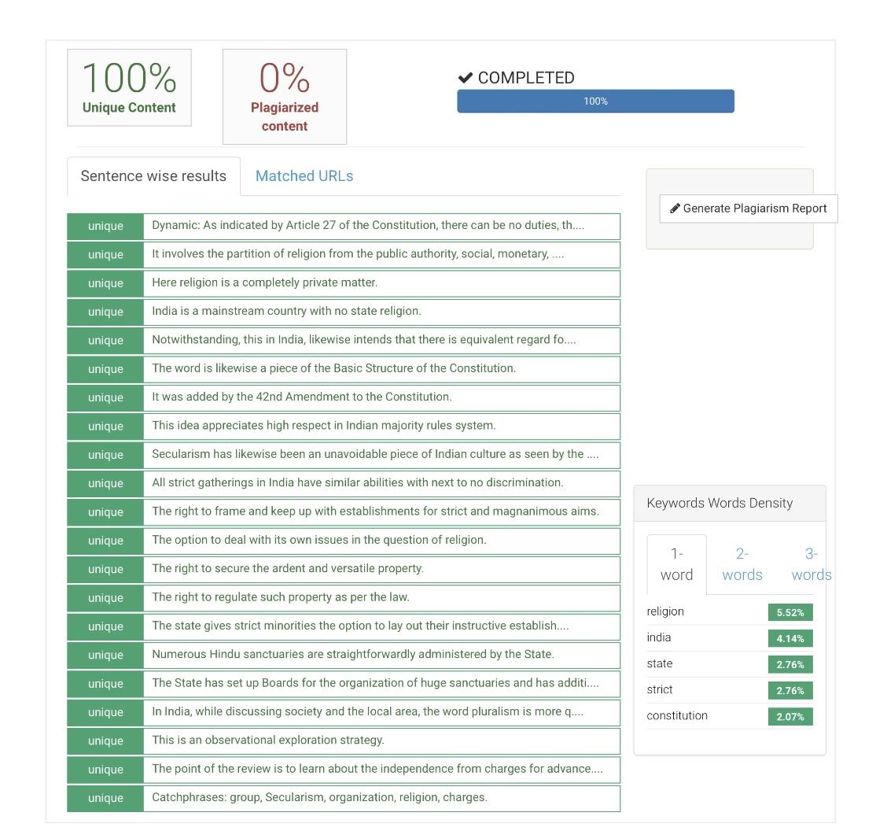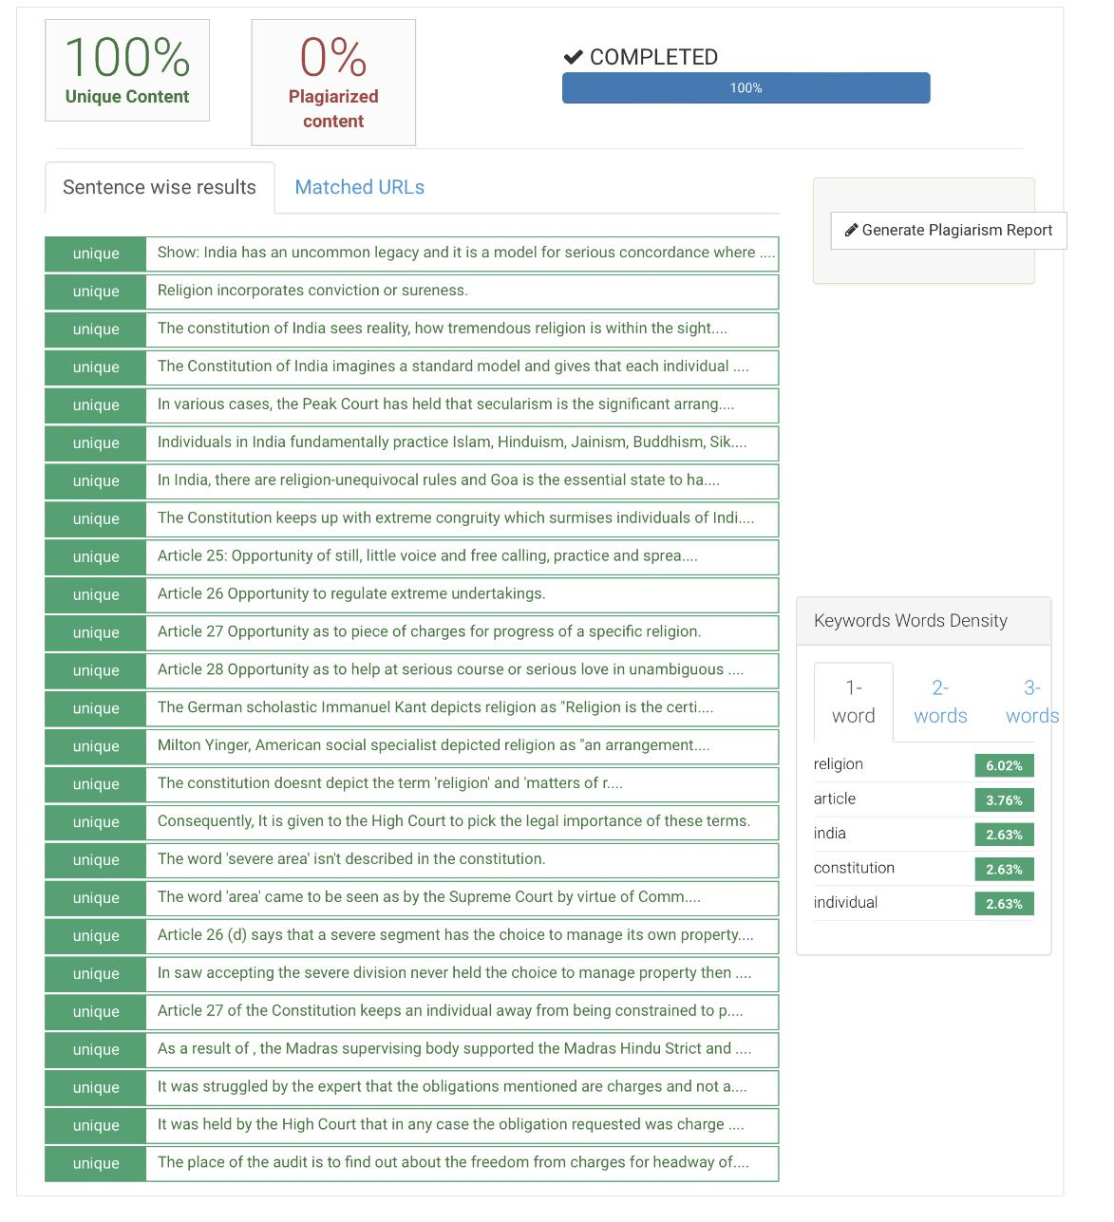

AKASH BALAJI J B.A.LLB (HONS) 5th, – YEAR, SAVEETHA SCHOOL OF LAW, SAVEETHA INSTITUTE OF MEDICAL AND TECHNICAL SCIENCES (SIMATS), SAVEETHA UNIVERSITY, CHENNAI - 600 007, E-MAIL ID: aakashbalajij@gmail.com phone number - 8825891199
S.BHUVANESHWARI ASSISTANT PROFESSOR OF LAW, SAVEETHA SCHOOL OF LAW, SAVEETHA INSTITUTE OF MEDICAL AND TECHNICAL SCIENCES (SIMATS), SAVEETHA UNIVERSITY, CHENNAI-600 007, E-MAILID:sbhuvaneshwari.ssl@saveetha.com Phone number - 9841150919

