A STUDY ON SOCIALISATION AND PARENTAL TECHNIQUE TO DEVELOP CHILDREN

AUTHOR

MADHUMITHA.S
saveetha school of law,
Saveetha Institute Of Medical and Technical,
Science (SIMATS),
Mobile no: 9361143383
Email I’d,-madhusuji1323@gmail.com

CO-AUTHOR

Mrs. K.S. BALA THIRUPURA SUNDARI
Assistant professor of law,
Saveetha school of law,
Saveetha Institute Of Medical And Technical
Science(SIMATS),
Saveetha university,
Mobile No:9600031223
E-mail I’d :balatripurasundari@gmail.com

A STUDY ON SOCIALISATION AND PARENTAL TECHNIQUE TO DEVELOP CHILDREN

AUTHOR : S.MADHUMITHA
CO-AUTHOR : Mrs.K.S.BALA THIRUPURA SUNDARI

ABSTRACT :
As children mature, parent-child relationships naturally change. Preschool and grade-school children are more capable, have their own preferences, and sometimes refuse or seek to compromise with parental expectations. This can lead to greater parent-child conflict, and how conflict is managed by parents further shapes the quality of parent-child relationships. In general, children develop greater competence and self-confidence when parents have high (but reasonable) expectations for children’s behavior, communicate well with them, are warm and responsive, and use reasoning (rather than coercion) as preferred responses to children’s misbehavior. This kind of parenting style has been described as authoritative (Baumrind, 2013). Authoritative parents are supportive and show interest in their kids’ activities but are not overbearing and allow them to make constructive mistakes. By contrast, some less-constructive parent-child relationships result from authoritarian, uninvolved, or permissive parenting styles,Social and personality development is built from the social, biological, and representational influences discussed above. These influences result in important developmental outcomes that matter to children, parents, and society: a young adult’s capacity to engage in socially constructive actions (helping, caring, sharing with others), to curb hostile or aggressive impulses, to live according to meaningful moral values, to develop a healthy identity and sense of self, and to develop talents and achieve success in using them. These are some of the developmental outcomes that denote social and emotional competence.Personality develops from temperament in other ways (Thompson, Winer, & Goodvin, 2010). As children mature biologically, temperamental characteristics emerge and change over time. A newborn is not capable of much self-control, but as brain-based capacities for self-control advance, temperamental changes in self-regulation become more apparent. For example, a newborn who cries frequently doesn’t necessarily have a grumpy personality; over time, with sufficient parental support and increased sense of security, the child might be less likely to cry. In addition, personality is made up of many other features besides temperament.

KEYWORDS : children,parents,development,adult

INTRODUCTION:

Understanding social and personality development requires looking at children from three perspectives that interact to shape development.(Rolnick 1966) The first is the social context in which each child lives, especially the relationships that provide security, guidance, and knowledge. The second is biological maturation that supports developing social and emotional competencies and underlies temperamental individuality. The third is children’s developing representations of themselves and the social world. Social and personality development is best understood as the continuous interaction between these social, biological, and representational aspects of psychological development. The different behaviors of securely- and insecurely-attached infants can be observed especially when the infant needs the caregiver’s support. To assess the nature of attachment, researchers use a standard laboratory procedure called the “Strange Situation,” which involves brief separations from the caregiver (e.g., mother) (Solomon & George, 2008).(Rolnick 1966; Otsu 1998) In the Strange Situation, the caregiver is instructed to leave the child to play alone in a room for a short time, then return and greet the child while researchers observe the child’s response. Depending on the child’s level of attachment, he or she may reject the parent, cling to the parent, or simply welcome the parent—or, in some instances, react with an agitated combination of responses.Children’s developing self-concept, their motivations to achieve or to socialize, their values and goals, their coping styles, their sense of responsibility and conscientiousness, and many other qualities are encompassed into personality(Otsu 1993).These qualities are influenced by biological dispositions, but even more by the child’s experiences with others, particularly in close relationships, that guide the growth of individual characteristics(Otsu 1993; Setyawati and Herlambang 2018; Van Trinh and Thuan 2016).Indeed, personality development begins with the biological foundations of temperament but becomes increasingly elaborated, extended, and refined over time.(Otsu 1993; Setyawati and Herlambang 2018) The newborn that parents gazed upon thus becomes an adult with a personality of depth and nuance.the aim of the research is to study the socialisation and parental technique to develop children.

OBJECTIVES :
- To stop children get addicted towards digital devices
- To educate anger management
- To stop rivalry between siblings to promote socialisation

REVIEW OF LITERATURE

Mehta, 2005 in his analysis of the educational system in India and of government-private primary schools in particular are often infeasible and hampered greatly due to the unavailability of data(Otsu 1993; Setyawati and Herlambang 2018; Van Trinh and Thuan 2016; Bang and Ryu 2008)

Gerard McCann, Féilim Ó Adhmaill (2020).The journal says about the outlines existing international human rights mechanisms which have relevance to education as a right and discusses contemporary multilateral attempts by non-governmental organisations (NGOs) and other campaigning organisations to market the popularity and realisation of a universal right to education. (Ma, Mao, and Zhou 2009)It assesses a number of the chances and difficulties of constructing the proper way to educate a reality in a very world of social, economic, cultural etc.

PROBE, 1999; Pratham, 2005; Tooley and Dixon, 2005; Muralidharan, 2006; Desai et al., 2010 In their study Many of such problems have roots in primary education and more particularly in the government education system. At primary level, there is a large concern that the government schools do not deliver quality education to children (Ma, Mao, and Zhou 2009; Wei and Qin 2011)

Narayan and Mooij, 2010 Many reasons have been put forward for the poor quality of education in government primary schools.Earlier studies considered poor quality of resources as the prime reason. The recent studies highlight the pervasiveness of teacher absence and inactivity in government schools which certainly deteriorate the quality of education
Sheila Carr-Stewart(2001)(Ma, Mao, and Zhou 2009; Wei and Qin 2011; 이범웅 and 이범웅 2018). This study focuses on the intent and expectations of education as a treaty right by the initial signatories and also the current divergent understandings. Today First Nations demand the fulfilment of their treaty right to education while Canada, despite constitutional authority and up to date court decisions on treaties, administers educational services within the boundaries of its own legislation: the Indian Act.(Karlimah 2019) Honouring treaty commitments offers hope for educational opportunities and equity within the context of First Nation governance,

JANDHYALA B G TILAK(2012). (Karlimah 2019; Turner-Brown et al. 2013)This journal says about the The affidavit submitted by the Ministry of Human Resource Development to the Delhi High Court recently clarifying that parents can choose to homeschool their children is violative of the Right to Education Act.(“Develope Your Inventions” 1872)
Tristan McCowan , Comparative Education(2010). This study focuses on the intent and expectations of education as a treaty right by the first signatories and therefore the current divergent understandings. Today First Nations demand the fulfilment of their treaty right to education while Canada, despite constitutional authority and up to date court decisions on treaties, administers educational services within the boundaries of its own legislation: the Indian Act. Honouring treaty commitments offers hope for educational opportunities and equity within the context of First Nation governance,(“Develope Your Inventions” 1872; Rasyid, Ade Putranto Prasetyo, and Sugiantoro 2021)

Vimala Ramachandran(2009).(“Develope Your Inventions” 1872; Rasyid, Ade Putranto Prasetyo, and Sugiantoro 2021; Gao 2019) To argue that alternative schools or private schooling can be sure of the requirements of primary school-going children ("Feasibility of Implementation of Right to Education Act", EPW, 20 June 2009) is to effectively condemn the poor and also the marginalised to a second-rate education since they will never afford private and expensive schooling. The requirement of the hour is higher public investment in school education.(“Develope Your Inventions” 1872; Rasyid, Ade Putranto Prasetyo, and Sugiantoro 2021; Gao 2019; Mafi, n.d.)
S. P. Sathe (1992). While the Supreme Court, in its recent judgment within the Mohini Jain v Karnataka case, could also be faulted on both doctrinal and practical grounds for its use of article 21 of the Constitution for articulating the proper to education, its indictment of the capitation fee system has not come daily ahead of time.(Admas et al., n.d.)

Geraldine Terry(2007). Esther Jena’s words vividly express the empowering potential of education for ladies. The proper education was first commenced within the UDHR in 1948, and therefore the Convention on the Rights of the Kid reaffirmed it ‘on the idea of equal opportunity’. Yet, in 2001/02, the newest year that statistics are available at the time of writing, 115 million primary-age children didn't attend school for even one day. Sixty-two million, about 53 per cent of them, were girls.(Admas et al., n.d.; Fives 2017)

PEGGY MOHAN(2008). As India begins to grapple with the problems of implementing the correct to Education Act, 2009, it'd move to appear at examples like that of Trinidad and Tobago. It's worth learning from that country's experiment with making school education free for all children and therefore the measures it undertook to make sure that children from the economically weak sections got quality education.(Admas et al., n.d.; Fives 2017; Numan 2020a, [b] 2020)

Eric Berger (2003). The South African Constitution epitomizes a replacement breed of contemporary constitution, enshrining socioeconomic rights instead of only "negative" liberties. Among these is the right to education. However, despite the Constitution's progressive values, many South African schools remain inadequate. This Note argues that, given the chance, the South African Constitutional Court should hold the present educational system unconstitutional as applied to the worst schools.(Admas et al., n.d.; Fives 2017; Numan 2020a, [b] 2020; Shelov 2009)

S. Mishra (2010). Rights are those essential conditions of life, which enable individuals to develop their personality and stick out dignity The Constitution of India, therefore, guarantees fundamental rights to individual citizens. the elemental rights under Article 29 and 30 pander to cultural and academic rights. (National Academies of Sciences, Engineering, and Medicine et al. 2016)But education features a broad perspective. It encompasses knowledge of all types. The sort of modern education through its institutions came late. But before that knowledge was acquired through other means.

Mary Arends-Kuenning and Sajeda Amin (2001). The World Bank promotes women's education because it's an input into human capital. within the capabilities approach, education may be a force that allows women to own expanded choices. Using data from in-depth interviews conducted in two villages in 1996 and 2000, we examine how rural Bangladeshis

METHODOLOGY:

The research method followed here is empirical research. A total no of samples 200have been taken out of which is taken through that conventional sampling method The sample frame taken by the research in the public area and bus stand. The independent variable taken here is age , gender, , educational qualification. The dependent variable is socialisation and parenting technique to develop the children. The statistical tools used by the researchers are corrections for table analysis and graphical representation.

Hypothesis :

Ho:
There is no significant association Between the socialisation and parental technique to develop the children.
Ha:
There is significant association between the socialisation and parental technique to develop the children.

ANALYSIS:

Age * Do you think Parents should be in a good communication with the children

Crosstab
Count
 |  | Do you think Parents should be in a good communication with the children |  |  |  | Total
 |  | agree | strongly agree | disagree | strongly disagree | Total
Age | below 18 | 16 | 20 | 3 | 1 | 40
Age | 18 to 25 | 40 | 21 | 3 | 0 | 64
Age | 25 to 30 | 3 | 7 | 3 | 2 | 15
Age | 30 to 40 | 13 | 27 | 12 | 0 | 52
Age | above 40 | 8 | 14 | 4 | 2 | 28
Total |  | 80 | 89 | 25 | 5 | 199

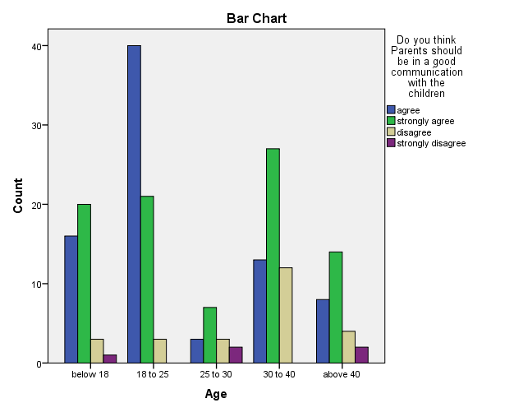
Legend : from the above fig 1 it shows the scaling of parental techniques in growing a child ,should they be in a good communication with the children.

Result :

Under age category the out of 199 responces 80 agreed ,89 strongly agreed,25 disagree,5 disagreed .

Age * At what level the parent should be friendly with the children in Parenting?

Crosstab
Count
 |  | At what level the parent should be friendly with the children in parenting |  |  |  |  |  |  |  |  |  | Total
 |  | 1 | 2 | 3 | 4 | 5 | 6 | 7 | 8 | 9 | 10 | Total
Age | below 18 | 9 | 5 | 7 | 2 | 2 | 1 | 2 | 1 | 1 | 10 | 40
Age | 18 to 25 | 1 | 8 | 5 | 5 | 6 | 6 | 11 | 4 | 11 | 7 | 64
Age | 25 to 30 | 2 | 1 | 4 | 1 | 2 | 1 | 0 | 1 | 2 | 1 | 15
Age | 30 to 40 | 10 | 12 | 4 | 6 | 1 | 2 | 1 | 0 | 3 | 13 | 52
Age | above 40 | 8 | 4 | 7 | 2 | 3 | 0 | 2 | 0 | 1 | 1 | 28
Total |  | 30 | 30 | 27 | 16 | 14 | 10 | 16 | 6 | 18 | 32 | 199

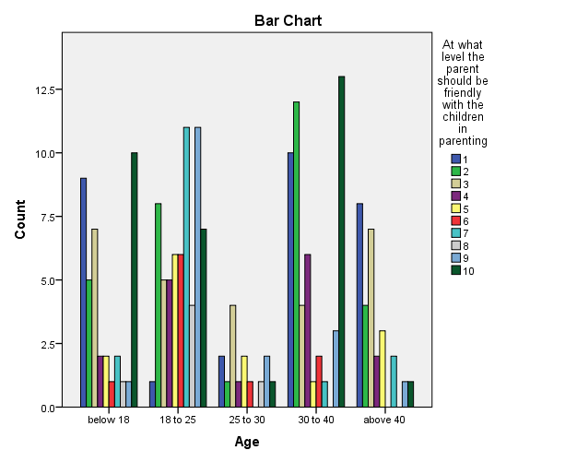

Legend :
from the above fig 2 it shows the scaling of parental techniques in growing a child ,at what level the parent should be friendly with the children in parenting .

Result :
Under age category out of 199 response 30 have responded the level of rating 1 ,30 for 2 ,27 for 3 ,16 for 4 ,14 for 5 ,10 for 6,16 for 7 ,6 for 8,18 for 9 ,32 for 10 .

Gender * Do you think Parents should be in a good communication with the children

Crosstab
Count
 |  | Do you think Parents should be in a good communication with the children |  |  |  | Total
 |  | agree | strongly agree | disagree | strongly disagree | Total
Gender | male | 23 | 29 | 6 | 1 | 59
Gender | female | 56 | 55 | 17 | 3 | 131
Gender | prefer not to say | 1 | 5 | 2 | 1 | 9
Total |  | 80 | 89 | 25 | 5 | 199

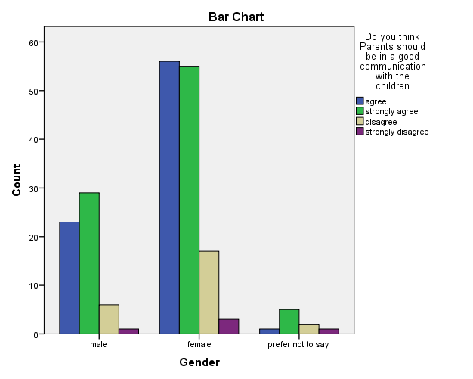

Legend : from the above fig 3 it shows the scaling of parental techniques in growing a child ,should they be in a good communication with the children.

Result :
Under gender catagory among 199 response of male female and prefer not to say ,80 have agreed ,89 strongly agree ,25 disagree,5 strongly disagree.

Gender * At what level the parent should be friendly with the children in parenting

Crosstab
Count
 |  | At what level the parent should be friendly with the children in parenting |  |  |  |  |  |  |  |  |  | Total
 |  | 1 | 2 | 3 | 4 | 5 | 6 | 7 | 8 | 9 | 10 | Total
Gender | male | 12 | 7 | 11 | 3 | 2 | 2 | 4 | 3 | 6 | 9 | 59
Gender | female | 17 | 21 | 14 | 12 | 10 | 7 | 12 | 3 | 12 | 23 | 131
Gender | prefer not to say | 1 | 2 | 2 | 1 | 2 | 1 | 0 | 0 | 0 | 0 | 9
Total |  | 30 | 30 | 27 | 16 | 14 | 10 | 16 | 6 | 18 | 32 | 199

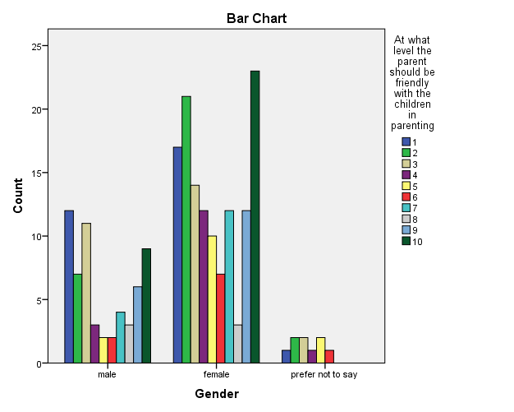

Legend : from the above fig 4 it shows the scaling of parental techniques in growing a child ,at what level the parent should be friendly with the children in parenting .

Result :
Under gender category out of 199 response 30 have responded the level of rating 1 ,30 for 2 ,27 for 3 ,16 for 4 ,14 for 5 ,10 for 6,16 for 7 ,6 for 8,18 for 9 ,32 for 10

occupation * Do you think Parents should be in a good communication with the children

Crosstab
Count
 |  | Do you think Parents should be in a good communication with the children |  |  |  | Total
 |  | agree | strongly agree | disagree | strongly disagree | Total
occupation | public | 40 | 16 | 4 | 2 | 62
occupation | private | 29 | 44 | 14 | 3 | 90
occupation | self employment | 11 | 29 | 7 | 0 | 47
Total |  | 80 | 89 | 25 | 5 | 199

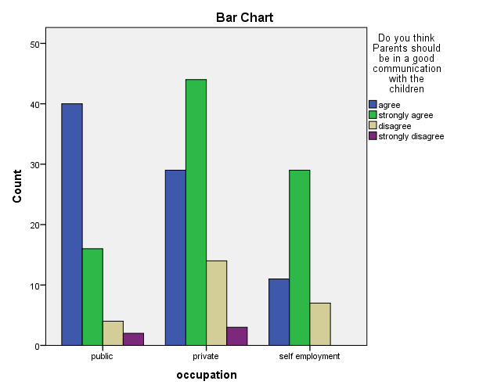

Legend :
from the above fig 5 it shows the scaling of parental techniques in growing a child ,should they be in a good communication with the children.

Result :
Under occupation catagory among 199 response of private ,public and self employed ,80 have agreed ,89 strongly agree ,25 disagree,5 strongly disagree.

occupation * At what level the parent should be friendly with the children in parenting

Crosstab
Count
 |  | At what level the parent should be friendly with the children in parenting |  |  |  |  |  |  |  |  |  | Total
 |  | 1 | 2 | 3 | 4 | 5 | 6 | 7 | 8 | 9 | 10 | Total
occupation | public | 8 | 8 | 5 | 8 | 9 | 5 | 7 | 3 | 6 | 3 | 62
occupation | private | 19 | 14 | 16 | 5 | 3 | 5 | 4 | 1 | 9 | 14 | 90
occupation | self employment | 3 | 8 | 6 | 3 | 2 | 0 | 5 | 2 | 3 | 15 | 47
Total |  | 30 | 30 | 27 | 16 | 14 | 10 | 16 | 6 | 18 | 32 | 199

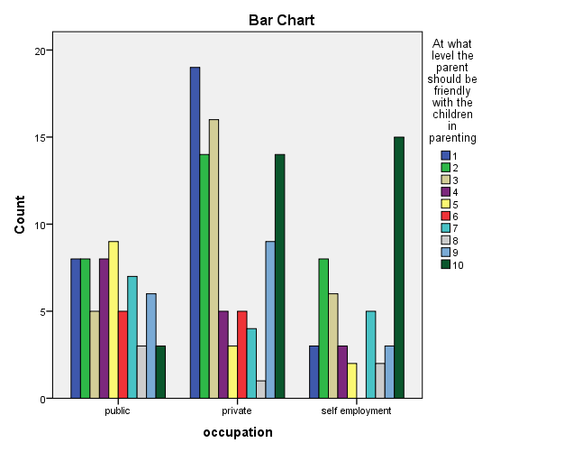

Legend
from the above fig 6 it shows the scaling of parental techniques in growing a child ,at what level the parent should be friendly with the children in parenting .

Result :

Under occupation category out of 199 response 30 have responded the level of rating 1 ,30 for 2 ,27 for 3 ,16 for 4 ,14 for 5 ,10 for 6,16 for 7 ,6 for 8,18 for 9 ,32 for 10

Educational qualification * Do you think Parents should be in a good communication with the children

Crosstab
Count
 |  | Do you think Parents should be in a good communication with the children |  |  |  | Total
 |  | agree | strongly agree | disagree | strongly disagree | Total
Educational qualification | schooling | 14 | 19 | 5 | 1 | 39
Educational qualification | under graduate | 47 | 44 | 11 | 2 | 104
Educational qualification | post graduate | 15 | 20 | 5 | 1 | 41
Educational qualification | illiterate | 4 | 6 | 4 | 1 | 15
Total |  | 80 | 89 | 25 | 5 | 199

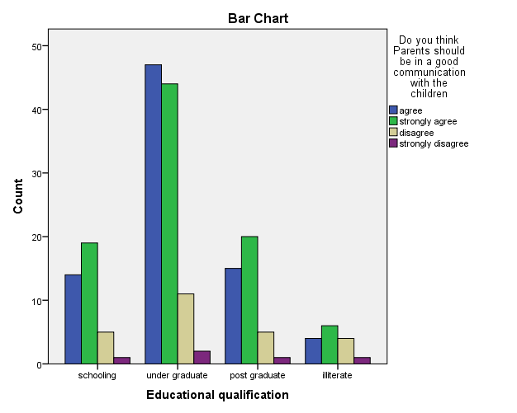

Legend :
from the above fig 7 it shows the scaling of parental techniques in growing a child ,should they be in a good communication with the children.

Result :
Under the educational qualification category among 199 response of schooling ,ug ,pg, and illiterate ,80 have agreed ,89 strongly agree ,25 disagree,5 strongly disagree.

Educational qualification * At what level the parent should be friendly with the children in parenting

Crosstab
Count
 |  | At what level the parent should be friendly with the children in parenting |  |  |  |  |  |  |  |  |  | Total
 |  | 1 | 2 | 3 | 4 | 5 | 6 | 7 | 8 | 9 | 10 | Total
Educational qualification | schooling | 8 | 6 | 8 | 2 | 1 | 1 | 1 | 1 | 2 | 9 | 39
Educational qualification | under graduate | 14 | 14 | 12 | 11 | 9 | 7 | 11 | 4 | 12 | 10 | 104
Educational qualification | post graduate | 4 | 7 | 4 | 3 | 3 | 1 | 1 | 1 | 4 | 13 | 41
Educational qualification | illiterate | 4 | 3 | 3 | 0 | 1 | 1 | 3 | 0 | 0 | 0 | 15
Total |  | 30 | 30 | 27 | 16 | 14 | 10 | 16 | 6 | 18 | 32 | 199

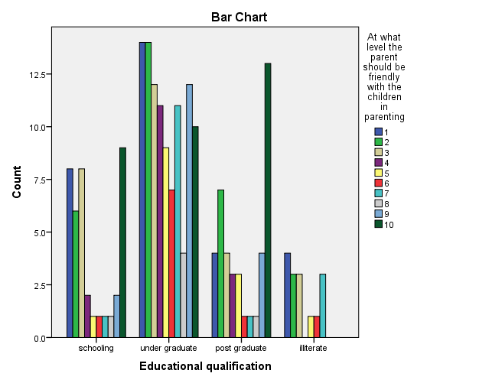

Legend
from the above fig 8 it shows the scaling of parental techniques in growing a child ,at what level the parent should be friendly with the children in parenting .

Result :
Under occupation category out of 199 response 30 have responded the level of rating 1 ,30 for 2 ,27 for 3 ,16 for 4 ,14 for 5 ,10 for 6,16 for 7 ,6 for 8,18 for 9 ,32 for 10

DISCUSSION :

Information and education on optimal parenting styles and early establishment of effective practices are both important to a child’s social adjustment and success. In many situations, adoption of a flexible and warm authoritative parenting style is most beneficial for a child’s social, intellectual, moral and emotional growth. However, research in the area of parent-child interaction must continue to expand to evaluate not only outcomes in a broader variety of ethnic/racial/cultural and socioeconomic groups, but also outcomes in children of different ages so that families in all types of situations can reap the full benefits of research. The development of personality, morals, goals and problem-solving that occurs during the first years of life is critical and developmentally unlike any other time in the life course. It is important for family policy-makers and family support service workers to aid new parents in adopting appropriate parenting techniques and strategies to ensure that children receive guidance that will best allow them to succeed in later life. However, research into the broad applicability of certain types of parenting techniques must continue so that policy-makers can tailor advice and guidelines to optimize outcomes for every child.

LIMITATION:

The Major limitation of the study is the sample frame. The sample frame Collected through online platforms like sending mail, sending links via WhatsApp is the limitation of the study, the real field experience is missed out due to corona pandemic. The restrictive area of sample size is yet another drawback of the research.Collection of data via online platform is limiting the researcher to collect data from the field.Since the data is collected on online platform wherein the respondent is not known, the original opinion of the respondent it is not found, The researcher could only come to a approximate conclusion of what the respondent is feeling to convey.

CONCLUSION :
As this article has shown, children continue to grow and to change in amazing ways as they move from toddlerhood to school-age. During the Preoperational stage, between ages 2 to 7 years, young children continue to grow taller as their bodies take on more adult proportions. They gain the ability to run and to climb stairs independently, as well as to cut with scissors and to grip a writing tool. Cognitively, young children learn how to think symbolically, which leads to make-believe play, and their language explodes and matures. Emotionally, children learn how to express their own feelings and to feel reflective empathy. Socially, they begin to cultivate relationships with peers as well as deepen family relationships. Morally, they begin to understand "right" versus "wrong," and to understand they have the choice about which way to go. Sexually, young children continue to form their gender identity and begin to understand what it means to be male or female. Beyond just understanding how young children are growing and developing during these early years, parents also need practical, everyday knowledge on how to care for their children and how to meet their needs. More information on Parenting can be found in our corresponding article on Parenting Skills for the Preoperational Level.As the preceding sentence suggests, social and personality development continues through adolescence and the adult years, and it is influenced by the same constellation of social, biological, and representational influences discussed for childhood. Changing social relationships and roles, biological maturation and (much later) decline, and how the individual represents experience and the self continue to form the bases for development throughout life. In this respect, when an adult looks forward rather than retrospectively to ask, “what kind of person am I becoming?”—a similarly fascinating, complex, multifaceted interaction of developmental processes lies ahead.

Reference :
- Admas, Adugnaw, Berhane Kidane, Melaku Admasu, and Tesaka Misga. n.d. “Develope Micro Clonal -Propagation Protocol forOxytenanthera Abyssinica A.Rich. Munroto Large Scale Micro-Propagation.” https://doi.org/10.1101/2020.04.28.063883.
- Bang, Jounghae, and Chungsuk Ryu. 2008. “A Study to Develope Measurements of Design Sensitivity.” Journal of Consumption Culture. https://doi.org/10.17053/jcc.2008.11.4.002.
- “Develope Your Inventions.” 1872. Scientific American. https://doi.org/10.1038/scientificamerican10121872-232.
- Fives, Allyn. 2017. “Parental Power.” Evaluating Parental Power. https://doi.org/10.7228/manchester/9781784994327.003.0006.
- Gao, Z. 2019. “Bilateral vs. Unilateral Cochlear Implantaton in Mandarin Speaking Childreen: Surgical Experience and Preliminary Results.” Abstract- Und Posterband – 90. Jahresversammlung Der Deutschen Gesellschaft Für HNO-Heilkunde, Kopf- Und Hals-Chirurgie e.V., Bonn – Digitalisierung in Der HNO-Heilkunde. https://doi.org/10.1055/s-0039-1686373.
- Karlimah, K. 2019. “How to Develope Primary School Mathematics Learning Media.” Journal of Physics: Conference Series. https://doi.org/10.1088/1742-6596/1318/1/012009.
- Mafi, Mojtaba. n.d. “Review of ‘Non Alcoholic Fatty Liver Disease May Develope in Individuals with Normal Body Mass Index.’” Publons Reviews and Discussion. https://doi.org/10.14322/publons.r2283967.
- Ma, Jinfeng, Feng Mao, and Wensheng Zhou. 2009. “Utilizing Multi-Agent Modelling to Develope Urban Simulations.” 2009 International Asia Conference on Informatics in Control, Automation and Robotics. https://doi.org/10.1109/car.2009.106.
- National Academies of Sciences, Engineering, and Medicine, Division of Behavioral and Social Sciences and Education, Board on Children, Youth, and Families, and Committee on Supporting the Parents of Young Children. 2016. Parenting Matters: Supporting Parents of Children Ages 0-8. National Academies Press.
- Numan, Michael. 2020a. “Parental Behavior.” The Parental Brain. https://doi.org/10.1093/oso/9780190848675.003.0002.
- ———. 2020b. “The Parental Brain in Humans.” The Parental Brain. https://doi.org/10.1093/oso/9780190848675.003.0008.
- Otsu, Takayuki. 1993. “To Develope Further the Radical Polymerization.” Kobunshi. https://doi.org/10.1295/kobunshi.42.295.
- ———. 1998. “To Develope Further the Precision Polymerization.” Kobunshi. https://doi.org/10.1295/kobunshi.47.61.
- Rasyid, Erwin, Ade Putranto Prasetyo, and Hari Akbar Sugiantoro. 2021. “Trust Issues in the Health Communication of Childreen in Street Situation.” Jurnal ASPIKOM. https://doi.org/10.24329/aspikom.v6i1.824.
- Rolnick, Norma. 1966. “Psychological Exploratory Service as a Technique for Parental Counseling.” PsycEXTRA Dataset. https://doi.org/10.1037/e469452008-105.
- Setyawati, Vilda Ana Veria, and Bambang Agus Herlambang. 2018. “Mobile Health Nutrition Book Design to Prevent Stunting at Childreen <5 Years.” 2018 International Seminar on Application for Technology of Information and Communication. https://doi.org/10.1109/isemantic.2018.8549745.
- Shelov, Steven P. 2009. Caring for Your Baby and Young Child: Birth to Age Five. Bantam Dell Publishing Group.
- Turner-Brown, Sandra, Jan Kidder, Denise L. Winsor, and Jodie Friedman. 2013. “Parental Storytelling As an Interviewing Technique for Preschool Children.” PsycEXTRA Dataset. https://doi.org/10.1037/e598932013-001.
- Van Trinh, Mai, and Nguyen Dang Thuan. 2016. “USING SELF-MADE COMPUTERIZED EXPERIMENT KIT TO DEVELOPE CREATIVITY COMPETENCE OF PUPILS IN PHYSICS TEACHING IN VIETNAM HIGH SCHOOLS.” Journal of Science, Educational Science. https://doi.org/10.18173/2354-1075.2016-0214.
- Wei, Guangxing, and Xinghong Qin. 2011. “Modes for Chongqing to Develope Urban-Rural Balanced Logistic System.” 2011 Fourth International Conference on Intelligent Computation Technology and Automation. https://doi.org/10.1109/icicta.2011.270.
- 이범웅, and 이범웅. 2018. “A Study on Exploring the Methods of Moral Education to Develope Empathic Capability.” KOREAN ELEMENTARY MORAL EDUCATION SOCIETY. https://doi.org/10.17282/ethics.2018..62.1.
Plagerism
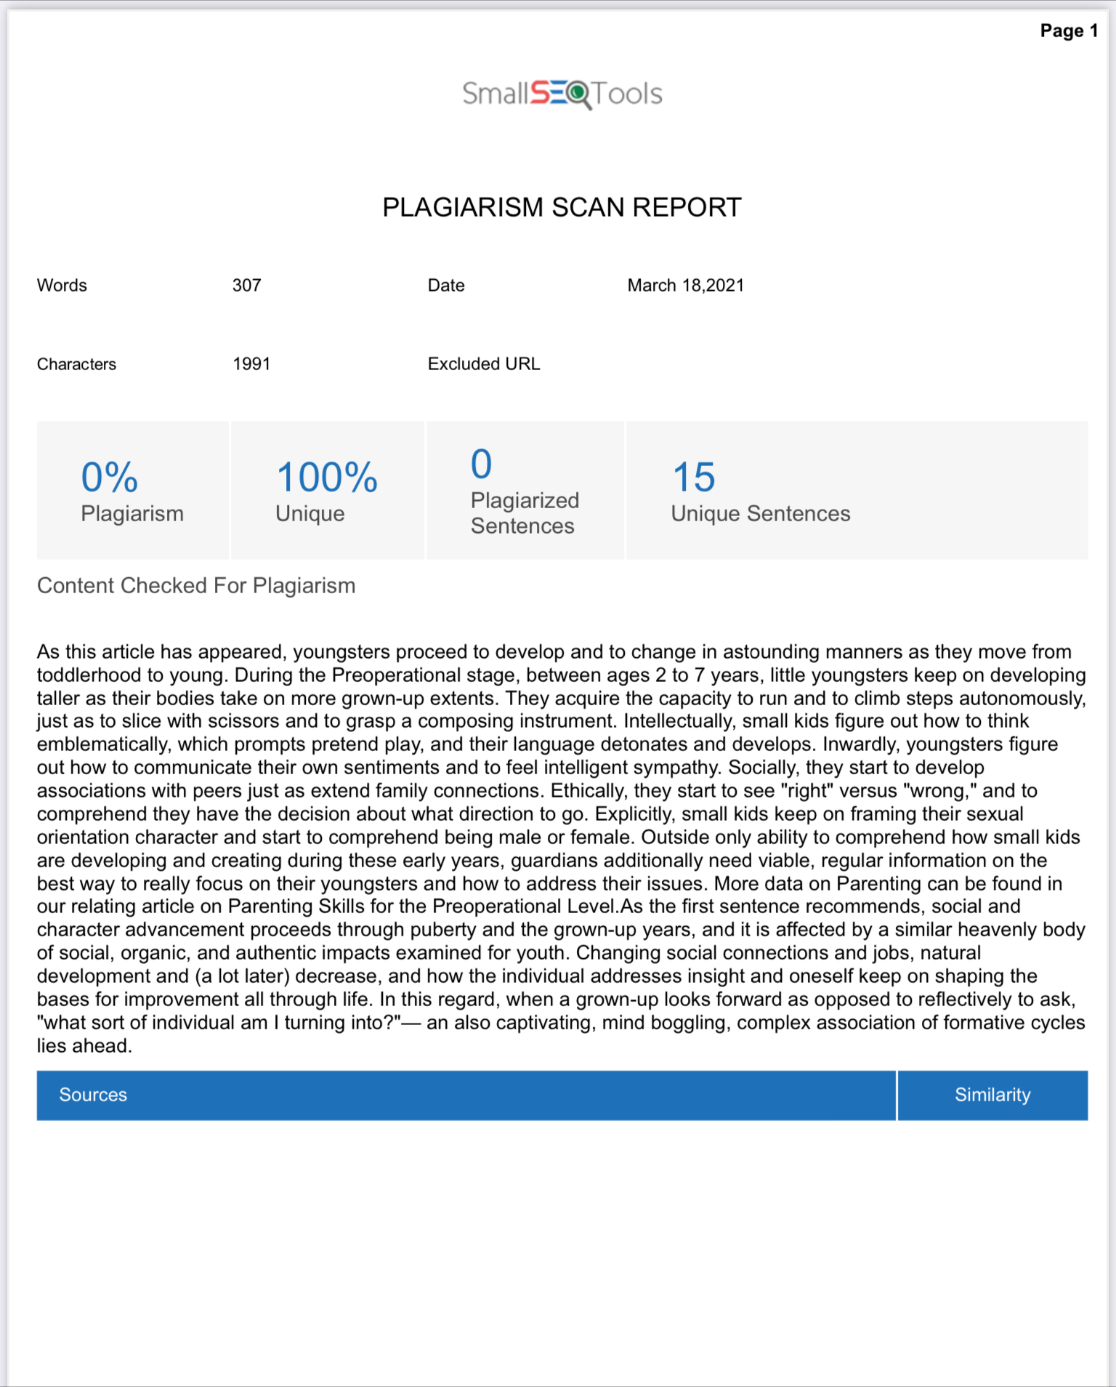

S.MADHUMITHA, saveetha school of law ,Saveetha institute of medical and technical science (SIMATS), mobile no : 9361143383, email id :madhusuji1323@gmail.com.
Mrs.Bala tripura sundari, saveetha school of law ,Saveetha institute of medical and technical science (SIMATS), mobile no :9600031223, email id : balatripurasundari@gmail.com

