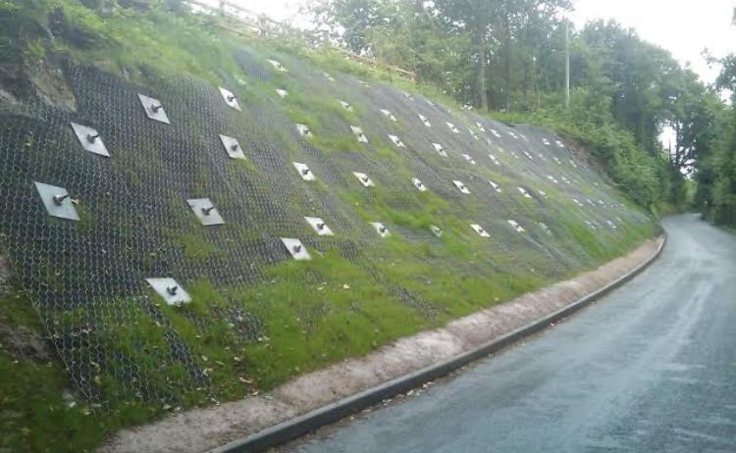
Soil  Nailing  According to Wikipedia, France was the country where soil nailing initially became popular. The project, started in 1961, was the first one to strengthen a concrete barrier employing steel nails. In 1972, a wall using the current soil-nailing method was built close to Versailles. | As a construction structure that allows the safe over-steepening of new or existing soil slopes, soil nailing is a therapeutic construction strategy to rectify unstable natural soil slopes or unstable man-made (fill) slopes. The technique entails inserting relatively thin reinforcing elements into the slope; these are frequently rebar’s for general use, however there are additional bars with distinctive solid or hollow systems available. Hollow bars can be drilled and grouted synchronously by using a sacrificial drill bit and pushing grout down the sunken bars as drilling advances. Solid bars are typically inserted into pre-drilled holes and then grouted into place using a separate grouting line. It has also been designed to penetrate comparatively short bars into natural slopes using vibration techniques.  Use of soil nails to strengthen soil and increase stability. Additionally, it strengthens slopes, excavations, retaining walls, and other structures to make them more stable.

