Dynamical Analysis of the Billiard System Inside a Torus
Swarnabha Debnath, Shiv Nadar University, currently pursuing undergraduate in physics, Address: Dhaleswar, Kalyani, Agartala, Tripura, pincode:799001, email id: sd689@snu.edu.in, contact no: 8527015180
Amber Habib, Professor of Maths Department, Shiv Nadar University, email id: amber.habib@snu.edu.in

Abstract:
The billiard system in complex geometries has been a subject of interest due to its intriguing dynamics and complex behaviour. This research project aims to provide a comprehensive analysis of the dynamical system governing the motion of particles within a torus-shaped region using Hénon's equations. The study aims to explore the system's behaviour, stability, and properties under different conditions and parameters. The study aims to explore the system's behaviour, stability, and properties under different conditions and parameters. By combining concepts from geometry, classical mechanics, and dynamical systems theory, this project offers insights into the intricate behaviour of the billiard system and provides a foundation for further research in the field of chaotic dynamics within complex geometries.
Keywords: Dynamical systems, Billiard system, Torus, Hénon's equations, Stability analysis, Bifurcation analysis.

Introduction:
The study of dynamical systems in billiards has attracted significant attention due to its rich and intricate behaviour. In particular, the investigation of billiard systems within torus-shaped regions has been the subject of numerous research studies. This project aims to contribute to the understanding of the dynamics of billiard systems inside a torus through a comprehensive dynamical system analysis. One influential work in this field is the research by Alsheekhhussain on the "Rotation Sets of Billiards with N Obstacles on a Torus" [1]. This study explores the rotation sets associated with billiard trajectories in torus billiards with multiple obstacles. The findings shed light on the rotational dynamics and the role of obstacles in shaping the system's behaviour.
Another relevant study by Menini et al. focuses on trajectory tracking in rectangular billiards by unfolding the billiard table [2]. This work presents a novel approach to analyse the dynamics of billiard systems by unfolding the billiard table onto a flat surface. The unfolded representation allows for the application of standard tools from dynamical systems theory to study the trajectory tracking problem. The investigation of level statistics and eigenfunctions in square torus billiards is addressed by Tuan et al. [3]. This research explores the transition from regular to chaotic behaviours in billiard systems through the analysis of level statistics and the properties of eigenfunctions. The findings contribute to the understanding of the underlying quantum behaviour in billiard systems on a torus.Transient chaos in a generalized Hénon map on the torus is studied by Izrailev et al. [4]. The authors investigate the emergence of transient chaos in a modified Hénon map on a torus. The analysis reveals the presence of complex and unpredictable dynamics, highlighting the sensitivity to initial conditions and the intricate behaviour of the system. Additionally, the work by Gonchenko et al. presents examples of Lorenz-like attractors in Hénon-like maps [5]. This research explores the existence of chaotic attractors resembling the famous Lorenz attractor in a class of Hénon-like maps. The investigation provides insights into the rich dynamics exhibited by Hénon-like maps and their relevance to the study of chaotic systems. Furthermore, the concept of homeomorphisms in topological spaces is addressed by Ganesan and Parimelazhagan [6]. This research explores the properties and characteristics of B* homeomorphisms in topological spaces, providing a theoretical foundation for understanding the structural transformations and dynamics in billiard systems on a torus.
In conclusion, this project aims to contribute to the field of dynamical system analysis of billiard systems within a torus. By drawing upon the aforementioned works and incorporating their insights, the project seeks to deepen the understanding of the intricate dynamics, stability properties, and chaotic behaviours exhibited by billiard systems inside a torus.

1. Homeomorphism and Identification Spaces
In the study of dynamical systems, understanding the geometric properties of the underlying space is crucial.
A homeomorphism is a mathematical transformation that preserves topological properties, allowing us to relate different spaces while preserving their essential characteristics. To derive a torus from a square billiard board, we employ a specific homeomorphism that captures the intrinsic and extrinsic geometry of the system. Formally, a homeomorphism is defined as a function that is a continuous bijection between two topological spaces, with a continuous inverse function.
Let's denote two spaces as X and Y. If there exist continuous maps f: X → Y and g: Y → X such that f ◦ g = $I_{y}$ (the identity map on Y) and g ◦ f = $I_{X}$ (the identity map on X), then X and Y are said to be homeomorphic [8],[7].
This notion of homeomorphism forms an equivalence relation on the class of all topological spaces. It satisfies reflexivity , symmetry ,and transitivity. The resulting equivalence classes are called homeomorphism classes.
In the context of billiard dynamics in a torus, the concept of identification spaces becomes relevant. We can represent the torus as an identification space derived from a square billiard board. The partition of the square corresponds to the identification of opposite edges to form the torus. Now, let's consider the concept of identification spaces. A partition of a topological space X is a collection of disjoint nonempty subsets of X that covers the entire space. In other words, the partition divides X into distinct subsets. We can construct an identification space, denoted as Y, from X by associating each subset of the partition with a point in Y. The topology of Y, known as the identification topology, is defined such that a subset O of Y is open if and only if its preimage under the mapping π from X to Y is open in X [8].
Mathematically, we can express this identification by considering the square billiard board as the unit square in the xy-plane, where (0, 0) corresponds to the bottom-left corner and (1, 1) to the top-right corner. The identification of opposite edges can be described by the equations:
Identifying left and right edges:
(x, y) ~ (x + 1, y) for 0 ≤ x ≤ 1, 0 ≤ y ≤ 1 (1.0)
Identifying top and bottom edges:
(x, y) ~ (x, y + 1) for 0 ≤ x ≤ 1, 0 ≤ y ≤ 1 (1.1)
In the extrinsic view, we imagine embedding the square billiard board in three-dimensional space and bending it to form a torus. This geometric transformation involves mapping the square board onto the surface of a torus in a way that preserves the distances between points. The extrinsic view allows us to visualize the torus as a curved surface with two different radii, representing the major and minor axes of the torus.
By employing these homeomorphisms and identification spaces, we can now analyse the dynamical system of billiards within the torus. The transformed system retains the essential properties of the original square billiard board, while also exhibiting the unique characteristics associated with the toroidal geometry.

2. Classical Dynamics for Billiard Torus System
2.1 Equations of motion for toroidal geometry
The motion of particles inside the dynamical system of a torus can be described by a set of equations of motion. These equations capture the velocity and acceleration of the particles as they move along and around the torus.
To derive the equations of motion for a billiard chaotic system inside a torus, let's consider a point particle moving freely inside a toroidal billiard table. The torus can be represented parametrically in terms of two angles, θ and φ, as follows:
θ(t) = θ₀ + ω₁t (2.1.0)
φ(t) = φ₀ + ω₂t (2.1.1)
where θ₀ and φ₀ are the initial angles, and ω₁ and ω₂ are the angular velocities along the two directions on the torus.
The particle's position on the torus can be described by its coordinates (x, y, z) in Cartesian coordinates. However, since we are interested in the billiard dynamics, we can express the position in terms of the angles θ and φ as follows:
x = (R + r cos(θ)) cos(φ) (2.1.2)
y = (R + r cos(θ)) sin(φ) (2.1.3)
z = r sin(θ) (2.1.4)
where R represents the major radius of the torus, and r represents the minor radius and for ellipse toroid R and r is written in terms of phi [9],
$r→r\left(ϕ\right)=\frac{a}{\sqrt{\cos^{2}ϕ+\frac{a^{2}}{b^{2}}\sin^{2}ϕ}}$ ; (2.1.5)
$R→R\left(ϕ\right)=\frac{A}{\sqrt{\cos^{2}ϕ+\frac{A^{2}}{B^{2}}\sin^{2}ϕ}}$, (2.1.6)
where a, b, A and B are constant parameters for the elliptical torus.
The velocity of a particle at a given time is determined by the toroidal coordinates (θ, φ) and is represented by the vector v(t).
v(t) = (R + r cos(φ)) (cos(φ)cos(θ), cos(φ)sin(θ), sin(φ)) $\frac{dθ}{dt}$+ (r sin(φ)) (-sin(θ), cos(θ), 0) $\frac{dϕ}{dt}$ (2.1.7)
The acceleration of the particle at time t is represented by the vector a(t), which can be expressed as:
a(t) = (R + r cos(φ)) (-cos(φ)sin(θ), cos(φ)cos(θ), 0) ($\frac{d^{2}\left(θ\right)}{dt^{2}})$ + (R + r cos(φ)) (-sin(φ)cos(θ), -sin(φ)sin(θ), cos(φ)) ($\frac{d^{2}\left(φ\right)}{dt^{2}}$) - rcos(φ) (-sin(θ), cos(θ), 0) ($\frac{dθ}{dt}\frac{dϕ}{dt})$ (2.1.8)
The third term considers the cross product between the linear and angular velocities, accounting for the change in direction as the particle moves along the torus.
For a particle moving in a chaotic system on a torus, the Lagrangian function can be expressed as:
L = $\frac{1}{2}$m (r²θ'² + r'²) - V(φ), (2.1.9)
For a particle moving in a chaotic system on a torus, the Hamiltonian function given by:
H = $\frac{1}{2}$m(r²θ'² + r'²) + V(φ), (2.1.10)
where V(φ) represents the potential energy.
Now, let's consider the particle's motion inside the torus as it bounces off the walls. When the particle reaches the boundary of the torus, it undergoes elastic reflection according to the laws of billiard dynamics. The angle of incidence is equal to the angle of reflection. Since we are considering a billiard system, the force acting on the particle arises solely from the elastic collisions with the torus walls. The direction of the force changes whenever the particle reaches the boundary and undergoes reflection. The magnitude of the force remains constant throughout the motion. The reflection process can be described using the law of reflection, which states that the angle of incidence is equal to the angle of reflection. By considering the geometry of the torus, we can determine the appropriate components of the force (F_{X}, F_{Y}, F_{X}) during reflection.

2.2 Harmonic Motion inside the Torus
Harmonic motion within a torus exhibits fascinating dynamics that can be described using the principles of Lagrangian and Hamiltonian mechanics. The study of such motion has been explored in works such as [9] and [10]. In three-dimensional motion within the torus field, where the z-direction is considered, the equations of motion become [9]:
ẍ + ωₓ²x = 0, (2.2.0)
ÿ + ω_{Y}²y = 0, (2.2.1)
z̈ + ω_{Z}²z = 0 (2.2.2)
In the case of three-dimensional motion near the torus, where the frequencies for motion in the x and z-directions (or y and z-directions) are different, the equations of motion was proved as [9]:
x(t) = A cos(ωₓt - α), (2.2.3)
z(t) = B cos(ω_{Z}t - β), or (2.2.4)
y(t) = B cos(ω_{y}t - α), (2.2.5)
z(t) = C cos(ω_{z}t - γ) (2.2.6)
These equations represent the three-dimensional motion of the particle near the torus, and the trajectories followed by the particle form rich and interesting paths. The frequencies ωₓ, ω_{y}, and ω_{z} determine the oscillatory behaviour along the respective directions, and the phases α, β, and γ introduce phase differences that influence the shape and orientation of the trajectories. The harmonic motion inside the torus can be analysed using the Lagrangian and Hamiltonian formulations. The Lagrangian function, denoted by L, captures the kinetic and potential energies of the system. It can be expressed as [9]:
L = (R + r cos(φ))² (θ̇)² + r² (sin(φ))² (φ̇)² - V(φ), (2.2.7)
where θ̇ and φ̇ represent the time derivatives of the angles θ and φ, respectively, and V(φ) represents the potential energy.
The corresponding Hamiltonian function, denoted by H, is obtained through a Legendre transformation from the Lagrangian. It is given by [9]:
H = $\frac{1}{\left[2{\left(R+rcos\left(ϕ\right)\right)}^{2}\right][pθ² / r² + pφ² / (r² (sin(φ))²)] }$ + V(φ), (2.2.8)
where pθ and pφ are the canonical momenta conjugate to θ and φ, respectively.
The equations of motion can be derived from the Lagrange equations or Hamilton's equations. In particular, the harmonic oscillations within the torus exhibit a periodic nature with characteristic angular frequencies. The angular frequencies, denoted by ωθ and ωφ, correspond to the oscillations in the θ and φ directions, respectively. The expressions for the angular frequencies are given by [10],
ωθ = $\frac{1}{r\sqrt{(R + r cos\left(φ\right)) / (R + 2 r cos(φ))}} ,$ (2.2.9)
ωφ = $\sqrt{(R + r cos(φ)) / (r² (sin(φ))²)}$ (2.2.10)
These formulas provide insights into the harmonic motion inside the torus, including the oscillation frequencies and the dependence on the toroidal coordinates and system parameters.

2.3 Chaotic dynamical system for different torus
The equations for chaotic motion in a torus depend on the specific type of torus. Here are the differences for the three types:
Ring torus: The motion on a ring torus is characterized by two independent angular coordinates. The equations of motion for a particle on a ring torus are given by the Euler-Lagrange equations and Hamilton's equations. The main difference between a ring torus and a rectangular billiard is that the motion on a torus is periodic in both angular coordinates, which leads to interesting dynamics such as the formation of KAM curves. A ring torus, also known as a standard torus, is defined by the equation:
$(\sqrt{(x2 + y2)}$ - R)² + z² = r², where R is the distance from the centre of the torus to the centre of the tube, and r is the radius of the tube. The trajectory in a ring torus can be described by the following equations in polar coordinates:
θ(t+1) = θ(t) + k φ(t) (2.3.0)
φ(t+1) = φ(t) + m|2π| (2.3.1)
where k and m are integers representing the winding numbers of the torus.
Horn torus: The horn torus is a type of torus that has a boundary consisting of two circular holes. The equations of motion for a particle on a horn torus are similar to those of a ring torus, but with the added complexity of the boundary. The boundary introduces a new term in the Hamiltonian that describes the interaction of the particle with the boundary. This term leads to interesting dynamics, such as the formation of boundary layer solutions.
A horn torus is defined by the equation:
($\sqrt{(x2 + y2)}$+ a z - R)² + b² z² = r², where R is the distance from the centre of the torus to the centre of the tube, r is the radius of the tube, and a and b are constants that determine the shape of the torus.
The trajectory in a horn torus can be described by the following equations in cylindrical coordinates:
ρ(t+1) = ρ(t) + vρ(t) Δt (2.3.2)
θ(t+1) = θ(t) + vθ(t) Δt (2.3.3)
z(t+1) = z(t) + vz(t) Δt (2.3.4)
where ρ, θ, and z are the cylindrical coordinates, vρ, vθ, and vz are the velocity components in the respective directions, and Δt is the time step.
Spindle torus: The spindle torus is a type of torus that has two holes, one at each end. The equations of motion for a particle on a spindle torus are similar to those of a horn torus, but with the added complexity of the two boundaries. The dynamics on a spindle torus are highly dependent on the shape of the holes, and can exhibit complex behaviour such as chaos and quasi-periodicity.
A spindle torus is defined by the equation:
($\sqrt{(x2 + y2)}$+ a z² - R)² + b² z² = r², where R is the distance from the centre of the torus to the centre of the tube, r is the radius of the tube, and a and b are constants that determine the shape of the torus.
The trajectory in a spindle torus can be described by the following equations in cylindrical coordinates:
ρ(t+1) = ρ(t) + vρ(t) Δt (2.3.5)
θ(t+1) = θ(t) + vθ(t) Δt (2.3.6)
z(t+1) = z(t) + vz(t) Δt + A sin(2πz(t)) (2.3.7)
where A is a constant and represents the amplitude of the sinusoidal perturbation
added to the z coordinate to make it non-uniform.

3. Hénon map for Dynamical Analysis:
The Hénon map is a discrete-time dynamical system that exhibits chaotic behaviour. It is defined by M. Hénon by the following equations [11]:
x(t+1) = 1 - a x(t)² + y(t) (3.0)
y(t+1) = b x(t), (3.1)
where the parameters a and b can be adjusted to control the chaotic behaviour and by iterating the Hénon map equations we can generate a sequence of points that trace out the trajectory of the particle.
For the 3D Henon's Map, the dynamical equations were written in the form [12]:
x(i+1) = a-(y(i)²)-b(z(i)) (3.2)
y(i+1) = x(i) (3.3)
z(i+1) = y(i) (3.4)
In torus coordinates, we use the azimuthal angle (θ), the radial distance (ρ), and the vertical displacement (z) from the torus axis. The transformation equations from (5), (6), (7) are:
x = (R + ρ cos(θ)) cos(φ)
y = (R + ρ cos(θ)) sin(φ)
z = ρ sin(θ)
Here, R represents the major radius of the torus, and φ represents the toroidal angle. To generalize the Hénon's map for torus parameters, we can incorporate the torus coordinates into the equations as,
(R + ρ(i+1) cos(θ(i+1))) cos(φ(i+1)) = a - [(R + ρ(i) cos(θ(i))) sin(φ(i))]² - b ρ(i) sin(θ(i)) , (3.5)
(R + ρ(i+1) cos(θ(i+1))) sin(φ(i+1)) = (R + ρ(i) cos(θ(i))) cos(φ(i)) , (3.6)
ρ(i+1) sin(θ(i+1)) = (R + ρ(i) cos(θ(i))) sin(φ(i)) (3.7)
To solve for θ(i+1), ρ(i+1), φ(i+1) we will use the dynamical system analysis by numerical techniques based on coding.
3.1 Relations between the parameters by dynamical analysis
Here we considered different initial parameters for drawing relations within the parameter and the dynamical system characters. However we will not change θ(i), ρ(i), φ(i) as it will get complex to relate the initial states effects on the overall system along with the other parameters.
Let's consider three cases keeping R constant and look into graphs between θ(i), ρ(i), φ(i) and θ(i+1), ρ(i+1), φ(i+1) for analysing the system.
i) a,b>0: a<b
So, we considered a function based on this following parameters R, a, b, θ(i), ρ(i), φ(i) and got the
values of θ(i+1), ρ(i+1), φ(i+1) as 0.29990258707113, 1.1993785344629586 ,0.5630865843554195 and the following jacobian matrix;
[[-0.01907492 0.95056378 -0.35432899]
[-0.00590057 0.29404383 1.14544924]
[ 0.19900083 0.09983342 0. ]]
and the corresponding eigenvalues [-0.23972408+0.51028805j, -0.23972408-0.51028805j , 0.75441707+0.j ] by taking θ(i) = 0.1 ,ρ(i)= 0.2, φ(i) = 0.3 ,R = 1.0, a = 2.0, b = 3.0 as initial parameters.
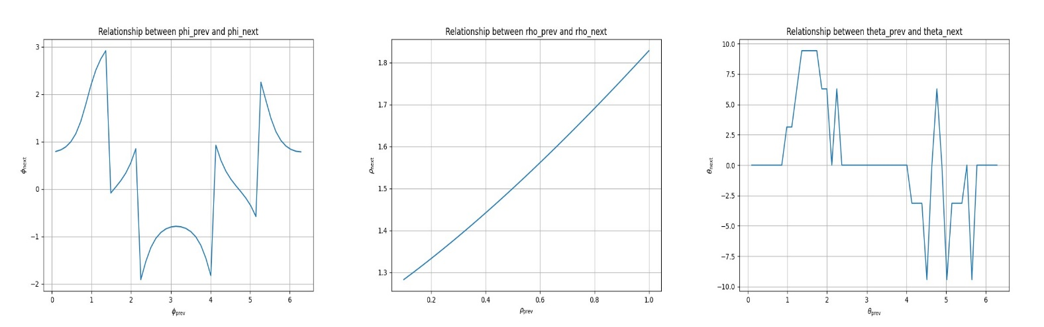
Figure 1. For a = 2.0, b = 3.0, the graph between θ(i) and θ(i+1) is pretty unstable same for the φ(i) and φ(i+1)
Now if we take θ(i) = 0.1 ,ρ(i)= 0.2, φ(i) = 0.3 ,R = 1.0, a = 0.3, b = 0.4 as initial parameters, then the values of θ(i+1), ρ(i+1), φ(i+1) are 1.1525664530414714, 0.3877493642948581, 1.4264799936415733 and the jacobian matrix is
[[-0.01907492 0.95056378 -0.35432899]
[-0.00590057 0.29404383 1.14544924]
[ 0.19900083 0.09983342 0. ]]
and the eigenvalues are [-0.23972408+0.51028805j , -0.23972408-0.51028805j , 0.75441707+0.j ]

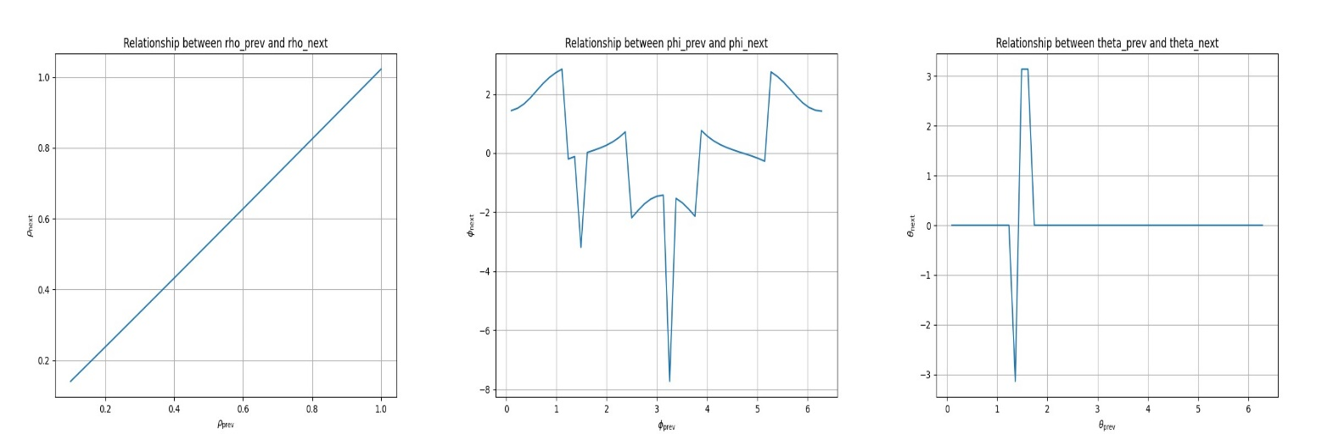
Figure 2. For a = 0.3, b = 0.4, the graph between φ(i) and φ(i+1) is more unstable than for the θ(i) and θ(i+1)
ii) a,b>0: a>b
We will take θ(i) = 0.1 ,ρ(i)= 0.2, φ(i) = 0.3 ,R = 1.0, a = 1.5, b = 1.0 as initial parameters, then the values of θ(i+1), ρ(i+1), φ(i+1) are 0.429367010411234, 0.8511480403000865, 0.7019759802827099 and the jacobian matrix is
[[-0.01907492 0.95056378 -0.35432899]
[-0.00590057 0.29404383 1.14544924]
[ 0.19900083 0.09983342 0. ]]
and the eigenvalues are [-0.23972408+0.51028805j, -0.23972408-0.51028805j , 0.75441707+0.j ]

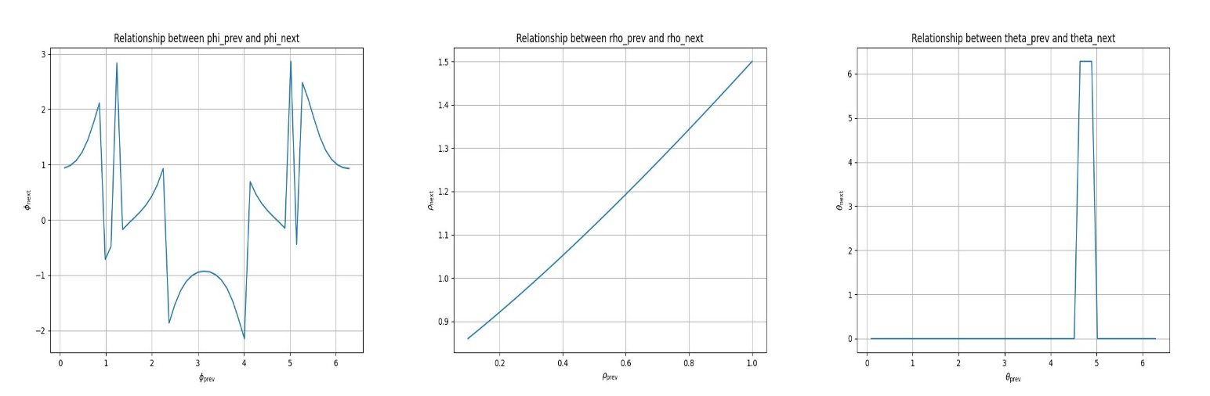
Figure 3. For a = 1.5, b = 1.0, the graph between φ(i) and φ(i+1) is more unstable whereas θ(i) and θ(i+1) is quite stable
iii) a=b
θ(i) = 0.1 ,ρ(i)= 0.2, φ(i) = 0.3 ,R = 1.0, a = 1.0, b = 1.0 as initial parameters, then the values of θ(i+1), ρ(i+1), φ(i+1) are 0.6902974716158693, 0.5564503325018737, 0.9298718275005879 and the jacobian matrix is
[[-0.01907492 0.95056378 -0.35432899]
[-0.00590057 0.29404383 1.14544924]
[ 0.19900083 0.09983342 0. ]]
and the eigenvalues are [-0.23972408+0.51028805j, -0.23972408-0.51028805j , 0.75441707+0.j ]

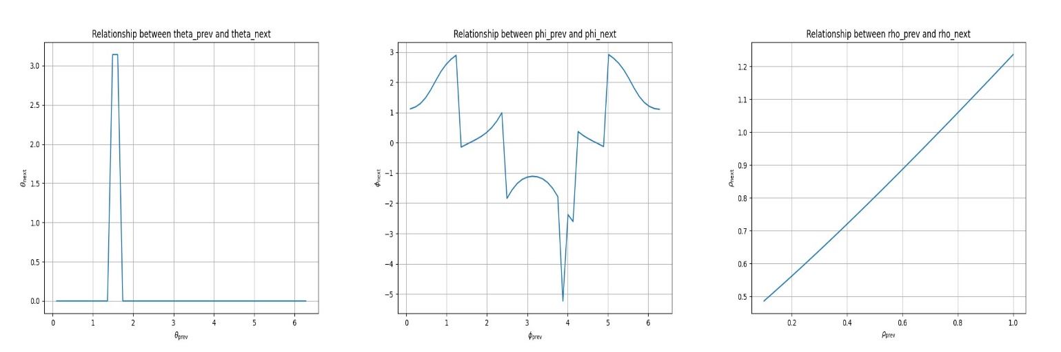
Figure 4. For a = 1.0, b = 1.0, the graph between φ(i) and φ(i+1) is more unstable whereas θ(i) and θ(i+1) is quite stable just like fig 3.

For another case, θ(i) = 0.1 ,ρ(i)= 0.2, φ(i) = 0.3 ,R = 1.0, a = 0.0, b = 0.0 as initial parameters, then the values of θ(i+1), ρ(i+1), φ(i+1) are 1.1648227053215991, 0.385677481239298, 1.6799673338387877 and the jacobian matrix is
[[-0.01907492 0.95056378 -0.35432899]
[-0.00590057 0.29404383 1.14544924]
[ 0.19900083 0.09983342 0. ]]
Eigenvalues:
[-0.23972408+0.51028805j -0.23972408-0.51028805j 0.75441707+0.j ]

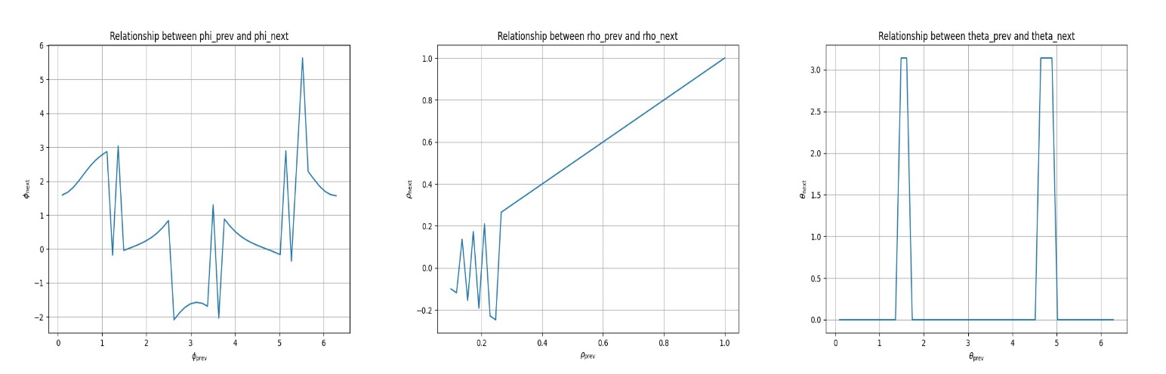

Figure 5. For a = 0.0, b = 0.0, the graph between φ(i) and φ(i+1) is more unstable whereas θ(i) and θ(i+1) is a bit stable and for ρ(i) and ρ(i+1) it is unstable at first and gradually turned stable

iv) a,b<0 , a>b
θ(i) = 0.1 ,ρ(i)= 0.2, φ(i) = 0.3 ,R = 1.0, a = -0.2, b = -0.6 as initial parameters, then the values of θ(i+1), ρ(i+1), φ(i+1) are 1.0838793071869879, 0.4009245931575332, 1.8380019038892093 and the jacobian matrix is
[[-0.01907492 0.95056378 -0.35432899]
[-0.00590057 0.29404383 1.14544924]
[ 0.19900083 0.09983342 0. ]]

and the eigenvalues are [-0.23972408+0.51028805j ,-0.23972408-0.51028805j, 0.75441707+0.j ]
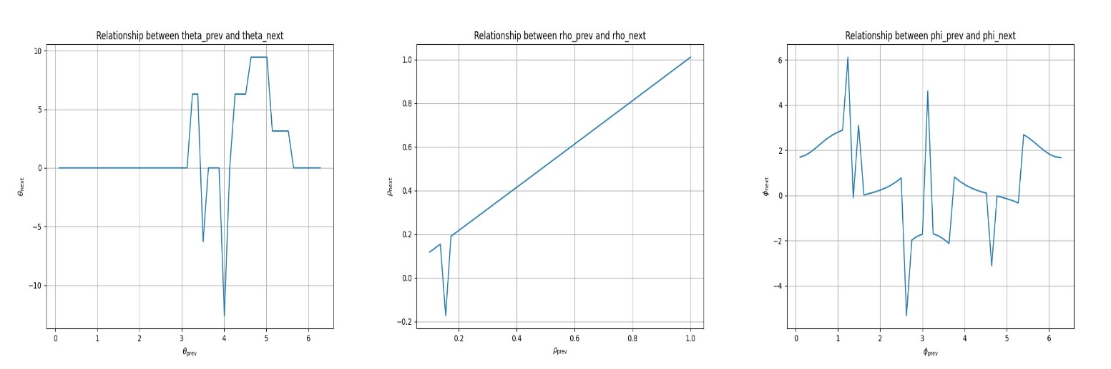
Figure 6. For a = -0.2, b = -0.6, the graph between φ(i) and φ(i+1) is more unstable than θ(i) and θ(i+1) and for ρ(i) and ρ(i+1) it is a bit unstable at first and gradually turned stable
v)a,b<0, a<b
θ(i) = 0.1 ,ρ(i)= 0.2, φ(i) = 0.3 ,R = 1.0, a = -3.0, b = -2.0 as initial parameters, then the values of θ(i+1), ρ(i+1), φ(i+1) are 3.2950141508169764, -2.3185984290610975, 2.786138072642039 and the jacobian matrix is
[[-0.01907488 0.95056381 -0.35432901]
[-0.00590057 0.29404383 1.14544924]
[ 0.19900083 0.09983342 0. ]]
and the eigenvalues are [-0.23972406+0.51028806j ,-0.23972406-0.51028806j, 0.75441708+0.j ]
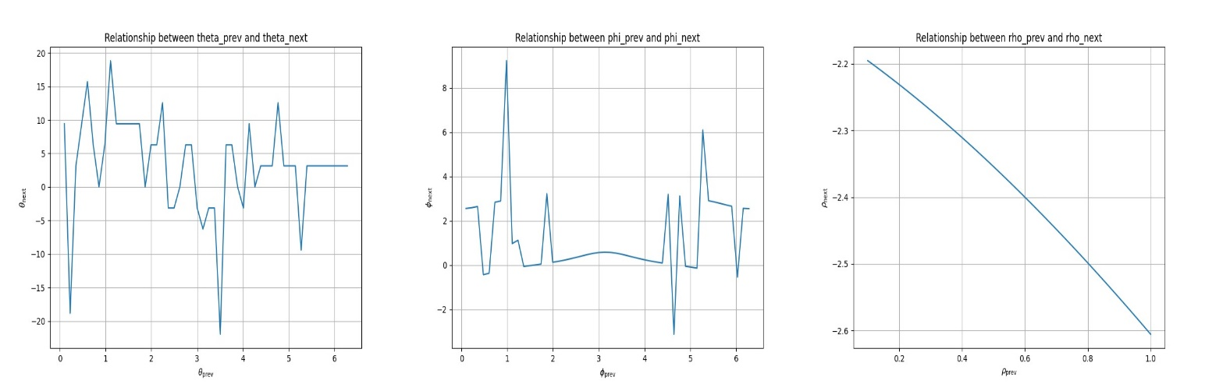
Figure 7. For a = -3.0, b = -2.0, the graph between θ(i) and θ(i+1) is more unstable than φ(i) and φ(i+1) and for ρ(i) and ρ(i+1) it is completely inversely proportional due to change in sign for ρ(i+1) and it mostly depends on the negative values

Now we will take the cases of varying R considering a and b as constants.
i) θ(i) = 0.1 ,ρ(i)= 0.2, φ(i) = 0.3, R=100, a=2.0, b=3.0 as initial parameters,
then θ(i+1), ρ(i+1), φ(i+1) are 600.0821372714481, -780.6440583846556, 3.0326103146682373 and the jacobian matrix is
[[-1.90766514e-02 9.50558388e-01 -2.96108283e+01]
[-5.90034688e-03 2.94043900e-01 9.57237617e+01]
[ 1.99000993e-01 9.98333860e-02 0.00000000e+00]]
Eigenvalues:
[-1.49742081+1.97140733j, -1.49742081-1.97140733j, 3.26980887+0.j ]
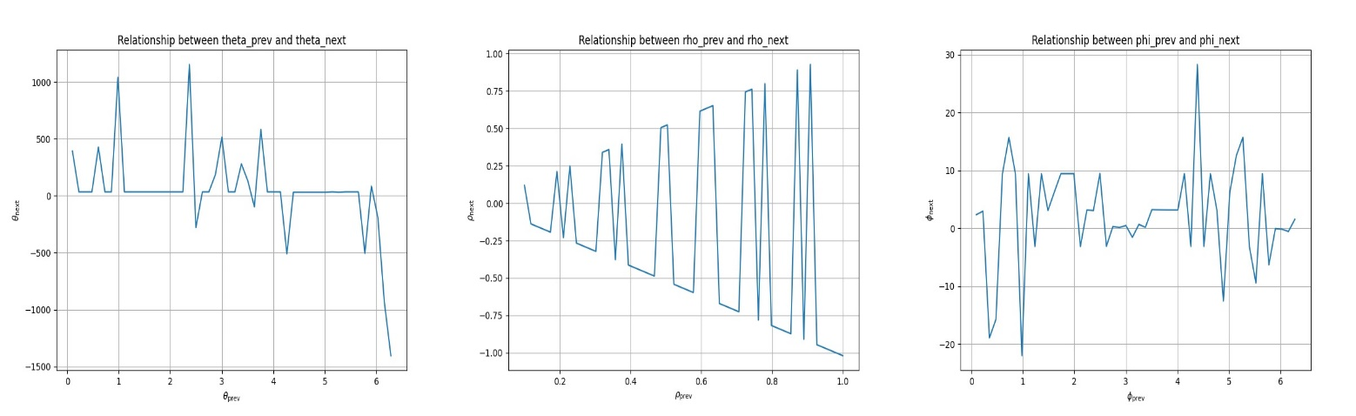
Figure 8. For R=100 all the three graphs are pretty unstable for a variety of different ranges

ii) θ(i) = 0.1 ,ρ(i)= 0.2, φ(i) = 0.3, R=1000, a=2.0, b=3.0 as initial parameters,
then θ(i+1), ρ(i+1), φ(i+1) are 505.7967559232151, -8723570.703881575, 9.4236840312251 and the jacobian matrix is
[[ 0.00000000e+00 9.31322575e-01 -2.95527279e+03]
[-5.82076609e-03 2.94130587e-01 9.55355499e+03]
[ 1.98997441e-01 9.98170435e-02 0.00000000e+00]]
Eigenvalues:
[-15.29020957 , -5.91697134 , 21.50131149]
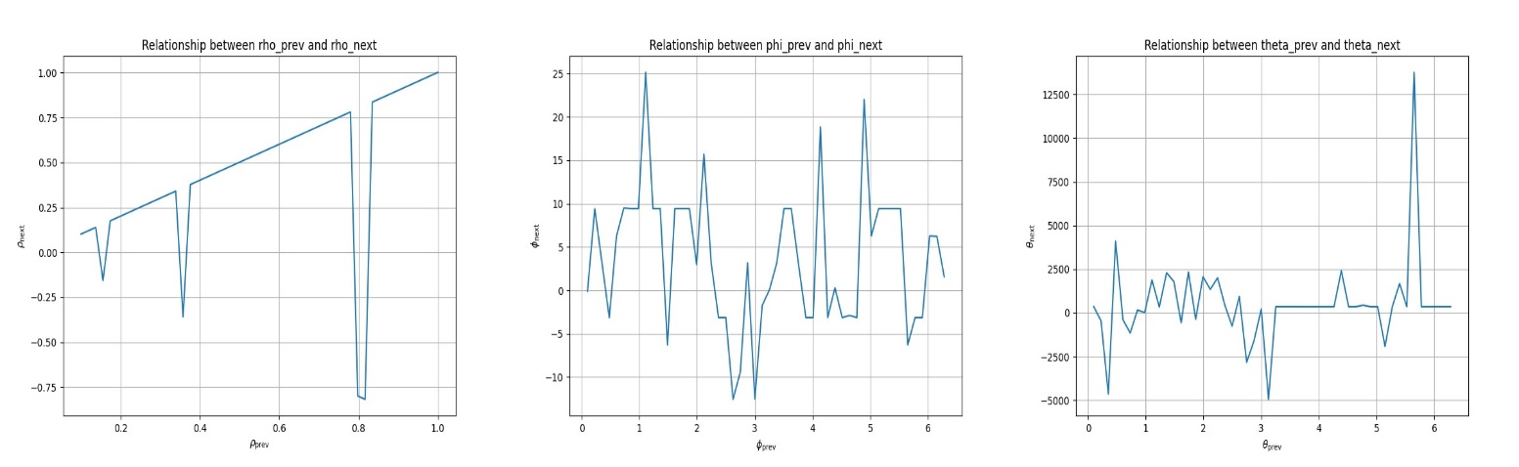
Figure 9. For R=1000 all the three graphs are very unstable than fig 7. for larger ranges

iii) θ(i) = 0.1 ,ρ(i)= 0.2, φ(i) = 0.3, R=0.001, a=2.0, b=3.0 as initial parameters,

then θ(i+1), ρ(i+1), φ(i+1) are 0.030378314652083686, 1.9459071320016945, 0.09834301445601125 and the jacobian matrix is
[[-0.0190749 0.95056378 -0.05910428]
[-0.00590056 0.29404384 0.19106809]
[ 0.19900083 0.09983342 0. ]]
Eigenvalues:
[-0.09796159+0.27449777j ,-0.09796159-0.27449777j , 0.47089212+0.j ]

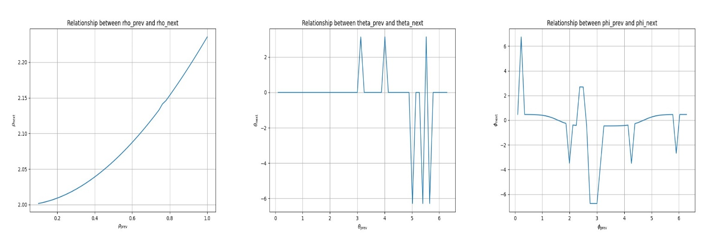

Figure 10. For R=0.001 all the three graphs are less unstable as the radius decreased by magnitude

iv)θ(i) = 0.1 ,ρ(i)= 0.2, φ(i) = 0.3, R=10⁻⁵, a=2.0, b=3.0 as initial parameters,

then θ(i+1), ρ(i+1), φ(i+1) are 0.03022854081887009,1.9467456721391987, 0.09790172580001776 and the jacobian matrix is
[[-0.0190749 0.95056381 -0.05883831]
[-0.00590056 0.29404384 0.19020829]
[ 0.19900083 0.09983342 0. ]]
Eigenvalues:
[-0.09771625+0.27404925j , -0.09771625-0.27404925j , 0.47040143+0.j ]
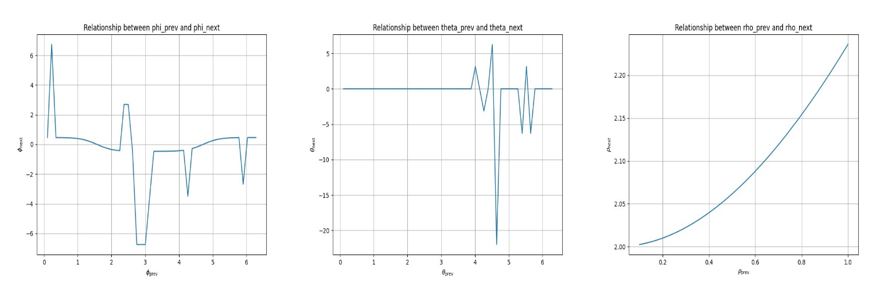

Figure 11. For R=10⁻⁵ all the three graphs are kind of stable than fig. 10

3.2 Bifurcation analysis:
In the context of our data, the bifurcation analysis provides insights into the system's response to changes in the parameter values, specifically in terms of eigenvalues and the Jacobian matrix upto 1000 iterations.
We will show the graphs for varying a and b;

i) a,b>0: a<b

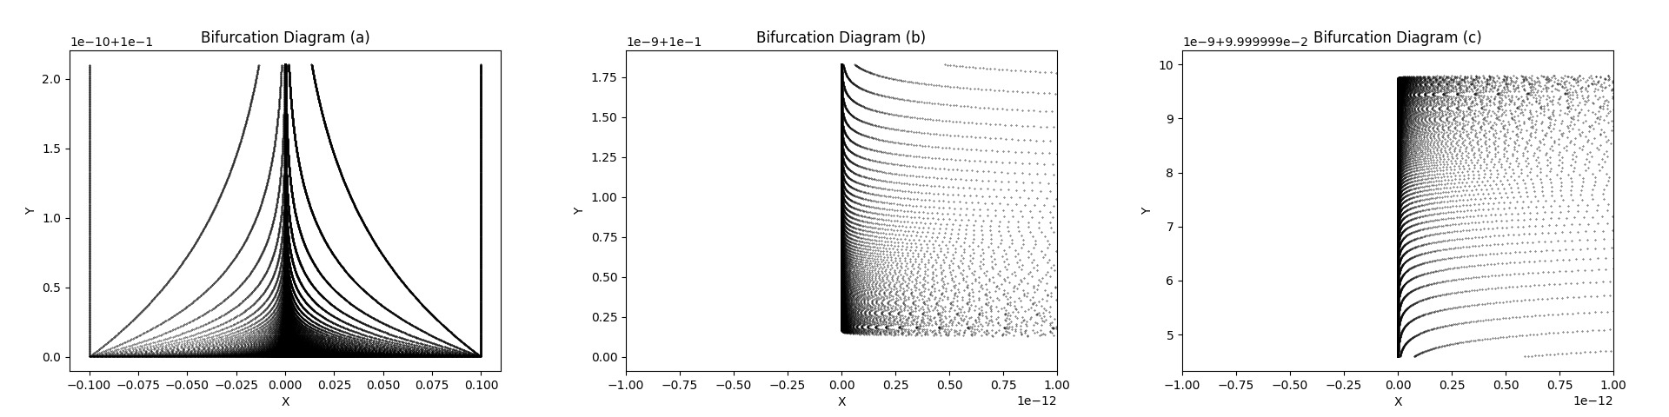

Figure 12. Here (a) has parameters a=2,b=3 ; (b) has a=0.3,b=0.4 ; (c) has a=0.5,b=1.0 and represents that in case (a) in the small range the chaos is more at first and then it stabilises after sometime while in (b) it shows very unstable and then gradually becomes more stable while the opposite is shown in case (c) being stable at first and then changing to unstable state

ii) ) a,b>0: a>b

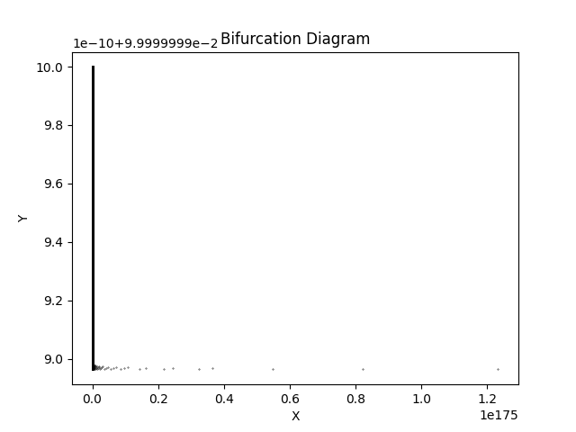

Figure 13. Here in this case a=1.5 , b=1.0 showing that the system is clearly not showing unstable system and rather it signifies that at the very beginning over a small range it was a bit unstable but gradually becomes more stable over time

iii) a=b

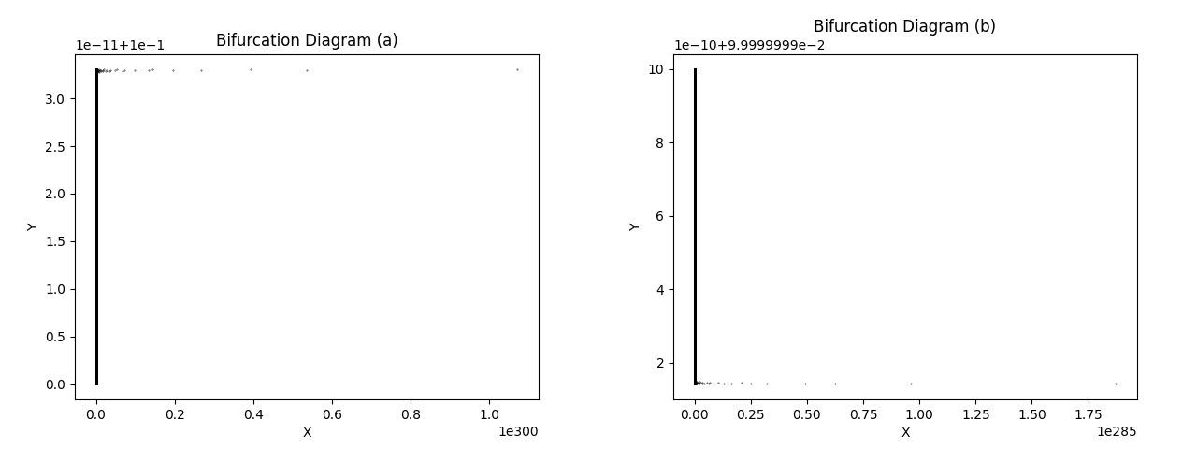

Figure 14. Here in case (a) we took a=1.0 , b=1.0 which shows that the system become more unstable over time and in case of (b) a=0.0 , b=0.0 shows that the system becomes more stable gradually and both of the cases shows less chaos as the values of a and b have decreased
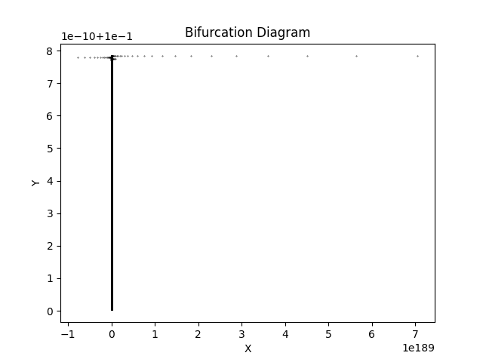

Figure 15. Here in this case we took a=10 , b=10 which shows that the system is gradually shifting to more unstable state as the initial values are more positive than in case (a) in fig 14.

iv) a,b<0 , a>b

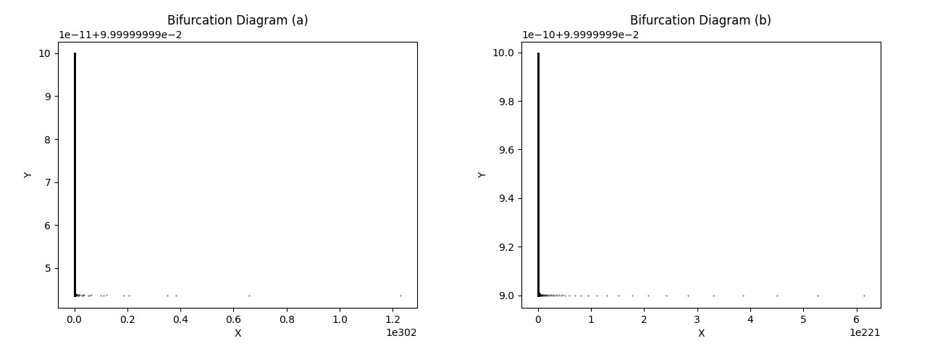

Figure 16. Here in case (a) we took a=-0.2 , b=-0.6 which shows that the system is gradually shifting to more stable state and in case of (b) a=-10 , b=-15 shows that the system was more chaotic than (a) as the initial values was more negative and then become more stable

v) a,b<0, a<b
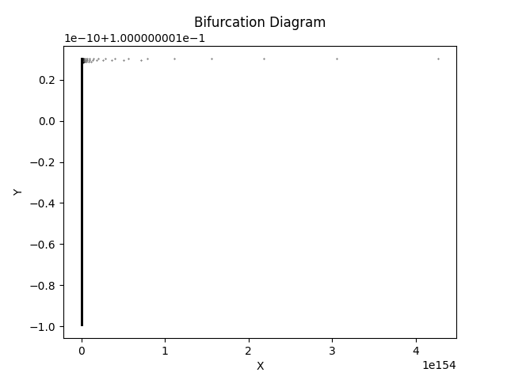

Figure 17. Here in this case we took a=-3.0 , b=-2.0 which shows that the system is gradually shifting to more unstable state

Now, for varying R with constant a=2.0 and b=3.0,

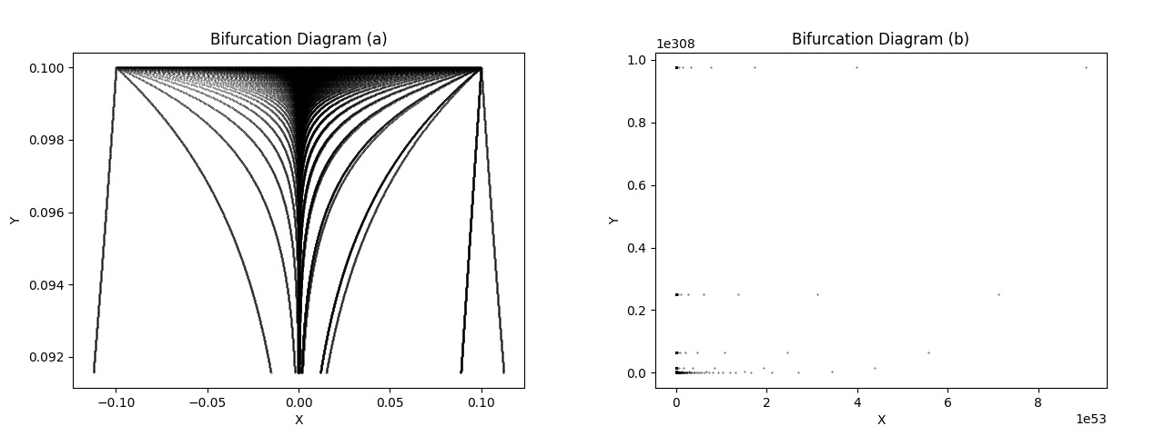

Figure 17. Here in case (a) R=100 which shows that the system is gradually shifting to more unstable state and case (b) with R=1000 shows more chaos but with more iterations it’s less clear in this fig.
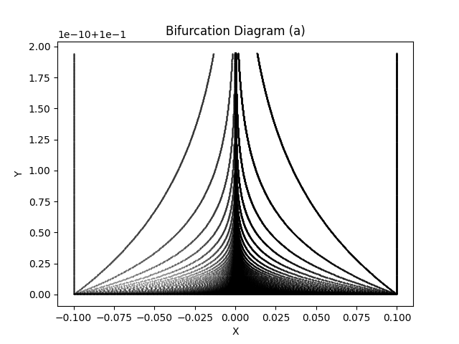
Figure 18. Here in case (a) R=10⁻⁵ which shows that the system is gradually shifting to a more stable state
3.3 Stability analysis/Final Result
In this section, we will justify the result of 3.1 and 3.2 and will do the stability analysis for the change of parameters in each sections. So in first part we took R as constant and in case 1(where a,b>0; a<b) we took two examples of a=2.0, b=3.0 and a=0.3, b=0.4 where the system was unstable at first by the positive eigenvalue and then due to effect of negative real part and the complex parts the system becomes stable gradually over time due to the damped oscillations from the boundary of the torus and the exact thing has been shown by the bifurcation graphs.
In case 2(where a,b>0; b<a) we considered a=1.5, b=1.0 in which the system was first stable due to damped oscillations then it turned to a slight unstable system.
In case 3(where a=b) we took two examples and in the first one where a=1.0, b=1.0 the system was stable at first and then turned to slight chaos over time and in the second example where a=0.0, b=0.0 the system was consistently stable.
In case 4(where a,b<0 ; a>b) we took a=-0.2, b=-0.6 and the system was stable throughout the time as the magnitude of negative initial parameters are less.
In case 5(where a,b<0 ; b>a) we took a=-3.0, b=-2.0 and the system was stable initially and then it become unstable due to positive real eigenvalues.
Now next, we considered a and b as constant and took different initial R values ; in case 1 we took R=100 and the system suddenly transformed to a chaotic system with positive real eigenvalues and same goes for case 2, R=1000, the system gradually becomes very unstable with large positive real eigenvalues and in this case there were no complex eigenvalues. In case 3 and case 4, we decreased R as 0.001 and 10⁻⁵ respectively and the result was stable systems.
Finally from this analysis, we got to know that the chaos in the system can vary depending on the values of a and b drastically and for the second case, as R increases, the system becomes more unstable and as R decreases, the system tends to be more stable.

Conclusion
In this project, we embarked on a captivating journey through the dynamical analysis of a billiard system confined within a torus. Our investigation began with a detailed description of the torus's topology, highlighting its unique properties and geometric characteristics. We delved into the intricacies of its surface, understanding how it seamlessly wraps around itself, forming a continuous, curved space. Next, we derived the equations governing the motion of the billiard system within the torus. These equations, rooted in classical mechanics, captured the interplay between the billiard ball's position, velocity, and the torus's boundaries. With the equations in hand, we embarked on a thorough exploration of the system's behaviour. By considering the eigenvalues and Jacobian matrix, we unearthed vital insights into the stability, sensitivity to initial conditions, and potential for chaos within the system. The presence of complex eigenvalues hinted at the possibility of oscillatory and chaotic dynamics, injecting an element of unpredictability into the system and last but not least by conducting a bifurcation analysis, we traced the evolution of the system as its parameters varied. Through visualizations of bifurcation diagrams and bifurcation graphs, we witnessed the intricate details of stability and chaos.
Acknowledgement
I would like to express my deepest gratitude and appreciation to Professor Amber Habib of the Maths department for their invaluable guidance and support throughout this project.
Conflicts of interest
There is no conflict of interest to declare regarding this project.
References
[1] Zainab Alsheekhhussain, "Rotation Sets of Billiards with N Obstacles on a Torus," Differential Equations and Dynamical Systems, vol. 27, pp. 369–377, 2019.
[2] Laura Menini, Corrado Possieri, Antonio Tornambè, "Trajectory tracking in rectangular billiards by unfolding the billiard table," arXiv:1804.05768, 2018.
[3] P. H. Tuan, Y. T. Yu, P. Y. Chiang, H. C. Liang, K. F. Huang, and Y. F. Chen, "Level statistics and eigenfunctions of square torus billiards: Manifesting the transition from regular to chaotic behaviors," Physical Review E, vol. 94, 062222, 2016.
[4] F.M. Izrailev, B. Timmermann, W. Timmermann, "Transient chaos in a generalized Hénon map on the torus," Chaos, Solitons & Fractals, vol. 12, no. 2, pp. 311-321, 2001.
[5] S.V. Gonchenko, A.S. Gonchenko, Ivan Ovsyannikov, D.V. Turaev, "Examples of Lorenz-like Attractors in Henon-like Maps," Mathematical Modelling of Natural Phenomena, vol. 8, no. 5, pp. 44-59, 2013.
[6] Palanimani Ganesan, R. Parimelazhagan, "B * Homeomorphisms in Topological Spaces," International Journal of Computer Applications, vol. 67, no. 13, pp. 975-9887, 2013.
[7] "Ask a Topologist: What is the difference between a torus and a doughnut?", York University, Accessed April 2023.
[8]"Renzo’s Math 490 Introduction to Topology - Xah Lee." http://xahlee.info/math/i/topology_intro__renzo_44247.pdf.
[9]"IC/2001/153 abdus salam educational, scientific and cultural ...." https://inis.iaea.org/collection/NCLCollectionStore/_Public/33/011/33011164.pdf.
[10]"Motion on a Torus Kirk T - DocsLib." https://docslib.org/doc/385702/motion-on-a-torus-kirk-t.
[11]"Non uniformly hyperbolic dynamics: Hénon maps and related dynamical systems." 28 Apr. 2003, https://arxiv.org/abs/math/0304450.
[12]"Image Encryption Using 3D-CHEN's Map and 3D-Henon Map for Secure ...." https://www.academia.edu/34073360/Image_Encryption_Using_3D_CHENs_Map_and_3D_Henon_Map_for_Secure_Transmission.

