Non-Invasive Human Vein Detector

Mr.Shashank Biradar
Mentor (EnTC)
VPKBIET, Baramati
shashank.biradar@vpkbiet.org

Rahul Gorakh Talekar
Student (BE EnTC)
VPKBIET, Baramati
rahul.talekar.entc.2019@vpkbiet.org

Prajakta Namdeo Yele
Student (BE EnTC)
VPKBIET, Baramati
prajakta.yele.entc.2019@vpkbiet.org

Gauri Sunil Wable
Student (BE EnTC)
VPKBIET, Baramati
gauri.wable.entc.2019@vpkbiet.org

Punam Prabhakar Deshukh
Student (BE IT)
VPKBIET, Baramati
punam.deshmukh.it.2019@vpkbiet.org

Abstract—Presently doctors face many difficulty to inject medicine into the veins for any IV procedure. vein finder system is an effective solution not only to safe and accurate but also to reduce anxiety and stress of patients and to donation comfort and efficiency. Vein visualization technology utilizes noninvasive infrared technology in capturing the real-time venous image on the patient’s skin and making it observable. Raspberry Pi 4 Model B, connected with NoIR Camera, is utilized as an image acquisition equipment to capture the vein. A vein finder system is an effective solution not only to make vein puncture safe accurate but also to reduce anxiety stress of patients to improve donation comfort efficiency. The main aim of this project is to develop a device which can detect the veins to provide doctors an easy access for efficient Drug delivery.The main aim of this device to feel comfort patients to getting any fluid injection or blood test.
Index Terms—component, formatting, style, styling, insert
- INDEX TERMS—
Health care, Patients, Nursing, Venipuncture , Near-infrared
, Filtering and processing ,Vein Finder,Median Filtering. .
- INTRODUCTION
Nowadays, millions of people are suffering from blood test, vaccination and fluid injection. The basic step for these procedure is to locate the patient’s vein. But in many cases, there is difficulties while finding the vein. That’s why, we building a device which easily locate the vein.The infrared light can penetrate into the biological tissue up to 3mm depth. The deoxygenated blood absorbs more of infrared radiation than the oxygenated blood and the surrounding tissue, so it enhances the contrast of blood veins in the image acquired. A NOIR camera with an IR flash is ideal for capturing the vein pattern of the desired body part. Hence, this device aids more support in the vein tracking process of the phlebotomists because venipuncture is an essential part of clinical testing, donation, or medical research.
- MOTIVATION
- Babies vein finding problem
Normally for born babies or small babies when doctor giving injection to baby due to sensitive or conscious skin there is difficult to find vein.Sometimes baby get injured due to improper injection .

- Fatty or overweight people
In fatty people due to fat or overweight it even more pressure on the vein .So it is difficult to find vein properly. So, the veins of that people are not visible properly.

- Phobia
Needle phobia is a fear of medical procedure that involve needle or injection.Due to this heart rate as well as blood pressure increases , it is feel more painful.

- In old people difficult to find veins during injection
In old people aging is the most cause of visible bulging hand vein. Old people’s skin is thin and they loose volume in their face and hand. This leads to their vein being more obvious.The rising blood pressure can sometimes cause them to bluge.

- IV out during injection out during injection
An intravenous (IV) injection is injection on vein directly in the bloodstream.It is one of the fastest way to get drugs into the body. A vein can be damaged during injection if it is not detected properly.This leads pain around the IV site.

- Vein out and internal blooding
If doctor do not find vein properly, saline get out or vein out causing blood flow to backward and pool in your leg. Damaged vein can cause swelling and pain.This cause air bubble and tiny air bubble may rise in blood stream.Yes, problem is already solved in foreign country but cost is not affordable so we are made same system with low cost and easy to handle.

- OBJECTIVE
Aim is to develop a low-cost vein finding system. System uses NOIR (No infrared filter) camera to capture the images of the veins. Using the image processing to improve contrast of these images and detecting the more accurate vein pattern.

- LITERATURE SURVEY
  - Chiao FB, Resta-Flarer F, Lesser J, Ng J, Ganz A, Pino- Luey D, Bennett H, Perkins C Jr, Witek B. Vein visualization: patient characteristic factors and efficacy of a new infrared vein finder technology. Br J Anaesth. 2013 Jun; 110(6):966-71. doi: 10.1093/bja/aet003. Epub 2013 Feb 5. PMID: 23384732.
Randomized prospective study by Chiao et al. (2012) titled ”Vein visualization: patient characteristic factors and efficacy of a new infrared vein finder technology” examined the char- acteristics of patients that are associated with the detection of venipuncture areas without any visual assistance. In this study, patient characteristics, including age, gender, height (inches), weight (pounds), ethnicity, and skin color, were collected from every study sample. Observers, including skilled phle- botomists, physicians, and nurses in venipuncture, investigated at least ten independent characteristics each. Each character- istic was examined via both the conventional method and the infrared vein finding (VF) device. The results demonstrated a power analysis for moderate effect size requiring 54 samples for within-subject differences. As a whole, the conventional method (CM) of vein visualization was less effective in obese [4.5 (95 percentage CI: 3.8–5.3)], AfricanAmerican [4.6 (95
percentage CI: 3.6–5.5 veins)], and Asian [5.1 (95 percentage CI: 4.1–6.0)] subjects. Consequently, vein visibility was de- creased in these patients. The new infrared device improves the visibility of veins for cannulation in all participants (21).

  - C.Francisco MD, Chen WF, Pan CT, Lin MC, Wen ZH, Liao CF, Shiue YL. Competitive Real-Time Near Infrared (NIR) Vein Finder Imaging Device to Improve Peripheral Subcutaneous Vein Selection in Venipuncture for Clinical Laboratory Testing. Micromachines. 2021 Apr;12(4):373.
Francisco et al. (2021) conducted a randomized control trial titled ”Competitive Real-Time Near Infrared (NIR) Vein Finder Imaging Device to Improve Peripheral Subcutaneous Vein Selection in Venipuncture for Clinical Laboratory Test- ing”. They used nearinfrared technology to develop a low-cost real-time near-infrared (NIR) router for cannulation. The study included several healthcare providers and students to train and develop their abilities in performing cannulation. They first developed a reflective-type optical vein finder using three (23) light-emitting diode (LED) lights with a wavelength of 960 nm and a complimentary infrared (CMOS-IR) sensor camera with 1920× 1080 UXGA (1080P) infrared filter set for the specified wavelength, and open-source image processing software. Next, they carried out the actual testing in a human lab at two locations, the arm and the back of the hand on 242 people. The included indicators were gender, age, body mass index (BMI), and skin color. To evaluate the device, the researchers included the circumference of the arm. The difference in vein images was compared by digital and visual imaging. The results of the study showed the effectiveness of the device in identifying the vein in real-time for both locations (arm and dorsal hand sites) (24)
  - Vein Visualization Using Near Infrared (NIR) Vein Finder Technology in Nursing Care: A Review of the Benefits and Shortcomings
: A Review of the Low-Cost Vein Finder Prototypes Utilizing near Infrared (NIR) Light to Improve Peripheral Subcutaneous Vein Selection for Phlebotomy” discussed the limitations of the published studies dealing with evaluating people who perform venipuncture, the differences in their re- search methodology, the number and type of patients based on demographics, and the tools used in evaluating the developed prototypes. The study also showed the limitations of research on the actual testing of the initial model on humans. The study indicated that the development of an effective, affordable NIR vein residual is in the optimization stage
  - Carr PJ, Rippey JC, Cooke ML, Trevenen ML, Higgins NS, Foale AS, Rickard CM. Factors associated with periph- eral intravenous cannulation first-time insertion success in the emergency department. A multicentre prospective cohort analysis of patient, clinician and product characteristics. BMJ open. 2019 Apr 1;9(4):e022278.
Carr et al. conducted a prospective cohort study titled ”Factors associated with peripheral intravenous cannulation firsttime insertion success in the emergency department: A multicenter prospective cohort analysis of patient, clinician and product characteristics”. The study sample included 879 patients, and 1,201 cannulas were inserted into the peripheral vein by physicians specializing in emergency medicine. The final form combined the characteristics of the patient, clinical, technological, and product characteristics that had a higher discriminatory effect than the specific forms of characteristics. Its sensitivity was 74.26 percent, its specificity was 57.69 percent, its positive predictive value was 82.87 percent, and its predictive value was negative 44.85 percent. Thus, first-time insertion success (FTIS) can be improved by more experienced and self-reliant physicians .
  - Girgis KK. Ultrasound guidance versus transillumination for peripheral intravenous cannulation in pediatric patients with difficult venous access. The Egyptian Journal of Cardio- thoracic Anesthesia. 2014 Jan 1;8(1):39.
Girgis et al. (2013) conducted a study titled ”Ultrasound guidance versus transillumination for peripheral intravenous cannulation in pediatric patients with difficult venous access” at the Cairo University Children’s Hospital to compare the effect of ultrasonography to trans-illumination (under inhaled anesthesia) on peripheral intravenous cannulation in pediatric patients. A total of 80 samples (40 for ultrasound and 40 for veinlite), similar in their demographic and clinical char- acteristics, were included in the study. The time required for cannulation and the number of attempts was measured. The study showed that peripheral IV cannulation is easy with ultrasonography and trans-illumination in pediatric patients with difficult venous access, resulting in a high overall success rate of cannulation. The results of the sonar device were better than trans-illumination.

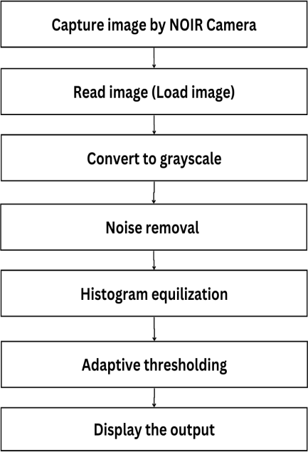
- MATERIALS / TECHNIQUES
Technologies:
Image Processing
Compiler : MATLAB / Geany / Thonny Language : Python
Raspbian OS Material:
Raspberry Pi 4B NOIR camera
LCD Screen(3.5 inch)
Near Infrared (NIR) Transmitter IR LED

- DATASET
The Dataset consists of capturing vein images and storing those. This data or captured video is processed in terms of frames. Multiple frames are captured by the Camera. The frame grabbing method is widely used which stores the images captured by each camera in the memory. It works in the repeated loops which firstly captures the frame from the video and then processes the information present in it. After capturing, it is further carried out with Image Synchronization. This process is used to check whether the processed / Captured frames of images are properly lined up or not. This step is

E. Algorithm

Fig. 1. Flowchart.

necessary in order to provide the correct images which will be treated as the dataset for drowsiness detection.

- METHODOLOGY
- System Design
The system is built up by some essential components such as a LED array (850 nm), an image capturing device (NoIR camera), a camera controller (Raspberry Pi 4 Model B), a com- puter with MATLAB installed, and a DLPDLCR2010EVM projector. The NIR light source will be operated to emit NIR light to the skin surface of the skin. Because of the absorption of Hb, the image of the venous system can be captured by a NoIR Camera Board connected to Raspberry Pi. From the controller, the image is transferred to the computer to perform the image enhancement and noise filtering process on MATLAB. Finally, the resulting image is either display on the screen or re-projected on the skin by the projector.

- Software Implementation
Image processing technique will be discussed thoroughly: median filtering and adaptive histogram Equalization.

- Grayscale Image
- Histogram equalization
This technique is used to remove noise with preservation of edges in an image.
CLAHE is a variant of Adaptive histogram equalization
(AHE) which takes care of over-amplification of the contrast. CLAHE operates on small regions in the image, called tiles, rather than the entire image. The neighboring tiles are then combined using bilinear interpolation to remove the artificial boundaries. This algorithm can be applied to improve the contrast of image.
- EXPERIMENTAL ANALYSIS
Aim of the model is to Presently doctors face many diffi- culty to inject medicine into the veins for any IV procedure. vein finder system is an effective solution not only to safe and accurate but also to reduce anxiety and stress of patients and to donation comfort and efficiency.
- ACKNOWLEDGMENT
During the successful execution of this project, many people have showered their blessings on us and extended their whole hearted support, this time we would like to thank all the people associated with this project. We have made efforts for this project, but it would not have been possible without the co -operation of many individuals and organizations. we would like to thank all of them from the bottom of our heart we are mainly thank Guide for the successful completion of this project. Then we would like to thank my project guide Mr.Shashank Biradar whose valuable guidance is helping me to patch and make this project successful. His suggestions and suggestions have contributed greatly to the completion of the project. We take this opportunity to thank Dr. R. S. Bichkar, Principal, VPKBIET, Baramati, for providing all the facilities

and supporting us in all academic endeavors Then we would like to thank our parents and friends who helped our with their valuable suggestions and guidance at various stages of project completion.
- A Novel Method of Vein Detection with the Use of Digi- tal Image Correlation Zbigniew Lutowski,1,*† Sławomir Bujnowski,1,† Beata Marciniak,1,† Sylwester Kloska,2.

- RESULT

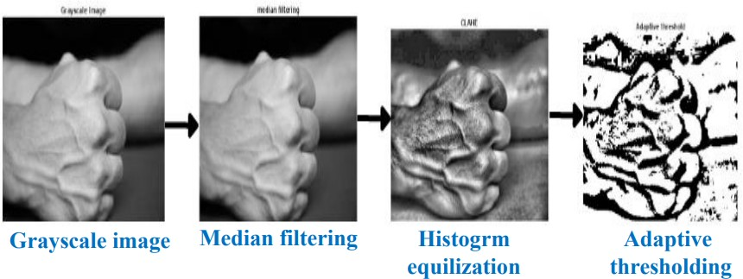

Fig. 2. Image Processing Steps.

- CONCLUSION
An infrared based vein detector was developed based on the differential adsorption of IR light of the veins and surrounding tissue.A flashing circuit consisting of 9 Infrared LEDs. This circuit helped co-ordinate the flash with the capture of the image and hence ensured minimum wastage of power for driving the flashing circuit.It is used to point out the location of the identified vein. The 9V potential provided by the battery.The accuracy is observed to be good in different lighting conditions, and on different test cases. However, since the LEDs used only provide a maximum of 3mm penetration on the skin, presence of extra fat and hair on the skin interfere with the functioning of the image processing algorithm.
- REFERENCE
  - Nundy, Koushik Kumar, and Shourjya Sanyal. ”A low cost vein detection system using integrable mobile camera devices. ” India Conference (INDICON). 2010.
  - Shahzad, Aamir N. M. Saad, N. Walter,et.al ”An efficient method for subcutaneous veins localization using Near Infrared imaging. “ In Intelligent and Advanced Systems (ICIAS), 2014 5 th International Conference on, pp. 1-4. IEEE, 2014.
  - Non-Invasive Vein Detection using Infra-red Rays Arad- hana Singh1, Dr. S.C. Prasanna Kumar2, Dr. B.G. Sud- ershan3, August 2016.
  - Crisan, Septimiu, Joan Gavril Tarnovan, and Titus Eduard Crisan. ”A low cost vein detection system using near infrared radiation. ” In 2007 IEEE Sensors Applications Symposium, pp. 1-6. IEEE, 2007.
  - Chakravorty, Tanushri, D. N. Sonawane, Suchakrapani Datt Sharma et.al. ”Lowcost subcutaneous vein detection system using ARM9 based single board computer. ” In Electronics Computer Technology (ICECT), 2011 3rd International Conference on, vol. 2, pp. 339-343. IEEE, 2011.

