ELECTRONIC VOTING SYSTEM
Vaishnavi Vilas Pawar
Institute of Distance and Open Learning Vidya Nagari, Kalina, Santacruz East – 400098. University of Mumbai
-------------------------------------------------------------***-------------------------------------------------------
Abstract –
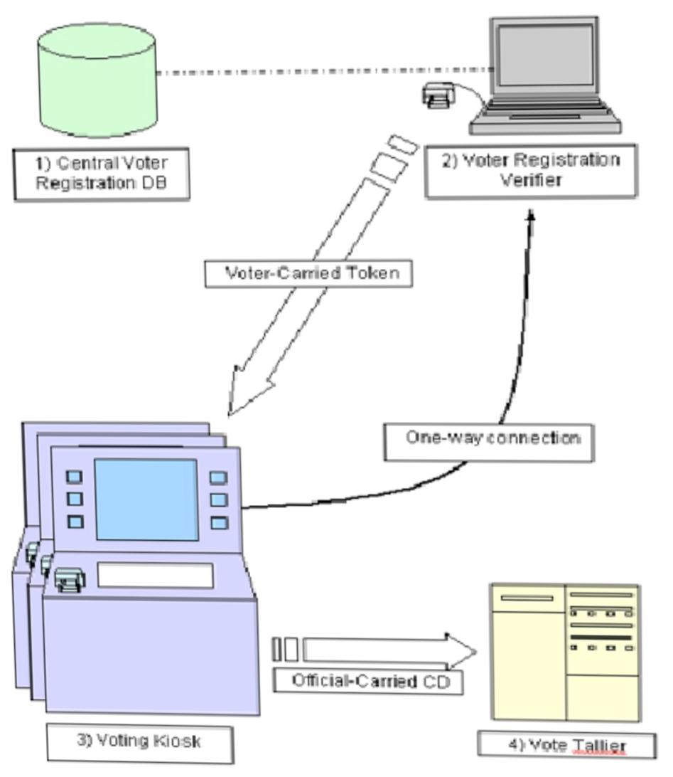
Electronic voting, a form of computer-mediated voting in which voters make their selections with the aid of a computer. The voter usually chooses with the aid of a touch-screen display, although audio interfaces can be made available for voters with visual disabilities. To understand electronic voting, it is convenient to consider four basic steps in an election process: ballot composition, in which voters make choices; ballot casting, in which voters submit their ballots; ballot recording, in which a system records the submitted ballots; and tabulation, in which votes are counted. Ballot casting, recording, and tabulation are routinely done with computers even in voting systems that are not, strictly speaking, electronic. Electronic voting in the strict sense is a system where the first step, ballot composition (or choosing), is done with the aid of a computer.
Keywords: electronic voting, e-voting, blockchain, e-government, verifiable voting
- INTRODUCTION
Electronic voting and counting refers to the use of electronic technologies that assist or automate the voting and/or counting processes. In electronic voting, often called “e-voting,” voters use an electronic device to mak-voting systems architecture by J. Brown, 2003 in the above systems architecture we can see that the central voter e and record their ballot choices. Choices are recorded on the machine itself or the machine produces a token on which the choices are recorded, such as a magnetic card or a printout of the ballot choice. Electronic voting systems include electronic voting machines (EVMs) placed in polling stations, SMS voting and Internet voting. In electronic counting, part or all of the tabulation of results is automated. E-voting systems can be remote or non-remote, referring to whether the voters’ ballot choices are transmitted to a central location (e.g. Internet or SMS voting) or recorded on a local medium (such as the EVM or a printed ballot). Systems will also be supervised or unsupervised, which relates to whether election staff are present to manage the voting process (e.g., if voting is done in a polling station) or not (such as Internet voting). The most common e-voting systems involve non-remote EVMs used in the supervised environment of the polling station. There are many key decisions that must be reached in adopting, designing, implementing and overseeing an e-voting system.
Figure 1: Voting system

E registration server is link to the voter registration verifier so that whenever an eligible voter login and tries to cast or update his/her information, the administrator at the server will monitor everything. The systems use a token to verify any process initiated by the user through the voting kiosk. but the implication with this approach is that there is one way connection and therefore it is very difficult for admin to monitor the instances from his own end.

2. E-VOTING BACKGROUND AND REQUIREMENTS
Electronic voting has been an area of research. focus for many years by using computing. machines and Equipment for casting votes and. producing high quality and precise results in. accordance with the Sentiments of the participating voters. Various attempts have been adopted in practice to support election
Process. Initially computer counting system allowed the voter to cast vote on papers. Later on, those cards Went through the process of scanning and tallying at every polling cell on a central server (Kadam et al, 2015; Rockwell, 2017; Hao et al, 2010). Direct Recording Electronic (DRE) voting systems were put in
Place later on which were admired and acknowledged greatly by the voters in-spite of the resistance from Computer scientists. If the voting system is well understood by the voters, the system’s usability can be Increased remarkably. DRE systems in particular have gathered a lot of successes in bringing the voters To use this technology. These systems work more or less in the same way as any conventional election
System does. In the case of DRE, a voter begins his journey by going to their polling place and get their Token to vote where he utilizes his token at the voting terminal to vote for his candidate. When the Candidate selection procedure is completed, DRE systems present the final selection to the voter before
Actually casting it (in case if the voter wants to change his opinion) and after the final selection, the ballot Casting is completed (Multichain, 2017; Dalia et al, 2012).
More recently, distributed ledger technologies such as blockchain have been used to achieve e-voting Systems primarily due to their advantages in terms of end-to-end verifiability. With properties such as Anonymity, privacy protection and non-repudiation, blockchain is a very attractive alternative to Contemporary e-voting systems. The research presented in this paper also attempts to leverage these Properties of blockchain to achieve an efficient e-voting system. A detailed analysis of such systems is
Presented in the next section along with the identification of comparison with these approaches.

- OBJECTIVE
Online voting tools and online election voting systems help you make important decisions by gathering the input of your group in a way that’s systematic and verifiable.
Oftentimes, these decisions are made on a yearly basis – during an event (e.g. your organization’s AGM) or at a particular time of the year. Or you might run ongoing polls amongst your group (e.g. anonymous employee feedback surveys).
It’s a good idea to use an online voting system to:
Elect your leadership: A board of directors election is a good example, where there are multiple positions (e.g. chair, vice president, secretary, treasurer). All of which may include supporting documentation (e.g. biographies, resumés, headshots).

Admit new members to your group. This helps you stick to a regular, fair process of evaluation and lets candidates know what to expect.

Gather anonymous feedback from your employees. Managers (and managers of managers) want to know how their employees truly feel about their jobs and work life. Using an online voting system with a capacity for secret balloting helps employees express their true feelings, by understanding and trusting that their feedback will be heard, but not tied directly to them.

Vote on yearly budgets. And since adjustments to your budget are often needed, an online voting system will keep voting secure and accessible – no matter where the members of your group may happen to be.

Alter your operational procedures and bylaws. Just like leadership elections, expect group members to react strongly toward changes – no matter how minor – to organizational processes. You’ll want to collect individual responses to these changes in a systematic manner.
In all of these cases, an online voting system will enable better decisions, justify those decisions, and let you share proof that these decisions were carried out in line with the standards of your group.
Using an online voting tool will generate confidence in the results of your votes and elections, lower your voting-related costs, and streamline the election process for both you and your voters.

Cost Savings and Efficiency
The cost savings and efficiencies you’ll gain are unparalleled to any other method of voting. Groups switching to web-based online voting systems from more expensive and less efficient voting technologies like voting machines, paper ballots, and in-person meetings will reap these benefits without increasing risk.

Voter Accessibility
Needing to fly halfway around the world to vote at your organization’s annual meeting is an example of a vote with low accessibility. On the other hand, tapping a link on your mobile device that securely logs you into the online voting system website is an example of a vote or election with high accessibility.

High accessibility generates greater turnout rates among your group.
Auditability and Verifiability
With an online voting system, you can easily showcase election results to eliminate concern. Sharing all administrator activity during your election to prove no one went in altered the results is just one of the many trust-building tactics you’ll be able to use in light of a vote challenge.
Security, Confidence, and Trust in Your Election Results
The confidence in your voting and election results is by far the most valuable aspect that online voting systems will offer to your group. The fallout of a vote being perceived as unfair is expensive, time-consuming, and wrecks havoc on the hard-earned trust you’ve built among group members. From this perspective, an online voting system offers unparalleled election security.
The best online voting systems are flexible enough to help a variety of organization types.

4. Here are some examples of groups that use online voting systems to run their votes and elections:
Membership associations – Associations run the gamut from small industry-specific groups to gigantic professional organizations. Regardless, they need a means of allowing their members to weigh-in on key aspects. Membership association voting examples include board of directors elections and officer elections.
Partnerships – Law firms (and other partner-based firms) regularly elect leadership. Partnership voting examples include: law firm and accounting firm partner elections.
Corporations – Small, medium, and enterprise businesses require feedback from their employees, boards, and shareholders alike. Corporate voting examples include employee feedback surveys and voting amongst shareholders.
Unions – Union leadership and documentation alterations are a regular occurrence. Union voting examples include: union officer elections and contract ratifications.
Educational institutions – Across colleges, universities, and K-12 schools, votes and elections for faculty, student, and alumni groups are built into their foundations. The wider school systems themselves often have their own large-scale matters to vote on as well. Example educational institution voting events include SGA elections, faculty elections, and alumni elections.
Churches – Just like other groups, churches have leadership and these individuals are often elected officials. Example church voting events include church leadership elections.
Clubs – While group size and budgets may be smaller, that doesn’t mean local and interest-based clubs don’t benefit from structured and secure voting. Example club voting events include voting to admit new members and approvals of budget spend.
Homeowner associations (HOAs) – HOAs have board of directors to elect, budgets to approve, and rules & regulations to update. HOA voting examples include board of directors elections and community budget approvals.
A high-quality online voting system or online election system will offer these core capabilities:
Create what is to be voted on. Build ballots that let your group vote on things or elect people.
Upload your list of voters. The individuals in your group who are eligible to vote on ballots need to be uploaded into the voting system. Often, you’ll have the option of grouping these individuals into different segments (e.g. region, department).
Notify and follow up with your voters. You’ll need to let your voters know about upcoming votes and elections. And you’ll probably want to remind those that haven’t voted.
Gather and report on your results. After you vote, you’ll want to determine who or what won out over others. This may be an internal review or you may want to immediately share the results with your group.
- E-voting experiences around world
The State of California allows e-voting machines to be used only under strict conditions. Polling stations won’t be able to have more than one of those systems in place, and county registrars will have to take steps such as reinstalling the software and firmware for the devices and resetting them encryption key. E-voting systems were used by one quarter to one-third of California voters in November elections year 2006. But during state-sponsored review of the machines and their source code, a team of penetration tester found 15 security problems, including the ability to exploit flaws in windows (Klossner, 2007; Towns, 2008). In the case of Florida State, the Florida legislature passed a bill that would require all voting districts in the state to replace most touch-screen voting systems with optical scan devices. The bill estimates the cost of replacing the touch-screen systems at $18.5 million (Songini, 2007). In America’s voting systems shift from lever machines and hand-counted paper to optical scanners and touch screens with printed voter-verified paper audit trails and the system served an estimated 133 million voters on Nov.4 (Seligson, 2008). On the other hand, and in the European Union countries, e-voting was introduced as a part of the federal and provincial elections in Belgium in November 1991, when two cantons were selected for an experiment in e-voting. Through a law of 11 April 1994, this experiment was broadened and institutionalized to 20% of all voting areas and since 1999, 44% of all voting is registered electronically to attain 100% by 2006 elections. The main objectives of Belgium government from shift to e-voting system are difficult to manage and control manual voting, reduced the costs, account the result earlier and make the result more accurate (Towns, 2008; Vuyst and Fairchild, 2005).

Trust

In general, the following requirements can be formulated for electronic voting media.

- Secure (accurate; only legitimate voters participate – and only once; protected against Fraud and mistakes)
- Protect privacy (the voter should remain anonymously),
- Enable accountability (it should be possible to proof that the outcomes are correct; Process is transparent; results have to be repeatable – ‘recounting’)
- Economic (cheaper voting and polling than currently with paper based media, Including postal voting)

In traditional voting procedures (paper based) these above mentioned requirements are Implemented, and citizens are used to those media, and trust the procedures – at least in Democratic countries. With the introduction of new media in voting, this changes. Public Confidence in the manner in which ballots are counted is fundamental to the legitimacy of the
Electoral process. Internet voting is likely to lead to changes in how the public maintains Confidence in the integrity of elections. Internet systems pose a problem in that the tallying Process is not transparent.
With electronic voting systems, public confidence in the election relies on trust in technical Experts instead of a transparent process (IPI, 2001). Media stories about various security Threats to the Internet have an immediate impact on public confidence. Online voting may as a Result not achieve the goal of increasing turnout of voters do not trust it. Therefore, it is Important to make the voting and counting processes as transparent as possible. Because of This transparency there will be a greater confidence in the process and the result. Trust in an Online voting system means having confidence in the machinery and infrastructure, rather Than simply in the physical and administrative processes. However, all non-free software is Secret by nature and there is virtually no way to be sure that the software does not include a Trick to change the results of the vote. Only Free Software can ensure transparency (open Source code). There are many ways to make Internet voting more secure. Mechanisms that form the Structure of security are: Personal Identification Number (PIN) or password, encryption, Digital signature, smart cards, biometric identifiers (like fingerprints), or casting more than One vote where only the last one counts. Baseline integrity checks are for instance Registration, authentication, privacy, and verifiable results. To mention the most prominent problem as an example, technical experts agree that there is a Trade off between the requirement of voting anonymously, and the requirement of Accountability of the voting system. If a system is 100% privacy protecting, the accountability Becomes low, as the transparent reconstruction of the vote becomes impossible, and the other Way around.

- CONCLUSION
Online Voting Systems have many advantages over the Traditional voting system. Some of these advantages are less Cost, faster generation results, easy accessibility, accuracy, And low risk of human and mechanical errors. It is very Difficult to develop online voting system which can allow Security and privacy on the high level. Future development Focused to design a system which can be easy to use and will Provide security and privacy of votes on acceptable level by Proper authentication and processing section.. It is easy to Use and it is less time consuming. It is very easy to debug.

- ACKNOWLEDGEMENT
We would like to take the opportunity to express our Heartfelt gratitude to the people whose help and co-Ordination has made this seminar a success. We thank Prof. Miss. TRUPTI KINI for knowledge, guidance and co-operation In the process of making this project. We owe Seminar Success to our guide and convey our thanks to them. We Would like to express our heartfelt to all the teachers and Staff members of Computer Engineering Department for Their full support. We would like to thank our principal for Conductive environment in the institution.

- References
[1] Himanshu Agarwal and G.N. Pandey “Online Voting System for India Based on AADHAAR ID” 2013 Eleventh International Conference on ICT and Knowledge Engineering
[2] Smita B. Khaimar, P. Sanyasi Naidu, Reena Kharat “Secure Authentication for Online Voting System”
[3]Shivendra Katiyar, Kullai Reddy Meka, Ferdous A. Barbhuiya, Sukumar Nandi “Online Voting System Powered By Biometric Security” 2011 Second International Conference on Emerging Applications of Information Technology.

