"TRAVELLER INFORMATION APPLICATION FOR SUN-LINC TRANSPORTATION"

¹Vishwambhar Kute, ²Sahil Shaikh, ³Sonu Shaikh, ⁴Kunal Khotkar,
⁵Dillip Rout, ⁶Ram Kumar Solanki
^{1,2,3,4}(B. Tech) Scholar, School of Computer Science and Engineering, Sandip University, Nashik.
^{5,6}Professor, Assistant Professor, School of Computer Science & Engineering, Nashik

ABSTRACT
Transport is an essential part of the organization which facilitates the socio-economic growth of the society. Bus transport system is widely used in the world. Bus stops are the point of contacts between the user and the system. Location and spacing between the bus stops affect the performance of the bus transport system. Our aim is to analyse the bus stop efficiency. For performing the analysis, students’ data, route map and bus stop locations data is required. This research paper focuses on different data collection and processing techniques used while collecting and processing the data. The process of collecting and processing the required data is described in this research paper. This data will be used to analyse the area and students served by the bus stops. This will help to improve the efficiency of transport facilities and also help in planning the bus stops.

INTRODUCTION
Imagine living in an organization without transport facilities, we can’t. If we look at any period of time throughout the history of education, we can find that there were various means of transport. If we take out the transport facilities from the current world’s schools & colleges, it will come to stand still. Transportation is an important part of organization and can also be considered as the basic need of organization. For any organization to function optimally, properly planned transport facilities are of importance. Transportation is important for overall development of organization. Transportation system plays an important role in development of the interaction between students. Transportation system has numerous benefits; studies have shown that proper planned transport facilities can improve the socio-economic aspects of the students, reduction in air & noise pollution, reduces congestion, increases mobility. In Organization Transportation, major share of transport facilities throughout belongs to Bus Transport. We have focused on the home to school and return trip. We have tried both analytically and experimentally to attract the students to the transport. Optimization of location of bus stops in such a manner that they will result in more advantages. This will improve the efficiency of the transport. The points to focus while optimizing the bus stop locations are student demands, walking distance, minimum number of bus stops and providing the most possible service coverage. This paper focuses on the Data collection and processing of the required data.

DATA COLLECTION
STUDY THE AREA OF SERVICE
Boundary of transportation was obtained from the Dr. Sanjeev Shukla Sir (Transportation Department, Sandip Group of Institutes). Map was obtained from the Google Maps analysis. There is total 10 routes of Sandip Transportation Service. Out of which 3 are merge with other 7 routes. Thus, only 7 routes are at operations. Students’ data was also obtained from the Dr. Sanjeev Shukla Sir. The collected department wise data was in the Xcel file.
Study of the routes was done using Google Maps as shown in the below figure 1.
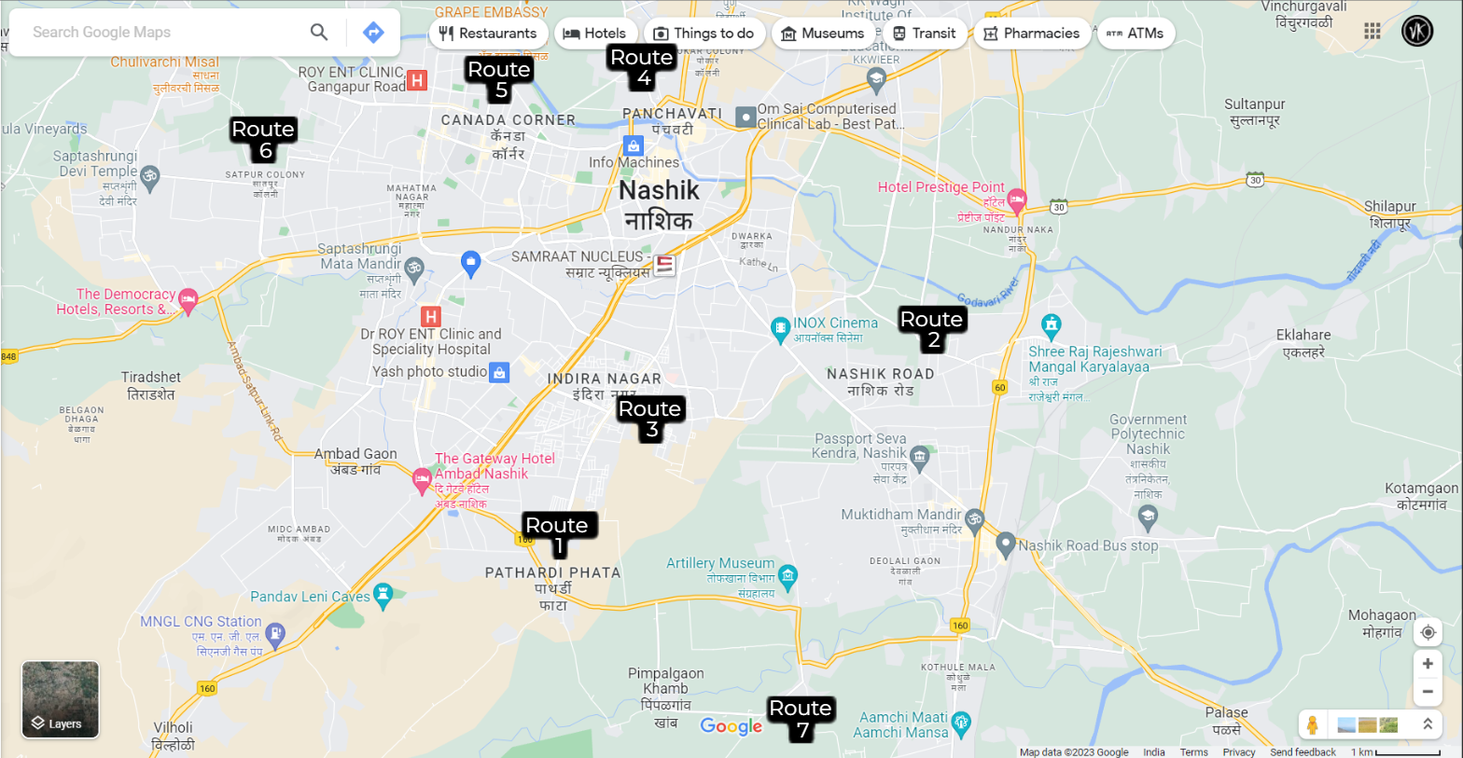
Figure 1: Bus Routes

BUS STOPS
Locations of Bus Stops were collected by us from Dr. Sanjeev Shukla Sir & Prof. Dillip Rout Sir. The Bus Stops were analysed and Integrated in the Database. Application was also designed to calculate the transportation fee according to the pick-up and drop-off points of the students.
Bus Stops are mentioned in figure 2 as below.
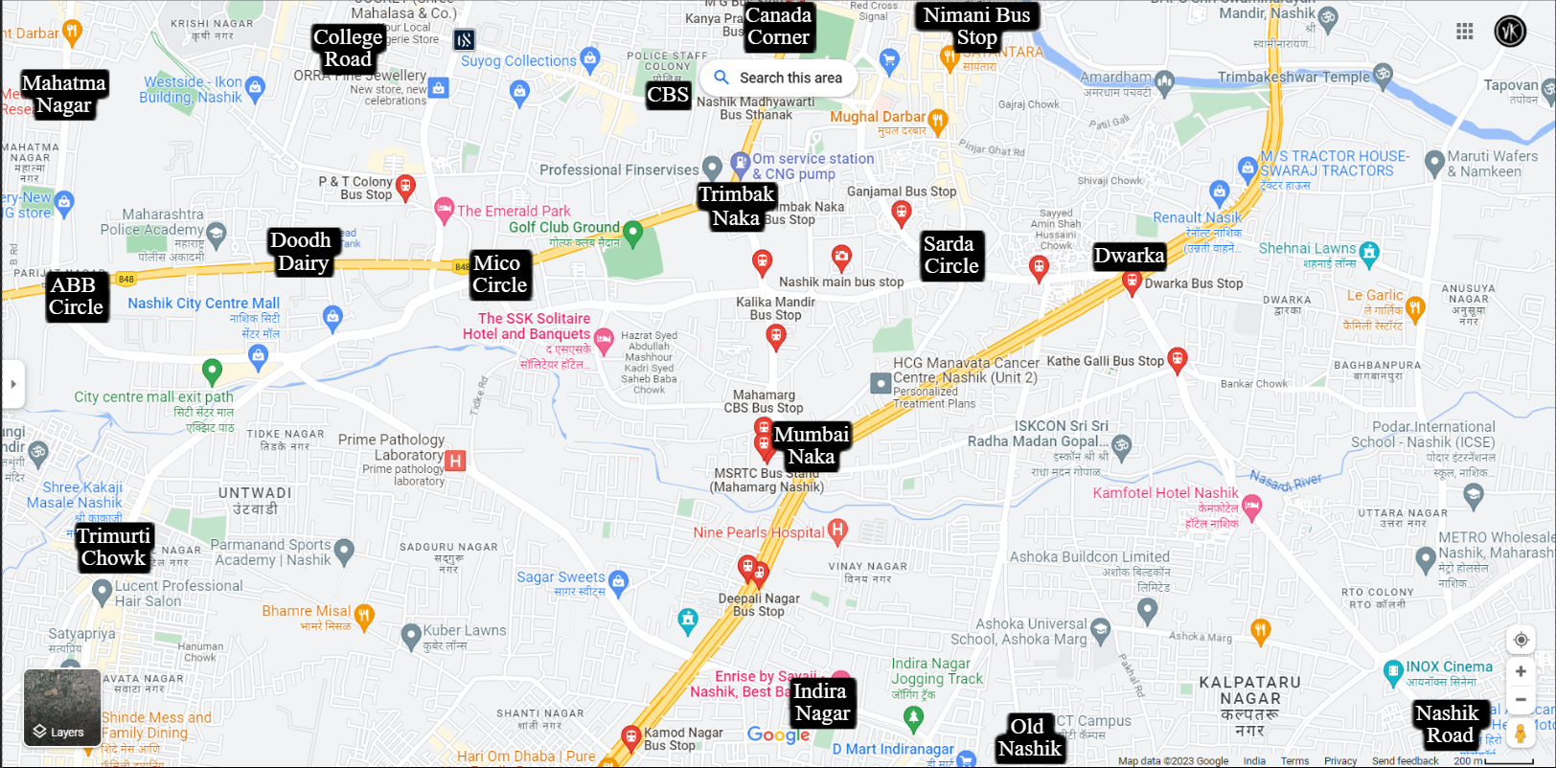
Figure 2: Bus Stops of Sandip Transportation

METHODOLOGY
We aim to do a quantitative and qualitative analysis to find the efficiency of the bus transportation. For this, a vast data is required. The collected data was digitized and processed MongoDB Database. We designed the appropriate user interface using Android Studio. All the intents are well integrated to match the efficiency with the database and Back-End.
As the part of actual implementation our application’s Back-End was developed using C# programming Language using VS Code. We developed APIs (Application Programming Interface) to connect to the database for the retrieval of the record of the students. APIs was tested using Postman software which allows user to test the API integration to databases using the locally hosted server through VS Code.

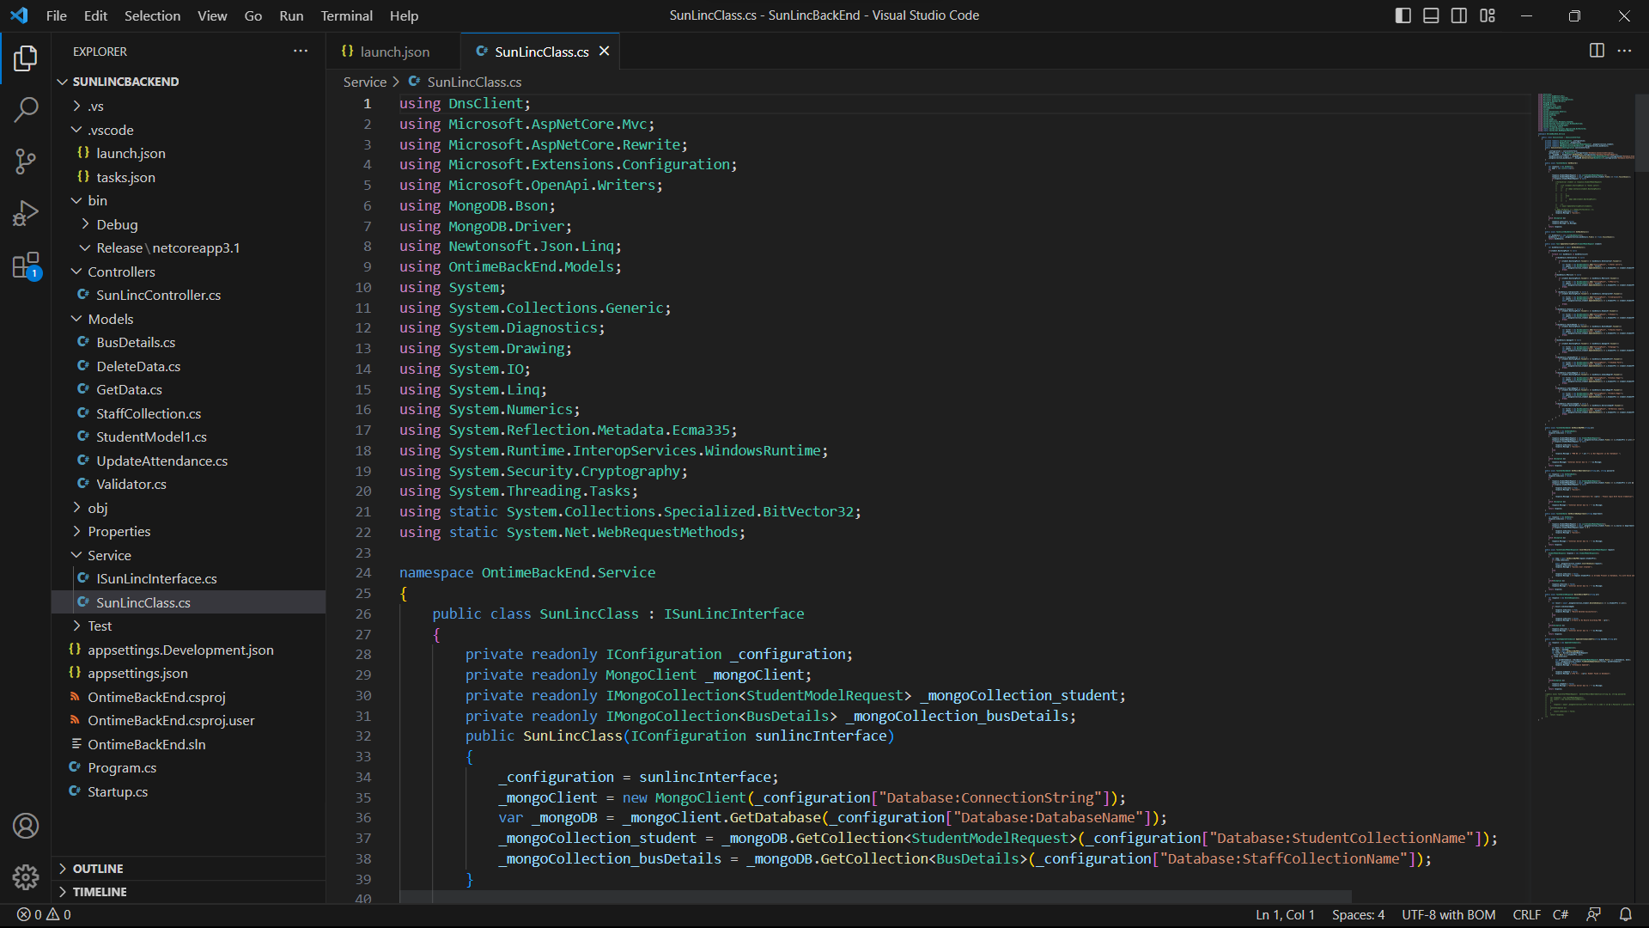
Figure 3: APIs Source Code Glimpse

Conclusion
In this research paper, different data types and the process for collection and processing of the data was required as a prerequisite for carrying out the analysis of bus stops. This is described briefly in this research paper. Bus Routes, Bus Stops, etc. was identified using this data. Sandip University to Deolali route was selected for the study area and the bus stops on that route. This paper discusses about the development of mobile application or SUN-LINC transportation. The Maps obtained as a result are explained in this paper.

REFERENCES
- Nashik Mahanagar PariVahan Mahamandal Limited
URL: https://citilinc.nmc.gov.in/

- Google Maps
URL: https://www.google.co.in/maps/@19.9688453,73.7729478,12.39z?entry=ttu

- Students ERP Records of Sandip University
(Source: Dr. Sanjeev Shukla Sir (Transportation department, Sandip Group of Institutes))
- App Dude
URL: https://www.appdupe.com/school-bus-management-software

