Porting Zephyr RTOS for Cortex-M55 based target

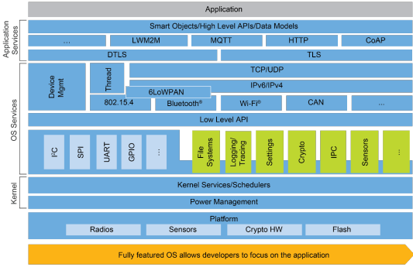
Abstract— The Zephyr real-time operating system (Zephyr RTOS) has gained significant traction in the embedded systems domain due to its lightweight and scalable nature. However, its adoption has been limited by the lack of support for certain hardware platforms. This paper presents a comprehensive study on porting Zephyr OS to a specific hardware platform, aiming to expand its reach and applicability. This paper discusses developing the necessary adaptations and optimizations to ensure Zephyr RTOS run on cortex-m55 based microcontroller board. This paper sheds light on the significance of gaining a holistic understanding of the Zephyr RTOS code base to facilitate successful code modifications and porting endeavors. The initial step entails analyzing the Zephyr RTOS code base to identify the relevant components for customization, such as device drivers and libraries.
Then the board and architecture-specific logic are incorporated into the code base to ensure seamless integration with the target hardware. To tailor the Zephyr RTOS to the platform's requirements, kernel configuration options are modified, including the selection and configuration of appropriate features and subsystems. Then, the ported Zephyr RTOS is loaded onto the target hardware, and extensive debugging is conducted to address any errors, compatibility issues, or performance bottlenecks. The results indicate that the porting process successfully extended the capabilities of Zephyr OS, enabling its utilization in diverse embedded systems applications. This research contributes to the broader Zephyr RTOS community and with its open-source nature as well as of myriad benefits, emerges as the future of embedded systems. Its accessibility, flexibility, and collaborative development model make it an attractive choice for developers.
Keywords—Zephyr, RTOS Porting, Embedded OS porting, Cortex M55, Smaller targets

INTRODUCTION
Porting an operating system to specific hardware platforms is a complex and crucial task in the domain of embedded systems. The process involves adapting the operating system to the unique characteristics and requirements of the target hardware, enabling optimal utilization of its capabilities. Porting also promotes reusability and scalability, allowing the operating system to be deployed across multiple hardware platforms.
In the context of embedded systems, porting is critical due to the wide variety of hardware platforms available, each with its own unique characteristics and requirements. An operating system designed for one hardware platform may not be directly compatible with another, necessitating the porting process. By porting an operating system, developers can harness the capabilities of specialized hardware components, such as sensors, actuators, and communication interfaces, enabling efficient utilization of system resources and delivering tailored solutions for specific application domains.
Fig.1. Zephyr RTOS architecture
Porting Zephyr RTOS involves analyzing the underlying code base, customizing device drivers and libraries, modifying kernel configurations, and ensuring compatibility with the target hardware's architecture. The successful porting of Zephyr RTOS expands its reach, enabling developers to leverage its rich feature set and real-time capabilities in a variety of embedded systems. Moreover, the porting process requires a comprehensive understanding of the operating system's architecture Fig.1 and design principles, as well as familiarity with the intricacies of the target hardware.

CORTEX-M55 MCUs
The Cortex-M profile is a family of 32-bit microcontroller architectures designed for embedded systems. These microcontrollers are optimized for low power consumption, real-time performance, and efficient code execution.

The Cortex-M55 is a new microcontroller architecture based on the Armv8.1-M architecture. It is optimized for machine learning and artificial intelligence applications, with features such as low-latency integer and floating-point operations , SIMD (Single Instruction Multiple Data) instructions, and support for vector processing. The Cortex-M55 also includes hardware support for neural network acceleration, making it suitable for applications such as image and speech recognition.

The Cortex-M55 is designed to work in conjunction with the Ethos-U55 microNPU (Neural Processing Unit), which provides additional hardware acceleration for machine learning workloads. Together, the Cortex-M55 and Ethos-U55 form a complete solution for edge-based machine learning applications.
Advantages of cortex-m55 based Microcontroller Units and Zephyr RTOSs security capabilities can be utilized to offer society a wide range of products.

ZEPHYR CODEBASE ARCHITECTURE
Understanding the codebase is a critical initial step in any porting project. It involves analyzing the existing code to identify the specific areas where modifications are needed. By comprehending the code structure and logic, developers can determine where new code should be added or existing code should be modified to successfully port the software to a new platform.
<arch> directory in the project contains the architecture-specific code and configurations within the subdirectories for different processor architectures like ARM, RISC-V, x86, etc.
<boards> directory contains board specific configurations as various files like dts, kconfig within subdirectories under the board’s architecture. <soc> provides support for specific System-on-Chip platforms, including device-specific code and drivers. <kernel> hosts the core components of Zephyr RTOS. <dts> contains device tree sources for defining hardware configurations.
Various supporting files are grouped into different folders. <drivers> directory houses device drivers for hardware peripherals and subsystems. <cmake> contains build system files. <include/zephyr> includes public API headers for Zephyr RTOS. <samples> contains example applications. <scripts> includes utility scripts for various development tasks.
The diverse range of folders in the Zephyr RTOS project showcases its versatility, making it a powerful and future-proof choice for embedded system development.

A. Insights
Upon careful analysis of the Zephyr codebase and an understanding of the target platform, it is observed that Zephyr RTOS already provides native support for the Cortex-M55 processor architecture. This discovery implies that the porting process requires minimal modifications, as the existing framework readily aligns with the requirements of the target platform. This compatibility highlights the flexibility and adaptability of Zephyr RTOS, further establishing its suitability for a wide range of embedded systems.

B. Board Porting
There are two aspects to porting RTOS for new target, Board porting and Architecture porting. Board porting requires adding or modifying board-specific code, such as device drivers, configuration files, and pin mappings, to enable proper hardware initialization and interaction unlike Architecture porting which entails modifying low-level code, such as context switching, interrupt handling, memory management, and CPU-specific optimizations, to align with the requirements and characteristics of the target architecture. Porting guide in the zephyr documentation provide with more details. Since target processor architecture is already supported, remaining section of this paper presents Board porting process.

IMPLEMENTATION
The implementation is majorly divided into three parts. First is the board specific logic which includes the dts file, Kconfig file, board’s default configuration file and cmake file. Second part is the platform specific logic which includes Kernel configuration files again, linker script, cmake files and soc initialization file. The third part is modifying the code to suit for specific requirements of the board.

A. Board specific files
An existing supported board sharing the same ARM Cortex-M55 architecture as target has been identified, providing a solid starting point for the hardware customization process. The contents of the board directory can be conveniently adjusted to suit the target hardware requirements. Within this directory, a default configuration file captures crucial kernel settings, such as the utilization of the Memory Protection Unit (MPU) and the specific System-on-Chip (SoC) utilized.
Device Tree Source file comprehensively describes hardware aspects of the target device. To ensure organizational clarity, one primary file is retained within the board directory, while the remaining files are housed in designated <dts> folder.
Kconfig is a configuration file used by Linux kernel to define its configuration, in Zephyr it server a similar purpose allowing developers to configure the kernel and subsystems during build process. This enables customization to meet specific application and platform requirements without the need to modify the source code directly. The kernel configuration files, located within the board directory, play a vital role in defining and specifying the board’s characteristics, including the SoC employed.

B. System-on-Chip specific files
If the target board’s soc isn’t supported, new soc directory to be created under specific architecture. The <soc> directory within the Zephyr Project follows a similar approach to the board configuration using Kconfig files. It encompasses the definition of the System-on-Chip (SoC), SoC series, and SoC family. This organizational structure allows for a coherent representation of the hardware components associated with the SoC.

Additionally, the directory contains a linker script that defines the memory layout specific to Cortex-M devices. Since Cortex-M processors typically share the same memory map, a single linker script file is included and utilized across various SoCs based on the Cortex-M architecture. The linker script's address and address range symbols are derived from the hardware configuration specified in the Device Tree Source (DTS) files, establishing an interconnected relationship between the linker script and DTS files. This integration ensures consistent and accurate memory mapping based on the hardware configuration. Moreover, the "soc" directory also incorporates a SoC initialization C file responsible for initializing and setting up the specific SoC, facilitating seamless integration and optimal functioning within the Zephyr RTOS.

C. Customized Adaptations
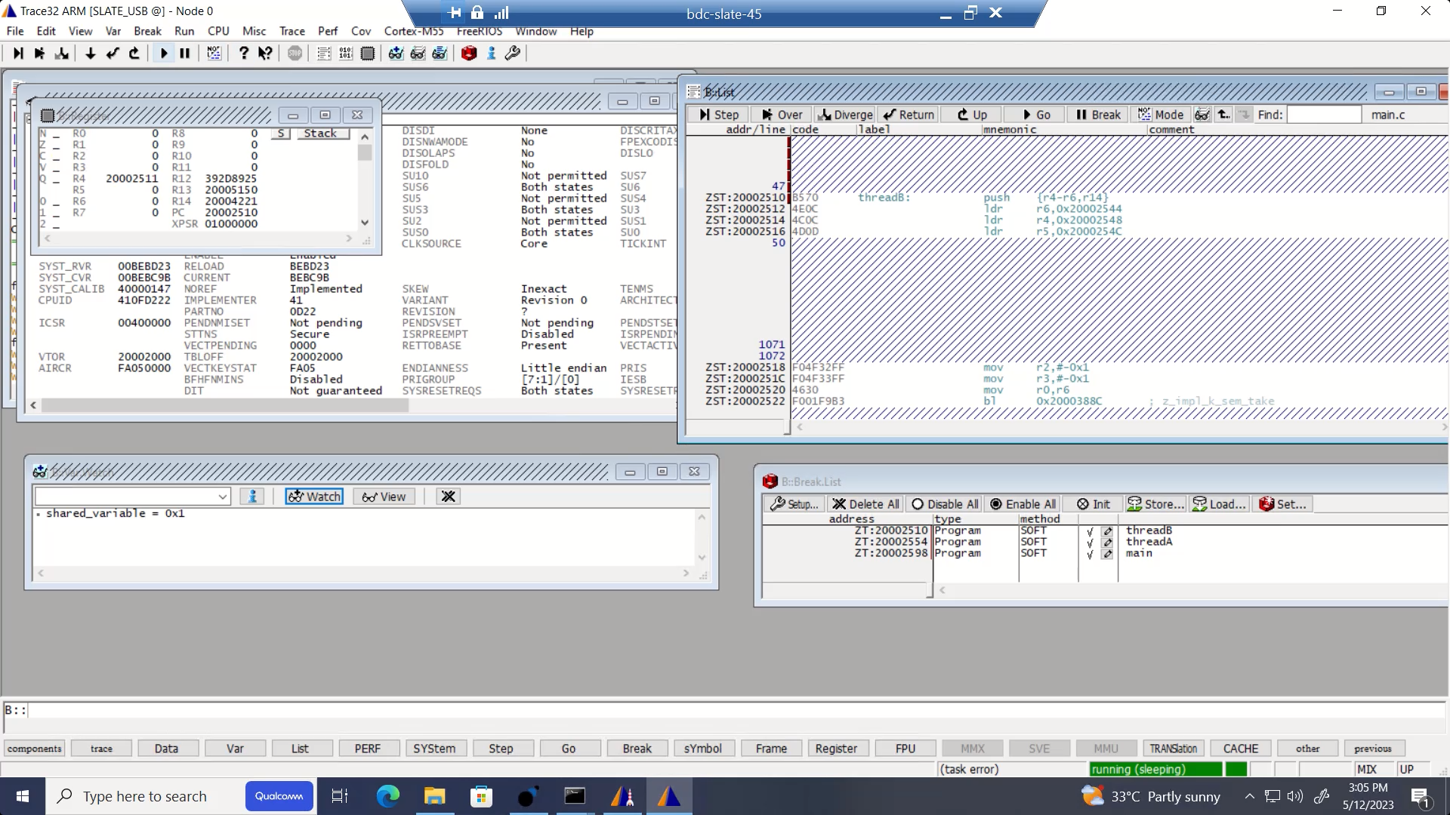
After incorporating the necessary board and "soc" directory files, the code is compiled, resulting in the generation of an .elf file. This file represents the compiled binary that can be loaded onto the target hardware and executed. To cater to specific target devices, customizations are introduced into the code.

For instance, if the device necessitates the code to reside in RAM instead of flash memory, certain Kconfig variables with the desired values are added. These customizations ensure that the build process produces the desired configuration, enabling the code to operate as intended on the target device. By tailoring the code to meet the specific requirements of the hardware, optimal performance and compatibility can be achieved.

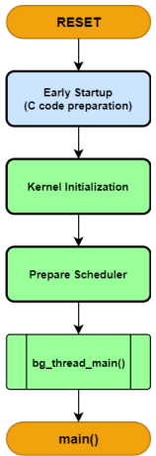
E. Zephyr RTOS Startup and initialization flow
Fig. 2. Startup and initialization flow

Zephyr RTOS startup and initialization Fig.2 involve a series of steps to ensure smooth operation. First, the bootloader takes charge by initializing the hardware and loading the Zephyr kernel into memory. It handles tasks such as configuring clocks, setting up memory regions, and loading the kernel image from storage. Once the bootloader completes its tasks, the kernel initialization routine takes over. It initializes crucial components like data structures, device drivers, system services, and the interrupt system. The kernel initialization also allows developers to configure the RTOS based on their specific requirements, and board-specific initialization code takes care of initializing the hardware specific to the board, such as pins, peripherals, and interfaces. These steps collectively ensure a robust startup and initialization process for Zephyr RTOS, laying the foundation for the reliable operation of embedded systems.

D. Target Initialization issue

Following the customizations and successful build, when attempting to execute the program on the hardware using Trace32 debugger, an IACCVIOL (Instruction Access Violation) fault is encountered. This fault arises when a memory region is designated as "execute never," and the processor tries to fetch an instruction from that specific memory area. Analysis of the stack call trace reveals that the fault occurs during the initialization of the MPU (Memory Protection Unit) and the configuration of MPU regions. Specifically, the RAM region is set as "execute never," despite the presence of code within that memory region, resulting in the IACCVIOL fault.
Fig. 3. Execution reaching main, successfully booting up target.

To resolve this issue, there are two potential solutions. The first option is to disable the MPU altogether, effectively bypassing the memory protection mechanism. Alternatively, the configuration of the memory region can be adjusted to allow execution, making it an executable region. By implementing either of these solutions, the fault is rectified, allowing the target to initialize properly and reach the main function fig.3, enabling the execution of the intended code.

RESULTS

Zephyr RTOS has been successfully ported to cortex-m55 based target. To showcase the same, once the initialization issues have been resolved and it is confirmed that the program successfully reaches the main function, the real-time operating system (RTOS) is compiled with a sample multithreading application that demonstrates synchronization using semaphores.

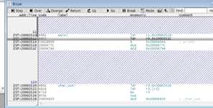
The logic behind this application involves a shared_variable, where one thread increments the value while another thread decrements it by 1. The initial value of the shared_variable is set to 0. Without any race conditions, the expected behavior is for the value of the shared_variable to toggle between 1 and 0.

Fig. 4. Zephyr Running on target (1)

Breakpoints are set at functions main, threadA and threadB. Shared_variable is watched for its value change. As it can be seen in Fig. 4. on executing threadA(increments value by 1) and reaching thread, shared_variable value is changed from 0 to 1.

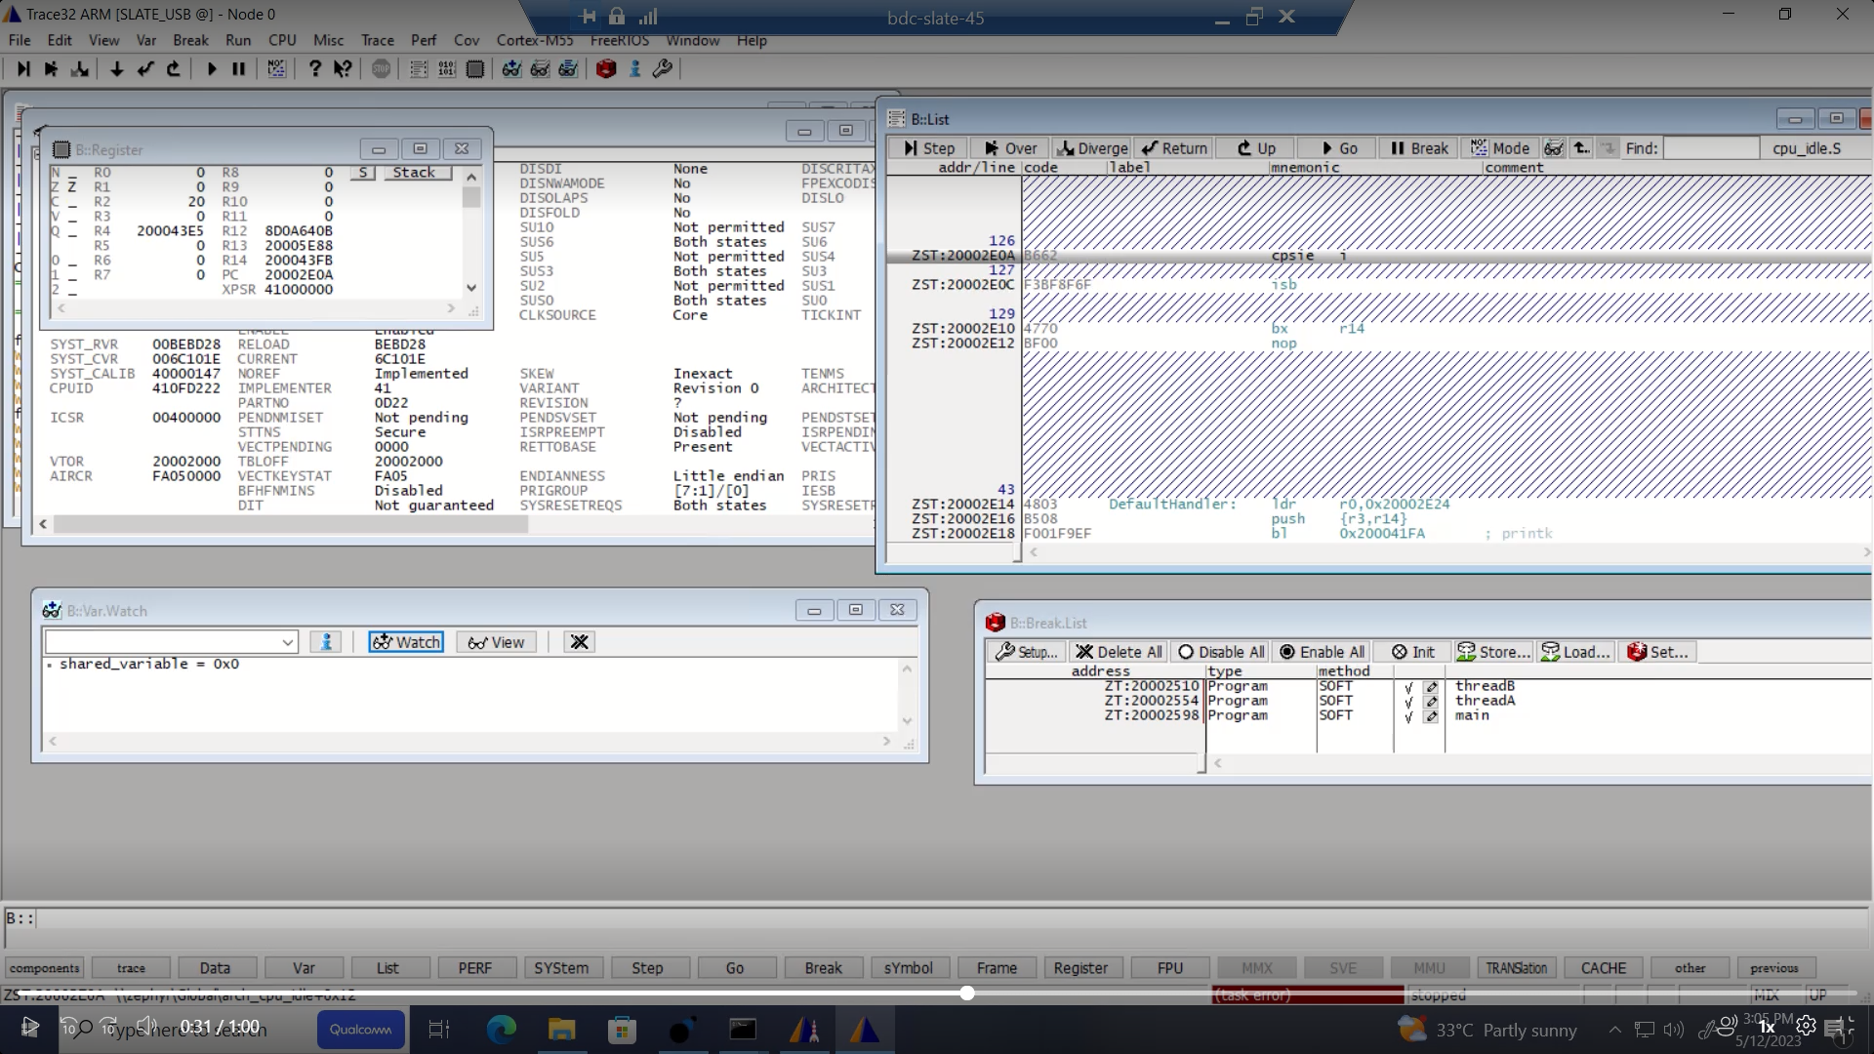
Fig. 5. Zephyr running on target (2)

Fig. 5. shows that on executing thread (decrements the value by 1), shared_variable value changed to 0 from 1.

System Control Block provides the developer information regarding the configuration, control, and reporting of the system exceptions. It highlights that no exception has occurred and the code is running successfully on the board.
This provides the evidence that the Zephyr RTOS has been successfully ported to target.

CONCLUSION AND FUTURE WORK

In conclusion, the successful porting of Zephyr to a Cortex-M55 based target marks another significant addition to the list of supported boards by the Zephyr Project. This achievement underscores the versatility and adaptability of the Zephyr RTOS, showcasing its potential for future developments in embedded systems and Internet of Things (IoT) applications. With its extensive feature set, open-source nature, and growing community support, Zephyr holds great promise as a leading RTOS for a wide range of hardware platforms.

However, certain limitations still exist regarding performance of Zephyr on the target, necessitation further evaluation.

To address this, the project has outlined the future enhancements of performance tests and generation of comprehensive performance report to gain insights into the efficiency and suitability of Zephyr on the target. This will guide decision-making regarding the deployment of Zephyr on hardware, potentially replacing proprietary RTOSs with a flexible, scalable solution.

Additionally, the project aims to conduct a comprehensive analysis of Zephyr with other RTOSs, focusing on time profiling and memory usage. This comparison will provide valuable information for selecting suitable RTOS for future projects.

REFERENCES

- PB Hemanthkumar et al. “Introduction to ARM processors & its types and Overview to Cortex M series with deep explanation of each of the processors in this Family”. In 2022 International Conference on Computer Communication and Informatics (ICCCI). IEEE. 2022, pp. 1–8.
- Tomoaki Kawada et al. “TZmCFI: RTOS-aware control flow integrity using trustzone for Armv8-M”. In: International Journal of Parallel Programming 49.2 (2021), pp. 216–236
- Ayaz Akram et al. “Performance analysis of scientific computing workloads on trusted execution environments”. In: arXiv preprint arXiv:2010.13216 (2020).
- Allan Skillman and Tomas Edso. “A technical overview ¨ of cortex-m55 and ethos-u55: Arm’s most capable processors for endpoint ai”. In: 2020 IEEE Hot Chips 32 Symposium (HCS). IEEE. 2020, pp. 1–20.
- Jie Wang et al. “TrustICT: an efficient trusted interaction interface between isolated execution domains on ARM multi-core processors”. In: Proceedings of the 18th Conference on Embedded Networked Sensor Systems. 2020, pp. 271–284
- Antonio Ken Iannillo and Radu State. “A proposal for security assessment of trustzone-m based software”. In: 2019 IEEE International Symposium on Software Reliability Engineering Workshops (ISSREW). IEEE. 2019, pp. 126–127.
- Sandro Pinto and Nuno Santos. “Demystifying arm trustzone: A comprehensive survey”. In: ACM computing surveys (CSUR) 51.6 (2019), pp. 1–36.
- Jinsoo Jang et al. “Privatezone: Providing a private execution environment using arm trustzone”. In: IEEE Transactions on Dependable and Secure Computing 15.5 (2016), pp. 797–810.
- Bernard Ngabonziza et al. “Trustzone explained: Architectural features and use cases”. In: 2016 IEEE 2nd International Conference on Collaboration and Internet Computing (CIC). IEEE. 2016, pp. 445–451.
- Hwi-Min Choi, Chang-Bok Jang, and Joo-Man Kim. “Efficient security method using mobile virtualization technology and trustzone of arm”. In: Journal of Digital Convergence 12.10 (2014), pp. 299–308.
- B Manoj Kumar Reddy, GSR Satyanarayana, and B Seetaramanjaneyulu. “Scheduling latency comparison of two open-source RTOSs on CORTEX-M3”. In: 2014 International Conference on Embedded Systems (ICES). IEEE. 2014, pp. 59–62.
- DongSeok Cho and DooHwan Bae. “Case study on installing a porting process for embedded operating system in a small team”. In: 2011 Fifth International Conference on Secure Software Integration and Reliability Improvement-Companion. IEEE. 2011, pp. 19–25.
- Tiago Alves. “Trustzone: Integrated hardware and software security”. In: White paper (2004).

