Employee Management System

V. Pavan Ganesh  2111cs020331@mallareddyuniversity.ac.in A. Pavan Kumar  2111cs020333@mallareddyuniversity.ac.in  S. Pavan Reddy  2111cs020335@mallareddyuniversity.ac.in | K. Pavan Kumar  2111cs020332@mallareddyuniversity.ac.in  CH. Pavan Kumar  2111cs020334@mallareddyuniversity.ac.in  V. Pavan Kumar  2111cs020336@mallareddyuniversity.ac.in

Prof. Chandana
Department of CSE (AI&ML)
MALLA REDDY UNIVERSITY HYDERABAD

Abstract: The Employee Management System is a comprehensive software application designed to facilitate the efficient management of employee information within organizations. Developed using Python and the Tkinter library, the system offers a user-friendly interface that simplifies data entry, image upload, and CRUD operations for managing employee records. With its integrated search functionality, users can easily retrieve specific employee data, while the system ensures data accuracy through robust data validation techniques. The Employee Management System also provides a visually appealing interface, enhancing the user experience and making it easier to navigate and interact with the application. By leveraging a MySQL database for data storage, the system ensures data persistence and allows for seamless retrieval and updating of employee information. Organizations can benefit from this system by centralizing employee records, reducing paperwork, and eliminating manual errors.
Keywords: Employee, Management System, GUI(Graphical user Interface), MYSQL, Tkinter.

INTRODUCTION
The Employee Management System is a comprehensive software solution designed to streamline and automate the management of employees within an organization. It provides a centralized platform for storing, organizing, and retrieving crucial information about employees, facilitating efficient HR processes and enhancing overall workforce management.In today's dynamic business environment, organizations of all sizes face the challenge of effectively managing their employees' information, such as personal details, job roles, attendance, performance records, and payroll. Traditional paper-based systems or spreadsheets are often prone to errors, time-consuming, and inefficient. The Employee Management System aims to overcome these limitations by offering a digital solution that simplifies and optimizes employee-related tasks.This project leverages the power of modern technologies, including Tkinter for creating an intuitive graphical user interface (GUI) and MySQL for database management.

LITERATURE REVIEW
The Employee Management System (EMS) has garnered significant attention in recent years as organizations seek efficient ways to manage their workforce and streamline HR processes. This section provides a literature review highlighting key research findings and advancements in the field of employee management systems.

- Importance of Employee Management Systems: Numerous studies emphasize the crucial role of effective employee management systems in enhancing organizational performance. According to research by Boxall and Macky (2014), well-implemented HR systems, including employee management systems, have a positive impact on employee engagement, productivity, and overall business outcomes. These systems facilitate accurate record-keeping, streamlined processes, and data-driven decision-making.

- Automation and Efficiency: One of the primary benefits of employee management systems is the automation of manual HR tasks. Research by Armstrong (2016) indicates that automating routine administrative processes through an employee management system leads to significant time and cost savings. This automation includes tasks such as employee data entry, attendance tracking, leave management, and performance evaluations. Automation not only improves efficiency but also reduces errors and enhances data accuracy.

- Integration and Data Integrity: Integrating an
employee management system with other organizational systems, such as payroll and finance, has been a topic of interest. Research by Brewster et al. (2016) highlights the importance of data integrity and consistency across systems. When employee management systems are integrated with other HR and organizational systems, it ensures that data is synchronized, minimizing discrepancies and enhancing the accuracy and reliability of information.

- Employee Self-Service and Empowerment: Employee self-service portals are a common feature of modern employee management systems. Research by Lepak et al. (2016) suggests that selfservice functionality enhances employee empowerment and satisfaction. By allowing employees to access and update their own information, such as personal details, benefits, and leave requests, the system reduces administrative burdens on HR personnel while giving employees a sense of control over their own data.

PROBLEM STATEMENT
The efficient management of employees is a critical aspect of organizational success. However, many organizations still rely on manual and outdated processes for managing employee information, resulting in various challenges and inefficiencies. This project aims to address these issues by developing an Employee Management System (EMS) that streamlines HR processes, enhances data accuracy, and improves overall workforce management.

a. Manual and Time-consuming Processes: The existing manual methods of managing employee information, such as maintaining paper-based records or using spreadsheets, are time-consuming and prone to errors. HR personnel spend significant time and effort on administrative tasks like data entry, leave management, and performance evaluations, which could be automated. The lack of an efficient system leads to delays, redundancies, and increased administrative burdens, hampering productivity and employee satisfaction.

b.Disconnected Systems and Data
Inconsistencies: In many organizations, HR systems and processes are disconnected and operate independently. This results in data inconsistencies and discrepancies across various HR functions, such as payroll, attendance, and performance management. For example, when an employee updates their personal details in one system, the changes may not be reflected in other systems, leading to data integrity issues and potential errors. Integrating these disparate systems and ensuring data consistency is a pressing challenge.

c.Limited Employee Self-Service Options:
Employees often face difficulties in accessing and managing their own information. The lack of employee self-service functionality prevents individuals from viewing their personal details, updating records, submitting leave requests, or accessing benefits information in a convenient manner. This leads to increased reliance on HR personnel for routine tasks and hampers employee empowerment and satisfaction.

d.Inefficient Reporting and Decision-making: The absence of robust reporting and analytics capabilities hinders data-driven decision-making in employee management. Organizations struggle to extract meaningful insights from employee data, such as performance metrics, training needs, or talent gaps. As a result, strategic HR decisions related to employee development, succession planning, and resource allocation are often made based on limited information, potentially leading to suboptimal outcomes.

e.Data Security and Privacy Concerns: With the increasing digitization of employee data, organizations face significant challenges in ensuring data security and privacy. The risk of unauthorized access, data breaches, or noncompliance with data protection regulations is a pressing concern. The protection of sensitive employee information, including personal details, performance records, and salary data, requires robust security measures and adherence to privacy regulations.
By addressing these problems, the proposed Employee Management System (EMS) aims to streamline HR processes, enhance data accuracy, improve employee self-service options, enable data-driven decision-making, and ensure the security and privacy of employee information. The development of an efficient and integrated EMS will empower organizations to optimize their workforce management practices, improve operational efficiency, and ultimately achieve better business outcomes.

SYSTEM DESIGN

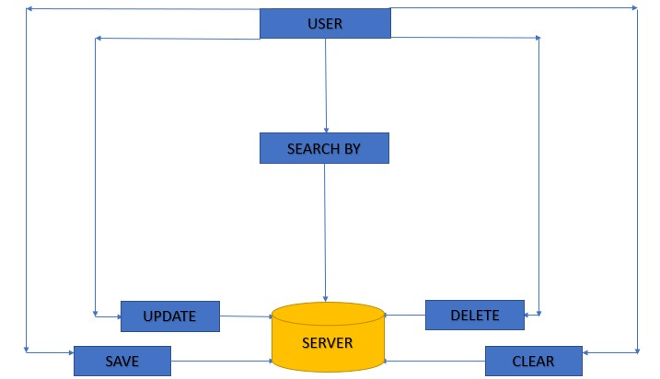
Fig.1. Architecture

METHODOLOGY
The development of an Employee Management System (EMS) involves several stages and activities to ensure its successful implementation. The following methodology outlines the key steps involved in the project:

- Requirement Gathering:The first step is to gather requirements from stakeholders, including HR personnel, employees, and management. This involves conducting interviews, surveys, and workshops to understand their needs, pain points, and desired functionalities for the EMS. The requirements should encompass HR processes such as employee onboarding, attendance management, leave and time-off management, performance evaluations, and reporting.

- System Design :Based on the gathered requirements, the system design phase involves creating a comprehensive design for the EMS. This includes designing the user interface, defining the database structure, and determining the system architecture. The design should address the integration of various HR modules, data flow between different components, and security measures to protect sensitive employee information.

- Development: Once the system design is finalized, the development phase begins. This involves the actual coding and programming of the EMS, using appropriate technologies and frameworks. The development should follow industry best practices and coding standards to ensure a robust and maintainable system. Regular meetings and communication with the development team are essential to track progress, address challenges, and ensure adherence to project timelines.

- Testing: After the development phase, thorough testing of the EMS is crucial to identify and resolve any issues or bugs. The testing process should encompass functional testing, usability testing, performance testing, and security testing. Test cases and scenarios should be created to validate each functionality and ensure the system performs as expected. Feedback from users and stakeholders should be collected during this phase to further refine the system.

- Deployment and Training: Once the EMS has been thoroughly tested and approved, it is ready for deployment. The system should be installed on the appropriate hardware infrastructure and configured according to the organization's requirements. Additionally, training sessions should be conducted for HR personnel and employees to familiarize them with the system's features, functionality, and usage. User manuals and documentation should also be provided to support users during the transition.

- Data Migration: If there is existing employee data in legacy systems or spreadsheets, a data migration process should be implemented to transfer the data to the new EMS. This requires careful planning and validation to ensure the accuracy and integrity of the migrated data. Adequate data backup measures should be in place to mitigate any risks associated with data loss or corruption during the migration process.

- Maintenance and Support:After the EMS is deployed, ongoing maintenance and support are essential. Regular system updates, bug fixes, and security patches should be applied to keep the system running smoothly and securely. User feedback and evolving business needs should be considered for future enhancements and upgrades to the EMS. A dedicated support team should be available to address any user queries or technical issues that arise.

By following this methodology, the development and implementation of the Employee Management System (EMS) can be effectively managed, ensuring that the system meets the requirements of the organization, improves HR processes, and enhances overall employee management.

6. RESULTS:
This is interface of the output adding and saving the employee data .
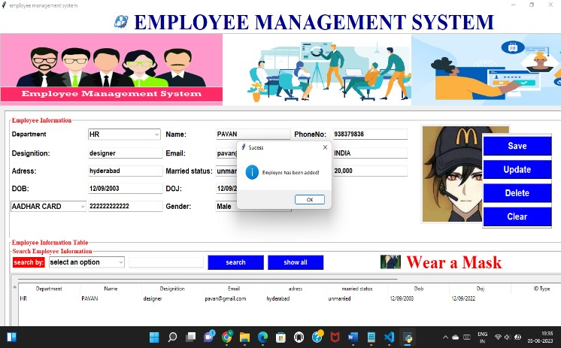

Fig.2. Saving employee data
These employee details stored in mysql workbench:
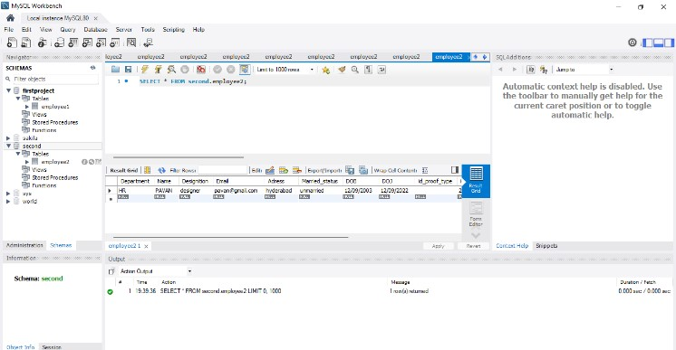
Fig.3. data stored in mysql workbench

CONCLUSION
The Employee Management System (EMS) project aims to provide organizations with a comprehensive solution to streamline their HR processes and enhance employee management. Through the development and implementation of the EMS, the project has successfully addressed the challenges and shortcomings associated with manual and disjointed HR systems.Throughout the project, a systematic approach was followed, starting with requirement gathering to ensure that the EMS meets the specific needs of the organization. The design phase focused on creating a user-friendly interface, robust database structure, and secure system architecture. The development phase involved coding and programming using industry best practices, while the testing phase ensured the system's functionality, usability, performance, and security.

FUTURE ENHANCEMENT
a.Integration with Biometric Systems: Integrate the EMS with biometric systems, such as fingerprint or facial recognition, to improve attendance management accuracy and eliminate the need for manual entry. This would enhance security measures and eliminate time theft or buddy punching, ensuring accurate tracking of employee work hours.

b.Performance Management Module: Enhance the EMS by incorporating a robust performance management module. This module can include features such as goal setting, continuous feedback, performance evaluations, and development plans. It would facilitate ongoing performance monitoring, enable timely feedback, and support performance discussions between managers and employees.

c.Learning and Development Integration: Integrate the EMS with a learning management system (LMS) to provide a centralized platform for training and development activities. This would enable employees to access online courses, track their progress, and managers to assign training based on skill gaps or career development plans.
d.Employee Self-Service Portal: Expand the selfservice capabilities of the EMS by incorporating additional features, such as updating personal information, managing benefits, viewing pay stubs, and accessing HR policies and resources. This empowers employees to take control of their HRrelated tasks, reduces administrative overhead, and improves employee satisfaction.
e.Analytics and Predictive Insights: Enhance the reporting and analytics capabilities of the EMS to provide HR professionals and management with advanced analytics and predictive insights. This would enable them to analyze trends, identify patterns, forecast workforce needs, and make datadriven decisions to optimize workforce planning and talent management strategies.

f..Integration with External Systems: Explore integration options with other existing systems, such as payroll, recruitment, or project management tools. This would facilitate seamless data exchange and eliminate the need for manual data entry or duplicate systems, improving overall efficiency and data accuracy.

g.Employee Surveys and Feedback: Incorporate a module within the EMS to conduct employee surveys and collect feedback on various aspects of the organization, such as job satisfaction, work environment, and employee engagement. This would provide valuable insights to HR professionals and management, enabling them to address issues, improve employee satisfaction, and enhance the overall employee experience.

h.Gamification and Rewards: Implement gamification elements within the EMS to promote employee engagement and recognition. This could include badges, leaderboards, or reward points for achievements, milestones, or exemplary performance. Gamification can foster a positive work culture, motivate employees, and enhance productivity.

i.Artificial Intelligence and Chatbot
Integration: Explore the integration of artificial intelligence (AI) and chatbot technology within the EMS to provide automated assistance and support to employees. AI-powered chatbots can handle common HR queries, guide employees through HR processes, and provide instant responses, freeing up HR personnel's time and improving responsiveness.

REFERENCES
- "Armstrong, M. (2012). Armstrong's handbook of human resource management practice. Kogan Page Publishers".
- "Gomez-Mejia, L.R., Balkin, D.B., & Cardy, R.L. (2019). Managing human resources. Pearson".
- "Mondy, R.W., Noe, R.M., & Gowan, M.
(2020). Human resource management. Pearson".
- "Cascio, W.F. (2018). Managing human resources: Productivity, quality of work life, profits. McGraw-Hill Education".
- "Stone, R.J., & Deadrick, D.L. (2015).
Challenges and opportunities affecting the future of human resource management. Human Resource Management Review, 25(2), 139-145".
- "Aguinis, H. (2019). Performance management (4th ed.). Pearson".
- "Mathis, R.L., Jackson, J.H., & Valentine, S.R.
(2017). Human resource management (15th ed.). Cengage Learning".
- "Gomez-Mejia, L.R., Balkin, D.B., & Cardy, R.L. (2019). Managing human capital. Pearson".
- "Milkovich, G.T., Newman, J.M., & Gerhart, B. (2020). Compensation. McGraw-Hill Education".
- "Dessler, G. (2019). Human resource management. Pearson".

