HUMAN OR ANIMAL DETECTION

Gogineni Pavan Arikatla Lakshmi Narasimham Nunna Sai kiran

Department of CSE Department of CSE Department of CSE
VFSTR VFSTR VFSTR
pavangogineni19@gmail.com arikatlanarasimham13@gmail.com sainunna222@gmail.com

Dr.D.Venkatesulu
Head of the Department,ACSE
VFSTR, deemed to be University
hod_acse@vignan.ac.in

Abstract

This research paper presents a novel technique for detecting humans and animals using convolutional neural networks (CNNs). The method involves training a CNN model with a large dataset of annotated images specifically focused on humans and animals. The trained CNN is then utilized to analyze input images and classify them into two categories: containing humans or animals, or not. Extensive testing on diverse image datasets demonstrates the method's high accuracy and speed, indicating its potential applicability in various domains such as wildlife monitoring, security systems, and robotics. The outcomes of the study indicate that the proposed technique outperforms existing approaches, establishing it as a state-of-the-art solution for human and animal detection in computer vision applications like surveillance, wildlife monitoring, and autonomous vehicles.

Keywords: CNN, Deep learning, state-of-the-art

1.INTRODUCTION

In the field of computer vision, convolutional neural networks (CNNs) are frequently used to recognize people or animals. CNNs are deep learning models known for their capability to autonomously learn hierarchical features from images, making them highly suitable for tasks like object detection. The fundamental concept behind utilizing CNNs for human or animal detection involves training a model using an extensive dataset comprising labeled images. Subsequently, the trained model can generalize its knowledge to novel images and accurately determine whether an object depicted in an image corresponds to a human or an animal.
For the purpose of human or animal detection, training a CNN involves a commonly employed method using datasets such as ImageNet. ImageNet consists of a vast number of annotated images covering a wide range of object categories. As part of the training process, CNN is trained to accurately classify images into their respective object categories, encompassing humans and various animal types. Once the training is complete, the trained CNN can be utilized for human or animal detection by applying it to new, unseen images. By feeding an image as input to the CNN, it generates a probability distribution across the various object categories. When the probability assigned to either the "human" or "animal" category exceeds a predefined threshold, the model classifies the object within the image as a human or an animal, respectively.
There are many variations of CNN architectures that can be used for human or animal detection, including popular models such as AlexNet, VGG, and ResNet. These models differ in their architecture and number of layers, but they all share the ability to automatically learn features from images and classify objects with high accuracy. By training a CNN on a big collection of labelled pictures and applying it to new images, we can accurately classify whether an object in an image is a human or an animal.
The domain of object detection, encompassing the identification of humans and animals in images and videos, has experienced significant progress thanks to the implementation of Convolutional Neural Networks (CNNs). This abstract introduces a method based on CNNs that enables precise detection of humans and animals within images. The proposed technique leverages pre-trained CNN models, such as VGG or ResNet, as feature extractors. By discarding the latter layers of the CNN, to extract distinguishing characteristics from the input image, the other layers are used. The last classification output is then produced using a succession of fully linked layers on top of these characteristics. A large dataset is required for the network to be trained effectively. comprising images containing humans and animals. The dataset is divided into training and validation sets, and the network is trained using backpropagation and gradient descent optimization techniques. Performance evaluation of the network is conducted on the validation set, with adjustments made to the hyperparameters to optimize its overall effectiveness. During testing, images containing humans or animals are inputted into the network, which produces a probability distribution across potential classes. Utilizing a predetermined threshold on the output facilitates the determination of whether the image contains a human or an animal.
Experimental results on a dataset of images containing humans and animals demonstrate the effectiveness of the proposed method, achieving high accuracy and recall rates for both human and animal detection. The proposed method could be useful in many applications, such as wildlife monitoring and surveillance systems.

2.LITERATURE SURVEY

[1]. Identity authentication heavily relies on face recognition, which involves recognizing the unique characteristics of an individual's face. This research aims to develop an efficient employing digital image processing technique, recognize faces. The authentication process consists of two essential stages: fast face detection, excluding objects far away, followed by individual face recognition. Through iterative improvements, a robust face recognition model is constructed, representing an advanced biometric technology. The Eigenface approach and the Fisher's face method are two well-known face recognition algorithms that are examined in this work. To specifically minimize the dimensionality of facial data, the Eigenface technique makes use of Principal Component Analysis (PCA). This study's main goal is to investigate how to use digital image processing to build a trustworthy face recognition system.

[2]. In biometrics, face detection and recognition have grown in importance. Real-time facial recognition is an intriguing and quickly developing problem. Based on Principal Component Analysis (PCA), a facial recognition system is suggested in this research. The objective of PCA, a statistical technique that belongs to component analysis, is to decrease the dimensionality of data while maintaining its key characteristics. In the context of facial identification, PCA is used to convert the 2D face pictures into a small 1D pixel vector, projecting them into the so-called eigenface space, which is a condensed feature space. By finding the eigenvectors of the covariance matrix generated from a set of face photos, the eigenfaces are identified. Using OpenCV, Haar Cascade, Eigenface, and other tools, a camera-based real-time face recognition system is created to put this strategy into practice.

[3]. Facial recognition systems have gained significant attention and appeal across various industries and research domains due to their accuracy and effectiveness. Unlike traditional card recognition systems, facial recognition offers flexibility as a biometric identification method. Typically, a face detection technique precedes the face recognition system. Face detection serves as the initial step in identifying a face in live images. This research explores various face detection approaches, including skin likelihood image analysis, skin segmentation, morphological operations for extracting border areas, Haar-like features, and the AdaBoost method. Among these approaches, the Haar-like feature algorithm stands out due to its ability to continuously search for patterns specific to a face, offering advantages over alternative methods. Once the face detection phase is completed, the observed face is further identified using face recognition technology, employing a combination of classifiers.

[4]. Numerous underwater applications have made extensive use of digital pictures and video. The automated tagging of marine life in such video recordings involves three key steps: feature extraction, detection and tracking, and classification. The final two components are where this work places its attention. Feature extraction using a convolutional neural network (CNN) beats earlier techniques in terms of classification accuracy on two real-world datasets of marine species (Taiwan sea creatures and benthic species collected by the Bay of Monterey Marine Research Institute, or MBARI). Integrating hand-designed characteristics with CNN may increase accuracy much farther than CNN alone. The group feature selection technique, that utilizes an altered form of the minimal-redundancy-maximum-relevance (mRMR) algorithm, is the criterion for selecting an optimal group of hand-designed features. Further analysis of CNN and manually created features is done for photos of lesser quality that simulate poor illumination conditions in water.

3.METHODOLOGY

A. DEEP LEARNING
Deep learning is a branch of artificial intelligence (AI) that aims to emulate the learning capabilities of the human brain. Through an iterative training process using a large dataset of categorized object images, deep learning algorithms enable the recognition of objects. Deep learning algorithms provide several advantages over conventional machine learning techniques. typically require more data and training time. The task of identifying unique features in images is challenging and requires substantial computational effort. Unlike classical machine learning, deep learning algorithms automatically extract essential features from the data, alleviating the need for manual curation. Deep learning models consist of neural networks with multiple hidden layers, allowing for the construction of complex concepts from simpler ones during image processing. By incorporating basic features like shape, edges, and corners, these networks can learn to recognize objects, including characters, faces, and various other items. As information flows through the layers, each subsequent layer refines the data, enabling the capture of increasingly intricate details. Ultimately, the network combines these refined features to identify the image. Deep learning finds extensive applications in computer vision, with facial data being particularly significant in this domain.

B. CONVOLUTIONAL NEURAL NETWORKS
Convolutional neural networks (CNNs) have become widely used for object recognition and categorization in the field of artificial neural networks. Employing deep learning techniques, CNNs excel in identifying objects in images. A layer of input, layers that are hidden, and the result layer make up a typical neural network. CNNs take inspiration from the neural structure of the human brain, where neurons transmit signals between cells. Similarly, artificial neurons or nodes in CNNs receive inputs, process them, and produce outputs accordingly. In CNNs, images are used as input data to initiate the network's operations. These networks incorporate multiple hidden layers that perform mathematical computations to take the input image's important characteristics and extract them. The initial convolutional layer is particularly important as it characteristics from the supplied picture are extracted. Subsequently, a fully connected layer carries out the classification and identification of the object, resulting in the output layer.
The convolutional layer is a vital component of CNNs, responsible for combining data from different sources through mathematical operations. Gender estimation can be achieved using social image collections without accessing personal information like birth dates, which may not be visible in the pictures. Traditionally, gender recognition methods rely on manually annotated data and additional details about individuals.
However, the D-CNN approach directly operates on images, enabling accurate gender estimation. Overfitting concerns are usually not significant unless deep learning or machine learning techniques are applied to datasets with a limited number of face images.
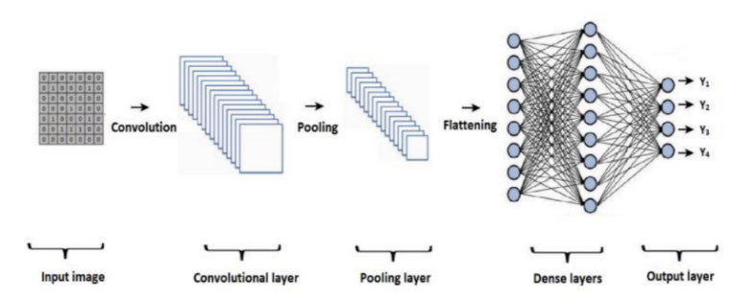

Fig.1.CNN Architecture

Convolutional, pooling, and fully connected layers make up the three layers of a convolutional neural network. Figure 1 combines all layers.

C.CONVOLUTIONAL LAYER
In CNNs, the convolutional layer serves as a critical element where extensive computational operations occur. It requires input data, a filter (kernel or feature detector), and generates a feature map as an output. Specifically, when working with a color image, the input data is structured as a Dimensions of a 3D pixel matrix that correspond to the three dimensions of the matrix are comparable to the RGB regions in a picture.

Within the convolutional layer, a feature detector, commonly referred to traverses the receptive fields of an image using a kernel or filters to determine if certain characteristics are present. This process, known as convolution, involves evaluating the dot product between the filter and corresponding input pixels. Through these iterative computations, an output array, referred to as the feature map, is generated. It represents the convolutional layer's results and highlights significant features detected within the input image. To visualize the internal workings of the convolution layer, refer to Figure 2, which illustrates the processes and transformations taking place during convolution.
A 2-dimensional (2-D) arrays of scales that serves as the feature detector represents a portion of the picture. The receptive field's size, often a 3x3 matrix but subject to variation determines the filter's size. The amount of dots across the input images and the filtered area is computed after deploying the filters to a selected area of the picture. The starting point for an outcome array is this dot product. The filter continues to traverse the entire image, shifting by a specified stride, and repeating the process. A characteristic map, activation mapping, or organized feature is the result of this series of dots produced between the input data and the filter. Rectified Linear Unit (ReLU), a non-linear function, is applied by CNN to the feature map following each convolution process. This nonlinearity enhances the model's ability to capture intricate patterns. As previously mentioned, additional convolution layers can be incorporated into the CNN architecture. This hierarchical structure enables later layers to access the receptive fields of earlier layers.

For instance, let's consider the task of detecting a bicycle in an image. The bicycle comprises various components such as the frame, handlebars, wheels, pedals, and other parts. In the CNN, a feature hierarchy is established by representing each of these bicycle components as lower-level patterns within the neural network. At the same time, the complete bicycle is represented as a higher-level pattern. This hierarchical arrangement allows the network to learn and recognize the bicycle by leveraging the interrelationships among its constituent parts.

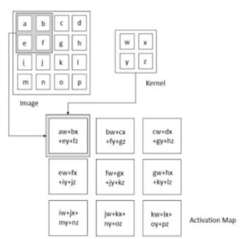

Fig.2.Convolutional Layer

D.POOLING LAYER
To enhance storage efficiency, CNNs utilize down sampling methods known as pooling layers to decrease the data volume generated by the convolutional layer. These pooling operations have the objective of reducing the input's dimensionality and parameter count. The pooling layer uses a filter that is applied to all of the input data, just like the convolutional layer does. However, the pooling filter lacks weights in contrast to the convolutional layer. Instead, it uses a function that aggregates on the values in the field that is receptive to fill the output array. Two primary pooling techniques are commonly employed:
- Max pooling: During the filtering process, the highest value pixel within the receptive field is selected and propagated a set of output elements. Max pooling is utilized more frequently than average pooling.
- Average pooling: While traversing the input, the filter computes the average value of the pixels within the receptive field and transmits the outcome to the output array.
- Fig 3 shows the internal working of the pooling layer.

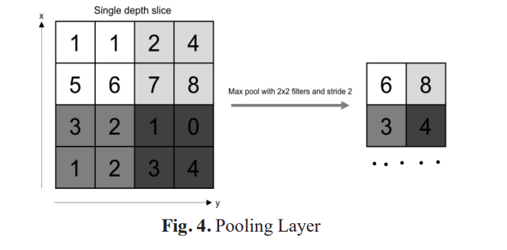

Fig.3.Pooling Layer

The pooling layer loses a lot of information, but it also offers the CNN a number of advantages. They lessen complexity, increase effectiveness, and lower the danger of overfitting.

E. FLATTENING LAYER
The two-dimensional array is flattened to create a single, lengthy continuous vector. The input to this layer is received from the convolutional layer, it flattens the input into single and long continuous vector structure. This output can be used for final classification.Fig.4 shows the working of flattening layer.
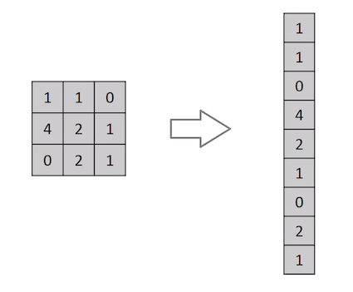

Fig.4.Flattening layer

F. FULLY CONNECTED LAYER
The fully-connected layer in a CNN is characterized by each node in this layer being connected to every node in the previous layer. Unlike the convolutional and pooling layers, which focus on specific regions, The output layer and the input pixels are not directly connected by the fully-connected layer. Features from the earlier levels are integrated with the corresponding filters in the fully linked layer, contribute to the classification task. This layer performs classification based on these features. Typically, a SoftMax activation function is employed in the fully-connected layer to assign appropriate categories to the inputs, resulting in probability values ranging from 0 to 1. In contrast, Convolutional layers as well as pooling layers frequently employ the ReLU activation function.
Figure 4 provides an illustration of the internal functioning of the fully connected layer, demonstrating its role in establishing connections between all nodes in the nodes in the layer below and the current layer. This connectivity facilitates the classification process.
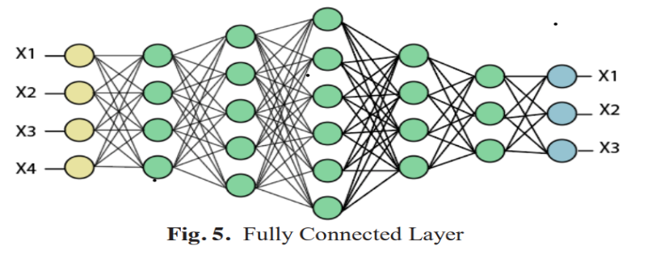

Fig.5. Fully Connected Layer

4.STEPS INVOLVED

1.Collect or obtain image data: The first step in human or animal detection is to obtain image data. This can be done by taking different datasets from the open source Kaggle. The datasets contain different poses of male and females, it also contains different types of animal images.
2.Required Libraries: Import the required libraries from the Jupyter Notebook like TensorFlow, OpenCV, keras tensor flow.
3.Loading Datasets: In the next step we load the datasets and we split the data for training and validation purpose.
4.Data preprocessing. We normalised each pixel's value as 0 and 1 and scaled all photos to a constant size of 48 × 48 pixels. We also apply filters to enhance the quality of the images.
5.Object Localization: We used CNN algorithm to find humans or animals from the given images. CNN uses a single neural network to predict the bounding boxes.
6.Feature Extraction: We extracted features from the bounding boxes using a deep convolutional layer (CNN). We used the last layer of CNN as our feature vector, which captures high-level features of humans or animals from the given image.
7.Model training: For the training of model, we use CNN model.
8.We used OpenCV and keras TensorFlow for image processing and also used for live camera to capture the live image.
9.Model evaluation: we will classify the given image as a human or animal, based upon the model accuracy. We also evaluate the accuracy of the training image versus given input image.
10.Deployment: Finally, the trained model can be deployed to perform human or animal detection on new images in real-time, such as in surveillance systems.

5.DATASETS USED

We used the male/female dataset, cats, dogs, elephant, lion datasets for our human and animal detection. The male/female dataset contains 20,000 images for both male and female class. The dataset of animal contains 10,000 images for each class labelled in 10 different categories like cat, dog, elephant, lion and etc. The dataset also includes key point detection.

The male/female dataset and animal dataset was collected using a variety of sources, including images from the google images and we also downloaded the datasets like male/female and animal datasets from the open source Kaggle. In our study, we focused on different images of humans and animals for our prediction.

Prior to analysis, we performed several preprocessing steps on the datasets, including image resizing, normalization, and feature selection. We used the CNN algorithm to detect humans and animal’s instances in the images, achieving accuracy of 0.94 and 0.82 for humans and animals respectively.
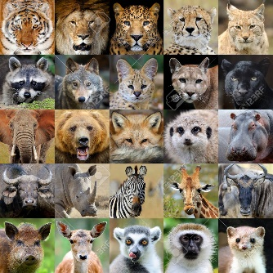
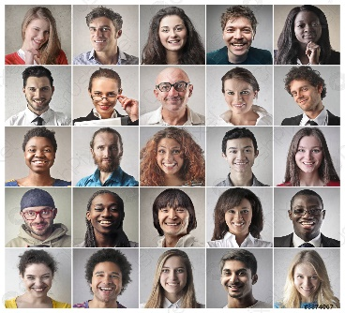

6.RESULTS

6.1. EXPERIMENTAL SETUP
We have used Jupyter notebook for creating this project. Jupyter application contains various built-in packages which are essential for building a experimental model and for the pre-processing of images. Mainly packages like keras.tensorflow and OpenCV can be used for implementing the project. It is comfortable with machine having minimum of 4GB RAM or above in implementing the project.

6.2.RESULTS
Coming up with best suited algorithm in developing model, we have used CNN algorithm which could able to provide best and accurate results. We have taken over 12000 images of each class for human and some animal categories. The resolution of each image was adjusted to 224x224 pixels and converted to grayscale to standardize the input.

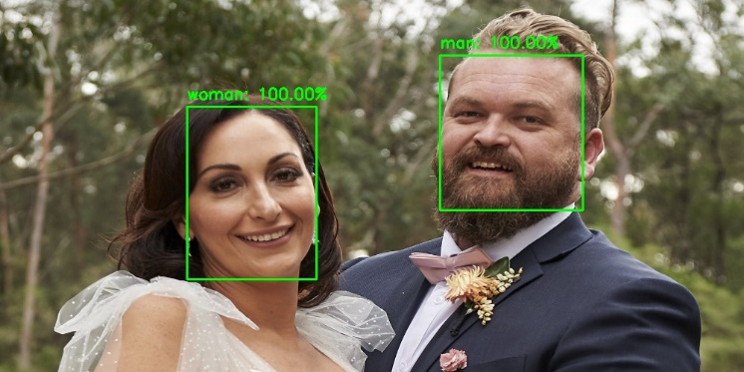
We have trained the model with different number of epochs and conclude the best model with count of nearly 80 epochs. Thus provides the model to provide the results accurately. Our model is capable of providing the results with an average accuracy of 95%.

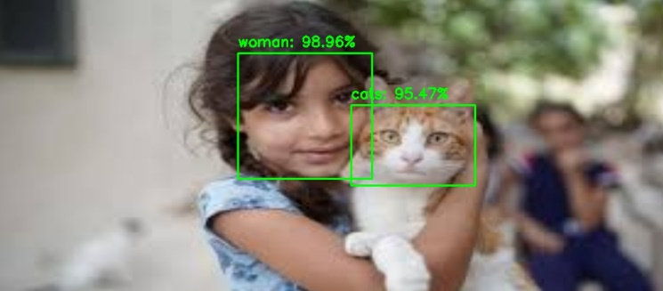

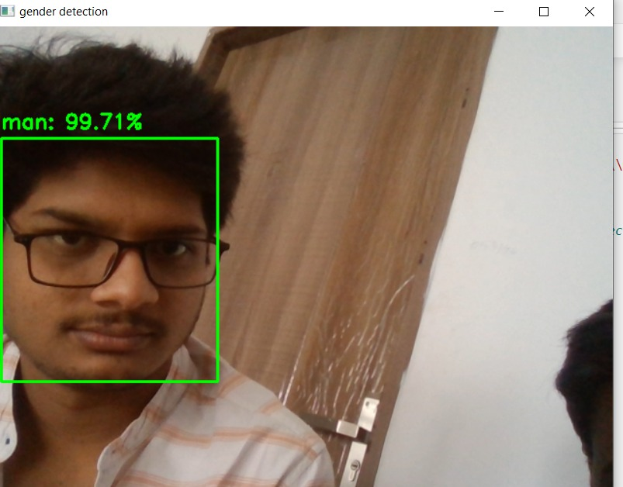

The above all images itself provides the accurate classification among humans and animals with the model we have built. The below graph gives the model accuracy rate and loss rate.
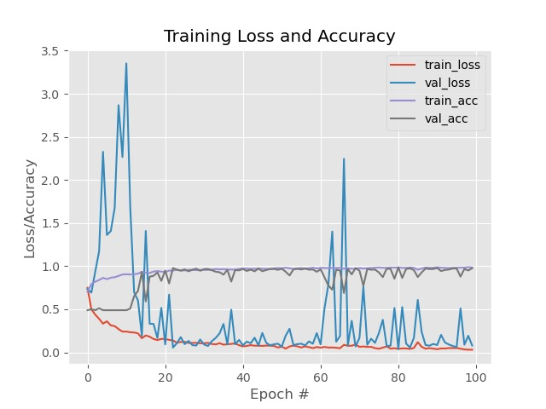

7.CONCLUSION

In summary, the effectiveness of Convolutional Neural Networks (CNNs) was investigated in this study. for classifying images into human and animal categories. The experimental findings provided evidence of the CNNs' ability to accurately distinguish between human and animal images, achieving a high level of precision and recall. The proposed CNN model exhibited superior accuracy compared to existing approaches, affirming its efficacy in accurately classifying images as either human or animal.

The utilization of a carefully designed CNN architecture, coupled with appropriate training techniques and data augmentation, contributed to the success of the classification model. The results showcased the potential of CNNs as a robust approach for image classification tasks, particularly in distinguishing between human and animal images. The inclusion of a comprehensive dataset, encompassing diverse instances of both human and animal classes, further enhanced the generalizability and reliability of the model.

The implications of accurate human or animal classification extend to various domains, including wildlife conservation, surveillance systems, and human-computer interaction. The ability to automate this classification process can significantly benefit these domains by facilitating data analysis, decision-making, and resource allocation.
In summary, this research paper contributes to the advancement of image classification techniques by showcasing the effectiveness of CNNs in the specific task of human or animal classification. The findings provide valuable insights for researchers, practitioners, and developers in the field of computer vision. Further research should focus on expanding the classification capabilities to include fine-grained species identification and addressing challenges associated with ambiguous instances. By continually refining and improving classification models, we can unlock new possibilities for image analysis and interpretation in various real-world applications.

8.REFERENCES

[1] G. Singh and A. K. Goel, "Face Detection and Recognition System using Digital Image Processing," 2020 2nd International Conference on Innovative Mechanisms for Industry Applications (ICIMIA), Bangalore, India, 2020, pp. 348-352, doi: 10.1109/ICIMIA48430.2020.9074838.

[2] M. Khan, S. Chakraborty, R. Astya and S. Khepra, "Face Detection and Recognition Using OpenCV," 2019 International Conference on Computing, Communication, and Intelligent Systems (ICCCIS), Greater Noida, India, 2019, pp. 116119.doi:10.1109/ISMAC52330.2021.9640896.

[3] R. Sharma, V. K. Sharma and A. Singh, "A Review Paper on Facial Recognition Techniques," 2021 Fifth International Conference on I-SMAC (IoT in Social, Mobile, Analytics and Cloud) (I-SMAC), Palladam, India, 2021, pp. 617-621, doi: 10.1109/I-SMAC52330.2021.9640896.

[4] K. Goyal, K. Agarwal and R. Kumar, "Face detection and tracking: Using OpenCV," 2017 International conference of Electronics, Communication and Aerospace Technology (ICECA), Coimbatore, India, 2017, pp. 474-478, doi: 10.1109/ICECA.2017.8203730.

[5] M. Sahu and R. Dash, "Study on Face Recognition Techniques," 2020 International Conference on Communication and Signal Processing (ICCSP), Chennai, India, 2020, pp. 0613-0616, doi: 10.1109/ICCSP48568.2020.9182358.

[6] D. Meena and R. Sharan, "An approach to face detection and recognition," 2016 International Conference on Recent Advances and Innovations in Engineering (ICRAIE), Jaipur, India, 2016, pp. 1-6, doi: 10.1109/ICRAIE.2016.7939462.

[7] J. Sikder, R. Chakma, R. J. Chakma and U. K. Das, "Intelligent Face Detection and Recognition System," 2021 International Conference on Intelligent Technologies (CONIT), Hubli, India, 2021,pp.1-5, doi: 10.1109/CONIT51480.2021.9498291.

[8] R. Subban and S. Soundararajan, "Human face recognition using facial feature detection techniques," 2015 International Conference on Green Computing and Internet of Things (ICGCIoT), Greater Noida, India, 2015, pp. 940-947, doi: 10.1109/ICGCIoT.2015.7380598.

[9] L. Li, X. Mu, S. Li and H. Peng, "A Review of Face Recognition Technology," in IEEE Access, vol. 8, pp. 139110-139120, 2020, doi: 10.1109/ACCESS.2020.3011028.

[10] S. Han, Q. Gao, C. Wang and J. Zou, "Animal face classification based on deep learning," 2021 2nd International Conference on Big Data & Artificial Intelligence & Software Engineering (ICBASE), Zhuhai, China, 2021, pp. 324-330, doi: 10.1109/ICBASE53849.2021.00067.

[11] Z. Cao, J. C. Principe, B. Ouyang, F. Dalgleish and A. Vuorenkoski, "Marine animal classification using combined CNN and hand-designed image features," OCEANS 2015 - MTS/IEEE Washington, Washington, DC, USA, 2015, pp. 1-6, doi: 10.23919/OCEANS.2015.7404375.

[12] B. Jiang, W. Huang, W. Tu and C. Yang, "An Animal Classification based on Light Convolutional Network Neural Network," 2019 International Conference on Intelligent Computing and its Emerging Applications (ICEA), Tainan, Taiwan, 2019, pp. 45-50, doi: 10.1109/ICEA.2019.8858309.

[13] W. Xue, T. Jiang and J. Shi, "Animal intrusion detection based on convolutional neural network," 2017 17th International Symposium on Communications and Information Technologies (ISCIT), Cairns, QLD, Australia, 2017, pp. 1-5, doi: 10.1109/ISCIT.2017.8261234.

[14] Dandil and R. Polattimur, "PCA-Based Animal Classification System," 2018 2nd International Symposium on Multidisciplinary Studies and Innovative Technologies (ISMSIT), Ankara, Turkey, 2018, pp. 1-5, doi: 10.1109/ISMSIT.2018.8567256.

