Premise Smart Baby Incubator

Mr. Vishwajeet Suryawanshi
Computer Science and Engineering
Dr.DaulatraoAher College of Engineering Karad, India
Vishwajeetsuryawanshi11@gmail.com

Prof. S. P. Shinde
Computer Science and Engineering
Dr.DaulatraoAher College of Engineering Karad, India
spshinde.cse@dacoe.ac.in
Mr. Rajsingh Jadhav
Computer Science and Engineering
Dr.DaulatraoAher College of Engineering Karad, India
Rajsinhjadhav4411@gmail.com

Mr. Rohan Kadam
Computer Science and Engineering
Dr.DaulatraoAher College of Engineering Karad, India
Kadam7.rohan12@gmail.com

ABSTRACT
In the era of Industry 4.0, domestic baby incubator manufacturers are challenged by the competition from foreign products that utilize IoT technology for innovation. However, the NICU units in hospitals lack facilities for parents to directly monitor their baby's condition inside the incubator, presenting an opportunity for improvement. The purpose of this project is to create a prototype of an internet-based baby incubator monitoring system that utilizes sensors to send real-time data to a server and mobile app for parental monitoring, including the ability to capture the baby's voice. This study focuses on the development of baby incubators equipped with artificial intelligence to interpret the baby's crying.

Mr. Daud Mulla
Computer Science and Engineering
Dr.DaulatraoAher College of Engineering Karad, India
Daudmulla08@gmail.com

Keywords: —Internet of Things (IoT), Neonatal Intensive Care Unit (NICU)

INTRODUCTION
A smart baby incubator is a high-tech device that provides a controlled and safe environment for new born infants who require medical attention. It is equipped with various sensors that monitor temperature, humidity, oxygen levels, and vital signs, ensuring that the baby is in a stable and comfortable environment that promotes healthy development. In recent years, there has been a growing interest in developing smart baby incubators due to the increasing number of premature births and the need for better care for these vulnerable infants. Smart baby incubators provide a range of benefits over traditional incubators, including improved safety, customized environments, early detection of health problems, remote monitoring, improved efficiency, data-driven decision-making, and improved health outcomes for new-borns.
This project aims to develop a smart baby incubator that can provide these benefits and more. By using state-of-the-art sensors and control systems, the smart baby incubator will be able to monitor vital signs, adjust its settings based on the baby's needs, and provide real-time feedback to medical staff or parents. This project will also incorporate machine learning algorithms to analyse the data collected by the sensors, enabling early detection of health problems and customized care for each baby.
The development of a smart baby incubator project has the potential to revolutionize the way we care for new-borns, providing improved health outcomes and a better quality of life for infants and their families.
LITERATURE REVIEW
Preterm infant care is a crucial and sensitive field in biomedicine due to the increased risk of illness and mortality in babies with low birth weight and gestational age. For these babies, an environment similar to that of the womb is necessary to provide the necessary support. An incubator is designed to create such an environment by regulating temperature, humidity, and light levels. To ensure the best care for preterm babies, it is important to monitor and maintain these parameters, and in case of emergency, the alarm system and GSM technology can alert parents. This is according to Kale et al. (2018). [1-4]
The primary goal of this project is to develop a closed-loop control system that utilizes LEDs to regulate the temperature, relative humidity, and light intensity within the incubator in order to prevent complications. The system was built using Arduino and Pulse Width Modulation and has the advantage of being simple to implement due to its compact components and small size. However, it is limited in that it can only control temperature and humidity and does not provide notifications.
Sivamani D, et al. (2018) addressed the design of a cost-effective embedded device for real-time monitoring of newborns in the incubator. In a smart incubator, doctors and nurses can access a child's medical data through mobile phones or computers from any location that has internet access to cloud storage. The smart incubator continuously monitors the newborn and sends medical data directly to cloud storage, where it is stored. This approach allows for close monitoring of changes in health parameters and provides precise values for doctors to easily assess the baby's health and prevent future health issues. Its advantage is the ability to monitor and maintain a safe environment for the newborn, while its disadvantage is the limited display capability of only showing the value on the LCD and sending a message to the phone.
PROPOSED SYSTEM
Sr.no | Controlled parameter | Parameter Value
1 | Air Temperature | 20-30 degree celsious
2 | Baby  Temperature | 34-38 degree celsious
3 | Humidity | 30-60 %
The proposed baby incubator aims to maintain the same environmental conditions that the baby experienced in the mother's womb. The temperature

Table 1: Controllable Parameter

is adjusted to a few degrees of Fahrenheit, depending on the baby's age. A heater is used to raise the temperature inside the incubator if it falls below the required temperature. An LED indicates when the heater is active. The incubator's temperature increases when the baby's body temperature increases, and a fan turns on to lower the temperature inside the incubator when the set value is
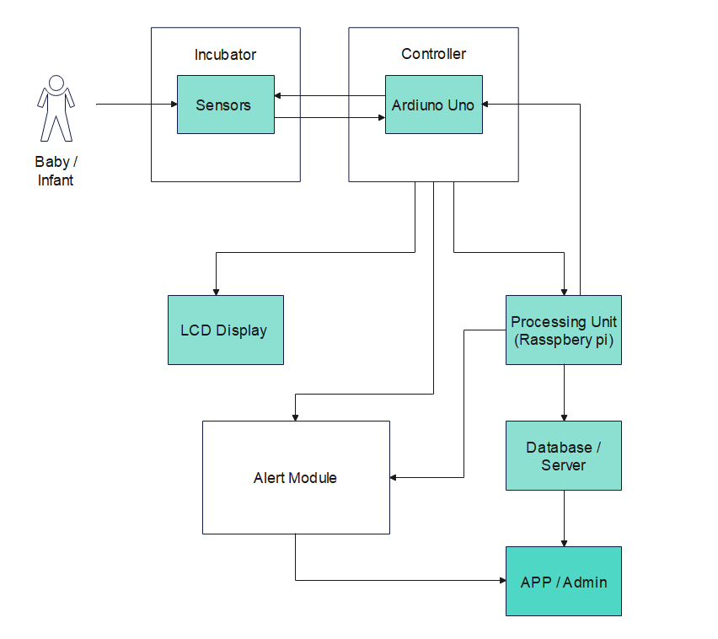
and sweating of the baby during inappropriate conditions is noted. Respiration is critical, and some babies require external help for breathing. Nasal cannulas, CPAP, and ventilators are three methods of providing external breathing support. An oxygen hood is used to measure the breathing rate of the baby. The baby's heart rate is continuously monitored, and a sensor detects movement. A LCD displays the temperature, heart rate, breathing rate, sweating indication, movement indication, and humidity level. A web server displays all these values, allowing doctors to monitor the baby continuously. movement indication, and humidity level.
Benefits | Features
Protection | Self-checking
Easy to use | Lamp illumination
Durable | Noise reduction
Lightweight | Mobile  application

TOOLS
Arduino UNO :

Arduino is a platform for prototyping that is open-source, and its simplicity makes it suitable for hobbyists or professionals, as well as novice users. The Arduino Uno has a 16 MHz crystal oscillator, a USB connection, a power jack, an ICSP header, and a reset button, as well as 14 digital input/output pins. To get started, simply connect it to a computer using a USB cable or power it using an AC-to-DC adapter or battery. The Uno R3, shown in the figure of an Arduino board, also has SDA and SCL pins adjacent to the AREF.

Table 2: Features and Benefits

There are two newpins near the RESET pin as well.

One is the IOREF, which allows shields to adjust to the board's supplied voltage. The other is reserved for future purposes

and is not connected. The Uno R3 is compatible with all existing shields, but it can adapt to new shields that use these additional pins.
Features of the Arduino UNO:
- Microcontroller: ATmega328P
- Operating Voltage: 5V
- Input Voltage: 7-12V
- Input Voltage: 6-18V
- Digital I/O Pins: 14 (of which 6 provide PWM output)
- Clock Speed:16 MHz
Relay :
A relay is a switch that is controlled by an electrical signal and is used to manage the flow of electricity within a circuit. Here are some key features and information about relays:
Construction: A relay consists of a coil, an armature, and one or more sets of contacts. The coil is energized by an electrical signal, causing the armature to move and close or open the contacts.
Types: There are many different types of relays, including electromechanical, solid-state, and reed relays. Each type has its own advantages and is suited for different applications.
Applications: Relays are used in a wide range of applications, including industrial control systems, automotive electronics, home automation, and more. They can be used to switch high currents or voltages, or to isolate one part of a circuit from another.
Advantages: Relays offer several advantages over other types of switches, including isolation between the control and load circuits, low power consumption, and the ability to switch high currents or voltages.
Limitations: Relays have some limitations, such as limited switching speed, susceptibility to mechanical wear and tear, and the need for a separate power supply to energize the coil.
Control: Relays can be controlled by a variety of sources, including microcontrollers, switches, sensors, and other electronic devices.
Relays are a versatile and widely used component in electronics, offering a reliable way to control the flow of electricity in a wide range of applications. They are easy to use, highly customizable, and available in a range of sizes and configurations to suit almost any need.
DHT 11 Sensor:
The DHT11 is a low-cost digital sensor capable of measuring temperature and humidity, and it can be conveniently connected to microcontrollers like Arduino and Raspberry Pi for real-time readings. It is available in two forms: a standalone sensor and a module that includes a pull-up resistor and an LED for power indication. The DHT11's humidity sensing element uses a capacitive humidity sensor and a thermistor to determine the surrounding air's humidity and temperature, respectively. The moisture-holding substrate within the capacitor functions as the dielectric between its two electrodes, resulting in a capacitance value change proportional to the humidity levels. The resistance values are then measured and processed by the IC in the DHT11 to convert them to digital form. Meanwhile, the DHT11 uses a Negative Temperature Coefficient thermistor to measure temperature, which has a reduced resistance value as the temperature rises. The thermistor, which is made of semiconductor ceramics or polymers, is designed to provide high resistance even for minor temperature changes.

Algorithm:
Step -1: Begin by measuring the temperature, humidity, and oxygen levels of the incubator using sensors.
# Set the desired temperature and humidity
Desired temp = 37.5 # Celsius
Desired humidity = 60 # percent

Step -2:Record the values and compare them to the recommended levels for a newborn baby.
# Read the current temperature and humidity
Current temp = read temperature()
current humidity = read humidity()

Step-3: If any of the levels are outside the recommended range, adjust the temperature, humidity, or oxygen levels using the incubator's heating, cooling, or ventilation systems.
# Control the temperature
if currenttemp < desiredtemp:
turnonheater()
elif currenttemp >desiredtemp:
turnoffheater()
# Control the humidity
if currenthumidity < desiredhumidity:
turnonhumidifier()
elif currenthumidity > desiredhumidity:
turnoffhumidifier()

Step-4: Monitor the baby's vital signs, such as heart rate, respiratory rate, and oxygen saturation, using sensors attached to the baby's body.
Step-5: If any of the vital signs fall outside the recommended range, alert the medical staff or parents via a visual or audible alarm system.
Step-6: Maintain a log of all vital sign readings and incubator settings for future reference and analysis.
Step-7: Use machine learning algorithms to analyze the data and identify patterns that could indicate potential health problems in the baby.

Step-8: Provide real-time feedback and recommendations to medical staff or parents based on the data analysis.
Step-9: Use remote monitoring and communication technologies to enable medical staff or parents to monitor the baby's progress and communicate with the incubator's control system from a remote location.
Step-10: Implement security measures, such as encryption and authentication, to ensure the safety and privacy of the baby's data and control system

RESULT
The result of implementing a smart baby incubator project would be a state-of-the-art incubator that provides a safe and comfortable environment for new born babies. By using sensors to monitor temperature, humidity, oxygen levels, and vital signs, the incubator can adjust its settings to maintain optimal conditions for the baby's health and development.
The machine learning algorithms used to analyse the data collected by the sensors could provide valuable insights into the baby's health and help medical staff or parents detect potential health problems early on. Real-time feedback and recommendations based on the data analysis could also help prevent health problems before they occur.

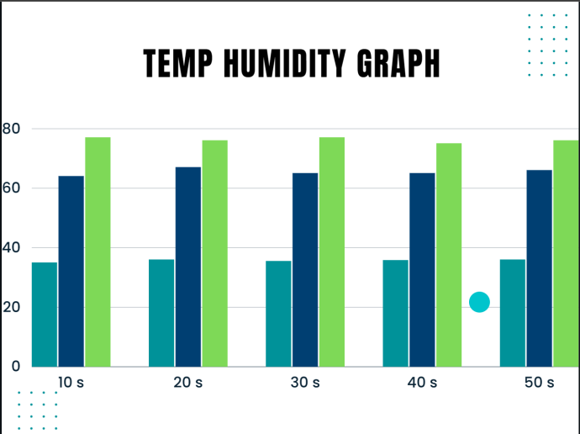

Remote monitoring and communication technologies would enable medical staff or parents to keep a close eye on the baby's progress, even when they are not physically present. The security measures implemented in the control system would ensure the safety and privacy of the baby's data and control system.
Overall, a smart baby incubator project would represent a significant advance in neonatal care, providing improved health outcomes for new born babies and peace of mind for their families and medical staff.

ADVANTAGES:
- Improved safety: A smart baby incubator uses sensors to monitor temperature, humidity, oxygen levels, and vital signs, which reduces the risk of errors in manual monitoring.
- Customizable environment: The smart baby incubator can adjust its settings based on the baby's needs, providing a comfortable and stable environment that promotes healthy development.
- Early detection of health problems: By monitoring vital signs and using machine learning algorithms to analyze the data, potential health problems can be detected early, allowing for prompt medical intervention.
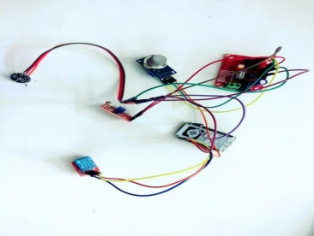
- Remote monitoring: The smart baby incubator can be monitored remotely, which allows parents or medical staff to keep an eye on the baby's progress even when they are not physically present.
- Improved efficiency: The automation of the incubator's control system reduces the workload for medical staff, allowing them to focus on other aspects of patient care.
- Data-driven decision-making: The data collected by the sensors and analysed by the machine learning algorithms can be used to make informed decisions about the baby's care.
- Improved outcomes: A smart baby incubator project can lead to improved health outcomes for new-borns, including reduced mortality rates and decreased risk of complications.
Previous Incubator | Current Incubator
Bulky | Lightweight
Complicated | Easy To Use
Output Show On Small LED Panel | All The Readings User Can see On Adroide Application

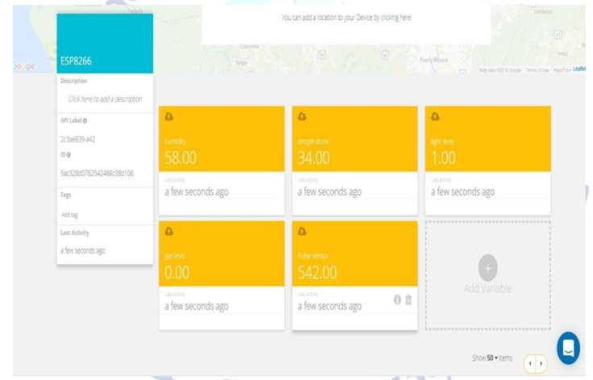
Output Screenshots-

Fig: GUI of Application

Fig :circuit diagram

CONCLUSION –
The real-time monitoring and control-based neonatal incubator proposed in this study is capable of detecting and monitoring changes in the environment surrounding the incubator such as pulse rate, temperature, humidity, light, and gas values. This is done through the use of various sensors including the pulse rate sensor, temperature and humidity sensor, light sensor, and gas sensor. The information gathered by these sensors is then sent to the microcontroller and Arduino UNO which in turn alerts the caregivers or medical professionals via IoT. The aim of this system is to prevent any unexpected accidents or deaths that may occur due to inadequate monitoring of the incubator. However, despite the monitoring of essential parameters, there remains an issue of excessive noise exposure in the Neonatal Intensive Care Unit (NICU). Therefore, changes need to be made to the The real-time monitoring and control-based neonatal incubator proposed in this study is capable of detecting and monitoring changes in the environment surrounding the incubator such as pulse rate, temperature, humidity, light, and gas values. This is done through the use of various sensors including the pulse rate sensor, temperature and humidity sensor, light sensor, and gas sensor. The information gathered by these sensors is then sent to the microcontroller and Arduino UNO which in turn alerts the caregivers or medical professionals via IoT. The aim of this system is to prevent any unexpected accidents or deaths that may occur due to inadequate monitoring of the incubator. However, despite the monitoring of essential parameters, there remains an issue of excessive noise exposure in the Neonatal Intensive Care Unit (NICU). Therefore, changes need to be made to the behavior of the NICU to minimize noise exposure. Additionally, the impact of Electromagnetic Fields (EMF) on the health of preterm babies remains unclear, hence future incubator designs should aim to minimize both noise and EMF exposure to the neonate

FUTURE ENHANCEMENT
There are certain improvements required for following:
The future work is focused on the implementation of the monitoring system to monitor all the pathological parameters of infants in all the hospitals with common physician/consultant.
If there will give a particular set point for different parameters, the controller will automatically on if the measuring value goes below the set value and the controller will automatically off if the measuring value goes high compare to the set value.
There is also a possibility of replacing the power source by solar cell. In rural area there is a big problem in supplying of electricity. So this problem will also overcome in future implementations.
Integration with electronic medical records: Integration with electronic medical records would allow medical staff to access and track the baby's health data in real-time, improving communication and coordination between healthcare providers.
Integration with wearable devices: Integrating wearable devices such as smartwatches or fitness trackers could enable the smart baby incubator to monitor additional vital signs or biometric data.
Artificial intelligence-based diagnosis: Using artificial intelligence algorithms to analyze the data collected by the sensors could lead to faster and more accurate diagnoses of health problems.
Smart alert system: The smart baby incubator could be designed to send alerts to medical staff or parents when a critical health parameter goes beyond the threshold, providing early warning of potential health issues.
Virtual reality therapy: Incorporating virtual reality technology into the smart baby incubator could provide a soothing and calming environment for the baby, which could help with pain management and reduce stress.
Voice-activated control: Incorporating voice-activated control could allow medical staff or parents to adjust the incubator settings without having to touch it, reducing the risk of contamination and improving convenience.
Integration with telemedicine: Integrating telemedicine capabilities could enable medical staff to remotely consult with parents or other healthcare providers in real-time, improving access to care and reducing the need for transport.
REFERENCES
[1] Saikat Sahoo, BiswajeetChampaty, Kunal Pal, Sirsendu S Ray “Wireless transmission of alarm signals from baby incubators to neonatal nursing station”, 10.1190/ACES.2014.6808003, May2014.

[2] Simbruner, G., E. M. Ruttner, A. Schulz, and K. Perzlmaier. “Premature infants are less capable of maintaining thermal balance of head and body with increases of thermal environment than with decreases”. Am. J. Perinatol. 22:25–33, 2005.

[3] AlexandruArchip, Nicolae Botezatu, Elena Serban, Paul CorneliuHerghelegiu and Andrei Zala, “An IoT based system for remote patient monitoring”, 10.1109/CarpathianCC.2016.7501056, Jun2016.

[4] Shin, D.I., Huh, S.J., Lee, T.S., Kim, I.Y., “Web-based remote monitoring of infant incubators in the ICU”, International Journal of Medical Informatics vol. 71 issue 2-3 September, 2003. pp. 151-156.

[5] Freddy Jiménez and Romina Torres, “Building an IoT-aware healthcare monitoring system”, 10.1109/SCCC.2015.7416592, Nov2015.

[6] L. Nachabe, M. Girod-Genet, B.ElHassan, and J.Jammas, “M-health application for neonatal incubator signals monitoring through a CoAP-based multi-agent system”, 10.1109/ICABME.2015.7323279, Nov2015.

