Design and Development of an EOG-based System to Control Electric Wheelchair for People Suffering from Quadriplegia or Quadriparesis
¹Mrs.S.Usha , ²M.Nithish , ³B.Padmesh , ⁴M.Sivaganesh
¹Assistant Professor, ^{2,3,4} Student
Department of Electronics and Communication Engineering
Paavai Engineering College, Namakkal,637018

s.ushasp1@gmail.com,nithishsmart39@gmail.com,padmeshbalaji179@gmail.com,msivaganesh0202@gmil.com

Abstract— Even in this modern day, it is very difficult for physically challenged people to move from one place to other without others help. To give them an independent feel, a smart eye controlled system is provided. A novel design of an embedded cardio-respiratory monitoring system for wheelchair users is proposed. This system gets the input from from eye. The movement of the wheel chair will be controlled by these inputs. Depending on these input the wheel chair will move forward, left, right or backward. With the help of this system the user can move independently without others help. It also included with obstacle detection system to ensure the safety for the user. If any obstacle is detected then the indication can be given with the help of LCD.The entire system is composed of a sensor node, and a cloud server. The former is used to obtain continuous vital-sign signals, and the latter processes the sampled signals to estimate the temperature level, implemented in an embedded system to achieve a fully integrated radar system. This is used to sense the movement of the eye ball’s direction using eye ball sensor (Straight Command, Left/Right Command, Stop Command). The system is cost effective and thus can be used by patients spread over a large economy range

Keywords-LCD, Arduino, DC motor, eyeball sensor, Wheelchair.
I. INTRODUCTION
This project is an attempt to make lives of the people suffering from this phenomenon simple and by simpler which will thereby reinstate their confidence and their happiness. The idea is to create an Eye Monitored System(EMS) which allows movement of the patient’s wheelchair depending on the eye movements. We know that a person suffering from quadriplegia can partially move his eyes and tilt his head, thus presenting an opportunity for detecting those movements. We have created a device where a patient sitting on the Wheel Chair assembly looking directly at the eyeball sensor, is able to move in a direction just by looking in that direction. The signals are monitored by a script, which will then guide the motors wired to the ATmega328 Microcontroller over the Serial Interface to move in a particular direction. The system is cost effective and thus can be used by patients spread over a large economy range. This project makes use of microcontroller, which is programmed, with the help of Embedded C instructions. It provides the information to the microcontroller and the controller judges whether the instruction is right movement or left movement instruction and controls the direction respectively. The controller is interfaced with two dc motors to control the direction of the wheel chair. To perform the task the controller is loaded with intelligent program written using Embedded C language.

II. LITERATURE SURVEY
A smart wheelchair (SW) is a power wheelchair (PW) to which computers, sensors, and assistive technology are attached. In the past decade, there has been little effort to provide a systematic review of SW research. This paper aims to provide a complete state-of-the-art overview of SW research trends. We expect that the information gathered in this study will enhance awareness of the status of contemporary PW as well as SW technology and increase the functional mobility of people who use PWs. We systematically present the international SW research effort, starting with an introduction to PWs and the communities they serve. Then, we discuss in detail the SW and associated technological innovations with an emphasis on the most researched areas, generating the most interest for future research and development. We conclude with our vision for the future of SW research and how to best serve people with all types of disabilities. Overall, past studies have successfully achieved initial technological advancements that aid PW users in their daily activities. Nevertheless, there is little assistive technology included in the wheelchair to make it “smart,” which is the goal of research on integrating “intelligent” technology on a PW, called “SW.” Medicare prescription guidelines limit PWs to those individuals who cannot use a manual wheelchair. But many more people would benefit from a PW and often resort to less expensive generic solutions that often do not meet the needs of the individual and their particular disability. Some people with quadriplegia end up making major modifications to their own wheelchairs in order to have additional safety measures, like lights or reflectors, rear-view cameras, and assistive technology to use as an input method for computing. SWs represent a paradigm shift unlike the one that occurred when PWs became available on a mass scale, which was a technological advancement from the manual wheelchair. In the last decade, sensors and computers have gotten faster, cheaper, and smaller, while computer vision software has become more sophisticated and readily available than ever before. The research community has developed many prototypes, the best parts of which should be fused into a modular upgradable system that can be marketed to the millions of people who need PWs. Electric vehicle manufacturers are in a prime position to produce a stand-alone SW and capitalize on the millions of aging Baby boomers worldwide, who will want to have an SW. We discuss in detail the SW and associated technological innovations with an emphasis on the most researched areas.[1] The sudden loss of motor and/or cognitive capabilities as well as chronic or degenerative impairment can induce permanent handicaps. Disabling conditions have thus to be carefully considered to preserve or provide people independence and autonomy. In particular, it has been shown that autonomy and dignity are strongly linked. The ability to freely move remains then a fundamental need for well-being and living well at home. Moreover, maintaining this capacity prevents from affecting the mental condition. In this context, assistive robotics for mobility purposes are closely in relation with personal living assistance major issues. Autonomous or semiautonomous wheelchair navigation has been widely studied in the literature. A semi-autonomous navigation system refers to cooperation between the user and the robotic system. The idea is then to provide an aid for navigation that improves the ease to steer the wheelchair and thus leads to reduce fatigue sensation. To maximize the acceptability of the assistance solution, this assistance has to be adaptively activated only when necessary and to be deactivated as soon as the user wants to act by himself. As a consequence, the control process has to be designed as a man-in-the-loop scheme where the user remains the leader of the navigation process. Different solutions have been already proposed in this context. They typically rely on the partial or global knowledge of the environment. We here aim at designing a control system that performs in an unknown environment We consider the wheelchair as a six-wheel robot that moves on a horizontal plane. Two differentially actuated wheels are located at the middle of the robot body. Additional two passive caster front wheels and two passive caster rear wheels are also required. A wheelchair can be modelled as a unicycle robot, thus matching nonholonomous constraints. The two control variables related to the wheelchair are then the translation velocity u along its forward/backward direction and the angular (steering) velocity ω. Figureure 1 depicts the different cartesian frames considered in this modelling. Fg(O, xg, yg, zg) represents the world frame and Fr(PO, xr, yr, zr) is a frame of the wheelchair attached on the middle of the segment formed by the centers of the two differentially actuated wheels. We define Fc(C, xc, yc, zc) as the camera frame that is rigidly fixed to the wheelchair, where C represents the optical center. The image frame is defined by FI (I0, X, Y ) where I0 is the center point of the image. Relatively to Fg, the robot state coordinates are given by q = (x, y, φ) where x and y denote the Cartesian position of the robot, and φ ∈ [−π, π] corresponds to the angle between the driving direction of the wheelchair and the x-axis of the world coordinate frame. In short, φ corresponds to the heading angle defined as the positive counterclockwise orientation of the wheelchair with respect to xg axis. The optical center of the camera is positioned on the wheelchair in such a way that we observe a translation vector c tr = (cw, 0, −cl). The distance between the floor and the camera optical center is equal to ch. Preserving the autonomy and the mobility is essential for disabled people well-being. In this paper, we proposed a semi-autonomous system designed for safe wheelchair navigation along corridors. This control system relies on the combination of two tasks: first the manual steering and second wall avoidance task obtained by a dedicated visual based servoing approach. The idea is then to correct the trajectory indicated by the patient by servoing only the necessary degrees of freedom. Experiments have been conducted over corridors that present different conFigureurations and illumination conditions. Results demonstrate the ability of the system to smoothly and adaptively assist people during their motions.[2] Electric wheelchair is an important means of transport for handicapped and aged people. Although there are many people suffering from severe loss of motor function due to variety of accidents or diseases such as a Spinal Cord Injury (SCI) or Amyotrophic Lateral Sclerosis (ALS), the development of wheelchairs for paralyzed users is surprisingly recent starting with conventional manually powered wheelchairs and advancing to electrical wheelchairs. Conventional wheelchair user tends to focus exclusively on manual use which assumes users still able to use their hands which excludes those unable to do so. Conventional joystick controlled powered wheelchairs, are inappropriate for some categories of disabled people, especially, the disabled people with the high-level spinal cord injury, and quadriplegia. As an alternative to the joystick control, various input interfaces such as voice recognition and vision recognition has been implemented. Another possible human machine interface is the use of nonverbal information such as biopotential signals, including electrooculographic (EOG), electromyographic (EMG), and electroencephalographic (EEG) signals. Many studies have focused on using EMG signals for the humanmachine interface. The EOG signal is also exploited as a mode of the interface in some cases. It would be ideal if such biopotential signals could be used in an interface; however, there have been certain problems when using the signal unimodally. The developed EMG system consists of disposable biopotential electrode as sensor, an eight-channel pre-amplifier module which measure and amplifies the EMG signal, ATMEGA8 processor for data acquisition, high speed USART module for real time serial transmission, a digital isolator unit and a computer with visual studio platform for signal filtering, processing and display. Signal is filtered and processed to extract root mean square value in visual studio platform. Special USART serial transmission provides bandwidth of about 3 Mbps along with a digital isolator which provides noise isolation arising due to serial connection with electronic circuitry. Difficulties lie in signal extraction due to very small voltage of about few micro volts, very high input impedance of human skin, signal distortion by noise, motion artifacts and real time processing. In designs available, bulky size and high power consumption makes the system quite unfit for use in wearable system for prosthetic use, gait analysis etc. Also there are bandwidth limitations which limits the number of channels to be accessed simultaneously and distortion due to noise from connected electronic circuitry. We have successfully implemented joystick and EMG control signals to drive a homonymic mobile robot platform. In next stage neural network technique will be implemented for adaptive thresholding of different muscles. Incorporation of neural network will remove the muscle fatigue related problems. Dynamic analysis of the Omni robot will also be analyzed and friction and wheel slip response will be modeled. Autonomous navigation and intelligent path planning algorithms will be implemented. Robots localization in the arena has been done with an overhead mounted webcam and a special augmented reality based marker.[3] Semi-autonomous wheelchair technologies have the potential to improve the quality of life for millions of handicapped individuals throughout the United States who are limited in mobility. Equipped with a suite of range-finding and visual sensors, these wheelchairs are fully capable of navigating and mapping indoor and outdoor environments without requiring human intervention. Through the use of semi-autonomous wheelchairs, a wide variety of handicapped individuals would be able to live more independent lifestyles and experience higher levels of self-esteem and personal empowerment. For individuals who are limited in mobility and in need of more capable rehabilitative technologies, semi-autonomous wheelchairs could be the solution. Semi-autonomous rehabilitative technologies fall under the domain of human-in-the-Ioop cyber physical systems (HiLCPS. An inherent characteristic of these systems is shared control between the human operator of the system and the system itself. Several research questions have emerged from this concept of a shared autonomy framework: "Who takes the control of the system, human or machine, and when?", "Under what circumstances, a decision is overridden by the human or by the machine?", and "How does the human-inthe-Ioop CPS decide on the level of autonomy in an adaptive way?". Authors present shared control architectures for brain-computer interface (BCI) control of semi-autonomous wheelchairs. The control framework is designed to keep as much authority with the users as possible, while the shared controller couples the intelligence and intent of the user with the precision of the machine, enabling both experienced and inexperienced users to safely complete navigation tasks. A distinct characteristic of the modules being designed is that they are easy to assemble and mount onto a given powered wheelchair, granting the ability for someone with a specified level of skill to assemble the system in a relatively short amount of time. To meet this requirement, modularity became a major theme for the project, which all developments followed. Since the wheelchair needed sensors, a sensor network was developed, allowing them to connect over a standardized interface to the main controller. Sensor modules could be any combination of sensors and processors, as long as they used the specified interface. All sensors also needed to have a standard communication protocol, so any sensor could be plugged in to the network, and the controller would understand the data without any reconFigureuration. While testing a semi-autonomous wheelchair system it is often beneficial to be able to rapidly interchange or relocate sensors to compare performance. Unfortunately, the process of reconFigureuring sensor suites is rarely trivial, often requiring new mounting hardware and over-complicated modifications to source code. The project presented in this paper offers a unique solution to this problem through the use of a headrest sensor and hardware mounts, as well as circuitry developed as part of a sensor network. To facilitate the collection of data across a large number of sensors, a sensor network was developed which allowed for effIcient routing of large amounts of data and also reducing the number of wires routed to the main controller. This network abstracts away the details of the individual sensors and allows many types of data to be received by the controller. Although the physical structure of commercially powered wheelchairs varies greatly from one design to the next, modular mounting devices where developed that abstract these differences, emphasizing simplicity and ease of use. Odometry data collected through the use of a mechanical wheel-on-wheel encoder mount which measures the wheelchair's wheel velocity through contact with a small wheel that is coupled to a quadrature encoder. The sensor packages are used for the semi-autonomous navigation of a powered wheelchair, the sensor network presented has the potential to be used in a number of different robotic applications.[4] Wheelchair is one of the most commonly used assistive devices for enhancing the personal mobility of people with disabilities. According to the World Health Organization an estimated 1% of the world's population or just over 65 million people need a wheelchair. Over 6.1 million people in India have movement related disability. For physically challenged and elderly people independent mobility is vital. They often require some assistance to perform their daily routine . A means that can provide them independent locomotion may help in making them self-sufficient. A wheelchair is one such means; it serves as an aid to such people and helps them perform their daily work without other’s assistance. In today’s fast world people don’t have much time for others thus, physically challenged and elder people need to be self-sufficient in performing their work. Our multipurpose wheelchair is designed in a way that it can help elderly, physically challenged and visually impaired persons also. The subsystem consists of a small navigation pad which can be either tied to wrist or to head. On tilting the pad in the desired direction of motion, the chair moves accordingly. The readings of x and y-axis are taken from the accelerometer and are compared against upper and lower limit, if they lie within the threshold, action is performed. This process also prevents motion of the chair due to abrupt high readings obtained from the accelerometer due to its accidental jerking. The table below shows the upper and lower threshold for the readings used in the prototype. This subsystem deals with monitoring of the location of wheelchair in a building. The subsystem is built using active RFID technology. Active RFID tags are placed in the building at locations where voice assistance is vital such as near stairs, doorways or at junctions where different paths lead to different places. RFID receiver is attached to the wheelchair, when the receiver comes in the range of a tag; it gets the unique ID of the tag which is passed on to the microcontroller. Voice guidance system is meant for guiding visually impaired persons. It consists of an MP3 player which is interfaced to the microcontroller. MP3 player has preloaded audio clips. While moving in a building when the wheelchair encounters an RFID tag, its unique ID number is received by microcontroller and it then sends signals to MP3 player to play a particular audio clip which gives the information about the surrounding environment at that place. User listens to the clip through headphones and can easily know where he is and the possible places where he can go. The proposed system is aimed towards the welfare of not only physically challenged but also visually impaired and elderly people. The system has proven to be of simple implementation and cost effective. The results obtained clearly imply that the system is easy to handle by the patients. The system is equipped with accelerometer for the movement of the chair and ultrasonic sensors for obstacle detection. Voice guidance system of the chair guides the user through the way at each and every instant. Thus, proposed system is a realistic, efficient and a good way to assist the daily needs of the person in need. It also has obstacle avoidance system comprising of four ultrasonic sensors, real time location tracking system which makes use of RFID for tracking the chair inside a building and voice guidance system to assist the visually impaired.[5] The most common image of disability is the people in wheelchairs. Wheelchairs are used by people who find themselves unequipped to move without external aid. The special needs of the elderly may differ from that of a physically challenged person or a large individual but they all have “special needs” and often require some assistance to perform their daily routine. The required assistance may be due to ageing, physical limitations, medical conditions or other issues. The physically challenged people who use a normal wheelchair for navigation, usually requires an external person to move around. In this busy world, the elderly people may be left alone at home and also may not find an apt person for external help. Here comes the need of an automated home navigation system, which consists of a wheelchair which can be used by the elderly and the physically challenged people without the help of an external person. The proposed IHNS can be operated using voices which is recorded into it. Studies have shown that the elderly people forget the path to the different rooms in the home due to ageing. This problem is also dealt in IHNS as it navigates automatically. Today’s world comprises of a large variety of people. Some of them depend on others for their living. But in today’s fast world, everyone is busy and there are less people to care for the increasing number of elderly and the physically challenged people. Also these people find it tough to even navigate inside the home without external aids. The elderly people find automated wheelchairs as an easy way for locomotion. Having known about these facts, our aim was to bring an automated navigation system which can be used by both – the elderly and the physically challenged people in a user-friendly manner using voices for operation. When the voice for a specific room is detected then the line detection module is activated.. If obstacle is detected then it takes left and moves in straight line until it detects the line. If the line is detected then the wheelchair follows the line till it receives any signal from IR TSOP. By analyzing the data received from the TSOP the system determines if the destination is the particular room in the house dictated by the voice and then enters the room and stops. The received data from TSOP is compared with the predetermined data bits stored in the system, which denote the destination room and checks if there is a match. If there is a match, the wheel chair enters the room and stops. If it is a mismatch, the line is again followed until the destination room is reached. The hardware setup of the proposed IHNS is The real time testing of the demo wheelchair was done and the response time of the system upon recognition of proper voice was calculated. We calculated the response time of the Arduino assuming that the digital outputs from the voice recognition module was received. Upon receiving the commands, the Arduino board controls the motors to move in the intended direction. The Arduino uses ATmega168 microcontroller as its core. It has 14 digital I/O pins, 6 analog inputs, 16 MHz crystal oscillator, a USB connection and a power jack. It can transmit and receive TTL serial data. It also has SPI and I2 C interfaces. The Arduino board can be powered up using USB in standalone mode. The wheel chair can automatically navigate from one point to the other in the home as per predefined route based on the voice received.[6] The goal of the Wheelesley project is the development of a robotic wheelchair system that provides navigational assistance in indoor and outdoor environments, which allows its user to drive more easily and efficiently. A robotic wheelchair is usually a semi-autonomous system, which means that a full solution to Artificial Intelligence problems do not need to be found before a useful system can be built. A robotic wheelchair can take advantage of the intelligence of the chair's user by asking for help when the system has difficulty navigating. There are two basic requirements for any robotic wheelchair system. First and foremost, a robotic wheelchair must navigate safely for long periods of time. Any failures must be graceful to prevent harm from coming to the user. Second, in order for such a system to be useful, it must interact effectively with the user. Outside of these two requirements, desirable features may include outdoor as well as indoor navigation, automatic mode selection based upon the current environment and task to reduce the cognitive overhead of the user, and easily adaptable user interfaces. The robotic wheelchair was built by the KISS Institute for Practical Robotics The base is a Vector Mobility powered wheelchair. The drive wheels are centered on either side of the base, allowing the chair to turn in place. There are two front casters and a rear caster with spring suspension. The robot has a 68332 processor that is used to control the robot and process sensor information. For sensing the environment, the robot has 12 SUNX proximity sensors (infrared), 6 ultrasonic range sensors, 2 shaft encoders and 2 Hall Effect sensors. The infrared and sonar sensors are place around the perimeter of the wheelchair, with a higher concentration pointing towards the front half of the chair. The Hall Effect sensors are mounted on the front bumper of the wheelchair. We are currently adding additional sensors for indoor and outdoor light detection. A Macintosh PowerBooks is used for the robot’s graphical user interface. The focus was on creating an interface that could be easily customized for various users and their access methods The user clicks the single switch when the control panel shows the desired direction. Usually, these systems are not “latched” for forward. This means that person must keep pressing the switch as long as he wishes to go forward. Latching the system would mean the wheelchair would start going forward when the switch was pressed and would continue going forward until the switch is pressed again. This is considered too dangerous for a standard powered wheelchair conFigureuration since the wheelchair would continue to drive if the user was unable to press the switch to stop it Driving under this method is very tedious. However, the addition of the robotic system makes driving much easier. The user does not need to make adjustments to avoid obstacles or to compensate for drifting towards walls while traveling down a hallway. Additionally, the system can be latched due to the safety provided by robotic control. The indoor navigation system and a user interface that can be easily customized for a user’s abilities [7] The Wheelchair is an important way of transfer for handicapped and aged people. Many researchers have been developing intelligent wheelchairs due to the increasing requirement of safer and more comfortable wheelchairs. Kinds of developed wheelchairs uses electric power (EPWs) and are controlled by a joystick; when sensors and computers are added to EPWs an intelligent wheelchair (IWs) is obtained. The IWs can include different kinds of improvements as design or operation including devices that allow to go up the IWs to a provided car of special harness where the IWs takes the most convenient position to be able to ascend to the vehicle. An array of sensors and cameras are included as much in the automobile as in the IWs. Additionally, some works propose determine the IWs route analyzing the environment looking for borders of walls. The robot's hardware is designed to establish computer communication; additionally the economy and availability of components were an important factor to consider. The feasibility for implement in a real system and for new algorithm implementations does the PIC an adequate platform for this project. The software of control is developed in Labview, due to the capability of design offer by this software; One of the first stages has been the recognition of a defined form in a constrained scene to be able to control the movement of the robot trough the serial port of a computer port, the communication between PIC and PC is done by the RS232 port. The time that take the system to recognize the object of interest, this times are taken once the camera is already on (the time for the recognition of the first object at the first acquisition is 1 second). The system has limits for the contraction angle, in future work the aim will be recognizing an object spite its perspective transformation. The advances are presented in the realization of the control software using a Webcam and some distances and presence sensors controlled by a PIC microcontroller that establishes the communication with a program developed in Lab view.[8] Accurate localization of a vehicle is a fundamental challenge in mobile robot applications. A robot must maintain knowledge of its position over time to achieve autonomous navigation. Therefore, various sensors, techniques, and systems for mobile robot positioning, such as wheel odometry, laser/ultrasonic odometry, global position system (GPS), global navigation satellite system (GNSS), inertial navigation system (INS), and visual odometry (VO), have been developed by researchers and engineers. However, each technique has its own weaknesses. Although wheel odometry is the simplest technique available for position estimation, it suffers from position drift due to wheel slippage INS is highly prone to accumulating drift, and a highly precise INS is expensive and an unviable solution for commercial purposes. Although GPS is the most common solution to localization as it can provide absolute position without error accumulation, it is only effective in places with a clear view of the sky. Moreover, it cannot be used indoors and in confined spaces. The commercial GPS estimates position with errors in the order of meters. This error is considered too large for precise applications that require accuracy in centimeters, such as autonomous parking. Differential GPS and real time kinematic GPS can provide position with centimeter accuracy, but these techniques are expensive. INS is a relative positioning technique that provides the position and orientation of an object relative to a known starting point, orientation, and velocity. As shown in Figure. 3, it is a navigation aid that uses a computer, motion sensors (accelerometers), and rotation sensors (rate gyroscopes) to continuously calculate the position, orientation, and velocity of a moving vehicle, which could be a ground vehicle, an airplane, a spaceship, a rocket, a surface ship, or a submarine. The advantage of INS is that it is self-contained, that is, it does not require external references. Consequently, inertial sensors are inaccurate and unsuitable for positioning applications over an extended period of time and are usually utilized to supplement other navigation systems, such as GPS, to provide a higher degree of accuracy than is possible with the use of any single system Moreover, accurate inertial navigation requires high-cost equipment. VO and its types, approaches, and challenges were presented and discussed. The most common positioning sensors and techniques were presented, and their features and limitations were discussed and compared. Different sensors and techniques, such as wheel odometry, GPS, INS, sonar and laser sensors, and visual sensors, can be utilized for localization tasks. Each technique has its own drawbacks. VO is the localization of a robot using only a stream of images acquired from a camera attached to the robot. VO is a highly accurate solution to estimate the ego-motion of robots; it can avoid most of the drawbacks of other sensors. VO is an inexpensive solution and is unaffected by wheel slippage in uneven terrains. VO is compared with the most common localization sensors and techniques, such as inertial navigation systems, global positioning systems, and laser sensors. Several areas for future research are also highlighted.[9] Navigating within an unknown indoor environment using electrical wheelchair remains a challenging task. Indeed disabled people have to be vigilant while steering the wheelchair, thus inducing fatigability that affects their autonomy. Besides, depending on the disabilities, navigation accuracy can be deeply altered. In particular keeping a stable position along corridors in a secure way and without collisions with walls remains a socially relevant issue. In this study, we aim at following a corridor using a single camera fixed onto the rigid body of a wheelchair. In this context, visual servoing frameworks aim at controlling the relevant degrees of freedom (dof) associated with the robot. As for wheelchairs, they belong to differential drive cart like robots, thus requiring two dofs. In addition, they can be modelled as a simple unicycle. In the literature, different techniques have been proposed for wall/floor boundary detection. In [12] corners corresponding to the intersection of a vertical line and the floor plane are used to define wall/floor boundaries. In a dynamical Bayesian network model is applied on each column of the image to estimate the floor boundary. In our scheme, in order to detect the wall floor boundary, we first look for a set of non vertical lines as wall/floor boundary. They correspond to vanishing lines that cross the most vertical lines bottom extremities. To minimize false positive detections, a maximal distance between the vertical line extremity and the vanishing line is then defined. Experiments have been conducted on the robotized wheelchair. Results exhibit an accurate following of the middle of the corridor with an accuracy of ±2% of the corridor width. Future works aim at taking into account the dynamic model of the wheelchair, including the weight of the passenger as well as the behavior of caster wheels. This solution will be soon tested in real life condition with disabled people thanks to Ergovie Company. We proposed a complete solution for corridor following wheelchairs. First, two visual features were selected, i.e. the vanishing point xf position and the angle θm obtained from the projection of the median line of the corridor onto the image. An automatic extraction process from camera images of these visual features was realized. A control law was then designed, taking into account the kinematic of the wheelchair. This overcomes the process initialization issue typically raised in the literature[10]

III. METHODS AND MATERIAL A. Methodology
To overcome the foresaid issues, the eye control system gives the freedom to make their life simple and helpful. This system detects eye pupil’s movement. Microcontroller unit sends signals to driver circuit to move in particular direction. Ultrasonic sensors are used to avoid collision between wheel chair and objects in their path. In emergency situation if paralyzed patients close their eyes wheel chair stops. This chair moves in left, right, forward and back as per patient’s eye ball movement. This enables the paralyzed person’s life independent. The proposed system which are focused to the eyeball of the patient generate three different ranges of values depending upon the position of the eyeball. In the kit there are condition for store the value of every eye position i.e. left, right, straight and stop. Temperature sensor is used to detect patient’s temperature level; if temperature is high buzzer will be on. Camera is used to detect movement of direction (Left, Right and Stop) using motor with the help of motor driver; Ultrasonic senor used to detect objects in their path. This system uses LCD for displaying monitored parameters. Here uses the arduino controller for controlling overall system.
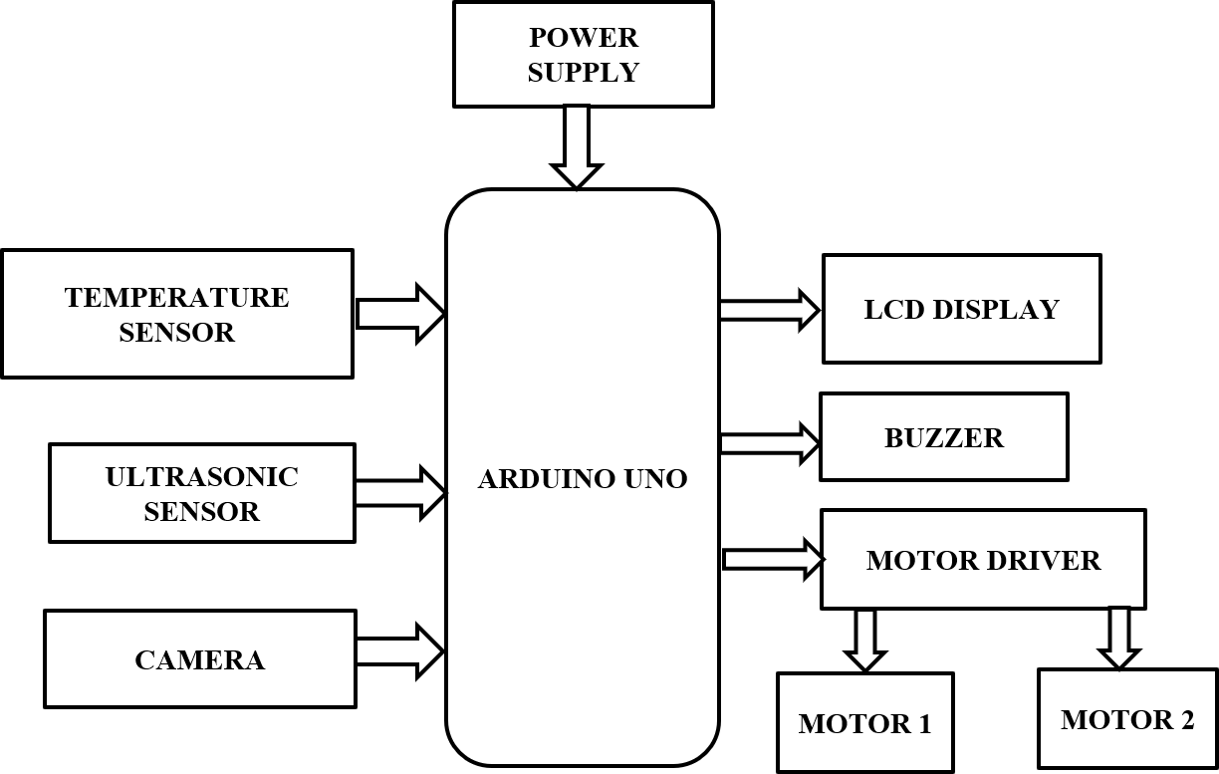

Figure 1 Block Diagram of Methodology

B. Components used
Arduino Uno
LCD Display
DC gear motor
Ultrasonic sensor
Temperature sensor
Buzzer
Webcam

- Arduino Uno
The Arduino UNO is an open-source microcontroller board based on the Microchip ATmega328P microcontroller and developed by Arduino.cc. The board is equipped with sets of digital and analog input/output (I/O) pins that may be interfaced to various expansion boards (shields) and other circuits. The board has 14 Digital pins, 6 Analog pins, and programmable with the Arduino IDE (Integrated Development Environment) via a type B USB cable. It can be powered by a USB cable or by an external 9 volt battery, though it accepts voltages between 7 and 20 volts. It is also similar to the Arduino Nano and Leonardo. The hardware reference design is distributed under The Arduino/Genuino Uno has a number of facilities for communicating with a computer, another Arduino/Genuino board, or other microcontrollers. The ATmega328 provides UART TTL (5V) serial communication, which is available on digital pins 0 (RX) and 1 (TX). An ATmega16U2 on the board channels this serial communication over USB and appears as a virtual com port to software on the computer. The 16U2 firmware uses the standard USB COM drivers, and no external driver is needed. However, on Windows, a .inf file is required. The Arduino Software (IDE) includes a serial monitor which allows simple textual data to be sent to and from the board. The RX and TX LEDs on the board will flash when data is being transmitted via the USB-to-serial chip and USB connection to the computer (but not for serial communication on pins 0 and 1). A Software Serial library allows serial communication on any of the Uno's digital pins

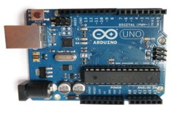

Figure 2 Arduino Uno
- LCD Display
A liquid crystal display (LCD) is a flat panel display, electronic visual display, or video display that uses the light modulating properties of liquid crystals. Liquid crystals do not emit light directly. LCDs are available to display arbitrary images (as in a general-purpose computer display) or fixed images which can be displayed or hidden, such as preset words, digits, and 7-segment displays as in a digital clock. They use the same basic technology, except that arbitrary images are made up of a large number of small pixels, while other displays have larger elements. An LCD is a small low cost display. It is easy to interface with a micro-controller because of an embedded controller (the black blob on the back of the board). This controller is standard across many displays (HD 44780) which means many micro- controllers (including the Arduino) have libraries that make displaying messages as easy as a single line of code.

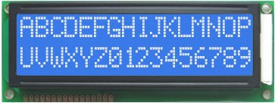

Figure 3 LCD Display
c.DC motor
A DC motor is a mechanically commutated electric motor powered from direct current (DC). The stator is stationary in space by definition and therefore the current in the rotor is switched by the commutator to also be stationary in space. This is how the relative angle between the stator and rotor magnetic flux is maintained near 90 degrees, which generates the maximum torque. DC motors have a rotating armature winding (winding in which a voltage is induced) but non-rotating armature magnetic field and a static field winding (winding that produce the main magnetic flux) or permanent magnet. Different connections of the field and armature winding provide different inherent speed/torque regulation characteristics. The speed of a DC motor can be controlled by changing the voltage applied to the armature or by changing the field current. The introduction of variable resistance in the armature circuit or field circuit allowed speed control. Modern DC motors are often controlled by power electronics systems called DC drives.

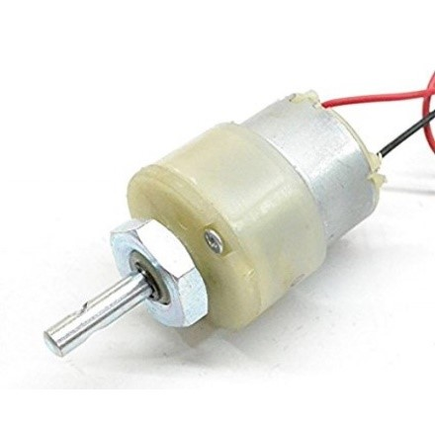
Figure 4 DC motor

- Ultrasonic Sensor
Ultrasonic transducers are transducers that convert ultrasound waves to electrical signals or vice versa. Those that both transmit and receive may also be called ultrasound transceivers; many ultrasound sensors besides being sensors are indeed transceivers because they can both sense and transmit. These devices work on a principle similar to that of transducers used in radar and sonar systems, which evaluate attributes of a target by interpreting the echoes from radio or sound waves, respectively. Active ultrasonic sensors generate high-frequency sound waves and evaluate the echo which is received back by the sensor, measuring the time interval between sending the signal and receiving the echo to determine the distance to an object. Passive ultrasonic sensors are basically microphones that detect ultrasonic noise that is present under certain conditions, convert it to an electrical signal, and report it to a computer. This technology can be used for measuring wind speed and direction (anemometer), tank or channel fluid level, and speed through air or water. For measuring speed or direction, a device uses multiple detectors and calculates the speed from the relative distances to particulates in the air or water. To measure tank or channel level, the sensor measures the distance to the surface of the fluid. Further applications include: humidifiers, sonar, medical ultrasonography, burglar alarms, non-destructive testing and wireless charging. Systems typically use a transducer which generates sound waves in the ultrasonic range, above 18 kHz, by turning electrical energy into sound, then upon receiving the echo turn the sound waves into electrical energy which can be measured and displayed. The technology is limited by the shapes of surfaces and the density or consistency of the material. Foam, in particular, can distort surface level readings. This technology, as well, can detect approaching objects and track their positions.

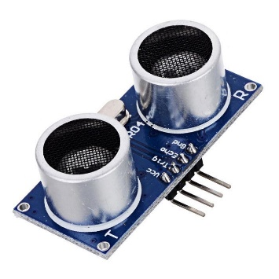

Figure 5 Ultrasonic sensor
- Temperature Sensor

DHT11 is a Humidity and Temperature Sensor, which generates calibrated digital output. DHT11 can be interface with any microcontroller like Arduino, Raspberry Pi, etc. and get instantaneous results. DHT11 is a low cost humidity and temperature sensor which provides high reliability and long term stability.
It uses a capacitive humidity sensor and a thermistor to measure the surrounding air, and outputs a digital signal on the data pin (no analog input pins needed). Its very simple to use, and libraries and sample codes are available for Arduino and Raspberry Pi.
This module makes is easy to connect the DHT11 sensor to an Arduino or microcontroller as includes the pull up resistor required to use the sensor. Only three connections are required to be made to use the sensor - Vcc, Gnd and Output.
It has high reliability and excellent long-term stability, thanks to the exclusive digital signal acquisition technique and temperature & humidity sensing technology.

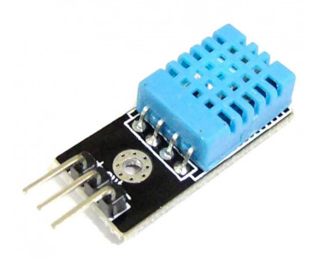

Figure 6 Temperature Sensor
- Buzzer
A buzzer or beeper is a signalling device, usually electronic, typically used in automobiles, household appliances such as a microwave oven, or game shows. It most commonly consists of a number of switches or sensors connected to a control unit that determines if and which button was pushed or a preset time has lapsed, and usually illuminates a light on the appropriate button or control panel, and sounds a warning in the form of a continuous or intermittent buzzing or beeping sound. Initially this device was based on an electromechanical system which was identical to an electric bell without the metal gong (which makes the ringing noise). Often these units were anchored to a wall or ceiling and used the ceiling or wall as a sounding board.
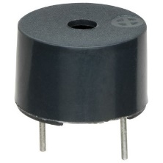
Figure 7 Buzzer

g.Webcam

A webcam is a video camera that feeds or streams its image in real time to or through a computer to computer network. When "captured" by the computer, the video stream may be saved, viewed or sent on to other networks via systems such as the internet, and email as an attachment. When sent to a remote location, the video stream may be saved, viewed or on sent there.
Unlike an IP camera (which connects using Ethernet or Wi-Fi), a webcam is generally connected by a USB cable, or similar cable, or built into computer hardware, such as laptops. The term "webcam" (a clipped compound) may also be used in its original sense of a video camera connected to the Web continuously for an indefinite time, rather than for a particular session, generally supplying a view for anyone who visits its web page over the Internet.

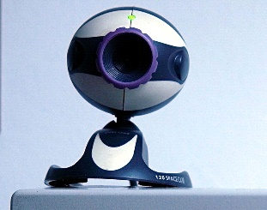

Figure 8 webcam

C. Proposed Work
The proposed system which are focused to the eyeball of the patient generate three different ranges of values depending upon the position of the eyeball. In the kit there are condition for store the value of every eye position i.e. left, right, straight and stop. Temperature sensor is used to detect patient’s temperature level; if temperature is high buzzer will be on. Camera is used to detect movement of direction(Left, Right and Stop) using motor with the help of motor driver; Ultrasonic senor used to detect objects in their path. This system uses LCD for displaying monitored parameters. Here uses the arduino controller for controlling overall system.

IV. RESULT AND CONCLUSION
The project carried out here will make an impressing task in hospitals and homes.This project has also reduced the cost involved in the concern.The production of this multipurpose wheelchair will be helpful in hospitals to improve the comfort of patient during their required movement such as to scan center, during night sleep etc.It is expected that production of low cost stretcher cum wheelchairs for patient handling will relive patient and nursing staff from a lots of physical discomfort.

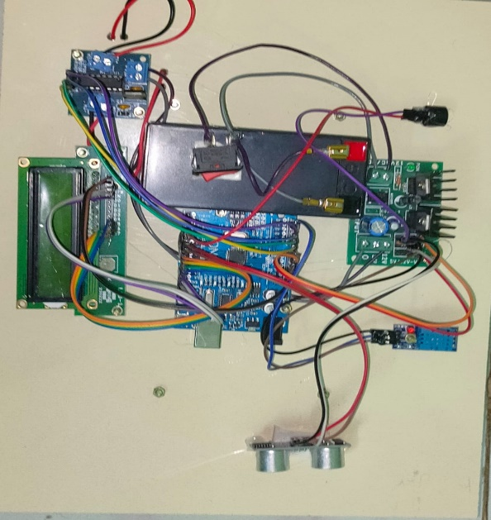

V. FUTURE ENHANCEMENT
The future scope of the project can be extended using wireless technology,and intelligent hand gesture wheel chair.

VI. REFERENCE
- R. C. Simpson, “Smart wheelchairs: A literature review,” Journal of rehabilitation research and development, vol. 42, no. 4, p. 423-436, Jul. 2005.
- O. A. Postolache, P. M. B. Silva Girao, J. Mendes, E. C. Pinheiro, and G. Postolache, “Physiological parameters measurement based on wheelchair embedded sensors and advanced signal processing,” IEEE Trans. Instru. and Measu., vol. 59, no. 10, pp. 2564-2574, Oct. 2010.

3. Y. Li, “A EOG-based switch and its application for start/stop control of a wheelchair,” Neurocomputing, vol. 275, no. 1, pp. 1350-1357, Jan. 2018.
4 . F. Khan and S. H. Cho, “A detailed algorithm for vital sign monitoring of a stationary/non-Stationary human through IR-UWB radar,” Sensors, vol. 17, no. 2, pp. 1-15, Feb. 2017.

5 .S. K. Leem, F. Khan and S. H. Cho, “Vital sign monitoring and mobile phone usage detection using IR-UWB radar for intended use in car crash prevention,” Sensors, vol. 17, no. 6, pp. 1-25, Jun. 2017.

6 . K. K Shyu, L. J. Chiu, P. L. Lee, and L. H. Lee, “UWB simultaneous breathing and heart rate detections in driving scenario using multi-feature alignment two-layer EEMD method,” IEEE Sensors J., vol. 20, no. 17, pp. 10251-10266, Sept. 2020.
7 . O. Postolache, P. S. Girao, G. Postolache, and J. Gabriel, “Cardiorespiratory and daily activity monitor based on FMCW Doppler radar embedded in a wheelchair,” in Proc. 2011 Annual International Conference of the IEEE Engineering in Medicine and Biology Society, Sept. 2011, pp. 1917-1920.
8 . A. Abdolalipour, O. Postolache, and P. S. Girao, “DSP based realtime adaptive vital signals extraction algorithm using CW-Radar for wheelchair users,” in Proc. 2011 Annual International Conference of the IEEE Engineering in Medicine and Biology Society, Oct. 2012, pp. 620-623.
9 . W. M. Elsayed, H. M. El-Bakry, and S. M. El-Sayed, “Data reduction using integrated adaptive filters for energy-efficient in the clusters of wireless sensor networks,” IEEE Embedd. Syste. Lett., vol. 11, no. 4, pp. 119-122, Dec. 2019.
10 . Raghuveer M.Rao and Ajit S.Bobaradikar, “Wavelet Transforms: Introduction to Theory and Applications”, Addison Wesley Longman Inc., 1998, pp.183-189.

