FACE RECOGNITION BASED ATTENDANCE SYSTEM
1.Renuka S
Student, Department of MCA , Vivekanandha of Arts and Sciences for Women (Autonomous)
Namakkal, Tamil Nadu
Email id: renukas1421@gmail.com

2.SathiyaM
Assistant Professor , PG & Research Department of Computer Science and Applications
Vivekanandha College of Arts and Sciences for women (Autonomous)
Namakkal , Tamil Nadu
Email id : sathiyamcs@vicas.org

Abstract
Today, practically all businesses use face recognition technology, which is essential in the digital world. One of the most popular biometric technologies is face recognition. It has a number of advantages and can be used for security, identity, and authentication. Despite being less reliable than iris and fingerprint verification, it is nonetheless often employed since it is non-intrusive and contactless. Facial recognition technology can also be used by companies, schools, colleges, and other places to monitor attendance. The goal of this system is to create a facial recognition-based class attendance system because the existing manual method of taking attendance is inefficient and challenging to maintain. Also possible is the appearance of a proxy. This system is hence becoming more and more popular.
Key words : attendance system, face detection, face recognition, and Haar-Cascade classifier.

Introduction
The traditional method of keeping track of attendance is a time-consuming task in many colleges and institutions. In order to take attendance, the teacher must also call out each student's name individually. This could take up to five minutes for the entire session.This is time-consuming. There is a chance that a proxy will appear. Many institutions have started implementing RFID [3], iris [4], fingerprint [5], and other technologies in order to adopt new methods of tracking attendance. But because they work in a queue, these technologies might take longer and be more intrusive.Face recognition is a crucial biometric trait that is easy to learn and non-intrusive. Face recognition systems typically have no idea what varied expressions look like.

Literature survey
A model for an automatic attendance system was put up by the authors
in [3]. The model focuses on how face recognition and Radio Frequency Identification (RFID) work together to identify and count authorized students as they enter and exit the classroom. Every student who has registered with the system has an authentic record kept. Additionally, the system maintains information about each student registered for a certain course in the attendance log and delivers necessary data as needed. The authors of this study [4] have developed and put into operation an
iris biometric attendance system. The participants were initially required to register their personal information and distinctive iris template. The system automatically recorded each
student's attendance by taking their eye image at the moment of attendance.
Existing System :
Previously, the attendance management system at schools and colleges was done manually, with students marking or signing next to their names in a name list to indicate their presence in a given class. While the institution's workers will report their attendance using a punch card machine, which likewise requires manual entry. After data collection, it will be analysed, and intelligent decisions will be made by computers without human involvement to either solve the problem at hand or make the situation better. In a nutshell, IoT technology makes many current systems more effective and intelligent.
- In many schools and universities, recording attendance using the traditional technique is a laborious effort.

- Additionally, the faculty must manually call out each student's name in order to record attendance. This could take up to five minutes out of the session.

- This takes a lot of time.
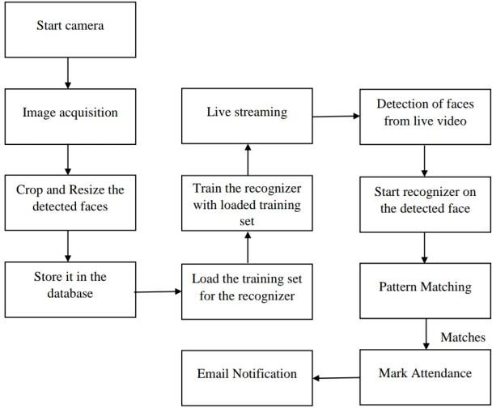
Proposed system
Before their pictures are taken and included to the dataset, each student in the class must first register by providing the required information. During each lesson, faces will be recognised from the live streaming video from the classroom. We will contrast the recognised faces with the image data from the dataset. In the event of a match, the pertinent student's attendance shall be noted. Each session will end with a mailing of a list of absentees to the faculty person in charge ofthat particularclass. Below is a diagram of the system architecture for the suggested system.
- Minimising time wasted while attending traditional classes.

- Using the most recent developments in machine vision to put into practise a workable system for tracking student attendance.

- Automating the entire process so that our surroundings are digital.
- Students will attend class on time more frequently. This is because any absences will be detected by the system, and a specific student's attendance may only be taken directly.

- This not only teaches students to be on time, but also helps them stay away from unethical practises like signing attendance for pals.

Modules :
This method typically consists of four steps:
Creation of the Dataset: The students are captured on camera by a webcam. Numerous photographs of a single student will be taken from various angles and actions.
Typically, there are four parts to this process:
1. Dataset Creation:
Using a webcam, pictures of the students are taken. One learner will be photographed multiple times from different positions and motions. These images have already undergone processing. The images are cropped to create the Region of Interest (ROI), which is then used in the recognition procedure. Following that, the clipped photos must be resized to a specific pixel point. These RGB photos will then be converted into their grayscale equivalents. The names of the corresponding students and these photos will then be retained in a folder.
These photos will thereafter be placed in a folder with the names of the respective students.
.
2. Face Detection:
Here, face detection is done with OpenCV and the Haar-Cascade Classifier. Before the Haar Cascade method can be used to recognise human faces, it must first it. In this case, we are utilising the OpenCV detect Multi-Scale module. To draw a rectangle around the faces in an image, this is necessary. There are three variables to take into account: scale-Factor, mini-Neighbors, and mini-Size. The scale Factor parameter is used to specify how much a picture must be scaled down. The number of neighbours that each candidate rectangle must have is specified by mini-Neighbors. Greater values typically detect fewer faces but better quality
images. The minimal object size is specified by mini-Size. It is always (30, 30) [8]. Scale -Factor and mini-Neighbors, with values of 1.3 and 5, are the parameters employed in this :

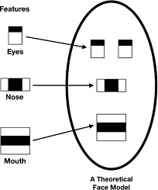
3. Face recongization:
Preparing training data, training the face recognizer, and prediction are the three processes in the face recognition process. The photographs in the dataset will serve as the training data in this case. They will be given an integer label designating which student they belong to. Face recognition software is then used to these photographs. This system uses the Local Binary Pattern Histogram as a face recognizer. First, the full face's list of local binary patterns (LBP) is compiled. Following the decimalization of these LBPs, histograms of all the
decimal values are created. One histogram will eventually be created for each image in the training data. The histogram of the face to be recognised is later calculated during the recognition process, and the previously computed.
4. Updated Attendance:
Following the face recognition process, the excel sheet will have the
recognised faces marked as present and the remaining faces marked as absent. The list of absentees will then be mailed to the appropriate faculties. At the conclusion of each month, faculties will be updated with a monthly attendance sheet.

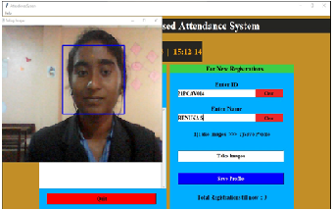

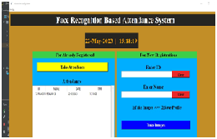

Result
Users can interact with the system through a GUI. Here, users will primarily have access to three options: teacher registration, student registration, and attendance marking. The students must thoroughly fill out the student registration form. A window resembling the one in displays as soon as you touch the register button, and the web camera starts to recognise the faces in the screen. It begins taking photographs automatically when 60 samples have been collected or when CRTL+Q is pressed. The edited photos will subsequently be placed in the training pictures folder. The faculties must fill out the provided faculty registration form with their email addresses and the correct course codes. The appropriate faculty member must enter the course code each session.
Conclusion
This technology seeks to develop a powerful face recognition-based class
attendance system. By using facial ID, the suggested system will be able to record attendance. It
will use a webcam to detect faces and then identify them. Following recognition, it will update
the attendance record and note the recognised student's attendance. As a result, the purpose of this article is to record student video, transform it into frames, connect it to a database to verify their presence or absence, and mark attendance for a specific student in order to keep a record. In order to satisfy the demand for autonomous classroom evaluation, the Automated Classroom Attendance System aids in improving accuracy and speed, finally achieving high-precision real-time attendance.

FUTURE WORK
The sole expense associated with this method is having enough room in the database storage to accommodate all of the faces. Thankfully, there are devices like micro SD that can make up for the data volume. The face database is successfully constructed in this project. In addition, the face recognition system is operating effectively. A user-friendly, fully functional website has also been successfully created. Although the user cannot see the built-in database, they can still access it and make changes through the generated webpage's superb user experience.

REFERENCES

- https://www.researchgate.net/publication/326261079_Face_detection_system_for_attendance_of_class’_students
- Hapani, Smit, et al. "Automated Attendance System Using ImageProcessing." 2018 Fourth International Conference on Computing Communication Control and Automation (ICCUBEA).IEEE,2018.
- Akbar,MdSajid,etal."Face Recognition and RFID Verified Attendance System." 2018 International Conference on Computing Electronics & Communications Engineering (iCCECE).IEEE,2018.
- Okokpujie, Kennedy O., et al. "Design and implementation of astudent attendance system using irisbiometric recognition." 2017International Conference on Computational Science and Computational Intelligence(CSCI).IEEE,2017.
- Rathod, Hemantkumar, et al. "Automated attendance system usingmachinelearningapproach." 2017 International Conference on Nascent Technologies in Engineering (ICNTE). IEEE, 2017.
- Siswanto,Adrian Rhesa Septian, Anto Satriyo Nugroho,and Maulahikmah Galinium."Implementation offace recognition algorithm for biometrics based time attendance system." 2014International Conference on ICT For Smart Society (ICISS). IEEE,2014.
- Lukas, Samuel, et al. "Student attendance system in classroom using face recognition technique." 2016 International Conference on Information and Communication Technology Convergence (ICTC).IEEE, 2016.
- https://becominghuman.ai/face-detection-using-opencv-with-haar- cascade-classifiers-941dbb25177
- https://www.superdatascience.com/blogs/opencv-face-recognition
- Salim, Omar Abdul Rhman, Rashidah Funke Olanrewaju, and WasiuAdebayo Balogun. "Class attendance management system using facerecognition." 2018 7th International Conference on Computer and Communication Engineering (ICCCE). IEEE, 2018.

