ONLINE FOOD ORDERING SYSTEM
1.Shahrukh Shaikh,
2. Aslam Shaikh
Project Guide : Prof. D.V.Jadhav

Karmayogi Instiute of Technology Shelve,
DBATU University,Pandharpur,
Maharashtra
shahrukhshaikh11072001@gmail.com
aslamshaikh032001@gmail.com

---------------------------------------------------------------------***---------------------------------------------------------------------

Abstract –
Online food ordering is a feature of our suggested system, which makes it convenient for customers. It eliminates the
drawbacks of the conventional queuing mechanism. Our system is an easy way to order food from restaurants and get a mess
service online. This system enhances the process of taking consumer orders. Customers can easily place orders as they like using
the online meal ordering system, which sets up a food menu online. Additionally, clients can simply follow orders if there is a
food menu. Additionally, this system has a feedback feature that allows users to rank the food products. Additionally, the
suggested system can suggest restaurants and hotels based on the ratings provided by the user. The hotel personnel will also be
advised of any quality and improvement issues. Both online and pay-on-delivery payment methods are available. By giving each
user a unique ID and password, separate accounts are maintained for each user for more secure ordering. n.

.

Key Words: Automated Food Ordering System, Cloud Computing, Dynamic Database Management, Internet of Things, Smart Phone.

1. INTRODUCTION

In today's fast-paced world, the demand for efficient and convenient food services is on the rise. As an esteemed publication, Pepar is always striving to provide its staff and customers with exceptional experiences. To cater to their needs and enhance the overall dining experience, we are thrilled to introduce an innovative food ordering system specifically designed for Pepar Publication.
An online food menu is set up by the proposed food ordering system and as per their will customers can easily place the order. Also, customers can easily track the orders with the food menu. The management improve food delivery service and preserves customers database. Motivation to develop the system is from the restaurant management system. To get the services efficiently the users of the system provides various facilities. Restaurants as well as Mess facility is considered by our system for the customers. Mostly mess users are person who are shifted to new cities and this can be considered as a motivation to our system. Another motivation can be considered as the increasing use of smart phones by the customers, so that any users of this system get all service of the system. The system will be designed to avoid users doing fatal errors where users can change their own profile also where users can track their food items through GPS and where users can provide feedback and recommendations to Restaurants / Mess service providers.
The flexibility to the Customers/Users to order from either Restaurants or Mess is provided by our system. Recommendations to the customers is also provided from the restaurants/mess owners which are updated daily. There will be no limitation on the amount of order the customer wants by ordering food from our system. As a Startup Business for the developers the same system application can be used. Real time customers feedback and ratings are provided by our system with the comments to the restaurants/mess owner. It gives appropriate feedbacks to users, so if there is any error happened, then there will be a feedback dialog toward users.
To avoid users doing fatal errors and inappropriate action our system application is designed. Input will be taken by the user from the graphical user interface. The major attributes such as name, address, email-Id, mobile no, other personal related values will give input to the dataset. The User/Customer’s Order, Bill, Feedback and Recommendation will provide the output. For the initial implementation of the system we have considered 2 restaurants and 2 mess services in 5 areas.

2. LITERATURE REVIEW

Food ordering systems have gained significant attention in recent years due to the growing demand for convenience and efficiency in the food service industry. This literature review aims to provide an overview of the existing research and advancements in food ordering systems, highlighting their key features, benefits, and impacts on various stakeholders.
Online Food Ordering Systems:
Online food ordering systems have revolutionized the way people order food, providing convenience and accessibility. Research by Liu and Li (2017) found that online food ordering systems improve customer satisfaction and increase sales for restaurants. These systems offer features such as menu customization, real-time order tracking, and secure online payments.
Mobile Applications:
With the widespread use of smartphones, mobile applications for food ordering have gained popularity. Research by Hu et al. (2019) highlighted that mobile applications provide a more personalized and interactive experience for users, allowing them to browse menus, place orders, and receive notifications on their mobile devices. Mobile applications also enable targeted marketing and loyalty programs, enhancing customer engagement.
Integration of AI and Chatbots:
Artificial Intelligence (AI) and chatbot integration have been explored to enhance the efficiency and user experience of food ordering systems. Research by Bapuji (2019) suggested that AI-powered chatbots can automate order taking, provide menu recommendations, and offer personalized suggestions based on user preferences. These intelligent systems can handle customer queries, reducing the workload on human staff.

Delivery and Logistics Optimization:
Efficient delivery and logistics management are crucial for successful food ordering systems. Research by Chen and Zhao (2018) highlighted the importance of optimizing delivery routes, reducing delivery time, and leveraging real-time GPS tracking to improve the overall delivery experience. Advanced routing algorithms and coordination systems have been developed to optimize the delivery process, resulting in faster and more accurate deliveries.

Impact on Food Service Providers:
Food ordering systems have significant implications for food service providers. Research by Ye et al. (2020) showed that implementing online ordering systems leads to increased order accuracy, reduced order processing time, and improved operational efficiency. These systems also enable better inventory management and data analysis, allowing restaurants to make informed decisions for menu planning and resource allocation.

User Experience and Customer Satisfaction:
User experience and customer satisfaction play a crucial role in the success of food ordering systems. Research by Kim et al. (2021) emphasized the importance of user-friendly interfaces, intuitive navigation, and personalized recommendations to enhance customer satisfaction. Positive user experiences lead to repeat orders, increased customer loyalty, and positive word-of-mouth.solution.
LAN, costly multi-touch screens, etc. to enhance dining experience. This paper highlights some of the limitations of the conventional paper based and PDA-based food ordering system and proposed the low-cost touch screen-based Restaurant Management System using an android Smartphone or tablet as a solution.

3. PROPOSED SYSTEM

To overcome the restrictions of above system, based on Internet of Things an Online Food Ordering System is proposed. The use of mobile technology has revolutionized as the Android devices have gained popularity in the automation of routine task in wireless environment. For mobile devices such as smart-phones and tablets android is a Linux built operating system. As a general Objective of the study to develop a reliable, convenient and accurate Food Ordering System is considered. As an objective, a system that will surely satisfy the customer service will be considered. To design a system that can accommodate huge amount of orders at a time and automatically compute the bill is one of the key objectives. One of the important objective is to evaluate its performance and acceptability in terms of security, user-friendliness, accuracy and reliability. One of key objective is to improve the communication between the client and customers.
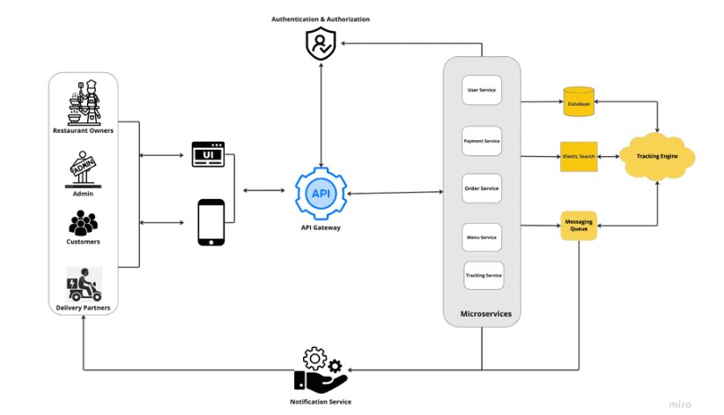

Figure-1: System Architecture

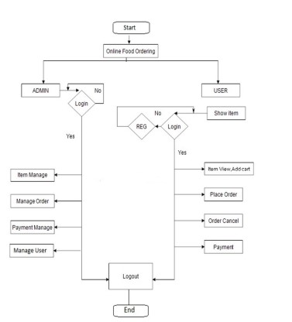
Figure -2 Flow Chart

4. ARCHITECTURAL DESIGN

The system implementation contains 3 main users: -
Service Customer, Proprietor of Mess/Restaurant, and Worker of mess. When a person moved to new city he must find source for clean and superior food, so he/she will explore and select restaurant or mess, or tiffin service based on his category.
The pattern in which user will search the services for a purpose GPS system should be on and a part of GeoHashing Algorithm is used. Person can have the facility to search service by location that is home location of the person is detected with GPS and nearby service get searched according to selected option location. Searching by cost is another way.
Search by rating is also possible by our system. List of service is given if matched by the user given ratings when the services that has ratings are checked with it. The search can be carried out by accepting distance from user where it needs to search and displaying service provider within a distance.

4.1 REQUIREMENTS DEFINITIONS

Analyzes based on similar application and determines the necessary features in the application, as well as do the details about the features that will be created with function of each features. Features that are needed in application for customer are as follows:
- New Order: New Order is the main feature of the customer side application that will be used to make orders. An order can be made in two separate ways, the one is by is using My Favorites feature to make an order by choosing one of the top three favorites restaurant and the other one is by using Make a new order feature to make an order by choosing restaurant and menus provided easily.
- Order History: Customer’s order history is shown by this feature namely order history.
- Restaurant Profile: Restaurant’s profile is shown by this feature. Through this feature customer can make call to the restaurant directly.
- Order Status: This feature is used to show that order status that includes “order received” means that restaurant has received the order, “order confirmed” means that restaurant has confirmed the order, “cooking” means restaurant is preparing the order, “delivering order” means that delivery of the order is done. While the status is on “delivering order” the customer can also show the delivery map.
- Profile Setting: To show and to change customer profile this feature is used that comprise of name, address, email, and phone number.
Features required in website for admin are:
- Resto: Restaurant list is shown by this feature. Admin can modify restaurant data and insert new restaurant including transformation from restaurant active or inactive status through this feature.

- Order: Order list which has been done by each restaurant is shown by this feature.

- Menu: Menu list of each restaurant is shown by this feature. Through this feature admin can also alter each menu.

- Courier: Courier list of each restaurant is shown by this feature. Through this feature admin can also amend each courier data.

- Customer: Customer list in this application is shown by this feature. Through this feature admin can also modify customer profile.

4.2 SYSTEM AND SOFTWARE DESIGN
Using the storyboard design, we construct the application design workflow for restaurant, customer, courier and admin side; the user experience design. The use case, class diagram, sequence diagram, activity diagram and database structure design are comprised in the Unified Modeling Language.
- Storyboard design: Designing the user interface is done by storyboard design which includes each interface description.
- User experience design: When interacting with the application, designing the totality of end user perception this design is used.
- UML design: The UML design contains use case to define the system function from each actor perspective then accomplished by explanation in use case narrative, to draw the process of each actor in diagram activity diagram is used, to draw object or class of system with its relationship class diagram is used and to draw the message interaction with its objects base on its order of time sequence diagram is used.
- Database structure design: By the result of class diagram, database structure design is made. Classes that need to be saved in database and its relationship are drawn by this design.

4.4 SYSTEM IMPLEMENTATION
The implementation of the system application is done in Java, jQuery, HTML and the datasets are stored in MySQL database. We have developed hybrid Android Application using Cordova.
We have developed a web-based application and based on it we have developed the android application.
The hardware required for our application includes Android Smart phone and a desktop or laptop with browser and internet connection.
For the initial implementation of the system we have considered 2 restaurants/mess from 5 areas nearby in our datasets.
Implementation of our system consists of a real time feedback system where once you place an order, an email will be sent to the customer regarding the feedback of their order.
According to the comments and ratings of the customer, using Sentiwordnet analysis we provide recommendation to the customers providing the highly rated restaurant/mess first and other respectively. The Sentiwordnet analysis uses the comments mentioned in the feedback and assign a value that can be positive and negative and organize the restaurant / mess in a fashion. This means the restaurant / mess with the highest positive value will be shown first and vice versa.

5. future scope
The future scope for online food ordering systems in paper publishing can bring several benefits and opportunities for both publishers and readers. Here are some potential areas of growth and development:
1.In-house Food Ordering Services: Publishers can integrate online food ordering systems within their premises to offer convenient and efficient dining options for their staff and visitors. This could involve partnering with local restaurants or setting up their own kitchen facilities to provide a range of menu options. By implementing an online food ordering system, publishers can streamline the food ordering process, reduce wait times, and enhance the overall dining experience.
2.Customized Menus for Special Publications: Publishers can leverage online food ordering systems to create customized menus for special occasions or publications. For example, during book launches, conferences, or author events, publishers can curate specialized menus that align with the theme or content of the event. This adds an extra level of personalization and engagement for attendees.
3.Collaboration with Food and Lifestyle Publications: Publishers specializing in food and lifestyle content can integrate online food ordering systems directly into their publications. This would allow readers to browse through recipes or food-related articles and seamlessly order the ingredients or pre-prepared meals featured in those publications. Such collaborations can enhance the reader experience and provide a seamless transition from reading about food to actually enjoying it.
4.Integration of Food Reviews and Recommendations: Online food ordering systems within paper publishing can incorporate food reviews, ratings, and recommendations from renowned critics or trusted sources. This would provide readers with valuable insights and help them make informed decisions while ordering food. Publishers can collaborate with food critics or experts to curate and feature reviews within the online ordering system, adding credibility and value to the dining experience.
5.Interactive and Multimedia Content: Publishers can leverage online food ordering systems to create interactive and multimedia content related to food. This could include video tutorials, cooking demonstrations, or behind-the-scenes glimpses of the culinary process. By integrating such content within the ordering system, publishers can engage readers on multiple levels and provide a more immersive experience.

OutPut
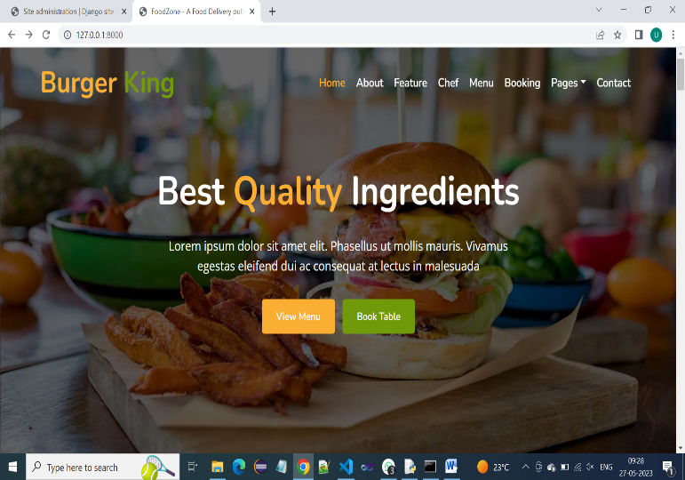

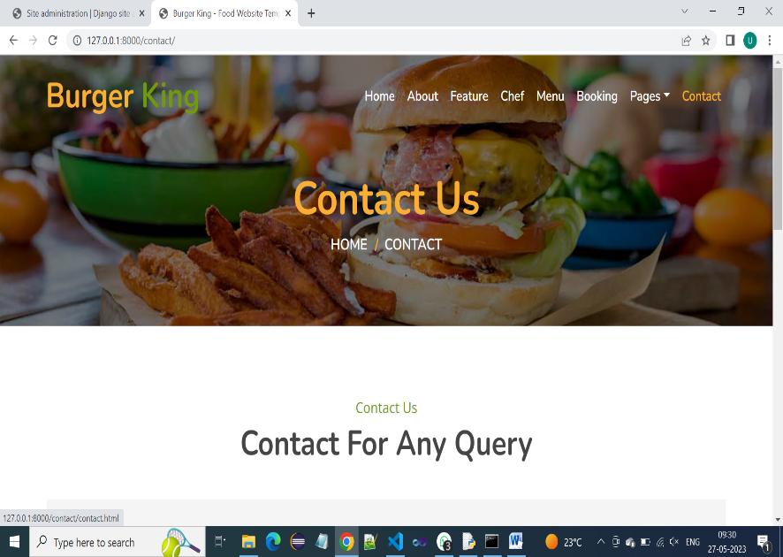

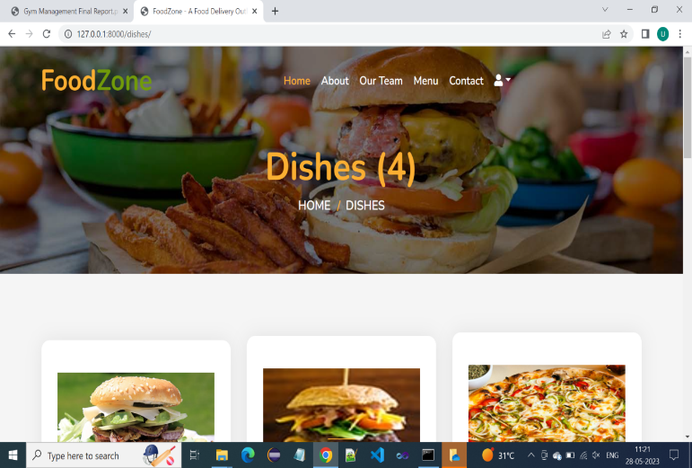

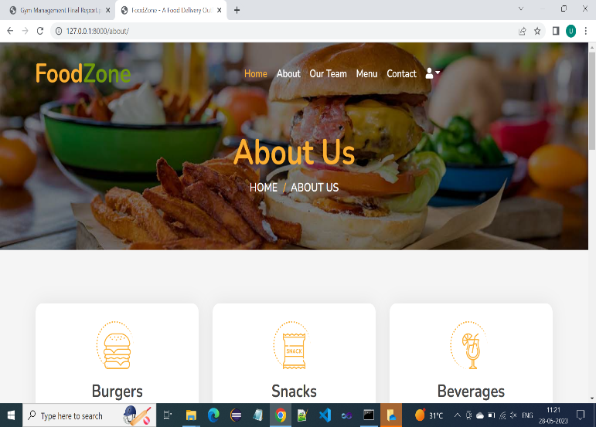

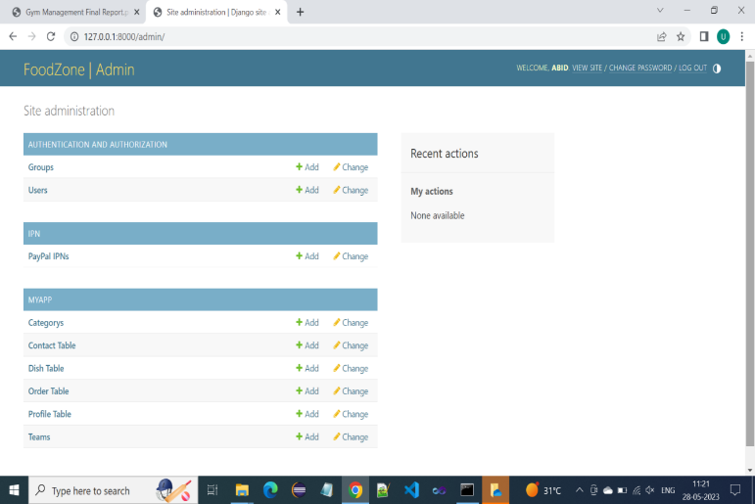

5. CONCLUSION
The application is based on user’s requirement and is user centered. All issues related to all user which are included in this system are developed by this system. If people know how to operate android smart phone wide variety of people can use the application. This system will solve the various issues related to Mess/Tiffin service. To help and solve important problems of people implementation of Online Food Ordering system is done.
It can be concluded that, based on the application: Orders are made easily by this system; Information needed in making order to customer is provided by the system. Receiving orders and modifying its data is possible through the application and it also helps admin in controlling all the Food system.

REFERENCES

[1]. Kirti Bhandge, Tejas Shinde, Dheeraj Ingale, Neeraj Solanki, Reshma Totare,”A Proposed System for Touchpad Based Food Ordering System Using Android Application”, International Journal of Advanced Research in Computer Science Technology (IJARCST 2015).

[2]. Varsha Chavan, Priya Jadhav,Snehal Korade,Priyanka Teli, ”Implementing Customizable Online Food Ordering System Using Web Based Application”, International Journal of Innovative Science, Engineering Technology(IJISET) 2015.

[3]. Resham Shinde, Priyanka Thakare, Neha Dhomne, Sushmita Sarkar, ”Design and Implementation of Digital dining in Restaurants using Android”, International Journal

