

The Restaurant: The Vintage Kitchen Project Centric Learning Report
Submitted in partial fulfilment of the requirements For the Degree of Master in Business Administration By

Group 127

21MBAR0107- Ajith Akash A 21MBAR0844 - Akshay Hondi

21MBAR0446- Meenakshi Sundaram RM 21MBAR0078 - Saloni Kumari 21MBAR0298 - Yashika Thakur 21MBAR0041– Ashwini Bhat K

Under The Guidance of Dr. G S Vijaya

Professor - Decision Science Department

No.17, Sheshadri Road, Gandhi Nagar, Bengaluru – 560009, India
Tel: +91 80 4684 0400, E-mail: bschool@cms.ac.in, Website: www.cms.ac.in June 2022

CERTIFICATE

This is to certify that this Project Centric Learning (PCL) report submitted to CMS Business School, Jain (Deemed-to-be University), Bangalore, by Saloni Kumari (21MBAR0078), Ajith Akash (21MBAR0107), Akshay Hondi (21MBAR0844), Yashika Thakur (21MBAR0298) and Meenakshi Sundaram RM (21MBAR0446) Ashwini Bhat(21MBAR) on the topic “Restaurant: The Vintage Kitchen''. This work was done by them during the academic year 2020-21, under guidance and supervision in partial fulfilment of the requirements for the award of Master in Business Administration (MBA).

This project report has not been submitted for the award of any Degree, Diploma, Associateship or Fellowship or any other title in this University or any other University.

Mentor 1

Signature

Name:

Date:

Mentor 2

Signature

Name:

Date:

DECLARATION

We, the students of Project Centric Learning Group - 123, of CMS Business School, JAIN (Deemed-to-be) University, hereby declare that the project work entitled, Restaurant: The Vintage Kitchen”, which is being submitted to JAIN (Deemed-to-be) University, Bangalore for the partial fulfilment of the requirement for the Master of Business Administration (MBA), is original and independent. No part of this work has been submitted to any other university or institution for the award of any degree or diploma.

21MBAR0107- Ajith Akash A 21MBAR0844 - Akshay Hondi 21MBAR0446- Meenakshi Sundaram RM 21MBAR0078 - Saloni Kumari 21MBAR0298 - Yashika Thakur 21MBAR0041 - Ashwini Bhat K

MBA (2021-23)

Jain (Deemed-to-be University): CMS Business School

ACKNOWLEDGEMENT

We would like to express our special thanks and gratitude to Dr. G.S. Vijaya as well as our dean Dr. Harold Andrew Patrick who gave us the golden opportunity to do this wonderful project on the topic (The Vintage Kitchen), which also helped us in doing a lot of research and we came to know about so many new things. We are thankful to them.
Secondly, we would also like to thank our parents and friends who helped us a lot in finalizing this project within the limited time frame.
We are overwhelmed in all humbleness and gratefulness to acknowledge our depth to all those who have helped us to put these ideas, well above the level of simplicity and into something concrete.
We would like to express our special thanks to our teacher as well as our principal who gave us the golden opportunity to do this wonderful project on the topic which also helped us in doing a lot of research and we came to know about so many new things. We are thankful to them. Any attempt at any level can't be satisfactorily completed without the support and guidance of our parents and friends.

Thanking you,

Group-127

21MBAR0107- Ajith Akash A 21MBAR0844 - Akshay Hondi 21MBAR0446- Meenakshi Sundaram RM 21MBAR0078 - Saloni Kumari 21MBAR0298 - Yashika Thakur 21MBAR0041 - Ashwini Bhat K

CIA 1

INTRODUCTION

Starting a restaurant will demand a whole lot of work. Also, the pace of failure can be quite high. But success is also totally possible. In virtually any business endeavour, success is relative. For you to make certain you are on the correct path towards success, you effectively need to do things. Starting a business is an exceptional idea and the medium-scale industry with the highest turnover and with the highest day-to-day working capital. As it is a small or medium-scale hotel we have an edge or an advantage because the prime target for our business is usually middle-class people. And our business plan consists of the opening of a theme-based restaurant which is a typical village-based restaurant we call ourselves a “vintage kitchen.”

Description of idea

- First and foremost is the theme i.e. The ambience it is typically a village-based theme as in today’s generation we forgot our heritage and how food culture used to work so this theme was introduced to escape from their stress.
- A restaurant without food is no restaurant, so we focused more on south Indian food with a few mixes of north Indian food like paneer, roti, etc.
- The plates or the equipment used to serve the food will all be village-based i.e., either copper or biodegradable products such as banana leaves also whatever the leftovers are there, we will supply to the needy and the waste will be given to compost.
- We also planned to first open our restaurant at Jayanagar in Bengaluru. And expand it.
- And also, the server will be in traditional wear which gives that authenticity and a real village look.
- As an ambience, we will promote a lot of organic farming by growing seasonal vegetables to a certain extent
- Also, some of the traditional ways of food cooking will be introduced as in Traditional Tandoor or old kitchen equipment

Minimum Viable Products (MVPs)

A minimum viable product (MVP) for The Vintage Kitchen would be a small, focused menu featuring a limited selection of classic dishes made with high-quality, locally sourced ingredients. The restaurant could start with a simple storefront or food truck setup, and gradually expand as demand grows. Some key components of the MVP might include:
Menu: The menu should be focused on a few signature dishes that represent the Vintage Food concept. These dishes should be well-executed and made with high-quality ingredients. Some possible menu items might include classic comfort foods like South Indian dishes idli, dosa, sambhar and followed by North Indian restaurant
Location: The restaurant should be in a high-traffic area that attracts the target demographic. For example, a Vintage Food restaurant might do well in a downtown area or near a college campus. As for every business, place plays a vital role. As the restaurant will be established in Jayanagar which is one of the porch places of Bangalore and find mostly middle-upper class and upper-class families.
Branding: The restaurant should have a clear brand identity that appeals to the target demographic. This might include a vintage-inspired logo, decor, and marketing materials.
Service: The restaurant should provide excellent customer service to create a positive experience for diners. This might include attentive staff, fast service, and a welcoming atmosphere. The unique selling point is that of ambience and vibe when a customer steps in. This will eventually take them back to the good old 80s or 90s and the food served in vintage-style vessels. Segmentation
Customer segmentation is simply the process of dividing your entire customer base into smaller groups based on similar demographics or traits.
Pricing: The restaurant should offer competitive pricing to attract budget-conscious diners while still maintaining quality. Pricing is focused mainly on the location bases and based on the customer segmentation and also makes sure that it’s affordable.
Overall, the key to a successful The Vintage Kitchen MVP is to keep things simple and focused while still delivering high-quality food and service. As the restaurant grows, it can expand the menu, add additional locations, and incorporate new branding and marketing strategies.

Supposition:

By offering a unique and memorable dining experience that combines high-quality, locally-sourced ingredients with a nostalgic atmosphere, the Vintage Kitchen will attract a loyal customer base and establish itself as a destination restaurant in the local community.
This hypothesis assumes that customers are seeking not only delicious food but also an experience that creates a sense of nostalgia or connection to the past. The Vintage Kitchen aims to provide this experience by creating a cosy, vintage-inspired atmosphere that transports diners back in time. The use of high-quality, locally-sourced ingredients is also an important factor, as it appeals to customers who are looking for authentic and sustainable dining options.
The hypothesis further assumes that by delivering on these elements consistently, the Vintage Kitchen will develop a loyal following of customers who will return regularly and recommend the restaurant to others. This will ultimately help the Vintage Kitchen establish itself as a destination restaurant in the local community, attracting both residents and tourists looking for a unique dining experience.
Of course, this hypothesis would need to be tested through research and data analysis to determine its validity and inform any necessary adjustments to the restaurant's strategy.

Description:

Data is collected from the respondents whose details are as follows:

- Student group: Average spend per customer = ₹1200, Standard deviation = ₹300
- Working professional group: Average spend per customer = ₹1600, Standard deviation =
₹300
- Senior citizen group: Average spend per customer = ₹1300, Standard deviation = ₹300
- Middle-class income group: Average spend per customer = ₹1400, Standard deviation =
₹300
- Upper-class income group: Average spend per customer = ₹1700, Standard deviation =
₹300
- Sample sizes: All groups have 100 customers each.
- Significance level (alpha) = 0.05

Preliminary Research

Vintage kitchens are a popular trend in interior design, often featuring nostalgic elements from the 1920s through the 1970s. These kitchens typically include elements such as brightly coloured appliances, checkered or floral-patterned linoleum flooring, and classic cabinetry with glass panel doors.
One of the defining features of a vintage kitchen is the use of antique or vintage appliances, such as a 1950s-style refrigerator or a retro-style stove. These appliances often have bold colours or chrome accents that make them stand out in the kitchen.
In addition to appliances, vintage kitchens often feature unique design elements like a farmhouse sink, a vintage-style faucet, or a decorative range hood. These elements add to the overall aesthetic of the kitchen and help create a warm and inviting atmosphere.
When it comes to colour schemes, vintage kitchens tend to favour bright and bold hues such as red, yellow, green, and blue. These colours are often used on the walls, cabinets, and backsplash, and can be paired with more muted tones like beige or cream to balance out the space.
Overall, vintage kitchens offer a charming and nostalgic feel that is perfect for homeowners who want to add a touch of old-school glamour to their homes.

The Art of the Pitch

Welcome to The Vintage Kitchen, where we specialize in creating kitchens that transport you back in time while meeting all your modern needs.
Our kitchens are designed with a nod to the past, featuring bold colours, antique appliances, and retro-inspired design elements. But do not be fooled by the vintage aesthetic – our kitchens are also designed to meet all your modern needs, with energy-efficient appliances, ample storage space, and cutting-edge technology.
Step into one of our vintage kitchens, and you will be transported to a world of charm and nostalgia. Imagine cooking a gourmet meal on a classic stove, surrounded by cabinets with glass-panel doors

and a farmhouse sink that exudes timeless elegance. Or picture yourself sitting down to a cosy family meal at a vintage-style table, with the warm glow of a retro-inspired light fixture overhead.
At The Vintage Kitchen, we believe that a kitchen should be more than just a functional space – it should be a place that inspires you and makes you feel at home. Our kitchens are designed to do just that, with a warm and inviting atmosphere that will make you want to spend time cooking, entertaining, and creating memories with your loved ones.
So why settle for a boring, cookie-cutter kitchen when you can have a timeless space that reflects your unique style and personality? Contact us today to learn more about how we can create the vintage kitchen of your dreams.

Proof of the Concept

There is ample proof that the concept of the vintage kitchen is a popular and enduring one. Here are a few examples:
- Popularity in Home Design: Vintage kitchens have become increasingly popular in recent years, with many homeowners seeking to create a cosy and nostalgic atmosphere in their homes. This trend is reflected in home design magazines and websites, where vintage kitchens are often showcased as examples of timeless style.
- Social Media: Social media platforms such as Instagram and Pinterest are awash with images of vintage kitchens, with thousands of posts dedicated to this style. This demonstrates the popularity of the trend and the extent to which people are inspired by vintage kitchens.
- Pop Culture: Vintage kitchens have long been a staple of popular culture, appearing in movies, TV shows, and even video games. For example, the hit TV series Mad Men featured a vintage kitchen that captured the essence of the 1960s, while video games like The Sims allow players to create their virtual vintage kitchens.
- Retro Kitchenware Sales: There has been a resurgence in the popularity of vintage kitchenware and appliances, with many companies producing retro-inspired products that hark back to the mid-century era. Sales of vintage-style kitchenware have surged in recent years, indicating a strong market for this style.

All of these examples provide proof that the concept of the vintage kitchen is not just a passing trend, but a lasting and enduring style that continues to inspire and captivate homeowners and designers alike.

Prototype

A prototype of a vintage kitchen might include the following features:

- Bold Colors: Vintage kitchens often feature bold and vibrant colours, such as bright red, sunny yellow, or aqua blue. These colours can be incorporated into the walls, cabinets, and even appliances to create a bold and eye-catching look.
- Antique Appliances: Vintage kitchens often include antique appliances that have been refurbished and updated with modern technology. These appliances can include a classic range or oven, a retro refrigerator, or a vintage-style dishwasher.
- Retro-Inspired Lighting: Lighting fixtures can also add to the vintage ambience of the kitchen. Retro-inspired pendant lights, chandeliers, or sconces can provide a warm and inviting glow while adding to the overall aesthetic of the space.
- Farmhouse Sink: A farmhouse sink is a popular feature in vintage kitchens. These sinks are typically larger and deeper than traditional sinks and have a classic, rustic look that fits in well with the vintage aesthetic.
- Glass-Panel Cabinets: Glass-panel cabinets can add a touch of elegance to the kitchen while also providing a space to display vintage-inspired dishware and kitchenware.
- Vintage-Style Flooring: Vintage kitchens often feature flooring that adds to the space's overall aesthetic. Options could include checkerboard tile, linoleum, or even reclaimed hardwood.
- Retro Accessories: Vintage-inspired accessories can add the finishing touches to the space. Items such as vintage posters, tin signs, or old-fashioned canisters can give the kitchen a touch of nostalgia and whimsy.
Overall, a prototype of a vintage kitchen would combine these design elements to create a space that feels both functional and charming, while evoking the nostalgia and warmth of a bygone era.

Supporting pictures are as follows as shown in the image:
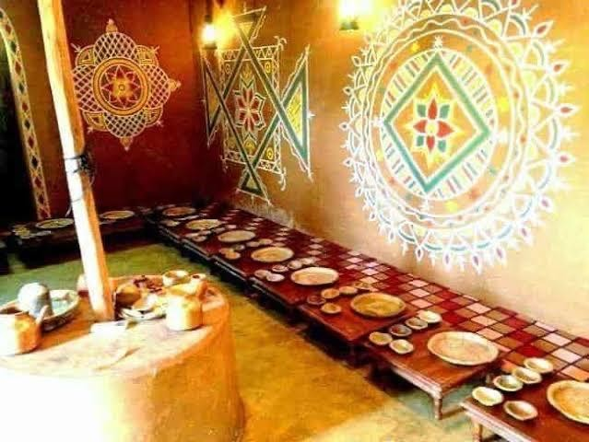
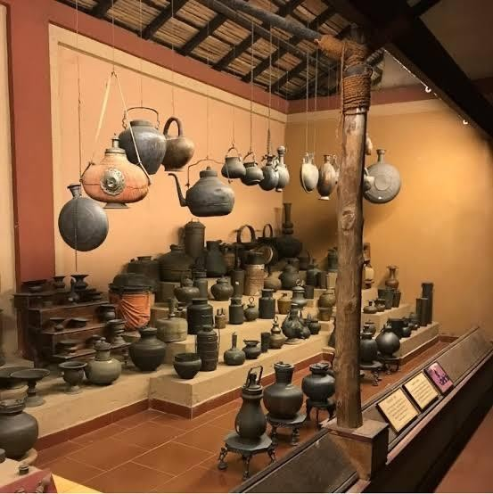
Image:1 Image:2

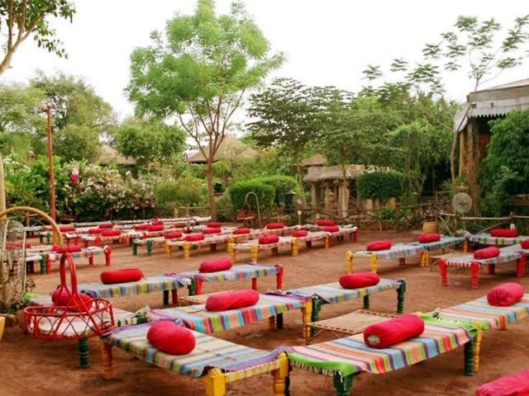

Image:3

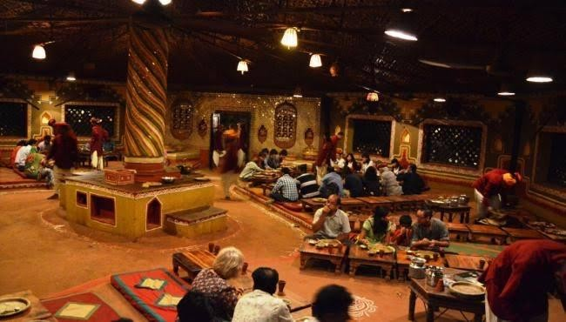

Image:4

Developing Customer persona

To develop a customer persona for The Vintage Kitchen, we need to understand the characteristics and preferences of the target audience. Here are a few potential customer personas:

- Nostalgic Homeowners: This persona is likely to be middle-aged or older and enjoys reminiscing. They appreciate vintage styles and may have fond memories of their childhood kitchens. They are likely to be interested in creating a cosy and nostalgic atmosphere in their home and may have a passion for collecting vintage kitchenware.
- Retro Enthusiasts: This persona may be younger and have a strong interest in retro and vintage styles. They may be drawn to the colourful and playful nature of vintage kitchens and appreciate the unique design elements of this style. They are likely to be active on social media and interested in sharing their vintage-inspired space with others.
- Foodies and Home Chefs: This persona is likely to be interested in cooking and entertaining and may appreciate the functionality and efficiency of a well-designed kitchen. They may appreciate the high-quality appliances and ample storage space that The Vintage Kitchen offers while still enjoying the vintage aesthetic.

- Design Aficionados: This persona may be interested in interior design and appreciate the unique and innovative elements of The Vintage Kitchen. They may be drawn to the bold colours, retro-inspired lighting, and antique appliances that make The Vintage Kitchen stand out from traditional kitchen designs.
By understanding the characteristics and preferences of these different personas, The Vintage Kitchen can effectively tailor its marketing and design strategies to appeal to its target audience.

Problem definition of The Vintage Kitchen

The Vintage Kitchen's main problem is that it caters to a niche market. The vintage kitchen style appeals to a specific group of consumers who appreciate the nostalgic, retro aesthetic, and unique design elements that come with it. However, this niche market may not be large enough to sustain the business in the long term.Additionally, the cost of acquiring and refurbishing antique appliances and other vintage kitchen accessories can be high, which can make it challenging to maintain competitive pricing. The Vintage Kitchen may need to find ways to balance the cost of these unique design elements while remaining affordable to its target audience.Another potential challenge is keeping up with modern design and technology while still maintaining the vintage aesthetic. The Vintage Kitchen needs to strike a balance between maintaining the unique charm of vintage kitchens while still incorporating modern amenities and technologies to meet the needs and preferences of today's consumers.
Finally, the limited availability of vintage appliances and accessories could also be a challenge. The Vintage Kitchen may need to be creative in finding ways to source these items to ensure that they can maintain the quality and authenticity of their vintage-inspired designs.

Conclusion

Nowadays Food Industries are one of the largest industries in the world. The food and beverage sector is a vibrant and multifaceted part of our society. Through our Vintage Kitchen restaurant, we are providing every potential customer of ours an experience of culture that they will not get in other restaurants. We are providing them with the best food with a vintage theme ambience, which makes them feel like they have entered a village of 90s style. There is no segmentation, our target people are those who have spending power. The special thing that you will find in our restaurant is that we are providing a wide variety of seasonal foods and for serving also there will be traditional ways that will make everyone dive into their culture. There will be a mix of service providers, who welcome guests with open arms and take care of their most basic needs as well as their ambas science. Our mission is to sail in the hearts and minds of every person who loves to be in their culture. To achieve this, we are looking forward to making people feel the worth of enjoying their culture through food. We want to be at the forefront of the changes in this food battle

Business Plan

CIA 2

Starting a restaurant will demand a whole lot of work. Also, the pace of failure can be quite high. But success is also totally possible. In virtually any business endeavor, success is relative. For yourself to make certain you are on the correct path towards success, you effectively need to do things. Starting a business is an exceptional idea and the medium-scale industry with the highest turnover and also with the highest day-to-day working capital. As it’s a small or medium scale hotel we have an edge or an advantage because the prime target for our business is usually middle- class people. And our business plan consists of the opening of a theme-based restaurant which is a typical village-based restaurant we call ourselves a “vintage kitchen”.

Description of idea

  - First and foremost is the theme i.e. The ambience it’s typically a village-based theme as in today’s generation we forgot our heritage and how food culture used to work so this theme was introduced to escape from their stress.
  - A restaurant without food is no restaurant, so we focused more on south Indian food with a few mixes of north Indian food like paneer, roti, etc.
  - The plates or the equipment used to serve the food will all be village-based i.e., either copper or biodegradable products such as banana leaves also whatever the leftovers are there, we'll supply it to the needy and the waste will be given to compost.
  - We also planned to first open our restaurant at Jayanagar in Bengaluru. And expand it.
  - And also, the server will be in the traditional wear which gives that authenticity and a real village look.
  - As an ambience, we’ll promote a lot of organic farming by growing seasonal vegetables to a certain extent
  - Also, some of the traditional ways of food cooking will be introduced as in Traditional Tandoor or old kitchen equipment

Business Canvas

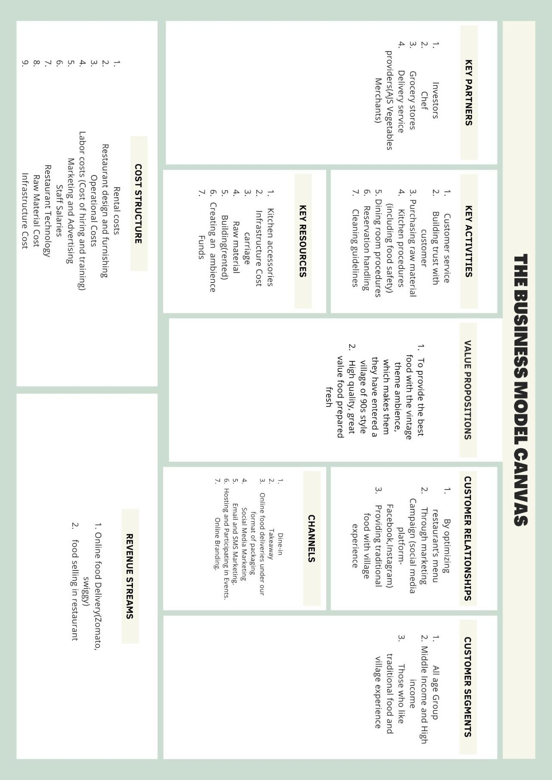

Customer Mapping journey
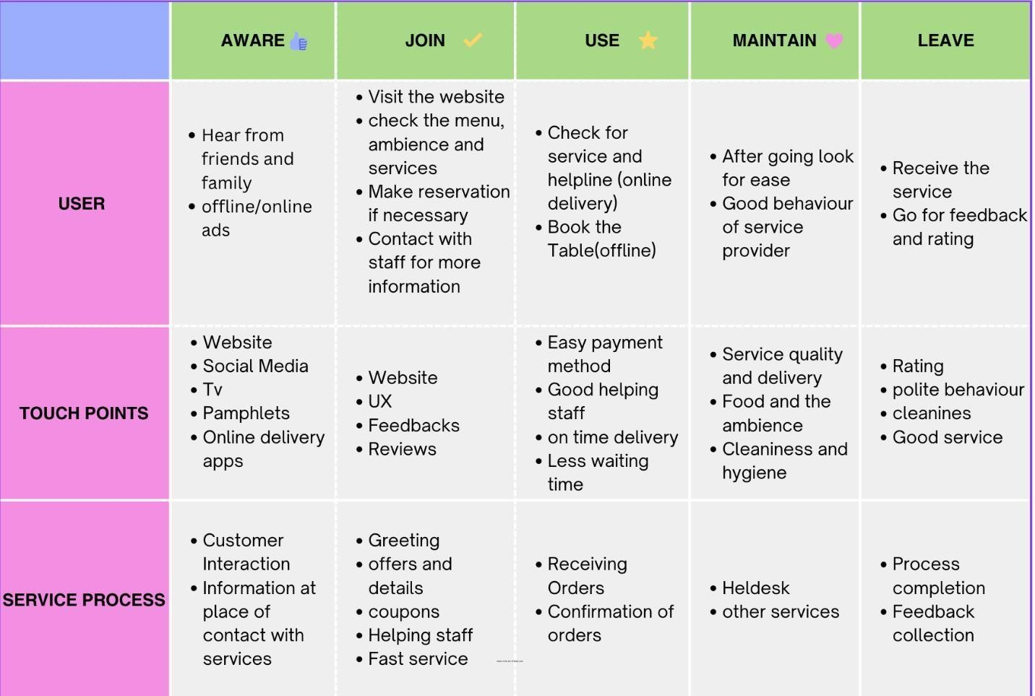
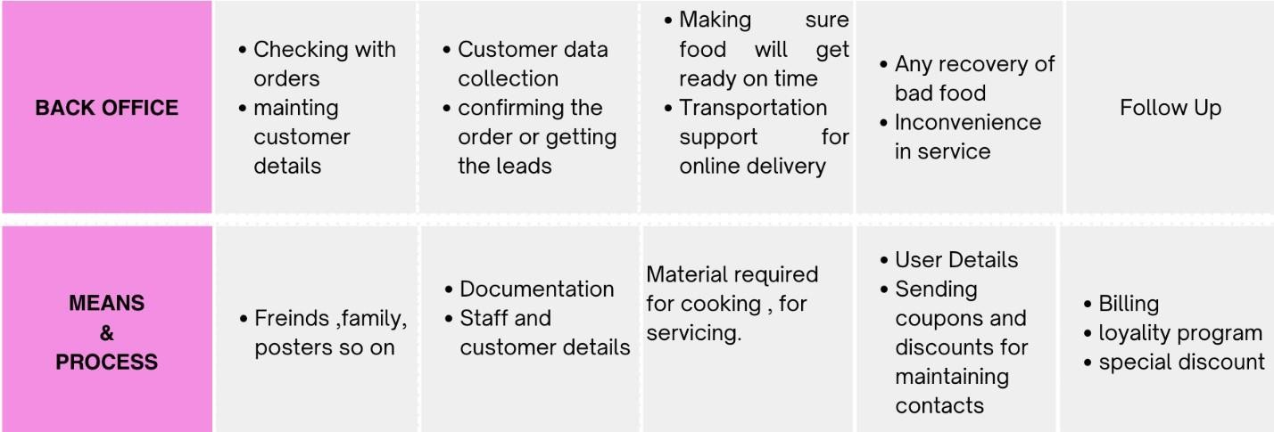

SYSTEMATIC ASSESSMENT OF IDEAS
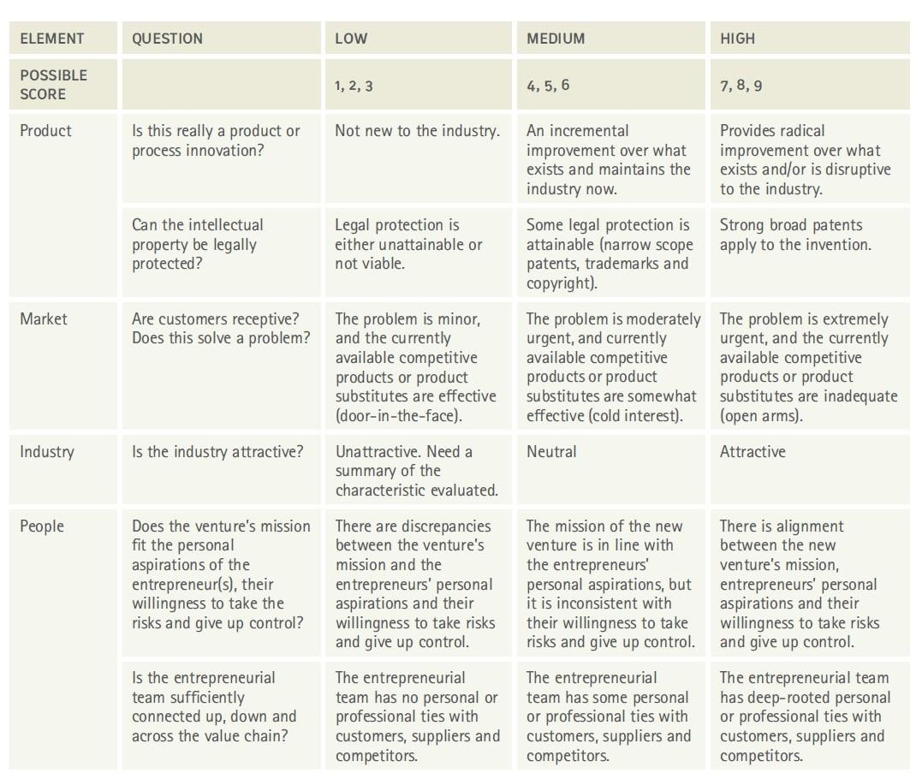IDEA ASSESSMENT – CONCEPT DEVELOPMENT – PROJECT IMPLEMENTATION

Scores

8

6

6

9

7

6

7

6

8

64
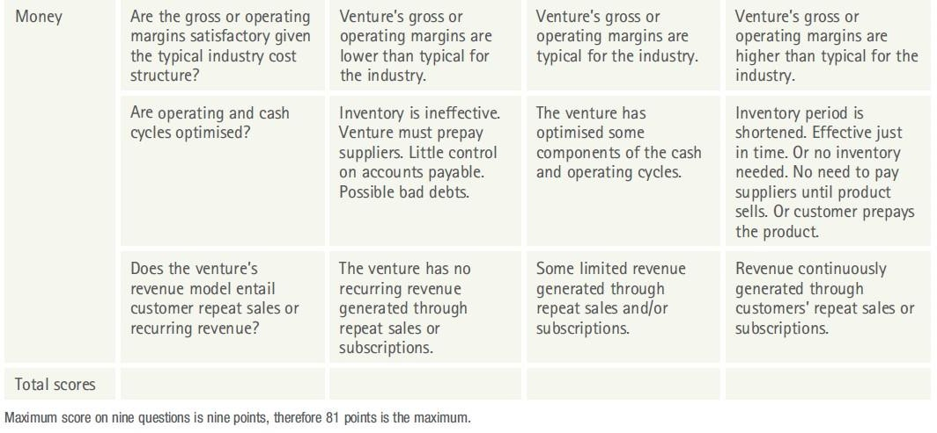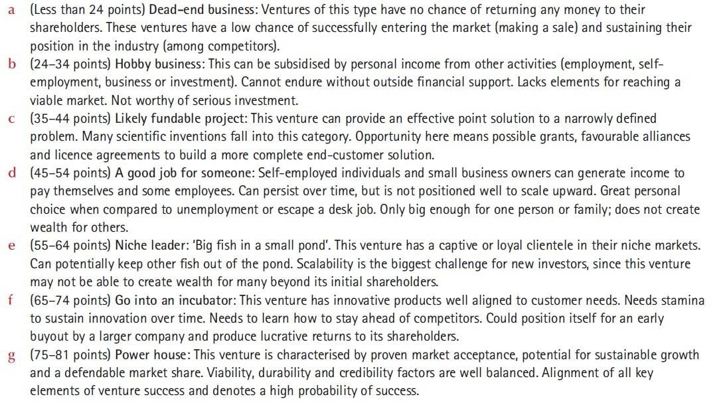

Feasibility plan outline

Name of the proposed company – The Vintage Kitchen Names of the founding members
Ajith Akash A Akshay Hondi
Meenakshi Sundaram RM Saloni Kumari
Yashika Thakur Ashwini Bhat K

Executive Summary

The Vintage Kitchen is an exceptional theme-based restaurant located in the heart of Bangalore city, Jayanagar. The restaurant's most unique selling point is its ambiance, which takes customers back to the 80s and 90s era. Natural shades of brown have been used in the decor, making the restaurant's ambiance versatile and reminiscent of traditional Indian architecture.
The restaurant caters to all customers, including senior citizens who prefer not to sit on the floor. Vintage theme seating arrangements have been made available to ensure that everyone can enjoy their dining experience comfortably.
The Vintage Kitchen focuses primarily on South Indian cuisine, with a few touches of North Indian dishes as well. However, the restaurant's long-term goal is to expand to most parts of Bangalore. In addition to delicious food, The Vintage Kitchen offers a peaceful ambiance with vintage music and organic farming on display.
For many people in their 60s, 70s, and 80s, The Vintage Kitchen is more than just a restaurant; it is a trip down memory lane. The restaurant takes them back to a time without mobile phones, where friends would gather, chat, and enjoy each other's company. The ambiance, which features slow tunes of old 80s famous songs, adds to the nostalgic atmosphere, making it a beautiful experience for everyone.

The Vintage Kitchen offers more than just food; it is an experience that takes customers back in time to relive old memories. The ambiance, food, and music combine to create a beautiful dining experience that is sure to leave customers feeling happy and satisfied.

Business Concept

The Vintage Kitchen has a unique and immersive theme that sets it apart from other restaurants in Bangalore. Its vintage ambiance, quality food, and peaceful atmosphere make it a destination for customers who want to experience more than just a meal. The restaurant's focus on South Indian cuisine, with a few touches of North Indian dishes, caters to a diverse customer base, while its long-term goal to expand to other parts of Bangalore promises future growth opportunities.
The Vintage Kitchen's value proposition lies in providing customers with a memorable dining experience that takes them back in time while enjoying authentic Indian cuisine. The restaurant's ambiance, vintage music, and organic farming on display are all part of this value proposition. Additionally, the restaurant's focus on quality ingredients and traditional cooking techniques ensures that customers have an authentic culinary experience.

Licenses

The specific licenses required for The Vintage Kitchen will depend on various factors, such as the location, the size of the restaurant, the type of food being served, and the number of employees. Generally, restaurant businesses in India require the following licenses:
- FSSAI (Food Safety and Standards Authority of India) license - for food safety and quality compliance
- GST registration - for tax compliance
- Local municipal corporation health license - for hygiene and sanitation compliance
- Fire safety certificate - for fire safety compliance
- Liquor license (if applicable) - for serving alcoholic beverages

Apart from these, the restaurant may also need to obtain licenses for music and other entertainment, if applicable. It is recommended to consult with a legal professional to determine the specific licenses required for The Vintage Kitchen based on its location and other relevant factors.

Marketing analysis

- Target Market: The Vintage Kitchen is targeting both upper and middle-class customers, focusing on senior citizens looking for a nostalgic dining experience. The restaurant's ambiance and menu are designed to appeal to customers who want to relive the past and enjoy traditional South Indian cuisine.
- Trends: There is a growing trend in the restaurant industry towards experiential dining, where customers are looking for more than just good food. They want an immersive experience that includes unique ambiance, music, and decor. The Vintage Kitchen is well- positioned to capitalize on this trend with its 80s and 90s theme and vintage music.
- Customer Age: The Vintage Kitchen's primary target market is senior citizens, but the restaurant's ambiance and menu will also appeal to younger customers who are looking for something different. The restaurant's vintage theme and traditional South Indian cuisine are likely to be popular with customers of all ages.
- Marketing Strategy: The Vintage Kitchen's marketing strategy should focus on creating awareness of the restaurant's unique ambience and menu. The restaurant could partner with local retirement communities or organizations to reach out to senior citizens, offering special discounts or promotions. Social media and online advertising could also be effective channels for reaching younger customers who are looking for an immersive dining experience.

The competition and how to overcome

The restaurant industry in Bangalore is highly competitive, with many established players in the market. However, there are few restaurants that offer a nostalgic dining experience like The Vintage Kitchen. The restaurant's unique theme and menu are likely to set it apart from competitors, and the focus on senior citizens is an untapped market in the industry
- Competitor Analysis: Unique selling proposition: The restaurant's ambiance and concept are its unique selling points. By emphasizing the nostalgic 80s and 90s theme, The Vintage Kitchen can create a unique and memorable experience that sets it apart from competitors.
- High-quality ingredients and service: The Vintage Kitchen can maintain its competitive edge by using high-quality ingredients in its dishes and providing excellent service.

Customers are willing to pay a premium for exceptional food and service, and this can help the restaurant stand out from competitors.
- Digital marketing: The Vintage Kitchen can leverage digital marketing techniques such as social media, email marketing, and search engine optimization to reach its target audience effectively. By using these channels, the restaurant can reach customers who are interested in vintage-themed dining experiences and build a loyal customer base.
- Loyalty programs: The Vintage Kitchen can implement loyalty programs to reward customers for their repeat business. The restaurant can encourage customers to return and build a loyal following by offering discounts, free items, or other incentives.
- Continuous innovation: The Vintage Kitchen can continuously innovate by introducing new menu items or events that align with its vintage theme. The restaurant can keep customers engaged and interested in returning by staying fresh and relevant.

Management Team

Our team comprises Ajith with expertise in finance, Saloni in marketing, Akashay in entrepreneurship, Sundharam in human resources, and Yashika in marketing. Each team member brings their unique skills and experience to the table, ensuring the success of our business.
At The Vintage Kitchen, we believe in offering an experience that takes our customers back in time, allowing them to relive old memories. We provide a comfortable and welcoming environment, catering to customers of all ages, including senior citizens. Our vintage theme seating arrangements make sure everyone enjoys their dining experience comfortably.
We aim to exceed our competitors by offering a unique experience, delicious food, and exceptional customer service. Our team is dedicated to ensuring that our customers leave happy and satisfied, creating a loyal customer base.

Risk

- Raw material sourcing: One of the most significant risks in the restaurant business is sourcing high-quality raw materials consistently. As a village-themed restaurant, you may

require locally sourced and organic ingredients, which can be expensive and challenging to procure.
- Government regulations: Regulations related to food safety, health and safety, licensing, and zoning can vary by region and are critical to follow. Non-compliance can lead to legal issues, fines, and even closure of the business.
- Seasonal availability of ingredients: Many village-themed restaurants feature locally grown or seasonal produce, which may not be available year-round. This can create challenges in menu planning, pricing, and customer satisfaction.
- Staffing and training: A restaurant are only as good as its staff. Finding and retaining qualified personnel can be a significant challenge, particularly in regions with low unemployment rates. Training staff to adhere to safety and hygiene protocols is critical to avoid issues with food safety and health inspections.
- Marketing and competition: Building a loyal customer base can take time and requires consistent marketing efforts. It's important to understand the local competition and differentiate the restaurant to stand out in the marketplace.
- Financial risks: Starting a new restaurant involves significant upfront investments, including equipment, rent, and marketing expenses. There is always a risk that revenue may not meet expectations, leading to cash flow issues and potential closure of the business.

Intellectual Property

- Trademarks: A trademark is a word, phrase, symbol, or design that identifies and distinguishes the source of goods or services. A village-themed restaurant may have a unique name or logo that serves as its trademark. Registering the trademark with the appropriate government agency can protect it from infringement by others.
- Copyrights: Copyright protection may apply to original artistic works, such as menu designs, graphics, photographs, and marketing materials. These works may be protected by copyright, which gives the owner the exclusive right to reproduce, distribute, and display the work.

- Patents: Patents may be relevant if the restaurant has developed a unique process or technology, such as a proprietary cooking method or equipment. Patents give the owner the exclusive right to manufacture, use, and sell the invention for a specified period.
- Trade secrets: A trade secret is a confidential business practice, formula, or process that gives a business a competitive advantage. For example, a restaurant may have a secret recipe for a popular dish. Trade secrets can be protected by non-disclosure agreements and other legal contracts.

Gaps:

There are several potential gaps that may exist in the management team of a village themed restaurant, including:
- Lack of experience: If the management team lacks experience in the restaurant industry, they may struggle with menu planning, food and labor cost management, staffing, and customer service.
- Inadequate staffing: If the management team is understaffed or lacks qualified personnel, it can lead to poor service, long wait times, and a negative customer experience.
- Poor communication: Effective communication among management team members is crucial to ensure that everyone is working towards the same goals and that issues are addressed promptly.
- Inefficient operations: If the restaurant's operations are not streamlined and efficient, it can lead to wasted resources, longer wait times, and decreased customer satisfaction.

To address these gaps, the management team can take several steps, including:

- Hire experienced staff: If the management team lacks experience, they can hire experienced personnel to fill key roles such as head chef, restaurant manager, or marketing manager.
- Conduct thorough training: Providing comprehensive training to all staff members can help ensure that they understand their roles and responsibilities, as well as the restaurant's policies and procedures.
- Foster open communication: Encouraging open communication among management team members can help ensure that issues are identified and addressed promptly.
- Implement efficient processes: Streamlining processes such as food preparation, order- taking, and table turnover can help improve efficiency and customer satisfaction.

- Monitor and adjust operations: Regularly monitoring and analyzing restaurant operations can help identify areas for improvement, such as menu offerings or staffing levels, and allow the management team to make informed decisions.
By addressing these gaps in the management team, a village-themed restaurant can increase the likelihood of success and provide a positive customer experience.

Product development analysis

- Menu Innovation: One way to keep customers interested and coming back is by continuously innovating and updating the menu. The Vintage Kitchen can experiment with new dishes, add seasonal specialties, and introduce fusion dishes that combine Indian and other international cuisines.
- Healthier Options: Another way to stand out is by providing healthier options on the menu. Customers are increasingly health-conscious and want to make healthier choices. The Vintage Kitchen can introduce healthier cooking methods, reduce oil and sugar content in dishes, and add more vegetarian and vegan options.
- Digital Presence: In today's world, having a strong digital presence is crucial for any business. The Vintage Kitchen can develop a user-friendly website, social media pages, and online ordering platforms. This will make it easier for customers to find information, place orders, and leave feedback.
- Private Dining and Catering: The Vintage Kitchen can also consider offering private dining and catering services for events and special occasions. This will increase revenue streams and give customers more options to enjoy the restaurant's food and ambiance.

Financial analysis

Revenue: The restaurant generates revenue from selling food and beverages to customers. The average price per person is INR 1,500.
Cost of goods sold: The cost of goods sold includes the cost of food, beverages, and other supplies required to prepare and serve meals. The variable cost per person is assumed to be INR 800, resulting in a contribution margin per person of INR 700.

Fixed costs: The fixed costs include expenses such as rent, salaries, utilities, insurance, and maintenance costs. The total fixed costs are assumed to be INR 2,500,000 per year.
Sales mix: The sales mix is assumed to be evenly split between food and beverages.

Operating expenses: The operating expenses include expenses such as marketing and advertising, legal and professional fees, and other general and administrative expenses. These expenses are assumed to be INR 500,000 per year.
Interest expense: The restaurant has a loan with a 5% interest rate, resulting in an annual interest expense of INR 125,000.
Depreciation: The restaurant's equipment has a useful life of five years and is depreciated using the straight-line method.
Income tax: The income tax rate is assumed to be 30% of the restaurant's taxable income.

Assumptions:

- The restaurant serves lunch and dinner.
- The restaurant operates for 30 days in a month.
- The restaurant has 50 seats and is fully occupied during lunch and dinner.
- The restaurant is open for 7 hours during lunch and dinner.
- The restaurant has 10 staff members and each staff member is paid a monthly salary of 20,000 Indian Rupees.
- The restaurant incurs monthly rent, utility, and other expenses of 100,000 Indian Rupees.
- Monthly Revenue:
- Assuming 50 customers per mealtime, the restaurant serves a total of 100 customers per day.
- At a per-person spending of 1500 Indian Rupees, the restaurant generates 150,000 Indian Rupees in revenue per day.
Monthly revenue can be calculated as: 150,000 x 30 = 4,500,000 Indian Rupees. Monthly Expenses:
Staff salaries: 10 x 20,000 = 200,000 Indian Rupees

Rent, utilities, and other expenses: 100,000 Indian Rupees Total monthly expenses: 300,000 Indian Rupees
Monthly Profit:

Monthly profit can be calculated as: Monthly revenue - Monthly expenses = 4,500,000 - 300,000
= 4,200,000 Indian Rupees. Profit Margin:
Profit margin can be calculated as: Monthly profit / Monthly revenue x 100 = 4,200,000 / 4,500,000 x 100 = 93.33%.
Based on these assumptions and calculations, the restaurant has the potential to generate a monthly profit of 4,200,000 Indian Rupees with a profit margin of 93.33%. However, these calculations are based on the assumptions provided and may vary depending on the actual operational costs and other factors affecting the restaurant's revenue and expenses

Establishment cost

Establishment Cost | Amount (INR)
Rent and Security Deposit | INR 500,000
Kitchen Equipment and Installation | INR 3,000,000
Dining Room Furniture and Decor | INR 1000,000
Licensing and permits | INR 15,00,000
Initial Inventory and Supplies | INR 500,000

Marketing and Advertising | INR 100,000
Legal and Professional Fees | INR 50,000
Contingency Fund (10% of total cost) | INR 275,000
Total Establishment Cost | INR6425000

Pro Forma Statement

Pro Forma Income Statement | Year 1 | Year 2 | Year 3
Revenue | INR 10,000,000 | INR 12,000,000 | INR 15,000,000
Cost of Goods Sold | INR 3,500,000 | INR 4,000,000 | INR 5,000,000
Gross Profit | INR 6,500,000 | INR 8,000,000 | INR 10,000,000
Operating Expenses:
Rent | INR 600,000 | INR 650,000 | INR 700,000
Utilities | INR 200,000 | INR 220,000 | INR 240,000
Salaries and wages | INR 1,200,000 | INR 1,400,000 | INR 1,600,000

Advertising and promotion | INR 150,000 | INR 200,000 | INR 250,000
Depreciation | INR 100,000 | INR 100,000 | INR 100,000
Other expenses | INR 250,000 | INR 300,000 | INR 350,000
Total Operating Expenses | INR 2,500,000 | INR 2,920,000 | INR 3,240,000
Operating Income | INR 4,000,000 | INR 5,080,000 | INR 6,760,000
Interest Expense | INR 50,000 | INR 40,000 | INR 30,000
Net Income Before Taxes | INR 3,950,000 | INR 5,040,000 | INR 6,730,000
Income Tax Expense | INR 950,000 | INR 1,212,000 | INR 1,614,500
Net Income After Taxes | INR 3,000,000 | INR 3,828,000 | INR 5,115,500

Break-even analysis

Units Sold | Profit | Unit Sales | Variable Costs | Fixed Costs | Total Costs | Break- Even  Point
0 | −₹600,000 | ₹ 0 | ₹ 0 | ₹700,000 | ₹ 7,00,000 | -
300 | −₹400,000 | ₹ 3,60,000 | ₹ 2,00,000 | ₹700,000 | ₹ 9,00,000 | 514.29
750 | −₹300,000 | ₹ 7,20,000 | ₹ 4,00,000 | ₹700,000 | ₹ 11,00,000 | 766.67
1,000 | −₹145,000 | ₹ 10,80,000 | ₹ 6,00,000 | ₹700,000 | ₹ 13,00,000 | 917.91
1,500 | ₹ 0 | ₹ 14,06,700 | ₹ 7,00,000 | ₹700,000 | ₹ 14,00,000 | 1,000.00
1,600 | ₹ 15,000 | ₹ 14,40,000 | ₹ 8,00,000 | ₹700,000 | ₹ 15,00,000 | 1,041.67
2,000 | ₹ 1,75,000 | ₹ 18,00,000 | ₹ 10,00,000 | ₹700,000 | ₹ 17,00,000 | 1,214.29
2,400 | ₹ 3,35,000 | ₹ 21,60,000 | ₹ 12,00,000 | ₹700,000 | ₹ 19,00,000 | 1,350.00

2,800 | ₹ 4,95,000 | ₹ 25,20,000 | ₹ 14,00,000 | ₹700,000 | ₹ 21,00,000 | 1,485.71

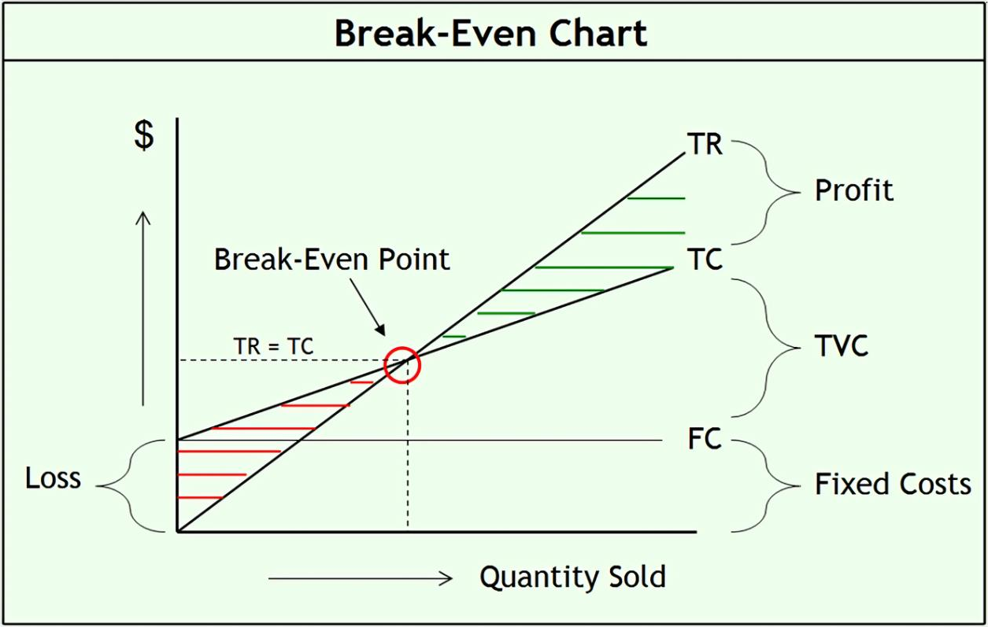

Conclusion

The Vintage Kitchen is a unique theme-based restaurant that caters to a wide range of customers, including senior citizens. Its ambiance, food, and vintage music make it a beautiful experience that takes customers back in time to relive old memories. The restaurant's focus on South Indian cuisine, with a few touches of North Indian dishes, sets it apart from other restaurants in the area.
Based on the marketing analysis, there is a growing trend towards nostalgia and experiences that take customers back in time. The Vintage Kitchen caters to this trend by providing an ambiance that is reminiscent of the 80s and 90s era. The target customer age group of 30-60 years, with a focus on senior citizens, also presents a promising market.
Competitive analysis shows that there are several other restaurants in the area, but The Vintage Kitchen's unique selling proposition sets it apart from the competition. However, there is always room for improvement and the restaurant can further exceed the competition by focusing on product development and customer satisfaction.
Overall, The Vintage Kitchen has the potential to be a successful business in the restaurant industry with its unique value proposition, customer focus, and continuous efforts to improve the dining experience.

CIA 03

Case Study Scenario 1:
Case Study: The Vintage Kitchen - Addressing the Issue of Food Waste Introduction:
The Vintage Kitchen is a theme-based restaurant located in Bangalore that specializes in traditional Indian cuisine. The restaurant offers a unique ambience that takes customers back to the 80s and 90s era, along with vintage music and organic farming on display. Despite being a successful business, the restaurant faces a significant challenge in addressing the issue of food waste, which is a growing problem in society. This case study explores the challenges faced by The Vintage Kitchen in managing food waste and how they can overcome this issue.

Background:

Food waste is a significant issue that affects businesses across the food industry. In India, it is estimated that nearly 40% of the food produced is wasted, which translates to approximately 68 million tonnes of food per year. The primary reasons for food waste are overproduction, spoilage, and improper storage. As a result, food waste not only leads to significant economic losses but also has environmental and social implications.
The Vintage Kitchen is not immune to this problem, despite being a theme-based restaurant that specializes in traditional Indian cuisine. The restaurant's success has led to increased demand, which has also led to higher levels of food waste. The management team at The Vintage Kitchen recognizes the importance of addressing this issue and is actively seeking ways to reduce food waste.

Challenges:

The challenges faced by The Vintage Kitchen in managing food waste are significant. Firstly, the restaurant specializes in traditional Indian cuisine, which requires the use of fresh ingredients. This means that the restaurant cannot compromise on the quality of its food, which may result in a

higher level of waste. Additionally, the restaurant's vintage theme means that it cannot use modern technology such as refrigerators and food preservatives to extend the shelf life of its food.
Secondly, the restaurant faces a logistical challenge in managing its food waste. The restaurant is in an urban area, and there are limited options for food waste disposal. The management team must find ways to dispose of food waste in an environmentally friendly manner while complying with local regulations.
Thirdly, the restaurant's success has led to increased demand, which means that it must maintain a consistent level of food quality and quantity. This means that the restaurant cannot reduce its production levels to minimize food waste without impacting its revenue.

Conclusion:

In conclusion, The Vintage Kitchen is a successful theme-based restaurant that specializes in traditional Indian cuisine. However, it faces a significant challenge in managing food waste, which is a growing problem in society. The management team recognizes the importance of addressing this issue and can adopt several solutions to reduce its food waste. By adopting a zero-waste policy, implementing a food waste management program, and partnering with local farmers and food banks, The Vintage Kitchen can overcome the challenge of managing food waste and continue to provide high-quality traditional Indian cuisine to its customers

The Vintage Kitchen: Promoting Sustainable Practices through Food Waste Reduction and Recycling
The issue of food waste is a major concern in the food industry, and The Vintage Kitchen can take steps to address this problem while also promoting sustainable practices. One solution would be to implement a "zero-waste" policy, which would involve reducing food waste by using all parts of ingredients, composting leftover food, and recycling packaging materials. This policy can be communicated to customers through signage and promotional materials, educating them about the restaurant's commitment to sustainability.
Another way to address food waste is to donate excess food to local food banks or shelters. The Vintage Kitchen can work with local organizations to ensure that their excess food is distributed to those in need, reducing waste and helping those who are less fortunate. This initiative can be

advertised on social media and the restaurant's website to showcase their commitment to social responsibility.
Furthermore, The Vintage Kitchen can work with local farmers to source fresh, locally grown produce. By supporting local farmers, the restaurant can reduce its carbon footprint and promote sustainable agriculture practices. The restaurant can also use seasonal ingredients, which not only promotes sustainability but also ensures that the food is fresher and more flavorful.

Reducing Food Wastage and Maintaining Profitability at The Vintage Kitchen

Food wastage is a serious issue that not only affects the environment but also the business's profitability. The Vintage Kitchen can implement various measures to reduce food wastage while maintaining profitability. Here are some ways:
- Conduct a thorough inventory analysis: The Vintage Kitchen can conduct a thorough inventory analysis to understand the quantity of ingredients they need to prepare a dish. This will help them reduce over-ordering ingredients that may expire or go to waste.
- Use proper storage techniques: Proper storage techniques can prevent food from spoiling. The Vintage Kitchen can implement proper storage techniques like labeling and organizing food items in their refrigerator and freezer to ensure that they are used before their expiration dates.
- Create a standardized recipe book: Creating a standardized recipe book with precise ingredient measurements can help The Vintage Kitchen avoid overcooking or undercooking, which may lead to food wastage. This can also help with inventory control and reduce food costs.
- Implement portion control: Implementing portion control can help reduce the amount of food that is wasted. The Vintage Kitchen can encourage customers to order only what they can eat or offer smaller portions at a lower price.
- Donate excess food: The Vintage Kitchen can donate excess food to food banks or charities that can distribute it to those in need. This can help reduce food waste while also making a positive impact on the community.

- Create a composting program: The Vintage Kitchen can create a composting program to reduce food waste. The compost can be used to fertilize plants or vegetables in the restaurant's garden or donated to a community garden.

The Vintage Kitchen measures to educate customers on the importance of reducing food wastage.
The Vintage Kitchen can take various measures to educate customers on the importance of reducing food wastage. Here are some ways:
- Display signs: The Vintage Kitchen can display signs that encourage customers to take only what they can eat or remind them of the consequences of food wastage. This can be done through posters or table tents placed on each table.
- Host events: The Vintage Kitchen can host events that raise awareness about food wastage. They can collaborate with non-profit organizations that specialize in food waste reduction and organize events like cooking classes, food drives, or workshops.
- Offer takeout containers: The Vintage Kitchen can offer takeout containers to customers who do not finish their meals. This will encourage customers to take their leftovers home rather than leaving them on their plates.
- Share stories: The Vintage Kitchen can share stories about how they are reducing food wastage on their website or social media platforms. This will help customers understand the restaurant's commitment to reducing food wastage and inspire them to do the same.
- Train employees: The Vintage Kitchen can train their employees on the importance of reducing food wastage and encourage them to educate customers about it. This can be done through staff meetings, training sessions, or informative posters displayed in the employee area.

The Vintage Kitchen collaborate with other businesses and organizations to address the issue of food wastage in the community
Collaborating with other businesses and organizations can help The Vintage Kitchen address the issue of food wastage in the community. Here are some ways:

- Donate excess food: The Vintage Kitchen can collaborate with food banks or charities and donate excess food. This can help reduce food wastage while also making a positive impact on the community.
- Partner with suppliers: The Vintage Kitchen can partner with their suppliers to ensure that they are not over-ordering ingredients. This can help reduce food wastage and promote sustainability in the supply chain.
- Participate in food recovery programs: The Vintage Kitchen can participate in food recovery programs organized by the local

The Vintage Kitchen expanding its customer base beyond the senior citizen demographic

While The Vintage Kitchen's ambience and theme may appeal primarily to senior citizens, the restaurant can take steps to expand its customer base beyond this demographic. One strategy would be to create a more diverse menu that appeals to a wider range of customers. For example, the restaurant can offer vegetarian and vegan options, as well as dishes that cater to specific dietary requirements such as gluten-free or dairy-free.
Another strategy would be to engage in targeted marketing efforts. The restaurant can partner with local businesses and events to increase its visibility and attract new customers. Social media campaigns and email newsletters can also be used to reach out to potential customers and promote the restaurant's unique ambiance and menu offerings.
The Vintage Kitchen can also host special events, such as live music performances, wine tastings, and cooking classes, to attract a diverse clientele. These events can be advertised on the restaurant's website and social media pages, and targeted towards specific demographics such as millennials or families.

The Vintage Kitchen ensure consistency in food quality and customer service as it expands to new locations.
As The Vintage Kitchen expands to new locations, maintaining consistency in food quality and customer service is critical to ensuring customer loyalty and positive reviews. To achieve this, the restaurant can implement a standard operating procedure (SOP) that outlines the specific steps to be taken in each aspect of the business, from food preparation to customer service.

In addition, the restaurant can invest in training programs for employees, ensuring that they are well-equipped to deliver high-quality service and maintain the restaurant's standards. This can include regular training sessions on food preparation, customer service, and hygiene practices.
Moreover, The Vintage Kitchen can utilize technology to maintain consistency across multiple locations. This can include implementing a centralized inventory and ordering system, as well as using software to track customer feedback and monitor quality control measures.
Finally, regular quality control checks and customer feedback surveys can be conducted to ensure that the restaurant is meeting its standards and addressing any issues that arise. By continuously monitoring and improving its processes, The Vintage Kitchen can maintain consistency and ensure a positive customer experience across all locations.

Scenario 2:

Case Study: The Vintage Kitchen and the Challenge of Adapting to Changing Consumer Preferences

Introduction:

The Vintage Kitchen is a theme-based restaurant located in the Jayanagar area of Bangalore city. The restaurant's ambiance takes customers back to the 80s and 90s era with natural shades of brown in its decor. The Vintage Kitchen primarily focuses on South Indian cuisine with a few touches of North Indian dishes. Its unique selling point is its ambiance, which has been a favorite among senior citizens. The restaurant offers vintage theme seating arrangements for comfortable dining. In addition, The Vintage Kitchen offers a peaceful ambiance with vintage music and organic farming on display.
The restaurant has noticed a shift in the demographics of its customers, with more young professionals and tourists visiting the place. These new customers are more health-conscious and prefer international cuisine, unlike the traditional South Indian dishes that The Vintage Kitchen is known for. As a result, the restaurant has seen a decline in its footfall and revenue.

The Challenge of Adapting to Changing Consumer Preferences

The Vintage Kitchen has faced the significant challenge of adapting to changing consumer preferences. The shift in the demographics of its customers has led to a decline in footfall and revenue. The restaurant's traditional South Indian cuisine, which was once its strength, has become a disadvantage in attracting new customers.
The restaurant has noticed that young professionals and tourists prefer international cuisine and are more health-conscious. To address this challenge, The Vintage Kitchen has to adapt and offer a diverse menu that caters to the changing preferences of its customers. The restaurant needs to introduce new dishes that are healthy, and international, and still maintain the essence of its vintage theme.

The Vintage Kitchen adapting to changing consumer preferences without losing its traditional identity
Adapting to changing consumer preferences without losing traditional identity:

To adapt to changing consumer preferences, The Vintage Kitchen needs to take a multi-pronged approach that balances innovation with tradition. The restaurant can explore options to include healthier alternatives in its menu while retaining the traditional flavors and spices. For example, it can introduce salads, soups, and vegan options without compromising on the traditional South Indian cuisine.
The restaurant can also offer cooking classes and workshops to teach customers how to make healthy and traditional South Indian dishes at home. This can attract health-conscious customers who are looking to learn how to cook nutritious meals.
Another approach is to offer fusion cuisine, where the traditional South Indian dishes are blended with international flavors. For example, the restaurant can introduce dosa wraps with fillings inspired by Mexican, Italian, or Middle Eastern cuisine. This can appeal to both traditional and modern customers and provide a unique culinary experience.

Marketing strategies to attract young professionals and tourists:

To attract young professionals and tourists, The Vintage Kitchen can adopt the following marketing strategies:
- Social media marketing: The restaurant can leverage social media platforms like Instagram, Facebook, and Twitter to showcase its traditional ambiance, menu, and unique dining experience. It can also collaborate with food bloggers, influencers, and travel bloggers to reach a wider audience.
- Online ordering and delivery: The restaurant can offer online ordering and delivery services to cater to the busy schedules of young professionals and tourists. This can help the restaurant reach a wider audience and improve its revenue.
- Seasonal promotions and discounts: The Vintage Kitchen can offer seasonal promotions and discounts to attract tourists and young professionals. For example, it can offer a discount on the total bill for customers who visit during the monsoon season or offer a free dessert with a meal during festivals like Diwali or Christmas.
- Community outreach: The restaurant can collaborate with local businesses, hotels, and tourist attractions to promote its unique dining experience. For example, it can offer a

discount to customers who visit the restaurant after visiting a nearby museum or monument.

Leveraging technology to improve operations and customer experience:

To improve its operations and customer experience, The Vintage Kitchen can leverage technology in the following ways:
- Online reservation system: The restaurant can introduce an online reservation system that allows customers to book a table in advance. This can help the restaurant manage its seating capacity and reduce wait times for customers.
- Mobile app: The Vintage Kitchen can develop a mobile app that allows customers to order food, pay bills, and earn loyalty points. This can improve the restaurant's customer experience and reduce waiting times for customers.

measures The Vintage Kitchen take to improve customer experience and increase customer loyalty
The Vintage Kitchen can take several measures to improve customer experience and increase customer loyalty. Some of these measures include:
- Personalization: Personalizing the dining experience can go a long way in improving customer satisfaction and loyalty. The Vintage Kitchen can collect data on customer preferences and use this information to personalize their dining experience. This can include customized menu items, special seating arrangements, and personalized greetings.
- Consistent Quality: Maintaining consistent quality is critical to building a loyal customer base. The Vintage Kitchen can achieve this by implementing standard operating procedures for food preparation, presentation, and service. This can ensure that customers receive the same high-quality experience every time they visit the restaurant.
- Online Presence: In today's digital age, having a strong online presence is essential to attracting and retaining customers. The Vintage Kitchen can leverage social media platforms like Facebook, Instagram, and Twitter to engage with customers, share updates about the restaurant, and offer special promotions and discounts.
- Loyalty Programs: Loyalty programs can be an effective way to incentivize customers to return to the restaurant. The Vintage Kitchen can offer rewards like discounts, free meals,

or exclusive offers to customers who frequent the restaurant. This can help build a loyal customer base and drive repeat business.
- Customer Feedback: Collecting feedback from customers can help The Vintage Kitchen identify areas for improvement and address customer concerns. The restaurant can implement tools like comment cards, online surveys, and social media polls to gather feedback from customers. Acting on this feedback can help improve the overall customer experience and increase loyalty.

The Vintage Kitchen expand its business while maintaining its core values and unique brand identity
Expanding the business while maintaining core values and unique brand identity can be a challenging task. However, The Vintage Kitchen can take several measures to ensure a successful expansion:
Thorough Planning: The Vintage Kitchen must carefully plan its expansion, considering factors like location, target audience, and competition. This can include conducting market research, analyzing customer data, and creating a detailed business plan.
- Consistency: Maintaining consistency in food quality, service, and ambiance is crucial to maintaining the brand's identity. The Vintage Kitchen must ensure that each new location adheres to the same standards and values as the original restaurant.
- Strong Leadership: Strong leadership is essential to maintaining the brand's identity during expansion. The Vintage Kitchen should have a dedicated team in place to oversee the expansion, including a project manager, operations manager, and marketing manager.
- Scalable Systems: The Vintage Kitchen must ensure that its systems and processes can scale effectively during expansion. This includes implementing technology solutions for inventory management, staff scheduling, and customer service.
- Innovative Marketing: The Vintage Kitchen can leverage innovative marketing strategies to differentiate itself from competitors and maintain its unique brand identity. This can include experiential marketing, social media campaigns, and partnerships with local businesses and organizations.

Conclusion

The Vintage Kitchen has faced the significant challenge of adapting to changing consumer preferences. The shift in the demographics of its customers has led to a decline in footfall and revenue. The restaurant needs to adapt and offer a diverse menu that caters to the changing preferences of its customers. The Vintage Kitchen needs to introduce new dishes that are healthy,

