FORMULATION AND IN VITRO EVALUATION OF NEOMYCIN SULPHATE LOADED HYDROGEL FILM FOR TREATMENT OF WOUND HEALING

By

Mr. Kushwah Prakash Enrollment No: 212420820004

Under the guidance of

Dr. Dhaval J Patel M.Pharm, Ph.D, Professor & Head
Department of Pharmaceutics

A Thesis Submitted To
Gujarat Technological University in Partial Fulfillment of the Requirements for
The Master of Pharmacy in Pharmaceutics

May-2023


Department of Pharmaceutics
Saraswati Institute of Pharmaceutical Sciences, Dhanap, Gandhinagar- 382355, Gujarat, India

CERTIFICATE

This is to certify that research work embodied in this thesis entitled “FORMULATION AND INVITRO EVALUATION OF NEOMYCIN SULPHATE LOADED HYDROGEL FILM FOR TREATMENT OF WOUND HEALING’’ was carried out by Mr. KUSHWAH PRAKASH, Enrollment No: 212420820004 at Saraswati Institute of Pharmaceutical Sciences (242) for partial fulfilment of M.Pharm. Degree to be awarded by Gujarat Technological University. This research work has been carried out under my guidance and supervision and it is up to my satisfaction.

Date: 10 /05/2023
Place: Dhanap, Gandhinagar

Signature and Name of guide: Signature and Name of Principal:

Dr. Dhaval J. Patel Dr. Ankit B. Chaudhary
M.Pharm., Ph.D., M.Pharm., Ph.D., FICS, PGDRA
Professor & HOD, PRINCIPAL
Pharmaceutics

COMPLIANCE CERTIFICATE
This is to certify that research work embodied in this thesis entitled “FORMULATION AND INVITRO EVALUATION OF NEOMYCIN SULPHATE LOADED HYDROGEL FILM FOR TREATMENT OF WOUND HEALING’’ was carried out by Mr. KUSHWAH PRAKASH, Enrollment No: 212420820004 at Saraswati Institute of Pharmaceutical Sciences (242) for partial fulfilment of M.Pharm. Degree to be awarded by Gujarat Technological University. She has complied to the comments given by the DP-I as well as Mid Semester Thesis Reviewer to my satisfaction.
Date: //2023
Place: Dhanap, Gandhinagar.
Signature and Name of Student: | Signature and Name of Guide:
Mr. kushwah Prakash | Dr. Dhaval J. Patel

PAPER PUBLICATION CERTIFICATE
This is to certify that research work embodied in this thesis entitled “FORMULATION AND INVITRO EVALUATION OF NEOMYCIN SULPHATE LOADED HYDROGEL FILM FOR TREATMENT OF WOUND HEALING’’ was carried out by Mr. Kushwah Prakash, Enrollment No: 212420820004 at Saraswati Institute of Pharmaceutical Sciences (242) for partial fulfilment of M. Pharm. degree to be awarded by Gujarat Technological University, has not published article.
Date: / /
Place: Dhanap, Gandhinagar.

Signature and Name of Student: | Signature and Name of Guide:
Mr. Kushwah Prakash | Dr. Dhaval J. Patel
Signature and Name of Principal:
Dr. Ankit B. Chaudhary

Seal of Institute

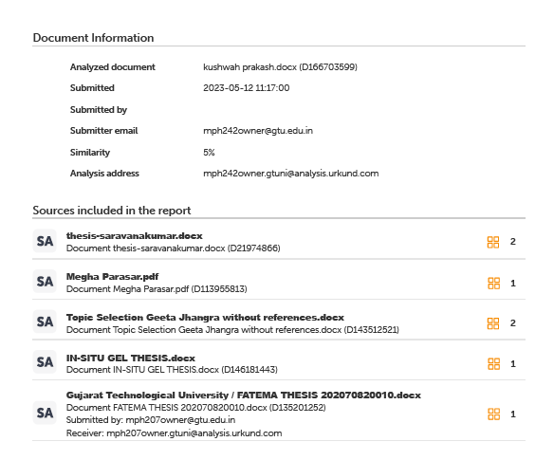
REPORT OF % SIMILARITY PREPARED USING URKUND

Date:
Place: Dhanap, Gandhinagar.

Signature and Name of Student: | Signature and Name of Guide:
Mr. Kushwah Prakash | Dr. Dhaval J. Patel
Enrollment No: 212420820004 | M.Pharm., Ph.D.,
 | Professor & Head,
 | Department of Pharmaceutics

DECLARATION OF ORIGINALITY

We hereby certify that we are the sole authors of this thesis and that neither any part of this thesis nor the whole of the thesis has been submitted for a degree to any other University or Institution.
We certify that, to the best of our knowledge, the current thesis does not infringe upon anyone’s copyright nor violate any proprietary rights and that any ideas, techniques, quotations or any other material from the work of other people included in our thesis, published or otherwise, are fully acknowledged in accordance with the standard referencing practices. Furthermore, to the extent that we have included copyrighted material that surpasses the boundary of fair dealing within the meaning of the Indian Copyright (Amendment) Act 2012, we certify that we have obtained a written permission from the copyright owner(s) to include such material(s) in the current thesis and have included copies of such copyright clearances to our appendix. We declare that this is a true copy of thesis, including any final revisions, as approved by thesis review committee.
We have checked write up of the present thesis using anti-plagiarism database and it is in allowable limit. Even though later on in case of any complaint pertaining of plagiarism, we are sole responsible for the same and we understand that as per UGC norms, University can even revoke Master of Pharmacy degree conferred to the student submitting this thesis.

Date:
Place: Dhanap, Gandhinagar.

Signature of Student: | Signature of Guide:
Student: Mr. Kushwah Prakash | Guide: Dr. Dhaval J. Patel
Enrollment No: 212420820004 | Institute Code: 242

THESIS APPROVAL

This is to certify that research work embodied in thesis entitled
“FORMULATION AND INVITRO EVALUATION OF NEOMYCIN SULPHATE LOADED HYDROGEL FILM FOR TREATMENT OF WOUND HEALING’’ carried out by Mr. kushwah Prakash, Enrollment No: 212420820004 studying at Saraswati Institute of Pharmaceutical Sciences (242) is approved / disapproved for partial fulfillment of the degree of Master of Pharmacy with
specialization of Pharmaceutics by Gujarat Technological University.
Date:
Place:
Examiners Sign & Name:
1.
2.

“SHREE GANESHAY NAMAH”



Dedicated To My Beloved Family

ACKNOWLEDGEMENT

Ever since the earth has taken birth and men emerged on it; an unending quest to unravel the truth – the research – is continued. It has widened human vision, opened newer avenues and lightened the dark – obscure facets of mysterious universe. Today, at the acme of my dissertation, with heartiness, I gratefully remember my parents, teacher, friends, relatives and well-wishers; as one flower makes no garland. This presentation would not have taken shape without their whole hearted encouragement and live involvement.
To my esteem guide, Dr. Dhaval Patel Department of Pharmaceutics, I wish to express my sincere gratitude for his unceasing encouragement, timely help so often sought and so generously given throughout this work. Above all, his unbiased observation in all kinds of works inspired me a great deal to arrive at a proper conclusion. It is a pleasure and privilege for me to acknowledge gratefully the interest and attention so generously lavished by him.
At this moment how can I forget my friends and colleagues, I really had good time with them all.
I am and will always be in debt to my mom, Dad and Relatives for their love, care and motivation. Only because of them I am at this stage in my life. I will never forget their continuous encouragement throughout my course of study. All I know is that without their care and faith in me it was impossible to reach at this stage of my life.

Kushwah Prakash
(B.Pharm)

Table of Content

Title Page  Certificate  Page Compliance Certificate  Report of % Similarity  Undertaking about Originality  Dedication Page  Acknowledgements  Table of Content  List of Figure  List of Table  Abstract  Chapter 1: INTRODUCTION  1.1 Introduction of Drug Delivery System  1.2 Introduction of Drug  Chapter 2: LITERATURE REVIEW  2.1 Review of Literature on Drug  2.2 Review of Literature on Hydrogel Films  2.3 Summary of PSAR Report  Chapter 3: AIM & OBJECTIVES  3.1 Aim of Work  3.2 Rationale  3.3 Objectives of Work  Chapter 4: MATERIALS AND EQUIPMENTS  4.1 List of Materials  4.2 List of Equipment  Chapter 5: EXPERIMENTAL WORK  5.1 EXPERIMENTAL WORK  5.2 Preparation of Hydrogel film  5.3 Evaluation of NS Hydrogel film  Chapter 6: RESULTS & DISCUSSION  Chapter 7: CONCLUSION  Chapter 8: REFERENCES  Appendix A List of Abbreviations  Appendix B DP-I Review Card  Appendix C MID SEM Review Card  Appendix D Review Card Comments & Justification | i  ii  iii  iv  vi  viii  ix  x  xii  xiii  xiv  1  1  6  6  8  10  12  13  13  13  13  14  14  14  15  15  15  16  21  30  31  32  33  34  35

List of Figure

Figure 1.1Marketed Preparation.  Figure 5.1 Calibration curve of NS.  Figure 6. 1 Hydrogel film of HPMC and Sodium alginate  Figure 6.1 Determination of water content  Figure 6.2 FTIR Spectra of SA, NS, FILM.  Figure 6.3 DSC Spectra of SA, NS, FILM.  Figure 6.4 In vitro Drug Release of NS.  Figure 6.16 Drug release comparison with marketed product. | 7  15  22  25  26  27  28  29

List of Table
Table 1.1 Drug Information  Table4.1 List of materials  Table4.2 List of equipment  Table5.1 Data for calibration curve of NS  Table5.2 Formulation of NS film  Table6.1 Evaluation of prepared hydro gel film  Table6.2 Microbial Penetration Test  Table6.3 Effect of Films on the pH of the Environment  Table6.4 Kinetic Models Regression and the value of n for NS hydrogel film | 6  14  14  15  16  22  27  29  29

FORMULATION AND IN VITRO EVALUATION OF NEOMYCIN SULPHATE LOADED HYDROGEL FILM FOR TREATMENT OF WOUND HEALING

Submitted By

Mr. Kushwah Prakash
Enrollment No: 212420820004

Supervised By Dr. Dhaval J Patel M. Pharm, PhD, Professor & Head
Department of Pharmaceutics

ABSTRACT
Introduction:
The aim of this study is to evaluate Neomycin-loaded sodium alginate/HPMC/Gellan gum hydrogel membranes, supplemented with Propylene glycol (a plasticizer), Calcium chloride (a cross-linking agent) as potential wound dressing materials based on their physicochemical properties and the sustain-release phenomenon.
Materials and Methods:
The physicochemical properties of the prepared hydrogel membranes were evaluated by several methods including Fourier transform infrared and differential scanning calorimetry. Different techniques were used to assess the swelling behavior, elongation, water vapor transmission rate (WVTR), and microbial penetration for the hydrogel membranes. In vitro neomycin release from the hydrogel membranes was examined using the Franz diffusion cell. Four kinetics models (zero-order, first-order, Higuchi equation, and Korsmeyer-Peppas equation) were applied to study drug release kinetics.
Result:
The addition of PG (15%w/w) was increase in the flexibility/elasticity of the hydrogel membranes. WVTR results suggest that hydrated hydrogel membranes can facilitate water vapor transfer.

None of the hydrogel membranes supported microbial growth. Sodium alginate-treated hydrogel membranes allow slow, but sustained, release of Neomycin for 8 h. Drug release kinetics revealed that both diffusion and dissolution play an important role in neomycin release.
Conclusion:
Given their physicochemical properties and neomycin release pattern, sodium alginate-treated hydrogel membranes exhibit effective and sustained drug release. Furthermore, sodium alginate treated hydrogel membranes possess physiochemical properties that make them effective and safe wound dressing materials.
Keywords:
Neomycin, Hydrogel membrane, in vitro drug release, sodium alginate, wound dressing.

Introduction of Drug Delivery System

1.1.1 Introduction of Hydrogel Films¹⁻⁵
Networks of polymers that have been significantly water-inflated. Hydrophilic gels are networks of polymer chains, occasionally occurring as colloidal gels with water as the dispersion medium. The majority of the materials discussed in this brief study are hydrogels, also referred to as hydrogels. Researchers have given several different descriptions of hydrogels over the years. The most well-known of them is hydrogel, a cross-linked, water-swelling polymeric network produced by the simple reaction of one or more monomers. It is a polymeric substance, according to another explanation, that can expand and can store a significant amount of water inside its structure without dissolving in it. In the past 50 years, there has been a lot of interest in hydrogels because of their exceptional potential in a wide range of applications. They also have a degree of flexibility that is quite similar to that of natural tissue because of their high water content. Hydrogels have the ability to absorb water thanks to hydrophilic functional groups attached to the polymeric backbone, and their ability to resist dissolution is due to cross-links between network chains. Numerous organic and synthetic materials fit the definition of hydrogels.. In Synthetic hydrogels, which have a long service life, a high capacity for absorbing water, and a high gel strength, have steadily displaced natural hydrogel over the past two decades. Thankfully, synthetic polymers frequently have well-defined structures that can be employed as raw materials to make hydrogels. It also keeps its stability in situations where hydrogels are normally made of materials with well-defined structures. Furthermore, it keeps its stability even in the presence of abrupt and significant temperature changes. Hydrogels, which have lately been classified as two- or multi-component systems, are composed of water that fills the space between macromolecules and a three-dimensional network of polymer chains. Depending on the properties of the (polymers) used, as well as the type and density of the network joints, these structures can contain varying amounts of water in an equilibrium state; typically, in the swollen state, the mass fraction of water in a hydrogel is much higher than the mass fraction of polymer. To achieve considerable amounts of swelling in real life, it is typical to use synthetic polymers that are water soluble in their uncross-linked condition. To make hydrogels, a number of "classical" chemical procedures can be applied. These consist of one-step procedures such as polymerization and concurrent cross-linking containing Following the cross-linking of polymer molecules, it's also possible for polymers to react with the right cross-linking agents. Structure can be controlled at the molecular level. The polymer engineer can create polymer networks with specific properties, such as cross-linking density, mechanical strength, and chemical and biological reactivity to stimuli.
Classification of hydrogel products
The hydrogel products can be classified on different bases as detailed below:

Classification based on source
Hydrogels can be classified into two groups based on their natural or synthetic origins.

Classification according to polymeric composition

The preparation process results in the development of several significant hydrogel classes. The following are examples of these:
(a) Homo-polymeric hydrogels are networks of polymers formed from a single type of monomer, which is the basic building block of every polymer network. Homo polymers may have a cross-linked skeletal structure, depending on the type of monomer and the polymerization procedure.
(b) Co-polymeric hydrogels are composed of two or more unique monomer species arranged randomly, in blocks, or alternately along the chain of the polymer network, and they must have at least one hydrophilic component.

(c) Multi-polymer Two independently cross-linked synthetic and/or natural polymer components are arranged in a network topology to form interpenetrating polymeric hydrogels (IPN), a significant class of hydrogels. The semi-IPN's one element

Classification based on configuration
According to their physical makeup and chemical content, hydrogels can be categorized as follows:
- Amorphous (non-crystalline).
- Semi-crystalline: A complex mixture of amorphous and crystalline phases.
- Crystalline.

Classification based on type of cross-linking
classification according to the cross-linking method
Hydrogels can be divided into two classes based on whether the cross-link junctions are chemical or physical. Contrary to chemically cross-linked networks, which have permanent junctions, physical networks have transient junctions caused by either polymer network entanglements or physical forces like ionic contacts, hydrogen bonds, or hydrophobic interactions.
classifying according to appearance
The method of polymerization that was used to create the hydrogel will determine how it appears as a matrix, film, or as individual hydrogels.

classification based on electrical network charge
Hydrogels can be categorised into four classes based on whether or not the cross-linked chains have an electrical charge:
• Neutral (Noninonic)
• Ionic (which includes cationic and anionic).
• Ampholytic electrolyte that is a mixture of acidic and basic.
• Polybetaines that are zwitterionic and have both cationic and anionic groups in each structural repeating unit.
• Proteins like gelatin and collagen as well as polysaccharides like starch, alginate, and agarose are examples of natural polymers that can create hydrogels. Chemical polymerization techniques are typically used to create synthetic polymers that produce hydrogels

Hydrogel's technological characteristics
The following is a list of the functional characteristics of an ideal hydrogel material:
o The maximum equilibrium swelling with the greatest capability for saline absorption.
o The ideal rate of absorption, as determined by the application's requirements (recommended particle size and porosity).
o The absorption under load maximum (AUL). the final monomer, with the least amount of soluble material.
o The best value.
o The highest possible level of stability and toughness during storage and in an environment with swelling.
Maximum biodegradability without the production of dangerous species following degradation.
o The neutralization of osmotic pressure after water swelling. o Completely odourless, colorless, and non-toxic.
o Photo stability.
o Depending on the requirements of the application (for example, in agricultural or hygienic applications), the hydrogel must be able to either retain or return the swallowed fluid for rewetting.
It should go without saying that a hydrogel sample cannot simultaneously possess all of these features, as doing so would reduce the efficacy of the others. In order to establish a suitable balance between the attributes, the manufacturing reaction variables must be optimised in practise. For instance, a sanitary hydrogel product must have the greatest absorption rate, the least amount of rewetting, and the least amount of residual monomer, while hydrogels utilised for drug delivery must be porous and responsive.
Since Wichterle and Limited created the first synthetic hydrogels in 1954, the hydrogel technologies have been used in a variety of fields, including but not limited to:
- Hygienic Products
- Agriculture Drug delivery
- Systems Sealing
- Coal Dewatering, Artificial Snow
- Food Additives, Pharmaceuticals
- Biomedical Applications
- Tissue Engineering and Regenerative medicines
- Diagnostics
- Wound Dressing
- Separation of Biomolecules or Cells
- Barrier Materials to Regulate Biological Adhesions
- Biosensor

1.2 Introduction of Drug: Neomycin Sulphate: - ⁶⁻¹⁰

Table 1.1 Drug Information
Name | Neomycin Sulphate
Description | Neomycin is an amino glycoside antibiotic agent used orally and topically to treat a wide variety of infections in the body.
Appearance | White powder
Structure | 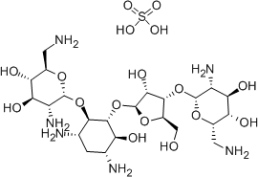
Category | Antibiotic Agent
Molecular Weight | 712.72 g/mol
Chemical Formula | C23H48N6O17S
Water Solubility | Soluble in water
Log P | 3.70
PKa | 12.9
Melting point (°C) | >187°C
Hygroscopic | Non-Hygroscopic
Identification | UV/FTIR
BCS Class | III
Dose | 250/500 mg tablet and 0.5% Cream
Absorption | Neomycin is poorly absorbed from the gastrointestinal tract. Gastrointestinal absorption of the drug may be increased if inflammatory or ulcerative gastrointestinal disease is present
Bioavailability | 4.84%
Protein binding | 30%
Metabolism | There is limited systemic absorption following drug administration. Metabolism is deemed to be negligible.
Half life | 2-3 hours
Indication | Oral neomycin sulfate is indicated as an adjunctive therapy in hepatic coma (portal-system encephalopathy) by reducing ammonia-forming bacteria in the intestinal tract. It is strongly recommended that oral neomycin is only used in infections that are proven or strongly suspected to be caused by susceptible bacteria to reduce the risk of the development of drug-resistant Bacteria.
Mechanism of action | Like other amino glycoside antibiotic drugs, neomycin inhibits bacterial ribosome by binding to the 30S ribosomal subunit of susceptible bacteria and disrupting the translational machinery of bacterial protein synthesis.

Marketed Preparations:-
Brand Name | Neomycin | 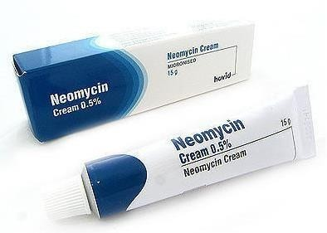
Dosage Form | Cream
Strength | 0.5%
Manufacture by | Luxida Pharma

Figure 1.1 Marketed Preparation

2.1 Review of Literature on Drug
Petty M et al¹¹ Neomycin sulfate-loaded ethosomes were created and described. Nanosized spherical or nearly spherical shaped vesicular structures were found, according to vesicle morphology. Malvern zeta size, high negative zeta potential values, and a poly dispersity index between 0.281 and 0.383 were reported for the particle size study in the nanometer range (500-2000 nm). From 55.63% to 85.84%, there was still high entrapment efficiency. The designed ethosomes displayed improved invitro drug release outcomes of 65–80%. The Neosporin® Antibiotic ointment yielded MIC values of 4.88 ug/ml, while the Ethosomal formulas revealed lower MIC values of 2.44 ug/ml and, finally, high stable stamina after 45 days.
Amol S et al¹² To boost the penetration through the skin and investigate the impact of concentration, sorbitan monostearate (span 60) and lecithin were used as surfactants in the preparation and evaluation of proniosomes of neomycin sulphate (NS). Neomycin sulphate (NS) proniosomes were created utilising the coacervation phase separation method and span 60 and lecithin. By using a factorial design, the impact of span 60 and lecithin concentration was investigated. The gelling chemical Carbopol was used to turn the prepared proniosomes into gel. The produced formulations underwent tests for in vitro drug diffusion, in vivo skin irritation, in vitro antibacterial activity, and entrapment efficiency.
Supriya A et al¹³ Neomycin-loaded chitosan nanoparticles were developed and analysed, and the drug release period was lengthened by using the ionic gelation process to create the nanoparticles. In the current work, various formulations were created utilising various ratios of sodium tripolyphosphate (a cross-linking agent) and polymer. Particle size, zeta potential, scanning electron microscopy, percentage practical yield, drug entrapment efficiency, antibacterial investigations, and in vitro drug release studies were all used to assess the prepared nanoparticle. The practical yield of the optimised CSNPs was determined to be 87.7%. 65.5% entrapment efficiency (%EE),

scanning electron microscopy round shape and smooth surface. The in-vitro release profile was found to be 96.65% sustained up to 330 minutes.
Singh N et al¹⁴ Neomycin sulphate ophthalmic gel was created and assessed in-situ for prolonged ocular administration. For the creation of the neomycin sulphate in situ gel, two different concentrations of sodium alginate (0.2–0.7%) and HPMC K4M were utilised. The produced gel was put through rheological testing, in vitro gelation, drug release testing, disc diffusion antimicrobial testing, and other tests. The pH of the formulations was found to be between 6.8 and 6.9; the drug content was found to be between 92 and 98% in all optimised in situ gelling systems. All formulations were also found to be transparent and clear. All formulations' viscosities dropped as the shear rate rose, indicating the fluids' pseudoplastic nature.
Anbarasan B et al¹⁵ produced thermo-responsive in-situ hydrogels based on pluronic polymers that are employed only for ophthalmic applications. The cold technique of production and several physicochemical factors, such as pH, flow capability, sol-gel transition, temperature, gelling capacity, and rheological qualities, that affect hydrogel preparations were briefly discussed. This paper has extensively explored how the ideal formulation might be chosen and analysed based on in-vitro release studies and gelling capacity. Various autoclaving (both before and after) and irritation experiments in rabbits were examined in the literature. Also disclosed was the aqueous humour analysis was out on albino rabbits. This review suggested that the physiochemical property of the sol-gel transition temperature increases with an increase in pluronic polymer concentration. These hydrogels are very well known for being safe, particularly for use in ocular applications, and they may dramatically increase medication bioavailability in humour analyses. The optimised in-situ hydrogels may offer a potential alternative to traditional eye drops, it is determined.

2.2 Review of Literature on Hydrogel Films
Hiral S et al¹⁶ analysed embelin-infused medicinal hydrogel sheet that possesses antibacterial and wound-healing properties. Embelin was extracted from Embelia ribes' fruits and identified using a variety of physical and analytical techniques, including melting point, UV/VIS spectroscopy, and HPTLC. Using the freeze-thaw method, polyvinyl alcohol and polyethylene glycol hydrogel sheets were created, and isolated embelin was successfully integrated into the sheet. In vitro drug release studies, swelling capabilities, gel fractions, water vapour transmission rates (WVTR), mechanical strength, and scanning electron microscopy (SEM) studies were used to further characterize the produced hydrogel sheets.
Huma M et al¹⁷ tested the effectiveness of encapsulating ofloxacin with tea tree or lavender oil in hydrogel films made of Gellan gum as a wound dressing. The prepared films were clear, flexible, and had antioxidant activity with an excellent antibacterial response against gramme positive and gramme negative bacteria, which are common occupants of wounds. Drug and oils were successfully incorporated into the hydrogel structure of the optimised formulation (OL3 and OT3) without causing any obvious interactions. Studies on the in vitro release of ofloxacin revealed an initial burst release, but the remaining amount released from the films in a regulated manner over the course of 48 hours. Additionally, the presence of oils had no effect on the ofloxacin release.
Manoj K et al¹⁸ Different hydrophilic polymers were used to assess the efficacy of silver sulfadiazine-loaded film-forming hydrogel for the treatment of burns. HPMC E5LV, HPMC E15LV, and mixtures of PVA & PVP were used to create the hydrogel matrix. The different physicochemical characteristics of the produced FFHs were tested. The agar diffusion technique was used to determine the best formulation based on antibacterial activity. Potentiometric titrations were used to conduct and analyse the in-vitro drug release investigation of the optimised formulation.

Praveen K et al¹⁹ Terbinafine hydrochloride topical hydrogel was studied for the treatment of skin fungal infections. Different gelling agents, such as HPMC, Sodium CMC, and Polaxomer, were used to create the gel at three different concentrations. The produced hydrogel formulations underwent testing for physical, chemical, and rheological factors including spreadability and extrudability, pH, skin irritancy, drug release, and content. The produced gels' antifungal efficacy was assessed using the model fungus Candida.
Ghauri H et al²⁰ developed ternary hydrogel flms as a new medication delivery system. By using the solution casting process, a polyelectrolyte complex comprising chitosan, guar gum, and polyvinyl pyrrolidone was created. The interactions between the polymeric chains, surface morphology, and heat stability were investigated using Fourier transform infrared spectroscopy, scanning electron microscopy, and thermogravimetric analysis, respectively. Due to the more entangled arrangement and decreased availability of holes in hydrogels, the swelling tests showed that swelling decreased with an increase in crosslinker concentration. Its release in simulated stomach fluid, simulated intestinal fluid, and phosphate buffer saline solution were examined using the model drug ciprofloxacin hydrochloride. The hydrogels pH responsiveness has been put to use in applications for medication release.
Durai P et al²¹ This study assessed sodium alginate hydrogel membranes enhanced with gatifloxacin based on their physicochemical properties, polymers, plasticizers, cross-linking agents, qualities, and sustain-release occurrence.
Amna S et al²² The study aimed to create a dosage form that could distribute cefazolin locally and continuously at the application site, using chitosan nanoparticles and films made of sodium alginate and pectin.
Bushar I et al²³ The previously described solvent casting procedure was somewhat modified to create the films. At first, a solution of sodium alginate in distilled water was made by swirling it continuously for 30 minutes at a speed of 700 rpm and a temperature of 50 °C. The aforementioned polymeric solution was then given a 15% w/w bulk addition of propylene glycol. The polymeric solution was then gradually supplemented with various quantities of bark extract dissolved in ethanol while being continuously stirred for 20 minutes at 700 rpm. A calcium chloride solution (0.5% w/v) solution was sprayed into the aforementioned solution from a distance of 6 cm onto a glass petri dish. At room temperature, the films were left to dry. The dried films were then removed, covered in aluminium foil, and kept., and stored in desiccators until further testing.

- SUMMARY OF PSAR REPORT: -

Sr. No. | Patent Application number | Title of Patent
 | US20120028942  US20120028942A1US20120028 | Medicinal Cream Made Using Neomycin Sulfate, Betamethasone Valerate, And Chitosan, And A Process To Make The Same
 | US3108996A | Neomycin sulfate purification
 | US3311607A | Neomycin pamoate
 | US3429967A | Stable neomycin solution
 | US3898330A | Corticosteroid phosphate salts/neomycin sulfate ophthalmic

Looking at above 05 patents, your Dissertation project is novel up to what extent?
Novelty grade: 50 to 90%

3. AIM & OBJECTIVES

3.1. Aim of Work
“Formulation and In Vitro Evaluation of Neomycin Sulphate Loaded Hydrogel Films for Treatment of Wound Healing”

3.2 Rationale
- Neomycin sulphate (NS) is an aminoglycoside antibiotic agent used orally and topically to treat a wide variety of infections in the body.
- NS is a broad-spectrum aminoglycoside antibiotic drug that is derived from the metabolic products of Streptomyces fradiae.
- Oral neomycin sulfate is indicated as an adjunctive therapy in hepatic coma (portal-system encephalopathy) by reducing ammonia-forming bacteria in the intestinal tract.
- NS is poorly absorbed from the gastrointestinal tract. There is limited systemic absorption following drug administration. Hence the bioavailability of the drug is very low (4%).
- Most of the formulation are cream and gel form of the NS due to its local effect on wounds.
- Hence, an attempt is made to prepare novel hydrogel films of NS which gives directly antibacterial effect on would after simple application on the infected area. Hydrogel films improve patient compliance and ease of administration.

3.3 Objectives of Work
- To carry out pre-formulation study of NS
- To screen the amount of polymers and prepare the hydrogel films of NS using solvent casting method.
- To performed various evaluation parameters of NS hydrogel films.
- To perform stability study on optimized formulation
- To compare the final formulation with market formulation.

4. MATERIALS AND EQUIPMENTS

4.1 List of Materials

Table 4.1 List of materials to be used
Sr.  No. | Material proposed to be used | Role | Sources of Material
1. | Neomycin Sulphate | API | Montage laboratories, Himmatnagar
2. | Sodium Alginate  HPMC K4M  Gellan Gum | Polymer | S.D Fine Chemicals, Ahmedabad.
3. | Propylene glycol | Plastisizer | S.D Fine Chemicals, Ahmedabad.
4. | Calcium chloride/ Glutaraldehyde | Crosslinking Agent | S.D Fine Chemicals, Ahmedabad.
5 | Ninhydrin solution | Indiactor | Chemdyes Corporation Chemicals,India

4.2 List of Equipments
Table 4.2 List of equipments to be used
Sr.  No. | Equipments | Manufacturers
1. | Digital weighing balance | Reptech weighing balance ltd., Ahmadabad
2. | Franz Diffusion cell | Purvi Enterprise, Ahmedabad
3. | U.V. Visible spectrophotometer | Shimadzu-1601, Kroyoto, Japan.
4. | FTIR | FTIR8400S, Shimadzu, Kroyoto, Japan.
5 | DSC
6. | Magnetic stirrer | Janki Impex Pvt. Ltd, Ahmedabad
7. | pH Meter | Janki Impex Pvt. Ltd, Ahmedabad

Experimental work

5.1 Preparation of calibration curve of Neomycin Sulphate
Developed Procedure :- Aliquot volumes 0.2-1.1 mL of Neomycin Sulphate standard solution 0.01 mol/L were moved into a series of 10 ml volumetric flasks utilizing a glassy pipette, 0.1 mL of borate buffer solution and 1.6 mL of Ninhydrin Solution 0.2 mol/L were added to each flask. The volume was diluted to the volume with distilled water, heated to 65ºC for more than 2.5 min and shaking well. The absorbance of the resulting compound was estimated at 574 nm against an appropriate blank.
Table 5.1. Data for calibration curve of NS in distilled water.
Sr. No | Concentration (µg/ml) | Absorbance
Sr. No | Concentration (µg/ml) | Trial 1 | Trial 2 | Trial 3 | Average Absorbance
1 | 52.7 | 0.03 | 0.121 | 0.264 | 0.138±0.118
2 | 87.5 | 0.236 | 0.238 | 0.237 | 0.237±0.001
3 | 122.5 | 0.323 | 0.322 | 0.321 | 0.322±0.001
4 | 157.5 | 0.582 | 0.586 | 0.584 | 0.584±0.002
5 | 192.5 | 0.667 | 0.670 | 0.673 | 0.670±0.003
6 | 227.5 | 0.762 | 0.764 | 0.763 | 0.763±0.001
7 | 262.5 | 0.935 | 0.936 | 0.937 | 0.936±0.001

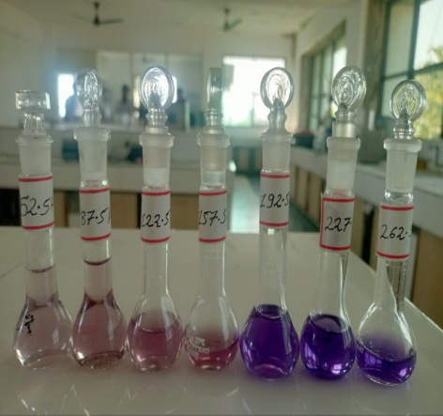
Figure 5.1. Calibration curve of NS in distilled water at 574 nm.

5.2 Preparation of Hydrogel film
The films were developed by a slight modification of the previously reported solvent casting method. Initially, a 2% w/v solution of sodium alginate, HPMC K4M and gellan gum was prepared in distilled water by continuous stirring for half an hour at 700 rpm at 50°C. Then, propylene glycol (15% w/w mass of polymer) was added to the above polymeric solution. Later, NS (0.5%w/w) were slowly added to the polymeric solution with continuous stirring for 20 min at 700 rpm. The above solution was cast into a glass petri dish and calcium chloride (0.5% w/v) solution was sprayed from a distance of 6 cm. The films were allowed to dry at room temperature. Finally, the dried films were peeled out, wrapped in aluminum foil, and stored in desiccators until further testing.⁽²¹⁾
Table 5.2 Formulation Table

Ingredients (%) | F1 | F2 | F3 | F4 | F5 | F6 | F7 | F8 | F9
Neomycin Sulphate | 0.5 | 0.5 | 0.5 | 0.5 | 0.5 | 0.5 | 0.5 | 0.5 | 0.5
Gellan gum | - | - | - | - | - | - | - | - | 1
Sodium Alginate | 0.5 | 1 | 1.5 | 2 | - | - | - | - | -
HPMC K4M | - | - | - | - | 0.5 | 1 | 1.5 | 2 | -
PG | 15 | 15 | 15 | 15 | 15 | 15 | 15 | 15 | 15

5.3 Evaluation of NS hydrogel film
5.3.1 Physical properties of the film
In terms of color, flexibility, and transparency, films were pictured. Vernier calliper was used to measure the films' thickness, and thickness was reported at five distinct locations. To determine the uniformity of the film thickness, take one sample from the centre and four samples from the edges.
5.3.2 Weight Variation of the film:
Three samples of each formulation are taken to calculate the weight variation. After each film was weighed separately, the average weight was determined. Then, using the following formula, the weight variation of each film (formulation) was determined:
Weight Variation (%) = [Average Wt. – Wt. of individual Film/ Average wt] x 100.
5.3.3 Drug Content Uniformity:- To estimate the percentage of drug loading and recovery in the movie, uniformity of the drug content was calculated (22). From various parts of the film, little pieces of uniform size and weight were cut, and they were precisely weighed. Each piece of trimmed film was put into its own glass vial and given the appropriate label. Glass vials were filled with 5 ml of phosphate buffer saline and shaken in a water bath at 50 rpm for 24 hours while keeping the temperature at 37 °C. After 24 hours, samples (1 ml) were taken from each vial and tested using a UV spectrophotometer at 574 nm.
5.3.4 Folding Endurance:- The films were divided into equal sections or sizes and repeatedly folded at the same location until they broke. The number of films that were folded in the same location shortly before they broke was then recorded. That quantity or point was regarded as the threshold for folding endurance. It describes the adaptability and durability of the films.
5.3.5 Percentage Breakage Elongation (E%) :- Three samples, one from each film, were initially taken and then the length of the films was noted in order to compute it. The films were then stretched to the point at which they broke, and that point was recorded on a numerical scale that represented the films' % elongation. It was determined using the formula.
E (%) = (Lb-Lo)/Lo x 100
Where; Lb is the length of the film at the time of breakage and Lo is the initial length of film.
5.3.6 Measurement of swelling behavior
The agar gel plate (2% m/v agar in STF, pH 7.4) was filled with the hydrogel membrane (2 cm2), which was then incubated at 37 1°C.[24] After 30 minutes, the hydrogel membrane was taken off the plate, the surface water was absorbed using filter paper, and the hydrogel membrane was reweighed. The swelling index (SI), as illustrated below, was used to express swelling.
%Swelling index= Wh-Wdx100
where Wh is the weight of the product after 30 min hydration, and Wd is the weight of the dried product.(23)
5.3.7 Water Vapour Transmission Rate
Water vapor transmission was used to determine the permeability of the films towards moisture and was assessed somewhat similarly by a previously reported method⁽²²⁾ By generating a humid atmosphere and measuring the amount of water that travelled through the film, the water vapour transmission rate for each of the three film samples was determined. The films were appropriately sized to fit the glass vials' or test tubes' mouths. Each of the three test tubes was filled with 2 g of calcium chloride after being carefully weighed before to the test, covered with films, and properly sealed to let air to travel through the film and into the test tube. The test tubes were then placed in a humidity chamber with a temperature of 25, relative humidity of about 80-85%.. The glass vials were then weighed after regular intervals to analyze the water vapor transmission rate through the films. The WVTR was calculated by the formula:
WVTR = W*24/ S*ΔT
Where, W is the weight of calcium chloride in gram, S is the surface area of the films exposed to water vapour transmission in m² and ΔT is the time difference at different interval
5.3.8 Microbial Penetration Test
The ability of the coatings to stop microorganisms from penetrating them was then evaluated. To do this, the films were opened separate vials and cut into the necessary sizes. The vials were then labelled, filled with 5 ml of nutritional broth, and covered with films. The films were secured to the vial mouths by the use of vial lids. To compare the test outcomes, a negative control and a positive control were offered. As a positive control, an open vial of nutritional broth was employed, and as a negative control, a cotton ball was used to seal the vial's opening. For one week, the vials were checked for any turbidity, which was regarded as a sign. which was considered as a sign of microbial penetration and contamination.
5.3.8 Effect of Films on the pH of the Environment The simulated wound fluid's (SWF) pH ranges from 7.0 to 7.4. The SWF's pH was kept at 7.4 and the films (F4 and F8) were cut into the proper sizes. Three different vials were filled with the SWF (about 10 ml), then the films were added. The bottles were then labelled accordingly. After 30 minutes, an hour, and twenty-four hours, the pH of the film containing liquids was assessed.
Preparation of Simulated Wound Fluid (SWF):- In order to make SWF, 200 ml of deionized water was added together with 16.6 g of sodium chloride and 0.56 g of calcium chloride, which were then mixed together until completely dissolved. After that, the volume was made up to solution contained 142 mM of sodium chloride and 2.5 mM of calcium chloride. The pH of the solution was adjusted to 7.5.
5.3.9 Stickiness of the Films
The Composition of degree of stickiness that F4 and F8 had towards the patient's clothing was tested. The amount of threads that might cling to the films' surface were counted after the films were firmly pressed with cotton or cotton balls to evaluate how sticky they were. The stickiness of the films increases with the amount of threads present on their surface.
5.3.10 Determination of Water Content
The water content of films F4 and F8 was assessed in order to assess the degree of hydration of the films and to ascertain the maximum amount of moisture or wound fluid that the films are capable of absorbing [31] and even when the wounds are dried, at that point, how much the films can maintain the wound's hydration to aid in wound healing. The films were carefully weighed and trimmed to the proper sizes. After that, the films were heated to a temperature of 50°C and weighed at regular intervals until the dried weight became constant [32]. The following equation was used to calculate the films' water content:
W (%) = Wd-Wi/Wi x 100
Where W is the percent water content of the films, Wd is the weight of the films after drying and Wi is the initial weight of the films.
5.3.11 Calculation for film casting
Topical dose of NS was selected 0.5%w/w because of it is similar to conventional topical product (Neomycin Cream 0.5%). A film of 2×2 cm dimension was planned to be prepared which should contain 50 mg of NS. But the mould i.e glass petridish (diameter= 8cm) for casting of films has 50.24 cm² area. So total amount of NS required to be added in the films casting solution (10 ml) was 625 mg.
5.3.12 Solid-State characterization
FTIR Analysis
A FTIR (FTIR8400S, Shimadzu, Kroyoto, and Japan) analysis of NS, sodium alginate and hydrogel film samples was performed in range of 4000 to 500 cm⁻¹ to investigate any possible interaction among formulation ingredients and polymer.
Thermal Analysis by DSC
Thermal degradation properties of NS, sodium alginate and film were analyzed by differential scanning calorimetry. It was used to observe the physical as well as chemical interaction of polymers used in the formulation. NS, sodium alginate and films were heated to the temperature range of 40-240°C in the aluminum pan under nitrogen flow rate of 20 mL/min and heated at scanning rate of 20 °C/min
5.3.13 In vitro drug release
A NS-containing hydrogel film (2×2 cm²) and a membrane of cellulose acetate mounted on the donor side of a Franz-type diffusion cell (vertical type). The receptor site was filled with 15ML of distilled water and stirred with a magnetic stirrer, while the outer layer was refluxed with water at 37°C to keep the temperature constant. Aliquots of 0.5 mL were collected over time of 8hr. Sample collection was followed by supplementation with the same volume of distilled water. Samples were analysed at 574 nm for NS by using UV-Visible spectrophotometer. Experiment was repeated identically in triplicate.
5.4 Stability Studies
The stability studies of the films were carried out by placing the films in stability chamber for one month at 40°C/75RH and room temperature. The films were evaluated for the change in the Weight Variation and color/Transparency.

6. Result and Discussion
6.1. Physical Properties of the Films
After solvent casting, hydrogel films appeared smooth, thin, flexible, free from bubbles and easily removed from petri dishes. The films were light brown color in case of Sodium alginate formulations. The films were flexible enough to be applied on any surface. Thickness of prepared hydrogel films were in the range of 0.038 ±0.0015 to 0.059 ±0.0016 mm. According to the data in Table 6.1, an increasing trend can be seen in the thickness of the films as percentage of polymer is increasing showing higher thickness than 0.5 % and 1 % films. Therefore, it is clear that the thickness of the films increases upon increasing the amount of polymers (SA or HPMC).
6.2 Weight variation of films
Weight variation of the films was done to analyze the uniformity of the weight in all the parts of the films in terms of weight content. The films showed more than 90 % of the weight uniformity in all the parts of the films with no significant variation. The 2% SA and HPMC films had 98.04%±0.02and 94.34%±0.026 uniformity in weight (Table 6.1). This indicates increasing in addition of polymer resulted in slight increase in weight of films which was uniformly distributed in film matrix
6.3 Drug Content
The content of drug within all the films was uniform or not was assessed by means of drug content uniformity test. In this test, PBS was used to analyse the drug content in the films after 24 hours. SA and HPMC (2%) films had 98.32±0.015and 97.22±0.02uniformity in drug content as in Table 3. These high values are indicative of high and similar content of drug in all the films with no or less variation and also ensures equal distribution of drug in all the parts or areas of the films. This means that this method of film preparation can be reproduced to prepare films having homogeneous drug distribution.
6.4 Folding endurance and breaking elongation
The mechanical strength of the films was the clear indicative of the mechanical properties of the polymers used. An ideal wound dressing must be flexible enough to be subjected for external wound application orin case of a support in internal wounds without undergoing any rupture or breakage. The F4 films possessed high mechanical strength as indicating that these films possesses good mechanical properties and will not break when applied to wounds. Also, F4 film had the high folding endurance and low elasticity as indicated by the decreasing breaking elongation values as shown in Table 6.1. The folding endurance was more than 100 for all the films hence indicating good mechanical strength of the films. ⁽²²⁾The film with 0.5% cross-linking agent, and sodium alginate (F4) had satisfactory flexibility and less stiffness as compared to HPMC film Therefore, Sodium Alginate film (2%) was considered optimal for wound dressing application
Table 6.1. Evaluation of prepared hydrogel films
Parameters | Formulations
 | F1 | F2 | F3 | F4 | F5 | F6 | F7 | F8
Appearance of Film | Light brown due to Sodium alginate |  |  |  | Light yellow due to the API color
Thickness (mm) | 0.038±  0.0015 | 0.04±  0.0014 | 0.042±  0.0013 | 0.061±  0.0016 | 0.04±  0.0016 | 0.041±  0.0012 | 0.05±  0.001 | 0.053±  0.002
%weight Uniformity | 92.00±  0.173 | 97.63±  0.032s | 97.72±  0.015 | 98.04±  0.02 | 91.46±  0.025 | 97.52± 0.03 | 94.98±  0.025 | 94.34±  0.026
Folding endurance | 110±  1.52 | 127±  2.08 | 138±  1.52 | 189±  1.52 | 121±  2.51 | 132±  3.81 | 138±  2.08 | 176±  3.21
Drug Content | 95.31±  0.061 | 96.37±  0.045 | 97.56±  0.02 | 98.32±  0.015 | 95.16±  0.041 | 96.54±  0.032 | 96.63±  0.03 | 97.22±  0.02
% Breaking Elongation | 28±  0.58 | 27±  1.53 | 23±  1.55 | 15±  1.58 | 26±  1.15 | 24±  1.52 | 23±  1.73 | 21±  1.52
Swelling Index (%) | 112±  5.20. | 88.33±  4.52. | 72.11±  4.52. | 65.11  ±3.11 | 146.11±  2.52. | 135.33±  3.12. | 128.44±  4.11. | 118.55±  3.58.
WVTR  (g/m² /24hr) | 2412± 17.00 | 2209± 8.15 | 2165±  22.14 | 2002±  12.00 | 2714±  15.82 | 2601±  12.01 | 2633±  9.29 | 2512±  10.50

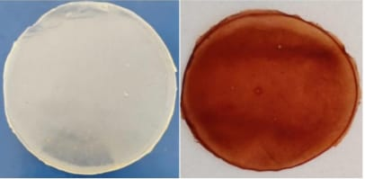
Figure 6.1 Hydrogel film of HPMC and Sodium alginate

6.5 Swelling behavior of hydrogel film
The swelling index was evaluated to study the fluid uptake capacity, which is an important parameter for elucidating the wound-healing property of hydrogel films. Different parameters can affect the swelling behavior of hydrogel films. Cross-linking agents and the nature of the drug/polymer also alter the swelling pattern of a hydrogel. The swelling index of the hydrogels was found to be from 65.11 to 146.11% as shown in table 6.1. It is observed from the data that as the concentration of SA increased (F1 to F4), the %swelling ratio also decreased. As an explanation, the higher concentration of polymer increases the cross-linking, thereby decreasing the porosity within the gel structure which results in a decrease in the % swelling ratio. The HPMC films (F5 to F8) shown rapid swelling owing to the hydrophilic polymer matrix which undergoes unwinding quickly upon exposure to water bringing about the loss of integrity of the films and complete film eruption in the exposed medium. The effect of cross-linking on the swelling behavior of the films upon exposure to water was studied. The HPMC films showed rapid swelling of around 146.11± 2.52.% within 30 minutes and this swelling increased for 30 minutes with the loss of integrity, shape, and strength. The sodium alginate cross-link films swelled gradually till the end of the experiment.
6.6 Water Vapor Transmission Rate
In order to assess the suitability of the film for use as wound healing dressings, wound fluid absorptivity and water vapor transfer through the films are key characteristics. Only if there is a sufficient transmission of water through the films can gases and moisture get through. The WVTR of the hydrogel sheets containing HPMC (F1-F4) is high as compared to the hydrogel sheets prepared by SA and the cross-linking agent (table 6.1). PG as an interference to SA cross-linking helps to maintain porosity within the hydrogel sheets up to a certain concentration. The WVTR plays an important role to keep the wound bed moist. If the WVTR of the hydrogel is more, it makes the wound bed very moist, whereas low WVTR makes the wound bed dry. Thus, a hydrogel dressing should have an optimum WVTR, so that it can provide proper moistening to the wound bed, and thus help in enhancing the healing process. The WVTR of an ideal wound dressing is reported to be 2000–2500 g/m² day. The higher WVTR values observed with hydrogel membranes treated with the HPMC polymer are due to the hydrophilic nature of this polymer. In the case of formulations F1 to F4, WVTR values were found to be in the optimum range, while higher values were obtained in HPMC-based formulations (F5 to F8).
From the above parameters, it was found that the hydrogels containing 2% SA with PG (15% of polymer weight), had a satisfactory % Breaking Elongation (15%), swelling ratio (65.11%), and WVTR (2002 g/m² day).
6.7 Microbial Penetration Test
To assess the wound protection capabilities of the films against secondary infections, a microbiological penetration test was carried out. In any environment, the nutrient broth is a suitable medium to promote bacterial growth. The nutrient broth appeared turbid in the positive control (with the lid open), promoting bacterial growth in the medium. By keeping the nutrient liquid transparent, the negative control (lid closed) revealed no evidence of bacterial growth. The F4 films enclosing vials gave evidence that the films are quite protective against the formation of secondary bacterial infections at the wound site using clear nutrient broth after 7 days. As a result, the dressings are thought to be suitable for persistent use.
Table 6.2 Microbial Penetration Test
Sample | Day 1 | Day 7
Positive control | Clear | Turbidity
Negative Control | Clear | Clear
Formulation F4 | Clear | Clear

6.8 Effect of Films on the pH of the Environment
The pH of the simulated wound fluid is around 7.0-7.4. The Formulation F4 films showed pH range as low as 5.64 in 24 hours because of concentration of calcium chloride in the cross-linking solution decreasing the pH of the surrounding environment by 5.64 (Table 6.3).
Table 6.2: Effect of Films on the pH of the Environment
Sample | 30 minutes | 1 hour | 24 hour
Formulation F4 | 6.49+0.01 | 5.78+0.02 | 5.64+0.02

6.9 Stickiness of the Films
The stickiness corresponds to the number of fibers of cloth that might get adhered to the films upon application and that fibers are indicative of patient clothes. The films are rated as high (dense fibers), medium (thin layer of fibers) or low (very few or occasional presence of fibers) sticky depending upon the number or density of fibers found on the surface of film upon applying low pressure with cotton. Formulation F4 presented with low stickiness when it comes to fiber adherence i.e., occasional.
6.10 Determination of water content
The films (F4 and F8) were assessed for the amount of water enclosed in them by drying them at high temperature in the oven until constant weight of the films was observed [32]. The polymers (SA and HPMC) used in the films are hygroscopic to absorb enough amount of water, but the cross-linking process molds the water content of the films towards the change in the concentration of the polymers after cross-linking The water content happens to be higher in case of F8 films because of the availability of polymers to interact freely with the environment but these free bonds of polymers decrease upon cross-linking (calcium chloride) (Figure 6.1).

Figure 6.2 Determination of Water content

6.11 Solid-State characterization
FTIR Analysis
To find any possible interaction among polymer and loaded components of hydrogel films, FTIR analysis was performed on NS, SA, and hydrogel films as shown in Figure 6.2. Sodium alginate displayed stretching vibrations of O–H in the range of 3088.03–3344.57 cm⁻¹. Stretching of the aliphatic C–H group was found between 2935.66 and 2839.22 cm⁻¹. The bands at 1101.35 and 923 cm⁻¹ were observed due to C–O vibration stretching of the pyranosyl ring and the C–O stretching of sodium alginate. NS had band at 1614.42, 1454.33, 972 cm⁻¹ due to O-H bending (aromatic), O-H bending (alcohol), and CO stretching (secondary alcohol) respectively. Distinctive peaks of NS and sodium alginate were observed in the developed hydrogel films. Therefore, it can be summarized that NS-loaded films were developed without any interaction.

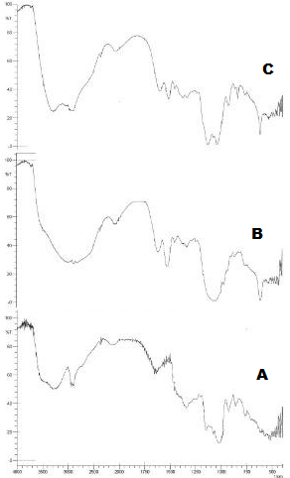

Figure 6.3 FTIR spectra of SA (A), NS (B), Film (F4) (C)

DSC
Different thermograms of NS, SA, and Film are shown in Figure 6.4. The DSC curve of NS depicted one endothermic peak at 225.77°C and two exothermic peaks at 242.01 and 284.50°C. The DSC curve of SA showed two peaks at 84.37°C and 299.17°C which was due to water loss and degradation of the polymer. The Hydrogel film DSC curve had three different peaks at 92.18°C, 217.83°C, and 288.48°C. In contrast to NS and SA, the DSC thermogram of the film showed a broad endothermic peak at 217.83°C and 288.48°C (shown in Fig. 6.4). This was due to the addition of PG (as plasticizer) and calcium chloride (as cross-linker) in the formation of d films. Few H-bonds were present in films leading to lower degradation in comparison to NS and SA. As a result, DSC thermograms of films indicate that SA is properly blended due to the presence of cross-linking and plasticizer that enhances the stability of films.
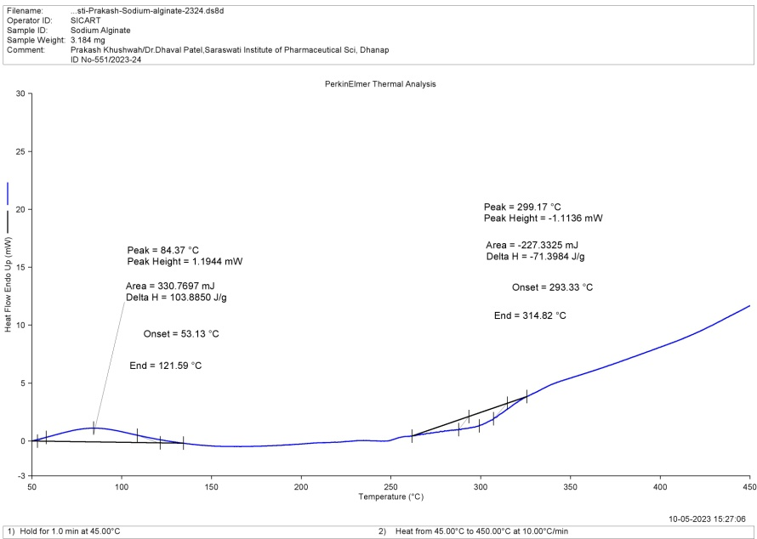
A
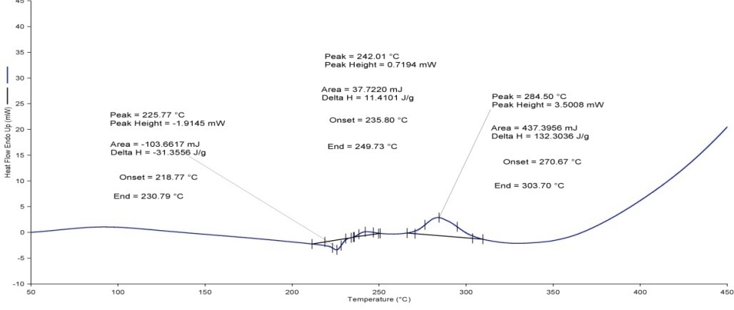
C
B

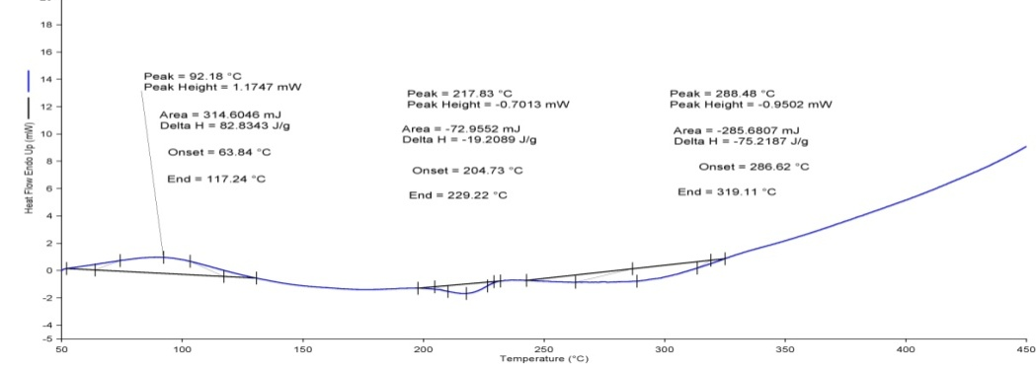
Figure 6.4 DSC of SA (A), NS (B), Film (F4) (C)

6.12 In vitro drug release
The Franz diffusion cell equipment was used to observe the drug release profile from the film (F4) and Neomycin Cream (0.5%), and the percent cumulative release of the drug over time, expressed in hours, is displayed. These are the polymeric dressings that use a specific process to release the medication from the matrix: first, the polymeric films swell, which allows the solute to diffuse into the matrix; next, the polymers degrade. The films demonstrated a consistent release of NS from films, and this release behaviour differed significantly from that of marketed products, as shown in Fig. 6.3. The films revealed an overall release of 75.39 0.85% for 8 hours and 98.22% 0.08% for promoted product after 2 hours. The films with high integrity and slower release rates, which account for prolonged release, would work well with wound dressings. By demonstrating continuous release and a lengthy retention period, this will aid in the healing of wounds and promote patient compliance by preventing the needless discomfort of frequent wound dressing changes.

Figure 6.5 IN VITRO DRUG RELEASE
The Korsmeyer-Peppas release model and the value of "n" were the ones that best explained the swelling behaviour of the films to release the drug after the release data was applied to several release and kinetic models (Table 6.3). The value of n provides information on the individual distinctive drug release mechanism. A number of 0.49 and above indicates a non-Fickian diffusion mechanism for drug release, which depends on diffusion and erosion to ensure proper drug release from the films. A value of less than 0.49 reveals Fickian diffusion of the drug. The regression findings make it obvious that Korsmeyer-Peppas is the best explanation for the drug release from the films.

Table 6.3 Kinetic Models Regression and the value of n for NS hydrogel film (F4)
Kinetic Models
Formulation | Zero-order | First-order | Higuchi | Korsmeyer-Peppas
 | R² | R² | R² | R² | n value
F4 | 0.9070 | 0.9778 | 0.9608 | 0.9832 | 0.646

6.13 Stability study
The prepared films were kept under accelerated circumstances and at room temperature for a month, but there were no changes in the films' outward appearance after that time. The weight of the films changed very little when they were exposed to accelerated humidity and temperature conditions. As demonstrated in Fig. 13 and Table 6.4, no significant changes in the films' physical appearance were discovered after testing them under accelerated stability conditions for a month.
Table 6.4. Stability Studies of the optimized Film
Formulation F4 | %Weight Variation | Transparency /Color
Initial | 0.3% | Translucent, Pale Yellow
After one month | 3.3% | Translucent, Pale Yellow

7. conclusion
Modern wound dressings are designed to limit the spread of infection by delivering antimicrobial agents and providing suitable conditions for faster skin healing. Our study reveals that the formulated neomycin-loaded hydrogel membrane with desirable physiochemical characteristics including better swelling, improved elongation, excellent barrerite, appreciated WVTR, and sustained drug release. In sum, our experimental approach was successfully undertaken to design a topical drug delivery system in the form of neomycin-loaded sodium alginate hydrogel membranes with desirable wound healing properties

REFERENCES
- David Moreau, Caroline Chauvet, François Etienne, François P. Rannou, Laurent Corte. “Hydrogel films and coatings by swelling-induced gelation. Proceedings of the National Academy of Sciences of the United States of America,” National Academy of Sciences, 2016, 113 (47), 13295-13300.

- Enas M, “Hydrogel: Preparation, characterization, and applications: A review,”
Journal of Advanced Research, 2015, 6(2), 105-121.
- Yahia L, Chirani N, Gritsch L, “History and Applications of Hydrogels.” J Biomedical Sci. 2015, 4(2), 1-9.

- Zhao Wen, Jin Xing, Cong Yang, Liu Yuying, Fu Jun “Degradable natural polymer hydrogels for articular cartilage tissue engineering”, J Chem Technol Biotechnol, 2013, 88 (3), 327-339.

- Boateng JS, Matthews KH, Stevens HNE, Eccleston GM “Wound healing dressings and drug delivery systems: A review.” J Pharm Sci, 2008, 97(8), 2892–2923.

- Drug Information, December 2021, https://go.drugbank.com/drugs/DB00994.

- Drug Information, December 2021, https://www.drugs.com/mtm/neomycin.html.

- Drug Information, December 2021, https://pubchem.ncbi.nlm.nih.gov/compound/Neomycin-sulfate.

- Drug Information, December 2021, https://www.rxlist.com/neomycin- sulfatedrug.htm#description.

- Drug Information, December 2021, https://www.1mg.com/drugs/neomycinsulphate.

11.Petty M & Gautam S, “Formulation and characterization of Neomycin Sulfate Loaded Ethosomes for Transdermal Delivery.” 2021, J Pharm Drug Res, 4(1) 462-469.
- Shete A, Thorat P, Doijad R, Sajane S “Formulation And In Vitro, In Vivo Evaluation of Proniosomal Gel of Neomycin Sulphate.” International Journal of Applied Pharmaceutics, 2019, 11(2), 156–163.

- A Supriya, J Sundaraseelan, B Srinivas and M Bindu, “Formulation and Invitro Characterization of Neomycin Loaded Chitosan Nanoparticles”, Acta Scientific Pharmaceutical Sciences, 2018, 2(2), 34-40.

- Singh Neha, Mazumder Rupa, Das Paul, Swarnali, “Preparation and In Vitro Evaluation of an Anti-bacterial In Situ Ophthalmic Gel” Current Nanomedicine, 2017, 7 (1), 67-72.

- Anbarasan B, Thanka J, Ramaprabhu S, Shanmuganathan S, “Optimization and Evaluation of Temperature Triggered in Situ Hydrogels for an Effective Treatment of Ophthalmic Preparations – A Perlustration”, Int. J. Pharm. Sci. Rev. Res., 2018, 50(1), 34-39.

- Hiral S, Uttam K, Manish N and Neeta S, “Fabrication and evaluation of a medicated hydrogel film with embelin from Embelia ribes for wound healing activity”, Future Journal of Pharmaceutical Sciences, 2019, 5(12), 1-10.

- Huma Mahmood, Ikram Ullah Khan, Muhammad Asif, Rizwan Ullah Khan, Sajid Asghar, Ikrima Khalid, Syed Haroon Khalid, Muhammad Irfan, Fauzia Rehman, Yasser Shahzad, Abid Mehmood Yousaf, Adnan Younus, Zahid Rasul Niazi, Muhammad Asim, “In vitro and in vivo evaluation of gellan gum hydrogel films: Assessing the co impact of therapeutic oils and ofloxacin on wound healing”, International Journal of Biological Macromolecules, 2020, 1- 37.

- Manoj K, Saranya K, “Formulation, Evaluation and Optimization of Novel Silver Sulfadiazine Loaded Film Forming Hydrogel for Burns”, Hygeia J D Med. 2016, 8(2), 1-10.

- Praveen K, Chinna M, “Formulation and evaluation of topical hydrogel containing antifungal drug”, Pharm Pharmacol Int J. 2020, 8(4), 249‒254.
- Ghauri Z, Islam A, Qadir M, “Development and evaluation of pH-sensitive biodegradable ternary blended hydrogel films (chitosan/guar gum/PVP) for drug delivery application.” Sci Rep, 2021, 11, 1-10.
- Durai Prabu, Amin F. Majdalawieh1, Imad A. Abu-Yousef1, Kadambari Inbasekaran, Tharani Balasubramaniam, Narayanan Nallaperumal, Conjeevaram J. Gunasekar” Preparation and characterization of gatifloxacin-loaded sodium alginate hydrogel membranes supplemented with hydroxypropyl methylcellulose and hydroxypropyl cellulose polymers for wound dressing” International Journal of Pharmaceutical Investigation 2016, 26, 1-59
- Amna Shahzad, Ahmad Khan, Zakia Afzal, Muhammad Farooq Umer, Jallat Khan, Gul Majid Khan “Formulation development and characterization of cefazolin nanoparticles-loaded cross-linked films of sodium alginate and pectin as wound dressings. “International Journal of Biological Macromolecules, 2018, 25, 1-29.
- Bushra Ishfaq, Ikram Ullah Khan*, Syed Haroon Khalid and Sajid Asgha” Design and evaluation of Sodium alignate –based hydrogel dressings containing Betula utilis extract for cutaneous wound healing.”Frontiers in Bioengineering and Biotechnology, 2023, 1-11.

Appendix A List of Abbreviations
ABBREVIATION | FULL NAME
PI | Active Pharmaceutical Ingredients
UV | Ultra Violet
FTIR | Fourier Transport Infrared Radiation
DSC | Differential Scanning Colorimeter
°C | Degree Centigrade
nm | Nanometer
mg | Milligram
mcg | Microgram
ml | Milliliter
% | Percentage
PG | Propylene Glycol
NS | Neomycin Sulphate
SA | Sodium Alginate
HPMC | Hydroxy propyl Methyl cellulose
SD | Standard Deviation
max | Maximum
conc | Concentration
mm | Millimeter
hr. | Hour
cm | Centimeter
Avg | Average
w/w | Weight by Weight
sec | Second
min | Minute
e.g | Example
ng | Nano gram

ITD REVIEW CARD
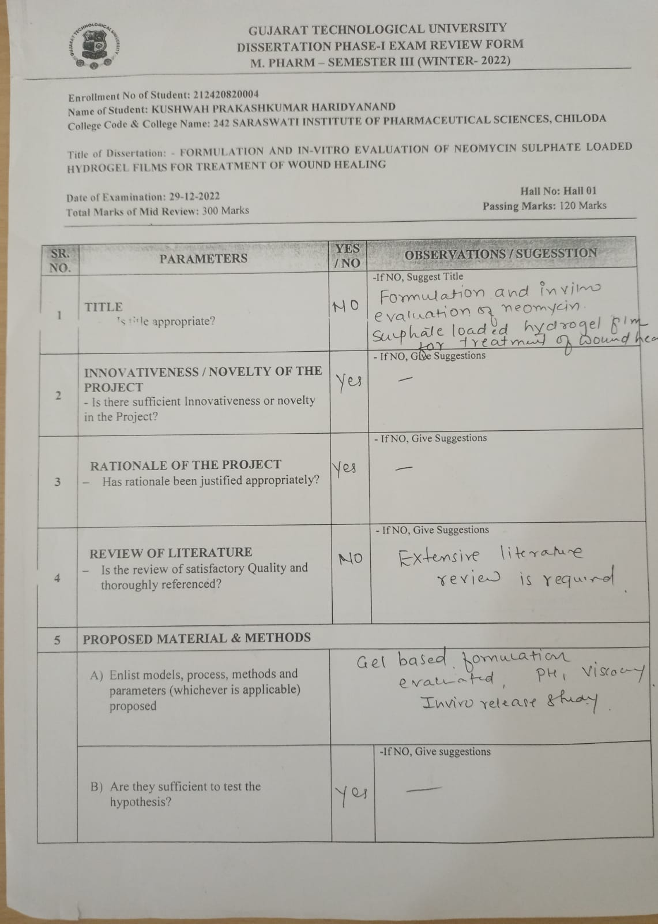

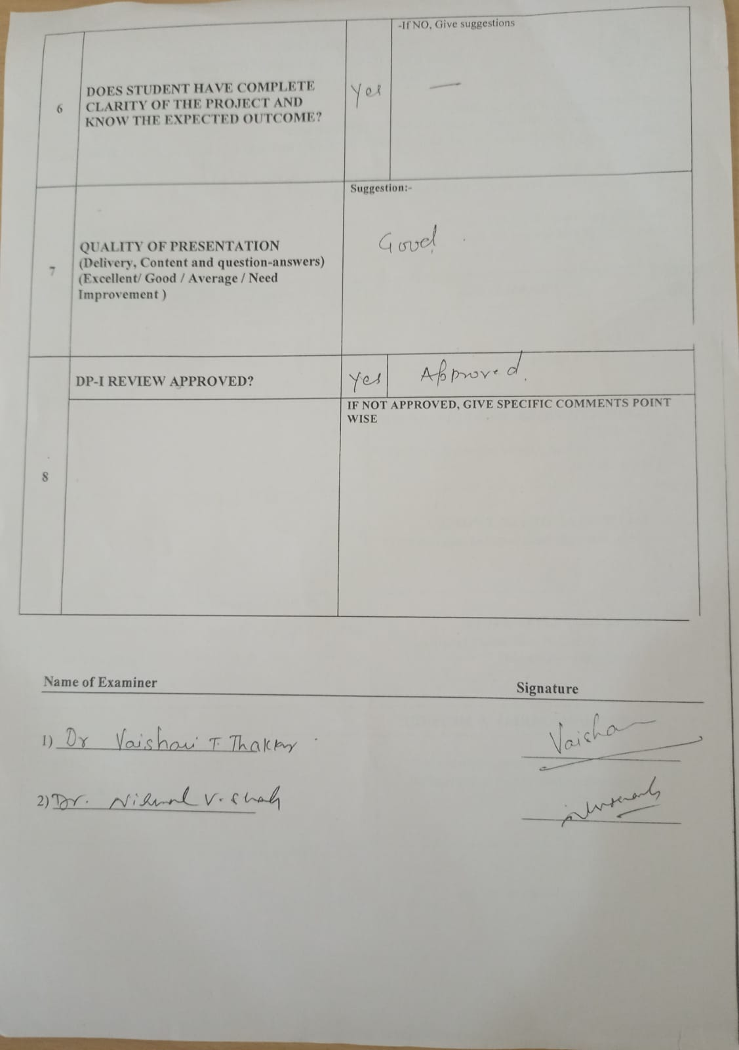

MID SEM REVIEW CARD

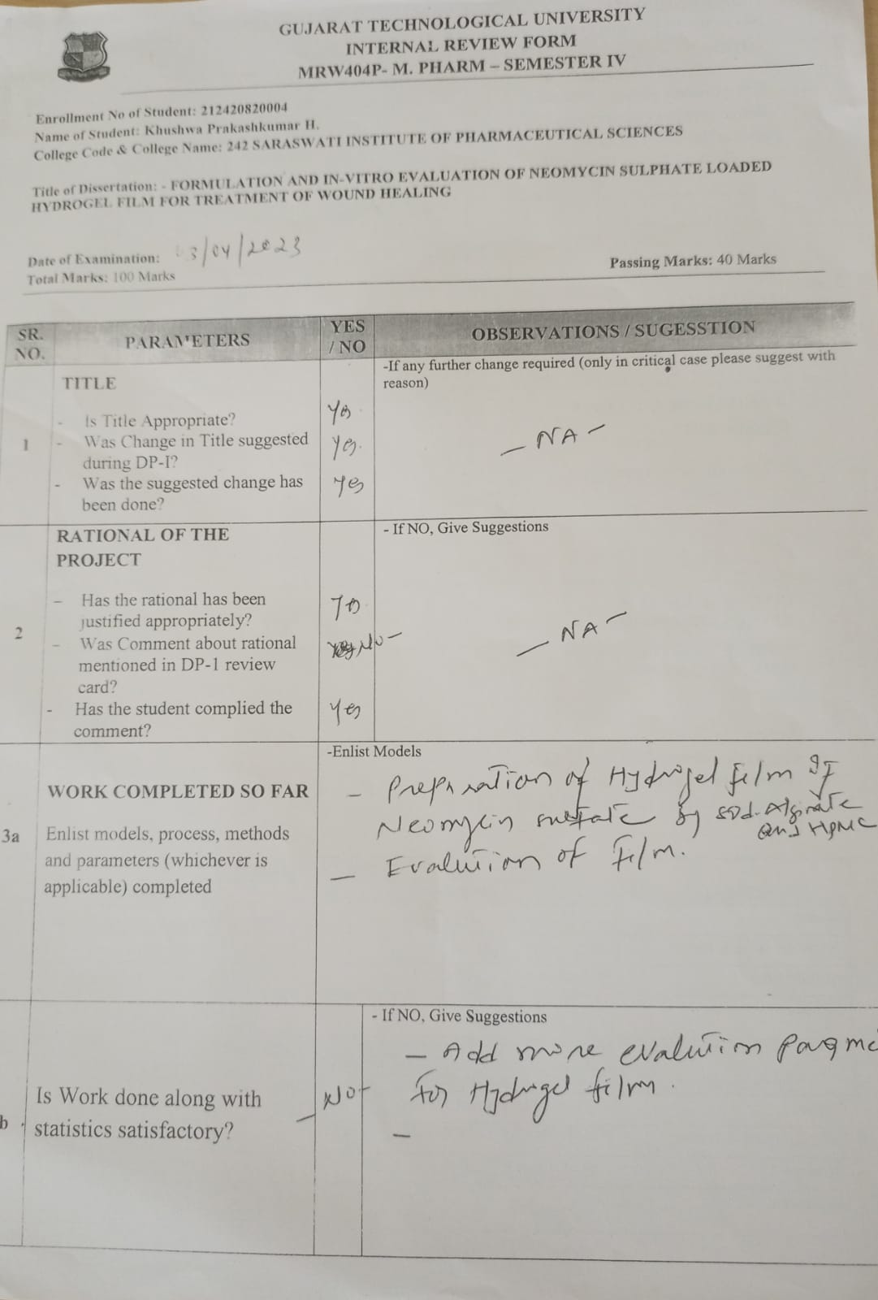
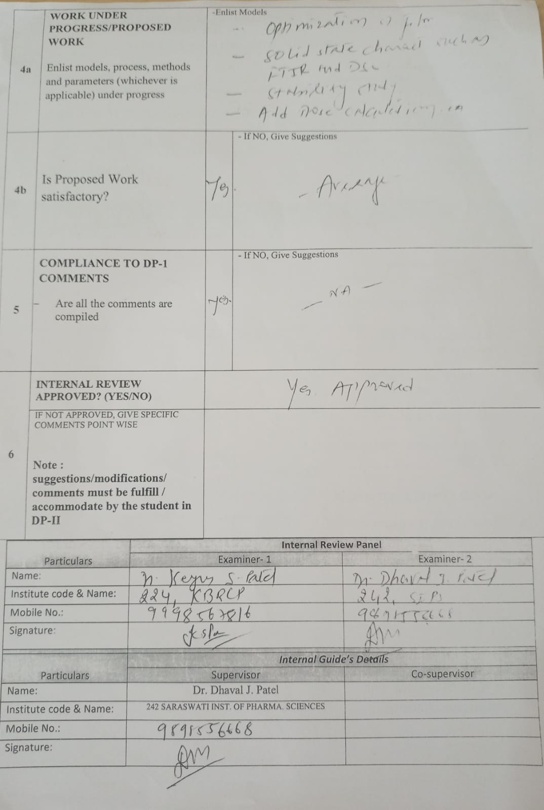

ITD / MID-SEM REVIEW CARDS COMMENTS AND JUSTIFICATIONS
Sr.No | COMMENT | JUSTIFICATIONS
1 | Title Suggestion | Title is corrected according to GTU Suggestion
2 | More extensive literature survey required | Literature reviews are added
3 | In Vitro release Study | Done

Sr. No | COMMENT | JUSTIFICATIONS
1 | Add more evaluation Parameters for hydrogel film | Done
2 | FTIR | Done
3 | DSC | Done
4 | Stability study | Done

