Face Mask Detection System Using Artificial Intelligence

¹Shrutik Mahajan, ² Shubham Banarse, ³Pragnesh Kathiriya, ⁴Jayesh Rayte, ⁵Pushpalata Aher
^{1,2,3,4}B.Tech Scholar , School of computer Science & Engineering , Sandip University , Nashik , India
⁵Assistant Professor , School of computer Science & Engineering , Sandip University , Nashik , India
¹shubhambanarse@gmail.com, ²shrutikmahajan1414@gmail.com, ³pragneshkathiriya18@gmail.com,⁴jayeshrayate1234@gmail.com, ⁵pushpalata.aher@sandipuniversity.edu.in

Abstract
In the current pandemic, Covid-19 has taught America the importance of masks, and we need to be more aware of the serious consequences of not wearing masks than in the past. Currently, there is no mask in the crowded area, but now we like to think that the most important thing in transitions, crowded areas, shops, home schools, nursing homes is the line. Mask detectors for public safety. In this article, we are trying to make a 2-phase mask that can be used easily in the shop above. Thanks to pc Vision, it is now possible to observe and use on a large scale. We have use CNN as our model. The processing is done in Python and using the python script we can train our mask on our selected data using TensorFlow and Kera’s. We provide more powerful features and we have trained our models on different sizes, we like to generate data with different sizes and extensions so the model can clearly recognize and recognize the sales face in live video. The training model has always been tested on both video and stills and outperformed the original model in all cases.

INTRODUCTION :-
The last few years have seen such astonishing advances in science and technology that we are now at a stage where we know that with the right knowledge, humans can achieve things that were nearly impossible a few years ago. Now, we have advanced machine learning and technology skills and knowledge, which has been proven to make our lives easier, from the micro level to the impossible. The last few years have witnessed the emergence of algorithms that have been found to solve our complex, One such place is image and object search, which helps us find and explore people and objects at the same time. Computer vision now plays an important role in our lives. Who would have thought that in a city you can easily find people from other cities? It's almost impossible to imagine that computer vision is now a new piece of technology. In 2019, the world saw the outbreak of the coronavirus, and almost a year later it has not left us, and still people continue to struggle for survival. In the midst of the struggle for survival, we realized that technology was our only salvation. From ubiquitous websites to 24/7 online services, technology has been our true companion in these difficult times. But even if we share everything with one click, there will be no life there. In the last few months, every country, every state has found its own new model to fight the epidemic. Whatever we do, we have to get out of there to survive. Schools, workplaces, universities, businesses, transportation are just a few important checkpoints in every country. Although we need public safety, people miss them [limitless life. That's why it's so important to engage the public and make them aware of the importance of the smallest details of survival gear. "Face detection system using artificial intelligence" One of the important things is that the face is widely used in our lives. Research has proven that with the help of face masks, when used correctly, we can reduce our chances of catching coronavirus from 80% to 85%.But even then it must have been nearly impossible to mask everybody have to put on mask. With the help of artificial intelligence and computer vision, we have the best way to enforce masking laws for humans. With the help of our system, we aim to detect the presence of masks in still images and live videos. Product identification, classification, returns, photos, and product tracking and analysis are the main focus of this article. Our target is a two-stage CNN mask detector. The first stage is the training stage where we learn our model, and the second stage is the application where masks with "masked" or "unmasked" are detected. In addition to stills, we also want to do this in real-time video, where we capture and track the face in real time and return information about the masked or unmasked face. Our papers can be very useful in the parking lot, airport, shopping mall, hospital, office, school and other places where there are many people who need timely attention.

LITERATURE REVIEW:-

Current models use deep learning, but the lack of variability in data means their models are ineffective at processing images and videos in real time. Deep learning is very useful for big data analysis focusing on some deep learning methods and applications. Deep learning can be used in unsupervised learning algorithms to process anonymous data. Lee et al. Introduce a CNN model for rapid face detection that evaluates low resolution images and removes non-faces and tracks higher resolution regions for accurate detection. Our model is a special deep learning and computer vision model trained to detect if a person is wearing a mask. Our model does not use deformed or ghostly masks in the data. Our model is very accurate because we use MobileNetV2 architecture which also makes the model more efficient. This simplifies the deployment of models for embedded systems. According to the current epidemic situation, we can use this mask to see the need to test the mask. This model can be used in public places such as airports, train stations, offices and schools.

PROPOSED WORK:-
The purpose of the face mask is to check if a person is picking up the phone, to warn the authorities to reduce the cell-19 count. The system uses a neural network (CNN) to analyze CCTV footage and determine whether people are wearing masks. Appropriate deep learning architecture such as convolutional neural network (CNN) will be chosen as the basic model for the face recognition algorithm. These pre-trained models will be developed on data compiled using transfer learning techniques. This process will allow for a unique model for the face recognition task.

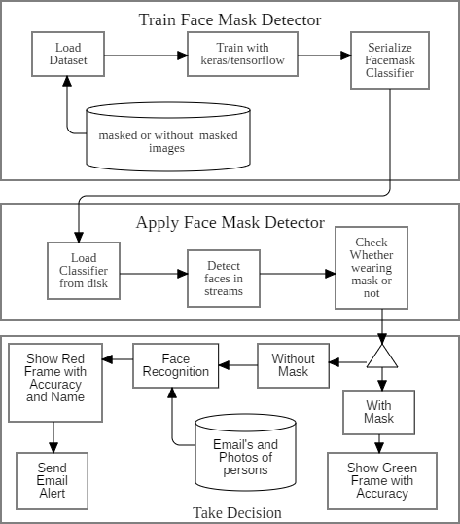

Fig 1. Architecture of Proposed System

Convolutional Neural Networks (CNN) are widely utilized in computer vision applications, particularly in pattern recognition tasks. CNNs employ convolutional layers to extract hierarchical features from input images, enabling effective representation learning. When constructing a CNN architecture, it is crucial to design a network that can efficiently capture relevant features. One notable architecture is the Residual Network (ResNet) proposed by K. He et al., which incorporates residual connections to allow the network to learn residual mappings from the previous layer, enabling the construction of deeper and more sophisticated neural networks. Another architecture specifically designed for resource-constrained devices is the Mobile Network (Mobile Net), which aims to achieve high performance while minimizing computational demands. The Mobile Net architecture is particularly suitable for article locators commonly used in portable or embedded devices that have limited computational resources.
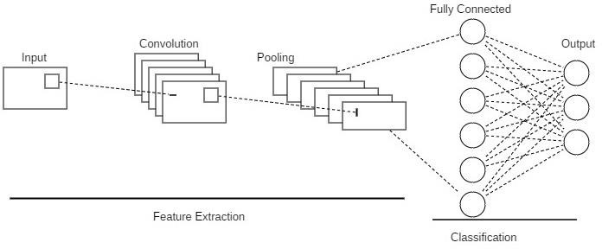

Fig 2-Convolutional Neural Network Convolutional Layer:-

The convolutional operation serves as a fundamental building block in Convolutional Neural Networks (CNNs). It involves combining two functions to produce another function. In the context of CNNs, the input data is typically represented as a four-dimensional tensor, consisting of the number of images, height, width, and number of channels. This input data is convolved with a convolutional filter, also known as a kernel, to obtain a convolved feature. Through the use of backpropagation, this convolution operation aids in extracting relevant features, which can be leveraged for pattern recognition tasks.

Key attributes in CNNs include the width and height of the convolution filter, the summation of input and output channels, the depth of the convolution filter, and the actual convolution operations performed. These attributes collectively contribute to the effective feature extraction capabilities of CNNs.

Pooling Layer:-
The obtained feature map in Convolutional Neural Networks (CNNs) is influenced by the local area of features present in the input. To address this sensitivity and make the feature map more robust to variations in the spatial aspects of the image, down sampling of features is performed. This down sampling is achieved through pooling operations, which reduce the dimensions of the input matrix while preserving important features.

Pooling methods, such as Average Pooling and Max Pooling, are commonly used. In this project, the implementation focuses on Average Pooling. Average Pooling involves dividing the feature map into non-overlapping patches, typically 2x2 in size, and calculating the average value within each patch. This process effectively sums up the average presence of features in the region covered by each patch, resulting in a single value representing that region.
In the proposed work, the Average Pooling Layer is applied to 2x2 patches of the feature map, with a stride of (2, 2). This means that each 2x2 square in the feature map is downsampled to a single average value. By utilizing Average Pooling, the feature map's dimensions are reduced while preserving important information about the presence of features.

- Flatten Layer:
The Flatten layer is used in convolutional neural networks (CNNs) to combine all the information from the previous convolutional layers while preserving the batch size. In CNNs, each feature map channel in a layer is generated by applying multiple 2-D kernels to each channel of the input layer and stacking them together to form a flattened 2-D array. The purpose of the Flatten layer is to convert this two-dimensional feature matrix into a one-dimensional array of vectors, which can then be passed to a fully connected neural network classifier. The tf.keras.layers. Flatten function reshapes the tensor to a shape that is equal to the sum of the elements present in the tensor.

- Fully-connected Layer:
A fully-connected layer, also known as a dense layer, is a fundamental component of artificial neural networks. It connects every neuron from the previous layer to every neuron in the current layer, forming a fully-connected network structure. Each neuron in the fully-connected layer receives input from all the neurons in the previous layer and produces an output that is passed on to the next layer.

In a fully-connected layer, the connections between neurons are represented by weights, which are learned during the training process. These weights determine the strength and significance of the connections between neurons. Additionally, a bias term is typically included in each neuron, allowing for a shift in the activation function. The output of each neuron is computed by applying an activation function to the weighted sum of its inputs, introducing non-linearity into the network.

- Dataset:
The collection of images comprises a total of 3918 pictures that are categorized into two groups: masked faces and unmasked faces. The unmasked faces dataset, sourced from Kaggle, consists of faces exhibiting various characteristics such as different skin tones, angles, occlusions, and other features. This diversity provides valuable data for training models that can handle a wide range of real-world scenarios. The unmasked faces dataset also includes images depicting faces with hands, masks, and other objects covering the face. This variety allows us to develop robust algorithms that can effectively handle different scenarios and variables.
The second collection of images contains pictures of individuals associated with the organization that installed our product. This set of images is particularly significant for tasks like facial recognition and targeted email communication. By having images of specific contacts associated with the organization, we can enhance our facial recognition algorithms to accurately identify individuals within the organization. Additionally, this information enables us to personalize email communication and ensure that messages are sent to the appropriate recipients based on facial recognition results. This integration of organizational images with our product provides valuable insights and functionalities for various applications.
4) MATHEMATICAL MODEL:-
In the context of image convolution, a mathematical model is employed to process an image using a matrix of numbers known as a kernel or filter. The image is convolved by passing the filter over it, and the output is determined based on the values from the filter.
The general formula for convolution can be represented as follows:
G[m,n] = (f * h)[m,n] = Σj Σi h[j,k] f[m-j,n-k]
As each convolution operation reduces the size of the image, the number of convolutions that can be performed is limited before the image disappears entirely. The limit is determined by the size of the filter and the dimensions of the image.
To control the movement of the filter during convolution, we can increase the step length instead of shifting it by one pixel. The step length is treated as one of the hyperparameters of the convolution layer. The total number of steps, n_out, can be calculated using the following formula:
n_out = floor(1 + (n + 2p - f) / s)
The filter and also the image you would like to it to should have a similar range of channels.
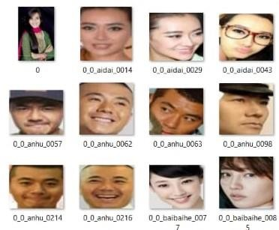
[n_out, n_out, n_c] = [floor(1 + (n + 2p - f) / s), floor(1 + (n + 2p - f) / s), n_c]

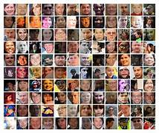

Fig 3 -Dataset With and without face mask

5) MODEL TESTING:-
Our system plays a vital role in ensuring compliance with mask-wearing protocols among the organization's employees. The provided image demonstrates the system's ability to accurately detect whether a person is wearing a mask or not. In this case, the system identifies that the individual in question is not wearing a mask, as indicated by the prominently displayed red box. Moreover, the system associates a "No" label with the person's name to further emphasize the absence of a mask.

To actively address non-compliance, our system took proactive measures by sending warning emails to 4,444 individuals who were identified as not wearing masks. This is clearly depicted in the accompanying table, which confirms that email notifications were indeed dispatched to the specified number of individuals without masks.
6) CONCLUSION:-
We have built machines that can observe the world with a real-time camera without the need for additional equipment. The system design is a simple hour video analyser. This is the probability of checking if the person is wearing a mask or is not wearing a mask. will be placed in all supermarkets and public places. This has helped the United States overcome the COVID-19 outbreak. Community transmission of the COVID-19 virus has been reduced by patients wearing face masks. We will use for reviews and a number of different options that every buyer will be faced with, such as credits. Staff Completed Inspections to access most doors. We will watch video and see if this person is and is wearing a mask. If the person is wearing the mask, everything is fine; otherwise it should send a warning email like "You are not wearing mask ".If you try to re-enter school without a mask, you will have to pay a fine of Rs 50"
REFERENCES
[1]Rahman, Mohammad Marufur; Manik, Md. Motaleb Hossen; Islam, Md. Milon; Mahmud, Saifuddin; Kim, Jong-Hoon (2020). [IEEE 2020 IEEE International IOT, Electronics and Mechatronics Conference (IEMTRONICS) - Vancouver, BC, Canada (2020.9.9- 2020.9.12)] 2020 IEEE International IOT, Electronics and Mechatronics Conference (IEMTRONICS) - An Automated System to Limit COVID-19 Using Facial Mask Detection in Smart City Network. , (), 1– 5. doi:10.1109/IEMTRONICS51293.2020.9216386
[2]Sakshi, S., Gupta, A. K., Singh Yadav, S., & Kumar, U. (2021). Face Mask Detection System using CNN. 2021 International Conference on Advance Computing and Innovative Technologies in Engineering (ICACITE). doi:10.1109/icacite51222.2021.940
[3]Islam, M. S., Haque Moon, E., Shaikat, M. A., & Jahangir Alam, M. (2020). A Novel Approach to Detect Face Mask using CNN. 2020 3rd International Conference on Intelligent Sustainable Systems (ICISS). doi:10.1109/iciss49785.2020.9315
[4]Suresh, K., Palangappa, M., & Bhuvan, S. (2021). Face Mask Detection by using Optimistic Convolutional Neural Network. 2021 6th International Conference on Inventive Computation Technologies (ICICT). doi:10.1109/icict50816.2021.9358
[5]Jiang, X.; Gao, T.; Zhu, Z.; Zhao, Y. Real-Time Face Mask Detection Method Based on YOLOv3. Electronics 2021, 10, 837. https:// doi.org/10.3390/electronics10070837
[6]Kumar, G. and Shetty, S. Application Development for Mask Detection and Social Distancing Violation Detection using Convolutional Neural Networks. DOI: 10.5220/0010483107600767
[7]Ejaz, Md. Sabbir; Islam, Md. Rabiul (2019). [IEEE 2019 International Conference on Sustainable Technologies for Industry 4.0 (STI) - Dhaka, Bangladesh (2019.12.24-2019.12.25)] 2019 International Conference on Sustainable Technologies for Industry 4.0 (STI) - Masked Face Recognition Using Convolutional Neural Network. , (), 1–6. doi:10.1109/STI47673.2019.9068044
[8]Z. Wang, P. Wang, P. C. Louis, L. E. Wheless, and Y. Huo, “Wear mask: fast Inbrowser face mask detection with server less edge computing for COVID-19,” 2021, https://arxiv.org/abs/2101.00784
[9]I. B. Venkateswarlu, J. Kakarla and S. Prakash, "Face mask detection using Mobile Net and Global Pooling Block," 4 2020 IEEE 4th Conference on Information & Communication Technology (CICT), 2020, pp.1-5,doi:10.1109/CICT51604.2020.9312083.
[10]N. Mehendale B-412, K. J. Somaiya College of Engineering, Mumbai, India Tel.: +91-9820805405
Email: ninad@somaiya.edu
[11]K.Nithiyasreea and T.Kavithab a Student, b Assistant Professor(SS) a, b Department of Computer Science and Engineering Periyar Maniammai Institute of Science & Technology, Vallam, Thanjavur-613403, Tamil Nadu, India
]

