Regenerative Braking and Power Converters for Electrical Vehicle
1Satyam N. Tate,2 Vaiju N. Kalkhambkar
Department of Electrical Engineering, Rajarambapu Institute of Technology
---------------------------------------------------------------------***---------------------------------------------------------------------
Abstract - Rising Trends in Electric Vehicles The sector motivates us to develop cutting-edge approaches to enhancing driving effectiveness. In contrast to conventional braking, regenerative braking includes recovering kinetic energy from the wheels that would otherwise be lost as heat and friction. Faster-moving vehicles can use it more effectively. The situation is made better by the use of the flywheel, ultracapacitor, sophisticated power electronic converter, and effective energy storage technologies. The amount of driving distance increased by regenerative braking is roughly 16.25%. The duration of the vehicle's braking is also reduced. Advanced control techniques, such as fuzzy logic, help electric vehicles save energy.

Key Words: Electric Machine, Electric Traction Drive System, Internal Combustion Engine, EV, BLDC motor, brake controller, Energy Recovery Mechanism, Sinusoidal PWM, Space Vector PWM, FC Fuel cell, ESS Energy storage system, Regenerative braking system

I.INTRODUCTION

Green energy has become increasingly essential for environmental preservation. Electric vehicles (EVs) play a crucial role in reducing air pollution by emitting zero emissions. However, a significant challenge for EVs is their limited driving range due to the size and weight limitations of batteries. Regenerative braking addresses this issue by recovering energy from the wheels that would otherwise be wasted during braking. This technology increases the driving range of EVs by approximately 16.25% [3].
During regenerative braking, Electromotive force (emf) is generated in the motor windings in significant amounts when the motor speed exceeds the rated speed, particularly when travelling downhill. Regenerative braking makes it possible to efficiently recover motor energy. Motors that promote regeneration are especially effective with high winding inductance and low winding resistance.
Induction motors were used to power electric vehicles in the past, but brushless DC motors (BLDC) are now a common choice. Despite BLDC motors being more difficult to regulate, advances in power electronics have made this easier. BLDC motors have a number of benefits over induction and brushed DC motors, including high efficiency, dynamic response, simplified construction, wider speed range, sturdy structure, higher starting torque, and noiseless operation.
Induction motors were used to power electric vehicles in the past, but brushless DC motors (BLDC) are now a common choice. Despite BLDC motors being more difficult to regulate, advances in power electronics have made this easier. BLDC motors have a number of benefits over induction and brushed DC motors, including high efficiency, dynamic response, simplified construction, wider speed range, sturdy structure, higher starting torque, and noiseless operation. They display a torque profile that is nearly constant. Regenerative braking has a number of benefits, including enhanced braking performance, which is especially beneficial for stop-and-go traffic in cities, the prevention of brake system wear and tear, and effective fuel utilization.
Overall, regenerative braking technology contributes to the advancement of green transportation by enhancing the driving range of electric vehicles and improving overall energy efficiency.

II. OPERATING PRINCIPLE OF REGENERATIVE BRAKING SYSTEM

The wheels of a moving vehicle provide a substantial quantity of kinetic energy. Usually, when braking mechanically, this energy is lost as heat and friction. Regenerative braking, on the other hand, provides an alternate approach to capture and effectively use this energy. Regenerative braking is a technique that transforms kinetic energy into electrical energy, which can then be stored in batteries for later use. The motor moves the car forward in the conventional forward driving state, as shown in the illustration below, by applying torque in the direction of the wheel's rotation.
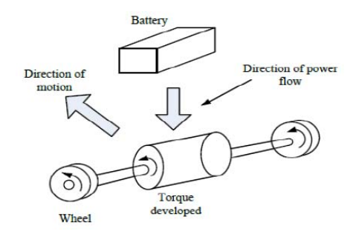

Fig.1. Forward driving condition [4]

During regenerative braking, the generation of reverse electromotive force (emf) aligns with Lenz's law, opposing the vehicle's motion. This opposition leads to changes in the speed profile of the vehicle, corresponding to variations in the strength of the magnetic field. As the motor acts as a generator during braking, the magnetic field weakens, resulting in a decrease in speed. The torque in a motor operates in the opposite direction of wheel rotation. The diagram above depicts the energy supply from the battery, while another diagram illustrates the energy being returned to the battery.
Regenerative braking greatly reduces the need for fuel, improving fuel economy and cutting pollution. In cities with lots of stop-and-go traffic, this method works particularly well. Furthermore, regenerative braking enables shorter braking periods compared to conventional braking, allowing the vehicle to come to a quicker stop.

III. Power Converters and inverters used for Regenerative braking in EVs:
- DC/AC converter:

In many modern electric vehicles (EVs), the electric motors (EMs) operate on AC power, while the energy source, such as the battery, provides DC power [51]. This necessitates the use of DC/AC converters, also referred to as inverters, within the Electric Traction Drive System (ETDS) to facilitate power transfer. Currently, commercialized EVs commonly employ Voltage Source Inverters (VSIs), which can be directly connected between the battery and the EM, or combined with a DC/DC boost converter for enhanced performance

- DC/DC boost converter
In electric vehicles (EVs), the battery and the DC-link of the traction inverter are connected by a DC-DC boost converter. The inverter and electric motor (EM) will function at their best thanks to this setup, which enables the battery voltage to be increased based on the driving circumstances. [18]. Increasing the battery voltage through this configuration helps optimize the overall system efficiency.

- VSI combined with a DC/DC boost converter:
High-efficiency three-phase Voltage Source Inverters (VSIs) based on Insulated Gate Bipolar Transistors (IGBTs) are frequently used in contemporary electric vehicles (EVs). The battery pack can be directly connected to the inverter's DC input using the schematic diagram presented below. Alternately, a DC/DC boost converter may be utilised to increase the battery voltage and supply a regulated DC voltage to the inverter. Six switches that are manipulated as part of the VSI topology are used to create a three-phase sinusoidal output current for the electric motor (EM). [19].
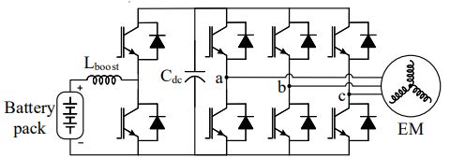

Fig.2

- Current source inverter :
The of inverter used to transform power from a DC current source into an AC output is the current source inverter (CSI). [19]. 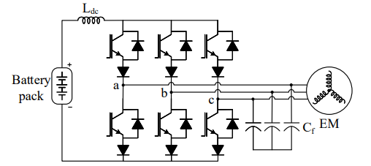
Fig.3

The advantage of the current source inverter (CSI) is that it raises the input voltage, producing an AC output peak voltage greater than the DC input voltage. By guaranteeing a sufficient output voltage, this removes the need for a separate DC/DC boost converter and increases the constant power range of the electric motor (EM) [20]. However, due to its poorer efficiency and higher cost as compared to the voltage source inverter (VSI), the current source inverter has not been widely adopted in automobile traction applications. [21] .

- Z-source inverter:
In order to enable direct connection of a voltage or current source to its input terminals, the Z-source inverter combines characteristics from both the voltage source inverter (VSI) and current source inverter. [22]. Because of its capacity to buck-boost, the Z-source inverter has drawn interest as a potential component for electrified powertrains. Because of their wide voltage range, batteries can be used as a number of DC sources, making this capability very helpful. [23, 24].
In recent times, three-level inverters have gained considerable attention as viable alternatives to the conventional VSINeutral Point Clamped (NPC) and T-type NPC (TNPC), among other topologies, have become top candidates for medium- to high-voltage applications. Regarding their applicability and performance, these various topologies offer solutions that are competitive [25-28]. Extensive research has highlighted numerous advantages of three-level inverters [29, 30], including reduced harmonic distortion in output voltages compared to VSIs. This characteristic leads to lower filter requirements and improved motor efficiency.
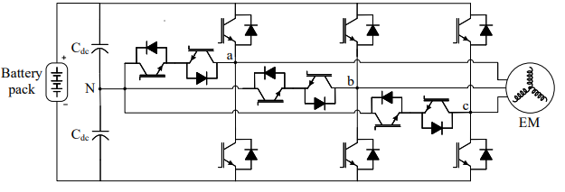
Fig.4
IV. MODULATION TECHNIQUES:
a. SPWM :
Due to its easy implementation and simplicity, the Sinusoidal Pulse Width Modulation (SPWM) technology is frequently used in the industry.[31].Initially developed using analog circuits, it has now become a standard procedure for digital implementation. In the Sinusoidal Pulse Width Modulation (SPWM) technique, a switching pattern is created by comparing a triangular carrier signal, which operates at the desired switching frequency, with three sinusoidal waveforms that are phase-shifted by 120 degrees. These sinusoidal waveforms operate at a fundamental frequency much less than the switching frequency.
b. SVPWM
Due to the growing use of digital signal processors and microcontrollers, Sine Voltage Pulse Width Modulation (SVPWM) has become more common. Despite the necessary processing needs, these technologies allow for the cost-effective implementation of SVPWM. [31, 32].
While it is difficult to ascertain the specific modulation strategy used in every electrified vehicle's traction inverters, SVPWM is widely believed to be the preferred choice due to its superior performance. For instance, reports [33, 34] indicate that General Motors utilizes SVPWM for the linear region of their vehicles.

V. ENERGY STORAGE SYSTEM
i. FUEL CELL
Over the past few decades, there has been a consistent rise in the global demand for fossil fuels. Nevertheless, relying on fossil fuels to meet future energy requirements is not a sustainable approach due to the environmental issues associated with them. [35, 36]. Vehicles powered by internal combustion engines (ICE) have a substantial impact on fuel consumption, leading to fuel market volatility and environmental concerns, primarily related to greenhouse gas emissions. According to projections, fossil fuels are expected to continue dominating approximately 75% of the global energy demand even by the year 2050. [35, 37, 38].
To address these challenges, alternative energy sources are crucial. One promising solution is Fuel Cell Electric Vehicles (FCEVs), where the electric power for propulsion is generated by a fuel cell (FC) that utilizes hydrogen as a sustainable and environmentally friendly fuel [35, 49-51]. FCEVs offer a potential resolution to the issues faced by Battery Electric Vehicles (BEVs) and hold promise as a future transportation fuel.
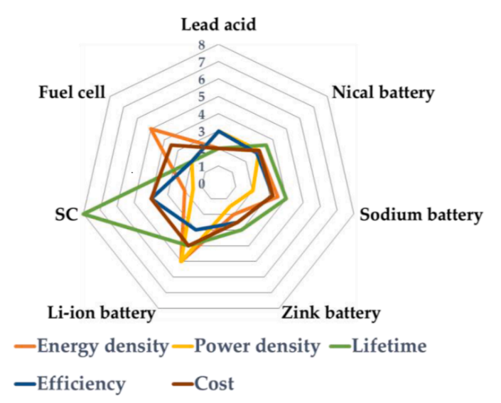

Fig.5. Comparison of different ESS
ii. Hybrid storage system
A hybrid storage system (HSS) combines many energy storage technologies, including fuel cells, supercapacitors, and batteries. These pairings can be a mix of battery, SC, and FC or a battery and one of SC, FC, or battery and FC. High capacity, specific power, power density, extended lifespan, temperature resilience, and discharge rate are only a few of the advantages that each combination offers. [42]. In hybrid storage systems (HSS), the use of batteries and supercapacitors (SC) is frequently preferred. Numerous benefits of HSS include its large storage capacity, affordability, longer lifespan, and improved system performance. HSS combinations based on battery and SC or battery and fuel cell (FC) are frequently used in the world of electric cars (EVs). [34, 43]. Several energy storage system (ESS) parameters, including standard discharge time, energy density, power density, longevity, and efficiency, are illustrated in the above image. [43-45]. For energy storage, electric vehicles (EVs) use a mix of a battery, supercapacitor, and fuel cell. Specific battery types are selected based on consumer preferences and EV needs. Energy storage systems (ESS) that are high-energy, sustainable, affordable, and environmentally friendly are now being actively developed by researchers and automakers for EV applications. For EVs to work, efficient energy storage and management technologies are essential.

VI. Control via Fuzzy Logic
Artificial intelligence (AI) integration has significantly increased the effectiveness of current systems. The complex interrelationships between many parameters that affect how braking force is distributed in electric vehicles (EVs) are best illustrated using fuzzy logic control. As a result, the distribution of EV braking force has been subject to fuzzy control theory [10].

Membership functions (MFs) are used to specify input variables in fuzzy control. Each point in the input space is given a membership value between 0 and 1 by these functions, indicating how much it belongs there. The state of charge (SOC), needed braking force, and vehicle speed are examples of typical inputs for the fuzzy controller. The controller's output is the amount of regenerative braking that is used to stop the car.

Furthermore, flywheel systems have been used as electromechanical batteriesFlywheels have the capacity to store excess energy and release it when supply is insufficient. The following arguments are in favour of using flywheels:
- Flexibility in terms of both operation and design.
- High cycle efficiency, with possible rates as high as 90%.
- Minimal impact, especially in situations when quick charging is used.
- Longer than usual maintenance intervals of ten years
- VII. Ultracapacitors
The ultracapacitor is a high-capacity capacitor Ultracapacitors, also known as supercapacitors, are capacitors with significantly higher capacitance values compared to regular capacitors. They exhibit characteristics that lie between electrolytic capacitors and rechargeable batteries. The integration of ultracapacitors in electric vehicles offers increased storage capacity, thereby extending the vehicle's range. The utilization of ultracapacitors in EVs brings forth several advantages [1]:
- Enhanced transient performance of electric vehicles.
- 20% higher energy storage capacity compared to electrolytic capacitors.
- Prevention of rapid and unexpected battery drainage during acceleration and braking events.
  - CONCLUSION
In conclusion, regenerative braking is a cutting-edge technology that enhances driving efficiency in electric vehicles (EVs) by capturing and utilizing kinetic energy that would otherwise be wasted during braking. It offers numerous advantages over traditional braking systems.
The implementation of regenerative braking systems in EVs has shown an approximately 16.25% increase in driving range, making it particularly advantageous for high-speed vehicles. By integrating components such as flywheels, ultracapacitors, advanced power electronic converters, and efficient energy storage technologies, the performance of regenerative braking systems is further improved.
The operating principle of regenerative braking involves converting kinetic energy into electrical energy during braking and storing it in batteries for later use. This approach not only reduces reliance on fuel but also enhances fuel efficiency and lowers emissions. Moreover, regenerative braking enables shorter braking distances, resulting in quicker stops and improved braking performance.
Power converters and inverters play a crucial role in regenerative braking systems by facilitating power transfer and optimizing the operation of the electric motor. Different types of converters, including DC/AC converters, DC/DC boost converters, voltage source inverters (VSIs), current source inverters (CSIs), and Z-source inverters, are used in various configurations to maximize system performance.
Various modulation techniques, such as Sinusoidal Pulse Width Modulation (SPWM) and Sine Voltage Pulse Width Modulation (SVPWM), are employed for efficient control of the traction inverters in regenerative braking systems.
Energy storage systems (ESS) are essential components of regenerative braking, and hybrid storage systems (HSS) that combine batteries with supercapacitors or fuel cells offer significant benefits. The specific selection of an ESS depends on factors such as capacity, power density, lifespan, and cost-effectiveness.
The integration of artificial intelligence, particularly fuzzy logic control, optimizes the distribution of braking force in EVs. Flywheels can be utilized as electromechanical batteries for storing inertia energy, providing flexibility, high cycle efficiency, and extended maintenance periods.
Ultracapacitors, with their high capacitance values and energy storage capabilities, play a crucial role in regenerative braking systems. They offer advantages such as enhanced transient performance, higher energy storage capacity compared to electrolytic capacitors, and prevention of rapid battery drainage during acceleration and braking.
In summary, regenerative braking systems contribute to the advancement of electric vehicles by improving energy efficiency, increasing driving range, and reducing environmental impact. Ongoing research and development in this field hold promise for further enhancements in driving effectiveness and sustainability.

REFERENCES

- K.W.Chew,C.K Leong, Y.H Gan, G.D Gan, M.K. Yoong, Z.Y Phuan,B.K Cheah, “Studies of regenerative Braking in Electric Vehicles”, IEEE conference on Sustainable Utilization and Development in Engineering and Technology, 2010.
- O. Ustun, G. Tosun O. C. Kivanc and R. N. Tuncay,“On Regenerative Braking Capability of BLDC Motor”,pp.1710-1715, 2016.
- Kuo- Kai Shyu, Hong-Lin Jhou, Ming-Ji Yang, Bin-Yen Ma, “A Cost- Effective Method of Electric Brake with Energy Regeneration for Electric Vehicles”, IEEE Transactions on Industrial Electronics, Vol.56,

- Sreerag K S, Lulu Joseph, “A Novel Energy Regeneration Technique in brushless DC motor for Electric vehicles”, International Journal for Science and Research (IJSR), August 2016.
- P.V.R.L. Narasimham, M.Rakesh, , “Different Braking Techniques Employed to a Brushless DC Motor Drive used in Locomotives”, International Electrical Engineering Journal (IEEJ), pp. 784-790.
- Cui Haotian , Xu Jiaqun, “Regenerative Brake of Brushless DC Motor for Light Electric Vehicle”, 18th International Conference on Electrical Machines and Systems(ICEMS), Oct. 25-28, 2015.
- Cao, B., Yu., Bai, Z., M., “Robust Control for regenerative braking of battery electric vehicle”, IET Control Theory Appl, pp. 1105-1114, 2008.
- Liping Chen, Mehrdad Ehsani, Yinmin Gao , “Investigation of the Effectiveness of Regenerative Braking for EV and HEV”, SAEInternational SP-1466.1999-0 1-29,10.1999.
- M. Nemec, Y. Xiao, H. Lu,L. Borle, V. Sreeram, “Regenerative Braking of Series Wound Brushed DC Electric Motors for Electric Vehicles,” in Proceedings 7th Conference on Industrial Electronics and Applications (ICIEA), pp. 1657-1662, 2011.
- Zijian Zhang, Guoquing Ku, Weimin Lee, “Regenerative braking foe Electric Vehicle based on Fuzzy Logic Control Strategy”, 2nd International Conference on Mechanical and Electronics Engineering, vol1.no.4, pp. 319-320,2010.
- Dixon,“Energy Storage for Electric vehicles”, Industrial Technology (ICIT), IEEE International Conference, pp. 20-26, 2010.
- “The Power Electronics Handbook, Industrial Electronics Series”, CRC press,2002.
- Ramesh Kumar Tripathi, Umesh Kumar Soni, “Novel Back EMF Zero Difference Point Detection Based Sensorless Technique for BLDC Motor”, IEEE, pp. 330- 335, 2017.
- Tim Bokker, Philipp Spichartz, , “Comparison of electric vehicles with single drive and four-wheel drive system concerning regenerative braking”, Twelfth International Conference on Ecological Vehicles and Renewable Energies (EVER), 2017.
- Gang wan, Xinbo Chen, Guobao Ning, Journal of Asian Electric Vehicles, 2009.
- C. C. Chan, “The state of the art of electric, hybrid and fuel cell vehicles,” IEEE, vol. 95, no.4, pp. 704- 718, April , 2007.
[18] J. O. Estima and A. J. M. Cardoso, “Efficiency analysis of drive train topologies applied to electric/hybrid vehicles,” IEEE Transactions on Vehicular Technology, vol. 61, no. 3, pp. 1021–1031, Feb. 2012.
[19] M. H. Rashid, Power Electronics Handbook: devices, circuits, and applications, 3rd ed. Elsevier Inc, 2011.
[20] Z. Wu and G.-J. Su, “High-performance permanent magnet machine drive for electric vehicle applications using a current source inverter,” in 2008 34th Annual Conference of IEEE Industrial Electronics, Orlando, FL, Jan. 2008, pp. 2812–2817.
[21] E. P. Wiechmann, P. Aqueveque, R. Burgos, and J. Rodr´ıguez, “On the efficiency of voltage source and current source inverters for high-power drives,” IEEE Transactions on Industrial Electronics, vol. 55, no. 4, pp. 1771–1782, Apr. 2008.
[22] F. Z. Peng, “Z-source inverter,” IEEE Transactions on Industry Applications, vol. 39, no. 2, pp. 504–510, Mar. 2003.
[23] F. Z. Peng, A. Joseph, J. Wang, M. Shen, L. Chen, Z. Pan, E. Ortiz-Rivera, and Y. Huang, “Z-source inverter for motor drives,” IEEE Transactions on Power Electronics, vol. 20, no. 4, pp. 857–863, Jul. 2005.
[24] F. Z. Peng, M. Shen, and K. Holland, “Application of Z-source inverter for traction drive of fuel cell in battery hybrid electric vehicles,” IEEE Transactions on Power Electronics, vol. 22, no. 3, pp. 1054–1061, May 2007.
[25]A. Nabae, I. Takahashi, and H. Akagi, “A new neutral-point-clamped pwm inverter,” IEEE Transactions on Industry Applications, vol. IA-17, no. 5, pp. 518–523, Sep. 1981.
[26] J. Rodriguez, J.-S. Lai, and F. Z. Peng, “Multilevel I nverters: a survey of topologies, controls, and applications,” IEEE Transactions on Industrial Electronics, vol. 49, no. 4, pp. 724–738, Nov. 2002.
[27] J. Rodriguez, S. Bernet, P. K. Steimer, and I. E. Lizama, “A survey on neutral-pointclamped inverters,” IEEE Transactions on Industrial Electronics, vol. 57, no. 7, pp. 2219–2230, Sep. 2010.
[28] M. Schweizer and J. W. Kolar, “Design and implementation of a highly efficient threelevel T-type converter for low-voltage applications,” IEEE Transactions on Power Electronics, vol. 28, no. 2, pp. 899–907, Jun. 2013.
[29] R. Teichmann and S. Bernet, “A comparison of three- level converters versus two-level converters for low-voltage drives, traction, and utility applications,” IEEE Transactions on Industry Applications, vol. 41, no. 3, pp. 855–865, May 2005.
[30] M. Schweizer, T. Friedli, and J. W. Kolar, “Comparative evaluation of advanced three-phase three-level inverter/converter topologies against two-level systems,” IEEE Transactions on Industrial Electronics, vol. 60, no. 12, pp. 5515–5527, Dec. 2013.
[31] D. G. Holmes and T. A. Lipo, Pulse width modulation for power converters: principles and practice. John Wiley & Sons, 2003.
[32] A. Mehrizi-Sani and S. Filizadeh, “An optimized space vector modulation sequence for improved harmonic performance,” IEEE Transactions on Industrial Electronics, vol. 56, no. 8, pp. 2894–2903, Nov. 2009
[33] S. Jurkovic, K. Rahman, B. Bae, N. Patel, and P. Savagian, “Next generation chevy volt electric machines; design, optimization and control for performance and rare-earth mitigation,” in 2015 IEEE Energy Conversion Congress and Exposition (ECCE), Montreal, QC, Canada, Sep. 2015, pp. 5219–5226.
[34] F. Momen, K. Rahman, Y. Son, and P. Savagian, “Electrical propulsion system design of chevrolet bolt battery electric vehicle,” in 2016 IEEE Energy Conversion Congress and Exposition (ECCE), Milwaukee, WI, Sep. 2016, pp. 1–8.
[35] Y. Manoharan, S.E. Hosseini, B. Butler, H. Alzhahrani, B.T.F. Senior, T. Ashuri, J. Krohn, Hydrogen fuel cell vehicles; current status and future prospect, Appl. Sci. 9 (11) (2019) 2296.
[36] S.E. Hosseini, A.M. Andwari, M.A. Wahid, G. Bagheri, A review on green energy potentials in Iran, Renewable Sustainable Energy Rev. 27 (2013) 533–545. [37] M. Derbeli, O. Barambones, L. Sbita, A robust maximum power point tracking control method for a PEM fuel cell power system, Appl. Sci. 8 (12) (2018) 2449.
[38] E.L.V. Eriksson, E.M. Gray, Optimization and integration of hybrid renewable energy hydrogen fuel cell energy systems–a critical review, Appl. Energy 202 (2017) 348–364.
[39] A. Kerviel, A. Pesyridis, A. Mohammed, D. Chalet, An evaluation of turbocharging and supercharging options for high-efficiency fuel cell electric vehicles, Appl. Sci. 8 (12) (2018) 2474.
[40] U.K. Chakraborty, A new model for constant fuel utilization and constant fuel flow in fuel cells, Appl. Sci. 9 (6) (2019) 1066.
[41] L. Giorgi, F. Leccese, Fuel cells: technologies and applications, Open Fuel Cells J. 6 (1) (2013). M.K. Hasan et al. Journal of Energy Storage 41 (2021) 102940 10
[42] T. Bocklisch, Hybrid energy storage approach for renewable energy applications, J. Energy Storage 8 (2016) 311–319.
[43] H. Wang, Q. Wang, B. Hu, A review of developments in energy storage systems for hybrid excavators, Autom. Constr. 80 (2017) 1–10.
[44] R. Hemmati, H. Saboori, Emergence of hybrid energy storage systems in renewable energy and transport applications–a review, Renewable Sustainable Energy Rev. 65 (2016) 11–23.
[45] A.A. Habib, S.M.A. Motakabber, M.I. Ibrahimy, A series regeneration converter technique for voltage balancing of energy storage devices, Indonesian J. Electr. Eng. Comput. Sci. 8 (2) (2017) 475–481.

