Breast Cancer Classification using Machine Learning : A Review
Gurmanjit Kaur¹ , Manveen Kaur²
^{1,2}DAV Institute of Engineering and Technology
¹gurmanbhangu2002@gmail.com
²manveendhanju7@gmail.com

Abstract— Breast cancer is a major health concern affecting women worldwide, and early discovery is pivotal for effective treatment. Machine learning algorithms have shown great potential in correctly classifying breast cancer subtypes. In this review paper, we epitomize the classification of breast cancer using machine learning techniques. We also review different machine learning algorithms similar as Support Vector Machine (SVM), Decision Tree, Naive Bayes (NB), K Nearest Neighbors (k- NN) for breast cancer classification. We've compared their performance. Eventually, we bandy the challenges and unborn directions of machine learning-based breast cancer classification. Overall, this review paper provides a comprehensive overview of the current state of- the- art in breast cancer classification using machine learning and can serve as a precious resource for experimenters in this field. Our aim is to review various ways to descry beforehand, efficiently, and directly using Machine learning. Since early discovery of cancer is crucial for effective treatment of breast cancer, we use various machine learning algorithms to prognosticate if a tumor is benign (noncancerous) or malignant (cancerous), grounded on the features handed by the data.
Keywords-Breast cancer classification, benign, malignant, Naïve Bayes, KNN, Support Vector Machine, Decision tree.

- INTRODUCTION
In women, breast cancer is one of the most prevalent cancers. The breast cells grow abnormally in this type of cancer. Globally, 2.3 million new cases of female breast cancer are reported every year, surpassing lung cancer. (11.7%) [ 1]. 10% of the breast cancer cases are hereditary and the other 90% are related to life factors. A significant increase in the prevalence rates of breast cancer was observed in 15 PBCRs in ladies. Maturity of cases passed multi-modality treatment and 97.7% were epithelial tumors. As far as breast cancer incidence in Asia is concerned, Israel (84.6) had the highest rate. Among the Indian districts, Hyderabad (48.0) had the highest incidence rate[2]. According to a report published by National Cancer Registry Programme (NCRP), cancer cases are anticipated to increase from 13.9 lakh in 2020 to 15.7 lakh by 2025, assuming a 20 percent increase overall [3]. Common cancers can be prevented from being fatal if treated beforehand. If detected early, it can be treated effectively.

The goal of the review paper is to classify the cases in Malignant and Benign types of tumors by classification techniques hence achieving advanced delicacy. The dataset is from the website names Kaggle. We've used supervised learning which is a machine learning concept where we give dependent and independent columns to the machine for learning and after the learning process is completed the machine will prognosticate the value for the dependent variable for a given input in the form of an
Author | Dataset Used | Technique Used | Tools Used | Result
Muktevi et al. [4] | Wisconsin breast  cancer-Kaggle | SVM, Random  Forest, KNN, LR,  NB | Python | The Random Forest model had the highest accuracy with 98.24%
Ramik Rawal  [5] | Wisconsin -Kaggle | SVM, Logistic  Regression, Random  Forest, K-NN | Jupyter  Notebook- Python | SVM- 97.13% highest efficiency and accuracy
Gaurav Singh  [6] | UCI repository | K-NN, SVM, LR, NB | Python | K-NN- 99%  SVM- 96% LR- 97%  NB-95%
Min-Wei et al. [7] | UCI Repository,  ACM SIGKDD Cup  2008 | SVM classifier, SVM ensemble | Weka | SVM ensembles perform slightly better than single  SVM classifiers
Deepika et al. [8] | UCI repository | Naïve Bayes, MLP | Weka | Naïve Bayes had better accuracy
Ch. Shravya et  al. [9] | UCI repository | SVM, K-NN, LR | Spyder Platform | SVM predicted the best accuracy of 92.78% followed by KNN-92.23%
Wang et al. [10] | Wisconsin Breast  Cancer Database  (1991)  Wisconsin  Diagnostic Breast  Cancer (1995) | SVM, ANN,  Adaboost, PCA | WEKA | 8 PCs -92.6% correlation, 10  PCS- 95%
independent variable. The classification techniques used for detecting the tumour are Decision tree, K Nearest Neighbour (KNN), Support Vector Machine (SVM), Naïve Bayes (NB) classification in google colab along with data visualization.

- LITERATURE SURVEY
- Nithya [4] applied the three categorizing methods such as Decision Tree, k-Nearest Neighbour, and Naïve Bayes for the different datasets. Additionally, the authors examine the evaluation metrics of error rate. Datasets with a particular attribute type were implemented.
- Shilpa M and C. Nandini [5] implemented the algorithm using Python and tested it on one data set, achieving an accuracy of 94.74 and reducing the time required.
- A. Hafizah [2] compared SVM and ANN using four different datasets of breast cancer. The researchers showed that SVM was better in performance and outcome than ANN.
- S. Gc [1] worked on extracting features including variance, range, and compactness. They used SVM classification to analyses the performance. Their results showed the highest variance of 95% and compactness 86%. According to their results, SVM can be considered as a suitable method for breast cancer prediction.
The following is a summary of work done in the following domain:

III. METHODOLOGY
- Dataset Description:
We have received Breast Cancer Wisconsin (Diagnostic) Dataset from Kaggle. Here 569 patient datasets were used for analysis, each instance has 32 attributes with diagnosis and characteristics. Each instance has a parameter of cancerous and non-cancerous cells, and we will predict the cancer only by entering the features. The values of the features are in numeric format. The "target" is the patient who has a "benign" or "malignant" cancer. Benign(mapped with 0) means the patient is not having cancer and Malignant(mapped with 1) means the patient is having cancer.

- Section Headings
We used Google Colab as a coding platform. Our methods include supervised learning algorithms and classification techniques like Support Vector Classifier (SVM), Naïve Bayes, Decision Tree, KNN. The dataset contains features that vary widely in units and magnitudes. Therefore, it is necessary to bring all features to the same order of magnitude. We achieved this using the default scaling in Sklearn. Model selection is the most important step in machine learning.
Machine learning algorithms can be classified as: supervised learning and unsupervised learning. For our project, we only need supervised learning. We have used all methods to predict the outcome and determined their accuracy.

- METHOD
The main goal of our experiment is to identify an effective and predictive algorithm for breast cancer detection. Therefore, we applied the machine learning classifiers Support Vector Machine (SVM), Random Forests, Logistic Regression, Decision Tree (C4.5), K-Nearest Neighbors (KNN) to the Wisconsin breast cancer diagnosis dataset and evaluated the obtained results to determine which model provides higher accuracy. The proposed architecture is detailed :

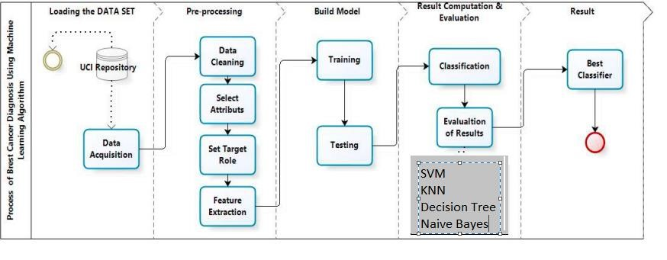
Fig. 1 Process of breast cancer Diagnostic using Machine Learning Algorithm

- BACKGROUND STUDY: MACHINE LEARNING ALGORITHMS
• Decision Tree Classifier:
In 1980, J. Ross Quinlan developed ID3 (Iterative Dichotomiser), a decision tree algorithm. The decision tree classifier is an example of supervised machine learning A decision tree operates on possible solutions to a decision based on certain conditions. It classifies the conditions at each node to find a solution.
The high-level pseudocode for the Decision Tree Classifier algorithm:
The most popular attribute selection measures are – Entropy (Information Gain), Gain Ratio, and Gini Index The entropy of any split can be calculated by this formula.

$$H\left(s\right)=-P_{\left(+\right)}\log_{2}{P_{\left(+\right)}-P_{\left(-\right)}\log_{2}{P_{\left(-\right)}}}$$

$Here\frac{P_{\left(+\right)}}{P_{\left(-\right)}}=$% of +ve class 1% of -ve class

The Gini impurity of features after partitioning can be calculated using the following formula:

GI = 1-$\sum_{i=1}^{n}{{(p)}^{2}}$
GI=1-[($P_{\left(+\right)})^{2}+(P_{\left(-\right)})^{2}$]

Algorithm:
- Start at root node.
- Root value compared with record real dataset attribute.
- Jump to next node based on comparison.
- Compare attribute value with subnode value and jump accordingly.
5)Repeat till left node of tree is reached.

• Naïve Bayes:
The Naïve Bayes classification technique is based on Bayes’ theorem. It is named ‘naïve’ because this algorithm assumes each input variable to be independent. This is a fast and simple ML algorithm used to predict a class, which is usually large. Given a class variable, the Naïve Bayes classifier assumes that the presence or absence of one feature is unrelated to the presence or absence of other features. It is very useful and effective when dealing with complex problems.
In Gaussian Naive Bayes, it is assumed that continuous values associated with each feature that is used for prediction follow a normal distribution (Gaussian Distribution) (“Naive Bayes Classifiers,” 2019). Hence, when they are plotted, a bell-shaped curve is formed which is symmetric about the mean of the feature as shown in equation :
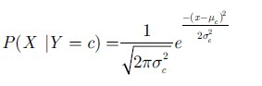
Algorithm:
- Separate the training data by class.
- Calculate mean and standard deviation for each attribute.
- Summarize and organize dataset by class.
- Calculate the Gaussian Probability Density function.
- Lastly calculate the class probabilities.

• Support Vector Machine:
Support Vector Machines (SVMs) are machine learning algorithms which are used to deal with both classification and regression problems. The linear SVM classifier is based on the principle of margin maximization. The SVM algorithm is used to create a decision boundary, called the hyperplane, which divides the n-dimensional space into different classes so that new data points can be easily added. This linear classifier plans to expand the space between the decision hyperplane and the nearest data points by finding the most suitable hyperplane.
The decision function in SVM is defined as: f(x) = sign(w^T x + b)
where x is the input instance, w is the weight vector, b is the bias term, and sign() is the sign function that returns -1 or +1 depending on the sign of its argument.

Algorithm:
- Correctly classify the training dataset based on lines/boundaries.
- Selects from the lines/boundaries the one that has the greatest distance to the nearest data point.

• K-Nearest Neighbour:
K-Nearest Neighbor is a machine learning algorithm that belongs to the supervised learning technique. The KNN algorithm can solve both classification and regression problems but is mainly used for classification problems.
It is a non-parametric classification method that makes no assumptions based on the underlying data. It is also called a "lazy learner" algorithm because the training set is not learned immediately, but the data set is stored and then an action is performed on it at classification time. In the K-NN algorithm, a similarity between a new case and the existing data is assumed, and the new case is placed in the category with the greatest similarity to the existing cases. All the available data is stored, and the classification of new data point based is done based on similarity. Thus, when new data appear, the K-NN algorithm can be easily used to classify them into an appropriate category. KNN stores records during the training phase, and when new records arrive, it places them in a category similar to the new data.
We have used the Euclidean distance metric in our implementation as it is most popular and suggested by experts. Let the points P and Q be represented by feature vectors P = (x1, x2, …, xm) and Q = (y1, y2, …, ym), where m is the dimensionality of the feature space. The Euclidean distance between P and Q is calculated by :

dist(P,Q)=$\sqrt{\frac{\sum_{i-1}^{m}{{(x_{i}-y_{i})}^{2}}}{m}}$

Algorithm:
- Load the training and testing data from the dataset.
- Choose the value of nearest data point (K).
- For each data point, calculate Euclidean (distance between testing and rows of training data) distance and sort them ascendingly.
- Choose the top K row from the sorted field and assign a class to the test point based on the most frequent class.

IV. CONCLUSION
This paper analyses a Breast Cancer (Diagnostic) Data Set with 32 attributes and makes a prediction using different classifiers whether the tumour is benign or malignant. It can be seen that the highest accuracy is obtained using the SVM model with an accuracy for the linear kernel. We can summarize by saying that the SVM model showed the most efficient and effective accuracy out of all the 4 models used for the classification of benign and malignant tumours. We can see the number of Malignant (M) (harmful) or Benign (B) cells (not harmful) cells and plot it in a graph.
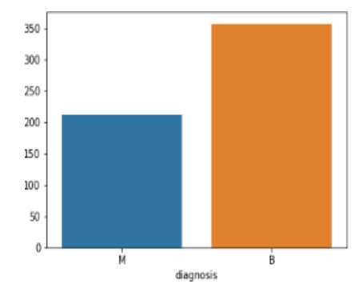
Fig. 2

A confusion matrix was plotted to calculate the miscalculations in each model. A confusion matrix is used to evaluate and recount the performance of a classifier.

 | Predicted Class
Actual Class |  | Yes | No
Actual Class | Yes | True Positive(TP) | False Negative(FN)
Actual Class | No | False Positive(FP) | True Negative(TN)

- True Positive (TP): Correctly predicts positive class.
- False Positive (FP): Incorrectly predicts positive class.
- False Negative (FN): Incorrectly predicts false class.
• True Negative (TN): Correctly predicts false class.

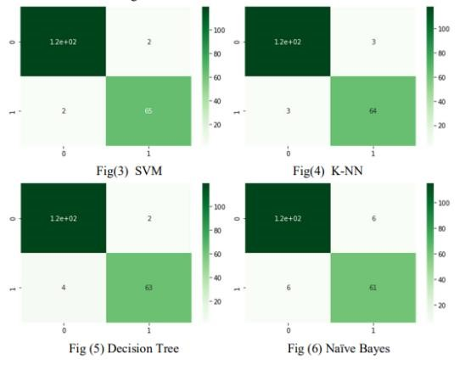

The data was then standard scaled for analysis.
It had the following predictions:

Techniques | Accuracy
SVM | 96.808%
KNN | 95.744%
Decision tree | 95.213%
Naïve Bayes | 93.617%
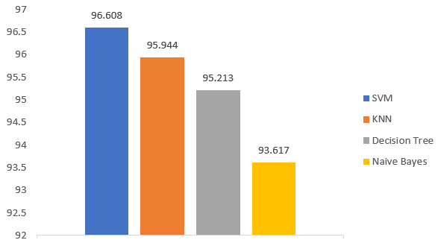

V.REFERENCES
- S. Gc, R. Kasaudhan, T. K. Heo, and H.D. Choi, “Variability Measurement for Breast Cancer Classification Mammographic adaptive and convergent systems (RACS), Prague, Czech Republic, 2015, pp. 177–182.
- S. Hafizah, S. Ahmad, R. Sallehuddin, and N. Azizah, “Cancer Detection Using Artificial Neural Network and Support Vector Machine: A Comparative Study,” J. Teknol, vol. 65, pp. 73–81, 2013.
- A. T. Azar, and S. A. El-Said, “Performance analysis of support vector Neural Compute. Appl., vol. 24, no. 5, pp. 1163–1177, 2014.
- Tüba Kiyanand Tülay Yildirim (2004), Breast cancer diagnosis using statistical neural networks, Journal of electrical & electronics engineering, vol.4, pp.1149- 1153.
- Sivapriya J, Aravind Kumar V, Siddarth Sai S, Sriram S, Breast Cancer Prediction using Machine Learning, ISSN: 2277-3878, Volume-8 Issue-4, November 2019.

