A STUDY OF LICENSING AND ASSIGNMENT OF PATENT
Author
V.R.SreeHari,
Advocate,
B.A,LL.B(Hons.),
Phone number:81482 55320,
Email id: sreehari0922@gmail.com .

Co-author:
K.S.Eniyavan,
Advocate,
B.A, B.L(Hons.), LL.M,
Phone no:9655335590,
Email id: k.s.iniyavan@gmail.com .

A STUDY OF LICENSING AND ASSIGNMENT OF PATENT

AUTHOR:V.R.SreeHari
CO-AUTHOR:K.S.Eniyavan

Abstract:

Patent is a choice directly to possess, use, or move a technique or an item for a constrained period, conceded to a creator by the administration permitting to industrially misuse his protected innovation. At whatever point a patent holder can't industrially endeavor or work the protected innovation, he looks to permit or dole out his entitlement to some other gathering under a concurred set of conditions who can take ideal favorable position of the development and consequently gives eminence installments to him. Under Indian law, a patent holder has a few commercialization ways accessible viz, the directly to utilize, deal, exchange, permit, home loan, and promise the patent. Be that as it may, the choice to permit or allot a patent relies on different urgent variables. This announcement will investigate the different features of patent authorizing and patent task and the components that impact the choice of finding the best commercialization way for a patent holder – to permit or to allot.

Keywords: Holder,license,rights,patent,assignment

Introduction:
Basically, the choice to either allocate or permit relies on the most invaluable commercialization pathway that the patent holder can choose(Heywood and Ye). And keeping in mind that choosing these fundamentals are dependably to be weighed against the other - the advantages accessible in getting eminences against getting a singular amount cost or giving without end title or simply give the rights to abuse the development in a specific domain for a constrained time frame. Task might be more favorable on specific events than authorizing(Heywood and Ye; Haedicke). In spite of the way that the Act secures the enthusiasm of a patentee, it is appropriate for the patent holder to make a reasonable task or permit consent to maintain a strategic distance from any potential dispute(Lin).Essentially, the choice to either dole out or permit relies on the most beneficial commercialization pathway that the patent holder can choose. And keeping in mind that choosing these basics are dependably to be weighed against the other - the advantages accessible in getting sovereignties against getting a singular amount cost or giving endlessly title or simply give the rights to misuse the innovation in a specific domain for a constrained time frame.(Wang et al.) Task might be more invaluable on specific events than authorizing. Notwithstanding the way that the Act secures the enthusiasm of a patentee, it is relevant for the patent holder to make a reasonable task or permit consent to keep away from any potential dispute(Chang et al.).A permitting understanding is an organization between a patent holder (licensor) and another who is approved to utilize such rights (licensee) in return for a concurred installment (expense or sovereignty). A patent authorizing understanding can be either a "selective permit ascension", a "non-restrictive permit ascension" or an "obligatory permit". A patent holder, by a permit, allows others to make, use, or exercise the innovation which generally would not be permitted(Li and Yanagawa). A restrictive permit bars every single other individual including the patent holder from the utilization of innovation and wherever constraint is given, it is commonly a confinement identified with people, time, put, make, use or deal. Area 2(f) of the Act characterizes a "select permit" as "a permit from a patentee which gives on the licensee, or on the licensee and people approved by him, to the prohibition of every other individual (counting the patentee), any directly in regard of the protected development, and 'restrictive licensee' will be understood in like manner(Mauleon et al.)." The restrictiveness may rely upon the land degree of the licensee's correct time factor, or potentially the selectiveness to practice the rights authorizedThe expression "task" isn't characterized under the Act. A patent holder can allot the entire or any piece of the patent rights to the entire of India or any part thereof(Lemley). Task is generally an exchange of proprietorship regardless of whether it is partial.There are three sorts of assignments: legitimate task, fair task and home loans. A task of a current patent is a legitimate task where the trustee may enter his name as the patent proprietor(Wang and Mukherjee) .A specific offer given to someone else is called a fair task. An impartially chosen one can't have his name entered in the enrollment as owner of the patent; however he may have noticed his enthusiasm for the patent entered in the enlist(Wang and Mukherjee; Din and Liang). An alloy of patent rights previously the give of patent is a fair task, which gives the chosen one the right to call upon the patentee when the patent is conceded to allocate that patent to the appointee. A home loan is when patent rights are completely or somewhat exchanged to get cash. On reimbursement of the cash the mortgagor winds up qualified to get his name entered in the enlist as the owner. Area 68 gives that the task deed will, when enlisted, have impact from the date of its execution.It is critical to note here that according to segment 40 of the Indian Contract Act, an agreement which the promisor is required to perform by and by isn't equipped for the task. Area 37 further says that without an opposite expectation, an agreement is enforceable against chosen ones also. To entirety, a task ascension needs to fulfill the prerequisites as provided under the Contracts Act. The task of understanding makes lawful and fair rights in law.

OBJECTIVES :
The objective of the paper is to find the major.Points on This paper enlights Grounds of assignment of patent.This paper enlights licensing of patent.This paper aim is to study about transferring patent rights.The paper aim is to know the monopoly right of patent holders.

HYPOTHESIS:-
NULL HYPOTHESIS: There is significant for the assignment of patent.And licensing of patent rights
ALTERNATE HYPOTHESIS: There Is significant for assignment of patent.And licensing of patent rights.

MATERIALS AND METHODS:

The methodology used in this study is Doctrinal. It is based on the information and data collected from secondary sources. They include publication research, International Journal of Pure and Applied Mathematics Special Issue Surveys , Journals ,historical information of both past and present. When a research is concerned with some legal problem, issue or question, it is referred to as doctrinal, theoretical or pure legal research.Doctrinal research is a theoretical study where mostly secondary sources of data are used to seek to answer one or two legal propositions or questions or doctrines. Its scope is very narrow and there is no such need for field work.

Review literature:

Does protected innovation move toward becoming un-critical on the internet? Weber Rolf H, International Journal of Law and Information Technology, 9(2) 2001,171-185.Since an expanding number of people make their living in the 'data economy', immaterial resources are ending up increasingly essential.(Sengupta) Lawfully, riches obtained by working with information required on a basic level the presence of legal framework ensuring non-material property rights and comparative conservative positions; the separate 'titles' locate their legitimate source and premise in licensed innovation law(“ASSIGNMENT OF PATENT RIGHTS TO THE ST. LOUIS UNIVERSITY SCHOOL OF MEDICINE”). Licensed innovation rights and the third world, Mashelkar RA (www.patent-matics.com) . Issues of age, insurance and exploitation of protected innovation (IP) are assuming expanding significance(Leontief). The new IP routines will have wide extending socio-economic, mechanical and political effects. According to the commitments under the Trade-Related Intellectual Property Systems (TRIPS), every one of the individuals from World Trade Organization (WfO) should execute national frameworks of protected innovation rights following a concurred set of least standards. In any case, there is an expanding feeling that harmonization is requested from those that are not equivalent, either financially or institutionally(Leontief; Lee et al.). The significant worries of the third world about such harmonization and the new test it faces in differing territories of licensed innovation insurance are discussed and a few recommendations about the route ahead are made. (S. and C.)The discourse incorporates the requirement for a reasonable play in innovation exchange, formation of 'favorable financial aspects' of fundamental medications from the perspective of the third world, insurance of traditional information, etc.(Emling)The production of Traditional Knowledge Digital Library (a basically Indian activity) and connecting it to the International Patent Classification System (IPC) through a Traditional Knowledge Resource Classification System is an essential theoretical advance forward. The conceivable models for material exchange and advantage sharing when items are created dependent on network learning are additionally examined(Macedo). Other exchanges incorporate the test of spanning the gap between the third world and other created countries, with extraordinary emphasis on protected innovation information sharing, limit working with production of proper physical and scholarly infrastructure and mindfulness building. It is argued that the third world ought to arrange another 'Treks in addition to which signifies 'Outings in addition to value and morals Intellectual property rights and outside direct speculation, Gloss Amy Jocelyn and Saggi Kamal, Journal of International Economics, January 200l. This paper builds up an item cycle display with endogenous advancement, impersonation, and remote direct speculation (FDI). The creators utilize this model to decide how more grounded licensed innovation rights aPR) assurance in the South influences development, impersonation and FDI(Deyle and Grupp). They found that more grounded IPR assurance keeps multinationals more secure from impersonation, yet no more so than North-ern firms. Rather, the expanded trouble of impersonation creates squandering assets and impersonation disincentive impacts that decrease both FDI and development. Diminished FDI then transmits asset shortage in the South back toward the North and therefore contracts advancement. Eventual fate of composites in IPR routine, Subramanian P N (www.patentmatics.com) General seek of patents amid 1996-2000 demonstrates the incomparable R&D enthusiasm for the field of composites(Fong et al.). The licenses cover almost all fields of composites, viz. thermoplastics and thermosetting materials, handling techniques for items and crude materials; assortment of items for automobile, transport, building, developments, sports enterprises, etc. In any case, the licenses taken for aviation items by fiber winding, pultrusion, RTM, and so forth are observed to be constrained. This might be because of less business potential outcomes and restricted applications. In any case, the licenses pertaining to RTM innovation show extraordinary enthusiasm for cutting edge innovations. Similarly, pultrusion has pulled in numerous R&D associations. A run of the mill patent on processing of rocket spout utilizing changed tape winding innovation was taken up for inside and out investigation to know its effects in the spout innovation in the nation. It is noticed that this procedure has not found sufficient pragmatic application and might not have much effect. Protected innovation rights and agricultural innovation - exchange and implications for India, Ravishankar An and Archak S, Economic and Political Weekly, 35(27)2000,2446-2452 t. With the Plant Varieties Protection and Farmers Rights' Bill being alluded to by a select parliamentary council, the coming of an IPR routine in the agrarian part is impending. This paper endeavors to portray heuristically, the exploration space and its portfolio in the horticultural segment. It is argued that entomb alia, the legitimate and approach structure will decide the state of things to come. In view of the idea of star tection for various advances, the job of likely partners and their conceivable effects are analyzed(McKone et al.). Finding new incentive in protected innovation, Rivette KG and Kline D, Harvard Business Review, 78(1) 2000, 54-t. Licensed innovation? Five years prior, that express wasn't even in the vocabularies of numerous CEOs, not to mention a piece of their business methodologies. To be sure, numerous CEOs still respect licenses, trademarks, copyrights, and different types of protected innovation as lawful issues best left to the corporate attor-neys. Be that as it may, the thriving learning economy has offered an ascend to another kind of CEO and another sort of business rivalry, one in which scholarly resources, not physical ones, have turned into the vital wellsprings of investor riches. What's more, upper hand. Also, in that lies one of the following extraordinary corporate difficulties.

Data analysis:

Age
 |  | Frequency | Percent | Valid Percent | Cumulative Percent
Valid | 15-30 | 465 | 47.5 | 47.5 | 47.5
Valid | 30-45 | 456 | 32.8 | 32.8 | 80.3
Valid | 45-60 | 534 | 17.3 | 17.3 | 97.5
Valid | above 60 | 24 | 2.5 | 2.5 | 100.0
Valid | Total | 1574 | 100.0 | 100.0

2. Age * 28. Whether the right of the patent can be transferred for money ?

Crosstab
Count
 |  | 28. Whether the right of the patent can be transferred for money ? |  |  | Total
 |  | yes | no | 28. Whether the right of the patent can be transferred for money ? | Total
2. Age | 15 - 30 | 368 | 224 | 0 | 592
2. Age | 31 - 45 | 305 | 298 | 0 | 603
2. Age | 2. Age | 0 | 0 | 1 | 1
2. Age | 46 - 60 | 131 | 216 | 0 | 347
2. Age | above 60 | 10 | 21 | 0 | 31
Total |  | 814 | 759 | 1 | 1574

Chi-Square Tests
 | Value | df | Asymptotic Significance (2-sided)
Pearson Chi-Square | 1632.018ª | 8 | .000
Likelihood Ratio | 75.285 | 8 | .000
N of Valid Cases | 1574
a. 7 cells (46.7%) are expected to count less than 5. The minimum expected count is .00.

As per the data,it shows that the right of the patent can be transferred for money, they think that it has to be regulated. As per Chi-square,the value 1632.018 more than 5 The it is how that the null hypothesis of the question is being favored.

2. Age * 29. Licensing gives monopoly rights to licensee.
Crosstab
Count
 |  | 29. Licensing gives monopoly rights to licensee. |  |  |  |  |  | Total
 |  | agree | disagree | 29. Licensing gives monopoly rights to licensee. | strongly agree | strongly disagree | neutral | Total
2. Age | 15 - 30 | 28 | 205 | 0 | 142 | 42 | 175 | 592
2. Age | 31 - 45 | 22 | 129 | 0 | 135 | 53 | 264 | 603
2. Age | 2. Age | 0 | 0 | 1 | 0 | 0 | 0 | 1
2. Age | 46 - 60 | 4 | 138 | 0 | 81 | 15 | 109 | 347
2. Age | above 60 | 1 | 10 | 0 | 3 | 6 | 11 | 31
Total |  | 55 | 482 | 1 | 361 | 116 | 559 | 1574

Chi-Square Tests
 | Value | df | Asymptotic Significance (2-sided)
Pearson Chi-Square | 1645.505ª | 20 | .000
Likelihood Ratio | 90.017 | 20 | .000
N of Valid Cases | 1574
a. 12 cells (40.0%) have expected count less than 5. The minimum expected count is .00.
As per the data,it’s shown that the Licensing gives monopoly rights to licensees, they think that it has to be regulated. As per Chi-square,the value 1645.505 more than 5 The it is how that the null hypothesis of the question is being favored.

Discussion:
This table shows the crosstab analysis for the following question, the year of validity of patent should be increased. The question had two opinions: yes and no. The total number of respondents around the age of 15-30 who answered the survey is 592 and among them 294 responded that they agree with the statement and 298 responded that do not agree with the statement. The total number of respondents around the age of 31-45 years who answered the survey is 603 and among them 219 responded that they agree with the statement and 384 responded that do not agree with the statement. The total number of respondents around the age of 46-60 years who answered the survey is 347 and among them 174 responded that they agree with the statement and 173 responded that they do not agree with the statement. The total number of respondents around the age of 60 and above who answered the survey is 31 and among them 12 responded that they agree with the statement and 19 responded that do not agree with the statement. This table shows the chi-square test for the statement, the year of validity of patent should be increased. Under pearson chi-square ,the value column has 1601.650, df has 8, asymp. Sig. has .000. Under likelihood ratio ,the value column has 44.567 , df has 8, asymp. Sig. has .000. This table shows the crosstab analysis for the following question,Whether patents can be revoked by controller patent. The question had four opinions: agree, disagree,neutral, strongly agree, strongly disagree. The total number of respondents around the age of 15-30 who answered the survey is 592 among them 29 strongly disagreed with the statement , 155 disagreed with the statement, 236 had neutral opinion about the statement, 37 agreed to the statement, and 135 of the respondents strongly agreed to the statement. The total number of respondents around the age of 31-45 years who answered the survey is 603 among them 46 strongly disagreed with the statement, 141 disagreed with the statement, 234 had neutral opinion about the statement, 29 agreed to the statement, and 153 of the respondents strongly agreed to the statement. The total number of respondents around the age of 46-60 years who answered the survey is 347 among them 40 strongly disagreed with the statement , 135 disagreed with the statement, 69 had neutral opinion about the statement, 16 agreed to the statement, and 87 of the respondents strongly agreed to the statement. The total number of respondents around the age of 60 years and above who answered the survey is 31 among them 2 strongly disagreed to the statement , 10 disagreed to the statement, 9 had neutral opinion about the statement, 1 agreed to the statement, and 9 of the respondents strongly agreed to the statement.And the total number of people who answered the survey is 1574. This table shows the chi-square test for the statement, Patenting of genes is considered as unethical. Under pearson chi-square ,the value column has 1732.591, df has 2, asymp. Sig. has .000. Under likelihood ratio ,the value column has 184.275, df has 20 , asymp. Sig. has .000.

Suggestions:
The main suggestion that is recommended by the total outcome of this paper is that there should be a process of amendment that is an improvement assignment and licensing of patents .

Conclusion:
Essentially, the decision to either assign or license depends upon the most advantageous commercialization pathway that the patent holder can decide. And while deciding these essentials are always to be weighed against the other - the benefits available in getting royalties against getting a lump sum price or giving away title or just giving the rights to exploit the invention in a particular territory for a limited period of time. Assignment may be more advantageous on certain occasions than licensing. Despite the fact that the Act protects the interest of a patentee, it is pertinent for the patent holder to create a suitable assignment or license agreement to avoid any potential dispute.

Reference:
“ASSIGNMENT OF PATENT RIGHTS TO THE ST. LOUIS UNIVERSITY SCHOOL OF MEDICINE.” Science, vol. 71, no. 1844, 1930, pp. 453–453.
Chang, Ray-Yun, et al. “Mixed Competition and Patent Licensing.” Australian Economic Papers, vol. 54, no. 4, 2015, pp. 229–49.
Deyle, Hanno-G., and Hariolf Grupp. “Commuters and the Regional Assignment of Innovative Activities: A Methodological Patent Study of German Districts.” Research Policy, vol. 34, no. 2, 2005, pp. 221–34.
Din, Hong-Ren, and Wen-Jung Liang. “PATENT LICENSING IN A LEADERSHIP STRUCTURE: COMMENT*.” The Manchester School of Economic and Social Studies, vol. 81, no. 3, 2012, pp. 332–39.
Emling, Bertin L. “A Patent Assignment.” Journal of Chemical Education, vol. 28, no. 3, 1951, p. 133.
Fong, Patrick S. W., et al. “Faculty Patent Assignment in the Chinese Mainland: Evidence from the Top 35 Patent Application Universities.” The Journal of Technology Transfer, vol. 43, no. 1, 2015, pp. 69–95.
Haedicke, Maximilian. “A. Common Foundations of Patent Transfer and Licensing.” Patent Law, 2014, pp. 350–60.
Heywood, John S., and Guangliang Ye. “Patent Licensing in a Model of Spatial Price Discrimination.” Papers in Regional Science: The Journal of the Regional Science Association International, vol. 90, no. 3, 2010, pp. 589–602.
Lee, Woo Jin, et al. “Patent Network Analysis and Quadratic Assignment Procedures to Identify the Convergence of Robot Technologies.” PloS One, vol. 11, no. 10, Oct. 2016, p. e0165091.
Lemley, Mark. Patent Licensing, Technology Transfer, & Innovation. 2016, doi:10.31235/osf.io/4m5y7.
Leontief, Wassily. “On Assignment of Patent Rights on Inventions Made under Government Research Contracts.” Harvard Law Review, vol. 77, no. 3, 1964, p. 492.
Lin, Lihui. “Licensing Strategies in the Presence of Patent Thickets.” Journal of Product Innovation Management, 2011, p. no – no.
Li, Yue, and Takashi Yanagawa. “Patent Licensing of Stackelberg Manufacturer in a Differentiated Product Market.” International Journal of Economic Theory, vol. 7, no. 1, 2011, pp. 7–20.
Macedo, C. R. “Patent Assignment Found Ambiguous as a Result of Too Much Specificity.” Journal of Intellectual Property Law & Practice, vol. 4, no. 8, 2009, pp. 536–38.
Mauleon, Ana, et al. “Bargaining and Delay in Patent Licensing.” International Journal of Economic Theory, vol. 9, no. 4, 2013, pp. 279–302.
McKone, Elinor, et al. “Caricaturing Faces to Improve Identity Recognition in Low Vision Simulations: How Effective Is Current-Generation Automatic Assignment of Landmark Points?” PloS One, vol. 13, no. 10, Oct. 2018, p. e0204361.
S., C. C., and C. S. C. “Patents: Assignment by Inventor before the Patent Is Issued: Extent of Assignment Determined by the State of the Art.” California Law Review, vol. 13, no. 6, 1925, p. 504.
Sengupta, Piyali. “Assignment of Patent in India.” SSRN Electronic Journal, 2013, doi:10.2139/ssrn.2281158.
Wang, Kuang-Cheng Andy, et al. “Patent Licensing in the Presence of Trade Barriers.” The Japanese Economic Review. The Journal of the Japanese Economic Association, vol. 67, no. 3, 2016, pp. 329–47.
Wang, Leonard F. S., and Arijit Mukherjee. “Patent Protection, Innovation and Technology Licensing.” Australian Economic Papers, vol. 53, no. 3-4, 2014, pp. 245–54.

Plagiarism report:
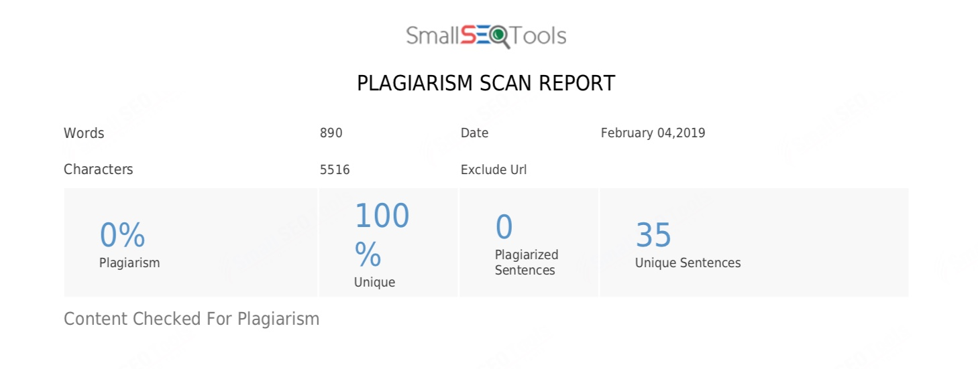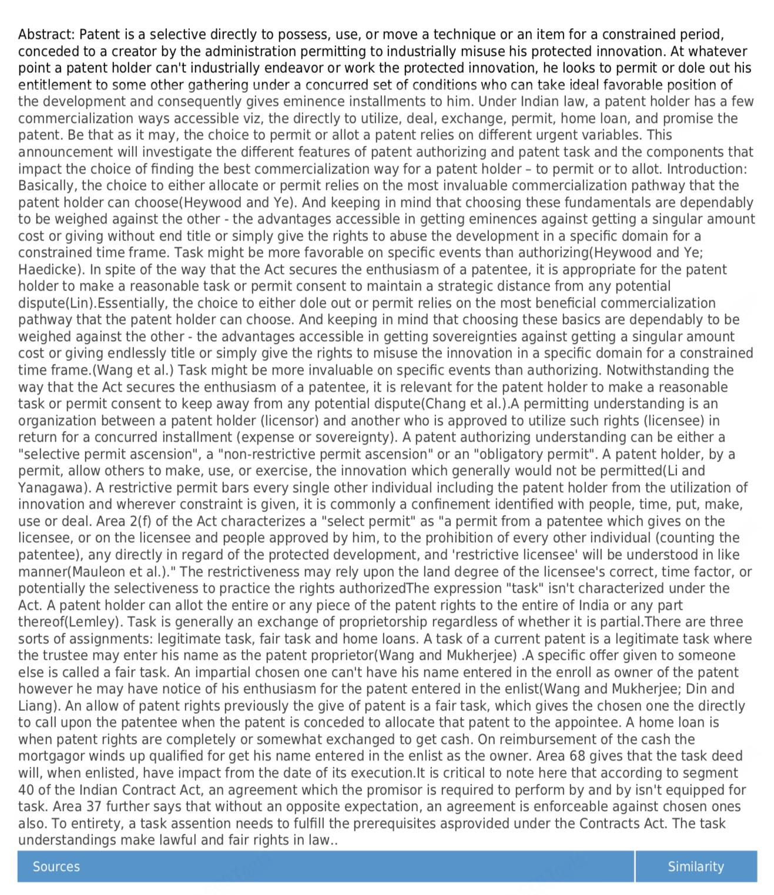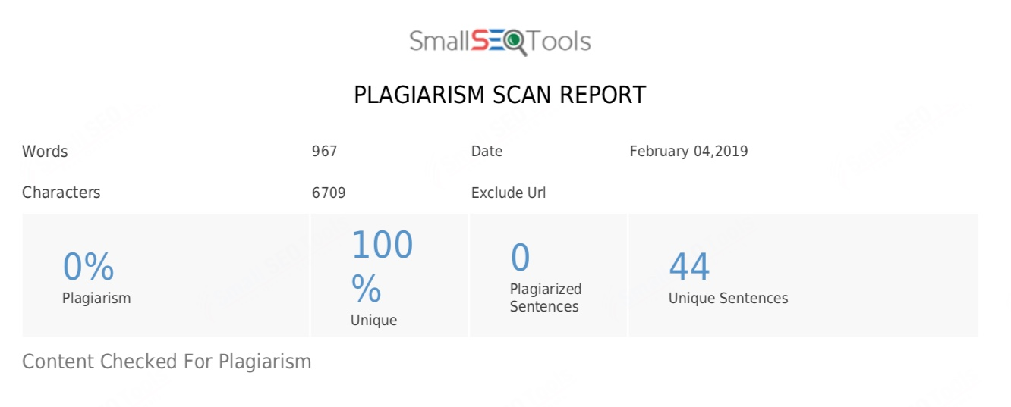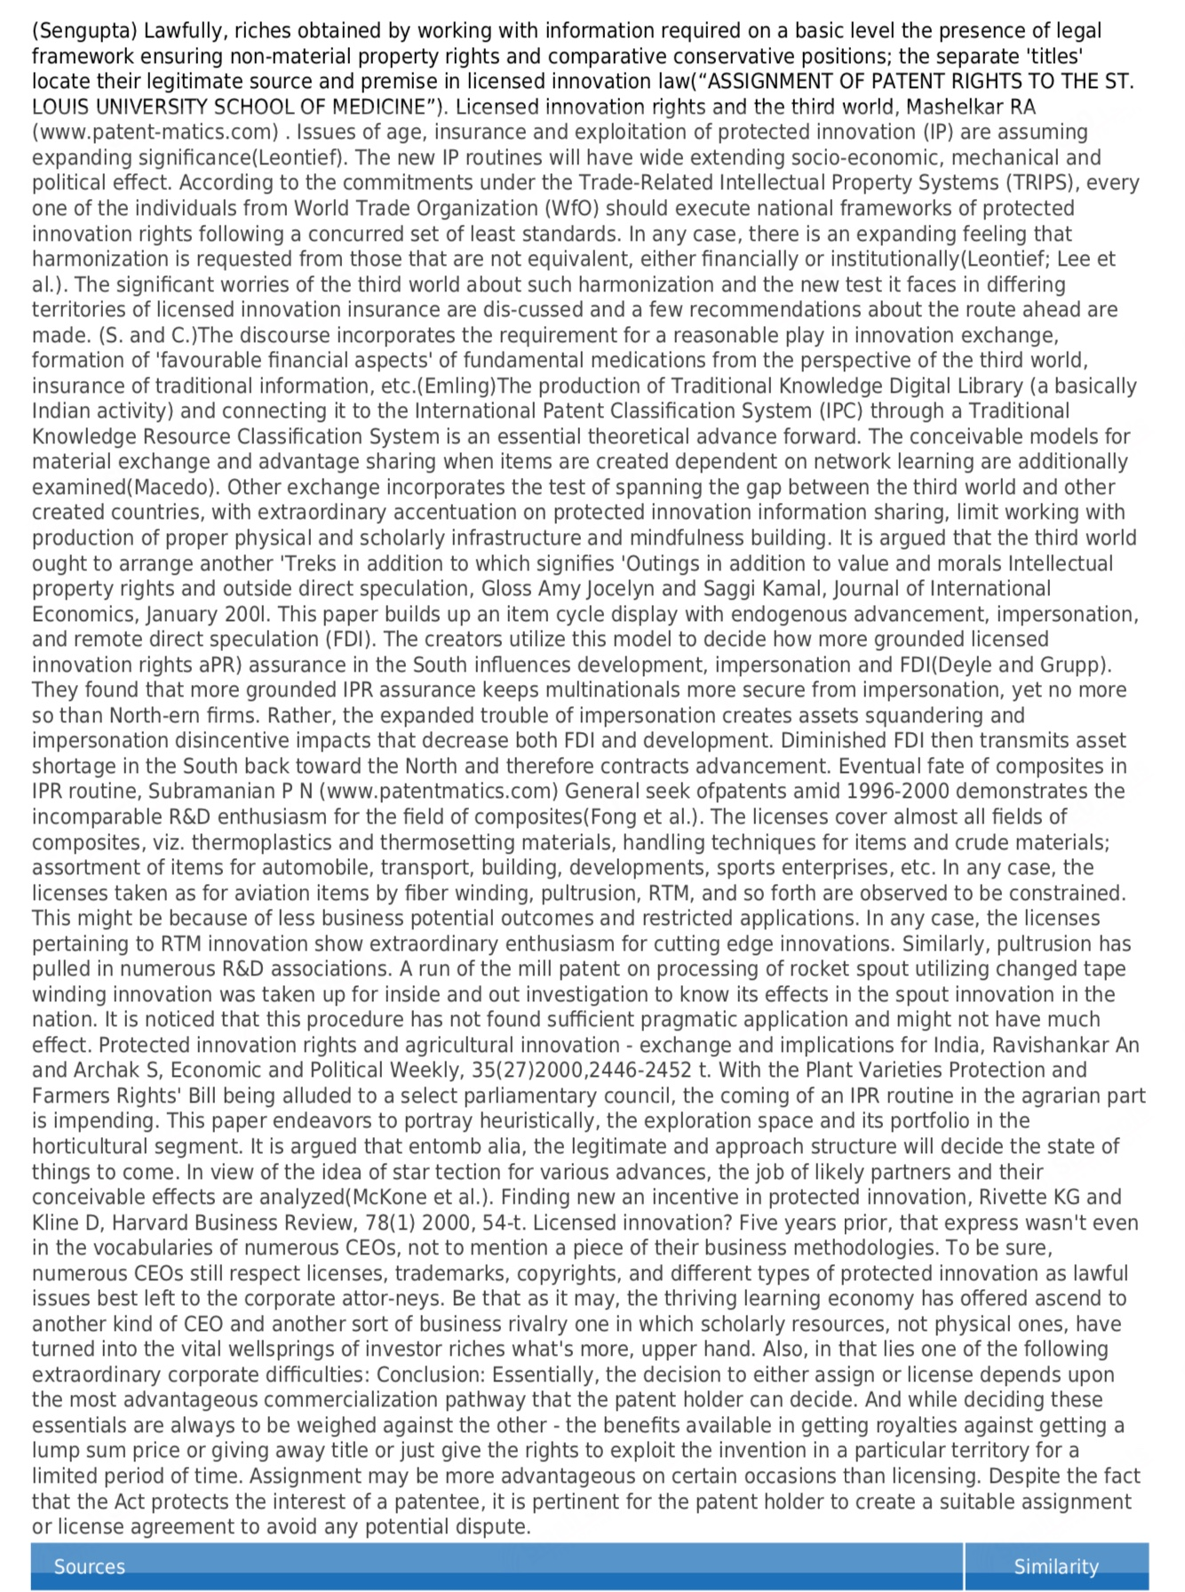

V.R.Sreehari,Advocate,B.A,LL.B (Hons.),Phone number:81482 55320, Email id:- sreehari0922@gmail.com
K.S.Eniyavan,Advocate,B.A,B.L(Hons.),LL.M, Phone no:96553 35590, Email id:- k.s.iniyavan@gmail.com

